


Meeting Date | 19 December 2023 |  | Agenda Item |  |  | 4.1
Report Title | Urgent and Emergency Care Report
Report Author | Neil Cooper, Asst Director of Operations – Urgent and Emergency Care  Jonathon Baglow, Business Intelligence
Report Sponsor | Deb Lewis, Chief Operating Officer
Presented by | Neil Cooper, Asst Director of Operations – Urgent and Emergency Care
Freedom of Information | Open
Purpose of the Report | To provide a summary of the Urgent and Emergency Care (UEC) improvement programme to improve the delivery of timely, safe patient care and the UEC care standards.
Key Issues | UEC performance has been escalated into enhanced performance monitoring by Welsh Government with the Chief Operating Officer holding oversight and assurance against developing and monitoring a UEC improvement programme.  The delivery of Tier 1 performance standards remains a significant challenge and the risk of patients coming to harm due to delays relating to timely handover of ambulances. Early assessment and treatment remain a key focus for the Emergency Department (ED) and ward based clinical management teams.  The overcrowding of the ED linked to poor flow and delayed admission of patients into the in-patient bed pool results in poor patient experience.  There are key system performance indicators that explain the challenges associated with delivering timely and safe patient care and thus the required levels of performance and these are discussed in the paper.  Service development schemes are in place and continue to be developed and implemented to support the recovery of UEC performance.  A structured approach for the UEC programme, approved by NHS Wales 6 goals programme is in place to support, deliver and monitor the schemes reporting to the UEC Board
Specific Action Required  (please choose one only) | Information | Discussion |  | Assurance | Approval
Specific Action Required  (please choose one only) | ☒ | ☐ |  | ☐ | ☐
Recommendations | Members are asked to:  - NOTE the UEC performance position and the ongoing actions taken to support its recovery and Improvement.

Urgent and Emergency Care Report

- INTRODUCTION
The report below describes urgent and emergency care (UEC) activity and performance to date including progress against the UEC care standards. Wider system indicators are also used to demonstrate the flow constraints that exist resulting in poor access to timely urgent and emergency care and poor patient experience. The report provides an update on the strategic and operational programme to improve the delivery of acute services to patients and on local improvement actions.

- BACKGROUND
The flow of Emergency patients within the health board continues to be significantly compromised due to the high occupancy levels within its hospitals. This is further exacerbated by the system flow challenges impacting patients transferring in a timely way into services outside the hospital sites which in turn increases delays in clinically optimised patients and increases the number of patients being treated outside of their core bed base. The impact of the lack of flow also has unintended consequences in other parts of the UEC system including:

- Delay in patient handover from ambulances into the ED;
- Delays in patients accessing inpatient beds
- Increase in utilisation of Surge capacity across the Hospital footprint and patients placed in inappropriate spaces i.e.SDEC
- Delays in patients transferring to the next stage of their recovery – complex and general rehabilitation at peripheral sites

In line with the 6 goals programme wider health board schemes targeting admission avoidance and earlier discharge are in place or in trial phase to support the wider system flow agenda.

- PERFORMANCE – Tier 1 URGENT & EMERGENCY CARE STANDARDS
The Charts below presents performance against the ED Access Standards and Ambulance handovers (12-month rolling position). Overall, 4-hour performance has improved and similarly, the number of patients waiting for 12 hours or more also reduced.
Despite the improvement, the ongoing challenging situation and generally poor performance against the 4-hour standard at Morriston Hospital translates operationally into poor patient experience. Patients can wait several hours for assessment by a clinician during which period their condition may be more serious than as assessed at triage, or may have deteriorated.

12 months to 31st Oct 2023
Front Door Measures

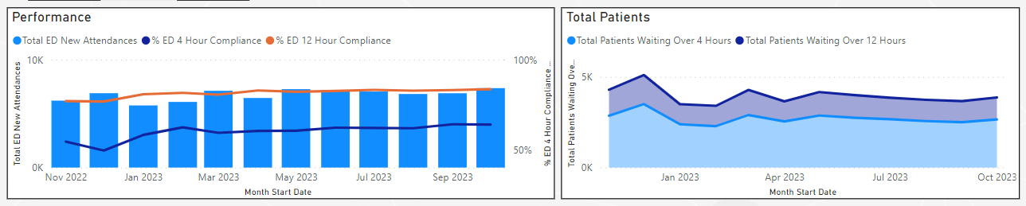

3.1 Ambulance attendance and handover delays >1 hour

Ambulance attendance to ED remains at a stabilised over recent months. This can be explained by several factors including:

- WAST Clinical Safety Plan is the escalation framework for WAST. WAST actions will vary depending on the level of escalation reported however at moderate to high levels of escalation, ambulance response is ‘rationed’ and persons in lower acuity categories will not receive an ambulance response.

- Advanced practice paramedic screening of the waiting demand with redirection of appropriate patients to alternative pathways thus avoiding ED – the Advanced paramedics have recently moved into the acute hub and work alongside the acute GPs in Same Day Emergency Care which will allow improved opportunity for non-conveyance and redirection;

- GP review of the waiting ambulance demand with redirection into alternative community pathways, self-care or into hospital SDEC services.

- Ambulance handover is of significant concern and has been a key focus from Welsh Government. The UEC programme is addressing this matter as one of its most critical areas for improvement

36 months to 31st October 2023
Number of Emergency Ambulances Waiting for Handover

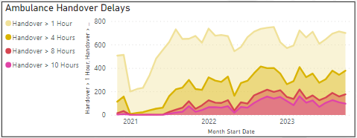

1st January to 31st October 2023
Number of Emergency Ambulance Hours Lost Waiting for Handover

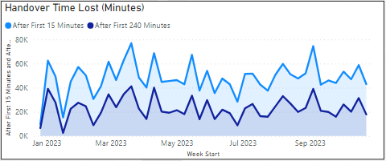

1st January 2023 to 29th October 2023
Mean Number of Emergency Ambulance Hours Lost Waiting For Handover

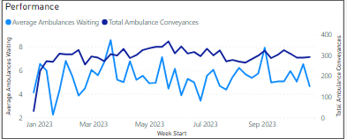

The reasons for the delays in handover are multi-factorial and include:
- Surges in demand from the ambulances or self-presenting patients;
- Availability of ED / AMU capacity to manage demand
- Onward flow to a hospital bed.
- Availability of onward hospital transfer
- High number of Clinically Optimised Patients (COPs) in the acute setting

The launch of initiatives within the UEC programme and effective operational leadership has shown an improvement in patients awaiting handover over 10 hours and a sustained reduction in hours lost to handover over the past 5 weeks. This past weekend has not been without its challenges with the Health Board declaring and operating at Business Continuity levels which has impacted the number of handover delays

Since Welsh Ambulance Service Trust (WAST) implemented its immediate release policy it has been recognised that there has been improvements in the ability to support the ‘amber 1 release’ and all requests for ‘red’ release have been supported.

3.2 Clinically optimised position

The clinically optimised position in the Health Board remains a critical issue with significantly high numbers of patients occupying acute beds waiting to move to more appropriate settings to continue their care pathway or waiting for community support/placement.

Morriston Hospital Clinically Optimised Patient Level 5th December 22 to 31st Oct 23

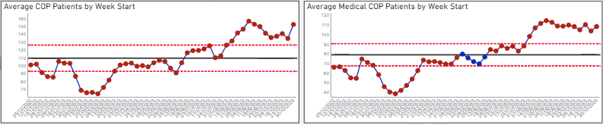

- Wider system measures and actions:
To understand performance in ED there is a requirement to explore wider system performance. The outputs in ED performance are directly impacted by performance in other parts of the health and social care system. There are internal measures that help to explain this and the Health Boards Unscheduled Care Delivery Group is actively working in conjunction with the 6 goals programme to develop a suite of information to support patient flow and develop key transformation and innovation work.

These measures will incorporate the agreed tier 1 targets but will also test our resilience on pathway changes and models of care. The UEC team are also committed to ensuring Quality and patient safety measures are monitored with a particular focus on the patient experience.

The following portfolio of work demonstrates the strategic programme of work in place ay SBUHB recognised and approved by the National 6 goals programme board.

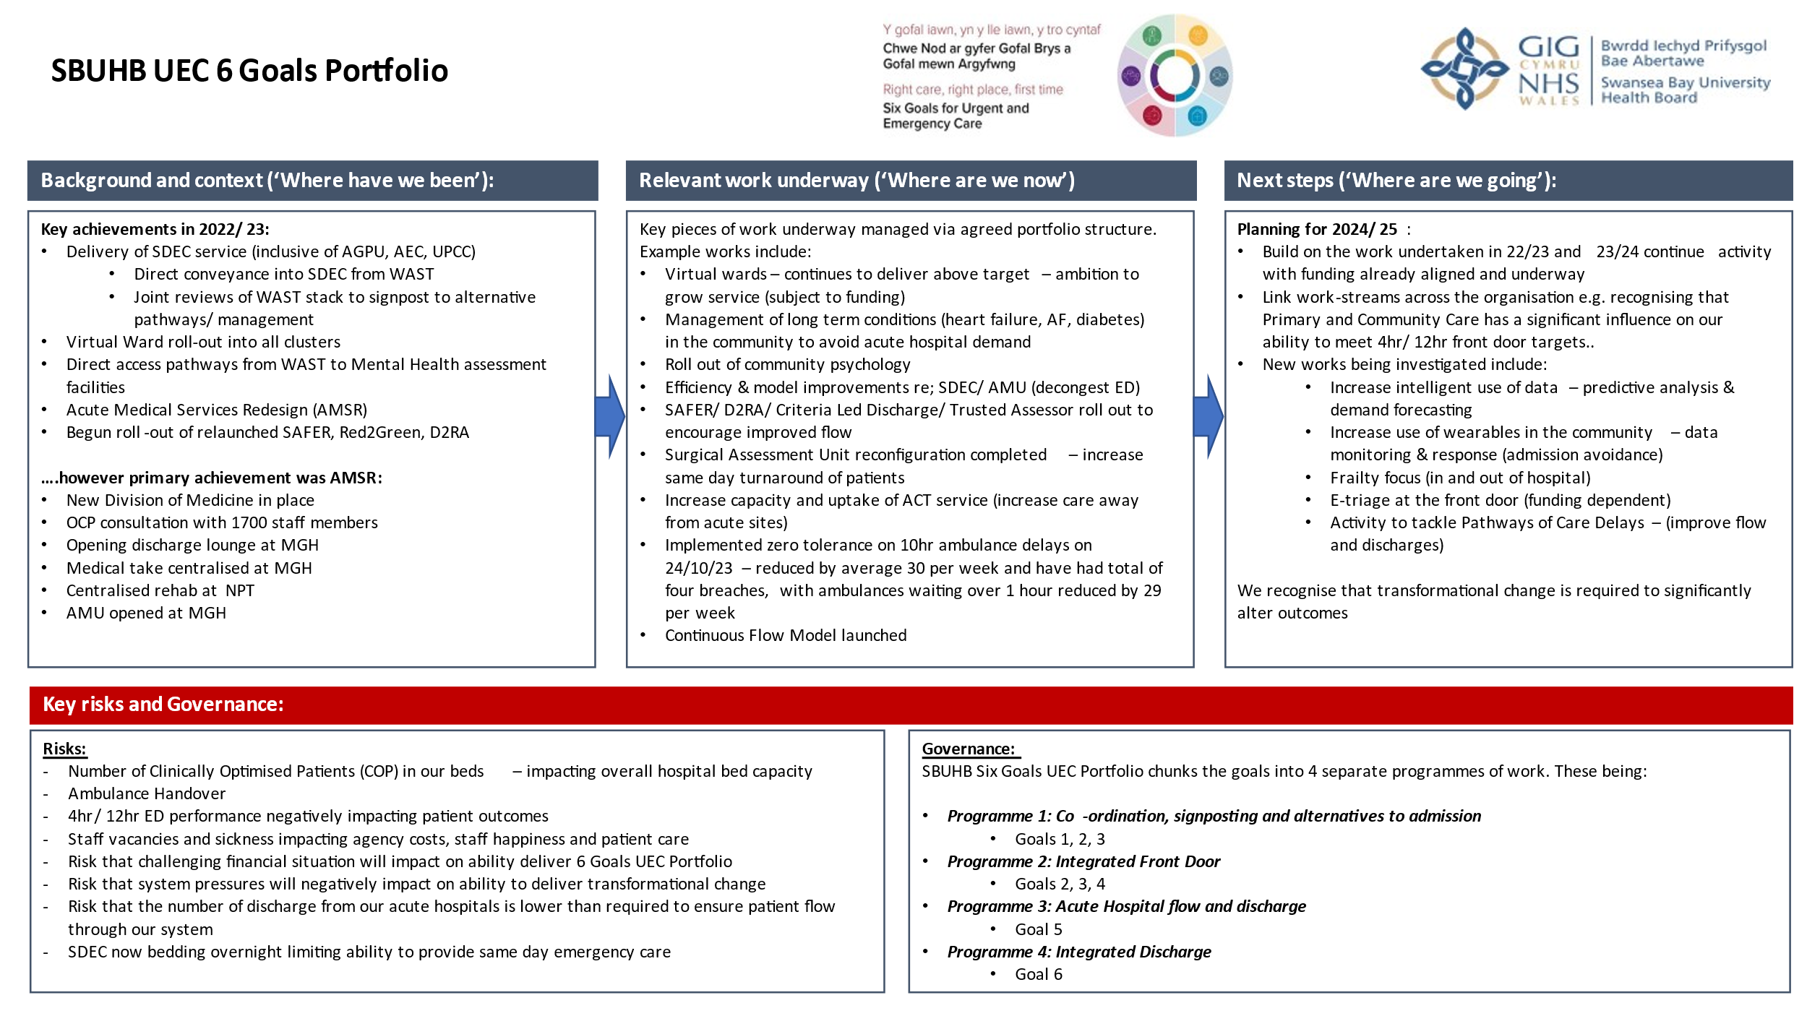
  - Management of UEC Programme / Performance

To ensure senior oversight and input into the UEW system the Health Board has recently made a new appointment to the Chief Operating Officers Team, The Assistant Director of Operations for UEC commenced in October. Alongside this post the Service Group Director for Primary and Community Care and Therapy Services has been assigned a lead Health Board wide role for UEC in recognition of the importance community services play in the delivery of sustainable UEC. To work alongside these two posts the Health Board will also align key nursing and medical leadership roles to ensure a triumvirate approach to UEC services improvement. These posts will be in place by the end of December.

To supplement the UEC Programme Board and ensure timely review / escalation of actions a weekly unscheduled care delivery group is in place chaired by the Asst Director of Ops and supported by the Interim Executive Medical Director and Chief Operating Officer. This group along with site based operational teams are fully committed in providing the presence and impact of plans to drive improvement and reduce the escalation status of the Health Board with Welsh Government.

- Recommendation
Members are asked to:
- NOTE the UEC performance position and the ongoing actions taken to support its recovery and Improvement.

Governance and Assurance

Link to Enabling Objectives  (please choose) | Supporting better health and wellbeing by actively promoting and empowering people to live well in resilient communities
Link to Enabling Objectives  (please choose) | Partnerships for Improving Health and Wellbeing |  | ☒
Link to Enabling Objectives  (please choose) | Co-Production and Health Literacy |  | ☐
Link to Enabling Objectives  (please choose) | Digitally Enabled Health and Wellbeing |  | ☒
Link to Enabling Objectives  (please choose) | Deliver better care through excellent health and care services achieving the outcomes that matter most to people
Link to Enabling Objectives  (please choose) | Best Value Outcomes and High Quality Care |  | ☒
Link to Enabling Objectives  (please choose) | Partnerships for Care |  | ☒
Link to Enabling Objectives  (please choose) | Excellent Staff |  | ☒
Link to Enabling Objectives  (please choose) | Digitally Enabled Care |  | ☒
Link to Enabling Objectives  (please choose) | Outstanding Research, Innovation, Education and Learning |  | ☒
Health and Care Standards
(please choose) | Staying Healthy |  | ☒
(please choose) | Safe Care |  | ☒
(please choose) | Effective Care |  | ☒
(please choose) | Dignified Care |  | ☒
(please choose) | Timely Care |  | ☒
(please choose) | Individual Care |  | ☒
(please choose) | Staff and Resources |  | ☒
Quality, Safety and Patient Experience
To improve the delivery of timely, safe patient care and the UEC care standards.

Financial Implications
There are no direct financial implications arising from the recommendations in this report.
Legal Implications (including equality and diversity assessment)
There are no direct legal implications arising from the recommendations in this report.
Staffing Implications
There are no direct staffing implications arising from the recommendations in this report.
Long Term Implications (including the impact of the Well-being of Future Generations (Wales) Act 2015)
Report History |  | N/A
Appendices |  | N/A

