

Meeting Date | 19th December 2023 |  | Agenda Item |  | 2.1
Report Title | Financial Report – Period 08 2023/24
Report Author | Samantha Moss, Deputy Director of Finance  Gemma Pearson, Finance Business Partner
Report Sponsor | Darren Griffiths, Executive Director of Finance and Performance, Acting Deputy Chief Executive
Presented by | Samantha Moss, Deputy Director of Finance
Freedom of Information | Open
Purpose of the Report | The report advises the Performance & Finance Committee of the Health Board on the financial position for Period 08 (November 2023) 2023/24 and risks regarding current forecast revenue year end outturn.
Key Issues | The report invites the Performance & Finance Committee to note the detailed analysis of the financial position for Period 08 (December 2023) 2023/24. The position reflects the part year impact of the application of additional £60.8m allocation received as part of the redistribution of Welsh Government budgets.  The report includes a summary of the key drivers of the position either at Service level or by expenditure type (i.e. Non Pay / Pay). It also provides information of the current position with regards to Health Board reserves to ensure transparency in the overall Health Board position.  It should be noted that in Month 8 a number of significant Service Transfers were completed, predominantly between Morriston and Neath Port Talbot & Singleton, but also affecting Primary Care & Therapies. Whilst there is no impact on the overall Health Board position, this means that the presentation of both the in-month and YTD financial positions between Service Groups are affected, along with Savings Targets.  Discussions have been held with Welsh Government and the Board regarding the options available to deliver the Control Total set, which are summarised and managed through the document referred to as the 2023/24 Landing Plan. As a result of the work completed to date the risk score in relation to the delivery of the financial plan in 2023/24 remains at 20.  Whilst the key messages are provided within the main body of the report, further information is provided in the Appendices.
Specific Action Required | Information | Discussion | Assurance | Approval
Specific Action Required | ☐ | ☐ | ☒ | ☐
Recommendations | Members are asked to:  - NOTE the agreed 2023/24 financial plan.  - Consider and comment upon the Board’s financial performance for Period 08 2023/24.  - NOTE the actions to ensure delivery of the financial forecast with a specific focus on savings delivery:  - Enhanced monitoring meetings in place above standard Finance & Performance Meetings to oversee and agree actions to mitigate run rates and deliver savings. Morriston / NPTS Service Group Directors  - Focused attention to ensure that 100% of the schemes are identified at the end of Q1 23/24. All Service Group Directors and Corporate Directors  - Focused attention to ensure that 100% of the schemes identified at the end of Q1 are green and amber by the end of Q2 23/24. All Service Group Directors and Corporate Directors  - Where savings delivery is not on track a further correspondence has been issued (Appendix 5). All Service Group Directors and Corporate Directors  - NOTE actions to ensure the operational pressures are mitigated and areas return to financial balance.  - Enhanced monitoring meetings in place above standard Finance & Performance Meetings to oversee and agree actions to mitigate run rates and deliver savings. Morriston / NPTS Service Group Directors  - Embed and deliver opportunities identified via the Independent Financial support provided to the Service Group to review run rate and savings. Morriston Service Group Directors  - NOTE the risks to the position at Month 8.  - NOTE the actions required to achieve Control Total (Appendix 4)  - NOTE the revised targets set to support Control Total (Appendix 5)  - NOTE the position with regards to Health Board Reserves.  - NOTE all actions and updates to support the management of the 2023/24 financial position.

FINANCIAL REPORT – PERIOD 08

- SUMMARY OF REVENUE PERFORMANCE

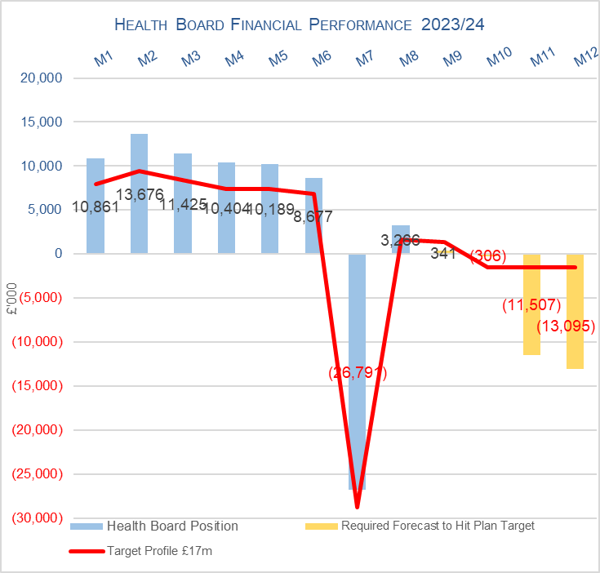

Target | In Month  £M | Year To Date (YTD)  £M
Delivery Against Revenue Resource Limit (RRL) DEFICIT / (SURPLUS) | 3,266 | 41,704
Delivery Against Financial Plan (Not Control Total) DEFICIT / (SURPLUS) | 1.606 | 21,344
Delivery Against Total Savings Target In Ledger DEFICIT / (SURPLUS) | 0.664 | 6,538

- FINANCIAL PLAN 2023/24

The Health Board (HB) submitted a revised plan on 31st May 2023 that reported a deficit of £86.6m. Following the hard work undertaken within Welsh Government, NHS Wales has received £460m of additional funding of which Swansea Bay received £60.8m for 2023/24 (of which £43.3m is recurrent). For 2023/24 there is then a requirement for the HB to deliver a 10% reduction based on the original deficit plan value of £86.6m, to achieve a Control Total of £17.1m.The profile of the £17.1m Control Total following the receipt of the £60.8m is provided below:

Table 1: Financial Plan 2023/24

The plan was developed on a tapering basis to allow the Health Board time to work on reducing the run rates, reduce COVD spend and identify savings. Performance against the plan and the agreed tapered values is summarised below:

Table 2: Plan & Performance 2023/24

- KEY PERFORMANCE AREAS
Performance is summarised from two different perspectives. Section 3.1 provides the reported position by Service Group/Directors and Section 3.2 onwards looks at the reported position from the components of the ledger i.e. Income, Pay and Non Pay, with further details provided in Appendix 1.

  - Summary By Service Area

Table 3: Summary

It should be noted that in Month 8 a number of significant Service Transfers were completed, predominantly between Morriston and Neath Port Talbot & Singleton, but also affecting Primary Care & Therapies. Whilst there is no impact on the overall Health Board position, this means that the presentation of both the in-month and YTD financial positions between Service Groups are affected. Transferring from NPT & Singleton to Morriston is Pathology; transferring from Morriston to NPT & Singleton is Trauma & Orthopaedics, Spinal, Theatres and Anaesthetics; transferring from NPT & Singleton to Primary Care & Community is Swansea Lymphoedema & Specialist Palliative Care. The below narrative reflects the post-transfer financial positions.

Key points of notes by Service Area (based on new Service Structure):

- Morriston
The key variances:
- Income: Month 8 is £0.153m over-achieved, however the Year To Date (YTD) remains under-achieved by £0.909m. This is driven by WHSSC performance. Plans are being developed to recover this via the Enhanced Monitoring meetings.
  - Pay: Month 8 is £1.203m overspent, which is a £0.1 m deterioration from Month 7, and remains £10.697m overspent YTD. Expenditure on variable pay was £2.790m in-month, which is an increase of £0.361m from Month 7.
  - Non-Pay (excluding Savings): Month 8 is £0.512m overspent and YTD £5.42m. Of the £5.42m, YTD £3.8m relates to Clinical Supplies (including Secondary Care Drugs).
  - Savings: YTD position at Month 8 is an £4.357m shortfall.

- Neath Port Talbot & Singleton (NPTS)
The key variances:
  - Income: Month 8 is an £0.166m under-achievement and YTD £0.543m under-achievement. This is primarily driven by the loss of Private Patient income.
  - Pay: Month 8 is £0.794m overspent; this is a deterioration of £0.148m compared to Month 7. The YTD position is £4.125m overspent. Expenditure on variable pay was £1.636m in-month, which is an increase of £0.228m from Month 7.
  - Non-Pay (excluding Savings): Month 8 is £1.526m overspent and YTD £7.176m overspent, which relates to Clinical Supplies and Primary Care Prescribing.
  - Savings: YTD position at Month 8 shows an £1.993m shortfall.

  - Summary By Type Expenditure

- Income
The Welsh Health Specialised Services (WHSSC) Income as a provider continues to impact on the performance against plan, with YTD underachievement of £1.0m. Whilst this has stabilised in the last 2 months, performance has not recovered the reduced activity on WHSSC services seen in Quarter 1 of 2023/24.

As reported for the previous 7 months of 2023/24, the pressure as a result in the loss of Dental Contract Income continues, with the YTD shortfall increasing to £1.2m in Month 8.

- Pay
The Month 8 pay overspend has deteriorated from Month 7 and stood at £1.9m (an increase from Month 7 overspend of £1.4m), taking the YTD overspend to £12.94m. There has been an increase of 255 WTEs between months, predominantly within Nursing & Midwifery, which is largely driven by the ongoing on-boarding of our Overseas Nurses along with new student streamlining. However, this has not delivered a reduction in Nursing variable pay expenditure within Month 8 (where there has been an increase of £0.2m) due to the supernumerary period and increased acuity requiring higher roster fill rates. Within Medical & Dental there is a reduction of 10 WTEs which has required additional variable pay cover within Month 8 (£0.2m) in addition to increased WLIs and increased activity.

Therefore, the Health Board clearly needs to address both the underlying run rate issue and the continued expenditure on variable pay, which is driving the in-month and YTD pay variance.

- Prescribing
At Month 8 the year to date position reflected in the ledger on Prescribing is £0.644m overspent and £4.854m YTD. The June 2023 PAR reflected a significant increase linked to the volume of items, which was pushing the forecast to £6.7m. However, July 2023 PAR saw the costs reduce only for an increase in volume in August 2023 PAR to increase the forecast again. This will continue to be a risk in the delivery of the control total for 2023/24 and updates will be provided as the year progresses.

- Non Delivery Savings
The Health Board has set a 3.5% savings target for 2023/24, after two years of achieving 4%. In additional there is a further £10.6m of unmet recurrent savings b/f from 2022/23. However there remains a gap in the delivery of savings to meet the target sets which has resulted in a £0.7m variance in Month 8, with a £6.5m YTD.

  - Action being Taken to Mitigate Position

The previous reports detailed the actions being driven by the Health Board to mitigate the planned deficit and the risks. Updates or additional actions above those reported in previous months are captured below:

- Landing Plan – The Health Board’s ‘Landing Plan’ to deliver the Control Total set by Welsh Government of £17.1m was presented to the Board on 30th November. The Board supported the aspiration to deliver the Control Total and the opportunities and actions needed to deliver the target. The control target requirements for Service Groups will be formally communicated to Budget Holders in December via a letter from the Chief Executive. The Landing Plan will be used going forward to oversee the delivery of the Control Total and will be shared with the Performance & Finance Committee monthly to provide oversight and assurance on the delivery of the actions.

- SAVINGS
Based on the latest saving position reported by the Savings Project Management Office (PMO), the schemes identified for delivery in 2023/24 by service areas are summarised below.

From Month 8 the PMO will provide supplementary information in Appendix 3 to support the assessment of the financial position following a recommendation by Internal Audit.

Table 4a In Year Performance Against 2023/24 Requirements

Table 4b Recurrent Performance Against 2023/24 Requirements

- RISK
Two Board level financial risks: -

- Achieving financial plan (HBR92) with the key elements as follows: -

  - Risk of delivery of savings quantum
  - Risk of operational overspend being in excess of funding available agreed via the Financial Plan
  - Risk of commitment of reserves (e.g. NICE) being above reserves available.

Following the Board meeting on 30th November, whilst there is a Landing Plan to achieve the control total set by WG, where is a significant amount of work to achieve the delivery of these, alongside some risk that not all with be achieved and further risks which have been included in the month 8 letter to WG around: -

  - Prescribing pressures linked to NCSO / Volume;
  - Winter Pressures (Surge/Variable Pay does not exceed current assumed levels within the assessment)
  - Energy costs remains within the assessment undertaken at Mth 6 and funding £7.8m is provided as anticipated, which is part of the £60.8m but not yet received from WG;
  - Pay Award funding allocated as per assumed anticipated income within MMR is received in full and at the time of writing this report WG were still working on the process by which funding would be allocated to HBs for the 20234/24 pay award;
  - LTA Performance (provider) does not deteriorate over Winter;
  - RLW is funded in full by WGas per the finalised values reported in Mth 6 MMR;
  - CHC – potential impact of any judicial review (£2.5m for 2023/24)
Therefore it is proposed that the Health Board Corporate Risk Register current report risk score of 20 score is maintained. An assessment of the risk score will be undertaken each month as the options within the Landing Plan are delivered and confirmation of material outstanding funding is received from WG.

- Availability of capital (HBR93). This risk was re-opened in 2022/23 given the reduction in discretionary capital allocation. Whilst work is underway to manage schemes to reduce commitments in 2023/24 and to produce a balanced plan, the risk varies during the year as more details on schemes emerge and potential slippage funding is made available by Welsh Government. A score of 20 is suggested at this stage as whilst the plan is now balanced, a number of schemes are on hold and the flexibility within the plan is extremely limited given the reduction in the allocation.

- RECOMMENDATIONS

Members are asked to:
- NOTE the agreed 2023/24 financial plan.
- Consider and comment upon the Board’s financial performance for Period 08 2023/24.
- NOTE the actions to ensure delivery of the financial forecast with a specific focus on savings delivery:
- Enhanced monitoring meetings in place above standard Finance & Performance Meetings to oversee and agree actions to mitigate run rates and deliver savings. Morriston / NPTS Service Group Directors
- Focused attention to ensure that 100% of the schemes are identified at the end of Q1 23/24. All Service Group Directors and Corporate Directors
- Focused attention to ensure that 100% of the schemes identified at the end of Q1 are green and amber by the end of Q2 23/24. All Service Group Directors and Corporate Directors
- Where savings delivery is not on track a further correspondence has been issued (Appendix 5). All Service Group Directors and Corporate Directors
- NOTE actions to ensure the operational pressures are mitigated and areas return to financial balance.
- Enhanced monitoring meetings in place above standard Finance & Performance Meetings to oversee and agree actions to mitigate run rates and deliver savings. Morriston / NPTS Service Group Directors
- Embed and deliver opportunities identified via the Independent Financial support provided to the Service Group to review run rate and savings. Morriston Service Group Directors
- NOTE the risks to the position at Month 8.
- NOTE the actions required to achieve Control Total (Appendix 4)
- NOTE the revised targets set to support Control Total (Appendix 5)
- NOTE the position with regards to Health Board Reserves.
- NOTE all actions and updates to support the management of the 2023/24 financial position.

Governance and Assurance

Link to Enabling Objectives  (please choose) | Supporting better health and wellbeing by actively promoting and empowering people to live well in resilient communities
Link to Enabling Objectives  (please choose) | Partnerships for Improving Health and Wellbeing |  | ☐
Link to Enabling Objectives  (please choose) | Co-Production and Health Literacy |  | ☐
Link to Enabling Objectives  (please choose) | Digitally Enabled Health and Wellbeing |  | ☐
Link to Enabling Objectives  (please choose) | Deliver better care through excellent health and care services achieving the outcomes that matter most to people
Link to Enabling Objectives  (please choose) | Best Value Outcomes and High Quality Care |  | ☒
Link to Enabling Objectives  (please choose) | Partnerships for Care |  | ☒
Link to Enabling Objectives  (please choose) | Excellent Staff |  | ☐
Link to Enabling Objectives  (please choose) | Digitally Enabled Care |  | ☐
Link to Enabling Objectives  (please choose) | Outstanding Research, Innovation, Education and Learning |  | ☐
Health and Care Standards
(please choose) | Staying Healthy |  | ☐
(please choose) | Safe Care |  | ☐
(please choose) | Effective Care |  | ☐
(please choose) | Dignified Care |  | ☐
(please choose) | Timely Care |  | ☐
(please choose) | Individual Care |  | ☐
(please choose) | Staff and Resources |  | ☒
Quality, Safety and Patient Experience
Financial Governance supports quality, safety and patient experience.

Financial Implications
The Board is reporting a forecast year-end deficit financial outturn.

Legal Implications (including equality and diversity assessment)
No implications

Staffing Implications
No implications

Long Term Implications (including the impact of the Well-being of Future Generations (Wales) Act 2015)
No implications

Report History |  | Updates on the financial position are provided at every meeting
Appendices |  | Appendices providing further detail

APPENDIX 1 – FURTHER DETAIL ON VARIANCES BY TYPE OF SPEND

- Overview of Income

- Overview of Pay Variances

Overall Variance by month
Note – movement between Month 2 and 3 and Month 4 and 5 budget relates to the one-off funding for the Recovery pay award and changes to the budget profiling linked to year-end accruals for Leave, Overtime and Time owing. Month 7 budget includes Medical & Dental Pay Award arrears (7/12th) for 2023/24.

Actual Variable Pay by month and type
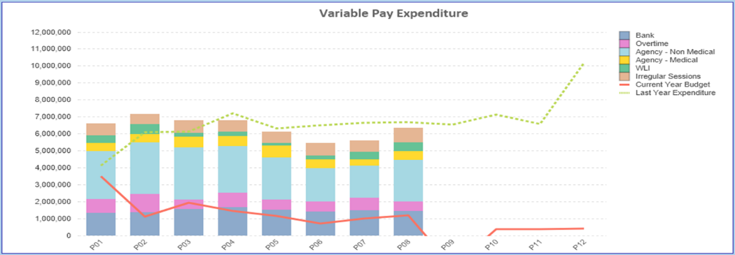

- Overview Non Pay

Note – movement between Month 2 and 3 budget relates to the one-off adjustment for Losses, which is normally reflected at year-end only and so had to be adjustment between months. Month 7 reflects 7/12th of budget linked to the additional funding of £60.8m.

Below are further details on the keys areas of Non Pay (excluding savings that is addressed in main body):

  - Clinical Consumables
This area continues to be a significant pressure with a YTD variance of £7.3m. With the in-month position being slightly (£0.1m) improved from Month 7 at £1.4m. There are 80+ subjective lines within this category including secondary care drugs but areas seeing most pressures YTD continue to be general consumables (M&SE), laboratory products and implants (which in part will be driven by activity).

  - Utilities
The most recent update on the forecast via British Gas/CCS ranges from £14.2m to £13.2m based on the email from NWSSP dated 2nd October 2023. It is important to note that this forecast is not based on actual or predicted volume usage but industry averages. This becomes important given the Moriston site acquires a significant amount of its power from the Solar Farm, which if using industry averages would not be built into the forecast.

Therefore alongside this the Health Board has under an assessment of its predicted usage costed at the CCS rate. The forecast included in the Month 8 MMR provides an estimate of £15.9m for 2023/24, including PFI. PFI costs are outside of the CCS forecast and to date we have not yet received any invoices for this financial year. The HB is assuming the full funding for energy of £7.8m in its overall Landing Plan.

  - CHC
The variance against budget for CHC is £0.720m overspent in month, and is £0.653m overspent YTD which reflects the impact of a number of retrospective packages were recognised in Month 8 partly offset by both the additional funding allocated to CHC through the financial plan and the non-recurrent benefit from the release of some accruals from 2022/23. An analysis of actual spend and patient numbers for 2023/24, along with the average values from 2023/24 is provided in table below.

CHC Analysis By Month

(Please note: PCT Group does not include the Singleton/NPT element. The NPTS element which covers Children and Young People CHC patients is provided internally by the Health Board and as such is part of the wider NPTS position and is not recorded in the ledger as PCT/MH/LD CHC is recorded)

  - Prescribing
See commentary in section 3.2 in the main body of the report.

  - LTA Performance
Historically LTA contracts have been based on a Cost and Volume approach, which reflects adjustments for under and over performance. From the start of the COVID pandemic in April 2020 all LTA agreements in both England and Wales transferred to a block arrangement, whereby commissioners funded providers on 2019/20 levels uplifted by nationally agreed rates with no adjustment for performance. From 1st April 2022 the previous block arrangements have ceased and a hybrid model adopted where under or over performance adjustments will become applicable above a tolerance level. This became relevant to both services we commission from other Health Boards and services commissioned from SBU HB. In 2022/23 the tolerance level was 10% but in 2023/24 the tolerance level has reduced to 5%.

Table below is the performance of Swansea Bay HB at the end of Month 6 as a provider, for services commissioned by other Health Boards. Under the previous Long Term Agreements the full year forecast for underperformance would be £1.151m, under the interim arrangements that risk has reduced and delivers a benefit of £1.304m.

The Table below is the performance of contracts provided by other Health Boards in Wales but commissioned by Swansea Bay. Here under the previous LTA arrangements we would have seen a benefit of £4.5m but under the interim arrangement that has reduced to £3.1m.

Of the net impact of £4.36m, some will already be accounted for in the YTD position, with the Landing Plan assuming there is further benefit delivered by the end of Financial Year. However the final impact of LTA performance will not be known until the Intra NHS Exercise/Agreement of Balances is complete as part of the Year End Closedown across NHS Wales.

APPENDIX 2 – DETAILS ON RESERVES & CENTRAL BUDGETS

- SUMMARY RESERVES
Overall management of the reserves is as per the Health Board Budget Management document.

  - Balances Main & NICE
For 2023/24, the Health Board will hold two central reserves and the purpose of these reserves are below: -
- Main – this holds funding from WG or the plan that has yet to be issued to Budget Holders. These items are not surplus but either due to timing have not been issued or is an area where funding is issued based on actual values consumed in future month.
- NICE – this holds the total Health Board funding for all of NICE costs (drugs and infrastructure) and is issued to the service each month based on the actual costs consumed as reported through the Pharmacy system.

Details on the balances and movements are provided in the Table below:

- COVID
As part of the Financial Plan £22.9m was set aside to support COVID Recovery (excluding Regional Investments). The £22.9m was funded through £15.2m from WG Annual Allocation letter issued in December 2023, and an additional £7.7m of Health Board discretionary revenue funding. The funding remains in Central Reserves, as recorded in Section 1 above. This funding is then issued to service areas based on the actual costs committed. A summary of the actuals to date and forecast costs against the £22.9m is summarised in the table below:

- Changes to Deficit
The Board supported the original £86.6m deficit plan. The deficit was held centrally with an element reflected each month in the reported performance against RRL (see Section 3.4 on Non-Pay) on a tapered basis, as previously agreed with the Board. Following the announcement by WG the HB received £60.8m, which has been allocated against the opening deficit. This leaves the planned deficit at £25.7m. However, this does not include the additional 10% required to meet the Control Total.

APPENDIX 3 – DETAILED SAVINGS REPORT
- Total HB Savings
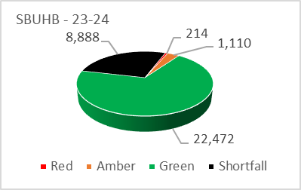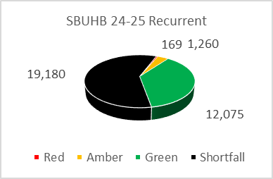
- The 2023/24 savings target is £32.7m (made up of £22.2m in year target and a brought forward sum of £10.5m).
- There are limited red schemes as part of the CIP plan this year due to improved governance. Current savings represent 72% of the in year target and 41% of the recurrent target.
- Morriston has the largest shortfall against target, achieving 40% in the current year and 16% recurrently. NPTS have achieved 55% and 18% respectively, and PCT 96% and 72% respectively, MHLD achieving 100% and 50% respectively

Total Savings for SBUHB by Service Group and by Risk Rating
- Morriston Savings
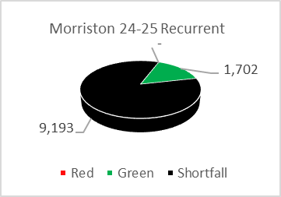
- Morriston have now identified £4.4m in-year with a current shortfall of £6.5m. (note the Morriston CIP Target has now reduced by £3.175m due to numerous cost centres transferring into NPTS).
- The recurrent savings show identified schemes of £1.7m with a shortfall at £9.2m (excludes red schemes).
- Pipeline CIP/Run Rate Opportunities include critical care bed alignment to demand, Plasma Exchange, ALAC, Pathology – Vitamin D, Health Care Business Solution invoicing arrangements to check, Procurement & Private Patients Opportunities.

- NPTS
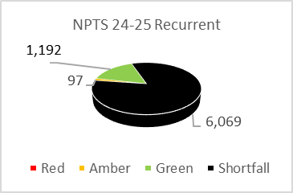
- The NPTS forecasted savings (excluding red schemes) remains at £4m, with an in-year shortfall of £3.3m. The recurrent shortfall remains at £6.1m.
- Further service transfers undertaken from month 8 have now increased the NPTS CIP Target by £3.017m (+£3.175m increase from Morriston and a reduction since this was passed onto PCC -£.158m).

- MHLD
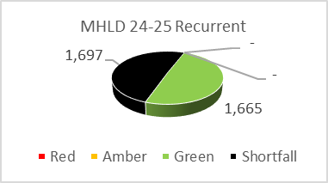
- MHLD forecasting remains the same with an in-year savings of £3.5m (all green) and no in-year shortfall, creating an overachievement against target of 202k. This success has come from the slippage from new funding streams. FYE savings is £1.7m recurrently, due to a drop in invest to save opportunities.
- Work is currently on-going to find recurrent saving schemes to fill the recurrent shortfall of £1.7m to work through areas which could fill this recurrent shortfall

- PCT
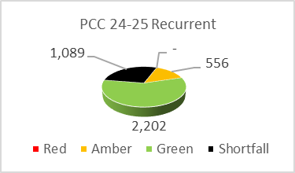
- PCCT have now had an increase in their Full Year Target by £.158m which has been transferred from NPTS.
- Savings identified has remained at £3.6m which now leads to a shortfall of £.157m.
- Recurrent savings identified are £2.7m with a shortfall of £1.1m.

- CORPROATE
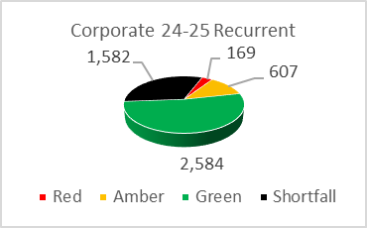
- Corporate Directorates forecasted savings identified have increased by £0.4m to £5.8m in year. This increase comes from a change in Digital status in respect of VAT recovery and reduction in vacancy management periods. The Corporate areas in-year forecast continue to over-achieve by £0.9m
- The Corporate recurrent shortfall has slightly increased to £2.4m.
- Finance and Estates have exceeded the in year target for in year savings. This is due to Solar Farm repayment savings, energy repayment from British Gas, and PFI De Minimis Interest.
- The anticipated progress with in year movements, particularly in Digital regarding the MS365 VAT savings have been retracted, however they continue to report an overachievement on their In year CIP Target. The MS365 Savings now need to be reflected in the RAG status and switched to red as no refund is likely in 2023/24, it’s not to say this is not achievable in the near future.
- The most challenging Directorates for achieving recurrent savings remain COO, Finance and Estates, WOD and the Health board Wide roll over.

APPENIDX 4: ACTIONS LANDING PLAN

APPENDIX 5: ACCOUNTABILITY LETTER REVISED TARGETS

