Meeting Date | 27 August 2024 |  | Agenda Item |  |  | 4.4
Report Title | Performance update on Ophthalmology Target Figures
Report Author | Rhodri Davies, Associate Service Group Director Surgery  Suzanne James, Service Manager Ophthalmology
Report Sponsor | Ceri Gimblett, Service Director NPTSSG  Deb Lewis, Chief Operating Officer / Executive Director of Primary Care & Mental Health
Presented by | Rhodri Davies, Associate Service Director NPTSSG
Freedom of Information | Open
Purpose of the Report | The purpose of this report is to present the most recent Ophthalmology performance information to Performance and Finance Committee.
Key Issues | The paper sets out Ophthalmology performance against key metrics across  - Referral to Treatment Times,  - Follow up Not Booked patients and the  - National Eye Care Measures.
Specific Action Required  (please choose one only) | Information | Discussion |  | Assurance | Approval
Specific Action Required  (please choose one only) | ☒ | ☐ |  | ☒ | ☐
Recommendations | Members are asked to :  - ACKNOWLEDGE the Ophthalmology performance information up to end of July 2024

Performance update on Ophthalmology Target Figures

- INTRODUCTION

The purpose of this report is to provide assurance regarding the most recent Ophthalmology performance information to Performance and Finance Committee. This paper links to a previous report to the Quality and Safety Committee in October 2023, which provided an update on the progress of the Ophthalmology Gold Command.

- BACKGROUND

There are three key performance targets that Ophthalmology services have to report against. These are set out below:

- Referral to Treatment times (RTT)
- Follow up Not Booked (FUNB)
- National Eye Care Measures

For RTT targets specifically, the current focus is on achieving no patients waiting over 52 weeks to be seen in outpatients (stage 1 of the pathway) and no patients waiting over 104 weeks for treatment (stage 5 of the pathway). The target for FUNB waiting times is an annual 30% reduction in the waiting list.
There are a number of metrics reportable under the Eye care measures, which are set out in more detail within this paper.
In September 2018, the Health Board reported that many patients (in excess of 10,000) who were beyond their noted target date for follow up appointments in Ophthalmology. Excessive waits in outpatient ophthalmology were common across all health boards in Wales.
An Ophthalmology Gold Command was established within SBUHB to coordinate and expedite the mitigating action plans associated with tackling the long waiting times. The group oversaw and monitored risk reduction against the Follow Up Not Booked (FUNB) profile for Ophthalmology and also extended to look at the R2 category of patients and Referral to Treatment Times (RTT) for cataract to ensure there is a single approach across Ophthalmology pathways to minimise duplication and consistency of reports.
Through 2018, the National Planned Care Programme worked with health boards, NWIS (now DHCW) and RNIB to develop processes and systems to introduce individualised target dates for a combined new and follow-up patient list, which is based on the patient’s clinical condition. Three defined categories have been agreed to support the clinical prioritisation:

- R1: Risk of irreversible harm or significant patient adverse outcome if patient target date is missed.
- R2: Risk of reversible harm or adverse outcome if patient target date is missed.
- R3: No risk of significant harm or adverse outcome
The highest risk category, R1, includes all patients with glaucoma, diabetic retinopathy, acute macular degeneration, and some paediatric patients. Large numbers of adult patients with other conditions would also fall into this category. One key issue is that patients with glaucoma and diabetic retinopathy are unlikely to recognise evolving sight loss themselves.
Cataract surgery is nationally categorised as R2, as any harm caused is usually reversible.
The Gold Command achieved significant improvement across Ophthalmology follow up backlog and serious incidents and as a result was stood down in 2023. A performance report including the metrics set out in this paper, continues to be submitted to the Eye Care Collaborative Group every two months.
Performance as at 31st July 2024
Referral to Treatment Time (RTT)
There are currently no RTT stage 1 new referrals waiting over 52 weeks to be seen as a first appointment in outpatients.
There are currently 4 paediatric patients at RTT stage 5 treatments waiting over 104 weeks. This is due to a specific constraint for paediatric squint surgery. However there is a plan in place to treat these patients by the end of August 2024 and for a zero breach position to be maintained
Follow Up not Booked (FUNB)
The graph below illustrates a 66% reduction in patients waiting over 100% over clinical target on FUNB in the last 12 months.
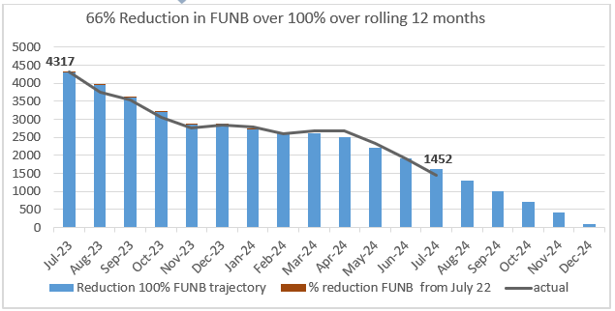

There has been a 45% reduction in all patients waiting over clinical target in the last 12 months.
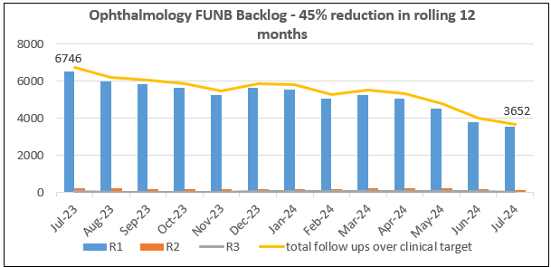
Eye Care Measures (combined new and follow up)
The following sets out specific performance information for the national Eye Care measures, which the Health Board reports on monthly to Welsh Government. It covers specific R1 categories/conditions such as paediatrics, age related macular degeneration, glaucoma, etc. (R1 patients are categorised as having significant risk of irreversible sight loss)
There are 2 Eye Care Measures:
- 95% of R1 patients are waiting within or 25% over clinical priority target. The trajectory below shows that the Health Board is on track to achieve the 95% target by May 2025.
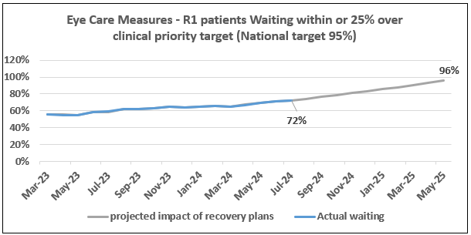
**Trajectory based against current recovery schemes detailed below
- 95% of R1 patients are appointed within or 25% over clinical priority target
Current data is showing the Health Board at 59% but the data has been found to be corrupt nationally and with DHCW to resolve
To note, while still dealing with an R1 backlog over 25% past clinical target, this Measure will be unpredictable to manage.
Paediatrics
There is a national capacity issue within paediatric eye surgery services. There are significant workforce pressures. The SBUHB service also supports the Hywel Dda population. There was an increase in backlog following the loss of a registrar clinic session and the position was at further risk following one consultant taking a career break from August 23. However, additional outpatient capacity was provided with the existing team from Sept 23 and a locum consultant from Feb 24, resulting in the backlog position has held.
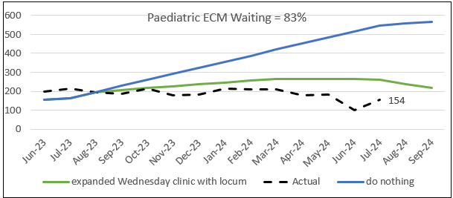
Age Related Macular Degeneration (AMD)
There is no backlog of patients for the Wet AMD service.
The 2-week new referral target and “treat and extend” injection regimes targets have been maintained. This service is supported by a robust non-medical workforce with contingency capacity plans in place during staff absences

AMD referral refinement scheme by contracted qualified optometrists has resulted in a 40% reduction in referrals requiring wet AMD new appointments, releasing capacity for time critical follow up treatments. Current Primary Care task & finish group in place to agree a formal transfer of this scheme to WGOS4 (Optometry contract)

Diabetic Retinopathy
Service improvements to date:
- An introduction of ophthalmic technician-led, scan only clinics (data collection) with clinician job planned virtual review sessions to determine next step outcome for patients.
- A Diabetic Retinopathy referral refinement scheme set up with four local qualified Optometrists has resulted in a continued 80% reduction in Diabetic Eye Screening Wales (DESW) referrals needing a hospital appointment, releasing capacity for time critical follow up patients. Current Primary Care task & finish group in place to agree a formal transfer of this scheme to WGOS4 (Optometry contract)

This eye care service is currently achieving 95% Eye Care Measure target. 5% tolerance will include follow ups CNAs/DNAs

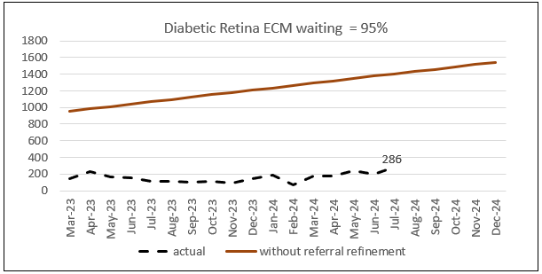

Glaucoma
The South West Wales regional glaucoma plan provided investment for additional glaucoma practitioners and ophthalmic technicians. Swansea Bay also employed two locum glaucoma consultants (substantive posts) to support this SWW regional plan to support clinics in Hywel Dda.
With additional outpatient space secured in Singleton Hospital from September 2023 and more data collection technician clinics with a new virtual clinical review office, this has resulted in a further significant reduction in the glaucoma waiting list backlog. The graph below demonstrates that performance is above the submitted trajectory and this is due to a delay in Hywel Dda setting up clinics for locums already in post, which has resulted in more clinics being held Swansea Bay up to December 2023.
In relation to GIRFT recommendations, a redesign of glaucoma patient clinic pathway and admin booking processes has been completed. This will ensure that patients are seen by the most appropriate health care professional.
Optometry contract WGOS4 glaucoma implementation will need to be phased pending Primary Care equipment specification and more local optometrists achieving higher certification in glaucoma and independent prescribing to perform glaucoma filtering examinations and issue prescriptions to appropriate patients that can be discharged from hospital services.

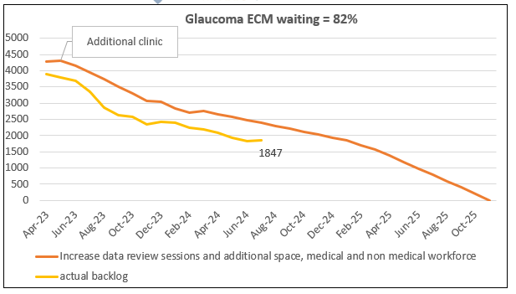
Cataract Service

Challenges
Stage 1 RTT (1st OPD waits)
The increase in cataract referrals from January 2023 outweighs current cataract one-stop clinic capacity. To mitigate breach risks as best as possible, small monthly shortfalls over 52 weeks have been placed into less appropriate general clinic consultation only slots. There are also additional WLI clinics booked over summer months to provide additional capacity due to leave. This will also give training opportunities to other ophthalmic practitioners to gain Pre-Assessment skills.
The graph below demonstrates what would happen to stage 1 if the above mitigation was not achievable.

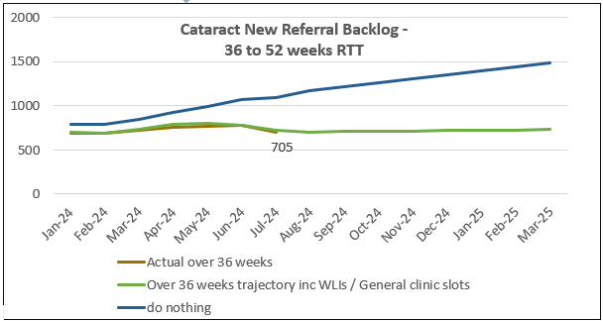
Stage 5 RTT (Treatment waits for Surgery)
The current Ophthalmology theatre capacity of 20.5 sessions is ‘shared’ between 15 consultants, which results in capacity deficits (pre-covid the service had access to 21.25 sessions for 12 consultants).
These are the lost DSU, Singleton Main and Morriston Paed sessions:
Ophthalmology Theatre Schedule
Theatre | Mon am | Tue am | Wed am | Thu am | Fri am
A, DSU | weekly |  | weekly |  | weekly
B, DSU | weekly |  | weekly
6, Main | alt weeks | monthly
11, MH |  |  |  | Paed weekly - request total 2 days a month
Theatre | Mon pm | Tue pm | Wed pm | Thu pm | Fri pm
A, DSU |  |  | weekly
5, Main |  |  |  | weekly

With ten dedicated cataract theatre sessions, routine capacity is tight, with priority cataracts requests coming for patients under current care eye services. Further risk of subspecialised priority treatments trumping routine cataract slots (e.g. glaucoma trabeculectomies from Hywel Dda clinics or oculoplastic USC).
The Health Board’s policy on treating routine patients in turn rate is often affected by the following in Ophthalmology:
- 52-week referrals converting from one stop cataract clinic for treatment prior to pre-operative assessment expiring by week 68
- Limited suitable low complexity patients for registrar backfill and high volume, low complexity (HVLC) sessions.
- Clinical priority cataracts – the below graph demonstrates the backlog priority patients under 25 weeks decreasing and the routine over 51 weeks increasing.
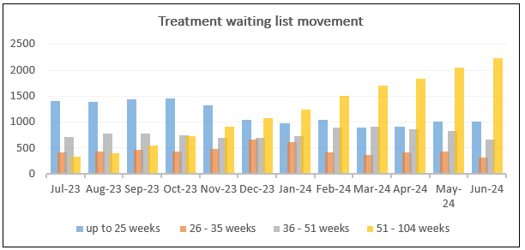
Capacity solutions being explored:
- Two HVLC sessions with 8–10 slots each including bilateral cataracts in place since September 2023.
- Remaining eight training sessions have increased to 4 hours with a 7th cataract slot from May 2024 – analysis of first 5 weeks gave a benchmark to improve against. The following 5 weeks has shown increase in cataracts treated with further discussions on improving late starts and early finishes.
- Retired consultant on ‘locum bank’ for theatre backfill (2 to 3 sessions a week)
- A cataract task and finish group is starting in September 2024 with theatre and anaesthetic colleagues to look to achieve further GIRFT patient flow efficiencies.
- A request has been made for Friday ‘all day’ Day Surgery Unit sessions to be returned to the service following post-covid changes - there are currently no theatre sessions available for a consultant returning from career break in August 2024
- Restore / increase theatre 6 GA case capacity at Singleton Hospital for Vitreoretinal, Cornea and Oculoplastic procedures and lost Paediatric Morriston theatre capacity.

Regional Eye Care

A Regional Eye Care Programme is currently under development between SBUHB and Hywel Dda UHB, with the primary aim of ensuring equal access to eye care services across the South-West Wales region. The programme focuses on establishing a sustainable service model, reducing waiting times, enhancing eye care outcomes, and maintaining rigorous quality and safety standards.
A service status report, which provided a comprehensive overview of the current eye care services and resource allocation across the region, was reviewed on the 5th of July 2024. Key actions resulting from this review include:
- Data Validation: Additional data is required to support further discussions. This includes the need for validation of certain data points within the report.
- Paediatric Service Review: The regional paediatric eye care service will undergo a thorough review to develop a more robust service plan.
- On-Call Model Development: The Clinical Lead will develop a preliminary outline for a regional on-call model.
- Regional Glaucoma Plan: Subject to resource availability, a regional glaucoma service plan will be developed.

These actions will form the basis of ongoing efforts to enhance the regional eye care services, ensuring that the programme’s objectives are met effectively.

- GOVERNANCE AND RISK ISSUES

To achieve 95% Eye Care Measure compliance the following subspecialties plans are also being undertaken

R1 backlog over 25% over target |  | Solutions | Risk
Vitreoretinal | 8% | Job plan review undertaken to expand clinic capacity | R1 New referrals must be seen by 18 weeks
General | 13% | Weekly note review meeting | Clinic capacity issue with routine cataracts referral over 52-week shortfall v R1 backlog
HCQ screening | 8% | Secondary care appointments from Nov 2023. Awaiting formal transfer to Optometry WGOS4 contract | Optometrist not identified to take on this work with specific equipment by April 25
Cornea | 11% | Ongoing clinical validation. | Funding an additional clinic session in job plan

A significant risk to Ophthalmology cataract pathways is the requirement for additional Pre-Assessment capacity to match additional theatre capacity solutions.

Continual service improvements are being initiated to increase capacity within the current footprint (Monthly patient questionnaire drop, telephone assessment, high volume clinics with shorter slots)

Workforce development and training for all Ophthalmic Practitioners to have Pre-Assessment skills to backfill planned absences could achieve 50 week service but with lost capacity in another sub specialty. Ideally, investment in additional practitioner sessions would solve this issue (SBAR completed)

The service is also exploring additional pre-operative assessment capacity within the main clinic footprint recently implemented at Singleton Hospital.

- FINANCIAL IMPLICATIONS

This paper does not set out any recommendations that result in financial implications.

- RECOMMENDATION

The Performance and Finance Committee is asked to:
- ACKNOWLEDGE the Ophthalmology performance up to July 2024 and the actions being taken to improve performance

Governance and Assurance

Link to Enabling Objectives  (please choose) | Supporting better health and wellbeing by actively promoting and empowering people to live well in resilient communities
Link to Enabling Objectives  (please choose) | Partnerships for Improving Health and Wellbeing |  | ☐
Link to Enabling Objectives  (please choose) | Co-Production and Health Literacy |  | ☐
Link to Enabling Objectives  (please choose) | Digitally Enabled Health and Wellbeing |  | ☐
Link to Enabling Objectives  (please choose) | Deliver better care through excellent health and care services achieving the outcomes that matter most to people
Link to Enabling Objectives  (please choose) | Best Value Outcomes and High Quality Care |  | ☒
Link to Enabling Objectives  (please choose) | Partnerships for Care |  | ☐
Link to Enabling Objectives  (please choose) | Excellent Staff |  | ☐
Link to Enabling Objectives  (please choose) | Digitally Enabled Care |  | ☐
Link to Enabling Objectives  (please choose) | Outstanding Research, Innovation, Education and Learning |  | ☐
Health and Care Standards
(please choose) | Staying Healthy |  | ☐
(please choose) | Safe Care |  | ☒
(please choose) | Effective Care |  | ☒
(please choose) | Dignified Care |  | ☐
(please choose) | Timely Care |  | ☒
(please choose) | Individual Care |  | ☐
(please choose) | Staff and Resources |  | ☐
Quality, Safety and Patient Experience
No proposal is being sought within this paper

Financial Implications
No financial proposal is being sought within this paper

Legal Implications (including equality and diversity assessment)
.

Staffing Implications
Long Term Implications (including the impact of the Well-being of Future Generations (Wales) Act 2015)
Report History |  | This paper links to the paper presented to Quality and Safety Committee in October 2023 in relation to Ophthalmology Gold Command
Appendices |  | None.

