Meeting Date | 27 August 2024 |  | Agenda Item |  |  | 4.3
Report Title | Cancer Performance Update
Report Author | Marisa Bennett, Cancer Performance & Information Manager
Report Sponsor | Craige Wilson, Deputy Chief Operating Officer
Presented by | Deb Lewis, Chief Operating Officer
Freedom of Information | Open
Purpose of the Report | The report provides an update on the delivery of the Single Cancer Pathway for Swansea Bay UHB patients. It focusses on recovery plans in place for the top tumour sites:  - Lower Gastrointestinal  - Breast  - Upper Gastrointestinal  - Gynaecological  - Urological  - Lung
Key Issues | This report will highlight current performance for both backlog and Single Cancer Pathway.  Demonstrates by tumour sites current performance to meet 10-day outpatient; 31-day Decision to Treat internal targets and 5-day pathology turnaround.  Identifies key service delivery challenges and mitigating actions.
Specific Action Required  (please choose one only) | Information | Discussion |  | Assurance | Approval
Specific Action Required  (please choose one only) | ☐ | ☐ |  | ☒ | ☒
Recommendations | Members are asked to:  - NOTE the performance and backlog volumes in the main tumour sites.  - NOTE the additional work required to improve both performance and backlog.

CANCER PERFORMANCE UPDATE

- INTRODUCTION

In October 2022 Welsh Government (WG) initiated the enhanced monitoring (EM) intervention process for the Health Board (HB) due to quality issues relating poor performance and long waiting times. In January 2024 the HB was escalated to targeted intervention (TI) within several areas, including performance against the Suspected Cancer Pathway (SCP). The HB meets with WG TI on a monthly basis. The areas of greatest focus both locally and nationally for improvement are:
- Lower Gastrointestinal, Gynaecological and Urological

In addition, the HB has identified other key tumour sites for improvement, including:
- Lung, Upper Gastrointestinal, Breast and Skin
Whilst performance for skin cancer regularly meets the 75% compliance target; as a high-volume tumour site any improvement or deterioration of the position will impact significantly on the HB’s performance.
In order to be de-escalated from TI, 60% of patients must be treated within 62 days for three consecutive months and a target of June 2024 has been set to achieve this target.

- BACKGROUND

The HB monitors two primary metrics for the single cancer pathway:
- % Performance within the 62-day target
- Backlog volumes (patients waiting over 62 days)

Performance

Graph 1 – SCP Performance

The graph above shows the HB’s SCP performance since April 2023. It represents the patients receiving first definitive treatment (FDT) within the 62-day target against the target of 75%. Performance improved to 58% for June 2024 and the Health Board has met trajectory for three months in succession.
.
Tumour Site | Total No. of patients treated | No. of patients treated within target | % | Tumour Site | Total No. of patients treated | No. of patients treated within target | %
Head and neck | 12 | 8 | 67% | Breast | 33 | 17 | 52%
Upper GI | 24 | 14 | 58% | Gynaecological | 9 | 3 | 33%
Lower GI | 28 | 12 | 43% | Urological | 51 | 19 | 37%
Lung | 24 | 13 | 54% | Haematological | 14 | 7 | 50%
Sarcoma | 3 | 2 | 67% | Acute Leukaemia | 3 | 2 | 67%
Skin(c) | 52 | 47 | 90% | Children's | 0 | 0 | -
Brain/CNS | 1 | 1 | 100% | Other | 5 | 5 | 100%

The backlog trajectories were developed based on the anticipated improvement for individualised tumour site, whilst reflecting traditionally what happened for previous bank holidays and holiday period. Some tumour groups targets were set at zero for backlog throughout the year: Children’s Cancer, Acute Leukaemia and Brain/CNS, the reason for this is that referrals trigger backlog infrequently and volumes do not impact on the overall position.

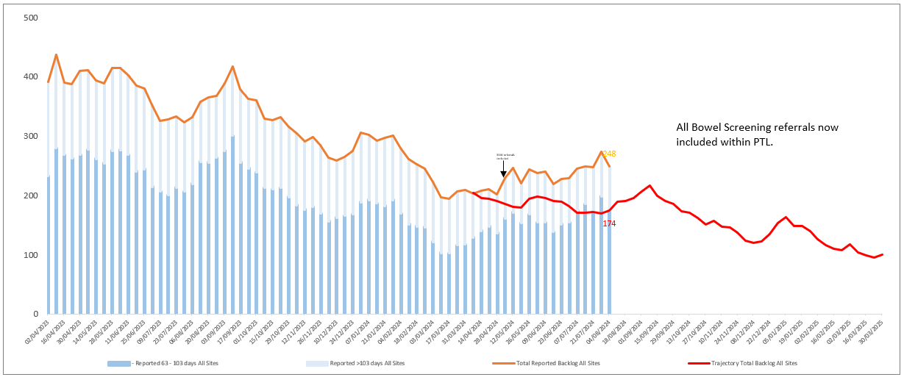

The table above shows the detail of the most recently reported backlog position, which stands at 248 patients, this is an increase since the last reported position to the Committee. The highest percentage of patients are in Lower GI (25%) this is inclusive of Bowel Screening Wales referrals), Gynaecological (15%), Urological and Skin (each 14%). The position demonstrates a gap to trajectory of 74 patients.
Tumour Site | Total Backlog | Trajectory for w/e 28/07/24 | Above or Below | % of backlog
Breast | 13 | 15 | -2 | 5%
Children’s | 0 | 0 | 0 | 0%
Gynaecological | 40 | 32 | 8 | 15%
Haematological | 10 | 7 | 3 | 4%
Head and Neck | 16 | 7 | 9 | 6%
Lower GI (Excl. BSW) | 41 | 27 | 14 | 25%
BSW | 28 | 0 | 28 | -
Lung | 23 | 15 | 8 | 8%
Other | 2 | 0 | 2 | 1%
Sarcoma | 5 | 2 | 3 | 2%
Skin | 38 | 13 | 25 | 14%
Upper GI | 19 | 16 | 3 | 7%
Urological | 38 | 36 | 2 | 14%
Grand Total | 273 | 170 | 103

In response to the performance escalation to Targeted Intervention (TI), the Health Board continues weekly TI meetings with both clinical and service leads, chaired by the Deputy Chief Operating Officer, attended by the Medical Director and supported by the Cancer Performance and Information Manager. The agenda for these meetings include:
- Discussion of tumour site or service action plans
- A review of performance against first outpatient waits and diagnostic turnaround times
- A review of the last 10 breaches to identify themes and trends for a summarised visual presentation.

The Health Board continues to focus efforts on the front end of pathway. Three pathway milestones previously identified by the Chief Operating Officer to further improve the SCP performance that we are monitoring are:

- First outpatient attendance must be within two weeks of receipt of referral.

The Planned Care Vitals Dashboard is used to report the waits based on activity within any month; this does not reflect patient choice/unavailability. Additional monitoring arrangements and scrutiny is in place via tracking data and weekly review meetings with the services. A slight decline in performance against this metric has been observed in a few services however there has been a reduction in median wait in some of these areas.

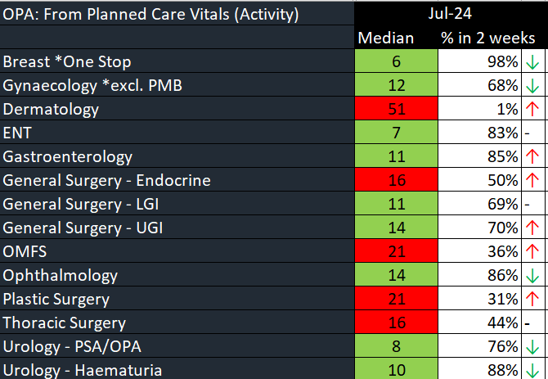

Following benchmarking discussions with colleagues at Cardiff & Vale UHB regarding their processes around cancer performance, the HB piloted daily huddles with breast and gynaecology services. This short meeting is focused on:
- Referrals received in the previous working day (or Friday for the Monday meeting)
- Volume of unvetted Urgent Suspected Cancer (USC) referrals
- Volume of not-booked USC patients over 7 days from the point of suspicion
- Volume of not-booked patients over 14 days from the point of suspicion
- Volume of patients booked over 14 days from point of suspicion the previous working day
This daily meeting commenced 3rd June 2024 and as can be seen below, the increased scrutiny and focus on these service areas has led to an improvement of percentage seen within two weeks and for breast a reduction in median wait.

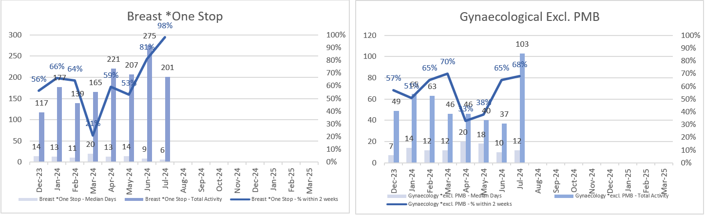

As a result of this success there will be a roll out to this enhanced monitoring in Oral Maxillo-Facial Surgery (OMFS), Dermatology and Plastic Surgery from 12th August 2024.

- That decision to treat must be attained by day 31 of pathway

The chart below demonstrates the median wait days from suspicion to decision to treat from September 2023 to June 2024 for closed (treated) pathways and percentage meeting 31 days.

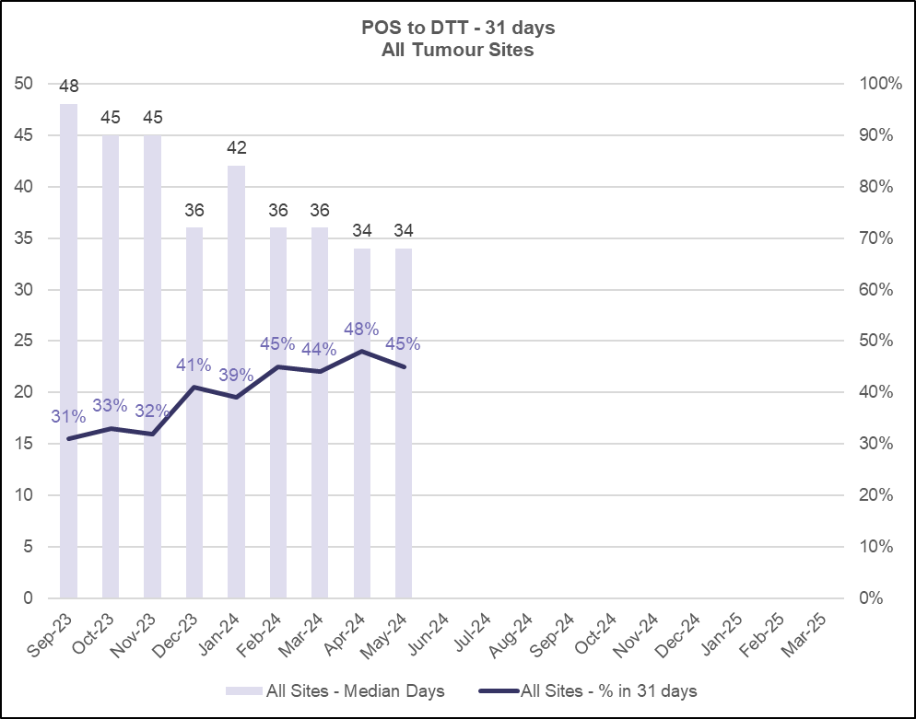

- That cellular pathology reports will be available within 5 days

The cellular pathology service remains under extreme pressure and whilst there has been some improvement in reporting USC cases, there is very much a need for improvement.

The chart below demonstrates the specimen turnaround times within cellular pathology for those labelled ‘USC’.

Daily comparison between SCP tracker and pathology waiting list continues to escalate specimens for reporting.
There is variation in turnaround times per tumour site, owing to complexity and sub-specialism. In an effort to address waits within some of the more complex tumour groups.
There is ongoing development work to produce dashboard to support performance monitoring and department flow and reduce reliance on a single consultant to undertake this work.
A new consultant has been appointed, specialising in GI and Skin; start date yet to be confirmed.

- GOVERNANCE AND RISK ISSUES

Improvement action plans have been developed across a number of tumour sites and diagnostic specialties; the key actions related to these are outlined below.

Breast
- Demonstratable improvement of waiting times to first outpatient/triple assessment clinic.
- A paper outlining options and costed investment required to improve sustainability of the breast service (including expansion radiographer/radiologist support) and requirement for breast nurse to manage breast pain referrals, has been presented to Cancer Performance and Improvement Group (CPIG) and Planned Care Board and is due to be considered at the Business Case Assurance Group (BCAG) group.
- Enhance surgical capacity to reduce waiting times for treatment. Additional theatre capacity is available to the service following disaggregation however this change also brings increased surgical demand on the service; this is another area identified through breach analysis to be contributing to delays, as such additional capacity is required. Discussions are ongoing currently regarding Monday theatre capacity with lists taking place on two sites, we are heavily impacted due to bank holidays, seeking to move the list to an alternative day.
- A lack of surgical assistants is too often an issue for the service and a risk that lists may be taken down at short notice.
- Advance Nurse Practitioner (ANP) appointed 1st August; this post will assist mitigation of USC waits going forwards, especially over this holiday period and management of some non-USC activity such as breast pain.

Date | PTL Volume | Backlog Volume / %
Oct-22 | 161 | 29 (18%)
Mar-23 | 138 | 11 (8%)
Jun-23 | 212 | 13 (6%)
Sep-23 | 223 | 16 (7%)
Jan-24 | 125 | 18 (14%)
Feb-24 | 105 | 24 (23%)
Jun-24 | 269 | 19 (7%)
Jul-24 | 162 | 13 (8%)

Gynaecology
Gynaecology remains under enhanced monitoring arrangements locally.
- As demonstrated earlier in this report, outpatient waits are improving.
- To mitigate Post-Menopausal Bleeding (PMB) waits a number of “scan only” clinics have been established (demonstrated in the increased outpatient activity in July), with hysteroscopy arranged thereafter if indicated. Waiting times will be monitored going forward and further scan only clinics arranged for mitigation where required and until sustainable long terms plans are in place.
  - Long term plan to train 2 additional nurse hysteroscopists. Next course intake commences September 2024.
  - Long Term Agreement (LTA) discussions with CTMUHB regarding gynaecological services
  - NHS Executive PMB workshop schedule for September 27th 2024, including discussion of unscheduled bleeding on HRT
- A locum Gynae-Oncologist commenced in post 5th August 2024, on a 6-month contract and following an induction period, the new consultant will utilise a Monday theatre list, increasing current operating capacity for the gynae-oncology service.
- There are ongoing discussions to undertake Saturday theatre lists which previously demonstrated significant improvement in the waiting volumes and time to surgery.
- A Clinical Nurse Specialist in Gynae-Oncology commenced in post in June 2024. This role will increase clinical (outpatient) activity, ensuring continuity of service during leave.

Date | PTL Volume | Backlog Volume / %
Oct-22 | 435 | 91 (21%)
Mar-23 | 484 | 160 (33%)
Jun-23 | 426 | 93 (22%)
Sep-23 | 331 | 64 (19%)
Jan-24 | 268 | 60 (22%)
Feb-24 | 275 | 41 (15%)
Jun-24 | 275 | 39 (13%)
Jul-24 | 220 | 40 (18%)

Urology
- Additional capacity for haematuria clinics delivered in June and July, which reduced the wait by 1 week to a median wait of 14 days.
- Improvement of pathology turnaround times continues to be requirement for this high-volume tumour group.
- Enhanced surgical capacity to reduce waiting times for treatment.
  - Development of a business case end of Q3, to support service expansion to include additional Clinical Nurse Specialist (CNS), administrative support and a 2nd Surgical Care Practitioner.
  - Development of a high care unit (2 beds) for Urology at NPTH, increasing acuity of patients able to be operated on at NPTH and increasing capacity at Morriston.

Date | PTL Volume | Backlog Volume / %
Oct-22 | 289 | 127 (44%)
Mar-23 | 237 | 64 (27%)
Jun-23 | 222 | 45 (20%)
Sep-23 | 226 | 53 (23%)
Jan-24 | 234 | 56 (24%)
Feb-24 | 233 | 60 (26%)
Jun-24 | 219 | 43 (20%)
Jul-24 | 183 | 38 (21%)

Lower GI
- The planned TI meeting with service leads for August has been deferred due to leave of numerous key individuals.
- Bowel Screening pathway is not aligned with the SCP, waits to endoscopy leading to extended pathway and increase in backlog.
- A review of the breaches in recent months demonstrates the diagnostic pathway and route to multi-disciplinary team (MDT) discussion has improved and patients imaged the same or next day following endoscopy and pathology/radiology reports available for the next MDT.
- Surgical capacity is a significant constraint for those waiting treatment.

Date | PTL Volume | Backlog Volume / %
Oct-22 | 890 | 258 (29%)
Mar-23 | 493 | 102 (21%)
Jun-23 | 336 | 36 (11%)
Sep-23 | 366 | 60 (16%)
Jan-24 | 311 | 52 (17%)
Feb-24 | 305 | 52 (17%)
Jun-24* | 412 | 59 (14%)
Jul-24 | 494 | 69 (14%)
*All new Bowel Screening Wales cohorts included in PTL for first time in May 2024

Upper GI
- To evaluate the accelerated diagnostic pathway, data from radiology and pathology has been gathered and the evaluation now in progress.
- Appointment of a new MDT Lead for the Hepatobiliary (HPB) MDT in July 2024. The MDT Lead has agreed to review MDT meeting processes to ensure efficiency and timely discussion. A review of the last 10 pancreatic breaches has been undertaken, whilst no patterns were immediately obvious, delays to MDT discussion and multiple discussions were noted. A meeting with the new lead is being arranged to review this information in further detail.

Date | PTL Volume | Backlog Volume / %
Oct-22 | 421 | 85 (20%)
Mar-23 | 271 | 31 (11%)
Jun-23 | 237 | 37 (16%)
Sep-23 | 184 | 43 (23%)
Jan-24 | 178 | 36 (20%)
Feb-24 | 154 | 32 (21%)
Jun-24 | 205 | 17 (8%)
Jul-24 | 187 | 19 (10%)

Lung
- Following the appointment of the third consultant surgeon, the median wait for outpatients has reduced from 22 days to 15 days in the first month.
- TI meeting with the service held, however clinical staff were unable to attend and this will be rescheduled.
- Anticipated long term sickness of 1 consultant surgeon, clarity of length of absence expected in the coming weeks then a decision regarding locum cover will be made.

Date | PTL Volume | Backlog Volume / %
Oct-22 | 97 | 42 (43%)
Mar-23 | 112 | 34 (30%)
Jun-23 | 74 | 26 (35%)
Sep-23 | 80 | 23 (29%)
Jan-24 | 76 | 25 (33%)
Feb-24 | 67 | 27 (40%)
Jun-24 | 100 | 18 (18%)
Jul-24 | 73 | 23 (32%)

- FINANCIAL IMPLICATIONS
There are no direct financial implications associated with this paper. The outputs from the modelling work or service initiatives and improvements will inform the development of the Health Board’s IMTP and financial plans for sustainable services.

- RECOMMENDATION

The Committee is asked to:

- NOTE the performance and backlog volumes in the main tumour sites.
- NOTE the additional work required to improve both performance and backlog

Governance and Assurance

Link to Enabling Objectives  (please choose) | Supporting better health and wellbeing by actively promoting and empowering people to live well in resilient communities
Link to Enabling Objectives  (please choose) | Partnerships for Improving Health and Wellbeing |  | ☒
Link to Enabling Objectives  (please choose) | Co-Production and Health Literacy |  | ☐
Link to Enabling Objectives  (please choose) | Digitally Enabled Health and Wellbeing |  | ☒
Link to Enabling Objectives  (please choose) | Deliver better care through excellent health and care services achieving the outcomes that matter most to people
Link to Enabling Objectives  (please choose) | Best Value Outcomes and High Quality Care |  | ☒
Link to Enabling Objectives  (please choose) | Partnerships for Care |  | ☒
Link to Enabling Objectives  (please choose) | Excellent Staff |  | ☒
Link to Enabling Objectives  (please choose) | Digitally Enabled Care |  | ☒
Link to Enabling Objectives  (please choose) | Outstanding Research, Innovation, Education and Learning |  | ☐
Health and Care Standards
(please choose) | Staying Healthy |  | ☐
(please choose) | Safe Care |  | ☒
(please choose) | Effective Care |  | ☒
(please choose) | Dignified Care |  | ☐
(please choose) | Timely Care |  | ☒
(please choose) | Individual Care |  | ☐
(please choose) | Staff and Resources |  | ☒
Quality, Safety and Patient Experience
Accurate, comprehensive demand and capacity plans can increase safety and quality whilst reducing risk and can lead to efficiency gains within clinical services. They will also facilitate more timely treatment of patients and enhance patient experience.

Financial Implications
There are no direct financial implications associated with this paper. Inputs (additional activity) into the demand and capacity models are funded via Recovery Money. However, the outputs from the modelling will inform the development of the Health Board’s IMTP and financial plans for sustainable services.

Legal Implications (including equality and diversity assessment)
There are no legal implications to consider.

Staffing Implications
There are no immediate staffing implications as a result of this paper but there is a need to be mindful that this is a very specialist area and we need to build robust and sustainable capacity in this area.

Long Term Implications (including the impact of the Well-being of Future Generations (Wales) Act 2015)
Report History |  | Previous reports have been presented to Management Board in November 2021 and February / August 2022 / October 2023 / February 2024
Appendices

