Meeting Date | 27 August 2024 |  | Agenda Item |  |  | 4.1
Report Title | Theatre Performance – Update Report
Report Author | Jonathan Gates, Interim Head of Nursing, Surgery  Victoria Gibbs, Directorate Manager, Theatres and Anaesthetics  Rhodri Davies, Associate Service Group Director, Surgery
Report Sponsor | Ceri Gimblett, Service Group Director NPTS  Deb Lewis, Chief Operating Officer / Executive Director of Primary Care & Mental Health
Presented by | Jonathan Gates, Interim Head of Nursing, Surgery  Rhodri Davies, Associate Service Group Director, Surgery
Freedom of Information | Open
Purpose of the Report | The purpose of this paper of to provide an update on Theatres performance work that is taking place for Swansea Bay University Health Board.
Key Issues | The key points in the paper are:  - Effective and efficient theatres are key requisites to the sustainable delivery of Health Board access standards.  - Theatre utilisation and efficiency is a complex measure and affected by multiple factors both within and outside of the theatre environment, all of which impact on the ability to utilise all available operating time effectively.
Specific Action Required  (please choose one only) | Information | Discussion |  | Assurance | Approval
Specific Action Required  (please choose one only) | ☒ | ☐ |  | ☒ | ☐
Recommendations | Members are asked to:  - ACKNOWLEDGE the current performance and the actions being taken to improve the overall performance in a sustainable and consistent manner.

Theatre Performance Report

- INTRODUCTION

This paper provides an update to the Performance and Finance Committee on Theatre performance and follows a previous report submitted in August 2022. A further paper was presented in March 2024 on GIRFT Theatre Metrics and the establishment of the Theatres Board.

- BACKGROUND

SBUHB currently has 37 theatres across Morriston (20 theatres), Singleton (9 theatres) and Neath Port Talbot (NPT) (8 theatres) hospital sites, providing both elective and emergency provision in support of the local, tertiary and specialist services. There is a current submission to WG to increase the theatre number to 40, with a strategic business case being considered to expand Singleton Theatres with three new theatres. From a revenue budget allocation perspective, there are 445 sessions of anaesthetic cover and 480 sessions of theatre staffing allocated to theatre capacity (note the gap of 55 sessions between the two functions).

Neath Port Talbot Hospital received significant investment in the summer of 2023 with the opening of three bespoke Orthopaedic and Spinal theatres to support regional working across SBU and Hywel Dda Health Boards. This centre currently continues to provide capacity for Cwm Taf Morgannwg (CTM) and reciprocally anaesthetic staff from CTM provide cover for 29 sessions weekly and on call cover.

Singleton Hospital provides a high quality orthopaedic and plastic surgical hand service based in the Day Surgery Unit. The site also houses the regional ophthalmology surgical service. The third day case theatre opened in summer 2022., following further investment from WG. All maternity services are centralised in Singleton Hospital and there are two obstetric theatres within the main theatre suite.

In response to changes in service reconfiguration and acknowledging an imbalance in allocation of emergency theatre capacity, an increase in the allocation of theatres to support emergency activity has occurred. This has resulted in an additional 33 sessions per week at Morriston and 27 sessions at Singleton transferring from elective to emergency work. In restoring elective recovery at SBUHB post pandemic, the focus has been on increasing the theatre programmes initially at Singleton and NPT to establish Centres of Excellence with resources being transferred from the Morriston budget to support the additional lists on these sites. Both Singleton and NPT Theatre sites are now over their 2019/2020 levels with increased utilisation of the lists also being reported.

Morriston Hospital has the largest of the theatre suites and houses the more complex elective surgery and the majority of the emergency activity for the HB, including CEPOD and Ortho-plastics. All paediatric surgery is also undertaken at Morriston Hospital. Recent investment has seen the hospital establish a robotics theatre for Urology and future plans look to expand this also to Colorectal and Head & Neck services.

Significant challenges remain on all sites to develop a retain a theatre workforce that can respond to the additional activity, prioritisations and the increase in emergency, elective, cancer/tertiary and specialist work which can only be undertaken at Morriston, Singleton and NPT hospitals.

Following a recent organisational change process (OCP), Theatre and Anaesthetics directorate is now hosted within the Neath Port-talbot / Singleton Service Group (NPTSSG). It was previously within the Morriston SG. Since that time, the Planned Care Board has established a Theatre Board to look at efficiency and performance of the theatres within SBUHB. This Board held its first meeting in June and since has agreed 7 programmes of work to improve areas of performance.

Establishing the workstreams aligned to the new Theatre Board is the critical aspect of theatre utilisation and improving the surgical patient pathway.

The workstreams and leads cover these fundamental areas:
Workstream | Programme Lead | Role
Resources | Rhodri Davies | ASD Surgery
Finance | Charlie Mackenzie | Head of SLR and External Commissioning
Scheduling & Performance | Victoria Gibbs | Directorate Manager Theatres & Anaesthetics
Quality & Safety | Jonathan Gates | Interim HON Surgery
Digital & Data | Dr Gordon Staple & Chris Jones | Associate Medical Director HCSE Assistant Director of Transformation & Head of HCSE
Improvement | Dr Gordon Staple & Chris Jones | Associate Medical Director HCSE Assistant Director of Transformation & Head of HCSE
Service Development | TBC

Theatre Capacity

Through recruitment and job planning, since the date of the last update to the Committee in August 2022, the overall theatre capacity has increased by six sessions per week, which is demonstrated in the graph on page 4 and are detailed below.

- Two added sessions for paediatric plastic lists since February 2023
- A third session appended to an existing colorectal list, restructured as pelvic oncology since end of May 2023
- Utilisation of an additional 3rd session fortnightly for OMFS/Max fax

Repurposing of theatre sessions:

The graph below shows total number of elective cases across all sites during month of July, which demonstrates a steady increase since 2022.
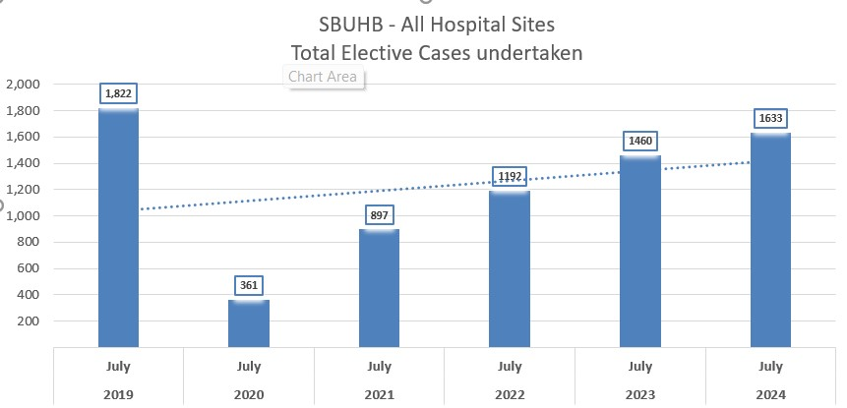

There has been a rise in the average number of cases per session across all sites (table below), with the most significant increase observed at Singleton Hospital where 4 cases per session on average were managed in the 23/24.

NPT is supporting the WG initaitive for efficent use of the orthopeadic athroplasty lists. Initial outcomes suggest that this is having a posiitve impact in an increase of average cases per list.
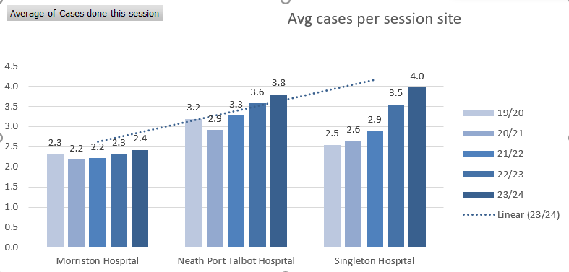
Utilisation of theatres involves the following key elements:

- Robust Pre-operative Assessment: ensuring patients’ suitability for surgery at the designated hospital site. Note: there is significant variation in clinical criteria for suitability at each site.
- Structured list allocations: implementing processes (6-4-2 compliance) to allocate lists to surgeons and book theatre schedules in advance.
- Scheduling: Strategically placing cases on theatre lists to optimise productivity throughput.
- Adequate facilities: Checking sufficient beds and trolley capacity is available to meet demand.
- Appropriate ward staffing: Maintaining the right level of staffing on wards to admit patients safely and promptly on the day of their surgery.
- Streamlined In-theatre processes: Efficiently managing the calling, holding and receiving of patients before their surgery.
- Adequate theatre workforce: Ensuring sufficient workforce is available to oversee the theatre for designated duration of list.
- Effective recovery: Providing enough capacity to recover patients before returning to the ward.
- Timely discharge: Regularly reviewing patients to ensure timely and safe discharge optimising available elective bed utilisation.

It is important to acknowledge that whilst utilisation is a significant metric, it may obscure issues such as over-running or under-running of theatre lists, which can appear as positive utilisation. Therefore this is also closely monitored.

NPTH Orthopeadic athroplasty lists

The work undertaken to deliver improvements to the NPT orthopaedic list utilisation has involved active collaboration with the Patient Pathway Team, Surgical Specialties and the Theatre Management Team.

The focus has centred on:
- Robust list booking: Ensuring comprehensive list booking for maximum utilization, supported by the Forward Look Dashboard. The dashboard serves to:
  - Aid the theatre list booking process with individual clinicians.
  - Provide surgical specialties with a user-friendly tool to review the booking status and corrective actions
  - Monitor overall booking and planned utilisation status of theatre lists to highlight under or overbooked theatre lists.
- Data accuracy: Ensuring accurate utilisation data on the electronic theatre system (TOMS).
- Timely feedback loop: Delivering timely utilisation performance feedback to all surgical specialties via the 6-4-2 theatre allocation meeting.
- Issues identification: Promptly identifying themes and issues contributing to lower utilisation.
- Specialty Engagement: Facilitating discussions and deep dive with specialties to inform subsequent decisions.

Examples of specific actions taken are:
- Specialty-specific meetings: Addressing compliance issues regarding timely surgeon allocation and patient booking to mitigate against risk of poor utilisation.
- List frequency review: Collaborating with specialties to reduce the frequency
of theatre lists with consistent low utilisation patterns, allowing other specialties to access theatre capacity for their delivery plans.

As part of theatre utilisation, it is necessary to capture data on agreed metrics. This will in turn demonstrate firstly, the full picture and reasons that impact theatre utilisation and secondly the progress made in our data sets and dashboards that provides transparency and ability to analyse the systems and processes.
Quarter 1 Performance All Sites

Tables below compare Quarter 1 2023 to Quarter 1 2024, and highlights the following key points

- Morriston and NPTH improved on completed cases compared to 2023.
- Late starts have improved in 2024 for NPTH and NPTH CTM.
- Slightly less cases cancelled on the day for Singleton and Neath.
- Please note that during QTR 2024 there was industrial action.

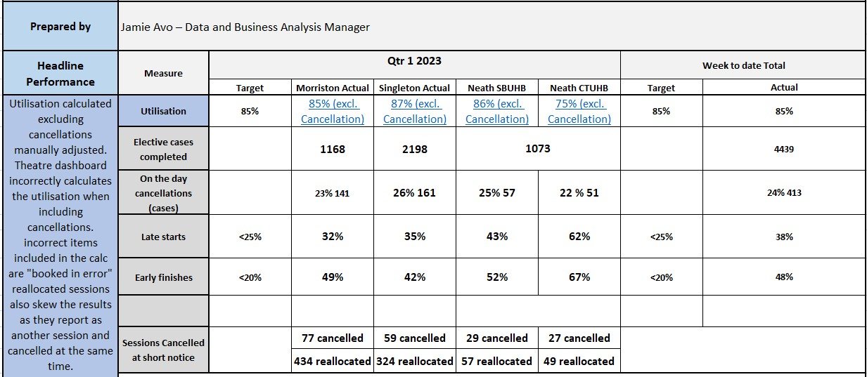

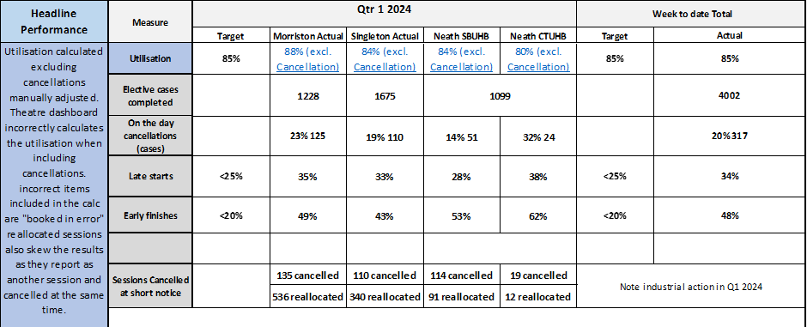

The increase in short notice cancellations is discussed and addressed in the Theatre Utilisation (TASS) meeting. The Theatre Board workstreams for Scheduling and Performance has developed a Theatre Assurance Group arm to review, record and improve the gap in planned and delivered activity with surgical speciality engagement.

The below table shows the top 5 cancellation reasons for the years 2022/2023 and 2023/2024.

Top 5 reasons for cancellations
22/23 | 23/24
No surgeon | No surgeon
Priority list taking preference | Industrial action
Other specialty to utilise | No anaesthetist
Audit | No patients
Other | Other specialty to utilise

Cancellation reasons are limited and so the theatre team now use free text to truly understand the reasoning behind ‘lost’ capacity.

No surgeon – lists are allocated on a 50 week per year basis. However, surgeons’ job plans usually cover a maximum of 42 weeks per year. Services will always try to back-fill vacant sessions with other surgeons who maybe available. If this fails then it is offered to other specialties. However, there are times when this is not possible and the session stays empty (known as fallow). There will also be times when emergency demand is such that elective theatres have to be cancelled at very short notice.

Priority lists taking preference – there needs to be further analysis of the D&C for emergency theatres to ensure the provision is adequate to protect elective capacity.
Other specialty to utilise – lists have been reallocated.

No patients – there have been significant deficits in the POA and “meet and greet” (M&G) capacity resulting in the inability to utilise lists. This is being reviewed with robust D&C plans for POA being developed. M&G is necessary due to the length of time patients have waited since being listed and this gives both the surgeon and the patient an opportunity to review treatment plans / options.

Other speciality to utilise is part of the 6/4/2 guidance. It applies when the theatre list has been given up by the allocated service, and another has taken it.. Whilst recorded as a cancellation against the original allocated specialty, the session would be fully utilised.

Theatre Workforce Analysis

A significant factor in delivering improvements in productivity has been the concerted effort to recruit into funded vacancies that will add additional activity to the theatre schedule and resilience to deliver this activity consistently with substantive staff. The following steps have guided this process:

Vacancy reduction: recruited staff have been assigned start dates. Importantly, there has been a significant decrease in the number of unfilled positions. This decrease reflects our dedicated endeavours to strengthen the workforce and enhance the efficiency of theatre operations.

Series of measures and initiatives are in place to ensure continued progress and effective management:

- Regular financial and nursing-led reviews
The commitment to monitoring the financial aspects and nursing workforce is exemplified by the weekly reviews conducted in collaboration with colleagues. These reviews serve as crucial checkpoints, aiding in maintaining financial stability and workforce efficiency.

- Vacancies and new staff
The current workforce profile includes 31.72 WTE vacancies, primarily within band 5 registered nurse / Operating Department Practitioner (ODP) positions.

- Induction progress
Additionally, the induction period for 8 internationally recruited staff members is expected to conclude within the next 8-12 weeks. This milestone marks the integration of new talent into the existing workforce and signifies the continuous growth of our team.

In conclusion, the recruitment drive into theatres has reduced vacancies with strategic workforce optimization efforts have culminated in a robust foundation for the theatre teams. The commitment to regular reviews, diverse staffing strategies, and ongoing induction processes ensure a trajectory of sustained progress and operational excellence.

Current vacancies are outlined below in the table.

Department | Post | Vacancy (WTE) | Recruitment Plan (including timescales)
Theatres MDU | Anaesthetic practitioner Band 5 | 3 | Vacancy at interview stage.  Interviews on 21st and 22nd August
Theatres MDU | Team leader Anaesthetics Band 6 | 1 | Successful applicant going through pre-employment checks
Theatres MDU | HCSW Band 2 | 2 | Successful applicants going through pre-employment checks.
Theatres MDU | Anaesthetic practitioner Band 5 | 5 | Student streamlining. Going through pre-employment checks and waiting on successful registration
Theatres MDU | Scrub practitioners Band 5 | 3 | Student streamlining. Going through pre-employment checks and waiting on successful registration
Theatres SDU / Day Unit | Team leaders’ scrub  Band 6 | 2 | Out to offer. Successful applicant going through pre-employment checks.
Theatres SDU / Day Unit | Ward nurse band 5 | 0.80 | Successful applicant going through pre-employment checks.
Theatres SDU / Day Unit | HCSW Band 2 | 1 | VCF in progress of being approved.  Will take at least 1 month to go through panel and then advert.
Theatres NPT | Speciality manager  Anaesthetics Band 7 | 1 | Successful applicant going through pre-employment checks
Theatres NPT | Scrub practitioners  Band 5 | 1 | Vacancy at interview stage.  Interviews on 7th August
Theatres NPT | Anaesthetic practitioner Band 5 | 3 | Vacancy out to advert. Closing date 14th August.
Theatres NPT | Anaesthetic practitioners Band 5 | 2 | Successful applicants going through pre-employment checks.
Theatres NPT | Scrub practitioners Band 5 | 3 | Student streamlining. Going through pre-employment checks and waiting on successful registration
Theatres NPT | Anaesthetic / Recovery practitioners Band 5 | 3 | Student streamlining. Going through pre-employment checks and waiting on successful registration
Theatres NPT | HCSW Band 2 | 2 | VCF at panel for approval

The impact and risk associated with the vacancies can be summarised as follows:
- Not complying with AFPP guidelines.
- Patient safety put at risk.
- Potential cancellations.
- Reduction in quality and safety standards.
- Staff shortages.
- Potential for sickness within department.
- Dissatisfaction of service users.
- Unable to commence new planned sessions

Summary

The data presented in this analysis showcases enhancements in theatre utilisation, capacity, and overall productivity. Proactive measures, including vigorous recruitment, have been implemented to counteract deficits and confront the challenges within theatre and anaesthetic recruitment.

Consideration into alternative opportunities have been undertaken to address workforce shortages, particularly within the anaesthetic cohort, and visa entry restrictions for international nurses have added complexity to the recruitment landscape.

Challenges, such as trade union strikes, have also impacted theatre activity, contributing to the variations observed in the information presented above.

The development of comprehensive data and theatre dashboard has been undertaken. This has empowered the management team with visibility and transparency into theatre activity, especially in cases where activity has been lost. This newfound insight enables us to share critical data with stakeholders, which is pivotal for achieving sustained theatre productivity. This will be undertaken as described above as part of the Theatre Scheduling and Performance workstreams with retrospective reviews of planned versus delivered performance. The data from this will be shared within the Theatre Board meeting for onward discussion on list allocation and available resources.

This comprehensive analysis not only highlights the progress achieved but also underscores the importance of strategic planning, recruitment, and the utilisation of data-driven insights to navigate the dynamic healthcare landscape successfully.

Next steps

The Theatre Board has scoped the high level actions that need to be implemented as part of establishing the workstreams under the Board. These are detailed below. As the detailed implementation plan becomes clearer, there will be specific leads identified for each of the actions, with clear timescales for completion and its members are committed to driving forward our theatre operations by implementing the following key steps and actions:

- Enhance Monthly Activity: the primary goal is to maintain and increase monthly activity figures by effectively leveraging theatre capacity.

- Speciality-Focused Meetings: speciality-focused meetings will be a focal point, involving all stakeholders that play a pivotal role in theatre delivery. The insights and collaboration provided will be vital in refining the approach.

- Enhance Governance Structure post OCP: Considering the service group transition, a comprehensive Service Group review involving representatives from theatres, anaesthetics, and notably, surgical specialists, becomes imperative. The core focus of this review is to meticulously assess the reasons behind cancellations and take informed actions accordingly.

- Extend SBUHB Utilisation: Building upon the successes achieved in Neath Port Talbot, the aim is to continue to improve utilisation across all three sites.

- Continued Development of Theatre Dashboard is imperative. It is a powerful tool that will provide valuable insights into performance. Sharing this data with stakeholders will foster transparency and accountability.

- Confidence in Measurement: It's essential to instil confidence in the accuracy of the data used for performance measurement. Ensuring that the information presented is reliable and aligned with operational reality is essential.

- Stakeholder Engagement: To make theatre performance a shared responsibility, easily navigable tools will be available for stakeholders to access and understand theatre performance metrics. This collective engagement will foster a culture of ownership.

- Internal Process Enhancement: continually monitor and build upon internal processes, such as theatre protocols and booking rules, which significantly influence and drive theatre efficiencies.

- Interdependence Focus: recognizing the interdependence of services special emphasis will be placed on areas like HSDU functionalities to ensure seamless coordination across all aspects of theatre operations.

- Unavailability Scrutiny: by closely examining unavailability reports and meticulously scrutinizing rosters, theatre staffing will be proactively planned. This approach will be instrumental in optimizing theatre productivity.

In implementing these steps, the Service Group is committed to enhancing theatre operations, fostering collaboration, and continually striving for improved efficiency and effectiveness in our service delivery.

- GOVERNANCE AND RISK ISSUES

The significant risk to note within this paper is the 31 WTE vacancy within theatre staffing and the pressure this put on the service to deliver the level of activity set out in this paper.

- FINANCIAL IMPLICATIONS

This paper does not set out any recommendations that result in financial implications.

- RECOMMENDATION

The Performance and Finance Committee is asked to:
- ACKNOWLEDGE the Theatres performance and the actions being taken to improve the overall performance in a sustainable and consistent manner.

Governance and Assurance

Link to Enabling Objectives  (please choose) | Supporting better health and wellbeing by actively promoting and empowering people to live well in resilient communities
Link to Enabling Objectives  (please choose) | Partnerships for Improving Health and Wellbeing |  | ☐
Link to Enabling Objectives  (please choose) | Co-Production and Health Literacy |  | ☐
Link to Enabling Objectives  (please choose) | Digitally Enabled Health and Wellbeing |  | ☐
Link to Enabling Objectives  (please choose) | Deliver better care through excellent health and care services achieving the outcomes that matter most to people
Link to Enabling Objectives  (please choose) | Best Value Outcomes and High Quality Care |  | ☒
Link to Enabling Objectives  (please choose) | Partnerships for Care |  | ☐
Link to Enabling Objectives  (please choose) | Excellent Staff |  | ☒
Link to Enabling Objectives  (please choose) | Digitally Enabled Care |  | ☐
Link to Enabling Objectives  (please choose) | Outstanding Research, Innovation, Education and Learning |  | ☐
Health and Care Standards
(please choose) | Staying Healthy |  | ☐
(please choose) | Safe Care |  | ☒
(please choose) | Effective Care |  | ☒
(please choose) | Dignified Care |  | ☐
(please choose) | Timely Care |  | ☒
(please choose) | Individual Care |  | ☐
(please choose) | Staff and Resources |  | ☐
Quality, Safety and Patient Experience
Timely and effective care: People of all ages to have timely access to admission for surgery. When arranged to have confidence in being admitted with the full knowledge of the procedure and its implications as appropriate. Establishing the workstreams aligned to the Theatre Board
- Resources
- Digital /DATA
- Finance
- Scheduling /Performance
- Q&S
- Service Improvements
- Service Developments
To achieve patient outcomes: to have outcomes comparable with the best in Europe.
Financial Implications
There are no additional financial implications identified as part of this report. However, efficient and effective utilisation of our theatre resources will deliver value for money from the Health Board in the use of its available and non-recurrent resources.

Legal Implications (including equality and diversity assessment)
There are no legal implications to consider.

Staffing Implications
To run an effective theatre service requires access to skilled theatre staff, surgeons and anaesthetists along with other key resources along the surgical pathway including referral from primary care, through to the outpatient clinic, Pre-Assessment and admission for surgery.
Long Term Implications (including the impact of the Well-being of Future Generations (Wales) Act 2015)
Optimizing theatre capacity across the Health Board will support an improved delivery against waiting time standards, whilst ensuring the effective deployment of resources reducing variation in cost and resources.
Report History |  | Theatre Performance report August 2022  Theatres GIRFT Metrics and Theatres Board March 2023
Appendices |  | N/A

