

Meeting Date | 27 August 2024 |  | Agenda Item |  |  | 3.3
Report Title | Continuing NHS Healthcare  Quarter 1 Report: April - June 2024
Report Authors | Amanda Davies Deputy Head of Nursing for Long Term Care  Richard Mugford Finance Business Partner  Dermot Nolan Director MHLD  Vicki Burridge Head of Nursing Children and Young People
Report Sponsor | Hazel Powell Interim Executive Director of Nursing
Presented by
  Sian Passey Group Nurse Director
Freedom of Information | Open
Purpose of the Report | This report aims to provide an update on the Q1 activity and highlight areas of relevance to the financial and performance management relating to CHC funded care.
Key Issues | - The sustainability of the independent care sector  - Approved Interim Funded Nursing Care (FNC) Rate 2024/2025  - Approved Interim Continuing Health Care (CHC) Rate 2024/25.
Specific Action Required  (please choose one only) | Information | Discussion |  | Assurance | Approval
Specific Action Required  (please choose one only) | ☐ | ☐ |  | ☒ | ☐
Recommendations | Members are asked to:  - Note the content of the report

Continuing NHS Health Care Quarter 1 Report – April - June 2024

INTRODUCTION

This report aims to provide an update on the Q1 activity and highlight areas of relevance to the Health Board relating to CHC funded care.

BACKGROUND

The revised National Framework for CHC was implemented on 1st April 2022.

As part of the CHC Performance Framework required by Welsh Government (WG), Boards are required to receive a quarterly report on CHC, and this paper fulfils that requirement. Its intention is to inform the Board of developments and current issues relevant to CHC, both nationally and locally.

1: GOVERNANCE AND RISK ISSUES

Retrospective Claims

The retrospective claims process for the organisation is managed through the Primary, Community and Therapies Delivery Group. The role of the Retrospective Team is to consider claims from individuals or their family/representative where they feel that they should have been eligible for CHC funding for past care needs.
All retrospective claims received within this quarter have been completed within the 6-month timescale and no Ombudsman enquiries relating to retrospective claims were received.

Mental Capacity Act (MCA)/ Deprivation of Liberty Safeguards (DoLS)
To align with Health Boards across Wales, MCA transferred from SBU Corporate to PCTSG on the 1st April 2024 to deliver a MCA/DoLS Service. MCA/DoLS is hosted within PCTSG but is a Health Board wide service. Data for this service is reported in the Mental Health & Legislative Committee Meeting on a quarterly basis.

Escalating Concerns

No Care Homes have been placed into escalating concerns during the Quarter 1 period. One Neath Port Talbot Care Home remains in Performance Management, Ty Nant Nursing Home, following concerns raised by NPT and Bridgend Local Authority regarding the management of the financial processes within the home.

Sustainability in the Care Home Sector
Recruitment and retention of staff remains a challenge across social care and is severely impacting both domiciliary and residential care. Care Home providers may need to consider a different approach regarding on-site availability of registered nurses. NHS pay awards will also affect the independent sector as providers compete with the NHS for nurses on higher wages and better terms and conditions.

Occupancy levels within the Independent Care Home Sector across the Swansea Bay footprint continues to grow and is now at the pre pandemic levels.

The pie charts below represent the level of occupancy on the 24th June 2024 for both Swansea Locality and Neath Port Talbot Locality.

The overall occupancy within the independent sector for Neath Port Talbot Locality is 94.5% occupancy.

The overall occupancy in the independent sector for Swansea Locality is 92.06% occupancy.

CIW registered Nursing and Residential Care beds across Swansea Bay totals 2,091 beds (this includes the registered beds in Swansea and Neath Port Talbot).
Neath Port Talbot
Capacity Registered | Current Residents | Nursing | Residential
542 | 491 | 275 | 216

Swansea
Capacity Registered | Current Residents | Nursing | Residential
1549 | 1426 | 1061 | 365

Care home fees have significantly increased since 1st October 2021 in recognition of the increased costs of food, fuel and inflation.
The Health Board is an active partner with Swansea Local Authority in the process of considering the costs of providing care and accommodation for care home providers.
Swansea Local Authority & care home providers reviewed the methodology used to calculate fee rates. Swansea Local Authority have uplifted their rates by 6% for 2024/2025- see table below

CATEGORY | 2023/2024 RATES | UPLIFT | INCREASE | 2024/2025  RATES
OP Res Care | £800 | 6% | £48 | £848
OP Nursing Care | £838 | 6% | £50 | £888
OP Dementia Nursing Care | £884 | 6% | £53 | £937

All specialist provider placements commissioned by the Health Board (currently there are three), utilise the costed care plan approach.

In relation to the Letter Before Claim threatening Judicial Review brought by the Caron Group, discussions have taken place with Health Board Executives and the Director of the Caron Group and a 7% uplift for Caron Group has been agreed from 1st April 2024.
Caron Nursing Homes | 2023/24 rate | 2024/25 rate
Three Cliffs EMI | £1,280 | £1,370
April Court | £1,118 | £1,260
Cwm Cartref | £1,118 | £1,260

Performance Activity
In line with the Welsh Government Framework for Continuing NHS Healthcare all individual’s eligibility is subject to review. The initial review is undertaken 3 months after the recommended outcome and thereafter on an annual basis. However, should there be a change in need identified by the individual, family, professionals or provider of care the review will be undertaken earlier.
The graph below shows the statutory reviews completed in QTR 1 period compared with same period for 2023/24.

The Projected review figures for next quarter based on current median review completion value:
For April to May 2024 – highest completion rate 99 reviews per week
Lowest completion rate 28 per week (due to sickness, annual leave, staff being reallocated to complete Retrospective Reviews)
Median completion review rate 63 reviews per week = 13 weeks in next financial quarter = 819 reviews projected to be completed by end of second quarter 2024
NB: based on approximate reviews required for financial year 2024/25 – detailed figures pending

Regional Step-Down Beds

The Home First Team ceased admission to Step-Down beds on 26/04/2024.
2 patients remain in step-down beds due to Local Authority care package availability.

2: FINANCIAL IMPLICATIONS

The table below shows the CHC expenditure for the SBU HB since 22-23, through to the current quarter.

Category | 2022-23 | 2023-24 | 2023-24 | 2023-24 | 2023-24 | 2024-25
 | Total | Qtr 1 | Qtr 2 | Qtr 3 | Qtr 4 | Qtr 1
 | £m | £m | £m | £m | £m | £m
MHLD CHC | 32.54 | 9.64 | 8.84 | 10.79 | 12.32 | 11.40
PCCS CHC | 27.55 | 7.37 | 8.65 | 9.70 | 9.00 | 9.32
PCCS FNC | 7.76 | 2.21 | 2.36 | 2.41 | 2.21 | 2.42
Child CHC | 1.63 | 0.47 | 0.47 | 0.46 | 0.48 | 0.49
Total | 69.47 | 19.69 | 20.32 | 23.36 | 24.01 | 23.63

The increase in expenditure is linked to:

- Increases in the base CHC and FNC rates responding to higher costs of providing residential care and nursing costs.
- A switch in the Older Adult case mix from CHC base rate to higher rate packages.

The FNC rate is set nationally and the rate for 2024/25 was increased to reflect the pay award, as shown below.

Year | RN | Continence | FNC Health rate | RN Social care | FNC Full Rate
2022/23 | £185.89 | £13.15 | £199.04 | £8.08 | £207.12
2023/24 | £192.47 | £14.48 | £206.95 | £8.37 | £215.32
2024/25 | £198.26 | £14.92 | £213.18 | £8.62 | £221.80

The HB is an active partner with Swansea Local Authority in the process of considering the costs of providing care and accommodation for providers.

Swansea Local Authority residential rates are used for the regional fee setting process as they are higher than the NPT residential rates and provider engagement is more extensive given the respective sizes of the markets in those areas.

The HB CHC base rate fee setting methodology is determined by a 3-yearly cycle of extensive engagement with providers and a lighter touch annual review, where in year and unexpected costs (e.g. utilities and living wage increases) are considered.

The base HB CHC base rate therefore is an amalgamation of the agreed care and accommodation costs plus a sum added to reflect nursing care requirements, together with any inflationary uplift and cost of living rises.

Continuing this methodology results in the following rate for 2024/25.

 | 2022/23 | 2023/24 | 2024/25
 | £ | £ | £
Swansea LA OP Nursing Res rate | 752.00 | 838.00 | 888.00
FNC rate - agreed Nationally | 199.04 | 206.95 | 213.16
CHC Base Rate SBUHB | 951.04 | 1,044.95 | 1,101.16
Increase % | 5.51 | 9.87 | 5.38

The potential JR has resulted in a re fashioning of the fee setting process and a new system which includes more formal engagement by the Health Board directly with the providers will be adopted.

CHC Growth

There has been a continued increase in the CHC case numbers as indicated

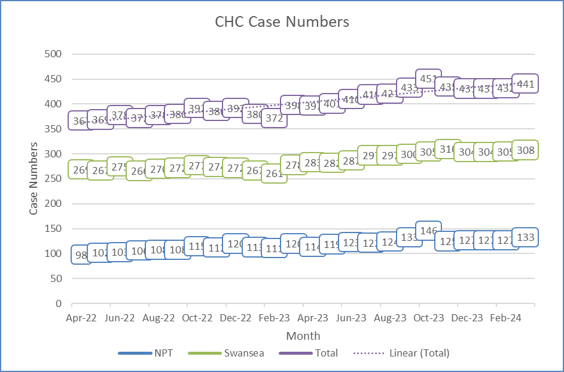

During the same period there has also been an increase in the number of high cost packages of care as a percentage of the total number of packages. These include high cost placements or packages of care for conditions such as MND/MS/Huntington Chorea and complex Mental Health needs. In August 2023-24 the base CHC rate has increased and tipped over the £1k level, backdated to April 2023. This means that 95% of packages are over £1k per week versus 39% in 2022-23.

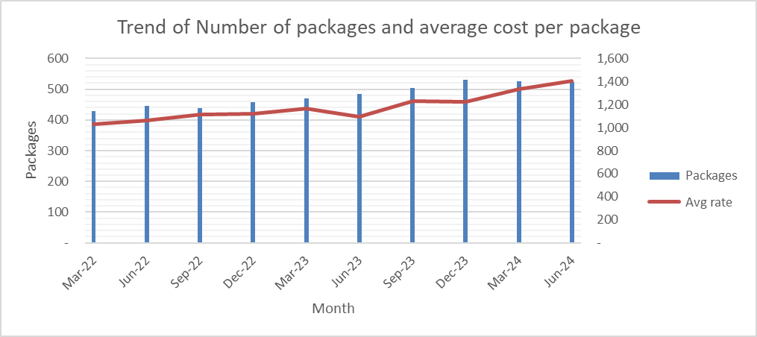

3: MENTAL HEALTH & LEARNING DISABILITY

MENTAL HEALTH & LEARNING DISABILITY – CHC Trend/Demand

Currently Funded Cases as of 30th June 2024

The MH and LD Service Group currently have 404 individual patients.

- MH = 210 individual patients, with a year-to-date expenditure of £4,753k.
- LD = 194 individual patients, with a year-to-date expenditure of £6,645k.

Referral Data for June 2024

As of the 1st – 30th June 2024 there have been a total of 22 referrals;
- 12 MH
- 7 LD
- 3 DST
During the month there were 9 requests for Out of Panel approvals, 8 MH and 1 LD

Drivers
Several drivers contribute to the level of demand within the month, primarily a general increase in pressure within adult mental health services and unscheduled care which appears to be overflowing into complex care commissioning.

FINANCIALS

As part of the budget setting process the Complex Care budget for 2024/25, funding provided in previous years has now been provided recurrently which includes funding for growth, inflation and Real Living Wage. Funding has also been issued into CHC budgets for the full year effect of the 2023-24 growth.

Further funding has been issued as part of the 2024-25 Financial Plan in respect of growth and inflation in 2024-25 to the value of £1.277m and £3.247m respectively.

June 2024 Financial Position

The Month 3 (June 2024) CHC financial position was reported as an overspend against budget of £105k (YTD £105k) compared to a breakeven position in Month 2.

Compared to the FY2023-24 baseline, the cost of new cases increased by £208k (Last month £119k) primarily due to the recognition of costs for two LD clients being re-patriated back to the Orchard following confirmation from Dimensions that they had the appropriate level of staff recruited. The position was also impacted by other new packages in the year that were not included in the baseline and also included a retrospective cost to them. Step up costs increase by £33k (Last month £37k) due to a client move and additional observations increased by £29k (Last month £45k) due to continued observations for a number of clients over and above their standard package costs offset by an accrual adjustment for reduced observation costs for an LD client.

Step-down expenditure reduced by £(62)k (Last month £(90)k) recognising patient transfers from Low-secure to residential providers. Reductions were also recognised for clients whose CHC costs have ended which totalled £(99)k (Last month £(66)k).

Savings achievement of £(80)k was recognised in month compared to with the Service groups cash releasing savings plan.

Growth funding of £150k (YTD £445k) was released into the position during the month to address the new costs and manage cost pressure brought forward from 2023-24. This level of funding was higher than planned due to the cost of the new placements in month and there is a significant risk that there will not be sufficient funding available to fund growth throughout the year. To manage this risk, there is a considerable amount of focus on converting several identified savings opportunities into realised schemes to reduce the current level of expenditure.

Whilst inflationary payments to suppliers have not yet been recognised, the Service groups proposal has been approved by the Executive team and letters are in the process of being issued to providers. Funding and expenditure associated with inflationary uplifts will start to be recognised in the revenue position from Month 4 (July 2024).

CHC Expenditure trend

As referenced above, whilst month 3 actuals are reduced compared to Month 2, this is due to calendar days in month. The budget between Month 3 and 2 has reduced by £188k however actuals have only reduced by £83k resulting in a net increase of £105k.

The reduction in actual expenditure in Month 6 relates to a Balance sheet release occurring following a review of provisions held in the balance sheet relating to FY2021/22 that were no longer required.

The increase in actual expenditure during Month 12 related to the recognition of several provisions and accruals identified as part of the year end accounts process.

Savings Plans
There is a blended approach to target setting in 2024-25 with two targets, the first based on spend to date at month 11 and the second based on investment in the financial plan. In this way the investment is effectively top sliced. Target 1 is £0.711m and target 2 £1.892m giving a total target of £2.602m. In addition to this savings target, the Service Group is also required to reduce the expenditure run rate and the brought forward underlying deficit from the last financial year. After funding received this is £5.723m.
To date the Service Group has identified budget releasing savings of £2.458m and run rate reduction of £1.112m, total £3,570m. Of these savings schemes, £1.884m relates to CHC.

As at the end of June, the Service group are forecasted to deliver against the full planned delivery in respect of CHC cash-releasing schemes.
No new cases have been identified in month however there are still a number of other CHC schemes that are currently being evaluated listed above and these are hopefully going to be transacted into actual benefits to the Service group in the coming months.

PERFORMANCE ACTIVITY

The issues that are new and remain relevant in terms of performance activity include:
- Increasing number of routine reviews have identified a significant number of recipients of NHS Continuing Healthcare (CHC) requiring review of their CHC status.
Rightsizing
- Our own in-house rightsizing reviews are ongoing across LD and MH.

Learning Disabilities
The LD Rightsizing spreadsheet has been amended to split out the identified actions into 3 distinct areas:

- Review of CHC Eligibility Required – Awaiting decision from talks with Service Partners on how these are to be progressed.

- Review of Commissioned Hours Required – These are the quick wins where savings can be realised in the short term.

- Identified Voids – These need to be considered as a whole in order to understand where we can fill any voids with existing /new service users. As at the time of writing we are awaiting information from both LA’s relating to the current void situation across the HB area.

This split will allow the Case Manager’s to prioritise the Review of Commissioned Hours case actions where we can quickly realise cost savings through discussion with the Care Coordinator Teams and the Provider.

It should be noted that progress in relation to Review of Commissioned Hours has been slow to date with little traction. In order to address this, a meeting has taken place with the LD Management Team and a process has been agreed that will remove barriers and allow for more timely action to be taken. The new process will be adopted from mid-July moving forwards.

- 35 LD reviews have been completed so far.

- In total there are 41 DST’s that need to be completed. Of these 17 individuals have been identified as requiring a DST, 7 DST’s need to be rearranged and there are 17 cases that the Local Authority put forward as part of the CHC process.

Mental Health
- Peter Collier is currently in the process of reviewing all mental health casefiles with the objective being to identify those requiring rightsizing or other potential cost saving measures. Once the list has been compiled Peter will be making the necessary appointments to right size these cases.

- Peter Collier is in regular contact with Katherine Jenkins from NPT local authority who is rightsizing from the LA side but is identifying savings via Section 117 aftercare for the Health Board. It is planned that Peter and Katherine will be jointly conducting rightsizing reviews of those mental health patients who are jointly funded.
Subsequently, all savings identified and made via the aforementioned result in a 50% saving for the Health Board. An ongoing scrutiny of all Mental Health commissioned patients is currently being undertaken, with a number of potential cost savings, both rightsizing and other cost saving anomalies.

Repatriations
Further work is required on the proposed repatriation lists that still have not been actioned for parts of our services. This will now be taken forward with the Divisional Triumvirate following the recent changes in service managerial structures within the Service Group.

Reviews

Mental Health Review stats from 1st – 30th June 2024
- 13 reviews were completed in the month, they are broken down as:-

10 | 12-month statutory reviews of which 9 continue to be eligible and 1 requires a review of funding responsibility.
3 | 3-month statutory reviews, all of which continue to be eligible.

Learning Disabilities Review stats from 1st – 30th June 2024

- 15 reviews were completed in the month, they are broken down as:-

14 | 12-month statutory reviews, all of which continue to be eligible.
1 | 3-month statutory review which continues to be eligible.

The above indicates that we have 75 reviews that are outstanding at the half year point. These will be prioritised to ensure that we get on top of the review situation and will be closely monitored over the coming months.
Caveat – The above data is taken from NCCD and may not be up-to-date. An exercise is underway to ensure that NCCD reflects the up-to-date situation moving forward.
As from next month we will begin to quality assure a sample of the Case Manager’s review documentation to ensure that it is robust from both a patient care and financial stand point.

MATTERS FOR FURTHER CONSIDERATION OR NOTE BY DIVISIONS AND SERVICE GROUP

- Increase in cases requesting additional observations by both our own clinical teams and independent sector providers on existing packages. Need to continue to manage this issue closely as a Service Group via Scrutiny Panel and Complex Case Panel.

- Ongoing work with both Local Authorities to agree joint funding agreement in place. Has been escalated via the Health Board Executives to try and get some progress on this issue.
- Health Board review of Complex Care structures across the three Service Groups is still ongoing. Repurposed Health Board CHC Board taking place on the 18th June.

4: CHILDREN CONTINUING HEALTH CARE

Quarter 1  Panel CYP | Referral declined | New referral Cases Presented | Packages agreed | Changes packages
April  2024 | 1 | 1  Case discussion | 1  Package of care. 12 month review | Case 1  CYP yearly review of existing care package 7 nights at B3.  Case 2  Referral from March. Cased discussed in panel. Meeting cancelled due to lack of core representation. DATIX raised.  CYP moved out of county for further assessment. Case closed.
May  2024 | 0 | 0  No new referrals | 1  Review of existing care Package | Case 1  CYP yearly review of existing care package.
June 2024 | 0 | 0 | 1  (Review existing packages) | Case 1  CYP an annual review of an existing package. DST May. Existing POC increase from 6 to 7 nights 2-1 B3 & B4. Equipment request.

Overall summary of packages

- Start of quarter, 17 packages of care. Support of band 3 and Band 4.
- Reduced to 15 packages of care March 1st
- Packages of Care day hours per week end of March = 160hrs
- Packages of Care night hours per week end of March = 616hrs

Drivers
Increase in demand within this quarter for band 4 HCSW due to complexity in Continuing care packages.

Risk

- Workforce risk on Register at score of 20 with a target score of 15. This is in relation to the fragility of the team including vacancies and sickness/absence in the non-registered workforce. Mitigation includes the backfill with bank/overtime, Recruitment and retention continues to remain challenging. 3.12 WTE Band 3 HCSW recruited into post. 1.68 WTE Band 4 HCSW have accepted offer. Band 4 HCSW 6.0 WTE advertised on TRAC.

- In line with service improvement, the Children Community Nurse team implemented the twilight service from January 14th 2024 in a staged approach to further enhance the service provision. Twilight service has increased HCSW supervision and facilitated training opportunities for HCSW staff.

Issues Relating to packages

- 13 Missed cares during this reporting period, all DATIX and reviewed. This relates to staff sickness. This is continually monitored and actively addressed through policy.

5. RECOMMENDATION

The Committee is asked to:
- Note the content of the report.

Governance and Assurance

Link to Enabling Objectives  (please choose) | Supporting better health and wellbeing by actively promoting and empowering people to live well in resilient communities
Link to Enabling Objectives  (please choose) | Partnerships for Improving Health and Wellbeing | ☒
Link to Enabling Objectives  (please choose) | Co-Production and Health Literacy | ☐
Link to Enabling Objectives  (please choose) | Digitally Enabled Health and Wellbeing | ☒
Link to Enabling Objectives  (please choose) | Deliver better care through excellent health and care services achieving the outcomes that matter most to people
Link to Enabling Objectives  (please choose) | Best Value Outcomes and High Quality Care | ☒
Link to Enabling Objectives  (please choose) | Partnerships for Care | ☒
Link to Enabling Objectives  (please choose) | Excellent Staff | ☐
Link to Enabling Objectives  (please choose) | Digitally Enabled Care | ☒
Link to Enabling Objectives  (please choose) | Outstanding Research, Innovation, Education and Learning | ☐
Health and Care Standards
(please choose) | Staying Healthy | ☒
(please choose) | Safe Care | ☒
(please choose) | Effective Care | ☒
(please choose) | Dignified Care | ☒
(please choose) | Timely Care | ☒
(please choose) | Individual Care | ☒
(please choose) | Staff and Resources | ☒
Quality, Safety and Patient Experience
The Health Board has a responsibility to ensure that its duty of care extends to NHS provision

Financial Implications
MH&LD and PCS delivery Units have identified financial risks and have implemented improvement plans.
Legal Implications (including equality and diversity assessment)
The Health Board is required to provide NHS funded care in line with agreed procedures. The sustainability of the independent sector, quality and governance concerns and the pre Judicial Review from the Caron Group challenging the methodology of setting the CHC rates for the Health Board have been identified as potential risk. This has now been resolved.
Staffing Implications
There are staffing issues in the private care sector which require a revised approach to ensure the sector remains positive and suitable for continued commissioning of NHS funded care.

