Meeting Date | 27th August 2024 |  | Agenda Item |  | 2.2
Report Title | Financial Report – Period 04 2024/25
Report Author | Samantha Moss, Deputy Director of Finance  Gemma Pearson, Finance Business Partner
Report Sponsor | Darren Griffiths, Executive Director of Finance and Performance, Acting Deputy Chief Executive
Presented by | Samantha Moss, Deputy Director of Finance
Freedom of Information | Open
Purpose of the Report | The report advises the Performance & Finance Committee of the Health Board on the financial position for Month 04 2024/25 (July 2024) and risks regarding the current forecast revenue year end outturn.
Key Issues | The report invites the Performance & Finance Committee to note the detailed analysis of the financial position for Month 04 2024/25 (July 2024).  The report includes a summary of the key drivers of the position either at Service level or by expenditure type (i.e. Non Pay/Pay). It also provides information of the current position with regards to Health Board reserves to ensure transparency in the overall Health Board position.  Risk will have been considered on the basis of the information provided within the report and the score updated where necessary.  Whilst the key messages are provided within the main body of the report, further information is provided in the Appendices.
Specific Action Required | Information | Discussion | Assurance | Approval
Specific Action Required | ☐ | ☐ | ☒ | ☐
Recommendations | Members are asked to:  - Consider and comment upon the Board’s financial performance for Month 04 2024/25.  - TAKE ASSURANCE from the actions to ensure delivery of a balanced financial position for all service areas as per the accountability letters issued, which now require:  - Re-submission of Financial Strategy by each Service Area on 14th August 2024. (Service Group Directors/ Corporate Directors)  - Second round of “Star Chamber” meeting chaired by CEO to assess revised plans submitted on 14th August.  - A summary of options to support financial balance to presented to Board 5th September  - TAKE ASSURANCE that the ‘saving’ reduction target set are per the accountability letters and ensure actions are logged on the savings trackers, with the additional savings identified and agreed from the 14th August submission to be reflected in Savings Trackers by mid-September.  - CONSIDER the risks to the position at Month 04.  - SUPPORT the position with regards to Health Board Reserves.  - CONSIDER all actions and updates to support the management of the 2024/25 financial position.

FINANCIAL REPORT – MONTH 04

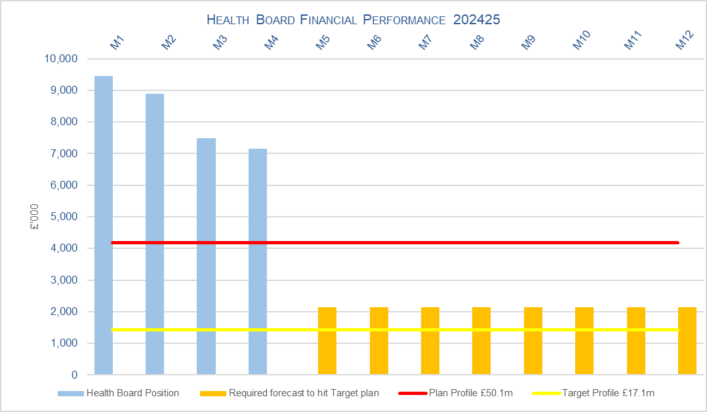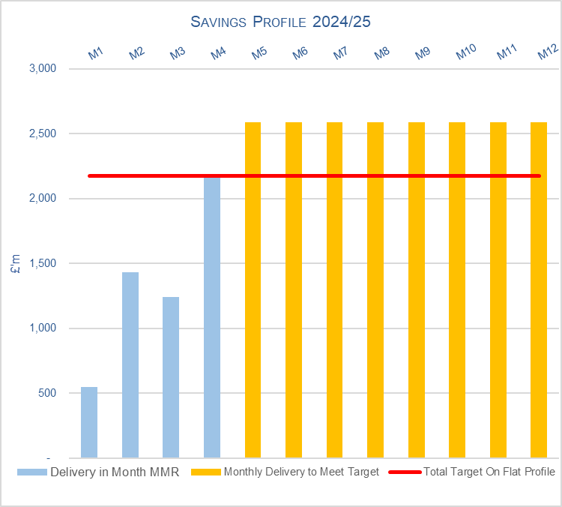

SUMMARY OF REVENUE PERFORMANCE

Target | In Month  £’m | Year To Date (YTD)  £’m
Delivery Against Revenue Resource Limit (RRL) DEFICIT / (SURPLUS) | 7.147 | 32.973
Performance Against Plan DEFICIT / (SURPLUS) | 2.972 | 16.273

In summary the Month 4 financial position was £7.1m overspent, this was £2.9m higher than the forecast deficit for the month.

The Annual Plan submitted on 28th March 2024 reported a deficit of £50.1m after the delivery of £26.1m of savings. The expectation was that the in-month position would reflect a 12th of the £50.1m deficit. For Month 4 the Health Board (HB) has reported a deficit of £7.1m against a 12th of the deficit plan of £4.2m and is £32.9m overspent against cumulative deficit plan of £16.3m. Clearly this position is unacceptable and immediate actions are being taken.

The components and the respective impact on the £7.1m are visualised in the chart below:

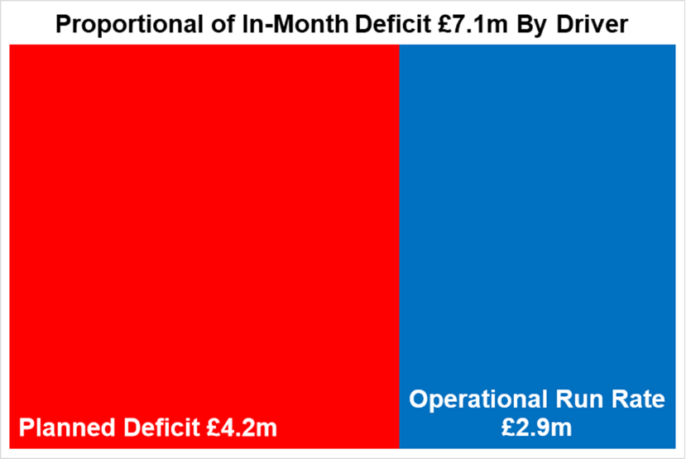

- FINANCIAL PLAN 2024/25
The Health Board submitted an Annual Plan on 28th March 2024 which reported a deficit of £50.1m. This has not been approved by Welsh Government (WG) with the request that as a minimum the Health Board reduces its deficit to £17.1m or better; work and discussions are ongoing. In order to meet the £50.1m deficit plan operational savings totalling £26.1m are required and all service areas are required to breakeven to their delegated budgets. This will require the need for a significant reduction to the Health Board’s run rate of expenditure.

A further review of the deficit in light of the Month 1 position was undertaken to be considered alongside the thematic work programme to reduce the deficit. The Board was advised in May 2024 that whilst the thematic review work had identified some technical changes that could be made and some variable benefits which could be realised, in light of the YTD position there are not sufficient granular plans to reduce the forecast deficit as actions would first be required to de-risk the run rate. Therefore, the plan remains at £50.1m deficit.

- KEY DRIVERS OF THE IN MONTH POSITION
The key drivers of the Month 4 and YTD position are summarised in the tables below. Further detail at a Health Board level of expenditure on Income, Pay and Non-Pay, is also provided in Appendix 1.

  - Key Drivers by Service Area In Month

  - Key Drivers by Service Area YTD

  - Summary By Expenditure Type

- Income
The Joint Commissioning Committee (JCC) Income as a provider improved in-month, with an in-month overachievement of £0.3m, largely due to activity levels in Burns & Plastics, Bariatric and TAVI/Cardiology procedures. The YTD underachievement is £0.5m.

Dental Contract Income underachieved by £0.1m in-month, with an YTD underachievement of £0.5m.

- Pay
The Month 4 pay overspend was £2.2m (Month 3, £2.8m), largely driven by Medical & Dental and Nursing across the acute sites and MH&LD in addition to Hotel Services within COO. The pay pressures are driven by a number of factors including the continuation of staffing surge bed capacity, pressures on services across the organisation and high levels acuity, coupled with high levels of sickness.

- Non Delivery Savings
The Health Board has set a 2.5% savings target for 2024/25 which has been issued to Service Areas. There is currently a gap in the identification, and therefore delivery, of savings to meet the target set. However, due to phasing of schemes this has resulted in a £nil variance in Month 4 (Month 3, £0.9m).

  - Action being Taken to Mitigate Position

The table below provides a summary of the actions being taken by the Health Board during July and those planned through to the end of September to provide assurance and details on how the improvement in financial performance will be achieved.

There are two areas of work underway linked to the Recovery & Sustainability (R&S) Programme. Programme 1 focusing on immediate actions to address controllable expenditure and Programme 2 focusing on Short Term Service Changes that will impact on run rates and savings delivery.

Date | Action
28th June | Programme 2 R&S - All Service Groups submitted options to mitigate operational pressures, run rate reductions and address savings target set for 2024/25, to be scrutinised via the ‘Star Chamber’ meetings scheduled for 11th-24th July.
8th July | Recovery & Sustainability Overarching - Director Recovery & Sustainability commenced role, working directly to the Director of Finance and Performance (SRO) leading on a three-programme approach supported by the existing Finance PMO Team.
11th - 24th July | Programme 2 R&S - Star Chamber meetings Round 1 held and Chaired by the CEO, with the next steps detailed in action dated 31st July 2024
17th July | Programme 1 R&S - Immediate pause on A&C Bank/Agency/Overtime and also a pause on all A&C Recruitment, with new vacancy panel being developed to increase the scrutiny on A&C posts being put in place after the 3 month pause.
23rd July | Programme 2 R&S - Summary of the submissions from 28th June and Star Chamber meetings held to date, presented to PFC (In-Committee), who requested further actions by Service Groups, communicated via the action dated 31st July.
27th July | Programme 1 R&S - Board authorised the Executive Team to consider and approve actions to reduce controllable expenditure.
w/c 29th July | Programme 2 R&S - Commencement of the review of investment and choices made through IMTP process over last 3-4 years. Work to date has focused on Omnicell Invest to Save (Non-Pay Theatres) and Emergency Department in Morriston.
29th July | Recovery & Sustainability Overarching - Launch of Phase 1 of the new Health Board Repository of Opportunities which brings together benchmarking, value and sustainability opportunities nationally and locally identified, as well as research on good practice to support the wider Recovery & Sustainability agenda. The product is similar to the NHS Executive FP&D Vault and has a direct link to this product. Phase 2 of this work, which is planned for the Autumn will include latest Welsh Costing Return data; Weekly Reporting of non-financial indicators that impact on financial position; Theatre comparison data; and further detailed analytics to highlight opportunities using the existing repository data.
31st July | Programme 1 R&S - Special Executive Team to consider options to reduce or cease controllable expenditure. Agreed reduction in Travel, Office Equipment, Telephones and Building/Maintenance Costs, which could reduce run rate by £0.9m in 2024/25.
31st July | Programme 2 R&S - Following actions required by the PFC, instructions and feedback were provided to all the Service Groups following first round of Star Chamber meetings (11th-24th July). Further submission of options, with required actions to be submitted 14th August.
7th Aug | Programme 1 R&S - Further Executive Team discussions on the Controllable expenditure focusing on Variable Pay and CHC, with agreed approach to setting reduction targets for Variable Pay, followed up by action from 12th August.
12th Aug | Programme 1 R&S - Issued instruction to Service Areas on the Variable Pay Control targets for 2024/25, with 25% reduction required by end September and a further 25% reduction by the end of December. This has the potential to reduce Variable Pay by £13.5m by the 31st March 2025.
13th August 2024 Completion and Submission Month 4 MMR
13th Aug | Programme 1 R&S – Issue further instructions to Service Areas on controllable expenditure agreed by the Executive Team, focusing on Travel, Office Equipment, Telephones and Building/Maintenance Costs.
14th Aug | Programme 2 R&S - Submission deadline for updated options to mitigate operational pressures, run rate reductions and address savings target linked to action from 31st July.
19th - 23rd Aug | Programme 2 R&S - Star Chamber meetings Round 2 Chaired by the CEO; there will also be a focus on Estates and Hotel Services in this round of meetings.
23rd Aug | Recovery & Sustainability Overarching - Submission of reply to Judith Paget letter dated 26th July on Annual Plan 2024-2025.
5th Sept | Programme 2 R&S - Special Board to consider options submitted on 14th August and scrutinised at Star Chamber meetings 19^{th -} 23rd August.
End Sept | Recovery & Sustainability Overarching - Combine data from Controllable Expenditure work, Outputs 5th September, Assessment of LTA Performance and Non-Recurrent opportunities to build an assessed position for 2024/25 and start assessment of underlying position for 2025/26 planning process.

- SAVINGS
The position reported in the MMR by each area is provided in the table below, which will only reflect Green and Amber schemes:

Savings Table 1

Overall, there has been progress in the identification of opportunities and further pipeline ideas. As the Health Board will need to deliver mitigating cost reduction actions to address the YTD overspend and run rate pressures the overall level of savings and mitigating actions required will be more than the £26.1m planned target.

Please note that the schemes in relation to recovery of Microsoft VAT have been removed in Month 4 in line with WG guidance; as one of these schemes was included in the Plan (and flagged as ‘Month 1’), removing this scheme would have amended the Plan section of Table A, therefore the original scheme remains unchanged, with a new line entered (flagged ‘In Year’) reporting negative values to fully offset the original scheme.

A summary of the total opportunities at 9th August 2024, is provided in the table below:

Savings Table 2
The total level of identified opportunities pending the full assessment of the service areas financial strategy/options submissions outlined in section 4.4 is £26.4m. The first call on savings identified by service areas is to address the £26.1m target. Once a service area has identified their target all other opportunities will be deployed to manage run rate pressures. So, in the table above whilst £26.4m has been identified £9.7m is to support run rate pressures, leaving a net value of £16.7m to meet the £26.1m target. However, unlike Table C this will include red/pipeline ideas.

- GOVERNANCE AND RISK
Two Board level financial risks:

- Achieving financial plan (HBR92) with the key elements as follows: -

  - Risk of delivery of savings quantum
  - Risk of operational overspend being in excess of funding available agreed via the Financial Plan
  - Risk of commitment of reserves (e.g. NICE) being above reserves available.
  - Risk of achieving the actions outlined in the 2024/25 Landing Plan.

Based on the financial performance at Month 4, it is proposed that the Health Board Corporate Risk Register retain the existing risk score to 25 given the unacceptability of the current financial plan and the variance from plan at the end of July 2024.

- Availability of capital (HBR93). This risk was re-opened in 2022/23 given the reduction in discretionary capital allocation. Whilst work is underway to manage schemes to reduce commitments in 2024/25 and to produce a balanced plan, the risk varies during the year as more details on schemes emerge and potential slippage funding is made available by Welsh Government.

A score of 20 is suggested at this stage as whilst the plan is now balanced, a number of schemes are on hold and the flexibility within the plan is extremely limited given the reduction in the allocation.

- RECOMMENDATIONS
Members are asked to:
  - Consider and comment upon the Board’s financial performance for Month 04 2024/25.
  - TAKE ASSURANCE from the actions to ensure delivery of a balanced financial position for all service areas as per the accountability letters issued, which now require:
    - Re-submission of Financial Strategy by each Service Area on 14th August 2024. (Service Group Directors/ Corporate Directors)
    - Second round of “Star Chamber” meeting chaired by CEO to assess revised plans submitted on 14th August.
    - A summary of options to support financial balance to presented to Board 5th September
  - TAKE ASSURANCE that the ‘saving’ reduction target set are per the accountability letters and ensure actions are logged on the savings trackers, with the additional savings identified and agreed from the 14th August submission to be reflected in Savings Trackers by mid-September.
  - CONSIDER the risks to the position at Month 04.
  - SUPPORT the position with regards to Health Board Reserves.
  - CONSIDER all actions and updates to support the management of the 2024/25 financial position.

Governance and Assurance

Link to Enabling Objectives  (please choose) | Supporting better health and wellbeing by actively promoting and empowering people to live well in resilient communities
Link to Enabling Objectives  (please choose) | Partnerships for Improving Health and Wellbeing |  | ☐
Link to Enabling Objectives  (please choose) | Co-Production and Health Literacy |  | ☐
Link to Enabling Objectives  (please choose) | Digitally Enabled Health and Wellbeing |  | ☐
Link to Enabling Objectives  (please choose) | Deliver better care through excellent health and care services achieving the outcomes that matter most to people
Link to Enabling Objectives  (please choose) | Best Value Outcomes and High Quality Care |  | ☒
Link to Enabling Objectives  (please choose) | Partnerships for Care |  | ☒
Link to Enabling Objectives  (please choose) | Excellent Staff |  | ☐
Link to Enabling Objectives  (please choose) | Digitally Enabled Care |  | ☐
Link to Enabling Objectives  (please choose) | Outstanding Research, Innovation, Education and Learning |  | ☐
Health and Care Standards
(please choose) | Staying Healthy |  | ☐
(please choose) | Safe Care |  | ☐
(please choose) | Effective Care |  | ☐
(please choose) | Dignified Care |  | ☐
(please choose) | Timely Care |  | ☐
(please choose) | Individual Care |  | ☐
(please choose) | Staff and Resources |  | ☒
Quality, Safety and Patient Experience
Financial Governance supports quality, safety and patient experience.

Financial Implications
The Board is reporting a forecast year-end deficit financial outturn.

Legal Implications (including equality and diversity assessment)
No implications

Staffing Implications
No implications

Long Term Implications (including the impact of the Well-being of Future Generations (Wales) Act 2015)
No implications

Report History |  | Updates on the financial position are provided at every meeting
Appendices |  | Appendix 1 – Variances by Area and Type of Spend  Appendix 2 – Reserves and Central Budgets  Appendix 3 – Savings

APPENDIX 1 – FURTHER DETAIL ON VARIANCES BY AREA & TYPE OF SPEND

- Overview Financial Position

- Overview of Income

A correction was made in Month 2 to reflect the subjective being used in R&D between Income & Non Pay totalling £3.9m

- Overview of Pay Variances

Overall Variance by month

Actual Variable Pay by month and type

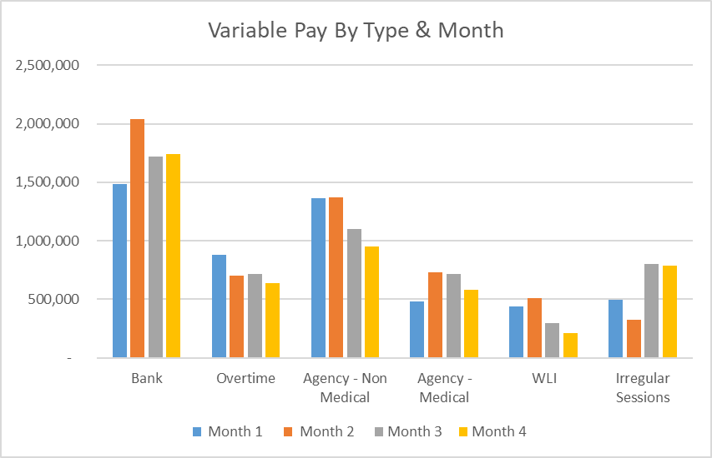

- Overview Non-Pay

A correction was made in Month 2 to reflect the subjective being used in R&D between Income & Non Pay totalling £3.9m

Below are further details on the key areas of Non-Pay (excluding savings that is addressed in main body):

  - Clinical Consumables
This area continues to be a significant pressure with an in-month position of £1.3m (Month 3, £1.2m). There are 80+ subjective lines within this category including secondary care drugs but areas seeing most pressures YTD continue to be general consumables (M&SE), laboratory products and implants (which in part will be driven by activity).

  - Energy
An update was received on 10th June 2024 from NWSSP regarding the forecast which has been validated and included in Month 3 MMR submission. As a result, Month 1 and 2 actuals have been restated. There is no update for the Month 4 MMR submission.

  - CHC
The variance against budget for CHC is £0.7m overspent in-month. An analysis of actual expenditure and patient numbers for 2024/25, along with the average values from 2024/25 is provided in table below.

CHC Analysis by Month

Please note:
- The above numbers include Domiciliary care cases.
- PCT Group does not include the Singleton/NPT element. The NPTS element which covers Children and Young People CHC patients is provided internally by the Health Board and as such is part of the wider NPTS position and is not recorded in the ledger as PCT/MH/LD CHC is recorded.

  - COVID Public Enquiry
The costs for this are allocated to a dedicated Cost Centre (6F25). A breakdown of spend YTD is provided below:

Expenditure type | YTD Expenditure £
Staff costs | 11,328
Legal Fees | 9,611
Total YTD expenditure | 20,939

  - Maternity Review
In the 2024/25 Financial Plan £0.7m was set aside to support the Maternity Review. A breakdown of spend YTD is provided below:

Expenditure type | YTD Expenditure £
Consultancy Fees | 30,000
Legal Fees | 158,203
Total YTD expenditure | 188,203

In August to improve the oversight of this area a dedicated Cost Centre was established (6F34).

APPENDIX 2 – DETAILS ON RESERVES & CENTRAL BUDGETS

- SUMMARY RESERVES
Overall management of the reserves is as per the Health Board Budget Management document.

  - Balances Main & NICE
For 2024/25, the Health Board will hold two central reserves and the purpose of these reserves are below:
- Main – this holds funding from WG or the plan that has yet to be issued to Budget Holders. These items are not surplus but either due to timing have not been issued or is an area where funding is issued based on actual values consumed in future month.
- NICE – this holds the total Health Board funding for all of NICE costs (drugs and infrastructure) and is issued to the service each month based on the actual costs consumed as reported through the Pharmacy system.

Details on the balances and movements are provided in the Table below:

- COVID RECOVERY
As part of the Financial Plan WG Funded £15.2m for Local COVID Recovery and £19.5m for Regional COVID Recovery. The funding remains in Central Reserves and reported in Main reserves in Section 1 above. This funding is then issued to service areas based on the actual costs committed. A summary of the actuals to date and forecast costs against the funding total of £34.7m is summarised in the table below.

APPENDIX 3 – SAVINGS

1. Summary

Section 3 above and the table below showed a forecast delivery of £26.4m of savings (£16.7m net of run rate mitigations) in year and £24.2m planned recurrently. However, this includes all schemes including Red schemes and schemes in progress of being developed.
Within the £26.4m forecast, £21.7m is considered deliverable with a Green/Amber risk rating. However, £4.7m (17%) are considered high risk of delivery this year (£6.2m, 25% recurrently) and are rated as Red.

If we take the Green/Amber schemes which have a higher chance of delivery, then Morriston has the lowest % of Green / Amber Savings, therefore have the highest risk of delivering on their Savings Target this financial year. MHLD and Primary Care have the highest confidence of delivery in-year.

- Profiling of Savings 24-25 in Year £16.7m

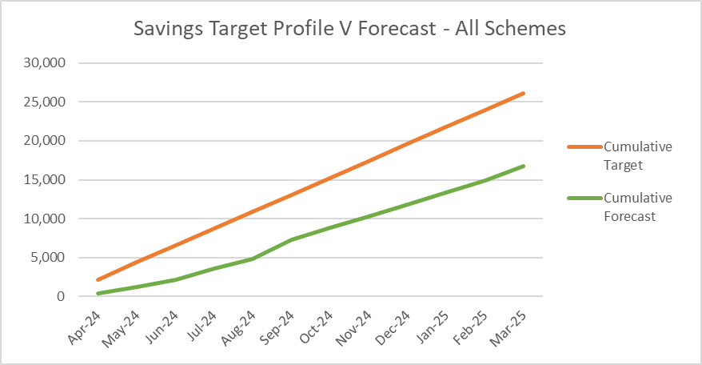
The profile shows the timeline of the forecast savings (net of run rate) of £16.7m for 24-25 against the £26m target. Currently this is for all Risk rated schemes. Sept offers the highest level of expected savings, although fairly flat lined delivery across the year. However the savings gap of £9.4m will need to be achieved in months 5-12 (Aug-Mar).

- Type of Savings Forecast at Month 4

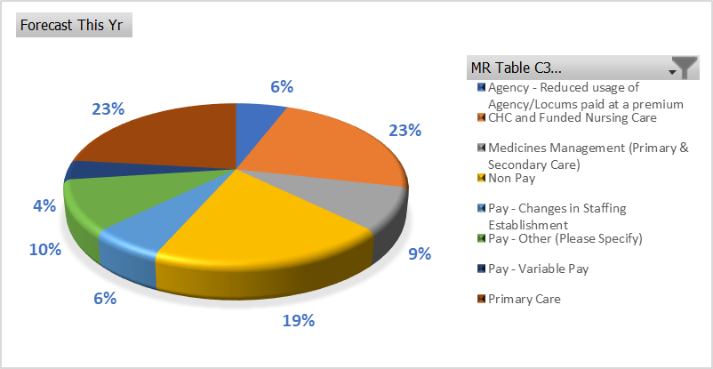

The largest type of savings to month 4 are Primary Care at £6m (23%) which include management of Optometry and Pharmacy contracts, managing levels of investments, dental clawback and in year slippage. CHC and Funded Care make up 23% of the savings, which include managing CHC growth and inflation, reviewing support, decommissioning, planned step downs and repatriations. Non Pay / procurement are at 19% of savings and include procurement savings identified by local and All Wales procurement teams, managing SLA’s, capping investments and managing maintenance contracts.

- SBUHB Savings Repository

To continually support the identification of opportunities for the Recovery & Sustainability programmes in 2024/25 and in future years, as well as ensuring all opportunities from the National Value & Sustainability are captured and shared within the Health Board, the Repository of Opportunities has been re-developed to ensure ease of navigation of the data.

The revised Repository is now live and online on the following SharePoint Site.

https://sbushare.cymru.nhs.uk/sites/Finance/Corp/Resources/savresp

The Repository is split into three sections:
- National Efficiency Reports - this will include details of the NHSE FP+D Vault, NHS Wide Value and Sustainability Board Updates including Medicines, and the Carter Report
- National Benchmarking – this will include the latest CHKS Benchmarks, NHSBN reports and analysis, and summary of the NHS Wide Savings schemes for comparisons.
- Local Reports and Benchmarking to include SBUHB Procurement dashboard, Medical Staffing, and some Pay and non-Pay potential opportunities.

- Value and Sustainability Update

Procurement and Non Pay – The group led by Hywel Jones (WG) focusses on the following priorities: Price and Volume, Contract Negotiations and Management, Management of Service Contracts.
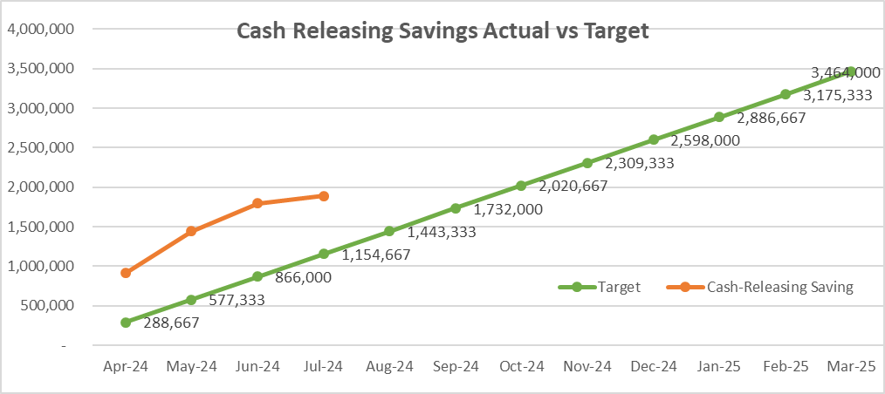
The NWSSP has set an annual target of cash releasing savings of £37m across NHS Wales. The savings achieved to the end July was £13m across Wales. The SBUHB savings plan has been updated to £3.464m. Currently SBUHB are reporting a cash releasing saving of £1.9m to July.

Workforce – The group is led by Liz Rogers (WG) focusses on the following priorities: monitoring reduction in agency costs, development of an international recruitment plan, nurse staffing levels and roster management and benchmarking. SBUHB update: Working to agree an all Wales rate for ADH’s to avoid competition between HB’s; working with NHS Wales on international recruitment but SBUHB already a leader in this with estimated 75 International nurses expected by end of year; working on Nurse Staffing Headroom to ensure consistency across 25B Wards.

CHC – The group is led by Jeremy Griffith (WG) focusses on the following priorities: High cost cases, private provider model, data on commissioned care, invest to save. During 2023/24, the NCCU, working alongside the FP&D, were tasked with reviewing high-cost patients utilising services across Wales. For 23/24, the NHS Wales saved £5.6m on a recurrent basis with a £14m of full year effect opportunities. SBUHB identified 46% of patients identified by NCCU with financial opportunity valuing £32k in 23/24. Key actions for 2024/25 include, a national management information system, upskilling of assessors, review of inflationary and cost pressures, and continuing of high cost patients, and potential benchmarking across Wales.

Medicines Value and Sustainability – The group is led by Alex Slade and Andrew Evans (WG) and focusses on the following priorities: Reducing spend through lower cost biosimilar, exclusive use of generic medicines, ending outsourcing of particular medicines, reviewing off contract procurement, reducing spend on low priority drugs. SBUHB Update - Where a biological medicine is indicated, all new patients in SBU are initiated on a biosimilar medicine where one is available. For generic switches, Apixaban and Sugammadex switches were implemented as soon as the generic product became available to purchase.

