

Meeting Date | 29 August 2023 |  | Agenda Item |  |  | 6.3
Report Title | Theatre Performance – Update Report
Report Author | Huma Stone, Associate Service Director Clinical Support Services
Report Sponsor | Deb Lewis – Chief Operating Officer
Presented by | Deb Lewis – Chief Operating Officer  Paul Flynn – Clinical Director Theatre
Freedom of Information | Open
Purpose of the Report | This report informs the Performance and Finance Committee of the current and historic performance against key performance indicators for Swansea Bay theatres provided in 08 August 2022.
Key Issues | Effective and efficient theatres are key requisites to the sustainable delivery of key access standards.  Theatre utilisation and efficiency is complex and affected by multiple factors both within and outside of the theatre environment, which will impact on the ability to utilise all available operative time effectively.
Specific Action Required  (please choose one only) | Information | Discussion |  | Assurance | Approval
Specific Action Required  (please choose one only) | ☐ | ☐ |  | ☒ | ☐
Recommendations | Members are asked to:  Receive and note the current performance and the actions being taken to improve the overall performance in a sustainable and consistent manner.

Theatre Performance – Update Report

Introduction
The following paper provides an update to the Performance and Finance Committee on the previous report submitted in August 2022. The paper focuses on:

- Theatre capacity
- Utilisation of Theatre lists
- Cancellations
- Theatre Comparison 2019/2020 and 2022/2023 theatre sessions
- New Theatre developments
- Workforce Overview
- Next steps

- Theatre Capacity
The increase in theatre sessions by 26 sessions (half-day lists) per week have been delivered and sustained since November 2021. A further increase in theatre sessions per week of 23 (all day lists) has been delivered since July 2022. A combined increase of 49 sessions per week going from 207 in 2022 up to 256 in 2023 on average (table below).

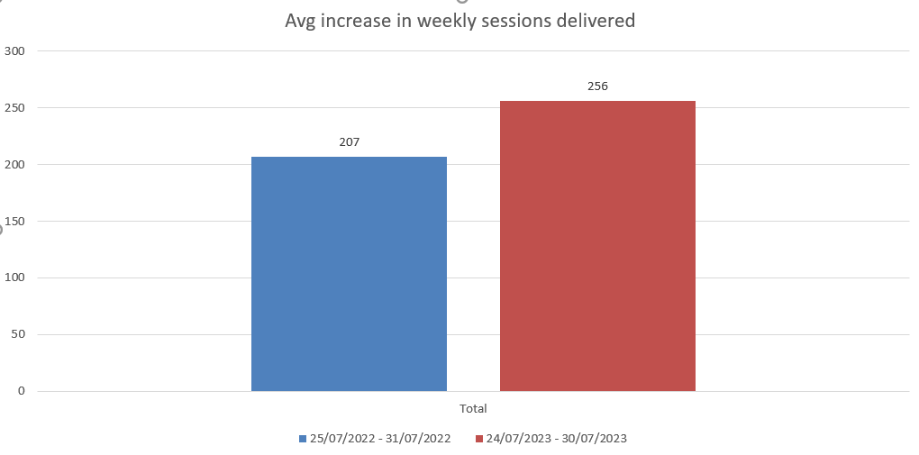

Analysis of specialty weekly sessions in 2022 and 2023 (table below) shows increases in Plastic Surgery, Trauma and Orthopaedics, Ophthalmology, General Surgery, Vascular Surgery and ENT.

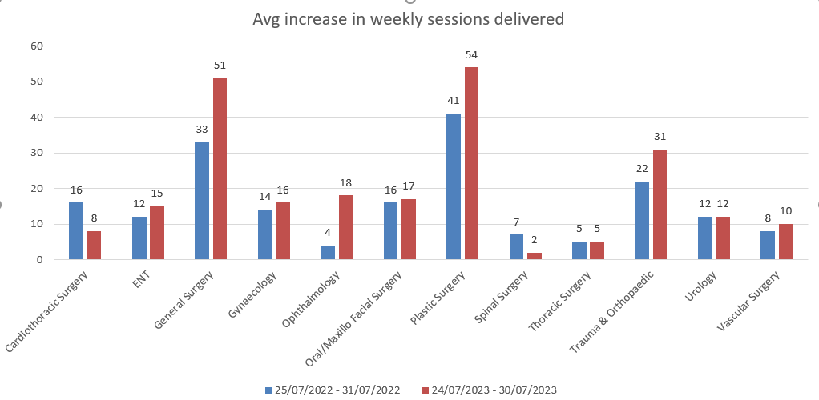
Repurposing of theatre sessions:
Our main focus has been on improving theatre activity and performance. The table below shows the number of sessions that were repurposed therefore reducing the number of cancellations. In 2019/2020, 59% of sessions were lost. However, through diligent adherence to 642 compliance and advances in internal processes, improvement is observed. As a result 64% of the sessions that would have been lost in 2022/2023 were successfully repurposed. It is important to mention that figures were somewhat lower in the 2022/2023 period. This was due to the impact of trade union strikes, highlighting the multifaceted dynamics that influence repurposing of sessions.

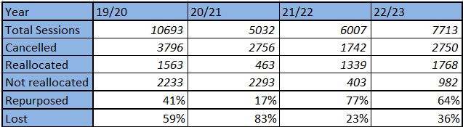

The table below illustrates the year-on-year growth in the number of delivered cases, showing 1460 cases in July 2023, 1192 in July 2022, and 877 in July 2021. Notably, elective sessions are not back to pre-covid levels which can be seen below. This is due to the increased requirement for unscheduled operating particularly at Morriston Hospital. Staffing shortages and challenges related to bed capacity has furthermore limited our abilities to reinstate elective procedures to 2019 levels, however efforts continue.

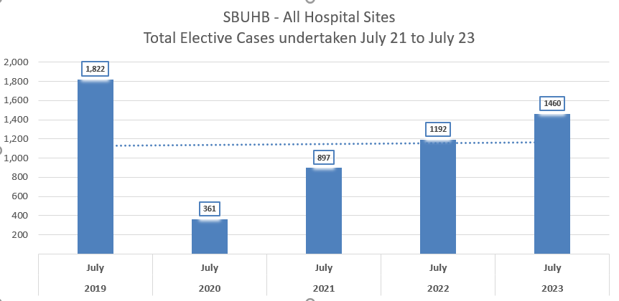

The biggest step-change in monthly cases delivered has been at Singleton Hospital, which has seen activity increase from 324 cases in July 2021 to 525 cases in July 2022 and again to 726 in July 2023. This reflects the step-change increase in the availability of theatre sessions at Singleton Hospital since November 2021.

There has been a rise in the average number of cases per session across all sites (table below), with the most significant increase observed at Singleton Hospital where 4 cases per session on average were managed in the 23/24.

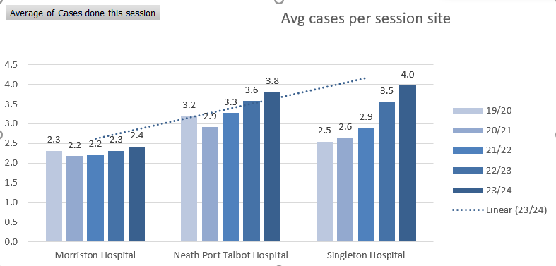

The table provided below demonstrates an average increase in cases being handled by specialites across all domains except paediatrics and OMFS which show a slight decline.

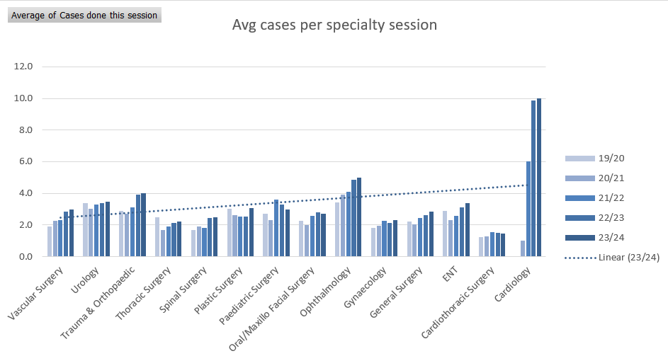

- Utilisation of Theatre lists
The graph below shows the In Theatre List Utilisation (time used vs time available) by Hospital site from 2019 to 2023. Post pandemic, the list utilisation in NPT has been significantly below the other two hospital sites. The NPT Theatre service is unique in that it has delivered capacity to both CTM and SBUHB surgeons.

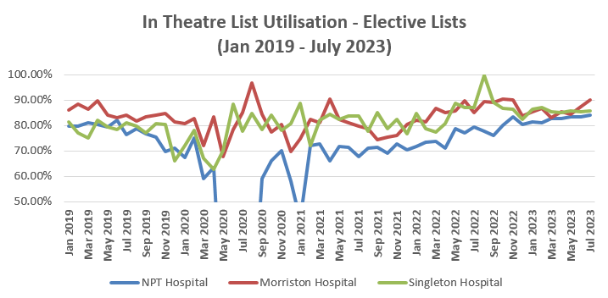

Utilisation of theatres involves the following key elements:

- Robust Pre-Assessment: ensuring patients’ suitability for surgery at the designated site.
- Structured list allocations: implementing processes (6-4-2 compliance) to allocate lists to surgeons and book theatre schedules in advance.
- Scheduling: Strategically placing cases on theatre lists to optimise productivity throughput.
- Adequate Facilities: Checking sufficient beds and trolley capacity is available to meet demand.
- Appropriate Ward Staffing: Maintaining the right level of staffing on wards to admit patients safely and promptly on the day of their surgery.
- Streamlined In-Theatre Processes: Efficiently managing the calling, holding and receiving of patients before their surgery.
- Adequate Workforce: Ensuring sufficient workforce is available to oversee the theatre for designated duration of list.
- Effective Recovery: Providing enough capacity to recover patients before returning to the ward.
- Timely Discharge: Regularly reviewing patients to ensure timely and safe discharge optimising available elective bed utilisation.

It is important to acknowledge that whilst utilisation is a significant metric, it may obscure issues such as over-running or under-running of theatre lists, which can appear as positive utilisation.

Since the last report in February 2022, significant amount of focus has been given to improving the list utilisation in Neath and Port Talbot Hospital for SBUHB surgeons specifically.

For context, during the first wave, all operating in NPT Theatres was suspended with staff reallocated to other services including Critical Care between March 2020 and September 2020. There was a further brief period between December 2020 and January 2021 when operating was again suspended due to significant bed pressures across the system and the need to re-designate NPT elective ward for non-elective patients.

The work undertaken to deliver improvements to the NPT list utilisation has involved active collaboration with the Patient Pathway team, Surgical Specialties and the Theatre Management Team.

The focus has centred on:
- Robust list booking: Ensuring comprehensive list booking for maximum utilization, supported by the Forward Look Dashboard. The dashboard serves to:
  - Aid the theatre list booking process with individual clinicians.
  - Provide surgical specialties with a user friendly tool to review the booking status and corrective actions
  - Monitor overall booking and planned utilisation status of theatre lists to highlight under or overbooked theatre lists.
- Data Accuracy: Ensuring accurate utilisation data on the TOMS system.
- Timely Feedback Loop: Delivering timely utilisation performance feedback to all surgical specialties via the 6-4-2 theatre allocation meeting.
- Issues Identification: Promptly identifying themes and issues contributing to lower utilisation.
- Specialty Engagement: Facilitating discussions and deep dive with specialties to inform subsequent decisions.

Examples of specific actions taken are:
- Specialty-specific meetings: Addressing compliance issues regarding timely surgeon allocation and patient booking to mitigate against risk of poor utilisation.
- List Frequency Review: Collaborating with specialties to reduce the frequency
of theatre lists with consistent low utilisation patterns, allowing other specialties to access theatre capacity for their delivery plans.

Analysis split by Health Board for the lists in NPT shows a 4% improvement in the utilisation of SBUHB lists in July 2022 following the improvement work undertaken, this is masked in the overall information by the decline in list utilisation for CTM Health Board lists for the same month. The trend in improvement continues to be noted.

Meetings have concluded with CTM Management colleagues to look at mirroring the approach adopted above for their theatre lists. Disaggregation completed

- Cancellations
As part of theatre utilisation, it is necessary to capture data on cancellations.
This will in turn demonstrate 1- the full picture and reasons that impact theatre utilisation and 2- the progress made in our data sets and dashboards that provides transparency and ability to analyse the systems and processes.
Top 3 cancellation reasons for the period February 2023 to July 2023:
- No surgeon available
- Industrial Action
- Other specialties to utilise

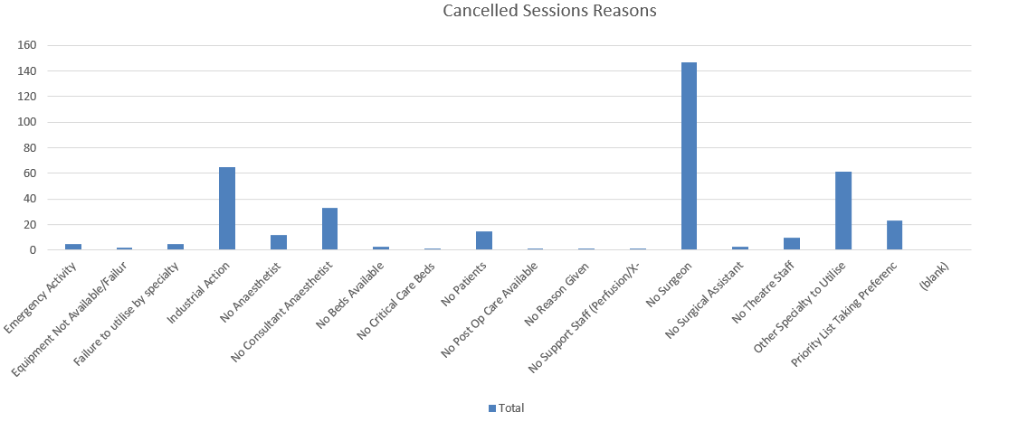

Below table shows the cancellation reasons for the for the years 2019/2020 and 2022/2023

Top 5 reasons for cancellations | 19/20 |  | 22/23
No Surgeon | 53% | No Surgeon | 58%
No Reason Given | 12% | Priority List Taking Preference | 27%
No Anaesthetist | 16% | Other Specialty to Utilise | 4%
No Theatre Staff | 5% | Audit | 4%
Other | 15% | Other | 8%

- Theatre comparison: 2019/2020 and 2022/2023 sessions per week
A thorough and comprehensive analysis was undertaken to evaluate the theatre programmes of 2019/2020 baseline activity in comparison to the present sessions. The objective was to effectively showcase the progress made on achieving an increase in funded activity. This ongoing recovery effort is illustrated in the subsequent table below.

The analysis delves into the distribution of lists between emergency and elective weekly sessions. Additionally, it highlights a crucial aspect of the recovery process: the reinstatement of 26 lists that were initially affected by the impact of COVID. In response to this challenge, these lists were strategically reallocated to various specialities as part of the clinical prioritisation which was integral to our recovery initiative.

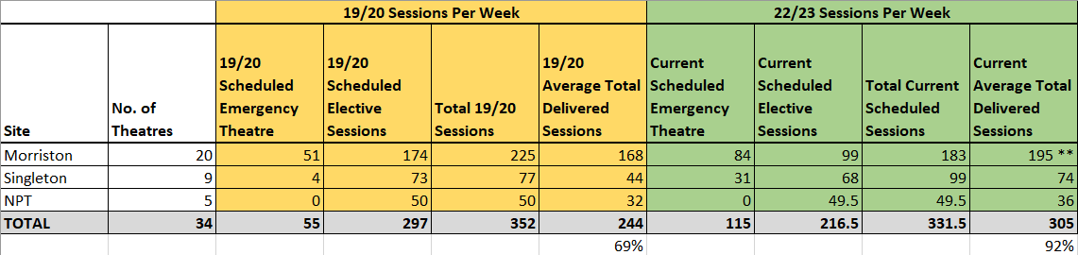

The aforementioned comparison yields the following insights:

2019/2020
- Scheduled Sessions 352
- Delivered Sessions: 69% (244) across all sites.

2022/2023
- Scheduled Sessions: 331.5
- Delivered Sessions: 92% (305) across all sites.

The data present the following observations:
- Higher Delivered Sessions: The current schedule 2022/2023 has resulted in higher number of sessions being delivered compared to the year 2019/2020.
- Increased Unscheduled Sessions: Notably, more unscheduled sessions were provided at Morriston and Singleton Hospital during 2022/2023 than in 2019/2020.
This data underscores our ongoing commitment to optimising theatre operations by adapting and effectively utilising available resources.

- New Theatre Developments
In tandem with the core theatre allocation previously outlined, several theatre developments have been earmarked for the fiscal year 2022/2023. These initiatives are detailed in the accompanying table below, complete with a RAG (Red-Amber-Green) status denoting their current delivery state and funding status. Importantly, this chart also conveys the extent of recruitment needed to support these programs.
Recruitment is progressing through various implementation phases, addressing the requirements of both the theatre and anaesthetic teams. It's worth noting that the estimated costs associated with these developments are subject to further refinement as we continue to delve into the intricacies of non-pay elements that are integral to these projects.

The prioritization of these initiatives is of paramount importance. By carefully determining their implementation order, we enable the theatre team to effectively allocate newly recruited staff while staying well within our available financial resources.

In addition to these developments, further supportive activity has been scheduled:

- 3 additional sessions for pancreatic lists since January 2023
- 6 extra sessions for orthoplastic lists from November 2022
- Introduction of a 3rd DSU theatre for ophthalmology at Singleton
- 2 added sessions for paediatric plastic lists since February 2023
- 2 more sessions for bariatric lists in Singleton since January 2023
- Implementation of 1.5 sessions for plastics (SNB) in NPT since January 2023
- Inclusion of 1 session for colorectal surgery at Singleton since January 2023
- Addition of 2 sessions for colorectal lists at Morriston from end of May 2023
- A 3rd session appended to an existing colorectal list, restructured as pelvic oncology since end of May 2023
- Alternate Tuesdays reintroduction of EAR (Endovascular Aneurysm Repair) since January 2023
- Utilization of an additional 3rd session fortnightly for OMFS/Max fax

Crucially, it should be noted that each additional list aligning with health board directives have been undertaken at ADH (additional Duty Hours) Anaesthetics rates.
This applies in conjunction with addressing the 674 session deficit in core sessions.

This dual approach is representative of our commitment to providing comprehensive healthcare services while strategically optimizing our resources.

6- Workforce overview: 2019/2020 to 2022/2023
This section provides comprehensive insight into the workforce dynamics from 2019/2020 to 2022/2023. It also highlights the strategic measures implemented to mitigate vacancies and address staff unavailability, ensuring seamless support for the theatre programme. This assessment encompasses both theatre and anaesthetic perspectives. Through this section, we aim to provide a clear picture of our workforce strategies and their impact on optimising theatre operations.

Additional Requests and Progress Overview:
The following points highlight the ongoing developments, their statuses, and associated progress:

- Ophthalmology (not fully funded): This development is successfully concluded with 2 anaesthetists and 9 theatre staff recruited. Funding review is underway to ensure all costs are secured. Estimated recurring funding gap is £951k without premium staffing and £1.4m with premium staffing.
- Enhanced Recovery Unit (partially funded): Completed with 4 consultant anaesthetists job planned to provide cover from Jan '23. Backfill costs for redirection of sessions amount to 1 WTE. Ongoing communication with Singleton colleagues to resolve related matters.
- Orthoplastic List (not fully funded): A necessity for major trauma provision. Introduction prior to orthopaedic and anaesthetic recruitment resulted in premium costs above agreed levels. Addressing unsustainable £25.5k/week pressure. Scrub agency may be phased out by October 2023 with staff induction completion and returns from maternity leave.
- Elective Orthopaedic Unit (funded): Managed separately, fully funded. Recruiting anaesthetic and orthopaedic trained staff is challenging, particularly when other developments like Orthoplastics also require such skilled personnel.
- 10 Emergency Sessions in Morriston (unfunded): Acknowledging increased unscheduled lists need, primarily on weekends, lost since 19/20 baseline. Requires additional workforce and anaesthetic sessions. Estimated additional cost: £676k (base rates) or £1m (premium and ADH payments).
- Morriston Only 3-Session Colorectal List (to be funded): Agreement to enhance colorectal lists due to patient waiting lists. A 3rd session added to an existing 2-session list for pelvic oncology since May '23. Funding approved by Deputy Chief Operating Officer. Estimated cost: £92k or £116k (premium rates).
- Morriston Only 3-Session Pancreatic List (unfunded): Acknowledged need to expand lists for complex pancreatic surgeries. List established since January '23, new staff and honorary contract for CTM anaesthetist. Estimated cost: £187k or £303k (premium costs).
- Morriston Only 2-Session Plastics (Breast List) (unfunded): New starters allocated to plastics hub, scheduled since June '23. New/upcoming posts will have anaesthetic sessions currently covered adhoc with ADH. Estimated cost: £151k or £256k (premium costs).

These developments reflect our commitment to enhancing our healthcare services.

6.1 Theatre Workforce Analysis
In comparing budget allocation and staffing composition within the theatre teams for the years 2019/2020 and 2022/2023, certain noteworthy trends emerge.

Budget Trends: There is an increment in the overall budget allocation which encompasses managerial clinical positions within the establishment. However, it underscores the necessity to reassess budget allocation by site, particularly in light of recurrent new developments.

Vacancy Reduction: We have successfully filled 24 positions, with individuals having been assigned start dates. Importantly, there has been a significant decrease in the number of unfilled positions. This decrease reflects our dedicated endeavours to strengthen the workforce and enhance the efficiency of theatre operations.

Series of measures and initiatives are in place to ensure continued progress and effective management:

- Regular Financial and Nursing-led Reviews: The commitment to monitoring the financial aspects and nursing workforce is exemplified by the weekly reviews conducted in collaboration with colleagues. These reviews serve as crucial checkpoints, aiding in maintaining financial stability and workforce efficiency.
- Current Staff Composition: As of August 2023, the collective service groups across various bands comprise a total of 27.68 Whole Time Equivalent (WTE) staff. This diversified composition reflects the diverse skill sets and roles contributing to the success of the theatre teams.
- Vacancies and New Staff: The workforce landscape includes 24.70 WTE vacancies primarily within band 5 nurse / Operating Department Practitioner (ODP) positions. Of these, 15 new staff members are students, while 6 are staff members who were recruited internationally.
- Induction Progress: Additionally, the induction period for 8 internationally recruited staff members is expected to conclude within the next 8-12 weeks. This milestone marks the integration of new talent into the existing workforce and signifies the continuous growth of our team.

In conclusion, the dynamic shifts in budget allocation, reduced vacancies, and strategic workforce optimization efforts have culminated in a robust foundation for the theatre teams. The commitment to regular reviews, diverse staffing strategies, and ongoing induction processes ensure a trajectory of sustained progress and operational excellence

6.2 Anaesthetic Workforce Assessment
 | Funded establishment | Staff in post | Vacancies
SBHB | 74.55 | 68.30 | -5.45
Total | 74.55 | 68.30 | -5.45

The workforce gap stands at 5.45 WTE positions. The expansion of Neath Port Talbot theatres necessitates the presence of 14.1 consultant anaesthetists. Collective workforce required is just under 20 WTE. It is pertinent to note that this requirement accounts for various appointments including 2 Senior Clinical Fellows for NPT, 1 consultant returning from career break and 3 locum appointments. These appointments will be allocated within the NPT setting.
Currently, the Consultant Anaesthetist workforce facilitates the provision of 229 theatre sessions per week for 50 weeks in a year (equivalent to 260.6 sessions when accounting for non-consultant career grades). In contrast, the present theatre schedule mandates anaesthetic coverage for 328 sessions per week (out of a total of 338 sessions, considering 10 sessions at DSU Singleton covered by 2 doctors across 3 lists). This discrepancy highlights a shortage of around 67.4 sessions per week necessary to uphold the core theatre template.

Recruitment efforts to address the 5.45 WTE vacancies are ongoing. Upon successful completion of these recruitment, the anaesthetic workforce would still face a deficit of approximately 35 sessions per week for scheduled sessions. This analysis highlights the significance of ongoing recruitment initiatives to enhance the anaesthetic workforce and align with the demands of our theatre programs. It also emphasizes the proactive approach taken to strategically allocate resources, ensuring optimal theatre operations and quality patient care.

6.3 Recruitment Initiatives
We have been diligently engaged in active and ongoing recruitment efforts aimed at mitigating the existing vacancy factor within our workforce. Notably, these endeavours have yielded significant successes. We have achieved remarkable outcomes in terms of reducing vacancies. Over the past year, a total of 165 theatre staff members have been successfully recruited, underscoring the effectiveness of our recruitment strategies.
TOTAL RECRUITED 165
 | NPT | MDU | SDU / DU | TOTAL
STARTED | 20 | 51 | 34 | 105
WAITING START DATES | 21 | 13 | 8 | 42
WITHDRAWN | 9 | 9 | 0 | 18
TOTAL PER SITE | 50 | 73 | 42 | 165

Summary and Conclusion
The data presented in this analysis showcases consistent year-on-year enhancements in theatre utilisation, capacity, and overall productivity. Proactive measures, including vigorous recruitment, have been implemented to counteract deficits and confront the challenges within theatre and anaesthetic recruitment.

Explorations into alternative avenues have been undertaken to address shortages, particularly within the anaesthetic cohort, and visa entry restrictions for international nurses have added complexity to the recruitment landscape.

Challenges like trade union strikes have also impacted theatre activity, contributing to the variations observed in the information presented above.

The development of comprehensive data and theatre dashboard has been undertaken. This has empowered us with visibility and transparency into theatre activity, especially in cases where activity has been lost. This newfound insight enables us to share critical data with stakeholders, which is pivotal for achieving sustained theatre productivity.

This comprehensive analysis not only highlights the progress achieved but also underscores the importance of strategic planning, recruitment, and the utilization of data-driven insights to navigate the dynamic healthcare landscape successfully.

- Next steps
We are committed to driving forward our theatre operations by implementing the following key steps and actions:

- Enhance Monthly Activity: Our primary goal is to maintain and increase our monthly activity figures by effectively leveraging our theatre capacity.
- Speciality-Focused Meetings: Speciality-focused meetings will be a focal point, involving all stakeholders who play a pivotal role in theatre delivery. Their insights and collaboration will be vital in refining our approach.
- Enhance Governance Structure post OCP: In light of the service group transition, a comprehensive Service Group review involving representatives from theatres, anaesthetics, and notably, surgical specialists, becomes imperative. The core focus of this review is to meticulously assess the reasons behind cancellations and take informed actions accordingly.
- Extend SBUHB Utilisation: Building upon the successes achieved in Neath Port Talbot, we aim to continue to improve utilisation across all three sites.
- Continued Development of Theatre Dashboard: We will persist in the development of our theatre dashboard, a powerful tool that will provide us with valuable insights into our performance. Sharing this data with stakeholders will foster transparency and accountability.
- Confidence in Measurement: It's essential to instil confidence in the accuracy of the data used for performance measurement. We will ensure that the information presented is reliable and aligned with our operational reality.
- Stakeholder Engagement: To make theatre performance a shared responsibility, we will offer easily navigable tools for stakeholders to access and understand our theatre performance metrics. This collective engagement will foster a culture of ownership.
- Internal Process Enhancement: We will continue to monitor and build upon our internal processes, such as theatre protocols and booking rules, which significantly influence and drive theatre efficiencies.
- Interdependence Focus: Recognizing the interdependence of services, we will place special emphasis on areas like HSDU functionalities to ensure seamless coordination across all aspects of theatre operations.
- Unavailability Scrutiny: By closely examining unavailability reports and meticulously scrutinizing rosters, we will proactively plan theatre staffing. This approach will be instrumental in optimizing theatre productivity.

In implementing these steps, we are committed to enhancing theatre operations, fostering collaboration, and continually striving for improved efficiency and effectiveness in our service delivery.

Governance and Assurance

Link to Enabling Objectives  (please choose) | Supporting better health and wellbeing by actively promoting and empowering people to live well in resilient communities
Link to Enabling Objectives  (please choose) | Partnerships for Improving Health and Wellbeing |  | ☐
Link to Enabling Objectives  (please choose) | Co-Production and Health Literacy |  | ☐
Link to Enabling Objectives  (please choose) | Digitally Enabled Health and Wellbeing |  | ☐
Link to Enabling Objectives  (please choose) | Deliver better care through excellent health and care services achieving the outcomes that matter most to people
Link to Enabling Objectives  (please choose) | Best Value Outcomes and High Quality Care |  | ☒
Link to Enabling Objectives  (please choose) | Partnerships for Care |  | ☐
Link to Enabling Objectives  (please choose) | Excellent Staff |  | ☐
Link to Enabling Objectives  (please choose) | Digitally Enabled Care |  | ☐
Link to Enabling Objectives  (please choose) | Outstanding Research, Innovation, Education and Learning |  | ☐
Health and Care Standards
(please choose) | Staying Healthy |  | ☐
(please choose) | Safe Care |  | ☒
(please choose) | Effective Care |  | ☒
(please choose) | Dignified Care |  | ☒
(please choose) | Timely Care |  | ☒
(please choose) | Individual Care |  | ☒
(please choose) | Staff and Resources |  | ☒
Quality, Safety and Patient Experience
- Timely and effective care: People of all ages to have timely access to admission for surgery. When arranged to have confidence in being admitted with the fill knowledge of the procedure and its implications as appropriate.
- Patient outcomes: to have outcomes comparable with the best in Europe.
Financial Implications
There are no additional financial implications identified as part of this report. However, efficient and effective utilisation of our theatre resources will deliver value for money from the Health Board in the use of its available and non-recurrent resources.
Legal Implications (including equality and diversity assessment)
There are no legal implications to consider.
Staffing Implications
To run an effective theatre service requires access to skilled theatre staff, surgeons and anaesthetists along with other key resources along the surgical pathway including referral from primary care, through to the outpatient clinic, Pre-Assessment and admission for surgery.
Long Term Implications (including the impact of the Well-being of Future Generations (Wales) Act 2015)
Optimizing theatre capacity across the Health Board will support an improved delivery against waiting time standards, whilst ensuring the effective deployment of resources reducing variation in cost and resources.
Report History |  | Theatre Performance report September 2020  Theatre Performance report November 2021  Theatre Performance report February 2022
Appendices |  | Nil

