

Meeting Date | 29th August 2023 |  | Agenda Item |  |  | 2.1
Report Title | Financial Report – Period 04 2023/24
Report Author | Samantha Moss, Deputy Director of Finance  Crystal Davies, Principal Finance Manager
Report Sponsor | Darren Griffiths, Director of Finance and Performance
Presented by | Darren Griffiths, Director of Finance and Performance
Freedom of Information | Open
Purpose of the Report | The report advises the Performance & Finance Committee of the Health Board on the financial position for Period 04 (July 2023) 2023/24 and sets out the current forecast revenue year end outturn.
Key Issues | The report invites the Performance & Finance Committee to note the detailed analysis of the financial position for Period 04 (July 2023) 2023/24.  The report includes a summary of the key drives of the position either at Service level or by expenditure type (i.e. Non Pay / Pay). It also provides information of the current position with regard to Health Board reserves to ensure transparency in the overall Health Board position. Risks remain unchanged at this point.
Specific Action Required  (please choose one only) | Information | Discussion |  | Assurance | Approval
Specific Action Required  (please choose one only) | ☐ | ☐ |  | ☒ | ☐
Recommendations | Members are asked to:  - NOTE the agreed 2023/24 financial plan.  - Consider and comment upon the Board’s financial performance for Period 04 2023/24.  - NOTE the actions to ensure delivery of the financial forecast with a specific focus on savings delivery: -  - Enhanced monitoring meetings in place above standard Finance & Performance Meetings to oversee and agree actions to mitigate run rates and deliver savings. Morriston / NPTS Service Group Directors  - Focused attention to ensure that 100% of the schemes are identified at the end of Q1 23/24. All Service Group Directors and Corporate Directors  - Focused attention to ensure that 100% of the schemes identified at the end of Q1 are green and amber by the end of Q2 23/24. All Service Group Directors and Corporate Directors  - Where savings delivery is not on track there will be further meetings with the Director of Finance and CEO at the end of Q1 and Q2. All Service Group Directors and Corporate Directors  - NOTE actions to ensure the operational pressures are mitigated and areas return to financial balance.  - Enhanced monitoring meetings in place above standard Finance & Performance Meetings to oversee and agree actions to mitigate run rates and deliver savings. Morriston / NPTS Service Group Directors  - External assessment of opportunities to mitigate pressures via the Grant Thornton post-AMSR assessment. All NPTS Service Group Director & COO  - Embed and deliver opportunities identified via two Independent Financial support provided to the Service Group to review run rate and savings. Morriston Service Group Directors and Corporate Directors  - NOTE the risks position at Month 4.  - NOTE the position with regard to Health Board Reserves  - NOTE all actions and updates to support the management of the 2023/24 financial position.

FINANCIAL REPORT – PERIOD 04

- SUMMARY OF REVENUE PERFORMANCE

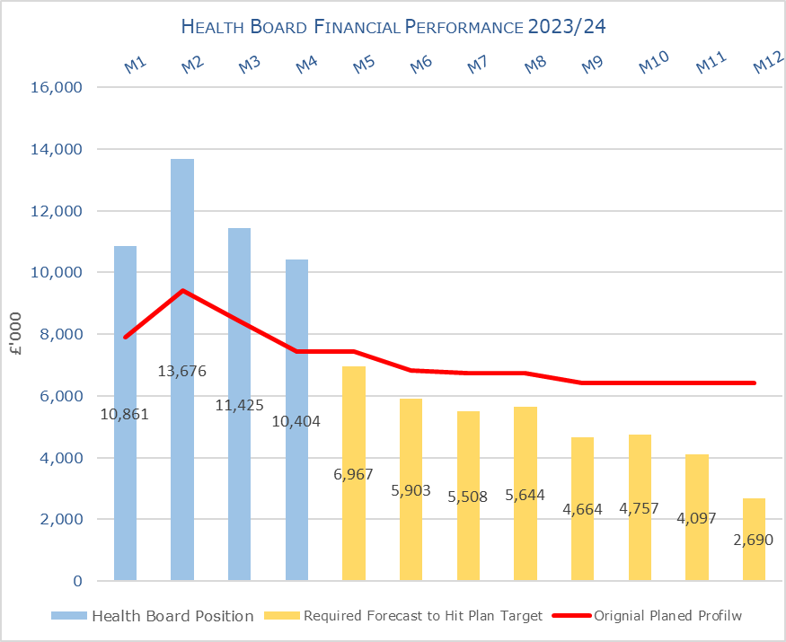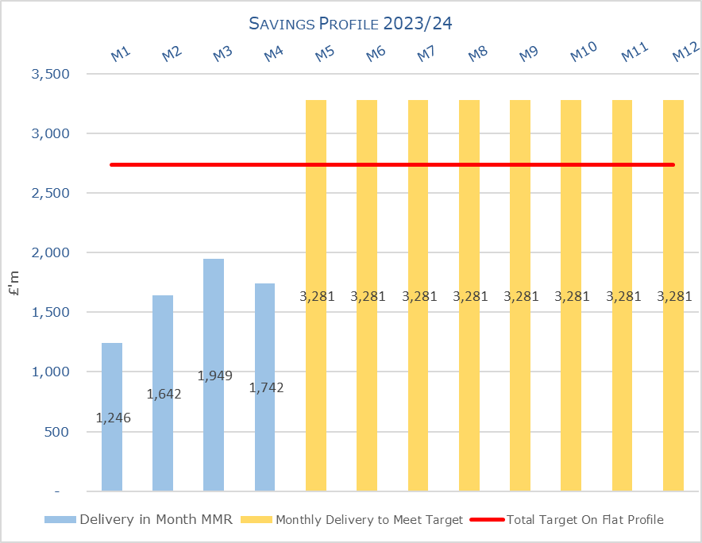

Target | In Month  £M | Year To Date (YTD)  £M
Delivery Against Revenue Resource Limit (RRL) DEFICIT / (SURPLUS) | 10.404 | 46.365
Delivery Against Financial Plan DEFICIT / (SURPLUS) | 2.98 | 13.18
Delivery Against Total Savings Target In Ledger DEFICIT / (SURPLUS) | 0.436 | 3.870

- FINANCIAL PLAN 2023/24
The Health Board (HB) developed and submitted a draft 3-year plan at the end of March 2023 showing an anticipated deficit of £69.9m. Following a further review in May 2023 the plan was updated to reflect the following changes: -

- Removal of income assumptions regarding COVID;
- Reduction in the energy assumptions by £3m;
- Reduction in cost pressure linked to disaggregation of an SLA with CTMUHB, which is delayed until 2024/25.
- Re-assessment of all risks to de-risk the plan.

The revised plan at 31st May 2023 reported a deficit of £86.6m.

Table 1: Financial Plan 2023/24
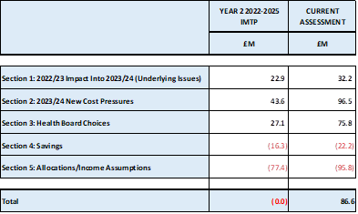

Key assumptions underpinning the plan:
- No unmet b/f savings from 2022/23 = £0m
- Run rate to remain within the envelop provided = £11m
- Savings requirement = £22.2m
- No COVID Response income = £21.2m

- KEY PERFORMANCE AREAS

Performance is summarised from two different perspectives. Section 3.1 provides the reported position by Service Group/Directors and section 3.2 onwards looks at the reported positon from the components of the ledger i.e. Income, Pay and Non Pay.

  - Summary By Service Area

Table 2 – Summary by Service Area

Key points of notes by type spent:
- Income
The WHSCC Income in Month 3 was unachieved by £0.531m but improved performance relating to WHSSC activity resulted in the income improving and the variance reduced to £0.147m in Month 4, but still remains at £1.3m YTD.
As reported for the previous 3 months of 2023/24 the pressure as a result in the loss of Dental Contract Income continues, with the YTD shortfall increasing to £0.659m.

- Pay
The Month 4 pay was overspent by £2.5m taking the YTD overspend to £7.4m Total Variable Pay remained static and in line with Month 3 reported position, although there were movements between the categorises of Variable Pay, with the reduction in Agency costs seen in table B2 offset by increases in Bank and Overtime. There was also a small increase in the actual WTE in Month 4 of 90, which is a mix of registered nursing and additional clinical services staff. In the last 3 of the 4 months of 2023/24 staff have received pay arrears linked to the 1.5% pay award, Recovery pay award and the 5% pay award, which make monitoring trends on an actual basis difficult.

Therefore, the Health Board clearly needs to address both the underlying run rate issue and the continued spend on variable pay, which is driving the in-month pay variance.

- Clinical Consumables
This area continues to be a significant pressure. There are 80+ subjective lines within this category including secondary care drugs but areas seeing most pressures YTD continue to be blood products, general consumables (M&SE) and laboratory products.

- Prescribing
At this point in the year, the Health Board has yet to receive any data with regard to Prescribing. However an in month overspend of £0.5m has been included to reflect the potential likely impact of recurrent impact of No Cheaper Stock Obtainable (NCSOs) and other growth pressures seen in 2022/23. However work on this will be required during Q2 once a number of months of 2023/24 data has been received.

- Non Delivery Savings
The Health Board has set a 3.5% savings target for 2023/24, after two years of achieving 4%. In additional there is a further £10.6m of unmet recurrent savings b/f from 2022/23. However there remains a gap in the delivery of savings to meet the target sets which has resulted in a £0.4m variance in Month 4 and £3.9m YTD, however the in-month gap is reducing month on month. (Savings are covered in more detail later in this report)

Key points of notes by Service Area:

- Morriston
The key variances:
  - Income = Month 4 £0.07m variance and YTD £1.41m driven by WHSSC performance. Plans are being developed to recover this via the Enhanced Monitoring meetings.
  - Pay = Month 4 £1.9m variance and YTD £6.38m, with average spend of £3.5m on variable pay.
  - Non Pay (exc Savings) = Month 4 £0.8m variance and YTD £3.1m of which £0.6m relates to clinical supplies and general consumables
  - Savings = Month 4 £0.784m variance and YTD £3.538m

- Neath Port Talbot Singleton (NPTS)
The key variances:
  - Income = Month 4 £0.018m variance and YTD £0.3m driven by loss of Private Patient income
  - Pay = Month 4 £0.78m (overspend) variance and YTD £1.4m,
  - Non Pay (exc Savings) = Month 4 £0.67m variance and YTD £1.4m which relates to clinical supplies and primary care prescribing.
  - Savings = Month 4 £0.3m over achieved and YTD £0.3m under achieved.

Key Actions being undertaken:
The Month 1-3 reports detailed the actions being driven by the Health Board to mitigate the planned deficit and the risks. Updates or additional actions above those reported in previous months are captured below: -

- Enhanced Monitoring – both NPTS Service Group and the Morriston Service Group remain in enhanced monitoring with the weekly meetings continuing chaired by the CEO. The output of this focus is contributing to the slowing down of both the Morriston and NPTS Service Group overspend rate as whilst there variance to plan did not change between Month 3 and Month 4, the overall variance of the Health Board reduced from £11.4m to £10.4m.
- Additional Support – in Month 2 and 3 it was reported that the Health Board would provide additional support from Finance Business Partner perspective into Morriston and NPTS Service Group. Given the need to provide more support to the Service Areas linked to the ongoing enhanced monitoring detailed above 3 additional band 5 staff will be recruited into the Operational Finance Team.

  - Summary Income

Table 3 – Income by month

  - Summary Pay

Table 4 – Pay Variance by month

Note – movement between Mth 2 and 3 budget relates to the one-off funding for the Recovery pay award and changes to the budget profiling linked to year-end accruals for Leave, Overtime and Time owing.

Table 5 – Variable Pay by month

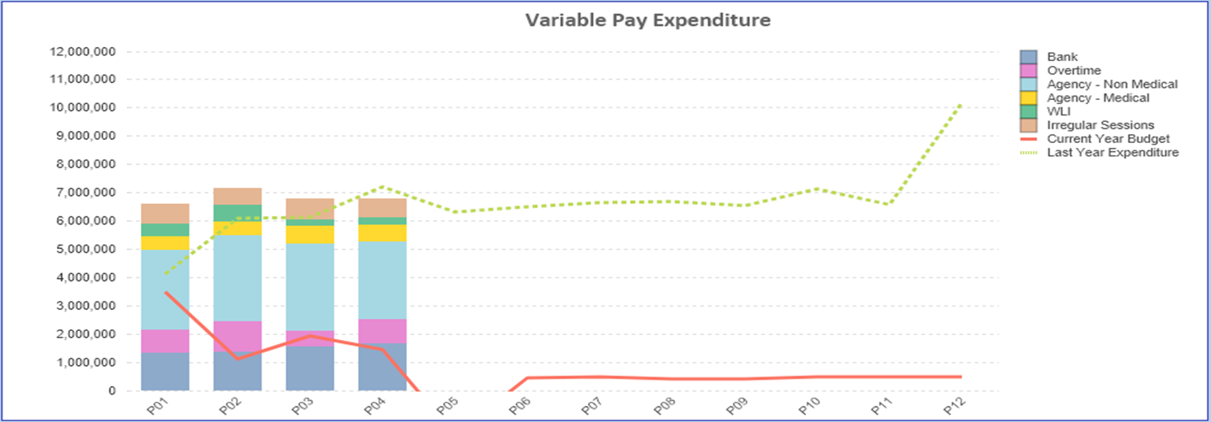

  - Summary Non Pay

Table 6 – Non Pay Variance by month

Note – movement between Mth 2 and 3 budget relates to the one-off adjustment for Losses, which is normally reflected at year end only and so had to be adjustment between months.

Below are further details on the keys areas of Non Pay (excluding savings which is addressed in Section 4):

    - Clinical Consumables
Clinical supplies and services were overspent YTD by £2.8m at the end of Month 4. Within the 80+ subjective lines within this category including secondary care drugs but areas seeing most pressures YTD continue to be blood products, general consumables (M&SE) and laboratory products.

    - Utilities
There were underspends in Gas of £24.6k in month 4, along with underspends in Electricity of £6k across the Service Groups and Corporate Directorates. Since 1st June 2023 the Health Board has received 2 forecasts from British Gas only and 1 forecast combining British Gas and CCS. The forecast is increasing each time from £13.2m in early June 2023 to the latest version of £14.5m from early August 2023. There are some key issues the Health Board needs to work through before assessing the true impact on the delivery of the plan and these include:
  - Level of usage built in and whether the reduced demand from the Morriston site as a result of the solar farm has been reflected correctly;
  - What the actual bills have been from Q1 compared to the forecast provided;
  - Both points above build on the lessons learnt from 2022/23 where the forecast provided by British Gas and the actual costs were materially different.

    - CHC

Table 7 – CHC Analysis By Month

(Please note: PCT Group does not include the Singleton/NPT element - which covers Children and Young People as this is provided internally by the HB).

The variance against budget for CHC is an underspend of £0.024m in month reflecting the additional funding allocated to CHC through the financial plan.

    - Prescribing
Whilst the first month of actual costs for 2023/24 is available it will not be until the end of Aug/September 2023 when a number of months of data is available before a true picture of the prescribing position can be determined for 2023/24. However at this point the forecast is to remain within the £3.2m pressure currently reflected within the in month positions.

    - LTA Performance
Full details on performance on LTA will not be available until later in Q2. Board to note that as part of the All Wales agreement for 2023/24 tolerances on contracts have reduced from 10% to 5%.

- SAVINGS SUMMARY
Based on the report from 7th August 2023, the schemes identified for delivery in 2023/24 by service areas are summarised below:

Table 8a In Year Performance Against 2023/24 Requirements

Table 8b Recurrent Performance Against 2023/24 Requirements

- SUMMARY RESERVES
Overall management of the reserves is as per the Health Board Budget Management document, which is aligned to the principles outlined in the Financial Plan documentation approved by Board (March 2023) and PFC (April 2023.)

  - Balances Main & NICE
For 2023/24, the Health Board will hold two central reserves and the purpose of these reserves are below: -

- Main – this holds funding from WG or the plan that has yet to be issued to Budget Holders. These items are not surplus but either due to timing have not been issued or is an area where funding is issued based on actual values consumed in future month.
- NICE – this holds the total Health Board funding for all of NICE costs (drugs and infrastructure) and is issued to the service each month based on the actual costs consumed as reported through the Pharmacy system.

Details on the balances and movements are provided in the Table below:

Table 9; Summary Main & NICE Reserves

  - COVID Recovery Summary
As part of the Financial Plan £22.9m was set aside to support COVID Recovery (excluding Regional Investments). The £22.9m was funded through £15.2m from WG Annual Allocation letter issued in December 2023, and an additional £7.7m of Health Board discretionary revenue funding. The funding remains in Central Reserves, as recorded in Table 9. This funding is then issued to service areas based on the actuals costs committed. A summary of the actuals to date and forecast costs against the £22.9m is summarised in the table below

Table 10: Summary Local COVID Recovery £22.9m

  - Changes to Deficit
The Board supported a £86.6m deficit plan. The deficit is held centrally with an element reflected each month in the reported performance against RRL (see Section 3.4 on Non-Pay) on a tapered basis, as previously agreed with the Board.

The Budgetary management process for 2023/24 stated that where the Board agreed additional investment, this could only be funded by increasing the deficit plan. Therefore, a table will be included within this paper each month showing the opening deficit plan figure and the changes made within the financial year to arrive at the current deficit held centrally. This is summarised in the below:

- RISK ASSESSMENT
Two Board level financial risks: -

- Achieving financial plan (HBR92), with the key elements as follows: -

  - Risk of delivery of savings quantum
  - Risk of operational overspend being in excess of funding available agreed via the Financial Plan
  - Risk of commitment of reserves (e.g. NICE) being above reserves available.

A score of 20 remains at this stage given the assessed financial risks the Health Board is facing the performance against RRL reported. As discussed in the Performance and Finance Committee meeting in July this will remain 20 pending a full assessment of the non-recurrent opportunities available and the outputs from the Enhanced Monitoring meetings currently in place.

The individual elements of the risk behind this score are provided in detail below and reflect the information reported to WG in the month 4 MMR and is aligned to the risks recognised as part of the signed of plan at the end of May 2023:

The £25m reflects the risks regarding the two Service Groups in enhanced monitoring. Morriston Service Group reporting a risk of £16.2m and the NPTS Service Group reporting a risk of £8.7m, which has reduced from £10.2m noted in the July report. This table will be updated at month 5 to show the further impact of the risk mitigation.

- Availability of capital (HBR93). This risk was re-opened in 2022/23 given the reduction in discretionary capital allocation. Whilst work is underway to manage schemes to reduce commitments in 2023/24 and to produce a balanced plan, the risk varies during the year as more details on schemes emerge and potential slippage funding is made available by Welsh Government. A score of 20 is suggested at this stage as whilst the plan is now balanced, a number of schemes are on hold and the flexibility within the plan is extremely limited given the reduction in the allocation. A paper on the capital resource plan was provided to the Performance & Finance Committee in July 2023.

- RECOMMENDATIONS
Members are asked to:
- NOTE the agreed 2023/24 financial plan.
- Consider and comment upon the Board’s financial performance for Period 04 2023/24.
- NOTE the actions to ensure delivery of the financial forecast with a specific focus on savings delivery: -
- Enhanced monitoring meetings in place above standard Finance & Performance Meetings to oversee and agree actions to mitigate run rates and deliver savings. Morriston / NPTS Service Group Directors
- Focused attention to ensure that 100% of the schemes are identified at the end of Q1 23/24. All Service Group Directors and Corporate Directors
- Focused attention to ensure that 100% of the schemes identified at the end of Q1 are green and amber by the end of Q2 23/24. All Service Group Directors and Corporate Directors
- Where savings delivery is not on track there will be further meetings with the Director of Finance and CEO at the end of Q1 and Q2. All Service Group Directors and Corporate Directors
- NOTE actions to ensure the operational pressures are mitigated and areas return to financial balance.
- Enhanced monitoring meetings in place above standard Finance & Performance Meetings to oversee and agree actions to mitigate run rates and deliver savings. Morriston / NPTS Service Group Directors
- External assessment of opportunities to mitigate pressures via the Grant Thornton post-AMSR assessment. All NPTS Service Group Director & COO
- Embed and deliver opportunities identified via two Independent Financial support provided to the Service Group to review run rate and savings. Morriston Service Group Directors and Corporate Directors
- NOTE the risks position at Month 4.
- NOTE the position with regard to Health Board Reserves
- NOTE all actions and updates to support the management of the 2023/24 financial position.

Governance and Assurance

Link to Enabling Objectives  (please choose) | Supporting better health and wellbeing by actively promoting and empowering people to live well in resilient communities
Link to Enabling Objectives  (please choose) | Partnerships for Improving Health and Wellbeing |  | ☐
Link to Enabling Objectives  (please choose) | Co-Production and Health Literacy |  | ☐
Link to Enabling Objectives  (please choose) | Digitally Enabled Health and Wellbeing |  | ☐
Link to Enabling Objectives  (please choose) | Deliver better care through excellent health and care services achieving the outcomes that matter most to people
Link to Enabling Objectives  (please choose) | Best Value Outcomes and High Quality Care |  | ☒
Link to Enabling Objectives  (please choose) | Partnerships for Care |  | ☒
Link to Enabling Objectives  (please choose) | Excellent Staff |  | ☐
Link to Enabling Objectives  (please choose) | Digitally Enabled Care |  | ☐
Link to Enabling Objectives  (please choose) | Outstanding Research, Innovation, Education and Learning |  | ☐
Health and Care Standards
(please choose) | Staying Healthy |  | ☐
(please choose) | Safe Care |  | ☐
(please choose) | Effective Care |  | ☐
(please choose) | Dignified Care |  | ☐
(please choose) | Timely Care |  | ☐
(please choose) | Individual Care |  | ☐
(please choose) | Staff and Resources |  | ☒
Quality, Safety and Patient Experience
Financial Governance supports quality, safety and patient experience.

Financial Implications
The Board is reporting a year-end deficit financial outturn in 2023/24.

Legal Implications (including equality and diversity assessment)
No implications

Staffing Implications
No implications

Long Term Implications (including the impact of the Well-being of Future Generations (Wales) Act 2015)
No implications

Report History |  | Updates on the financial position are provided at every meeting
Appendices |  | none

