

HEALTH BOARD RISK REGISTER
March 2025

RISKS ASSIGNED TO THE
PERFORMANCE & FINANCE COMMITTEE

Datix ID Number: 738  Health & Care Standard: |  |  | HBR Ref Number: 1  Risk Target Date: 31/03/2025 |  | Current Risk Rating  5 x 5 = 25
Objective: Urgent & Emergency Care |  | BAF Ref: 2.4 | Director Lead: Deb Lewis, Chief Operating Officer  Assuring Committee: Performance & Finance Committee  For information: Quality & Safety Committee
Risk: Access to Unscheduled Care  If we fail to provide timely access to Unscheduled Care then this will have an impact on quality & safety of patient care as well as patient and family experience and achievement of targets. There are challenges with capacity/staffing across the Health and Social care sectors. (This risk includes ED, AMU and impact in community from ability to release ambulances at both front doors.) |  |  | Date last reviewed: March 2025
Risk Rating  (consequence x likelihood):  Initial: 4 x 5 = 20  Current: 5 x 5 = 25  Target: 3 x 4 =12 | 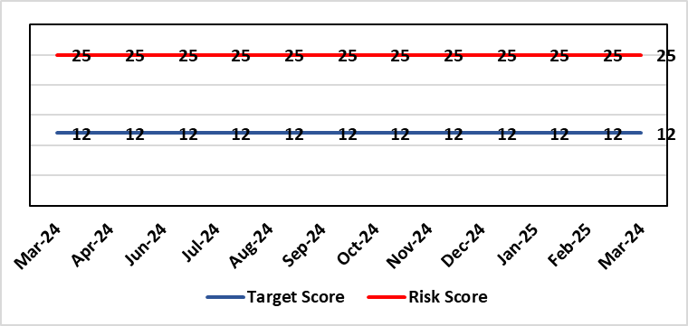 |  | Rationale for current score:  The UEC system continues to see high demand, with ambulance attendances in particular being higher than seen previously. This is coupled with reduced flow out of hospital beds due to an imbalance of acute / community / care service provision. These factors are resulting in unacceptable delays in patients accessing UEC services and therefore the risk score remains high.
Level of Control  = 50% |  |  | Rationale for target score:  The HB is currently under escalating performance monitoring from WG (Targeted Intervention or TI) for delivery of UEC services. The improvement plan developed as a response to TI and that already included in the HB annual plan is to implement models of care that reflect best practice and focus on areas that will benefit patients, staff and the UEC system most. The implementation of this plan will improve patient flow, length of stay and reduce emergency demand.
Date added to the HB risk register
26.01.16
Controls (What are we currently doing about the risk?) |  |  | Mitigating actions (What more should we do?)
Five main areas of work within the plan:  - Frailty strategy (already achieved: Older Persons Assessment & Short Stay Unit stood up; Hub stood up to triage/stream/capture outcomes from incoming calls; standard operating procedures developed for Short Stay, Assessment Unit, Neck of Femur Pathways/beds, and Hub; Phase 1 capital works completed)  - Grip & control operational management  - Senior decision makers at front door services  - Pathway of care delays (PoCD) Implementation of D2RA  - Home First  - ACT  - Interface with local authority  - Urgent & Emergency Care redesign programme linked to capital expansion scheme.  - Development of a UEC Care Co-ordination Hub to promote pre-hospital triage redirection and streaming.  In addition to BAU improvement actions:  - Continued focussed roll-out of 6-Goals schemes of work  - D2RA / Trusted assessor model  - SAFER  - Criteria-led discharge  - Continuous Flow Model (CFM)  - Robust SDEC model |  |  | Action | Lead |  | Deadline
 |  |  | Implementation of revised senior decision-making capacity within SDEC and AMU | GMD Morriston SG |  | 31/03/2025
 |  |  | Amended action: Review of community services being undertaken by SGNDs for PCT / Morriston to ensure return of investment ahead of expansion. | SGNDs (Morriston & PCT) |  | 31/06/2025
 |  |  | Implementation of UEC Navigation Hub to decrease demand and implement right patient right place process | COO |  | 31/03/2025
 |  |  | Focus on reducing pathway of care delays (PoCDs) as per the Care Action Committee 50-day Challenge | Associate SGD PCTS |  | 31/03/2025
 |  |  | Further develop admission avoidance pathways with WAST, focussing on Falls prevention and Respiratory conditions | Assistant Director Operations UEC |  | 31/03/2025
 |  |  | Reintroduce D2RA Principles across the Health Board with external consultancy support | Assistant Director of Operations UEC  Associate SGD PCTS |  | 28/06/2025
Assurances (How do we know if the things we are doing are having an impact?)  - Urgent & Emergency Care Board is meeting monthly chaired by the COO.  - Six Goals programme reviews the plan on a monthly basis  - UEC Redesign held 2-weekly to update on work streams  - UEC Summit meetings held x 2 with Executive Management Board – 3rd summit planned March 25.  - D2RA Executive meeting held Feb 25 – Memorandum of Understanding (MOU) re D2RA agreed. Operational workshop held Mar 25 with a plan to test D2RA principles pre-Easter weekend |  |  | Gaps in assurance (What additional assurances should we seek?)  The need to deliver sustained service.
Additional Comments / Progress Notes
01/04/2025: UEC Plan developed based on Six Goals. UEC Annual Plan agreed. Revised structure proposal being presented to UEC Programme Board 01/04/25.

Datix ID Number: 840  Health & Care Standard: |  |  | HBR Ref Number: 16  Risk Target Date: 31/03/2025 | Current Risk Rating  5 x 4 = 20
Objective: Planned Care |  | BAF Ref: 2.5 | Director Lead: Deb Lewis, Chief Operating Officer  Assuring Committee: Performance & Finance Committee  For information: Quality & Safety Committee
Risk: Access and Planned Care  There is a risk of harm to patients if we fail to diagnose and treat them in a timely way. |  |  | Date last reviewed: March 2025
Risk Rating  (consequence x likelihood):  Initial: 4 x 4 = 16  Current: 5 x 4 = 20  Target: 4 x 2 = 8 | 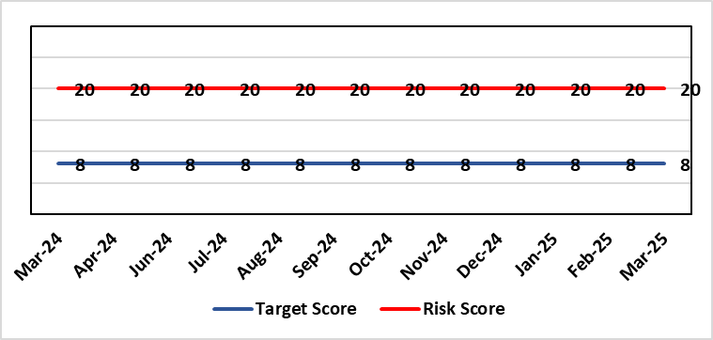 |  | Rationale for current score:  Whilst the HB has eradicated very long waits for surgery, patients are still waiting in excess of 104 weeks for surgical intervention, which is outside of national policy on RTT. The HB is currently under escalating performance monitoring from WG (Targeted Intervention or TI) for delivery of Planned Care services. The improvement plan developed as a response to TI mirrors that already included in the HB
Level of Control
= 90%
Level of Control  = 90% |  |  | Rationale for target score:  There is scope to reduce the likelihood score to reduce the overall risk to an acceptable level. The Risk target date indicates when we expect to see some reduction in waiting lists – albeit the overall risk level may remain as work continues.
Date added to the HB risk register
January 2013
Controls (What are we currently doing about the risk?) |  |  | Mitigating actions (What more should we do?)
- There is a bi-weekly Targeted Intervention (TI) meeting specifically for assurance on the recovery of our elective programme.  - Specialty level capacity and demand models set out the baseline capacity and identify solutions to bridge the gap this financial year.  - A focused intervention is in train to support to the 10 specialties with the longest waits.  - Long waiting patients are being outsourced to the Independent Sector, where appropriate  - Additional internal activity is being delivered on weekends (via insourcing), although this is currently at risk due to changes in policy pertaining to the payment of enhanced rates to A4C staff.  - Planned care trajectories were developed and submitted to WG.  - Governance process put in place to monitor performance against trajectories internally, and with Welsh Government as part of Targeted Intervention.  - External & internal validation continues.  - All long waiting patients are receiving clinical reviews to ascertain continued need for surgery. |  |  | Action |  | Lead | Deadline
 |  |  | Theatre Optimisation Programme now in place to maximise efficient use of theatre capacity |  | NPTSSG SGD | 31/03/2025
Assurances (How do we know if the things we are doing are having an impact?)  - TI dashboard developed to monitor performance in a live state  - Weekly TI monitoring meetings chaired by the COO  - Bi-weekly planned care meetings chaired by the COO  - Monthly TI monitoring meetings with WG |  |  | Gaps in assurance (What additional assurances should we seek?)
Additional Comments / Progress Notes
11/03/2025: The Health Board is on track to achieve the Ministerial target by end of March 2025.

Datix ID Number: 1761  Health & Care Standard: |  |  | HBR Ref Number: 50  Risk Target Date: 31/03/2025 | Current Risk Rating  5 x 5 = 25
Objective: Cancer Care |  | BAF Ref: 2.6 | Director Lead: Deb Lewis, Chief Operating Officer  Assuring Committee: Performance & Finance Committee  For information: Quality & Safety Committee
Risk: Access to Cancer Services  There is a risk of delay in diagnosing patients with cancer, and consequent delay in commencement of treatment, which could lead to poor patient outcomes and failure to achieve targets.  The HB remains unable to deliver on the target of 75% of patients being treated within 62 days and is currently under targeted intervention by WG to improve performance. The HB has been given an initial target of 60% to be delivered by the end of Dec 2024, increasing to 70% by the end of March 2025. |  |  | Date last reviewed: March 2025
Risk Rating  (consequence x likelihood):  Initial: 4 x 5 = 20  Current: 5 x 5 = 25  Target: 4 x 3 = 12 | 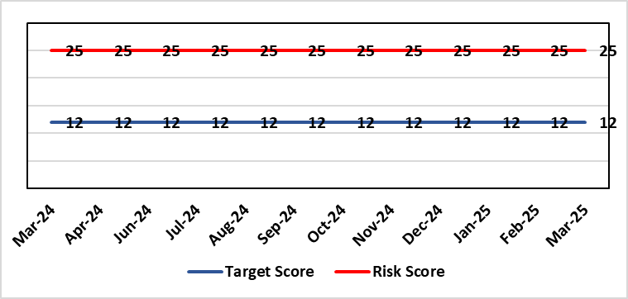 |  | Rationale for current score:  Risk score is based on being off trajectory for SCP.
Level of Control  = 70% |  |  | Rationale for target score:  Target score reflects the challenge this area of work present the Board and where small numbers of patients impact on the potential to breach target.
Date added to the HB risk register: April 2014
Controls (What are we currently doing about the risk?) |  |  | Mitigating actions (What more should we do?)
- Tight management processes to manage each individual case on the Single Cancer Pathway (SCP). Enhanced monitoring & weekly monitoring of action plans for top 6 tumour sites.  - Initiatives to protect surgical capacity to support SCPs have been put in place  - Tumour sites have been given additional targets to achieve by the end of Qtr1:  - Achieve the 10-day 1st Outpatient target  - Deliver a decision to treat (DTT) by day 31  - A specific plan is being delivered to support Pathology services and ensure SCP tests are turned around within 5 days. |  |  | Action |  | Lead | Deadline
 |  |  | Cancer Performance & Information Group to monitor improvement trajectories for both cancer backlog and SCP performance on a monthly basis |  | COO / Deputy MD | 31/03/2025
Assurances (How do we know if the things we are doing are having an impact?)  - TI dashboard developed to monitor performance in a live state  - Weekly TI monitoring meetings chaired by the COO  - Bi-weekly Cancer meetings chaired by the Dep COO  - Monthly TI monitoring meetings with WG |  |  | Gaps in assurance (What additional assurances should we seek?)  Performance and activity data monitored, but delays to treatment continue while sustainable solutions found.
Additional Comments / Progress Notes
20/01/2025: November performance was 66%, achieving the December 2024 performance target of 60% agreed with Welsh Government for patients treated within 62 days.
11/03/2025: Action complete: Specific focus on improvement in skin cancer performance

Datix ID Number: 1763  Health & Care Standard: |  |  | HBR Ref Number: 52  Risk Target Date: TBC |  | Current Risk Rating  4 x 4 = 16
Objective: People of Swansea Bay live healthier, equitable and more equal and prosperous lives |  | BAF Ref: 1 | Director Lead: Richard Thomas, Director of Communications and Engagement  Assuring Committee: Performance & Finance Committee
Risk: Impact Assessment Requirements  The Health Board does not have sufficient skills & resource in place to undertake integrated equality impact assessments in line with strategic service change and policy development. |  |  | Date last reviewed: March 2025
Risk Rating  (consequence x likelihood):  Initial: 4 x 4 = 16  Current: 4 x 4 = 16  Target: 4 x 2 = 8 | 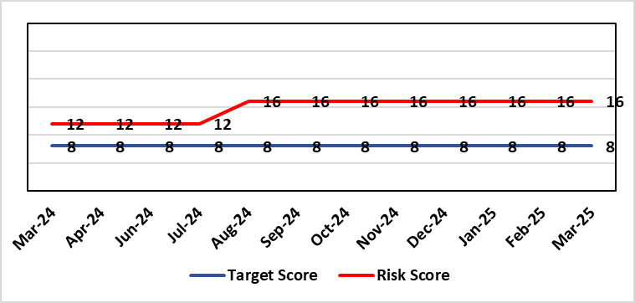 |  | Rationale for current score:  - Current lack of required skills / staff to deliver requirements.  - Judicial Review has been applied for in relation to EMRTS / Air Ambulance Changes which affects the Health Board, as part of the JCC decision-making process. This may indicate a rising likelihood of such challenges being launched in relation to other potential service changes.
Level of Control  = 50% |  |  | Rationale for target score:  - All of these areas need to have adequate resourcing and robust processes / policies in place for the organisation to make robust plans, engage public confidence and meet our statutory and public duties.
Date added to the HB risk register
November 2018
Controls (What are we currently doing about the risk?) |  |  | Mitigating actions (What more should we do?)
- Robust policies and processes to be in place for Impact Assessment going forward.  - EIA responsibilities incorporated into wider Impact Assessments.  - Development of Strategic Equality Group across organisation to support processes. |  |  | Action | Lead |  | Deadline
 |  |  | Appoint Head of Equality, Diversity & Belonging (EDB) – delayed in order to deliver savings via the vacancy suspension | Assistant Director of Insight, Engagement & Fundraising - DICE |  | 01/04/2025
 |  |  | Review of the current process for developing Equality Impact Assessments around service change, engagement and consultation. Progress slowed as delay in recruitment of Head of EDB. | Assistant Director of Insight, Engagement & Fundraising - DICE |  | 31/03/2025
 |  |  | Robust policies and processes to be in place for Impact Assessment going forward. | Assistant Director of Insight, Engagement & Fundraising - DICE |  | 31/03/2025  In progress
 |  |  | Roll out Impact Assessment process across organisation. | Assistant Director of Insight, Engagement & Fundraising - DICE |  | 30/06/2025
Assurances (How do we know if the things we are doing are having an impact?)  Advice on Equality Impact Assessment and then wider Impact Assessments available across organisation supported by robust policies and procedures, overseen by Strategic Equality Group. |  |  | Gaps in assurance (What additional assurances should we seek?)  Participation from across organisation in Strategic Equality Group.
Additional Comments / Progress Notes
12/03/2025: Risk reviewed. There has been no increase in the capacity for in engagement or impact assessment so the risk has not changed. We have a Head of EDB post funded in our budget and establishment but are unable to recruit to it because of the vacancy freeze. Action target refreshed.

Datix ID Number: 2522  Health & Care Standard: |  |  | HBR Ref Number: 75  Risk Target Date: TBC |  | Current Risk Rating  5 x 2 = 10
Objective: Care is high quality, safe, efficient, and delivers the best possible outcomes for people |  | BAF Ref: 2 | Director Lead: Deb Lewis, Chief Operating Officer  Assuring Committee: Performance & Finance Committee
Risk: Whole-Service Closure  Risk that services or facilities may not be able to function if there is a major incident or a rising tide that renders current service models unable to operate |  |  | Date last reviewed: March 2025
Risk Rating  (consequence x likelihood):  Initial: 5 x 4 = 20  Current: 5 x 2 = 10  Target: 5 x 1 = 5 | 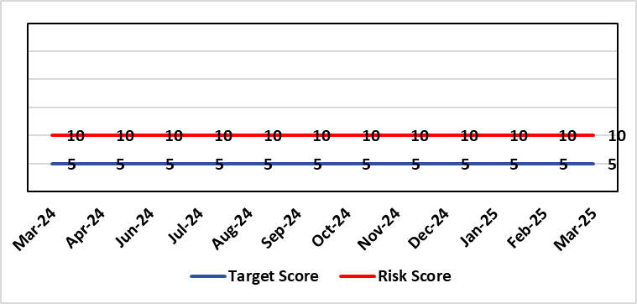 |  | Rationale for current score:  Risk reflects transition to business as usual as part of living with Covid strategy. BCP plans in place. There is still fluctuation in patient numbers and new variants continue to emerge so score maintained as watching brief.
Level of Control  = 25% |  |  | Rationale for target score:  The strategy of moving towards living with Covid will eventually lower the risk level to target.
Date added to the HB risk register
May 2021
Controls (What are we currently doing about the risk?) |  |  | Mitigating actions (What more should we do?)
- Sites have business continuity plans and the impact of one site being overwhelmed by COVID demand has been reviewed.  - Monitoring of associated risks has been being transferred to appropriate forums such as UEC Board, Elective Care Board and Nosocomial Group with overall oversight by Management Board.  - Ongoing surveillance of epidemiology data for early warning and further change to risk level via live Covid dashboard. |  |  | Action | Lead |  | Deadline
 |  |  | Periodic review of risk | COO |  | See Notes Below
Assurances (How do we know if the things we are doing are having an impact?)  Monitored via Management Board for early warning signs. |  |  | Gaps in assurance (What additional assurances should we seek?)
Additional Comments / Progress Notes

Datix ID Number: 3444  Health & Care Standard: |  |  | HBR Ref Number: 92  Risk Target Date: 31/03/2025 | Current Risk Rating  5 x 5 = 25
Objective: The health board is a resilient, financially sustainable and responsible organisation |  | BAF Ref: 6 | Director Lead: Darren Griffiths, Director of Finance and Performance  Assuring Committee: Performance & Finance Committee
Risk: Forecast Deficit  Forecast deficit is not met due to (1) insufficient progress on run rate reduction, (2) the extended saving targets required across all areas to meet the financial assessment submitted to WG on 26th September are not achieved, and (3) 30 other risks within the financial assessment are not mitigated. |  |  | Date last reviewed: March 2025
Risk Rating  (consequence x likelihood):  Initial: 5 x 4 = 20  Current: 5 x 5 = 25  Target: 5 x 1 = 5 | 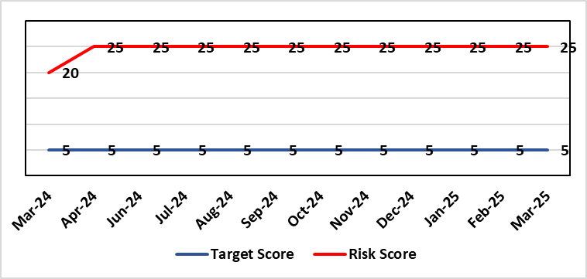 |  | Rationale for current score:  - Delivery of the deficit plan is predicated on a combination of savings and run rate reductions  - Consequence is significant as failure to deliver the plan could impact service delivery if cost reduction required later in the year  - A deficit plan is a failure to meet a statutory duty
Level of Control
= 25%
Date added to the risk register  June 2023 |  |  | Rationale for target score:  - The consequence will not change given the important of financial delivery and its relationship with the delivery of the Health Board recovery and sustainability plan  - Reducing likelihood to 1 supports a confidence that the deficit plan will be delivered.
Controls (What are we currently doing about the risk?) |  |  | Mitigating actions (What more should we do?)
The Health Board is doing the following:  - Enhanced governance arrangements in place from April 2024, including the submission of Financial Strategies from all Service Groups on 31st May 2024, which ultimately fed the financial assessment approved by Board on 25th September.  - From end June through to August, Service Areas have submitted options to address current pressures, which have been scrutinised through a number of Star Chamber meetings and via Executive Team. This links to the work required via the Accountability Letters issued in April 2024 and the submission of the Financial Strategies on 31st May 2024  - Financial plan was in place for 2024/25 alongside supporting documentation with regard to Budgetary Management, with further work being undertaken at the request of WG on revised financial assessment to be presented to the Board on 25th September. The initial plan set out the details on the Accountability Letters issued in April 2024, with further actions outlined in an email on 10th October following the submission of the financial assessment of WG and face-to-face discussions with the WG NHS Wales Director of Finance  - Publication of control targets on 10th October to all Service Areas for 2024/25 to provide additional controls in the process following the work on Star Chambers and associated options.  - Establishment of the Recovery and Sustainability (R&S) Team from July 2024 to support both immediate actions and longer term sustainability, with a Recovery & Sustainability Board overseeing the delivery, with its first meeting held on 21st October 2024. The R&S Board meet twice a month with a focus on the delivery of £43.7m deficit plan at 31st March 2025. This meeting is chaired by the CEO.  - Review of all controllable expenditure and directions issued via the R&S Team, including Variable Pay targets.  - Clear action requested directly from interim CEO from May onwards agreed at Management Board meetings and shared with all Staff via the CEO mid-week message.  - Further actions set by interim CEO in April and May for Executive Directors above Thematic programmes.  - Transparent exchange of position with NHS Executive & Welsh Government, with both weekly and monthly meetings with the NHS Executive, which will continue throughout 2024/25.  - Savings Programme Management Office (PMO) in place to support savings delivery. In July 2024, the PMO team expanded their remit to support the Recovery & Sustainability Programme  - Enhancing the national data in the Vault the PMO have developed a ‘Repository of opportunities, which went live in Q1. Updates and developments such as weekly reporting of drivers of expenditure, will be added throughout the year and communications on updates issued.  - Focus on efficiency of core resource to avoid spending premium cost resource  - Using the learning from publications like the Review of Cost Savings Arrangements published by Audit Wales in August 2024 to further enhanced existing systems and processes.  - Standard Day 5 Finance Reports on Variable Pay, Savings Performance and Flash report published via SharePoint site. |  |  | Action | Lead | Deadline
 |  |  | Continuation of financial performance meetings and escalation as necessary | Director of Finance & Performance | Will run until targets met
 |  |  | Develop robust cross system service change plans which improve quality of care and reduce system cost led by the R&S team. | Director of Finance & Performance and Chief Operating Officer | Will run until target is met
 |  |  | Recovery & Sustainability Board will strengthen and enhance the existing governance already in place and focus on short term and medium-term delivery of financial opportunities. | Director of Finance & Performance (SRO), supported by Director of Recovery & Sustainability | Will run for 2+ years
 |  |  | Refreshed: Following the submission of the financial assessment in September, all service areas were issued with control totals to deliver, recognising the areas of options and controllable expenditure. Oversight of this commenced in October via the Recovery & Sustainability Board, which is meeting twice a month. | Service and Corporate Directors to deliver targets | 31/03/2025
Assurances (How do we know if the things we are doing are having an impact?)  The Health Board financial performance is reviewed and monitored through:  - Monthly financial recovery meetings  - Performance & Finance Committee  - Recovery & Sustainability Board  - Routine reporting to Board of most recent monthly position and financial forecasts  - Development of weekly reporting of drivers of expenditure.  - Weekly meetings with the NHS Executive  - Monthly Enhanced Monitoring Meetings  - Monthly Financial Face to Face meetings with Director Finance for NHS Wales from August onwards  - Comprehensive mid-year and ongoing review of trajectory supported by a live ‘assessment of plan to March’ will be shared during Q3 and Q4. |  |  | Gaps in assurance (What additional assurances should we seek?)
Additional Comments / Progress Notes
27/01/2025: Special Board focusing on the actions to deliver the 2024/25 Financial Deficit Plan
24/03/2025: No significant changes to note.

Datix ID Number: 3448  Health & Care Standard: |  |  | HBR Ref Number: 93  Risk Target Date: TBC |  | Current Risk Rating  4 x 3 = 12
Objective: The health board is a resilient, financially sustainable and responsible organisation |  | BAF Ref: 6 | Director Lead: Darren Griffiths, Director of Finance and Performance  Assuring Committee: Performance & Finance Committee
Risk: Reduced Capital Funds  Reduced discretionary capital funds and reduced National NHS funds requiring a restricted Capital Plan for 2024/25. |  |  | Date last reviewed: March 2025
Risk Rating  (consequence x likelihood):  Initial: 5 x 4 = 20  Current: 4 x 3 = 12  Target: 5 x 1 = 5 | 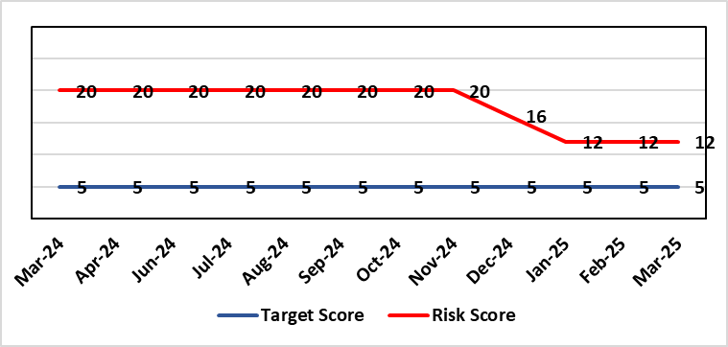 |  | Rationale for current score:  - The Health Board has been advised that its discretionary capital allocation for 2024/25 is £11.168m.  - The funding available within the Capital Resource Limit (CRL) will not meet the demands for capital investment. Discretionary capital is deployed to replace ageing medical devices & equipment; to address backlog maintenance of premises; and to support small scale, non-National service improvements with capital investments  - WG are currently assessing the outputs from the national capital prioritisation exercise, which means some major capital scheme business cases are on hold.  - The approved plan assumes additional disposal income of £850m which is yet to complete. Mitigations have been applied and the remaining disposal of £150k is on track to complete in early March.  - Assumed income of £1.124m from WG for business case fees has been removed from the plan due to the on-going national capital prioritisation exercise. A temporary hold of estates allocations agreed to mitigate this risk following receipt of an additional £4.4m capital funding from WG for estates backlog maintenance.  - Additional slippage bids to WG approved £13.6m  - There is potential for further capital requirements arising from service model changes which will need to be managed.  - Potential consequences of this risk are the inability to achieve the ambitions set out within health board plans; the potential failure of ageing equipment leading to service disruption; the exposure to potential environmental health & safety risks.
Level of Control
= 25%
Date added to the risk register  June 2023  (refreshed June 2024) |  |  | Rationale for target score:  The target score expresses the aspiration of the health board for addressing this risk. The target date indicated above reflects the point which the current actions are anticipated to reduce the risk, though knowledge of the actual funding available is required to reduce it further and this is not available until some months into the financial year.
Controls (What are we currently doing about the risk?) |  |  | Mitigating actions (What more should we do?)
The Health Board is doing the following:  - Regular dialogue with Welsh Government regarding capital requirements.  - Clear communication and reporting of the capital position, the risks and limitations.  - Close management of all schemes to ensure slippage is understood along with the impact on service.  - Clear prioritisation of any new requirements recognising the current constraints |  |  | Action | Lead |  | Deadline
 |  |  | Routine review and flexing of plan as spending is committed through the year. Routine monitoring processes will identify any potential slippage and will deploy this on risk based basis. | Director of Finance & Performance |  | Monthly through the financial year as plan is dynamic
 |  |  | Additional Digital Bids to WG | Assistant Director of Finance (Strategy & Planning) |  | Complete
Assurances (How do we know if the things we are doing are having an impact?)  The Health Board capital position is reviewed and monitored through:  - Quarterly capital prioritisation group  - Performance & Finance Committee quarterly finance report  - Monthly Monitoring Returns to Welsh Government. |  |  | Gaps in assurance (What additional assurances should we seek?)  Reporting on impact of constraints to the capital programme on service delivery.
Additional Comments
11/03/2025: Action complete: Additional digital bids submitted & approved by WG.

Datix ID Number: 3516  Health Care Standards: |  |  | HBR Ref Number: 94  Risk Target Date: TBC |  | Current Risk Rating  4 x 3 = 12
Objective: Mental Health & Learning Disability Services |  | BAF Ref: 2.3 | Director Lead: Deb Lewis, Chief Operating Officer  Assuring Committee: Performance & Finance Committee  For information: Quality & Safety Committee
Risk: CAMHS failure to meet required standards of performance  The CAMHS service is unable to meet the required level of performance due to workforce deficits in the team across all staff groups including medics, psychological therapies and nursing.  Links to other CAMHS risk register entries: (Ref: 3410/3373/3351/3346/3349/3350) |  |  | Date last reviewed: March 2025
Risk Rating  (consequence x likelihood):  Initial: 4 x 5 = 20  Current: 4 x 3 = 12  Target: 3 x 3 = 9 | 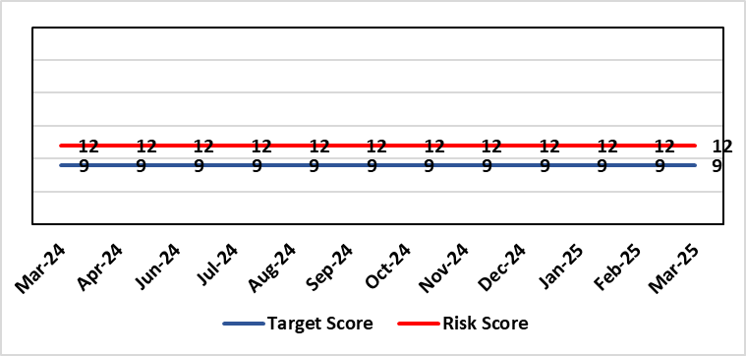 |  | Rationale for current score:  Marked improvement in the performance against the Mental health Measure for CAMHS. Data validation for new patients complete. Current risk score reduced to 12 in view of improved performance however this reflects the fragility in the workforce to deliver sustained performance.
Level of Control  = % |  |  | Rationale for target score:  The rationale for the target score is linked to successful recruitment and more timely access to services for children and young persons which will reduce risk.
Date added to the risk register
October 2023
Controls (What are we currently doing about the risk?) |  |  | Mitigating actions (What more should we do?)
-Ongoing recruitment into all staff groups  -Temporary agency workforce in nursing at premium pay rates to sustain current levels of performance  -Use of locum medical staff due to high vacancy level on medical workforce.  -Recent appointment into psychological therapies lead posts. |  |  | Action | Lead |  | Deadline
 |  |  | Continued efforts at recruitment | Acting Associate Service Director |  | 31/05/2025
Assurances (How do we know if the things we are doing are having an impact?)  -Monthly CAMHS Directorate meeting in place where performance and workforce are scrutinised  -Reporting into Weekly Business Team and MH & LD management board.  -Reporting into SBU Performance & Finance Committee and IQPD (Integrated Quality & Performance Delivery) meeting with Welsh Government  -Ongoing validation of the waiting list to ensure robust reporting going forward |  |  | Gaps in assurance (What additional assurances should we seek?)
Additional Comments / Progress Notes
28/01/25: Compliance against Part 1a (national target 80%) of the measure has continued to improve Aug 84%, Sept 91%, Oct 89%, Nov 80% and while Dec is 77%, Jan prediction is back in target. This demonstrates ongoing improvement from when CAMHs transferred across to SBUHB from last April (23%).
We have recruited to some of the workforce for part 1a of the service awaiting start dates, which will also allow ceasing of agency staff that we inherited. There is wider recruitment continuing in relation to medical and psychology workforce which is also improving. With all this detail the risk score remains appropriate at 12 currently.
01/04/25 Welsh Government have now removed this part of CAMHs services out of targeted intervention. There was a dip in compliance in January 2025 which recovered in February - but this still demonstrates the fragility of the available workforce is this area which is still being addressed, so risk rating remains the same. Two nursing posts and a new consultant psychiatrist have been appointed – awaiting start dates. There is some further discussion regarding requirement to make the service provision sustainable so will review further in two months.

Datix ID Number: 3571  Health & Care Standard: |  |  | HBR Ref Number: 96  Target Date: 31/03/2025 |  | Current Risk Rating  4 x 5 = 20
Objective: The health board is a resilient, financially sustainable and responsible organisation |  | BAF Ref: 6 | Director Lead: Marie Davies, Executive Director of Planning & Partnerships  Assuring Committee: Performance & Finance Committee
Risk: Failure to Develop an Approvable IMTP (statutory compliance)  If we fail to have an approvable Integrated Medium-Term Plan (IMTP) for 2026/27 then we will not meet our statutory duty to break even and may lose public confidence. |  |  | Date last reviewed: March 2025
Risk Rating  (consequence x likelihood):  Initial: 4 x 5 = 20  Current: 4 x 5 = 20  Target: 4 x 2 = 8 |  |  | Rationale for current score:  The Health Board does not have a WG approved IMTP and has been placed in enhanced monitoring for Finance, Strategy and Planning following the inability of the Health Board to submit a balanced IMTP in March 2023. Given the All-Wales financial context the Health Board was not able to submit an IMTP in March 2025. It has instead developed an Annual Plan 25/26 set in a three-year context.
Level of Control
= 70%
Date added to the HB risk register
October 2023
Date added to the HB risk register  October 2023 |  |  | Rationale for target score:  The target remains to develop a financially balanced IMTP so that we meet our statutory duties.
Controls (What are we currently doing about the risk?) |  |  | Mitigating actions (What more should we do?)
- As per the Welsh Government de-escalation criteria for Strategy and Planning, work has commenced to update and realign the Health Board’s strategy and clinical services strategic plan.  - As per the Welsh Government de-escalation criteria for Strategy and Planning, work has been undertaken to assess the Health Board against the planning maturity matrix and develop an action plan in response. This will be reported via the Board Planning & Partnerships formal report.  - The Recovery and Sustainability Board monitors delivery of agreed actions in relation to the financial position.  - The Annual Plan Oversight Group chaired by the COO, monitors delivery of Plan actions each quarter reporting to Management Board, Performance & Finance Committee and Board.  - Plan development will continue to be subject to robust challenge and scrutiny through regular briefings to Independent Members, Performance and Finance Committee (now meeting twice a month, once informally and once formally) and with detailed oversight from the Board itself. |  |  | Action | Lead |  | Deadline
 |  |  | A review of the planning process to produce the 2025/26 Annual Plan will be undertaken and recommendation for the 2026/27 Plan process will be developed. The review will be undertaken by the existing Integrated Planning Group and overseen by the IMTP Executive Steering Group. The process will report directly into Board | Executive Director of Planning & Partnerships |  | 27/06/2025
 |  |  | Review and update Health Board Organisational strategy | Executive Director of Planning & Partnerships/ Medical Director |  | 31/06/2025
 |  |  | Refresh Clinical Services Plan | Executive Director of Planning & Partnerships/ Medical Director |  | 31/03/2026
 |  |  | Strengthen governance and scrutiny of delivery of the plan through development of new performance management and accountability framework | Executive Director of Finance and Performance / Executive Director of Planning and Partnerships |  | 31/06/2025
 |  |  | Recovery and Sustainability Board to continue to focus on savings delivery and now shift to a more sustainable approaches in the longer term.  A new monthly performance review regime and Executive Team members to oversee thematic savings workstreams and support Service Groups to meet targets. | Executive Director of Finance and Performance |  | 31/03/2026
Assurances (How do we know if the things we are doing are having an impact?)  Progress against the delivery of the plan will be scrutinised through strengthened governance supported by a new performance management and accountability framework. |  |  | Gaps in assurance (What additional assurances should we seek?)
Additional Comments / Progress Notes
03/04/2025: Rationale, Control, Actions, Assurances refreshed

Datix ID Number: 3692  Health & Care Standard: |  |  | HBR Ref Number: 98  Target Date: TBC | Current Risk Rating  5 x 4 = 20
Objective: Care is delivered in safe and appropriate settings |  | BAF Ref: 3 | Director Lead: Darren Griffiths, Executive Director of Finance & Performance  Assuring Committee: Performance & Finance Committee
Risk: Overall condition/compliance and suitability of Health Board Estate  6 FACET survey undertaken in 2022 confirmed the poor condition and suitability of premises where health care services are provided. The backlog maintenance costs are in excess of £200 million. The overall level of controllable risk is affected – compounded – by the resilience of the HB’s H&S infrastructure (Datix 2159) and the level of resourcing of Operational Estates, which influences the adequacy of capacity and capability for responding to priority risk mitigation (Datix 3444) |  |  | Date last reviewed: March 2025
Risk Rating  (consequence x likelihood):  Initial: 5 x 4 = 20  Current: 5 x 4 = 20  Target: 3 x 3 = 9 | 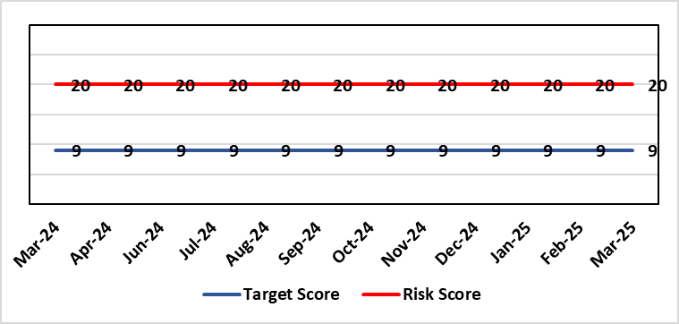 |  | Rationale for current score:  6 FACET survey  Estates Strategy and Development control plans  General compliance with fire regulations and WHTM/WHBN requirements.  Backlog maintenance  Health Board estates strategy and DCP task and finish group  Audit and Assurance limited assurance report  Access to funding  Ability to respond effectively to key HB initiatives such as the centralisation of medical records and the need to support mental health services and primary and community care services.
Level of Control  = 40% |  |  | Rationale for target score:  Through the 6 FACET survey a number of key items have been identified covering the Physical condition, Functional suitability, Space utilisation, Quality audit, Statutory compliance and Environmental management. All of which identified significant issues with the current estate, with very few areas achieving condition ‘B’. The overall backlog maintenance is in excess of £200m. The development of a plan to improve the capabilities of Operational Estates will allow a more proactive approach to risk mitigation.
Date added to the HB risk register
07/02/2024
Controls (What are we currently doing about the risk?) |  |  | Mitigating actions (What more should we do?)
- Planned preventative maintenance, prioritising highest risk depending on funding available (EFAB Year 2, Targeted Estate Fund 25/27, Discretionary) – linked to creation of decant space through service changes  - Planned preventative maintenance. Update Asset Register and review of all PPMs to ensure that these remain relevant and a good use of available resource  - Reactive maintenance.  - Address issues where practicable through EFAB/Discretionary capital  - Estates Strategy and development control plans task and finish group  - Regular reviews of the estate with reference to benchmarked best practice from NHS Wales/NHS England.  Further Developing Arrangements:  - Review 6 Facet conclusions with Oakleaf Consulting Ltd with reference to Operational Estates site knowledge and updated Asset Register, with a focus on the patient journey and patient safety.  - Develop partnership approach to working with Capital Planning to ensure that capital schemes are better informed of risks from an Operational Estates perspective.  - Develop Workforce Plan with HR/OD to address disproportionately high numbers of ‘retire and returns’ and loss of considerable experience, which is increasing in frequency.  - Review and make recommendations on structure of Operational Estates and investment plans, which will need to be cost neutral as far as reasonably possible. |  |  | Action |  | Lead | Deadline
 |  |  | Maintain effective engagement with Welsh Government to provide funding to implement estates strategy and development control plans to address all areas outlined. |  | Assistant Director of Capital Planning | 31 March 2025
 |  |  | Work with Welsh Government to source alternative solutions to funding the HB estates strategy and development control plans. |  | Assistant Director of Capital Planning | 31 March 2025
 |  |  | Review capacity and capability of Operational Estates and make recommendations on cost neutral investment in a longer-term plan to improve effectiveness. |  | Assistant Director of Estates | 30 September 2025
 |  |  | Update Asset Register, review PPMs, and implement SFG20 (industry standard compliance management) to enhance approach to ensuring viability of core infrastructure and provide assurance on business continuity. |  | Assistant Director of Estates | 30 September 2025
Assurances (How do we know if the things we are doing are having an impact?)  - Monitoring through quality & Safety, Audit & Assurance and Performance and Finance committee to receive assurance and or identify gaps for key compliance and adherence to applicable legislation.  - NWSSP internal audits  - Site visits/tours to identify compliance and gaps in compliances with NWSSP Shared Services  - Completion of FRA’s within targeted schedule  - Estates strategy and development control plans being implemented  - Half yearly Board oversight of strategy implementation. Consider appointment of Independent Member to support review of Operational Estates to provide advice to Officers and assurance to the Board on the range of proposed improvements.  Further Developing Arrangements:  - Complete review of capacity and capability of Operational Estates, which commenced in December 2024, and make recommendations on a way forward for improved effectiveness of resource utilisation and enhanced resilience.  - Complete review of Approve Persons and how duties are quality assured. This to also include action to address current gaps, i.e. AE Lifts and AE Pressure Vessels |  |  | Gaps in assurance (What additional assurances should we seek?)  - Suitable funding to implement the estates strategy and development control plans and sufficient resource to ensure that Operational Estates is capable and competent with regard to critical risk mitigation. This will need to be planned and implemented iteratively over the longer term, say 5 to 10 years, etc.  - Allocate funds where available to address issues outlined  - Detailed work and level of resourcing available for supporting same to be commissioned to consider primary and community estates strategy along with mental health services
Additional Comments
Through the 6 FACET survey a number of key items have been identified covering the Physical condition, Functional suitability, Space utilisation, Quality audit, Statutory compliance and Environmental management. The benefits of the 6 FACET survey will be enhanced through more detailed review of assets through updating the HB’s critical infrastructure asset register. All of which identified significant issues with the current estate, with very few areas achieving condition ‘B’. The overall backlog maintenance is in excess of £200m.
Key areas include ventilation and cooling with major infection control and other implications. Theatres/Wards/ED and general acute settings including mental health and learning disabilities being old and not compliant with the latest WHBN’s and WHTM’s. The heating, power and medical gas systems have also been identified as issues for concern in the 6 FACET surveys and from independent audits. The health board’s latest NWSSP estates audit received a limited assurance due to limited Welsh Government funding available to undertake backlog maintenance and implementation of estates strategy.
22/10/2024: Roofing is also being replaced as part of the backlog address and progress is being made in 2024/25 to replace aging roofing covering and structures, with just under a 1/3 of the roof expected to be completed by March 2025. Positive works have been undertaken covering fire alarm upgrades, fire doors/compartmentation, nurse call systems, flooring and windows.
27/01/2025: Targeted Estate Fund bid of circa £15m over two years will be submitted by the end of January 2025, which will continue replacement of Morriston roof, include a ward refresh programme, investment in a new oxygen ring main at Morriston Hospital, and improvements to decontamination, infection, prevention and control, and mental health services pending approval of the business case for the redevelopment of the Cefn Coed site. This will be further enhanced through investment in replacement fire dampers at Morriston Hospital (TEF bid).
17/04/2025: Funding approved by the WG on 27th March 2025 for £7.2m 25/26 and £9m 26/27.

Risk Score Calculation

For each risk identified, the LIKELIHOOD & CONSEQUENCE mechanism will be utilised. Essentially this examines each of the risks and attempts to assess the likelihood of the event occurring (PROBABILITY) and the effect it could have on the Health Board (IMPACT). This process ensures that the Health Board will be focusing on those risks which require immediate attention rather than spending time on areas which are, relatively, a lower priority.

