Meeting Date | 29 April 2025 |  | Agenda Item |  |  | 2.3
Name of Meeting | Performance and Finance Committee
Report Title | Monthly Recovery & Sustainability Programme Update
Report Author | Brian Owens – Director Recovery and Sustainability
Report Sponsor | Darren Griffiths – Director Finance and Performance
Presented by | Brian Owens – Director Recovery and Sustainability
Freedom of Information | Open
Purpose of the Report | The report is provided to update the committee on the current actions and work in progress of the Recovery & Sustainability Programme.
Key Issues | - R&S 2025/26 programme design and content approved on 9th April 2025  - Service Groups initial savings plans presented which identified £15.9m  - Agency reduction financial cost trajectories received from all four service groups
Specific Action Required  (please choose one only) | Information | Discussion |  | Assurance | Approval
Specific Action Required  (please choose one only) | ☐ | ☐ |  | ☒ | ☐
Recommendations | Members are asked to: -  - RECEIVE the updated report  - Take ASSURANCE from the ongoing delivery associated with the Recovery and Sustainability Programme

MONTHLY RECOVERY & SUSTAINABILITY PROGRAMME UPDATE

- INTRODUCTION
The paper provides the monthly formal update to the committee regarding the actions and progress within the Recovery and Sustainability programme.

- BACKGROUND
The first meeting of the Recovery and Sustainability (R&S) board for the new financial year occurred 9th April 2025. The meeting focused on the savings plans for 2025/26, each of the four Service Groups presented their current outline savings plans to date.

Table 1, provides a summary position as of 9th April for the Service Groups.

Table 1.

Service Group | Risk Category of Scheme
 | Red | Amber | Green | Total Identified Savings | Full Year Total Rq'd | Variance
PCT | 0.5 | 0.0 | 0.0 | 0.5 | 13.0 | -12.5
NPTS | 2.9 | 0.9 | 1.3 | 5.1 | 16.0 | -10.9
Morriston | 7.0 | 1.5 | 0.0 | 8.5 | 16.1 | -7.6
MHLD | 0.0 | 1.8 | 0.0 | 1.8 | 5.7 | -3.9
 | 10.4 | 4.2 | 1.3 | 15.9 | 50.8 | -34.9

£15.9m of savings schemes had been identified albeit most of those schemes were categorised as ‘red’ and therefore not being fully worked through at that time. Whilst all four of the Service Groups have significantly more savings to identify and deliver each demonstrated a clear understanding of the requirement and had processes in place to build on this initial position.

a. Agency Reduction

A component of the Cabinet Secretaries enabling actions requires Health Boards to ‘adopt or justify’ a 30% reduction in agency expenditure based on the 2024/25 outturn and to achieve zero agency usage by the end of September for administrative and clerical, health case support workers and estate and ancillary staff.

Each of the Service Groups had previously presented to the R&S board in February their plans to achieve this ‘enabling action’. However, in the April meeting, the Service Groups provided their costed financial delivery trajectories that sets out their expected variable pay reduction per month related to agency expenditure during 2025/26.

There is significant detail underpinning the delivery plans, including in some areas the conversion of variable pay cost into substantive staffing and increasing recruitment into the health boards own staffing bank plus service redesign. There are also some fragile and difficult to recruit services like Interventional Radiology and Diagnostic Reporting where the agency reduction plan hinges on successfully recruiting substantive staff into these areas.

b. 2025/26 R&S Programme Plan

The 2025/26 R&S programme plan was presented and agreed in the 9th April meeting. Copies of the paper and associated supporting documents where shared with some committee members following the R&S board regular briefing session.

The programme for 2025/26 consists of 12 overarching work streams, most of the work streams were briefly described in a project initiation document (PID) / plan on a page to provide an overview of the likely outcomes and delivery expectations.

See diagram 1 for the programme workstreams

Diagram 1
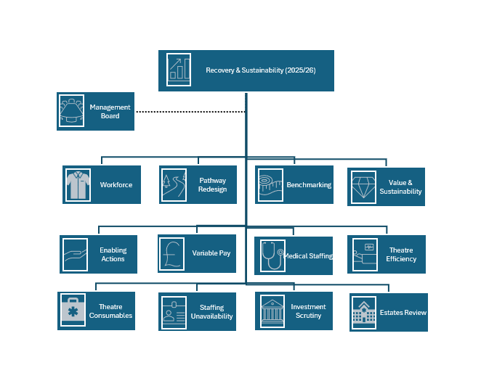

Following agreement of the plan, each of the senior leads for the workstreams are working with the R&S team to develop a full suite of project documentation including delivery trajectories and timelines.

c. NHS Graduate Scheme

There are currently active conversations with candidates that are commencing their second-year placements as part of the NHS Graduate programme. Since being able to articulate the 2025/26 programme, second year graduates have requested information and asked to be considered for a placement within the R&S programme.

The interest from the graduate scheme is significant as it helps to demonstrate the impact that R&S is starting to achieve as future leaders are seeking the skills required to sustainability deliver services in the future.

d. Absence Reduction Plan & Staffing Unavailability

The Interim Director of Workforce presented the absence reduction plan which received the support and backing of the board. R&S will receive regular updates on progress as part of the overarching workforce work stream.

The absence reduction plan dovetails with the work being led by nursing colleagues around increasing the availability of our substantive workforce. A more detailed update will be presented to R&S as the work stream matures however, it is building on the intelligence previously gathered related to roster sign off processes and therefore the expectation is that this work stream will more rapidly develop clear delivery objectives.

- GOVERNANCE AND RISK ISSUES
The agreed plan will enable increased governance and oversight of delivery once the full suite of project deliverables has been completed. Since the R&S board agreed the plan there has been some discussion around duplication of effort with the planned care board however, it is expected that this can be resolved swiftly to provide clarity on the delivery accountability.

- FINANCIAL IMPLICATIONS
The R&S programme as outlined will provide a range of actions that facilitates and supports the delivery of savings within the 2025/26 financial plan.

- RECOMMENDATION
Members are asked to: -
- RECEIVE the updated report
- Take ASSURANCE from the ongoing delivery associated with the Recovery and Sustainability Programme

Governance and Assurance

Link to Enabling Objectives  (please choose) | Supporting better health and wellbeing by actively promoting and empowering people to live well in resilient communities
Link to Enabling Objectives  (please choose) | Partnerships for Improving Health and Wellbeing |  | ☐
Link to Enabling Objectives  (please choose) | Co-Production and Health Literacy |  | ☐
Link to Enabling Objectives  (please choose) | Digitally Enabled Health and Wellbeing |  | ☐
Link to Enabling Objectives  (please choose) | Deliver better care through excellent health and care services achieving the outcomes that matter most to people
Link to Enabling Objectives  (please choose) | Best Value Outcomes and High Quality Care |  | ☒
Link to Enabling Objectives  (please choose) | Partnerships for Care |  | ☐
Link to Enabling Objectives  (please choose) | Excellent Staff |  | ☐
Link to Enabling Objectives  (please choose) | Digitally Enabled Care |  | ☐
Link to Enabling Objectives  (please choose) | Outstanding Research, Innovation, Education and Learning |  | ☐
Health and Care Standards
(please choose) | Staying Healthy |  | ☐
(please choose) | Safe Care |  | ☒
(please choose) | Effective Care |  | ☒
(please choose) | Dignified Care |  | ☐
(please choose) | Timely Care |  | ☒
(please choose) | Individual Care |  | ☒
(please choose) | Staff and Resources |  | ☒
Quality, Safety and Patient Experience
Financial Implications
Legal Implications (including equality and diversity assessment)
No Implications
Staffing Implications
Long Term Implications (including the impact of the Well-being of Future Generations (Wales) Act 2015)
No Implications

Report History |  | This is a routine monthly report to the committee
Appendices |  | There are no appendices to this report

