Meeting Date | 23rd April 2024 |  | Agenda Item |  | 4.3
Report Title | Performance Report Endoscopy
Report Author | Fiona Hughes  Associate Service Group Director, Morriston Service Group
Report Sponsor | Deb Lewis, Chief Operating Officer
Presented by | Fiona Hughes, Associate Service Group Director, Morriston Service Group
Freedom of Information | Open
Purpose of the Report | The purpose of this report is to provide the Performance and Finance Committee with an update on Endoscopy performance. The report presents an overview of the 8-week diagnostic and urgent suspected cancer target performance as well as provide an outline of current waits for Surveillance and Bowel Screening Endoscopy Actions being taken to improve performance are noted.
Key Issues | The key issues set out within this report are:  - SBUHB trajectory submitted to Welsh Government against the 8-week Diagnostic Endoscopy target for March 2024 of 3291 patients will be met.  - During 23/24 there has been a reduction of 1459 patients waiting over 8 weeks for a diagnostic Endoscopy.  - Waits for a diagnostic Endoscopy have reduced from 147 weeks in April 2023 to just over 90 weeks wait by end of February 2024. It is anticipated the wait will reduce to a maximum wait of 84 weeks by the end March 2024.  - There has been a significant reduction in the number of patients on the colorectal cancer pathway waiting for an urgent suspected cancer diagnostic endoscopy.  - There is a requirement to urgently develop a costed plan to manage the surveillance backlog of 1704 patients over planned target date within the service.  - The reduction in age range for Bowel Screening Wales (BSW) will require a significant increase in capacity from 5 sessions to 8 sessions a week by October 2024.
Specific Action Required  (please choose one only | Information |  | Assurance | Approval
Specific Action Required  (please choose one only | ☒ | ☐ | ☐ | ☐
Recommendations | Members are asked to:  - NOTE: The improvement in the over 8-week diagnostic waits since April 2023 and performance against trajectory.  - NOTE: The improvement in the Endoscopy wait for the colorectal cancer pathway  - NOTE: A further paper will be presented to Performance and Finance Committee to include a detailed options appraisal recovery plan for 24/25. This will outline the demand, the funded capacity and the efficiency gains that needs to be achieved by the service to close the unfunded capacity gap.

ENDOSCOPY PERFORMANCE UPDATE

- INTRODUCTION

The purpose of this report is to provide the Swansea Bay University Health Board (SBUHB) Performance and Finance Committee with a progress update on Endoscopy performance.
The report presents an overview of the 8-week diagnostic and urgent suspected cancer target performance as well as provide an outline of current waits for surveillance and bowel screening endoscopy actions being taken to improve performance are noted.

- BACKGROUND

Current Endoscopy Performance: 8 Week Diagnostic Target

The wait for an elective endoscopy has been monitored historically against the 8-week Diagnostic Target. As with all planned care targets, performance was significantly challenged during and following the COVID-19 pandemic and central monitoring of delivery was put on hold. In April 2023 the Welsh Government target was reset for a diagnostic procedure:-
- Zero patients waiting over 8 weeks waiting for a diagnostic endoscopy by March 2024.
Within SBHUHB an additional allocation of £3.6m was identified in the annual financial plan to reduce the capacity gap, to be achieved through increasing the current workforce (medical and nursing) and additional insourcing. The plan associated with the additional allocation predicted a residual gap of 3291 patients waiting over 8 weeks by the end of March 2024.
A trajectory was submitted to and accepted by Welsh Government (WG) as noted below:
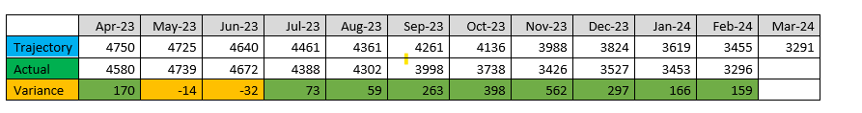
Since July 2023 the Endoscopy over 8-week performance has been ahead of the trajectory submitted to WG with an expectation that by the end of March 2024 waits over 8 weeks projected to be below 3291. This is despite the loss of capacity that due to 10 days of industrial action that has resulted in 3 weeks of disrupted activity during 2023/24
Projected March 2024 performance:
- The submitted trajectory against the 8-week target for March 2024 of 3291 patients will be met. The projected end of March 2024 over 8-week position is 3100.
- During 23/24 there has been a reduction of a minimum of 1459 patients waiting over 8 weeks for an Endoscopy.
- Maximum waits for an Endoscopy reduced from 147 weeks in April 2023 to just over 90 weeks wait by end of February 2024. It is projected by the end of March 2024 that the longest wait will be in the region of 82 weeks.
In August 2023 a further allocation of £1.5 million was received by SBUHB to further reduce and accelerate the reduction in the backlog. A plan was developed that included further insourcing capacity however securing the additional capacity and spending the allocation was very challenging. The detail of this is noted within the finance section of the paper.
Current Endoscopy Performance: Endoscopy Cancer Referrals
Patients referred for Endoscopy via the Single Cancer Pathway (SCP) on the Lower Gastro Intestinal pathway has reduced from 531 patients waiting in September 2022 to 202 patients in April 2024. There is capacity within Endoscopy to manage SCP referrals within 10 working days, which is the expected standard. On the 28th February 2024 there were 136 referrals for Endoscopy with 33 of those referrals not booked; these referrals would be new referrals received by the service and being processed.

Graph 1: Endoscopy SCP Referrals.

The SCP demand for Endoscopy has decreased marginally during 2023/24 from on average 125 per week to 119 per week from January 2023. The demand and weekly activity for these referrals is demonstrated in the graph below.

Graph 2: SCP Endoscopy Demand and Activity

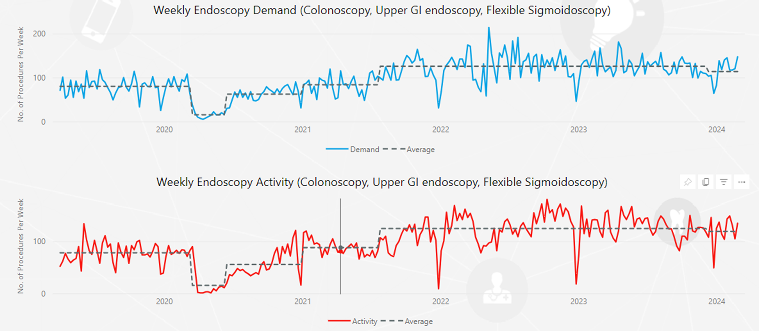

Current Endoscopy Performance: Surveillance and Bowel Screening Waits

Surveillance:

There are significant ongoing barriers to cancer surveillance with patients listed for a check colonoscopy or gastroscopy. Leaving patients on long overdue surveillance waiting lists in a permanent ‘holding’ pattern, or conversely, putting people at very low risk through invasive procedures for little benefit, is equally not acceptable. Within SBUHB there is a total of 1704 surveillance patients with lapsed target dates for a check procedure.

The clinical team has undertaken a risk stratification process as an interim mitigation strategy. However there continue to be patients waiting for a number of years for the procedure and the following actions are being taken immediately:

- Clinical Validation of all patients who are waiting with a planned date of prior to 01/01/20 for a surveillance procedure. There are 56 patients remaining in this cohort and this will be completed by 31st March 2024.
- Administrative validation of all procedures that were planned to be undertaken during 2020. There are 196 patients in this category. This to be completed by the end of April 2024.
- A costed plan to be drafted to outline actions that are needed to manage this backlog of patients and this includes the following:
- Administrative validation of the total list
- Review opportunities for the use of Cytosponge as an alternative to an Endoscopy. Cytosponge is a useful diagnostic tool to demonstrate pathology in cohorts of patients unable to access endoscopy during the COVID-19 pandemic. Initial results of trials using Cytosponge indicates that is can significantly reduce the burden on endoscopy services
- Increase short term capacity to manage backlog through insourcing or outsourcing.

Bowel Screening:

The Bowel Screening Wales (BSW) performance data is detailed in the table below.

Table 1: BSW Performance Data 2023/24

There are some concerns regarding the number of screening lists being delivered compared to the activity that has been commissioned from SBUHB. Whilst 85% of the commissioned activity between April and December 2023 has been delivered, there is currently a greater reliance on in-sourcing to provide the additional capacity required to meet the 5 lists a week required to achieve the screening demand. To date, the department’s priority has been to resolve the understaffed position to provide service to the diagnostic and SCP activity given the gap between demand and activity resource.
A plan is being developed for 2024/25 and the increase in funding from Public Health Wales that is anticipated has not yet been confirmed. There is a need to increase the capacity for BSW from 5 lists a week to 8 lists a week by October 2024 to manage the demand increases due to age expansion of bowel screening invites from 60 years to 50 years as directed by Public Health Wales.
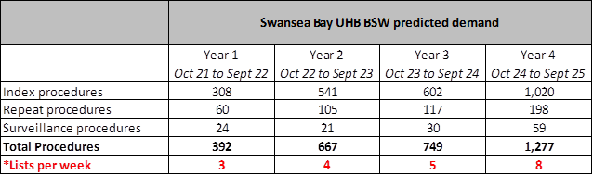
Securing capacity to meet the 5 lists a week has been increasingly challenging due to limited supply of screening colonoscopists. Actions to be taken to meet this capacity requirement as follows:
- Increasing from the three current screening colonoscopists to a minimum of 6. There are two within the Health Board that are currently within the accreditation assessment process but may not gain accreditation for a number of months. The accreditation process takes between 2 to 3 years depending on number of patients screened.
- Develop a regional plan to ensure capacity available across the South West region. The regional Endoscopy programme supported by ARCH includes BSW within the work stream scope.
- Secure insourcing during 2024/25 to manage the additionality in the short term.

Sustainable Improvement Plan

Currently the team is developing the plan for 2024/25 with the support of the Transformation Team and a Senior Project Manager assigned by the Chief Operating Officer. The target set by WG for the end of March 2025 is that no patients wait over 8 weeks for a diagnostic endoscopy. This in the context of a reduction in available recovery funding for 24/25.
In January 2024, SBUHB was placed in Targeted Intervention (TI) and for endoscopy the target set is as follows:
- Achieve 80% diagnostic endoscopy waits less than 8 weeks and maintain for 8 months. The current position is that only 22% of the waiting list has a wait of less than 8 weeks.
The team is developing a costed options appraisal for consideration by Performance and Finance Committee as follows:
- Option 1: Continue with funding source available in 2023/24 of £3.6million for 24/25 and 25/26. This will deliver a projected position of 2878 on the waiting list whilst maintaining the SCP targeted position by end of March 25.
- Option 2: 50% of 2023/24 funding available and impact on trajectory for end March 2025. This will see the waiting list numbers rise significantly to a projected 5270, again maintaining SCP target by end of March 2025.
- Option 3: Delivery of zero position by end March 2025 but this will be heavily reliant on insourcing and potential outsourcing.
- Option 4: Delivery of WG TI target (80%) by end of 24/25 again having insourcing and outsourcing implications.
Within all options increasing capacity through further efficiencies including a reduction in cancellation rates and improvements in list utilisation as well as further demand management initiatives are detailed.

Actions implemented to date to support moving towards a more sustainable plan for 2025/26 are noted as follows:

- Recruiting Endoscopy Nurses to support an additional 8 sessions to increase funded sessions from 38 to 46 sessions during 23/24.
- Clinical and administrative validation.
- Clinical endoscopist workforce increasing from one (currently within establishment and competent) to three whole time equivalent by April 2024.
- Appointed two new Gastroenterology Consultant posts. One whole time equivalent commenced and 0.8 whole time equivalent to commence in September 2023.
- Additional weekend list
- Insourcing capacity
- Fixed term booking clerks to support additional activity and validation.
- A weekly scheduling meeting has been introduced to review capacity two weeks ahead to ensure points are delivered as planned

- GOVERNANCE AND RISK ISSUES

Whilst the Health Board will achieve the current trajectory that has been set of 3291 patients over 8 weeks by the end of March 2024 there is a considerable challenge to meeting the zero position by March 2025. There are significant risks associated with this and are:
- Nursing capacity – this has improved in terms of recruitment and less vacancies however the long lead time of at least 6 months to train an Endoscopy nurse is challenging. The department has approximately 60% of RN’s employed yet to achieve full competencies.
- HSDU capacity – the refurbishment of the HSDU at Morrison and subsequent temporary centralisation of services on the Singleton site has the potential to cause difficulties in the responsiveness to Endoscopy demand.
- Financial Risk – Reduction in recovery funding 2024/25 will impact on speed of delivery of a reduced backlog of patients.
- Surveillance long waits- Potential for missed cancer diagnosis within this cohort of patients.

There is an established Endoscopy Recovery Group (ERG) to oversee the improvements/initiatives made to ensure that robust governance with the appropriate clinical and service management support is in place. The ERG escalates risks and issues through to the Division of Medicine and Morriston Service Group as well as through the established Diagnostic Recovery Group

- FINANCIAL IMPLICATIONS

The financial plan below was agreed for 2023/24 and includes a combination of non-recurrent and recurrent implications as described. The forecasted end of year position is also described.

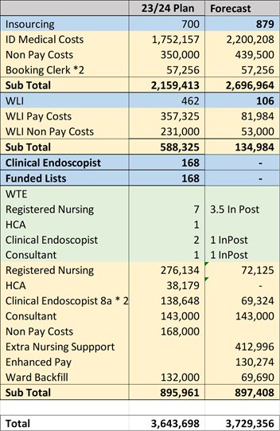

The financial plan is monitored on a weekly basis to ensure governance and control.
The 2024/25 allocation is to be confirmed.

- RECOMMENDATION
It is requested that the Performance and Finance Committee consider the following recommendations:

- NOTE: The Improvement in the Endoscopy wait for the colorectal cancer pathway
- NOTE: The improvement in the over 8-week diagnostic waits since April 2023 and performance against trajectory.
- ENDORSE: The development of an options appraisal recovery plan for 24/25.

Governance and Assurance

Link to Enabling Objectives  (please choose) | Supporting better health and wellbeing by actively promoting and empowering people to live well in resilient communities
Link to Enabling Objectives  (please choose) | Partnerships for Improving Health and Wellbeing | ☐
Link to Enabling Objectives  (please choose) | Co-Production and Health Literacy | ☐
Link to Enabling Objectives  (please choose) | Digitally Enabled Health and Wellbeing | ☒
Link to Enabling Objectives  (please choose) | Deliver better care through excellent health and care services achieving the outcomes that matter most to people
Link to Enabling Objectives  (please choose) | Best Value Outcomes and High Quality Care | ☒
Link to Enabling Objectives  (please choose) | Partnerships for Care | ☒
Link to Enabling Objectives  (please choose) | Excellent Staff | ☐
Link to Enabling Objectives  (please choose) | Digitally Enabled Care | ☐
Link to Enabling Objectives  (please choose) | Outstanding Research, Innovation, Education and Learning | ☐
Health and Care Standards
(please choose) | Staying Healthy | ☐
(please choose) | Safe Care | ☒
(please choose) | Effective Care | ☒
(please choose) | Dignified Care | ☐
(please choose) | Timely Care | ☒
(please choose) | Individual Care | ☐
(please choose) | Staff and Resources | ☐
Quality, Safety and Patient Experience
Outlined within the body of the paper but in summary considerable backlog of patients awaiting a diagnostic, therapeutic and surveillance endoscopy who are unable to access the service.
Financial Implications
Funding agreed for 2023/24
Legal Implications (including equality and diversity assessment)
Delay to diagnosis and treatment potential.
Staffing Implications
Increase in endoscopists and Nursing workforce to reduce capacity gap.
Long Term Implications (including the impact of the Well-being of Future Generations (Wales) Act 2015)
Report History | Endoscopy update Report shared with Management Board in December 2023

