Meeting Date | 30 September 2026 | Agenda Item | 3.1
Name of Meeting | Mental Health Legislation Committee
Report Title | MENTAL CAPACITY ACT COMPLIANCE REPORT Q1
Report Author | Amanda Davies Deputy Head of Nursing for Long Term Care  Richard Mugford Finance Partner
Report Sponsor | Executive Director of Nursing and Patient Experience
Presented by | Emily Davies Interim Group Nurse Director for Primary Care and Therapies Service Group (PCTSG)
Freedom of Information | Open
FoI Closed detail | If closed, choose detail
Impact Assessment Summary Outcome |  | IA Completion date
 |  | Click or tap to enter a date.
Purpose of the Report | For Assurance
Report Summary; detailing any action required
The purpose of the paper is to present to the Mental Health Legislative Committee a report on the activity and compliance relating to the Mental Capacity Act (MCA) 2005, including an update and assurance around the management of Deprivation of Liberty Safeguards (DoLS) for Q1.

Key Issues
- Staff competency and training for MCA/DoLS
- Supervisory Body and DoLS compliance
- New Supreme Court Judgement

Decision / Action required | No
Recommendations
Members are asked to:

- Receive for this report for assurance on the risks and mitigation following new Supreme Court Judgement.
- Consider the risks around MCA Training compliance.

MENTAL CAPACITY ACT COMPLIANCE REPORT

- INTRODUCTION
The Mental Capacity Act (MCA) 2005 provides a statutory framework for supporting individuals who lack capacity to make decisions. Compliance with the Act remains a legal requirement following the decision not to implement the Liberty Protection Safeguards during this Parliament.
This report outlines current compliance status, training performance, DoLS activity, financial implications, risks following the recent supreme court judgement, and actions taken to ensure adherence across Swansea Bay University Health Board (SBUHB).

- BACKGROUND
The MCA 2005 applies to adults aged 16 and over, ensuring autonomy and decision-specific capacity assessments. The Health Board must ensure staff are competent and confident in applying MCA principles in care and treatment planning.

Principles
- Presumption of capacity for all adults aged 16+.
- Decision-specific capacity assessments required.
- Staff must apply MCA principles consistently.
On 2nd June 2026, the Supreme Court fundamentally reshaped the legal landscape regarding Deprivation of Liberty Safeguards (DoLS). In a unanimous decision, seven Justices overturned the 2014 ruling in Cheshire West with immediate effect. Appendix 1.
The recent Supreme Court judgment marks a significant shift away from the Cheshire West acid test (can no longer be utilised), creating substantial legal, safeguarding, and operational implications for deprivation of liberty practice across health and social care.
No further National guidance has been given, and we await further information due to be released from Secretary State.
The Cheshire West ruling, in 2014, attempted to simplify a restriction of liberty through the ‘Acid Test’.
This led to a vast expansion of both DoLS and applications. Individuals living in supportive, domestic or family environments, often content and settled, were still legally classified as being deprived of their liberty and therefore in need of a legal framework to monitor that deprivation and ensure it was the least restrictive possible (Deprivation of Liberty Safeguards).
Under Cheshire West (2014), a person was considered deprived of their liberty if they were:
- Under continuous supervision and control; and
- Not free to leave
This test was intentionally wide and led to a substantial increase in DoLS applications and safeguarding scrutiny.
The 2026 Supreme Court judgment found that this approach was:
- Too simplistic and overly broad
- Inconsistent with European human rights case law
The Court has now removed the acid test, replacing it with a multi-factorial assessment of the person’s situation.

- GOVERNANCE AND RISK ISSUES

Risks and mitigation following new Supreme Court Judgement
The Supervisory Body has made immediate operational changes in line with interpretations from the New Judgement until further information from the Secretary State is received.
All current Deprivation of Liberty referrals have been paused with immediate effect and Best Interest Assessor resource has been re-deployed within the team to manage the increase in Health Board demand queries around the New Judgement and Deprivation of Liberty Safeguards process.

Risks
- Ward staff will require training on the implications of the Supreme Court judgment.
- Additional team capacity may be needed to review and scrutinise referrals in line with the new judgment.
- Greater emphasis will be required on Mental Capacity Act (MCA) compliance and safeguarding processes.
- The impact on workforce demand and the required skill mix remains unclear.
- New risk added to the PCTSG Risk Register 4535 - Significant.

Mitigation
- A ward-based screening flowchart has been developed to support staff in applying the requirements of the new judgement.
- An easy-read poster has been distributed across wards to provide interim guidance while awaiting updated national guidance.
- A 7-minute briefing is available on the intranet for staff awareness and education.
- The Form 1 referral process has been updated to reflect the implications of the new judgement.
- Service data will be monitored over the next six months to assess demand and inform future workforce and skill mix requirements.

Training compliance

Training Compliance Q1
- Level one – all staff (e-learning)
- Level two – Staff who have direct patient contact (e-learning)
- Level three – Staff involved in care and treatment planning (face to face).
54

862
Training Performance Q1

Level 1 Level 2
 69%* 72%*

Level 3

46%*
207

*compared with Q1 2025/26

Key drivers
- Electronic Staff Records (ESR) reporting limitations affecting accuracy
- Non-mandatory status reduces uptake
- Work force pressures impacting attendance. 121 did not attend and 54 withdrawals for Level 3.
- Two sessions were cancelled in April due to poor attendance.

Mitigation
- Larger venues secured to meet Health Boards (HB) training requirements
- Microsoft Teams Training dates have been added to the training plan to address workforce pressures and reduce travel expenses.
- Senior managers at all acute sites have been contacted and reminded of the requirement for relevant staff to attend this training.
- 2,084 HB staff have been trained since commencement of in-house Level 3 training in May 2024. 44.4% of registrants are in compliance.
- Risk score increased to Significant to reflect the risk on PCTSG Risk Register 3835.

Key Actions
- Implement mandatory MCA/DoLS training across all relevant staff groups
- Enhance ESR system to accurately reflect training requirements and compliance
- Awaiting All Wales Level 3 Training following new Court Judgement.
- August training sessions have been cancelled. All Best Interest Assessors (BIAs) are required to provide face-to-face training to Band 6 and Band 7 ward staff on the implications of the new court judgment. This approach is intended to reach a wider staff audience, strengthen understanding of the legal changes, and help mitigate risks to patient safety.
- Level 3 training to recommence September 2026.

Performance

DoLS Referral Activity Q1

Referral Type | April | May | June | Total
Standard Following Urgent | 126 | 108 | 83 | 317
Urgent | 1 | 7 | 3 | 11
Standard | 4 | 1 | 4 | 9
Review (Form 10) | 0 | 1 | 0 | 1
Further (Form 2) | 11 | 3 | 2 | 16
Total | 142 | 118 | 92 | 372

Following the new Supreme Court Judgement, there were no authorisations approved from 2nd June 2026.

Breaches
- Breaches reported for Q1 are 5. There were no reportable breaches for May or June.
- SBUHB remains reliant on external Best Interest Assessors (BIAs) to undertake assessments and reviews where required.
Improvement Plan
- Duty BIA scrutinizes all referrals for appropriateness and urgency under new court judgement.
- Triaging ensures safeguards and prioritization for urgent cases.
- Risk score remains at 12 on PCTSG Risk Register for Q1.
- No complaints or legal challenges reported to date.
- External assessors to undertake reviews and assessments to allow substantive BIA’s to undertake ward based training on new judgement.

Governance & Resource
- SBUHB has the lowest BIA resource in Wales: 3 WTE vs. benchmark of 7 WTE.
- Independent assessors provide limited support under Service Level Agreement (SLA).
- FINANCIAL IMPLICATIONS

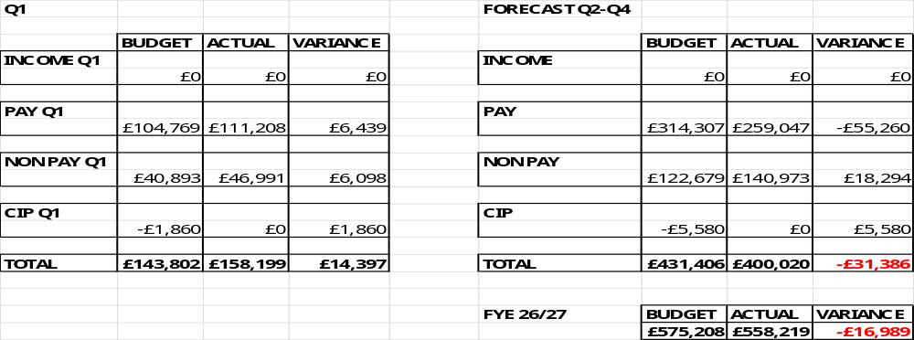

- RECOMMENDATION

Members are asked to:
- Receive for assurance the risks and mitigation following new Supreme Court Judgement.
- Consider the risks around MCA Training compliance.
Governance and Assurance
Strategic Objectives
Strategic Objectives  (please choose which is impacted) | People of Swansea Bay live healthier, fairer and more prosperous lives | ☒
Strategic Objectives  (please choose which is impacted) | Care is high quality, safe, efficient and delivers the best possible outcomes for people in partnerships | ☒
Strategic Objectives  (please choose which is impacted) | Care is delivered in partnership with our communities in safe and appropriate setting, supported by innovation | ☐
Strategic Objectives  (please choose which is impacted) | The health board is a great place to work where staff feel valued and work together towards a common goal | ☐
Strategic Objectives  (please choose which is impacted) | The health board is a resilient, sustainable and responsible organisation | ☒
Health and Care Standards
Standards (please choose which applies) | Safe Care | ☒
Standards (please choose which applies) | Timely Care | ☒
Standards (please choose which applies) | Effective Care | ☐
Standards (please choose which applies) | Efficient Care | ☐
Standards (please choose which applies) | Equitable care | ☐
Standards (please choose which applies) | Person-centred Care | ☒
Standards (please choose which applies) | Staff and Resources | ☒
Enablers (please choose which applies) | Whole Systems Approach | ☐
Enablers (please choose which applies) | Leadership | ☒
Enablers (please choose which applies) | Workforce | ☒
Enablers (please choose which applies) | Culture | ☐
Enablers (please choose which applies) | Information | ☒
Enablers (please choose which applies) | Learning, Improvement and Research | ☒
Quality, Safety and Patient Experience
Ensuring the Health Board has an MCA lead with a team to support staff competence and compliance with MCA and DoLS will ensure the human rights of those patients who lack capacity are protected so that they receive the care they require, ensuring it is in their best interests ensuing they are treated with dignity and respect within the law.
Financial Implications
All expenditure is budgeted, however managing the level of DoLs applications remain challenging within the current resource
Legal Implications (including equality and diversity assessment)
The MCA is primary legislation and the HB is obliged by law to comply. The court of protection is a higher court with powers to set precedence and non-adherence could result in high-cost fines and significant reputational damage for the organisation.
Staffing Implications
The resource within the team will need to be monitored against the level of DoLS applications and the need for support for patients with complex mental capacity issues within our hospital and community settings.
Long Term Implications (including the impact of the Well-being of Future Generations (Wales) Act 2015)
With the rise in the elderly and learning disabilities population forecast, long term planning must take this into account when considering the future development of the MCA resource.
Every individual has the right to be involved in and collaborate in their care and treatment planning within the NHS and it procured placements. Robust oversight and management of MCA will ensure this is possible for those lacking capacity who are often the most vulnerable in our society.

Report History
Appendices
Appendix 1

