Meeting Date | 17 September 2026 | Agenda Item | 2.5
Name of Meeting | Digital, Data, Research and Innovation Committee
Report Title | Research and Development Clial Trial Activity
Report Author | Jayne Caparros, Research Delivery Manager  Jemma Rogers, Research and Development Manager  Liz Wonnacott, Head of Service – Medical Director
Report Sponsor | Executive Medical Director
Presented by | Jayne Caparros, Research Delivery Manager
Freedom of Information | Open
FoI Closed detail | If closed, choose detail
Impact Assessment Summary Outcome |  | IA Completion date
N/A |  | Click or tap to enter a date.
Purpose of the Report | For Assurance
Report Summary; detailing any action required
The purpose of the report is to provide an update on research and development activity during the current financial year.
Key Issues
The health board supports research across most clinical areas and spans all research types, from randomised clinical trials of new drugs and technologies to qualitative methodologies and use of routine data, demonstrating a commitment and recognition of the vital role research and development in achieving a high-quality organisation. The report provides a snapshot of the clinical research activity currently ongoing within the research and development teams.
Decision / Action required | No
Recommendations
Members are asked to:
- TAKE ASSURANCE from the level of clinical trial activity undertaken in 2025-26;
- TAKE ASSURANCE from the performance figures to date in 2026-27;
- TAKE ASSURANCE that the health board is a significant recruiter to UK and Wales-wide clinical trials and studies.
RESEARCH AND DEVELOPMENT CLINICAL TRIAL ACTIVITY

- INTRODUCTION
The purpose of the report is to provide an update on research and development ongoing clinical trial activity.

- BACKGROUND
Research has long been supported and recognised by clinicians for its importance in healthcare and is one of the main drivers in providing evidence-based improved treatment and care options for patients, as there is a growing body of evidence that research-active hospitals have better patient outcomes, even for patients who are not directly involved in clinical trials. In addition, the opportunity to participate in research improves recruitment and attracts high-calibre candidates; and presents opportunities for cost reduction and income generation.

The health board supports research across most clinical areas and spans all research types, from randomised clinical trials of new drugs and technologies to qualitative methodologies and use of routine data, demonstrating a commitment and recognition of the vital role research and development in achieving a high-quality organisation.

It has a research and development team, under the remit of the Executive Medical Director, which is funded by Health and Care Research Wales (HCRW). Commercial income also supports the service financially.

The team comprises three delivery components (cancer, non-cancer and Joint Clinical Research Facility (JCRF)) which are supported by a management and governance function. The teams include specialist research nurses, allied health professionals, officers and facilitator staff who work to support research active clinicians deliver research studies, which may be externally led by a commercial or non-commercial sponsor or an in-house study, sponsored by the health board.

- GOVERNANCE AND RISK ISSUES
The chart below shows a summary of the activity in 2025-26, with further detail provided in the annual report, which is also on the agenda.

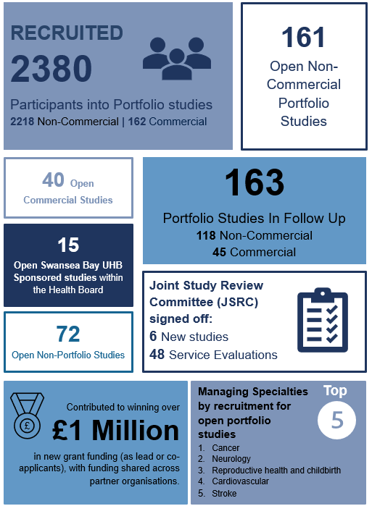

2026-27 saw the introduction of new performance targets, set by the UK Government, to reduce the time taken to set up commercial clinical trials to 150 days or less, measured from regulatory submission to recruitment of the first participant. This is intended to improve the UK's international competitiveness, attract more commercial research investment, and provide patients with earlier access to innovative treatments.

Wales, via HCRW, has chosen to apply these set up metrics to all studies, not just commercial studies.

All NHS organisations are expected to improve the speed of study set-up and recruitment. Faster set-up increases the time available for participant recruitment and helps meet commercial sponsors' expectations around study delivery.

The first 60 days of the target is to achieve regulatory and ethics approval; this will only apply to the health board if it is the sponsor of the study, otherwise, the remaining 90 days are the target, with the following requirements:

- Site Set-up Target
Sites are expected to complete study set-up within 60 calendar days or less.

- Recruitment Target
Sites are expected to recruit their first participant within 30 calendar days of being approved to start recruitment (unless study is classed as a rare disease or low recruiting study).

- Data Recording
Sites must record all required milestones accurately in their local portfolio management systems (LPMS). Failure to record all required data points will affect national performance reporting.

There are some implications for the research and development team as they will need to:
- Begin study set-up activities as soon as a site is selected.
- Ensure capacity and capability reviews are completed in parallel with regulatory approvals whenever possible.
- Improve the accuracy and completeness of LPMS data entry.
- Monitor local performance against the 60-day set-up and 30-day recruitment expectations.
- Work closely with research teams and support services to minimise avoidable delays.
- Collect information on reasons for delays outside site control.

Based on figures to date, this year is progressing well:
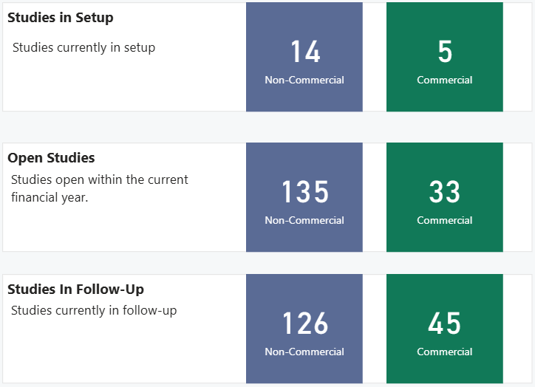

Performance for non-commercial studies is monitored by HCRW, with a requirement that 80% of studies close on time and have met the target number of participants. Regular finance and performance meetings take place with HCRW, during which this target is discussed, as if the health board was consistently below the 80% target, discussions would be held regarding oversight of the budget.

It is important to note that for all trials, the study sponsor running them will set a target number of patients to be entered, so it is not always a case of everyone eligible will be able to take part. The numbers below represent the numbers of studies which have recruited at least one patient this year and the total number of people recruited in 2026-27 so far:

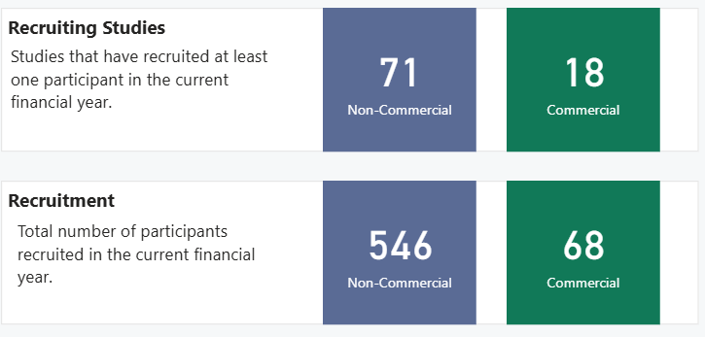

Studies and trials can be split across the categories – commercial, portfolio (which are ones recognised in the National Institute for Health and Care Research Clinical Research Network Portfolio and non-portfolio.

As at August 2026, there were 46 health board sponsored studies either proceeding through sponsorship review, regulatory review, open or in follow up.

The above figures represent portfolio and commercial studies only and there are currently 48 non-portfolio studies open. Some of the non-portfolio studies are research undertaken locally by health board staff who focus on their own areas of expertise to enhance practice for their patients. They go on to present their findings to colleagues at conferences and/or publish their work to help inform the work of others.

Usually for commercial or portfolio studies, there are multiple sites involved, normally across the UK. Each one will have a lead researcher, known as the Chief Investigator (CI), who will oversee the study across all sites. There are several ongoing trials for which a health board clinician is the Chief Investigator:
- Dr Unmesh Mohite, Consultant Haematologist, is the Chief Investigator for a study for patients with chronic lymphocytic leukaemia. This randomised controlled trial aims to determine whether adding chemotherapy delivered directly into the abdomen during keyhole surgery is better than standard chemotherapy alone for people whose cancer has spread inside the abdomen.
- Gastroscope study awarded by CRUK (Cancer Research UK) -£2.94m. Co-Sponsored by Swansea Bay and Velindre NHS Trust, the CI is Dr Sarah Gwynne, appointed trials unit is Cardiff Trials Unit, Cardiff University.
- Professor Steve Bain, Associate Medical Director for Research and Development has been selected as the Chief Investigator for two diabetes trials opening later this year.

Other achievements include Dr Mark Bowtell, Principal Clinical Scientist, being accepted onto the National Institute for Health and Care Research Principal Investigator Pipeline Programme. This is the first cohort that is open to healthcare scientists and Dr Andrew Claypole, Trainee Clinical Scientist in Rehabilitation Engineering, selected for the Healthcare Science Innovation Fellowship- one of four fellows in NHS Wales. His project title is Cost-effective sensor technology for improved pressure injury prevention.

Of the UK-wide trials, the health board has been successful in recruiting the first patent in several:
- EXCISE Trial - EXamining antibiotics for ulCerated skIn cancer Surgical Excision. Investigates whether giving a single dose of antibiotics during surgery for ulcerated skin cancer reduces postoperative wound infections, by randomly assigning patients to receive either an antibiotic or a placebo and monitoring their recovery for 30 days.
- RESHAPE - CLOU064C12306: Remibrutinib switch in relapsing-remitting multiple sclerosis (RRMS) - aims to assess whether remibrutinib is as safe and effective as continuous ocrelizumab over two years in people with relapsing multiple sclerosis who switch from ocrelizumab.
- BRUIN-CLL-211 - Lilly 211 study – a randomised study for patients with chronic lymphocytic leukaemia.
- INTerpath-014 - a randomized, placebo-controlled study testing whether a personalised cancer vaccine, with or without an immunotherapy drug, can reduce the risk of lung cancer coming back after surgery. The health board was the first in the UK to open this lung cancer commercial trial, and the sponsor has highlighted how impressed to HCRW it with the proactiveness and progress of made by the research delivery team at Singleton Hospital.

There were also trials on a Wales-wide basis where the health board recruited the first patient, such as:
- ROSALIND study of exceptional long-term survival in patients with poor prognosis solid tumours. This study aims to find out why a small number of people with very serious cancers live much longer than expected.
- CLASP - CLArithromycin for post-Stroke Pneumonia: A prospective, randomised open-label blinded-endpoint (PROBE) phase 3 multicentre trial. This study is looking at whether adding the antibiotic clarithromycin to the usual treatment for pneumonia after a stroke helps patients recover better.

In addition, the health board was the first in Europe to recruit to the GLORA study, which is testing whether adding a new cancer drug called lisaftoclax to acalabrutinib works better than acalabrutinib alone for people with chronic lymphocytic leukaemia (CLL) or small lymphocytic lymphoma (SLL). It includes people who have already been taking acalabrutinib for at least 12 months and whose cancer is stable or has partly responded to treatment, but where there are still signs of disease remaining. Some participants also have features that make their disease higher risk, such as certain genetic changes or blood test results that are linked to a greater chance of the cancer progressing.

Partnership working is also a key element of the work, with examples for clinical trials including:
- QuicDNA colorectal study – a Welsh led study which is looking at whether a new blood test can improve how doctors identify and monitor colorectal (bowel) cancer compared with current testing methods. Cancer and research delivery teams are collaborating to deliver this study within the health board. Study opened within 60 days, and first patient recruited within 30 days.
- Collaborating with Southampton University to be one of the first Welsh sites to open as a Cancer Vaccine Launch Pad which is a study looking to find people who may be able to take part in research trials for new ways to treat cancer, such as new immunotherapy treatments including cancer vaccines. Participants will then be referred to the nearest hospital that is conducting the clinical trial.

Other external partnerships under development are:
- ReconRegen Clinical Trial Matching Tool which aims to match patient clinical information from free-text sources (such as pathology reports, imaging reports and clinic letters) against clinical trial eligibility criteria using a large language model and ClinicalTrials.gov data. Initial disease areas are skin cancer and colorectal cancer.
- SenseIV – developing an IV cannula alert system and working with the health board on service evaluation activities and publication outputs. A partnership agreement has been drafted to formalise a collaborative approach to the development of the technology, including IP considerations.
- Agile Kinetic - Swansea Bay Community Stroke Team is collaborating with Agile Kinetic on project "Integrating MoveLab Digital Movement Monitoring into Community Stroke Follow-Up", which has been awarded NIHR Invention for Innovation (i4i) Funding At the Speed of Translation (FAST) funding. The project has been classed as a service improvement. The collaboration agreement is under review.

In addition to the work carried out by the health board’s research and development teams, patients also have the opportunity to participate in trials managed by the Joint Clinical Research Facility (JCRF), and the data from these trials are included in the health board’s metrics.

JCRF is a standalone clinical trials entity which is joint between the health board and university. It was previously hosted by the health board however upon receiving European funding prior to the pandemic, it transferred to Swansea University and the staff have honorary contracts with Swansea Bay. A regular JCRF board takes place with representatives from the health board, university and JCRF as an opportunity to discuss the performance and finance position of JCRF as well as update on any issues, challenges or opportunities which affect the three entities.

Below sets out the number of ongoing trials within JCRF:

In Setup | 5
[NOT SET] | 1
Cardiovascular | 1
Diabetes, Metabolic and Endocrine | 1
Neurology | 1
Renal | 1

Open To Recruitment | 28
[NOT SET] | 1
Cancer | 1
Cardiovascular | 11
Diabetes, Metabolic and Endocrine | 2
Gastroenterology and Hepatology | 2
Neurology | 8
Ophthalmology | 1
Renal | 1
Respiratory | 1

Closed to Recruitment, In Follow Up | 25
Cardiovascular | 9
Diabetes | 1
Diabetes, Metabolic and Endocrine | 2
Gastroenterology and Hepatology | 1
Neurology | 8
Renal | 4

The application of successful change following trials is not always in the gift of the health board as often the sponsors are external, and the majority require an application to the National Institute for Health and Care Excellence (NICE) to change guidance. However, local studies can and are published to inform the practice of others, with several publications already this year:

- Stroke Research Nurse, Sharon Storton was co-author, alongside Dr Manju Krishnan, Stroke Consultant, for the Swansea Stroke Scale (SSS - IRAS 341200) study. This study recruited over target.
- First results from the OPTIMA phase III randomized non-inferiority trial of test-directed chemotherapy in patients with high clinical risk ER-positive HER2-negative early breast cancer presented in the American Society of Clinical Oncology 2026.
- Drs Sarah Gwynne and Owen Nicholas, Consultant Clinical Oncologists, were named authors in ‘Clinical Oncology’ on the article "Radiotherapy Quality Assurance in the SCOPE2 Trial: What Lessons can be Learned for the Next UK Trial in Oesophageal Cancer?". The aim of the study is to determine whether increasing radiotherapy dose and adjusting chemotherapy based on early treatment response can improve outcomes for patients with oesophageal cancer.
- Sophie Barry-Richards, Research Midwife, is the principal investigator for MAGENTA_V1.0 - Maternal and pregnancy health and elevated heat, looking to understand how extreme heat affects maternal, foetal and child health across deprivation levels by collecting biological, physiological and environmental data from pregnant women and babies in the most and least deprived areas of Swansea before, during and after a heatwave. The article "How a warmer world is making pregnancy riskier" was published in the Financial Times.

And in terms of awards, the upper gastrointestinal cancer research team, along with clinicians have been nominated for Health and Care Research Wales National Award for embedding research in practice award for oesophageal radiotherapy clinical trials.

As well as the income from commercial trials, researchers can apply for grants to support an area of work. Below are a snapshot of grants awarded to date in 2026

Study | Funder | Award Date | Lead/SBU Contact | Awarded Funding*
COLD-FIRST (COLD-stored platelets For Initial Resuscitation in Shock and Trauma) | UK Defence Innovation (UKDI) | 01/05/2026 | David Rawlinson | £2,921,824 to the project
Emerging Researcher Fellowship | Welsh Government | 01/07/2026 | Siwan Evans | £75,408.73
GastroSCOPE | Cancer Research UK | 28/05/2026 | Dr Sarah Gwynne | £2.94m
999 R.E.A.C.H. | UKRI | 08/04/2026 | David Rawlinson (collaborator) | £695,032.87
Ambient Voice Technologies Evaluation | Welsh Government (ITP Programme) | 25/02/2026 | David Rawlinson | £21,301.00
*Award values are based on fields completed in the register.
In summary, the health board continues to be one of the more research active organisations in NHS Wales.

- OPEN AUDIT RECOMMENDATIONS
There are no open audit recommendations.

- FINANCIAL IMPLICATIONS
There are no financial implications associated with this report.

- RECOMMENDATION
Members are asked to:
- TAKE ASSURANCE from the level of clinical trial activity undertaken in 2025-26;
- TAKE ASSURANCE from the performance figures to date in 2026-27;
- TAKE ASSURANCE that the health board is a significant recruiter to UK and Wales-wide clinical trials and studies.
Governance and Assurance
Strategic Objectives
Strategic Objectives  (please choose which is impacted) | People of Swansea Bay live healthier, fairer and more prosperous lives | ☒
Strategic Objectives  (please choose which is impacted) | Care is high quality, safe, efficient and delivers the best possible outcomes for people in partnerships | ☒
Strategic Objectives  (please choose which is impacted) | Care is delivered in partnership with our communities in safe and appropriate setting, supported by innovation | ☐
Strategic Objectives  (please choose which is impacted) | The health board is a great place to work where staff feel valued and work together towards a common goal | ☐
Strategic Objectives  (please choose which is impacted) | The health board is a resilient, sustainable and responsible organisation | ☐
Health and Care Standards
Standards (please choose which applies) | Safe Care | ☐
Standards (please choose which applies) | Timely Care | ☐
Standards (please choose which applies) | Effective Care | ☐
Standards (please choose which applies) | Efficient Care | ☐
Standards (please choose which applies) | Equitable care | ☐
Standards (please choose which applies) | Person-centred Care | ☐
Standards (please choose which applies) | Staff and Resources | ☒
Enablers (please choose which applies) | Whole Systems Approach | ☒
Enablers (please choose which applies) | Leadership | ☐
Enablers (please choose which applies) | Workforce | ☐
Enablers (please choose which applies) | Culture | ☐
Enablers (please choose which applies) | Information | ☐
Enablers (please choose which applies) | Learning, Improvement and Research | ☒
Quality, Safety and Patient Experience
Research and development is an enabler to the health board’s 10-year vision to be a high quality organisation as there is a growing body of evidence showing that research-active hospitals have better patient outcomes, even for patients who are not directly involved in clinical trials.
Financial Implications
Not applicable
Legal Implications (including equality and diversity assessment)
Not applicable
Staffing Implications
Not applicable
Long Term Implications (including the impact of the Well-being of Future Generations (Wales) Act 2015)
Research and development supports innovation and opportunities for new medications and treatments within a number of specialities providing potential for people to live longer and healthier.
Report History
Bi-annual report to the committee.
Appendices
No appendices

