Meeting Date | 07 May 2026 |  | Agenda Item |  |  | 3.2
Name of Meeting | Digital Data Research and Innovation Committee
Report Title | Clinical Coding Update Paper
Report Author | Lee Morgan, Assistant Director of Digital Intelligence
Report Sponsor | Matthew John, Director of Digital
Presented by | Matthew John, Director of Digital
Freedom of Information | Open
Purpose of the Report | The purpose of this report is to provide an update on Clinical Coding within the Health Board.
Key Issues | The prioritisation of Hywel Dda University Health Board (HDDUHB) backlog coding and OPCS-4.11 training has impacted in-month coding performance.
Specific Action Required  (please choose one only) | Information | Discussion |  | Assurance | Approval
Specific Action Required  (please choose one only) | ☐ | ☐ |  | ☒ | ☐
Recommendations | Members are asked to;  - Receive the report for assurance.

Clinical Coding Update Paper

- INTRODUCTION
This report provides an update on Clinical Coding since the previous report of 5th March 2026.

- BACKGROUND
Since the previous update report, staff sickness levels across the coding department have continued to reduce. A sickness rate of 7.5% for March 2026 compares favourably with a 16% average across the previous six months. This improvement has contributed to an in-month coding completeness rate of 68% for both February 2026 and March 2026, exceeding the previous estimated trajectories of 61% and 63%. As noted in the previous paper, HDDUHB backlog has also been prioritised during these months and HDDUHB coding completeness currently sits at circa 87% for the 25/26 financial year with 3,893 backlog episodes coded during these months.

The total number of episodes coded per month has remained consistent since the implementation of primary diagnosis and procedure coding in September 2025. The 11,756 total coded in February 2026 was the second highest amount for a month in the last two years. March 2026 was slightly lower at 11,273 due to annual leave but it was higher than the 10,400 total that was projected in the previous update paper.

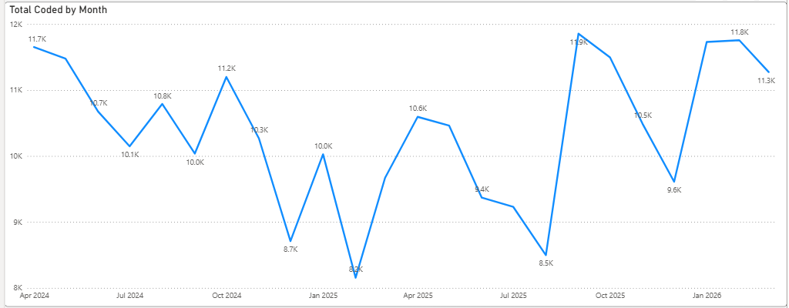
The 15,321 discharges in March 2026 were significantly higher than the 13,800 discharges that were projected in the April 2026 in-month coding completeness trajectory. Analysis has shown this is the highest number of in-month discharges in six years, predominantly driven by increased endoscopy and ophthalmology activity, with these areas alone accounting for approximately 1,000 additional procedures compared to the previous month. Therefore, due to the additional number of discharges, it is anticipated that the in-month clinical coding trajectory for April 2026 will be 73%, reduced from 81%.
Coding Month | Total Episodes Coded | In-Month % | In-month coded | Hywel Dda Backlog
November 2025 | 10,486 (73%) | 63% | 9,054 | 0
December 2025 | 9,604 (72%) | 61% | 8,108 | 0
January 2026 | 11,729 (87%) | 80% | 10,790 | 0
Trajectory: February 2026  Actual: | 11,500 (81%)  11,756 (83%) | 63%  68% | 8,850  9,602 | 2,650  2,100
Trajectory: March 2026  Actual: | 10,400 (79%)  11,273 (85%) | 63%  68% | 8,400  9,175 | 2,000  2,000
Updated Trajectory: April 2026 | 12,400 (81%) | 73% | 11,169 | 0
The deadline for coding 2025/26 episodes has been brought forward this financial year from the end of June to mid-June 2026, with the admitted patient care resubmission due on 15th June 2026. As a result, May 2026 will be used exclusively to code 2025/26 backlog, leading to a projected year-end coding position of between 78–81%. This is comparable to last year and achieved without the use of overtime or contract coders. In previous years, both May and June were required for backlog catch-up. Limiting backlog activity to May 2026 will therefore reduce carry-over pressure into the new financial year.
The clinical coding application continues to be used for the auto-coding of Neurology episodes. A dataset for Rheumatology episodes is currently in the process of being collated which will be used to develop an auto-coding model for Rheumatology. It is expected that this model will be available for testing in June 2026.

- GOVERNANCE AND RISK ISSUES
The Clinical Coding department is currently holding two vacant posts with the service improvement lead post set to go out to advert again in the next month after failing to recruit to the post previously. Recruitment to this post is the only remaining action from the Clinical Coding Audit Action plan.

The Clinical Coding risk around coding completeness rates has been escalated onto the Health Board risk register with a score of 20.

- FINANCIAL IMPLICATIONS
Implementation of re-banding and the auto-coding tool is within existing budgets.

- RECOMMENDATION
The Committee is asked to receive the report for assurance.

Governance and Assurance
Link to Enabling Objectives  (please choose) | Supporting better health and wellbeing by actively promoting and empowering people to live well in resilient communities
Link to Enabling Objectives  (please choose) | Partnerships for Improving Health and Wellbeing |  | ☐
Link to Enabling Objectives  (please choose) | Co-Production and Health Literacy |  | ☐
Link to Enabling Objectives  (please choose) | Digitally Enabled Health and Wellbeing |  | ☐
Link to Enabling Objectives  (please choose) | Deliver better care through excellent health and care services achieving the outcomes that matter most to people
Link to Enabling Objectives  (please choose) | Best Value Outcomes and High Quality Care |  | ☒
Link to Enabling Objectives  (please choose) | Partnerships for Care |  | ☐
Link to Enabling Objectives  (please choose) | Excellent Staff |  | ☐
Link to Enabling Objectives  (please choose) | Digitally Enabled Care |  | ☐
Link to Enabling Objectives  (please choose) | Outstanding Research, Innovation, Education and Learning |  | ☐
Health and Care Standards
(please choose) | Staying Healthy |  | ☐
(please choose) | Safe Care |  | ☐
(please choose) | Effective Care |  | ☐
(please choose) | Dignified Care |  | ☐
(please choose) | Timely Care |  | ☐
(please choose) | Individual Care |  | ☐
(please choose) | Staff and Resources |  | ☐
Quality, Safety and Patient Experience
Clinical Coding is used from a quality perspective to inform the Health Board Welsh Costing Returns (WCRs), completion of freedom of Information Requests (FOIAs) where clinical data is requested, and also population health requests when planning for future services. These services can also have a direct impact on patient experience.

Financial Implications
Cost-neutral plan within existing budgets has been approved for the recruitment of additional trainee coders, re-banding of department and implementation of auto-coding solution.

Legal Implications (including equality and diversity assessment)
Staffing Implications
Non-recruitment of staff will continue to have a detrimental effect on achieving the Tier 1 Target.

Long Term Implications (including the impact of the Well-being of Future Generations (Wales) Act 2015)
Report History |  | March 5th 2026
Appendices

