Meeting Date | 13 May 2025 |  | Agenda Item |  |  | 4.2
Name of Meeting | Digital, Data, Research and Innovation Committee
Report Title | Digital Transformation Progress Report
Report Author | Deirdre Roberts, Assistant Director of Digital Transformation, Kerith Jones, Interim Head of Value Based Healthcare
Report Sponsor | Matthew John, Director of Digital
Presented by | Deirdre Roberts, Assistant Director of Digital Transformation
Freedom of Information | Open
Purpose of the Report | The paper provides an overview of the digital progress made across the Health Board during the reporting period (March ‘25 and April ‘25).
Key Issues | - The long-term sustainability of health and social care is dependent on having the right digital foundations in place.  - The Health Board’s digital plan is aligned to the recently approved Digital Strategy, and the three priority components that contribute to the delivery of health and social care record.  - The Health Board’s digital plan is aligned to the delivery actions set out in the Health Board plan for FY 25/26.  - Most digital projects included in the digital plan for FY24/25 are progressing to schedule or are within their programme tolerance.  - Delays pertaining to the delivery of key diagnostics projects have been escalated locally and/or nationally; Cancer Network Information System Cymru replacement; Radiology Information Management System and the Laboratory Information Management System.
Specific Action Required  (please choose one only) | Information | Discussion |  | Assurance | Approval
Specific Action Required  (please choose one only) | ☐ | ☒ |  | ☐ | ☐
Recommendations | Members are asked to:  - Receive the update on progress being made across the digital portfolio of projects year to date.  - Consider the process in place to manage risks related to the delivery of the digital plan.

DIGITAL TRANSFORMATION PROGRESS REPORT

- INTRODUCTION
The paper provides a summary on the digital transformation progress across the seven key digital programmes of work during the reporting period (March ’25 and April ’25).

DIGITAL ANNUAL PLAN PROGRESS
The Red Amber Green (RAG) status used within this report is aligned to the Integrated Medium-Term Plan (IMTP) quarterly reporting mechanisms. Table 1 provides a key of the statuses that are used to reflect delivery against the milestones outlined in the plan.
Table 1
Green | ON TRACK - Action progressing as planned and to agreed timelines
Amber | OFF TRACK - Action not progressing as planned/to original timelines, however this is manageable, and mitigating actions are in place
Red | OFF TRACK - Action not progressing as planned/to original timelines, there are significant issues which require escalating

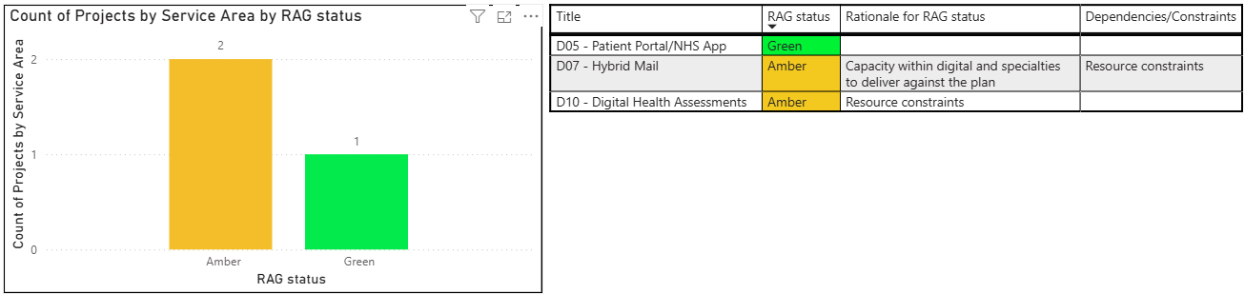
2.1 Patient Empowerment
Swansea Bay Patient Portal <Green>: A public communication campaign to promote the availability and benefits of the Swansea Bay Patient Portal (SBPP) is underway. Total number of patients registered to date is 11,997, of which 2,3457 have signed up during the reporting period. Focus for Q1 continues to be targeted communications in outpatient clinics, hospital reception (volunteer staff), General Practice surgeries and regional events, including the Eisteddfod and PRIDE whilst continuing a social media campaign. Integration of the Swansea Bay Patient Portal with the NHS Wales app has completed and testing with a small number of patients is due to conclude in Q1. The digital team is working with Digital Health and Care Wales (DHCW) to align communications in readiness for the Ministerial launch of the NHS Wales app in September ’25.

Hybrid Mail <Amber>: 7 services are live with the solution; 2 services went live during the reporting period (gastroenterology and endocrinology). Resource constraints from an operational perspective have limited adoption of the solution with additional services. The resource constraint has been escalated to the planned care board and discussions are underway with the Health Board Modernisation Outpatient Modernisation group to confirm priorities for 25/26.

VALUE BASED HEALTH CARE: Digital Health Assessment Solution <Amber>: 3 services went live during the reporting period capturing Digital Health Assessments (DHA’s) from surgical procedures and inpatient discharge; 9 services are now live. Auto form triggers from surgical waiting lists are due to go live at the end of June. This trigger will enable frailty screening to send Digital Health Assessments to their first cohort of patients automatically. The second auto waiting list trigger from referral to treatment (RTT) is due to go live at the beginning of September ‘25.
The Health Board continues to support work nationally including:
- Single Sign-On for Promptly – delayed by 4 weeks, revised go live date is 12th May ‘25.
- Promptly Patient Portal via NHS App – waiting for roll-out plan from Digital Services for Patients and Public (DSPP) and Kainos (3rd party provider supporting development).
- Data Standards Patient Reported Outcome Measures (PROMs) Standard Operating Model (PSOM) – work ongoing with Welsh Value in Health Centre (WViH) and Promptly Health.
- Engagement/analytics view within Promptly – testing underway, release date is 12th May ‘25.
- Digital Health Assessments viewed within Welsh Clinical Portal (WCP) – Hywel Dda health board is currently scoping to inform the national approach.

VALUE BASED HEALTH CARE: 3Ps Waiting Well National programme <Green>: PROMOTING Healthy Lifestyle, PREVENTING Deterioration and PREPARING patients for treatment or surgery. Waiting Well (WW) website link and Quick Response (QR) code (included on patient letters), have been sent to 245k patients to date. 3,445 hits to the website in March ‘25, compared to 476 in March ‘24. The Single Point of Contact team is almost in place, final 2.5 whole time equivalent (WTE) call handlers’ recruitment underway.
Health Screening Questionnaire (HSQ) screens patients referred for surgery to understand how ‘fit for surgery’ they are. The questions comprise of waiting list validation questions, frailty screening and national pre-assessment screening questions. The Health Screening Questionnaire continues to be manually validated by the Single Point of Contact (SPOC) team with a view manual validation will conclude by mid-May ‘25. Configuration and on boarding in Promptly will commence in June ‘25 such that the services will go live with the digital platform at the beginning of September ’25.
The Waiting Well holistic assessment question set is being finalised, going live in Promptly at the beginning of September ’25. The Health Board will be sending this question set to patients newly referred to the Health Board. These questions signpost patients to services that promote healthy lifestyle and self-management of symptoms.

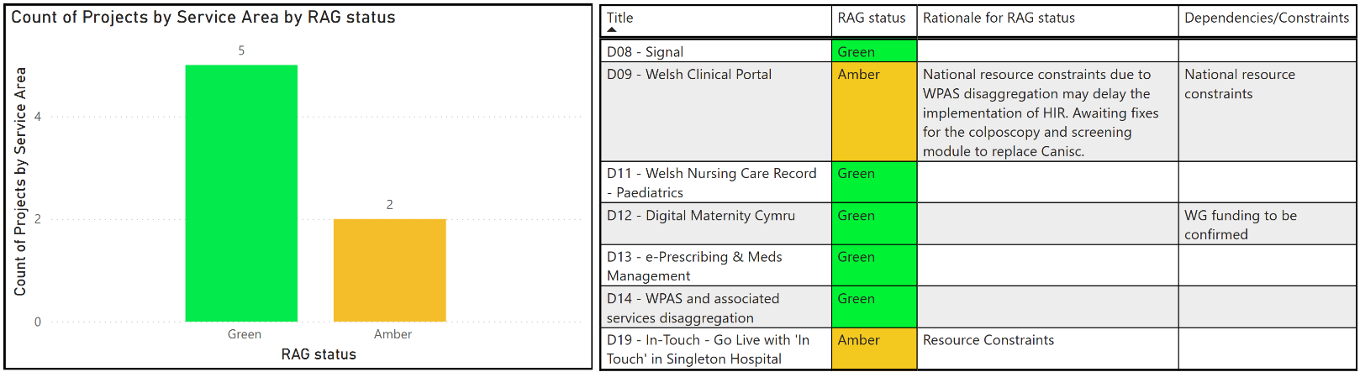
2.2 Planned Care
Signal <Green>: Development of v3.5 has concluded, and testing is underway in readiness for deployment in the first week of June (a 6-week delay to the original release date given the extended scope of the release and an urgent requirement to support Welsh Government reporting for package of care delays from April ‘25). The release will include capturing of mental health metrics to support regulation 28 reporting requirements, care after death functionality and performance enhancements.
Welsh Clinical Portal (WCP) <Amber>: Hospital Initiated Referral (HIR) functionality has been developed in Welsh Clinical Portal (WCP) to enable the electronic sending of internal hospital referrals. The solution is live enabling referrals from the Emergency Department to Neurology. Fixes to facilitate further rollout have been deployed and referrals from all services to Neurology is scheduled to go live mid – May ‘25. The Colposcopy and Screening module of Welsh Clinical Portal (WCP) did not go live on 31st March; further issues have been identified during testing. Fixes are expected by the 9th May, a revised go live date will be scheduled, on the assumption testing is successful. All health boards are required to go-live simultaneously and the digital team continue to meet with Digital Health and Care Wales daily to support a safe transition and implementation. Confirmation on the availability of Cancer Network Information System Cymru for up to 16 weeks following the Screening and Colposcopy go-live, has been confirmed by Digital Health and Care Wales. The Health Board has written to Digital Health and Care Wales to emphasise the importance of maintaining Cancer Network Information System Cymru access for the 16-week period (refer to Appendix A).
Digital Maternity Cymru <Green>: The business case was submitted to the Welsh Government on 1st April ’25 and is currently under review. Procurement has been completed, the System C contract has been signed, and the purchase order finalised. The Health Board is awaiting the funding letter from Welsh Government. Kick off meetings to plan for delivery are being scheduled with System C.
Hospital electronic Prescribing and Medicines Administration (HEPMA) <Green>: Scoping of an implementation in intensive care is underway. A decision to proceed with the implementation will need to be considered alongside the proposed way forward for the Welsh Intensive Care Information System (WICIS) programme.

In Touch implementation at Singleton: <Amber>: Priorities for the Health Board outpatient modernisation programme (including In Touch), are being considered in light of resource constraints across operational and digital teams.

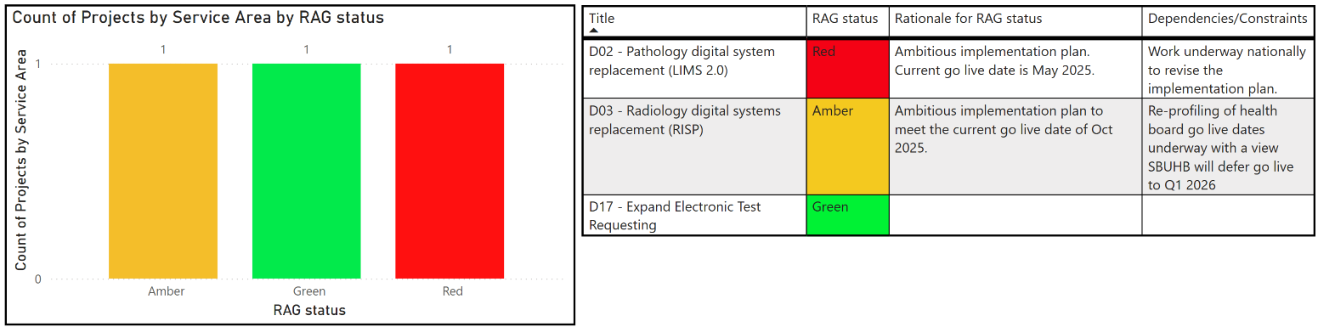
2.3 Diagnostics

Laboratory Information Management System 2 <Red>: The original go live date of May ’25 has been delayed due to the number of defects raised during user acceptance testing across Wales. Concerns relating to the number of issues identified during testing have been escalated collectively by all Health Boards to the national programme board. Additionally, the Swansea Bay Chief Executive escalated local concerns to Digital Health and Care Wales in readiness for discussion at the April all Wales Chief Executive meeting (refer to Appendix A). In response to these escalations, the national programme is conducting deep dive workshops to develop a revised implementation plan, which includes exploration of alternative options such as deployment by discipline.
Radiology Information System Procurement <Amber>: This ambitious national programme will replace the current Radiology Information System (RIS) and Picture Archive Communication System (PACS). The Health Board is scheduled to go live in October ‘25. Discussions between Digital Health and Care Wales, the supplier (Phillips) and Health Board colleagues are underway to re-baseline the national plan which includes a revised Swansea Bay UHB go live date of Q1 FY26/27.

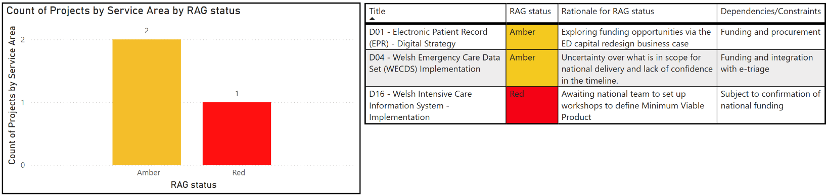
  - Unscheduled Care

Electronic Patient Record (EPR) <Amber>: The digital team are engaging with the Emergency Department capital redesign programme to establish if funding for the unscheduled care module of the electronic patient record can be included in the emergency department redesign business case with a view that, when submitted to Welsh Government, the digital element of the case can be endorsed and funded by the Digital Prioritisation Investment Fund (DPIF).

Welsh Emergency Care Data Set (WECDS) <Amber>: The Health Board continues to engage with the national Welsh Emergency Care Data Set programme and are developing a local implementation plan that aligns with the national programme. Submission of a delivery plan is required to secure funding for resources to support delivery.

Welsh Intensive Care Implementation System (WICIS) <Red>: Refer to business case paper for update.

  - Integrated Health and Care
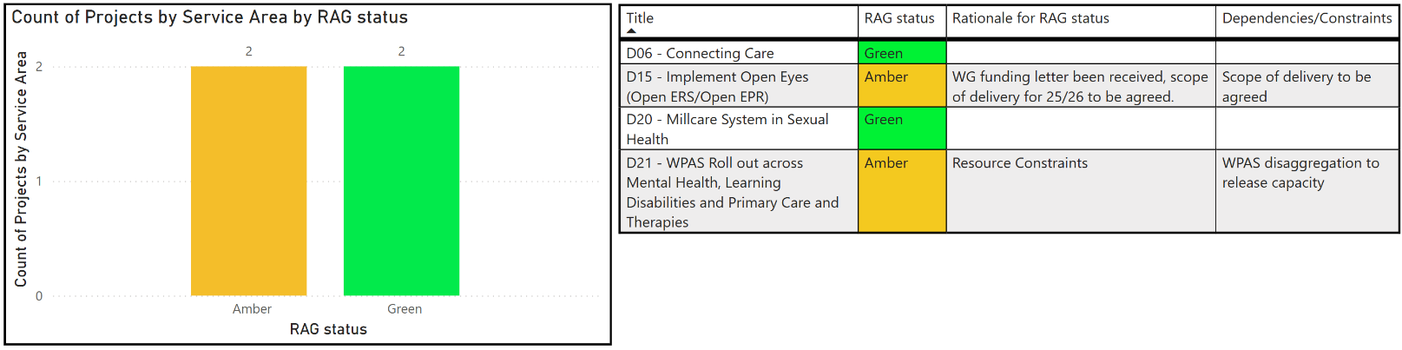

Open Eyes <Amber>: Discussions have been held with Cardiff and Vale Health Board to agree the best approach to support the implementation of Open Eyes. A recommendation on the way forward has been presented to key leads in the Ophthalmology service in readiness for submission to the Open Eyes Project Board for approval. Confirmation of funding has been received from Welsh Government to support the implementation.

Welsh Patient Administration System (WPAS) implementation for Mental Health, Learning Disabilities, Primary Care and Therapies: <Amber>: This work is dependent on the successful completion of the Welsh Patient Administration System disaggregation work and will be undertaken on a best endeavours basis. The follow-on work from the Welsh Patient Administration System disaggregation will be more extensive than originally anticipated as described in the Operational Performance paper. Implementation across Mental Health, Learning Disabilities, Primary Care and Therapies will be based on services that have been identified as a priority. This is a short to medium solution prior to a wider roll out of the regional or national solution for Mental Health, Learning Disabilities, and Community Health.

Digital Infrastructure
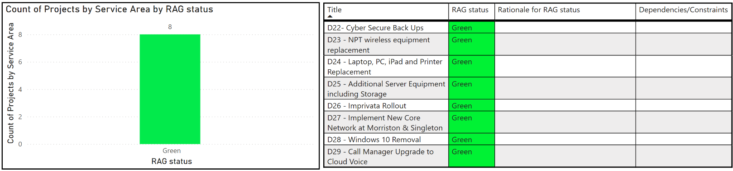

Imprivata (solution to facilitate fast log in to computer systems) <Green>: Imprivata provides a solution to facilitate fast access to computer systems. The login to the computer is made quicker and easier by simply tapping an Identity (ID) card on a card reader instead of entering a login and password using a computer keyboard, similar to chip and Personal Identification Number (PIN) when paying for goods.

Rollout across most in-patient wards has completed; implementation continues into Q1 of 25/26 across theatres and outpatients.

Technology Refresh <Green>: The Health Board received significant capital funding in 24/25 to address priority infrastructure technology refresh requirements, which will also strengthen the Health Board’s cyber resilience. The following key programmes of work are now in progress:
- Replacement of the core networks at Morriston and Singleton has commenced, with testing underway at both sites. This is expected to complete by the end of Q2.
- Replacement of the Singleton Hospital network by replacing the hospital network switches which provide access to computers, video surveillance systems, and medical equipment such as Computerised Tomography (CT) scanners and Magnetic Resonance Imaging (MRI) scanners. This work will commence on completion of the core networks replacement.
- Replacement of the wireless network at Neath Port Talbot Hospital is currently in the planning stages and is scheduled to commence in Q2.
- The replacement of the computer backup system providing additional protection against cyber-attacks has been installed and is currently being configured with a view to this work will be completed in Q2.
- The replacement of unsupported desktop and laptop computers whilst also migrating from Windows 10 to 11 in parallel is progressing well. The migration to Windows 11 is currently at 78% of desktops and laptop computers, with a target completion date of October ‘25.

2.7 Business Intelligence (BI)
<Green>: Key achievements include the launch of the weekly health board summary report which is sent automatically to executives on Monday mornings. Other achievements include the Maternity App to help support the monitoring of maternity performance and the addition of outpatient reports into the Mental Health and Learning Disabilities App including self-service tools for the user to create their own charts. Initial testing has completed on the machine learning auto-coding solution and a plan is being put in place to productionise it across select specialties. A further 50 staff have attended one of the Digital Intelligence Data Literacy Courses since the last update.

- GOVERNANCE AND RISK ISSUES
Governance
The digital plan is overseen by the Digital Leadership Group (DLG), which has representation from each corporate directorate and service delivery group and meets quarterly. The Digital Leadership Group reports to Management Board. The delivery of the digital plan continues to be managed by digital programme boards, providing updates and/or escalations (where appropriate) to Digital Leadership Group.

Risk
Risks pertaining to the delivery of digital programmes are managed via the relevant programme board and escalated to Digital Leadership Group when necessary. Risks that impact a live operational service will be recorded via the digital service management group (DSMG). Where a digital risk impacts a service or a service delivery group (SDG), digital services will work with the relevant service delivery group to ensure the risk and associated impact is reflected on the service delivery group risk register and where relevant, escalated to the Health Board risk register.

- RECOMMENDATION
Members are asked to:
- Receive the update on progress being made across the digital portfolio of projects year to date.
- Consider the process in place to manage risks related to the delivery of the digital plan.

Governance and Assurance

Link to Enabling Objectives  (please choose) | Supporting better health and wellbeing by actively promoting and empowering people to live well in resilient communities
Link to Enabling Objectives  (please choose) | Partnerships for Improving Health and Wellbeing |  | ☒
Link to Enabling Objectives  (please choose) | Co-Production and Health Literacy |  | ☒
Link to Enabling Objectives  (please choose) | Digitally Enabled Health and Wellbeing |  | ☒
Link to Enabling Objectives  (please choose) | Deliver better care through excellent health and care services achieving the outcomes that matter most to people
Link to Enabling Objectives  (please choose) | Best Value Outcomes and High-Quality Care |  | ☒
Link to Enabling Objectives  (please choose) | Partnerships for Care |  | ☒
Link to Enabling Objectives  (please choose) | Excellent Staff |  | ☒
Link to Enabling Objectives  (please choose) | Digitally Enabled Care |  | ☒
Link to Enabling Objectives  (please choose) | Outstanding Research, Innovation, Education and Learning |  | ☐
Health and Care Standards
(please choose) | Staying Healthy |  | ☒
(please choose) | Safe Care |  | ☒
(please choose) | Effective Care |  | ☒
(please choose) | Dignified Care |  | ☒
(please choose) | Timely Care |  | ☒
(please choose) | Individual Care |  | ☒
(please choose) | Staff and Resources |  | ☒
Quality, Safety and Patient Experience
Implementation of digital systems in healthcare can have a significant positive impact on quality, safety, and patient experience. Critical to success is the wide scale adoption of an effective business change model, digital service team capacity and capability, workforce digital skills and clinical leadership.
Financial Implications
Please reference agenda: Digital Financial Management
Legal Implications (including equality and diversity assessment)
None.
Staffing Implications
Increasing numbers of staff will be required to deliver the digital change programme in SBUHB. This will be detailed in future workforce plans, individual business cases and digital priorities and plans.
Long Term Implications (including the impact of the Well-being of Future Generations (Wales) Act 2015)
- Long Term – Health and Social Care “A Healthier Wales” (2018) sets out a long-term future vision of a ‘whole system approach to health and social care’, which is focussed on health and wellbeing, and on preventing illness
- Wellbeing of Future Generations Act (2015)
  - Focus on prevention, not service provision.
  - Prevent ill health, reduce impact of illness or injury and delay onset of frailty.
  - Provide services to carers that prevent, reduce, or delay them developing a need for support.
- Swansea Bay University Health Board’s Clinical Services Plan (2019-2024)
  - Adoption of digital solutions and technology.
  - Create a mobile workforce that is digitally connected to ensure staff work seamlessly to ‘Make Every Contact Count’.
  - Technology to support care closer to the patient’s home or in the community.
Report History
Appendices |  | Appendix 1

