Meeting Date | 10 July 2025 |  | Agenda Item |  |  | 5.1
Name of Meeting | Digital, Data, Research and Innovation Committee
Report Title | Delivery of the Digital Strategy and 2025/26 Plan
Report Author | Deirdre Roberts, Assistant Director of Digital Transformation  Gareth Westlake, Assistant Director of Digital Business Management and Information Governance
Report Sponsor | Matthew John, Director of Digital
Presented by | Deirdre Roberts, Assistant Director of Digital Transformation
Freedom of Information | Open
Purpose of the Report | This paper sets out the approach to demonstrate how the strategic objectives of the Digital Strategy will be operationalised through the Integrated Medium-Term Plan (IMTP) and the 2025/26 digital delivery plan. The paper also provides a summary of digital transformation progress for Q1 FY2025/26.
Key Issues | - The long-term sustainability of health and social care is dependent on having the right digital foundations in place.  - The Health Board’s digital plan is aligned to the recently approved Digital Strategy, and the three priority components that contribute to the delivery of a health and social care record.  - To provide the DDRI Committee with assurance that the delivery of the Digital Strategy is aligned with both the Health Board’s Integrated Medium-Term Plan (IMTP) including the 2025/2026 Digital Work Programme, three interlinked components are presented:  - 3-year plan on a page  - 2025/26 Timeline  - Project Delivery Dashboard  - Delays pertaining to the delivery of projects have been escalated locally and/or nationally: Radiology Information Management System, Laboratory Information Management System, Connecting Care and the Welsh Emergency Care Dataset.
Specific Action Required  (please choose one only) | Information | Discussion |  | Assurance | Approval
Specific Action Required  (please choose one only) | ☐ | ☒ |  | ☐ | ☐
Recommendations | Members are asked to:  CONSIDER: the refreshed approach to demonstrate how the strategic objectives of the Digital Strategy are being operationalised through the IMTP and the 2025/2026 digital delivery plan.  RECEIVE: the update on Q1 FY2026/2026 progress made across the digital portfolio.  CONSIDER: the risks related to the delivery of the digital plan for FY 2025/2026.

DELIVERY OF THE DIGITAL STRATEGY AND 2025/26 PLAN

- INTRODUCTION
The Digital Data Research and Innovation (DDRI) committee has emphasised the importance of ensuring the delivery of Swansea Bay University Health Board’s (SBUHB) Digital Strategy is aligned with the organisation’s Integrated Medium-Term Plan (IMTP) which includes the 2025/2026 digital work programme. This alignment is essential, not only to maintain strategic coherence across the Health Board’s transformation agenda, but also to provide assurance to members that digital investments are enabling tangible improvements in patient care, operational efficiency, and organisational resilience.

This paper responds directly to the DDRI Committee’s request for assurance by setting out the approach to demonstrate how the strategic objectives of the Digital Strategy are being operationalised through the IMTP and the 2025/2026 digital delivery plan.

The paper also provides a summary of digital transformation progress for Q1 FY 2025/2026 across eight programmes of work, aligned to the newly proposed Health Governance structure.

BACKGROUND

The Digital Strategy, published in March 2025, sets out a vision to harness the power of digital technology and transformation to improve the health and well-being of the population of Swansea Bay. It outlines a ten-year roadmap for becoming a digitally mature, data-driven, and patient-centred organisation. The success of this strategy depends on its integration with the Health Board’s strategic planning and delivery mechanism.

To provide the DDRI Committee with assurance that the delivery of the Digital Strategy is aligned with both the Health Board’s Integrated Medium-Term Plan (IMTP) including the 2025/26 Digital Work Programme, three interlinked components have been developed and are presented below.

2.1 Plan on a Page
The three-year “Plan on a Page” provides a high-level view of the digital transformation journey for 2025 – 2028. It demonstrates how key programmes and enabling capabilities such as infrastructure upgrades, digital front door initiatives, data platform enhancements, and workforce development are sequenced. It serves as a reference point for internal stakeholders, including the DDRI Committee, demonstrating the following:

- Clarity of Delivery: Enabling stakeholders to see how strategic ambitions are being operationalised over time, and where key milestones and decision points lie.
- Assurance of Progress: Providing a clear line of sight on delivery and/or delays, risk exposure, and benefits realisation.
- Alignment and Prioritisation: It supports alignment with the IMTP, financial planning cycles and the newly established Health Board governance framework, aiding prioritisation.
- Communication and Engagement: It offers a concise and accessible way to communicate the digital roadmap to staff, partners and the public.

The “Plan on a Page” will be updated periodically and used alongside the 2025/2026 timeline and Project Delivery Dashboard to provide a comprehensive view of digital delivery and strategic alignment. Figure 1 overleaf sets out the 3-year plan.

Figure 1 - “Plan on a Page”
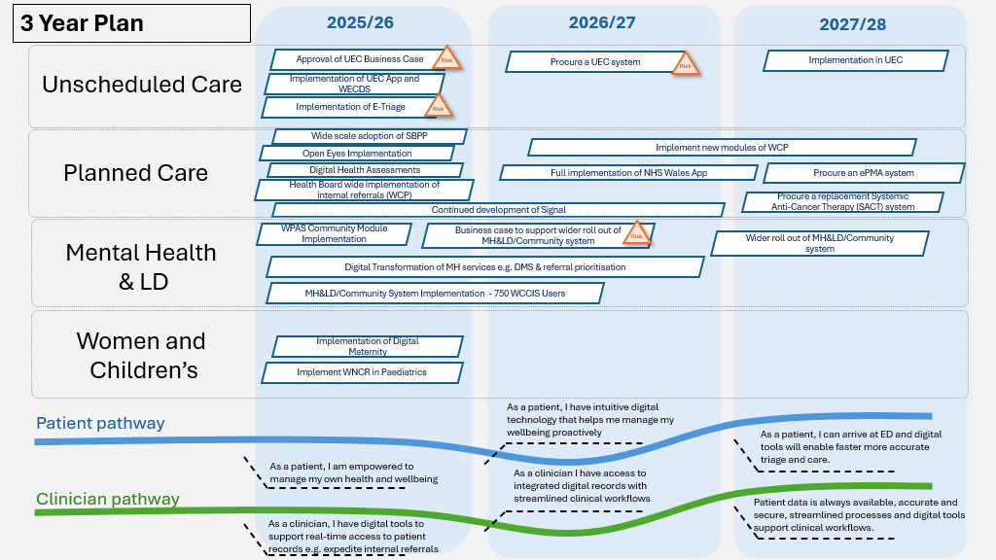

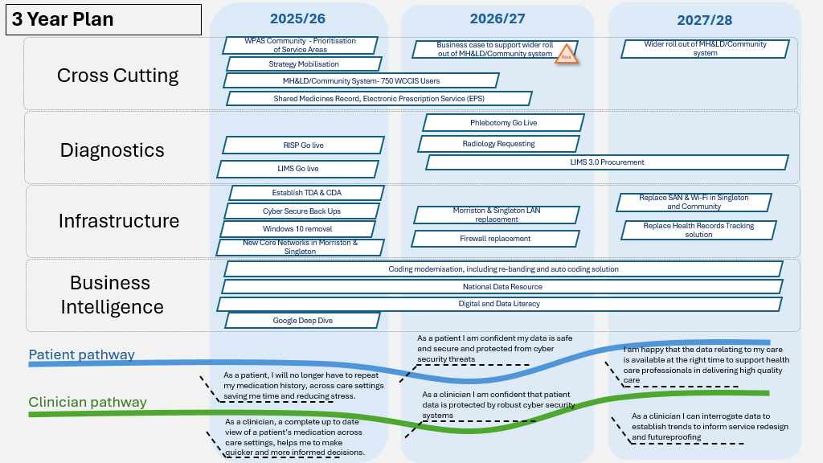
2.2 FY 2025/2026 Timeline
The purpose of the timeline is to outline key milestones for delivery across FY 2025/2026, offering a high-level roadmap of when major digital workstreams will be initiated, progressed, and / or completed. The timeline is designed to support assurance by showing how each milestone aligns with the Digital Strategy and the priorities articulated in the Health Board’s Integrated Medium-Term Plan (IMTP). For the FY 2025/2026 period in particular, the timeline highlights:
- Milestones that are fully aligned to both the Digital Strategy and the IMTP, demonstrating clear strategic and operational coherence.
- Milestones that align to one but not both, for example, where a workstream was included in the IMTP but not explicitly referenced in the Digital Strategy, or vice versa.
- Milestones that are not aligned to either the current IMTP or the published Digital Strategy but have emerged as organisational priorities. These may reflect urgent operational needs, national directives, or opportunities for innovation that have arisen in-year.

This categorisation provides the DDRI Committee with a transparent view of how the digital portfolio is evolving, where delivery is tracking against plan, and where flexibility has been required to respond to emerging priorities. It also supports more informed decision-making around resource allocation, risk management, and benefits realisation.

Figure 2 shows the FY2025/26 timeline including key milestones to mobilise the strategy. It is proposed that the timeline is updated on a quarterly basis.

Figure 2 – FY2025/26 Timeline
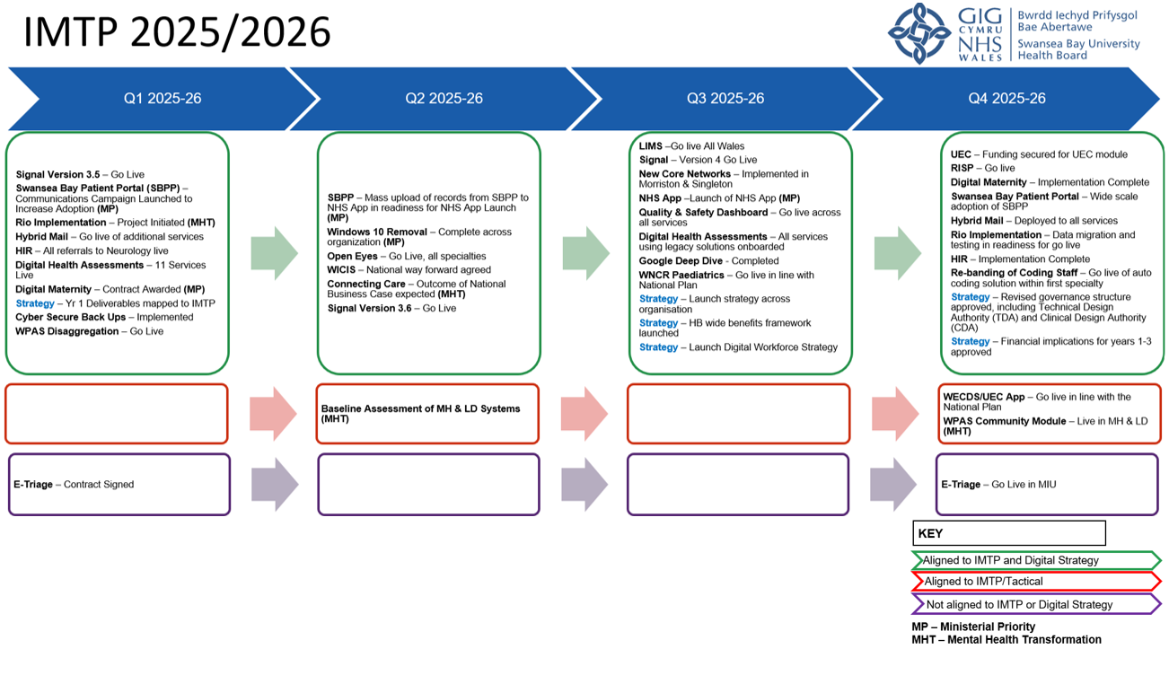
2.3 Project Delivery Dashboard
A detailed Project Delivery Dashboard for active Digital projects in FY 2025/2026 has been developed. It tracks progress, sets out the associated RAG status and milestones for forthcoming periods. Figure 3 is a summary of the Dashboard and shows the Q1 RAG status of each project. The dashboard will be updated monthly.

Figure 3 – Project Delivery Dashboard Q1 Status
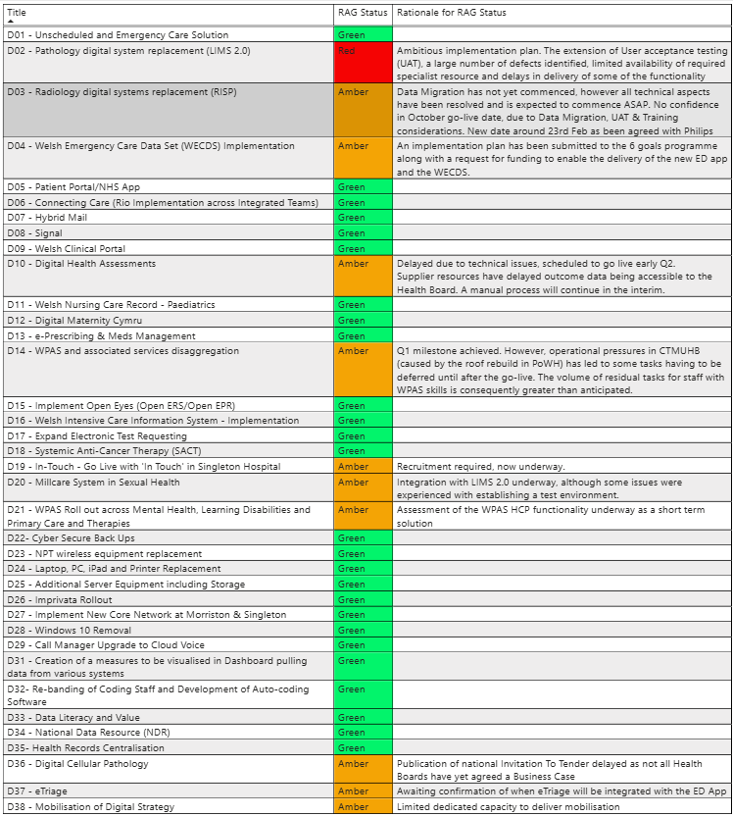

- GOVERNANCE AND RISK ISSUES
Governance
The digital plan is overseen by the Digital Leadership Group (DLG), which has representation from each corporate directorate and service group and meets quarterly. The Digital Leadership Group reports to Management Board. The delivery of the digital plan continues to be managed by digital programme boards, providing updates and/or escalations (where appropriate) to the Digital Leadership Group.

Risk
Risks pertaining to the delivery of digital programmes are managed via the relevant programme board and escalated to the Digital Leadership Group when necessary. Risks that impact a live operational service will be recorded via the digital service management group (DSMG). Where a digital risk impacts a service or a service delivery group (SDG), digital services will work with the relevant service delivery group to ensure the risk and associated impact is reflected on the service delivery group risk register and where relevant, escalated to the Health Board risk register.

Programmes at risk to delayed delivery are set out below:

- Laboratory Information Management System (LIMS): The ongoing User Acceptance Testing of the new Laboratory Information Management System (LIMS) has identified numerous issues, jeopardizing the all-Wales October 2025 deadline. A proposal from the National Programme Board, presented to Chief Executives and Directors of Digital on 11th June, suggests shifting the rollout strategy from organisation-specific to pathology discipline-specific and extending the availability of the current LIMS to December 2025. This proposal has an estimated cost of £1.6m across Wales. The Health Board is awaiting confirmation of the proportion of costs attributable to Swansea Bay University Health Board (SBUHB) to inform local discussions. Additionally, Swansea Bay is the only Health Board in Wales reliant on the current LIMS for Blood Transfusion, creating added pressure to transition to the new LIMS by the end of December 2025. A risk was approved for escalation to the Health Board Risk Register at the June SBUHB Risk Management Group (Datix ID 3114 – score 20).

- Radiology Information System Programme: The Health Board is scheduled to go live in October 2025. However, due to local and national concerns regarding Philips' delayed delivery, a formal request to revise the go-live date has been sent to Philips. The response received, which requires assurance from the national programme board, supports deferring the Swansea Bay go-live from October 2025 to February 2026. To mitigate the impact of potential delays beyond March 2026, the current PACS contract with Fuji has been extended to March 2027. This delayed go-live to February/March 2026, therefore, also offers the benefit of reduced dual running costs alongside the Fuji contract.
This risk is recorded on the Morriston SDG risk register with regular updates being presented to Morriston senior leadership team meetings and management board.

- Connecting care: Refer to Mental Health Transformation Programme; digital update paper. Risks relating to the delayed delivery for a service wide solution have been captured in the paper.

- Welsh Emergency Care Data Set: The Minor Injury Unit currently use the Welsh Emergency Department System (WEDS) provided by Optum. The contract expires in September 2026. As an interim solution, DHCW developed “the ED App” (including the dataset) which is being proposed as a replacement solution by the national 6 goals programme, until such time the Health Board can procure a 3rd party product. Concerns relating to delayed delivery of the solution coupled with requirements for local integration have been escalated to the Health Board UEC board with a view a discussion between the Health Board Chief Operating Officer, digital colleagues and the national 6 goals Programme Director is scheduled for mid-July.

- Strategy mobilisation: additional capacity is required to mobilise the Digital Strategy. Options are currently being explored to create the capacity and capability required to support this work within existing budgets. Alignment to the national approach and Ministerial priorities is also a key component in mobilising the Digital Strategy, the impact of the recommendations from the recent report from the Ministerial Advisory Group are currently being considered.

- FINANCIAL IMPLICATIONS

As outlined in previous reports the Digital Strategy will require significant investment to achieve the desired service-led, digitally enabled transformation. Digital experts suggest allocating 5-10% of total Health Board income to digital and data to reach digital maturity. The current annual spend on data and digital at SBUHB is just over 2%, and the strategy sets out the indicative requirement to increase this allocation to 4.6% over the next 10 years.

As previously reported progress has been made in terms of securing funding for delivery of solutions in 2025/26 including funding for the interim solution for integrated teams and to support the implementation of Open Eyes. Since the last update to DDRI funding has also been confirmed by Welsh Government for implementation of the Maternity EPR.

Discussions continue to be held with Welsh Government on the approach to securing funding for a system within unscheduled care and the costs for Connecting care have been included in the National Outline Business Case.

A detailed update on the financial management of Digital Services for 2025/26 is contained within a separate paper to DDRI.

It is recognised however, that further work will be required to ensure that the financial investment required is prioritised as part of the ongoing IMTP process for 2026/27 and beyond. The three-year investment plan outlined within the Digital Strategy will be reviewed prior to engagement with the CEO and Director of Finance. Digital will also engage on the development of the Health Board’s benefits framework to ensure the alignment of the Digital Strategy and the value of benefits it can deliver are appropriately quantified.

- RECOMMENDATION

Members are asked to:

CONSIDER: the refreshed approach to demonstrate how the strategic objectives of the Digital Strategy are operationalised through the IMTP and the 2025/26 digital delivery plan.

RECEIVE: the update on progress being made across the digital portfolio during Q1 FY2025/2026.

CONSIDER: the risks related to the delivery of the digital plan for FY2025/2026.

Governance and Assurance

Link to Enabling Objectives  (please choose) | Supporting better health and wellbeing by actively promoting and empowering people to live well in resilient communities
Link to Enabling Objectives  (please choose) | Partnerships for Improving Health and Wellbeing |  | ☒
Link to Enabling Objectives  (please choose) | Co-Production and Health Literacy |  | ☒
Link to Enabling Objectives  (please choose) | Digitally Enabled Health and Wellbeing |  | ☒
Link to Enabling Objectives  (please choose) | Deliver better care through excellent health and care services achieving the outcomes that matter most to people
Link to Enabling Objectives  (please choose) | Best Value Outcomes and High-Quality Care |  | ☒
Link to Enabling Objectives  (please choose) | Partnerships for Care |  | ☒
Link to Enabling Objectives  (please choose) | Excellent Staff |  | ☒
Link to Enabling Objectives  (please choose) | Digitally Enabled Care |  | ☒
Link to Enabling Objectives  (please choose) | Outstanding Research, Innovation, Education and Learning |  | ☐
Health and Care Standards
(please choose) | Staying Healthy |  | ☒
(please choose) | Safe Care |  | ☒
(please choose) | Effective Care |  | ☒
(please choose) | Dignified Care |  | ☒
(please choose) | Timely Care |  | ☒
(please choose) | Individual Care |  | ☒
(please choose) | Staff and Resources |  | ☒
Quality, Safety and Patient Experience
Implementation of digital systems in healthcare can have a significant positive impact on quality, safety, and patient experience. Critical to success is the wide scale adoption of an effective business change model, digital service team capacity and capability, workforce digital skills and clinical leadership.
Financial Implications
Please reference agenda: Digital Financial Management
Legal Implications (including equality and diversity assessment)
None.
Staffing Implications
Increasing numbers of staff will be required to deliver the digital change programme in SBUHB. This will be detailed in future workforce plans, individual business cases and digital priorities and plans.
Long Term Implications (including the impact of the Well-being of Future Generations (Wales) Act 2015)
- Long Term – Health and Social Care “A Healthier Wales” (2018) sets out a long-term future vision of a ‘whole system approach to health and social care’, which is focussed on health and wellbeing, and on preventing illness
- Wellbeing of Future Generations Act (2015)
  - Focus on prevention, not service provision.
  - Prevent ill health, reduce impact of illness or injury and delay onset of frailty.
  - Provide services to carers that prevent, reduce, or delay them developing a need for support.
- Swansea Bay University Health Board’s Clinical Services Plan (2019-2024)
  - Adoption of digital solutions and technology.
  - Create a mobile workforce that is digitally connected to ensure staff work seamlessly to ‘Make Every Contact Count’.
  - Technology to support care closer to the patient’s home or in the community.
Report History
Appendices |  | Appendix 1

Appendix 1 – Digital delivery: Q2 progress report

The Red Amber Green (RAG) status used within this report is set out below.

Table 1

Green | ON TRACK - Action progressing as planned and to agreed timelines
Amber | OFF TRACK - Action not progressing as planned/to original timelines, however this is manageable, and mitigating actions are in place
Red | OFF TRACK - Action not progressing as planned/to original timelines, there are significant issues which require escalating

Planned Care

Signal <Green>: Version 3.5 was successfully deployed in June which included the capturing of mental health metrics to support regulation 28 reporting requirements, care after death functionality and performance enhancements.

Welsh Clinical Portal (WCP) <Green>:

Hospital Initiated Referral (HIR) functionality has been developed in Welsh Clinical Portal (WCP) to enable the electronic sending of internal hospital referrals. Referrals from all services to Neurology went live at the end of June with a view an additional 3 services (Dermatology, Respiratory and Urology) will go live in July. This will inform a Health Board deployment in Q3 FY2025/2026.

Defects identified by SBUHB in the testing of the Colposcopy and Screening module of Welsh Clinical Portal (WCP) have been resolved, a revised go live for early July (subject to all Wales approval) has been proposed. Daily calls to maintain momentum on defect resolution continues. DHCW have confirmed they will continue to support CANISC for 16 weeks post go live to support migration off the legacy system.

Swansea Bay Patient Portal <Green>: A public communication campaign to promote the availability and benefits of the Swansea Bay Patient Portal (SBPP) continues. Total number of patients registered to date is 14,150. A text messaging campaign to further increase adoption is scheduled from mid-July. The ministerial launch of the NHS Wales app has been deferred from September 2025. Further work is required to ensure consistency and wider deployment of the features by GP Practices.

Hybrid Mail <Green>: 9 services are live with the solution; 2 new services went live during the reporting period. A task and finish group has been established to oversee adoption of the solution across services. The group will focus on embedding the use of the patient portal, including the hybrid mail offering as part of the patient booking process. It will also report on financial efficiencies derived from the project.

Open Eyes <Green>: The regional Project Board and a Clinical Reference Group have been established to ensure alignment with clinical priorities and governance, both met in June 2025. The technical configuration is in progress, including process mapping and establishment of minimum data sets. A go-live date for a minimum viable product has been proposed for September 2025. Welsh Government has allocated £50,000 for the project, while SBUHB is reallocating internal resources to support implementation and ongoing costs.

Digital Health Assessment Solution <Amber>: 2 services went live collecting Digital Health Assessments (DHA’s) during this reporting period; 11 services are now live. Automatic form triggers from surgical waiting lists are due to go live 3rd July ‘25. This automatic trigger will enable frailty screening for patients waiting for surgery. The final automatic form trigger is from referral into the Health Board, due to go live at the beginning of September ’25, completing configuration of automatic form triggers from agreed patient activity events.

The Health Board continues to support work nationally including:
- Single Sign-On for Promptly Health – Completed.
- Promptly Health Patient Portal via NHS App – Roll out plan received and work commencing on relevant documentation.
- Data Standards for Patient Reported Outcome Measures (PROMs) Standard Operating Model (PSOM) – work ongoing with the national Value Transformation team and Promptly Health.
- Engagement/analytics view within Promptly Health – Completed testing with final sign-off due for the end of June ’25.
- Digital Health Assessments viewed within Welsh Clinical Portal (WCP) – Digital Health Care Wales (DHCW) are currently engaging with the national Value Transformation team for National PROMs visualisations. Health Boards will submit an ‘All Health Board’ request for local PROM visualisations.

3Ps Waiting Well National programme <Green>: PROMOTING Healthy Lifestyle, PREVENTING Deterioration and PREPARING patients for treatment or surgery. Waiting Well (WW) website link and Quick Response (QR) code (included on patient letters), have been sent to 353k patients to date, an increase of 110k since last reporting period. There were 2,050 hits to the website in May ‘25, compared to the baseline of 476 in March ’24. The Single Point of Contact team is now in place, with an additional 3.0 whole time equivalent (WTE) call handlers now recruited.

Health Screening Questionnaire (HSQ) screens patients referred for surgery to understand how ‘fit for surgery’ they are. The digital system to use is under review – waiting confirmation from Planned Care Board end of July 2025. The Health Screening Questionnaire continues to be manually collected by the Single Point of Contact (SPOC) team with a view to move over to digital system when confirmed.

The Waiting Well holistic assessment question set is currently seeking sign-off, going live in Promptly system at the beginning of September ’25, this will be manually collected via MS Forms in the interim. The Health Board will be sending this question set to patients newly referred to the Health Board, which signposts patients to services that promote healthy lifestyle and self-management of symptoms.

Diagnostics

Laboratory Information Management System 2 <Red>: User Acceptance testing of the new Laboratory Information Management System (LIMS) is ongoing and has highlighted a significant number of issues, putting the all-Wales October 2025 deadline at risk.

A proposal from the National Programme Board was presented to Chief Executives and Directors of Digital (11th June), proposing to:
- Shift the rollout strategy from organisation-specific to pathology discipline-specific.
- Extend availability of the current LIMS to December 2025.

The proposal has an estimated cost of £1.6m across Wales. The Health Board awaits confirmation of the proportion of costs attributable to SBUHB to inform local discussions.

Swansea Bay is the only Health Board in Wales reliant on the current LIMS for Blood Transfusion, creating an additional pressure to transition to the new LIMS by the end of December 2025.

Radiology Information System Procurement <Amber>: This ambitious national programme will replace the current Radiology Information System (RIS) and Picture Archive Communication System (PACS). The Health Board is scheduled to go live in October ‘25. A letter has been sent to Philips to request a revision to the Health Board go live date in response to local and national concerns relating to Phillps delayed delivery. A response has been received and whilst it needs to be assured by the national programme board, it validates the Health Board suggestion of deferring the Swansea Bay go live from October 2025 to February 2026. The SBU current PACS contract (Fuji) has been extended to March 2027 by way of mitigation should delivery timescales slip beyond March 2026. A delayed go live to February /March 2026 has an associated benefit of reduced dual running costs alongside the Fuji contract.

Women and Children
Digital Maternity <Green>: The local business case has been approved by Welsh Government, recruitment and planning is underway. The inaugural project board took place on 2nd June.

Unscheduled Care
Unscheduled Care and Emergency system <Green>: The digital team continue to engage with the Emergency Department capital redesign programme. A letter summarising the Health Board’s proposed approach including its intention to bid for funding for an unscheduled and emergency care system has been drafted for submission to Welsh Government.

Welsh Emergency Care Data Set (WECDS) <Amber>: The Health Board continues to engage with the national Welsh Emergency Care Data Set programme and a local plan to support delivery of the solution (replacing the current system in ED) has been submitted to the national programme board. Supporting information accompanying the plan sets out key requirements specific for Swansea Bay which need to be addressed prior to a go live. These key requirements reiterate the Health Board’s concerns that the solution will not provide a pervasive digital solution across all unscheduled and emergency care settings and the ambition therefore to procure a 3rd party solution to span unscheduled care and emergency settings.

e-triage <Amber>: The Six Goals for Urgent and Emergency Care National Programme have confirmed funding for the FY 2025-26 to implement an e-triage system in the Minor Injuries Unit (MIU) in Neath Port Talbot hospital in the first instance.

Work has commenced with technical teams to understand the functionality provided by the e-triage system and what is required to integrate with Symphony, the software that is currently utilised in the MIU. The digital team are awaiting a response from the Symphony team to confirm integration requirements and associated costs. The Health Board are also engaging with the national WECDS programme to establish whether the national ED App will integrate with the e-triage system in the first phase.

Welsh Intensive Care Implementation System (WICIS) <Green>: A series of clinical engagement workshops were undertaken in June to establish the scale of the required changes to support delivery of a safe solution. The output from the workshops will be submitted to the National Clinical Assurance Group (CAG) and programme board for consideration and discussion with the 3rd party provider (ASCOM) such that a national plan for delivery can be agreed by September 2025.

Mental Health and Learning Disabilities

Welsh Patient Administration System (WPAS) implementation for Mental Health, Learning Disabilities, Primary Care and Therapies: <Amber>: The Health Board has commissioned an independent review of its Mental Health and Learning Disability services which aims to provide a clear and objective assessment of the current provision of service.

The review has identified several priority areas which require immediate action, including digital and information reporting. It is recommended that digital and mental health services explore the use of the Health Care Professional (HCP) module of WPAS as an interim solution with a focus on community and outpatient services. Work is underway to establish the appropriateness of this solution to meet administrative and reporting requirements.

Assuming the HCP module is suitable, a plan to implement the solution across community and outpatient services will be developed.

Priority teams for implementation will include teams who currently use paper and / or manual processes to manage care and activity e.g., Single Point of Access and Crisis Resolution Teams.

Digital Infrastructure

Technology Refresh <Green>:
- The new core networks at Morriston and Singleton have been implemented, and work is underway to remove the old core network. This is expected to complete by the end of Q2.
- Replacement of the Singleton Hospital network by replacing the hospital network switches which provide access to computers, video surveillance systems, and medical equipment such as Computerised Tomography (CT) scanners and Magnetic Resonance Imaging (MRI) scanners. This work will commence toward the end of Q2 (September).
- Replacement of the wireless network at Neath Port Talbot Hospital is currently in the planning stages and is scheduled to commence in Q2 (August).
- The replacement of the computer backup system providing additional protection against cyber-attacks has been installed and the work completed ahead of schedule during Q1.
- The replacement of unsupported desktop and laptop computers whilst also migrating from Windows 10 to 11 in parallel is progressing well. The migration to Windows 11 is currently at 84% of desktops and laptop computers, with a target completion date of October ’25.

Business Intelligence (BI) <Green>: Key achievements include the launch of the weekly health board summary report which is sent automatically to executives on Monday mornings. Other achievements include the Bed Management App to help support the monitoring of available core beds and the newly launched "Your Next Patient" beds on each ward. End of life care reports have been added to the mortality app along with a range of supporting measures. Bed projections have been included in the Population Health App which show estimates for the number of beds that will be required over the next 20 years for different age cohorts. Data literacy course have also been continued to be delivered with 40 staff members attending during this period.

Cross-cutting

Connecting Care

RIO Implementation – 750 WCCIS users <Green>:
A contract has been awarded to The Access Group (TAG) to implement TAG’s core Rio product, plus additional access to (with a view to informing the development of) their Access Intelligent Care Platform (AICP), which will serve as the integrated care record between Rio and their Mosaic product (social care system) purchased by Swansea Council. The project has now been initiated, and readiness activities have accelerated, workshops have been held locally and with Swansea Council.

National Programme Update

DHCW have engaged with stakeholders to revise the Connecting Care outline business case, incorporating individual Health Board position statements and procurement preferences. The revised business case was submitted to Welsh Government in May; formal feedback is yet to be received.

