Appendix A
Fig 1 - Fig 2.
Health Board Daily Summary

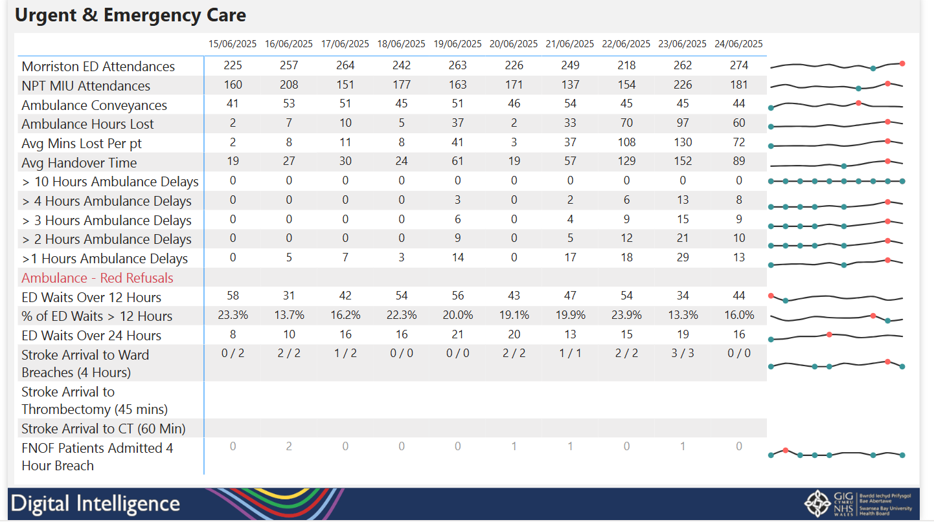

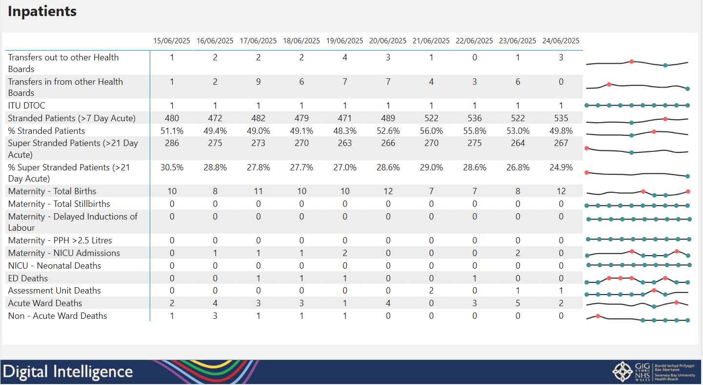

Automated report showing measures across Urgent and Emergency Care and Inpatients areas that is emailed to executives each morning.
Fig 3.
Your Next Patient Dashboard – Bed Management
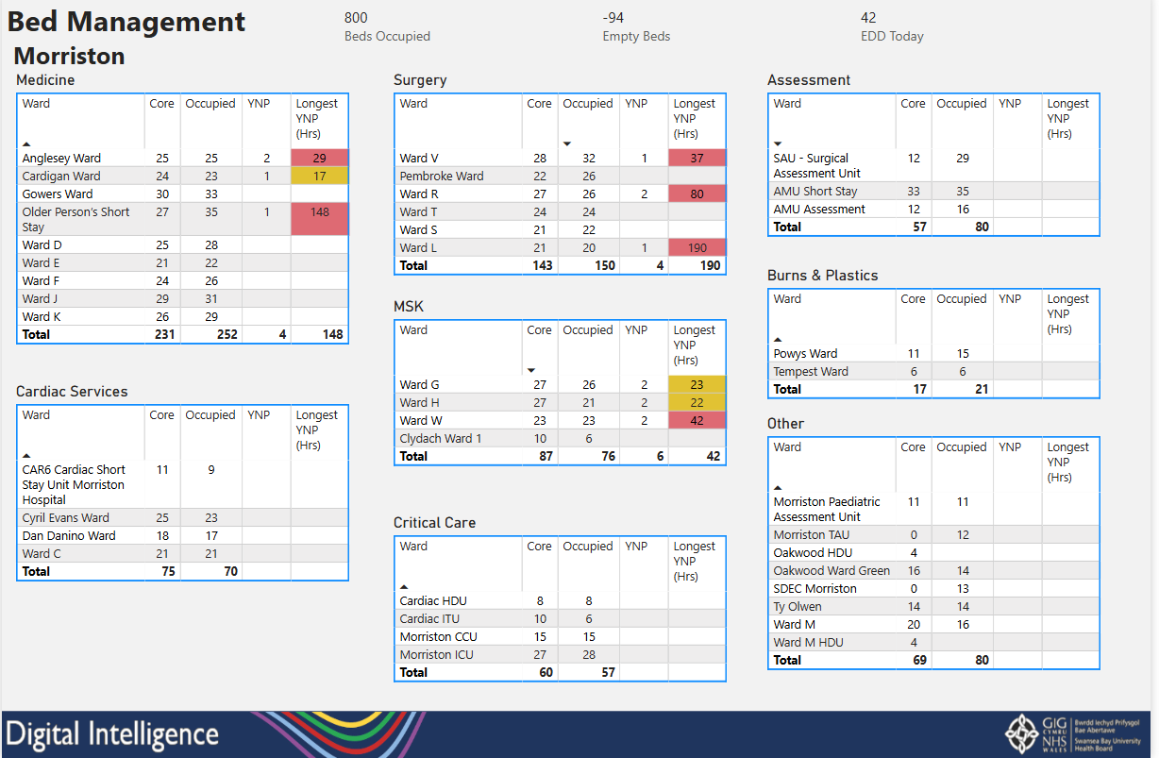

Dashboard showing bed occupancy across wards in all sites with the number of Your Next Patient Beds and length of stay.

Fig 4. - Fig 5
Mortality App – End of Life Care Reports
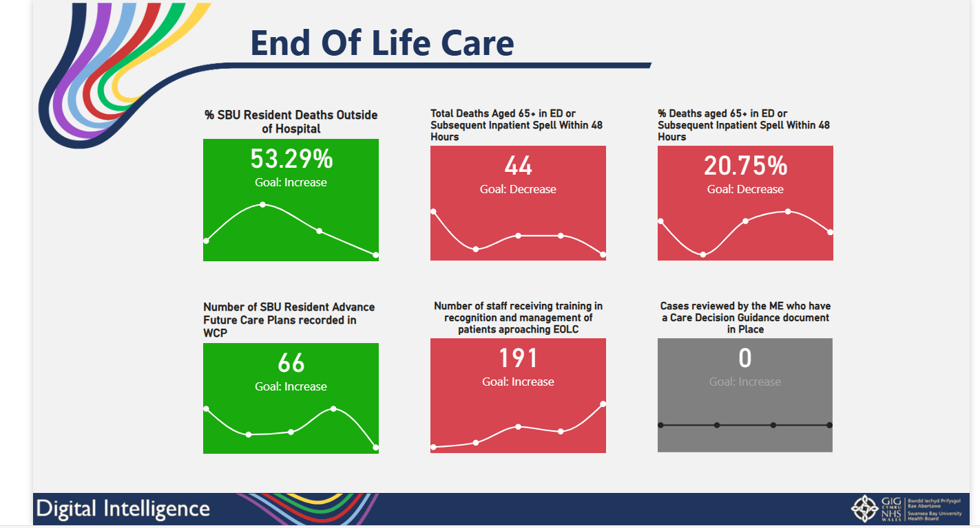

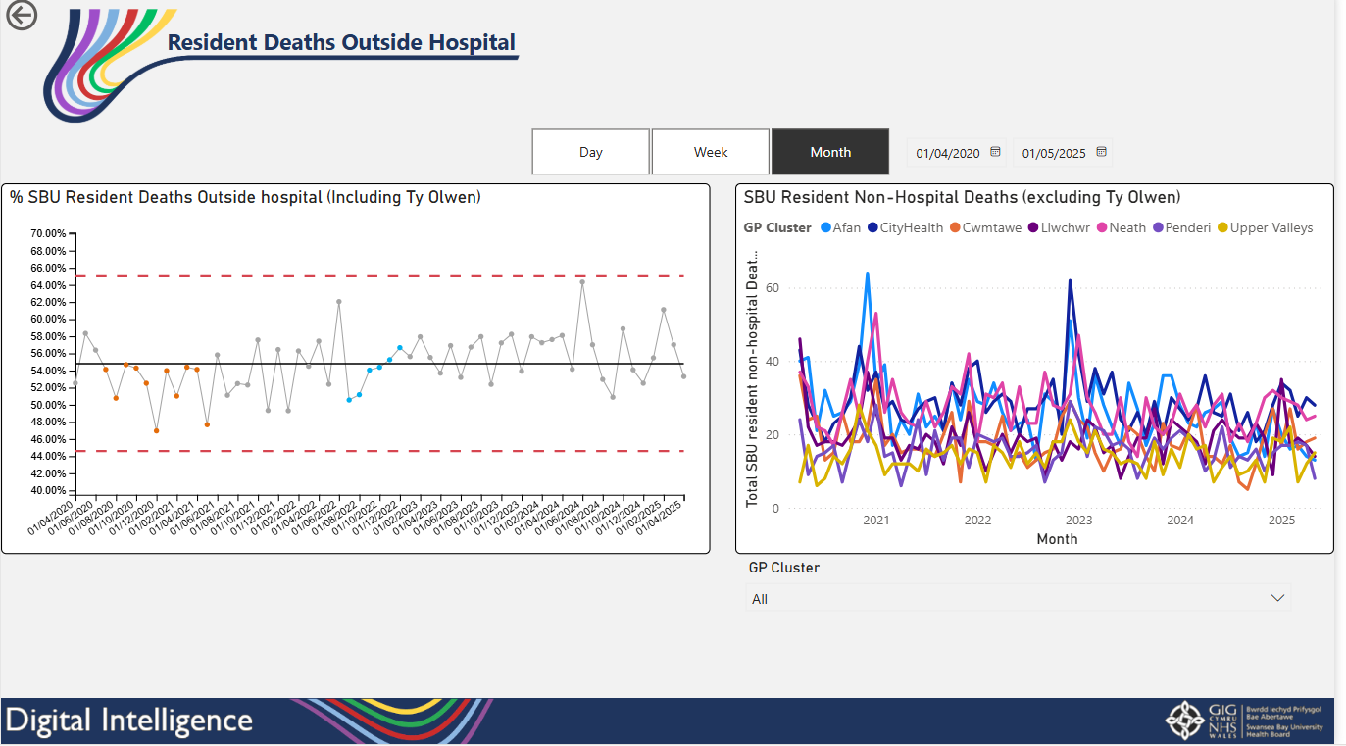

End of Life Care Reports within the Mortality App that can be drilled down further showing specific measures against goals.

Fig 6.
Mental Health App – Follow-up Waiting List Self-service Report
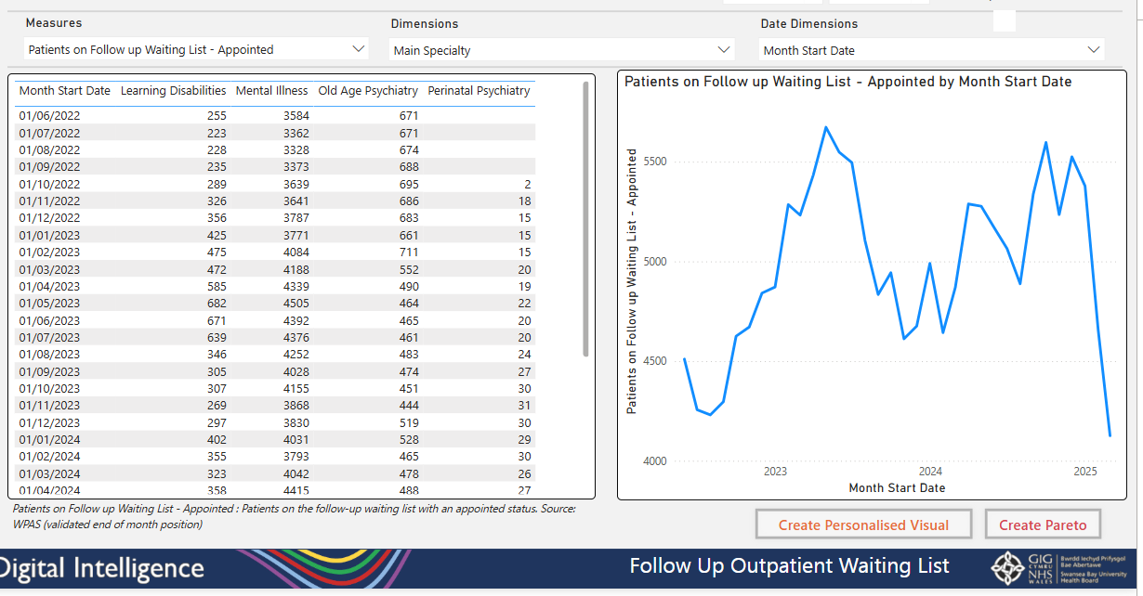

Self-service report added to the Mental Health App allowing users to choose from a suite of difference follow-up waiting list measures and dimensions to create their own visuals.

Fig 7.
Population Health App – Bed Projections
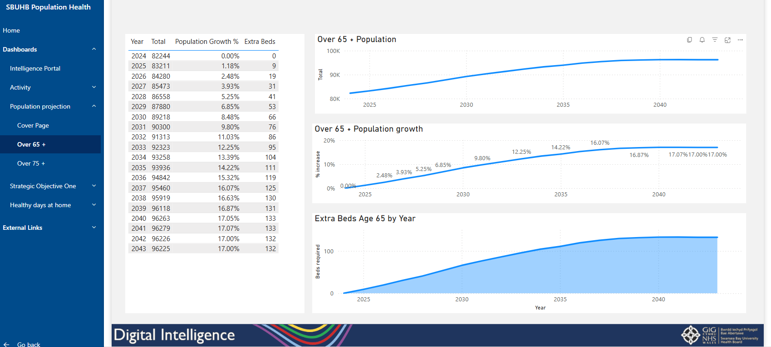

Report showing estimates of the extra beds required in the future based on 65+ and 75+ projections.

