
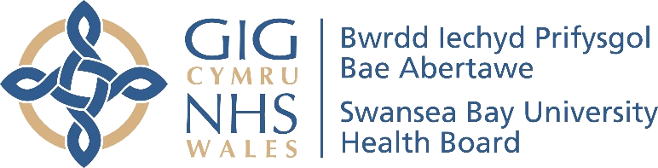
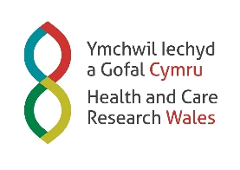
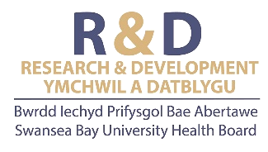



Swansea Bay University Health Board

Research and Development Annual Report 2024-2025

CONTENT
EXECUTIVE LEAD INTRODUCTION 4
SWANSEA BAY UHB R&D PROFILE 6
WHO’S WHO 6
ORGANISATIONAL CHARTS 8
CONNECTING R&D 11
HEALTH AND CARE RESEARCH WALES 12
RESEARCH & DEVELOPMENT TEAM FUNCTIONS 13
SUMMARY OF THE YEAR 2024-25 14
CASE STUDY HIGHLIGHTS 15
The development, external validation and impact of the STUMBL Score, a clinical prediction model for the management of patients with blunt chest injuries. 15
Swansea team celebrates global success of game-changing cancer treatment 16
Morriston first hospital in Wales to recruit for clinical trial involving babies with chest infection 17
'Pushing the envelope' leads to renewed hope for Sue 18
STAFF SPOTLIGHT 20
DR LISA WAKEMAN 20
LEANNE QUINN 22
PARTNERSHIP AND COLLABORATION 24
UNIVERSITY PARTNER – SWANSEA UNIVERSITY 24
ReconRegen 25
Welsh Centre for Emergency Medicine Research (WCEMR) 26
CanSense 28
Roche – Innovation collaboration - implementation of Strong HF protocol for management of Heart Failure 31
Collaborative working with Hywel Dda (TriTech) 31
Other collaborators and partners 32
PUBLIC INVOLVEMENT AND ENGAGEMENT 33
Research & Development Showcase Day 34
Supporting Engagement 35
OTHER KEY ACHIEVEMENTS 36
FINANCIAL SUMMARY 37
FORWARD LOOK & CONCLUSION 38
Research & Development Strategy 40

EXECUTIVE LEAD INTRODUCTION
It is with great pleasure I introduce the Swansea Bay UHB Research and Development Annual Report for 2024-2025.

The Health Board is fully committed to developing a thriving research culture as part of our One Bay Way commitment to quality. Research is at the cornerstone of quality-based care, with our dedicated and skilled clinical teams proud to work in partnership with patients, public, academia and the life sciences industry in researching new treatments, service delivery models across wide ranging health priorities, from cancer to diabetes, mental health to community-based healthcare.

We hope you find this report informative of the achievements made during the past year and the plans we are working toward. It has been another successful year for research and development, with multiple grants, research contracts and 266 publications awarded; a separate publication list is available alongside this report. The impact research has for patients cannot be underestimated, as for many it is a beacon for hope for the future at a time when other treatment options are not proving successful. Also, there is a growing body of evidence showing that research-active hospitals have better patient outcomes, even for patients who are not directly involved in clinical trials.

I am grateful to everyone who takes an active interest in research and development, not only in terms of the dedicated team who work hard to set-up and deliver trials for patients, but also our clinical staff who undertake the work as part of their roles. It has been really pleasing to see the variety of staff taking up chief investigator roles, including nurses, midwifes, allied health professionals and health scientists as well as medical staff, this was celebrated at our R&D Showcase event with presentations from local nurses who are acting as Principal Investigators in national studies, sharing their experiences to encourage more staff to take on these important roles. You’ll also read about the significant international impact made to the management of patients with blunt chest injuries, led by Prof. Ceri Battle, a Consultant Physiotherapist here at Swansea Bay UHB.

Clinical researchers of the future have also been a priority, with a pilot scheme for medical students to spend time with the research and development teams to get a feel for what is involved in clinical trials and how they may be able to participate as they move through their careers. The pilot took place over the summer and so far, feedback from our medical students is very positive. Therefore, it is something we have now implemented as a permanent feature with Swansea Medical School medical student training clinical rotations.

SWANSEA BAY UHB R&D PROFILE
Another key achievement for us last year was the opening of a dedicated clinical space at Singleton Hospital for patients part of cancer and haematology-based research trials where they can undergo the various tests and treatment, as well as be seen by the research nurses and consultants. Space is of premium across our sites given the operational pressures so having a facility specifically for patients taking part in these types of trials is of huge benefit and it also provides continuity in terms of where patients need to go each time they visit, and consultants know where to be.

This is an especially exciting year for us as we close it off by approving our Research, Development and Innovation Bridging Strategy for 2025-26. Mapped against the NHS Wales Research and Development 10 Pillars, this sets out what we are looking to achieve over the next 12 months to continue to provide high-quality care for our patients. While this report celebrates what we have achieved last year, it is important to keep looking ahead and moving forward, and this is supported by the strategy.

Until now, research and development has been locally focussed, working to serve Swansea Bay’s population and you will see from the examples in this report, the range of specialities and studies we have been able to offer. Going forward, there are opportunities to work more regionally with Hywel Dda University Health Board, widening the patient pool for clinical research.

There is also there is current opportunity via the Voluntary Scheme for Branded Medicines Pricing, Access and Growth (VPAG) scheme, which has been agreed by UK Government and will potentially bring an additional £30million funding into Wales in the next five years.

The funding is targeted at investment in staff and equipment to enable an increase in the NHS capacity to deliver commercial clinical research. Swansea Bay can build on its track record and reputation to work with industry in conducting commercial clinical research across drug and device development. It will also help to address risks within the R&D function to delivering commercial trials, such as additional resource, for example within pharmacy to manage the volumes of trial activity, or additional equipment.

The work in 2024-25 has provided a strong basis for the year ahead, and we look forward to progressing our strategy and providing more opportunities for research and development.

Dr Richard Evans
Executive Medical Director and Deputy Chief Executive


SWANSEA BAY UHB R&D PROFILE

WHO’S WHO
Dr Richard Evans | Executive Lead – Executive Medical Director
 | Richard joined the Health Board as Executive Director in 2018 and has also held the role of Deputy Chief Executive since 2022. His areas of responsibility as Executive Medical Director include: Responsible Officer for medical appraisal and revalidation; Caldicott Guardian; Clinical Audit and Clinical Outcomes; Research, Development and Innovation; medical education; and quality and safety, a portfolio he shares with the Director of Nursing. Richard has been a consultant in Infectious Diseases and General (Internal) Medicine for over 20 years and trained in the UK and at Harvard Medical School and Massachusetts General Hospital in the USA.

Professor Stephen Bain | Associate Medical Director for R&D
 | Professor Steve Bain is the Associate Medical Director for Research & Development and Health and Care Research Wales Speciality Lead for Diabetes.  Professor Bain completed his undergraduate training at St John's College, Cambridge and then was clinically trained at King's College Hospital, London. On qualifying in 1983, he went on to hold junior appointments in London and the Midlands. His research centred on the genetics of type 1 diabetes and he was granted a Medical Research Council Lectureship. In 1993, he became a Senior Lecturer/Honorary Consultant Physician at Birmingham Heartlands Hospital with promotion to Reader in Diabetic Medicine in 1998. Professor Bain became a Fellow of the Royal College of Physicians UK in 1996. He has been Chief Investigator for several multi-centre trials investigating novel therapies for diabetes.  Professor Bain is the Diabetes Lead Clinician for the Swansea Bay University Health Board, chairs the Joint Clinical Research Facility in Swansea and was Clinical Director of the Academic Health Science Collaboration in Wales until September 2015.
SWANSEA BAY UHB R&D PROFILE
Professor Dean Harris | Deputy Associate Medical Director for R&D
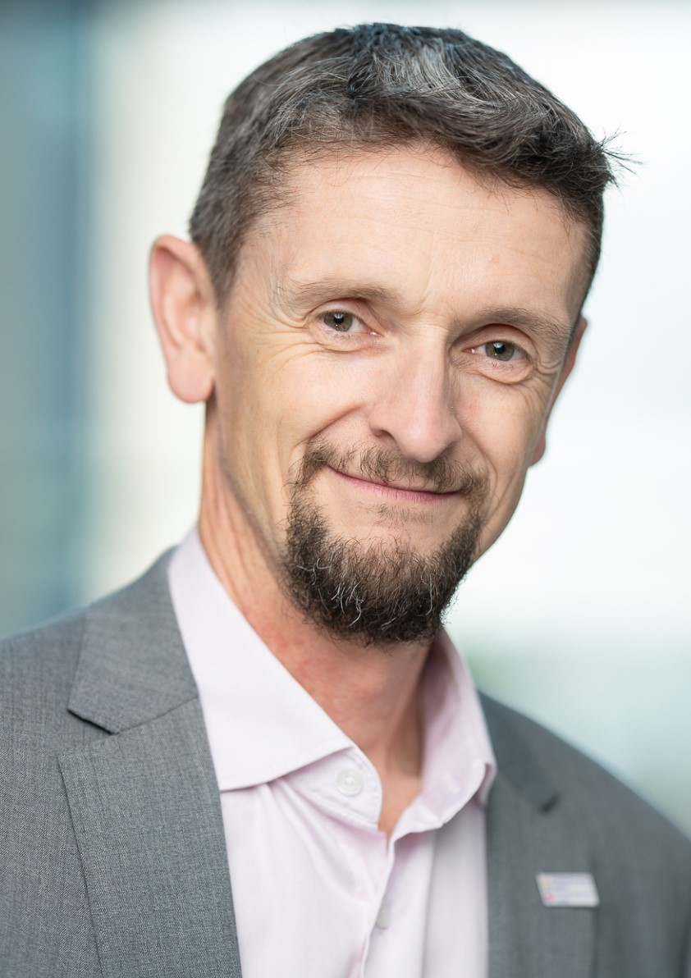 | Professor Dean Harris is the Deputy Associate Medical Director for R&D at Swansea Bay UHB and vice chair of the Joint Study Review Committee. He is a consultant colorectal surgeon providing a tertiary service for advanced rectal cancer. He is Lead Clinician of the Colorectal Cancer MDT (multidisciplinary team) and clinical lead for the Wales Cancer Industry Forum. He is on the NHS Clinical Entrepreneur Programme since 2020 fuelling his interest in MedTech innovation.  In 2013 he became an honorary clinical professor in Swansea University Medical School with research interests in early detection of cancer and personalised cancer treatment and has won over £2M in academic funding towards this.  He is co-founder and clinical director of CanSense, a Swansea University spin-out company, translating a reagent-free colorectal cancer serum diagnostic for the NHS to address cancer inequalities.

Professor Keith Lloyd | Board Champion
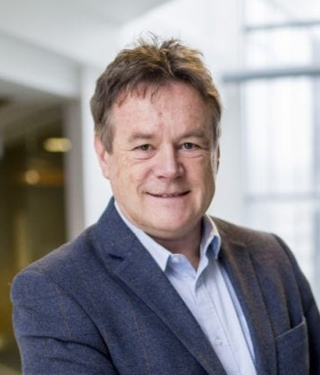 | Professor Keith Lloyd is Head of Swansea University Medical School and a clinical academic specialising in psychiatry. He trained in medicine before specialising in psychiatry and is a community psychiatrist in Swansea. .  Keith is committed to supporting innovation in health and social care and service innovation and is a principal investigator on Accelerate a pioneering collaboration between Welsh Universities and the Life Science Hub Wales. It helps translate innovative ideas into new technology, products, and services for the health and care sector, quickly.  Before taking up his current post, he was Head of NISCHR (now Health and Care Research Wales) – the Welsh Government body responsible for policy, strategy, and funding of health and social care research in Wales. He is the principal investigator for the National Centre for Mental Health.

SWANSEA BAY UHB R&D PROFILE

ORGANISATIONAL CHARTS

Research & Development Governance Team
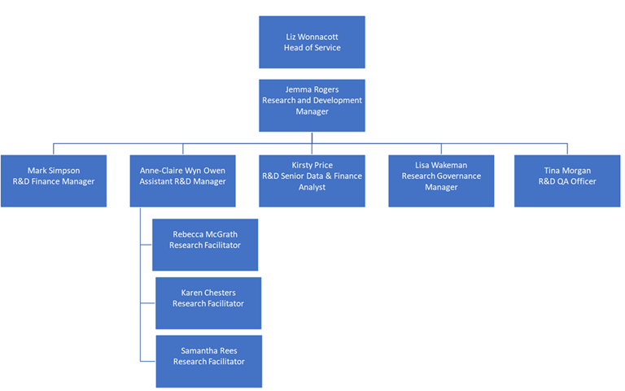

SWANSEA BAY UHB R&D PROFILE

Research & Development Delivery Team
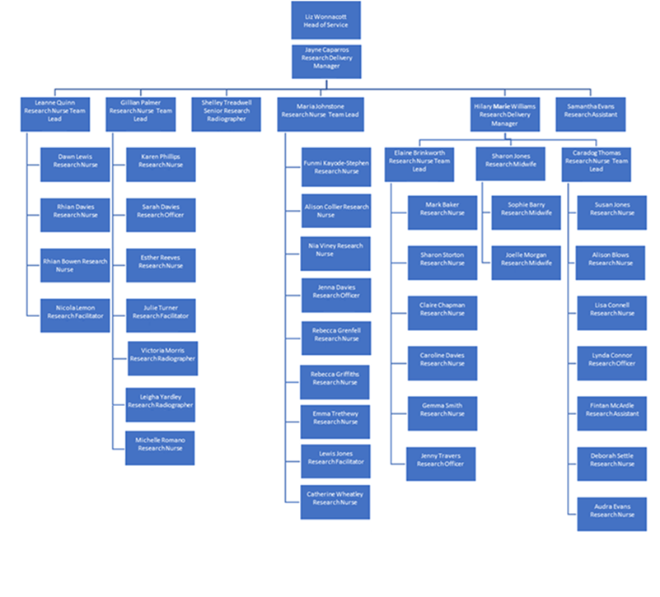
SWANSEA BAY UHB R&D PROFILE

R&D Groups

SWANSEA BAY UHB R&D PROFILE

CONNECTING R&D
R&D is a department within the Executive Medical Director’s Directorate. The function of the department is Health Board wide, supporting and overseeing research across all clinical directorates and structures.
Planning: Recognised as an important part of how Health Board services should be planned, R&D features within the Health Board Annual Plan and programmes of research active within the Health Board help contribute to the quadruple aims described within A Healthier Wales. All Health Board led research studies are required to assess their impact in supporting the Wellbeing of Future Generation Act 2017, climate and sustainability.
Alongside research, collaborative innovation is also at the heart of what we are seeking to deliver as an Organisation committed to quality. We are committed to the ambitions described within’ Wales Innovates’ with our current bridging Strategy linking together both R&D and Innovation objectives. These objectives are described later in this report and some collaborative innovation partnerships are included later in this report as examples.

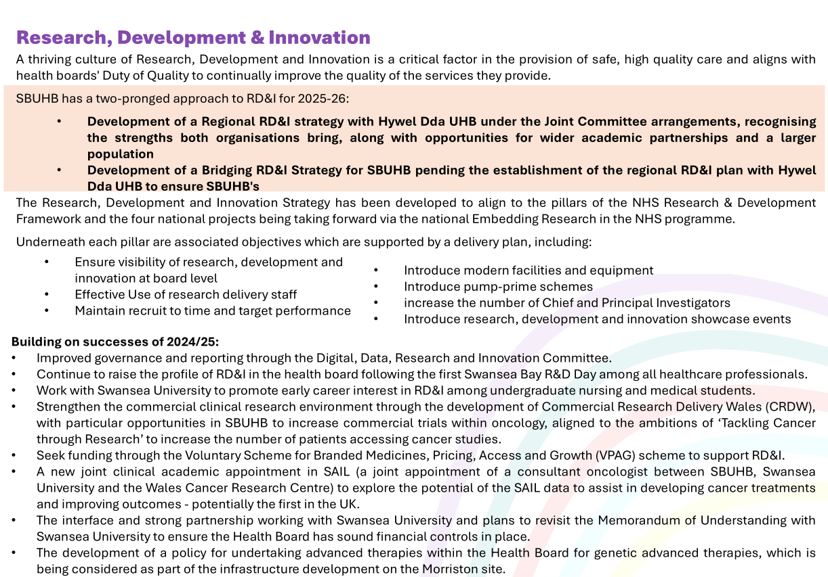
‘Through the commitment to ARCH (A Regional Collaboration for Health) and joint regional working, an Innovation Panel will be re-formed to offer appraisal and advice on potential local innovations, ensuring application of the health board intellectual policy to maximise benefits gained.’ - SBU RD& I Bridging Strategy 2025

SWANSEA BAY UHB R&D PROFILE

HEALTH AND CARE RESEARCH WALES
The Health Board R&D teams are proud to be part of Wales wide infrastructure of Health and Care Research Wales, working together to deliver the overarching HCRW goal that ‘today’s research makes a difference to tomorrow’s care.’
2024-2025 has seen a renewed self-assessment against the NHS R&D Framework, with our 3 R&D Strategic Pillars within our bridging strategy for 2025-26 aligned to the 10 Pillars of excellence described within the Framework – What excellence looks like in NHS Wales -
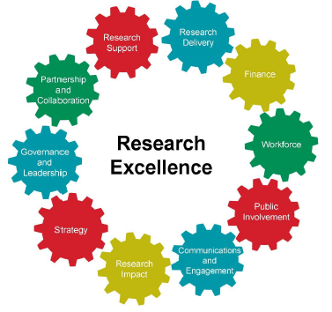
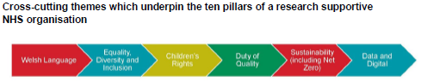

Health and Care Research Wales Speciality Leads
Health and Care Research Wales invests in Specialty Leads to champion and support research delivery by building networks of principal investigators within their specialty and supporting the uptake of studies throughout Wales. They map onto the 32 National Institute for Health Research therapeutic areas and provide strong UK-level engagement for Wales. There are 4 speciality leads within SBUHB.



Stroke
Dr Manju Krishnan

Diabetes
Professor Stephen Bain




Trauma and Emergency Care
Dr Suresh Kumar Gopala Pillai

Musculoskeletal Disorders
Mr Piers Page

SWANSEA BAY UHB R&D PROFILE

RESEARCH & DEVELOPMENT TEAM FUNCTIONS

SUMMARY OF THE YEAR 2024-25
£134,424
Received via Grants
in 24/25

Joint Study Review Committee (JSRC) signed off:
4 New studies | 39 Service Evaluations

25 Open Swansea Bay UHB Sponsored studies within the Health Board



209 Portfolio
Studies In Follow Up
122 Non-Commercial
87 Commercial

95 OPEN NON-PORTFOLIO STUDIES

23 Non-Portfolio
Studies In Follow Up

RECRUITED
2691
participants into Portfolio studies
2538 Non-Commercial | 153 Commercial


158 OPEN
NON-COMMERCIAL PORTFOLIO
STUDIES

40 OPEN
COMMERCIAL STUDIES

CASE STUDY HIGHLIGHTS

The development, external validation and impact of the STUMBL Score, a clinical prediction model for the management of patients with blunt chest injuries.
Sponsor: Swansea Bay UHB
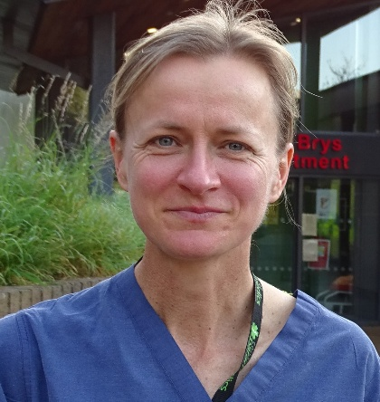
Blunt chest injuries are well-recognised as difficult to manage by healthcare professionals working in emergency and acute care settings. In the first few days following injury, as a result of severe pain, there is a high risk of complications developing. It is difficult for healthcare professionals to predict who will develop these complications when the patients are managed in the emergency department (ED). Clinical prediction models, or risk scores, are one method of assisting in the identification of patients who are at high risk of developing complications.
Professor Ceri Battle – Chief Investigator of STUMBL
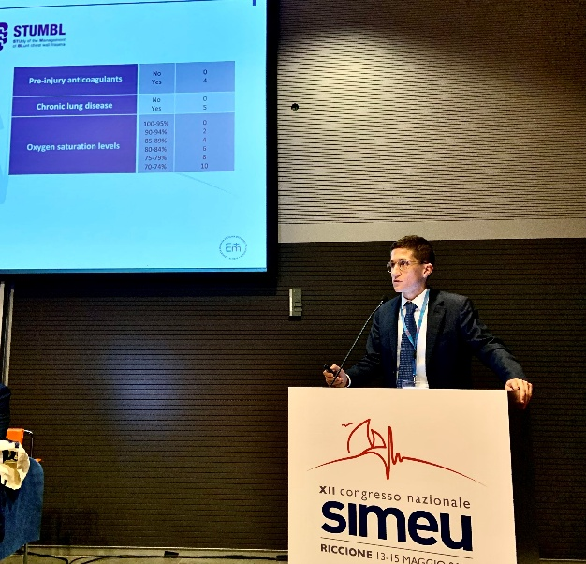
The STUMBL Score was originally developed in 2012, through the completion of a series of background studies. These included a systematic review and meta-analysis, a national survey study and a retrospective observational study. Each of these studies, led to a long list of potential predictors, or risk factors, that would be considered for the final clinical prediction model. In the development study, this long list of predictors was used to create the STUMBL Score, through statistical modelling. Five predictors were included in the final STUMBL Score, the patient’s age, the number of rib fractures sustained, whether the patient had chronic lung disease or used blood-thinner medication before their injury, and their oxygen levels. Each of the predictors were scored, and then the total score provided a risk of complications and a suggestion as to where the patient should be managed on discharge from the ED (home, ward or critical care). The STUMBL Score was then evaluated for use on real patients, in a multi-centre external validation study. It was found to have excellent predictive capabilities, meaning that it could be safely used by healthcare professionals in the ED to assist with patient management.
Dr Jacopo Giamello, Italy, Presenting at a conference in Europe
Since the STUMBL Score was first published, it has been integrated into care pathways
CASE STUDY HIGHLIGHTS
locally, regionally, nationally and many countries internationally. A recent study demonstrated that the STUMBL Score is now used to manage patients in two thirds of all major trauma networks in the UK. The STUMBL Score has also been externally validated for use in other countries, including Italy, New Zealand, Australia, America and Ukraine. A recent scoping review written by the team, demonstrated that the STUMBL Score is recommended for use in a number of national clinical guidelines on managing patients with chest injuries, including the Netherlands, Ireland, Spain, US and also in the UK NICE Rehabilitation after Traumatic Injury Guidance.
There have been numerous publications demonstrating a positive change in clinical practice and patient outcomes with the introduction of the STUMBL Score. These have been demonstrated across multiple professions including medical, trauma surgery, nursing, critical care outreach, anaesthetics, physiotherapy, and acute pain services. Although the score was originally developed to guide discharge disposition from the ED, it is now also used across the world to guide decision making regarding analgesia received by the patient, referral to physiotherapy and the acute pain team. Further validation is planned by the research team to evaluate the STUMBL Score’s effectiveness in these additional uses.

Swansea team celebrates global success of game-changing cancer treatment
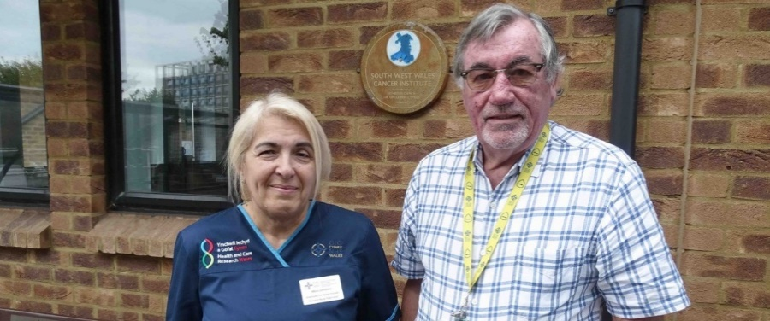
Sponsor: Bristol-Myers Squibb
(Professor Wagstaff is pictured with Maria Johnstone, the only research nurse within the Cancer Institute who worked on the clinical trial from start to finish)

A global clinical trial, in which Swansea’s Cancer Institute at Singleton Hospital played a key role, has significantly changed the outlook for patients with metastatic melanoma, an aggressive form of skin cancer. The CheckMate 067 trial, conducted in 2013–14, tested a combination of two immunotherapy drugs—Ipilimumab and Nivolumab—against traditional chemotherapy. The results marked a major breakthrough: ten-year survival rates rose to 43% with combination therapy, a dramatic improvement from the six-to-nine-month average survival seen with chemotherapy alone. Analysis also showed that patients in remission at three years had a very low risk of relapse, suggesting that many may be effectively cured.

CASE STUDY HIGHLIGHTS
The Swansea team, led by Professor John Wagstaff, medical oncologist, was one of the highest recruiting sites globally, contributing to the trial’s rapid progress and international impact. The trial’s success has helped position Singleton Hospital as a leading UK cancer research centre. The Cancer Institute now operates from a new purpose-built facility and runs up to 30 trials at a time, with funding support from the Welsh Government and Health and Care Research Wales. The success of this immunotherapy approach has extended beyond melanoma to other cancers, such as kidney and lung cancer, with similarly promising results, marking a transformative era in cancer treatment.

Morriston first hospital in Wales to recruit for clinical trial involving babies with chest infection
Sponsor: Imperial College in London.
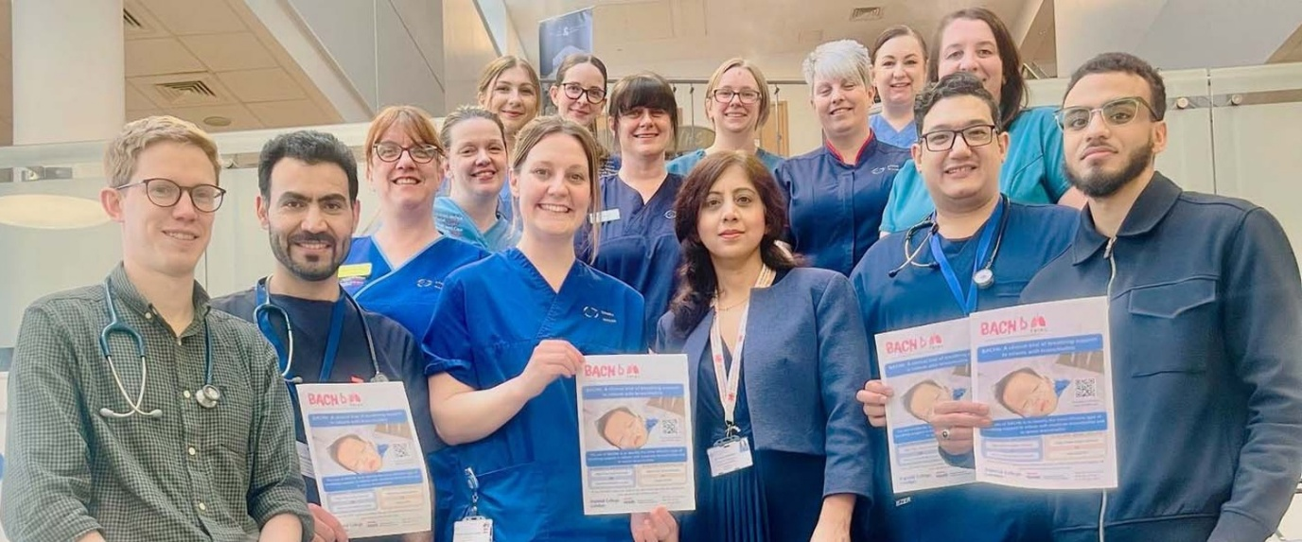Main photo above: the Morriston trial team of researchers and clinicians
Morriston Hospital has become the first site in Wales to recruit participants for a UK-wide clinical trial focused on improving care for babies with bronchiolitis, a common yet potentially serious chest infection in children under two. The trial, known as BACHb and sponsored by Imperial College London, will involve over 1,500 infants across 50 hospitals over the next 30 months. It aims to identify the most effective breathing support—comparing high-flow oxygen therapy, CPAP, and humidified standard oxygen—for babies with moderate to severe bronchiolitis. The goal is to help infants recover faster, reduce discomfort, and shorten hospital stays, especially during winter months when NHS services are under increased pressure.
Led locally by Dr Huma Mazhar and Dr Carwyn Dafydd, with support from trainee Dr Emily Ball and research nurse Gemma Smith, the trial reflects a strong commitment
CASE STUDY HIGHLIGHTS
to paediatric research within Swansea Bay. Participation not only benefits patients but also supports the
professional development of junior doctors through involvement in clinical research. Backed by the National Institute for Health Research and Health and Care Research Wales, the trial will use a randomized design, ensuring that infants receive the best available care while allowing researchers to evaluate treatment outcomes effectively. The initiative marks a significant step forward in standardizing and improving the treatment of bronchiolitis across the UK.

'Pushing the envelope' leads to renewed hope for Sue
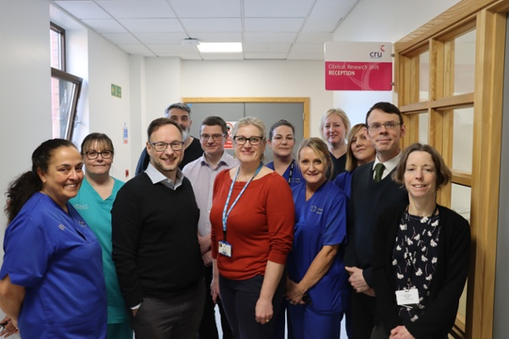
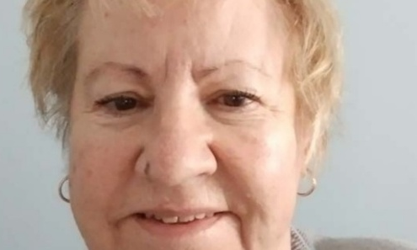
Sue Davies, diagnosed with Multiple Sclerosis (MS) nearly 40 years ago, is now experiencing renewed hope thanks to groundbreaking clinical research at Morriston Hospital. At 66, Sue is on her first life-improving treatment—fampridine—after years without any options for her secondary progressive MS. This drug, trialled at Morriston, helps improve walking by restoring nerve signal transmission and led to Wales becoming the first UK nation to approve it. Sue is also participating in a pioneering global clinical trial, the first to include wheelchair users, which investigates whether disease-modifying drugs, typically used in early stages, can also benefit those with advanced MS.
Staff in Morriston Hospital's Clinical Research Unit
Credit: SBUHB
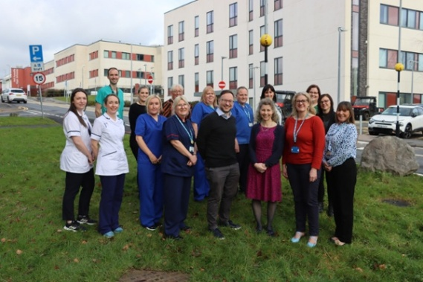
Morriston Hospital’s MS Service, now marking its 20th anniversary, has grown from a small team into a leading regional centre known for cutting-edge research and comprehensive care. With expanded outreach clinics and early adoption of virtual consultations, the team has improved access to multiple treatments and clinical trials. Patients now benefit from earlier diagnoses, quicker treatment starts, and a more holistic
Morriston Hospital's MS Service team. Consultant Neurologist Owen Pearson, centre of front row. Credit: SBUHB
CASE STUDY HIGHLIGHTS
approach to care, including education and support. While a cure remains elusive, specialists like Dr Owen Pearson and Dr Gillian Ingram emphasize the dramatic progress made, offering patients more hope and better quality of life than ever before.

STAFF SPOTLIGHT

DR LISA WAKEMAN

Research Governance Manager
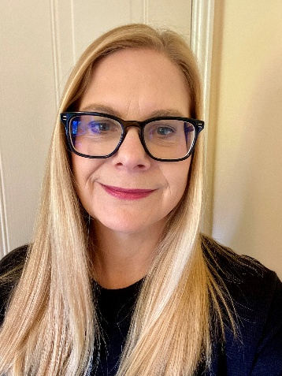
My role as Research Governance Manager covers the management of the Health Board Human Tissue Authority (HTA) research licence, Sponsor responsibilities and acting as a Sponsor Representative.
I moved from the Midlands to Swansea in 1997 for my first job with West Glamorgan Haematology Service as a trainee Biomedical Scientist after completing a BSc. Biomedical Science which included a year in a local NHS Haematology laboratory. I completed an Honours research project and gained my first experience of conducting a research study for myself. It was a different experience back then in terms of ethical approval and access to human samples for research.
Once qualified, I undertook a part time MSc. Biomedical Science including a research project which investigated the anticoagulant properties of certain leeches, involving trips in wellies to Welsh lakes, ponds and rivers. As my laboratory career progressed, I went on to complete a part time Professional Doctorate in Biomedical Science (DBMS), undertaking a research thesis and portfolio of scientific and management assignments. For my research I recruited thrombophilia patients who had experienced conditions such as DVT (deep vein thrombosis), stroke and miscarriage and healthy controls. I sought to evaluate the diagnostic potential of applying specialised quantitative platelet function tests as an adjunct to testing where the conventional thrombophilia screening profile showed no abnormalities.
I began to act as research supervisor for student BSc. and MSc. projects and

Holding a HTA licence means that we proactively govern the human samples in our care.
“
”

became the R&D lead for Haematology, providing laboratory support for clinical trials. This would involve reviewing trial protocols, providing costings and analyses. In this role I was able to publish alone and with research groups which allowed me to attend American Society of Haematology conferences across America and the International Society on Thrombosis and Haemostasis conference in Sydney.
The Human Tissue Act 2004.
Regulation of the collection, use and storage of human tissue for research changed radically following the scandal at Alder Hey Hospital in 1999 where, for years, human tissue and organs had been systematically removed and retained without consent. After the Royal Liverpool

STAFF SPOTLIGHT
storage, reporting to the Health Board HTA Operational Group and Assurance Committee and taking the lead at HTA inspections and data collection submissions.
HTA Licences
HTA licences require certain roles to be in place; a Designated Individual (DI) who takes legal responsibility for relevant material stored on licensed premises and Persons Designate (PD) placed throughout the organisation who support the DI. We have three PDs based in the Health Board labs and I have the role of Primary PD. I am also a PD for the Health Board Post Mortem HTA licence as there are times where post mortem and research overlap, and we need to support each other in our compliance. We have an exceptionally good relationship with our laboratory and mortuary teams.
I feel strongly that the donation of human samples for research should be respected and that we acknowledge that many of these samples are donated by patients undergoing treatment for serious illness and providing samples is an additional burden to them. We have a legal and ethical duty to ensure that those samples are stored correctly to maintain viability and are handled in line with consent. Holding a HTA licence means that we proactively govern the human samples in our care.
I enjoy my varied role, collaborating with supportive teams who work hard to improve processes and manage high quality research. I particularly enjoy reviewing haematology and haemostasis research trials and watching how care and treatment in that area continues to progress.
Children’s Inquiry Report in 2001 the Human Tissue Act 2004 was implemented in 2006, bringing in financial and custodial penalties for offences against the Act, and the HTA was established as the regulator of human tissue and organs.
Move from Laboratories
My laboratory journey gave me a range of transferrable skills and in 2014 I joined the R&D Department as the Human Tissue Governance Officer with the remit to develop and implement a Quality Management System to support the granting of a HTA research sector licence. In 2024, I took up the role of Research Governance Manager in which I continue to manage the HTA licence alongside a Sponsor role. Compliance with the HTA standards involves preparing and reviewing a suite of overarching HTA SOPs (standard operating procedures) and risk assessments, conducting internal audits, managing tissue related adverse events, overseeing HTA training and competency compliance for the laboratory, nurse and wider research teams, monitoring regulatory approval dates for all trials involving human samples, reviewing all Sponsored and hosted research studies and amendments to ensure the HTA consent and licensing requirements are met, drafting and arranging contracts and agreements to manage sample transfers or bespoke tissue sample collections and

I feel strongly that the donation of human samples for research should be respected.
“ 000
”

STAFF SPOTLIGHT

LEANNE QUINN

Research Nurse Team Lead
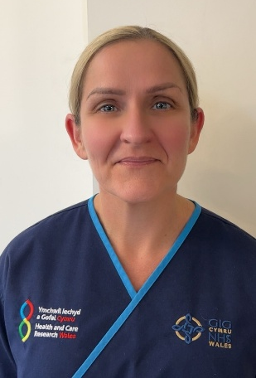
I started my clinical research career in 2005 as an Oncology Research Assistant whilst I was completing a Master’s degree. This role involved providing research administration support to research nurses, submitting oncology and haematology studies for local approval and maintaining essential documents in line with Clinical Trial Regulations and Good Clinical Practice guidelines (GCP), ensuring studies had all the necessary approvals to be conducted.
In 2008, I became a research officer for the research delivery team which enabled me to develop my clinical research skills by being more involved with the clinical side of research and recruiting participants into clinical trials. This role provided me with valuable experience of carrying out research activities from study set-up to recruiting participants, data collection and safety reporting. The role of research officer enhanced and developed my research knowledge and possessing a strong interest in research training and education I then became the Training and Quality assurance lead for South West Wales which involved me facilitating on a number of research specific courses including Good Clinical Practice (GCP). This role allowed me to develop and update my GCP and research legislative knowledge which enabled me to complete the certificate of GCP provided by the Faculty of Pharmaceutical Medicines, Royal College pf Physicians in 2012.

Clinical research is necessary for finding new treatments and improving patient care. Research nurses are an integral part of the clinical research and multi-disciplinary team working collaboratively with Principal Investigators to carry out high quality clinical research.
“
”
Good Clinical Practice (GCP)
Good clinical practice is a set of internationally recognised ethical and scientific quality requirements that must be followed when designing, conducting, recording and reporting clinical trials that involve people.

STAFF SPOTLIGHT
The purpose of GCP is to protect research participants and to protect the integrity of data and compliance with GCP assures research is conducted to the highest standard.
I still facilitate on research courses on the Health and Care Research Wales programme. I then progressed into a research team lead role within the delivery team which involved managing a team of research professionals and developing the research portfolio.
Making the move into nursing
During my time working within clinical trials, I worked alongside remarkable research nurses which made me want to complete my nurse training. I was successful in my application to Swansea University for a place on their Masters in Nursing Course. Following completion of my studies I worked as a registered nurse within SBUHB and Velindre NHS trust before returning to Swansea Bay University Health Board as an Oncology and Haematology research nurse in 2021 progressing to a research nurse team lead in 2024.
Clinical research is necessary for finding new treatments and improving patient care. Research nurses are an integral part of the clinical research and multi-disciplinary team working collaboratively
with Principal Investigators to carry out high quality clinical research. This role involves reviewing study protocols to confirm SBUHB has the capacity and capability to conduct the study and ensure studies are conducted in accordance to Clinical trial regulations and GCP. We identify participants that may be eligible for a clinical trial supporting them through the recruitment process. We ensure patients have all the necessary information to be able to make an informed decision about whether to participate. The informed consent process is a fundamental component of ethical research and it demonstrates the participant has had enough time and information to make an informed decision which is voluntary.
Once participants are in the study, we collect and record data, ensuring assessments are carried out in keeping with study protocols and data is accurate. Participant safety is at the centre of everything we do so safety reporting is an important role of the research nurse and has a direct link to the side effect profile of medicines.
The role is evolving with research nurses becoming Principal Investigators of research studies. Research nurses have to ensure they keep up to date with any changes in research legislation and the changing landscape of research and treatments. I am a proud research nurse and proud of the work that we do to make a difference to future care working as part of a team of research nurses, assistants, facilitators, radiographers and research officers in collaboration with our research participants.

The role is evolving with research nurses becoming Principal Investigators of research studies.
“ 000
”

PARTNERSHIP AND COLLABORATION

UNIVERSITY PARTNER – SWANSEA UNIVERSITY
The Health Board is a proud partner to Swansea University. As a University Health Board, the core aims of research and teaching are delivered in partnership with our academic colleagues, both via the role of Clinical Academics but also through establishment of honorary statuses afforded mutually to Health Board and University staff, facilitating partnership working at an operational level. Alongside medicine, partnerships and collaborations exist within the health disciplines of nursing, psychology, nano-technology, engineering and management.
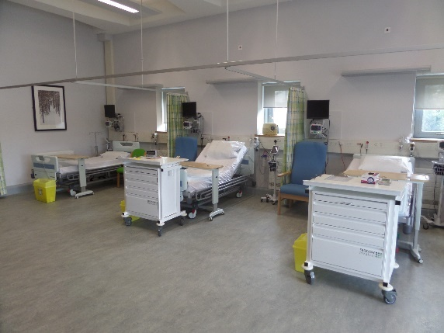
Our flagship research partnership with SU is that of our Joint Clinical Research Facility (JCRF). Funded in 2012, from European monies as part of the Institute of Life Science 2 development, the JCRF is a jointly run specialist facility for conducting high quality clinical research, with dedicated imaging suite and ward area. The Facility has a strong reputation for efficient delivery of commercial studies, earning partnership status with many global life science companies. Areas of excellence include diabetes, neurology and cardiovascular. Supporting clinicians from across the Health Board, in 2024-25, the team hosted 25 commercial studies recruiting 73 patients.
One example of a commercially hosted clinical trial includes the recently published ‘SOUL’ study sponsored by Novo Nordisk. The SOUL study was co-chaired globally by Prof Steve Bain, Associate Medical Director for R&D at Swansea Bay, who conducted the study within JCRF. The study found that semaglutide tablets – best known as the active ingredient in some weight-loss treatments – can ‘significantly’ help reduce the risk of heart attacks in adults who have type 2 diabetes and cardiovascular and/or chronic kidney disease. As a result of the study findings, the study Sponsor are submitting a label extension application for Rybelsus® (semaglutide tablets) for cardiovascular event risk reduction in adults living with type 2 diabetes to the UK Medicines and Healthcare products Regulatory Agency (MHRA), US Food and Drug Administration (FDA) and European Medicines Agency (EMA).

PARTNERSHIP AND COLLABORATION

ReconRegen
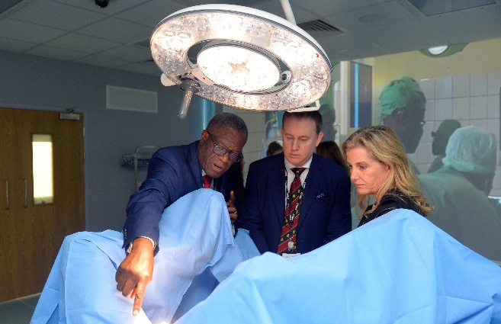
Established in 2012, and led by Professor Iain Whitaker, ReconRegen in Swansea University Medical School has developed into the largest single centre reconstructive surgery research group in the UK. In 2020, ReconRegen was awarded £2.5 million to establish the multi-year Scar Free Foundation and Swansea University Programme of Research in Reconstructive and Regenerative Medicine, supported by Health and Care Research Wales. The Programme’s main research projects include:

3D Bioface project (2020 – 2027). Original award: £1,975,368. Additional funding awarded 2024/25: £95,500
The aim of 3D Bioface is to 3D print durable cartilage implants, using a natural ‘bioink’ combined with the patient’s own cells. If successful, the outcomes could revolutionise our ability to reconstruct form and function in patients affected by facial deformities.
We have developed a high performance, ultra-pure bioink that supports cell growth and that has excellent shape fidelity when used with our novel printing process. We have carried out multiple lab experiments to show that our bioink is non-toxic and non-immunogenic and, in 2024, we carried out a first round of animal testing in collaboration with Harvard University that confirmed our lab results.

RESECT project (2020 – 2026). Original award: £385,610. Additional funding awarded 2024/25: £58,500
The focus of the RESECT project is to develop recommendations for service redesign in skin cancer management. We have published multiple studies that evaluate the patient and healthcare burden of skin cancer in Wales, including the first ever audit of the environmental impact of non-melanoma skin cancer surgery.
We are also currently developing a computerised ‘virtual MDT’ tool. This reads the text in pathology reports and clinic letters and, within a second, suggests the next step that matches national guidelines - for example, “patient can be discharged” or “needs further surgery.” Pilot data has shown our tool to be as accurate as specialist doctors nine times out of ten. Rolled out across the UK, efficiency savings from the virtual MDT
PARTNERSHIP AND COLLABORATION
tool could top £6 million a year for skin cancer alone, and even more for breast, prostate and bowel cancers. It could also double the number of patients spotted for life-saving clinical trials.
Swansea - Panzi Alliance for the Reconstruction & Care of victims of conflict related sexual violence (SPARC) (2024- ). Funding awarded 2024/25: £86,821
SPARC is a collaborative initiative between Swansea University and Panzi Hospital, led by Dr Denis Mukwege and Professor Iain Whitaker and with support from The Office of Her Royal Highness The Duchess of Edinburgh. SPARC aims to enhance surgical care and develop comprehensive support to alleviate the physical and psychological burden of conflict-related sexual violence (CRSV).
In July 2024, Professor Whitaker led an exploratory visit to Panzi Hospital, which highlighted the urgent need for upskilling in advanced reconstructive techniques. In October 2024, Dr Mukwege and Her Royal Highness The Duchess of Edinburgh visited Swansea University to discuss next steps in the evolution of SPARC, including the ongoing development of our novel ‘ANSWERS’ 3D printed surgical training models, for which we have been awarded £45,000 from the Engineering and Physical Sciences Research Council (EPSRC).

Welsh Centre for Emergency Medicine Research (WCEMR)
WCEMR is a unique collaboration between the Swansea Bay University Health board and Swansea University (medicine and Engineering) which focusses on advances in Emergency Medicine (EM) research. This translational research centre was opened in March 2019 and is currently under the directorship of Dr Suresh Pillai who is a honorary Consultant in EM and Intensive Care Medicine (ICM) at Morriston Hospital. Dr Pillai took over from Professor Adrian Evans on 1st April 2024 and was appointed as Senior Lecturer in Emergency Medicine (Enhanced research) at Swansea University. WCEMR is staffed by two junior clinical research fellow (one WTE) who spend 50% of their time in ED (emergency department).
During 2024/25, three research projects were undertaken in WCEMR. The project ‘Development of a nano-diagnostic rheological biomarker (A new biomarker for Red Blood Cells, IRAS-309259), completed recruitment of 15 participants on June 2024. ‘Effects of COPD and treatments on blood clot functionality (IRAS- 327917)’, is another project that has recruited 30 participants from Singleton Hospital respiratory clinics.

PARTNERSHIP AND COLLABORATION
This project was part of the Masters in Research (MRes) by the previous junior clinical research fellow. Currently, the project ‘Fibrinogen-level monitoring using microfluidic rheometry (IRAS- 346311) is recruiting participants. In addition, there is a service evaluation ‘Clinical outcomes of patients with pulmonary embolism managed by SBUHB Venous Thromboembolism (VTE) service’ is undertaken in WCEMR.
Dr Pillai was one of the co-applicant for the successful Engineering and Physical Sciences Research Council (EPSRC) standard research grant (£1.14m) for the project "Clot Busting: Advanced rheometry for informing the development of future thrombolytic therapies" led by Professor Karl Hawkins, Swansea University. An ethical approval will be sought in 2026 as part of this research project recruiting stroke patients from Morriston Hospital Emergency Department. This part of the research project will be undertaken in WCEMR. There was one research publication from WCEMR during 2024/25, ‘Zaldua JC et al. The impact of physical activity and intensity on clot mechanical microstructure and contraction in middle-aged/older habitual runners. BMC Neurol. 2025 Mar 1;25(1):81’. We are hoping to have several publication this year from WCEMR.
WCEMR was hosting a research programme called Morriston Emergency Department Research programme (MEDReP) that was limited to in-house research on blood coagulation rheological biomarkers. However, in 2024 the research programme was restructured into several streams to get involved in,
- National trials- expressed interest as a site for Brains-TBI study
- To get involved with PERUKI trials (paediatric emergency medicine)
- Projects from Minor Injuries Unit- LIMP criteria (service evaluation), Pittsburg with Ottawa x-ray rules (service evaluation), Missed rotator cuff injuries (service evaluation)
- Trainee Emergency Research Network (TERN) projects
- Other specialties trials in ED [CONSEPT- respiratory team (IRAS- 314206)]
PARTNERSHIP AND COLLABORATION
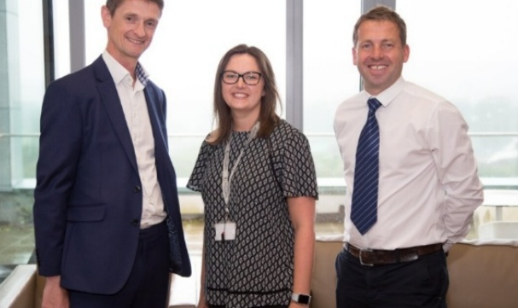
CanSense
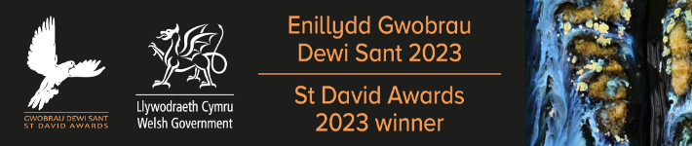
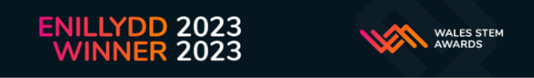
Multiple award winning research collaboration. CanSense was co-founded by Prof Dean Harris as a spin-out through Swansea University, Swansea Bay UHB collaborates with CanSense and academic colleagues at Swansea University (Prof. Peter Dunstan) in developing a new non-invasive test for early detection of cancer. The development is supported by Health Board R&D both as study Sponsor working in partnership with Swansea Trials Unit and through support of delivery staff in conducting multi-centre studies which are generating the data feeding into the innovation development.

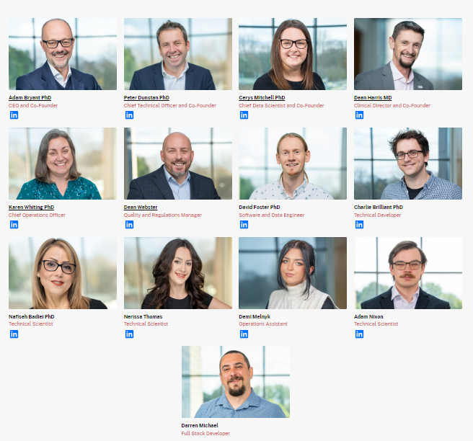
CanSense Team
PARTNERSHIP AND COLLABORATION
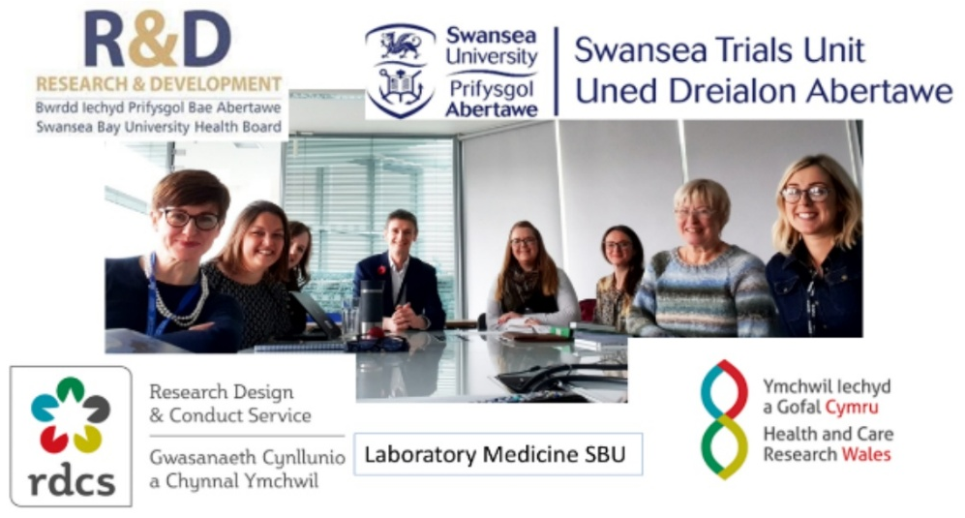
CanSense Collaboration Team

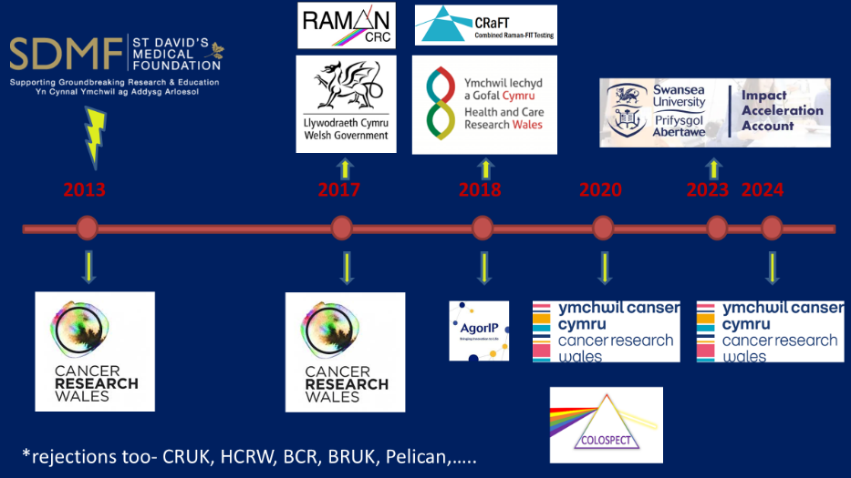
Grant Award Timeline

PARTNERSHIP AND COLLABORATION
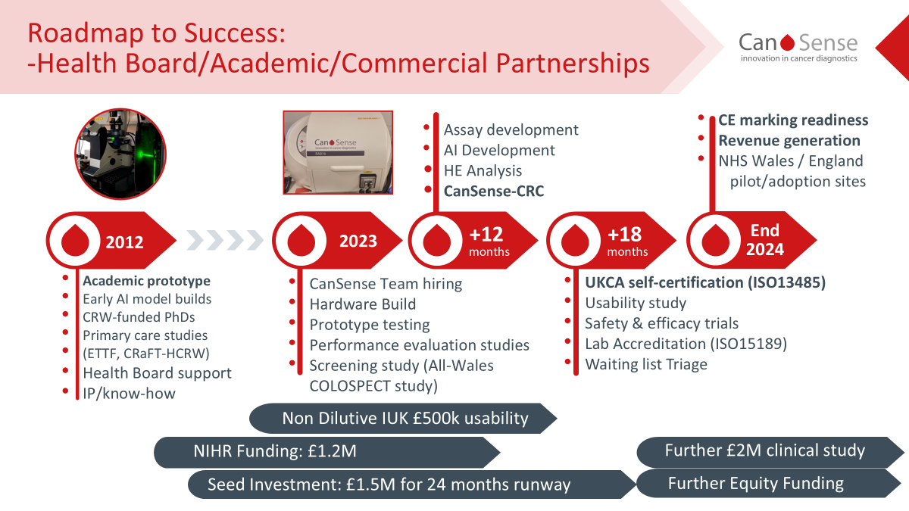
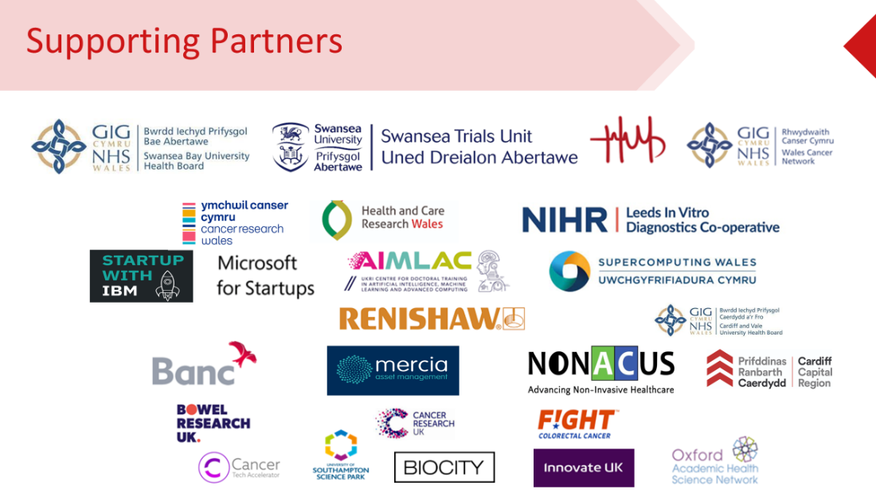
PARTNERSHIP AND COLLABORATION

Roche – Innovation collaboration - implementation of Strong HF protocol for management of Heart Failure
Health board Lead: Dr Parin Shah
A new heart failure treatment available at Morriston Hospital, one of three sites in the UK to introduce it, and the only one in Wales. Normally it can take up to six months for heart failure treatments to fully optimise for patients. However, an international study called STRONG-HF showed that early and quicker increases in doses of medication reduced symptoms and hospital readmissions. Swansea Bay has been working in partnership with Roche Diagnostics to adopt the groundbreaking new treatment strategy, which has been endorsed by the European Society of Cardiology.

This is a significant development for both patients and our services, as it will lead to a much quicker improvement in quality of life, and reduce the pressure on our services, with the potential to benefit around 500 people, or 10%, in Swansea and Neath Port Talbot. New and innovative ways to treat patients and develop services are a must if we are going to provide the highest quality care to our populations.

Collaborative working with Hywel Dda (TriTech)
The JCRF has been working on an innovation project for AMGEN with colleagues at TriTech (Hywel Dda) assessing a new clinical pathway in the preventive care of patients with atherosclerotic cardiovascular disease (ASCVD) in primary care. There is a known variation in quality of care and this pathway was aimed at optimising lipid and blood pressure control in patients with and at increased risk of ASCVD most at risk of adverse cardiovascular outcomes.
Patients with and at high risk of ASCVD with recent test results showing uncontrolled levels of LDL-cholesterol or blood pressure were invited by a number of local GP practices to enter the Pathway evaluation which ran for 12 months (just completing). Patients had 3 – 5 visits with a prescribing pharmacist and research nurse at various locations namely, Outpatient’s clinic (JCRF), Local GP surgeries both in Carmarthenshire and Swansea and a Community Hub in Carmarthenshire. Both health boards recruited 75 subjects.
The Pathway primarily assessed baseline medication in relation to lipid levels and blood pressure with the pharmacist modifying medication aiming to optimise medical management and achieve guideline targets for LDL-cholesterol and blood pressure, supported by Consultant Cardiologists (Prof Julian Halcox and Dr Clive Weston). At the clinic visits patients were encouraged to follow a healthy lifestyle and offered the
PARTNERSHIP AND COLLABORATION
DASH diet, discussed physical activity and information in respect of stopping or reducing smoking. The patients’ GPs was informed of any changes and results from blood tests and blood pressure after all clinic visits.
The main outcome measures evaluated are improvement in LDL-cholesterol and blood pressure levels as well as proportion of patients achieving European Society of Cardiology and National Institute of Health and Care Excellence (NICE) guideline targets for lipids and
blood pressure. A survey of patients and clinicians’ views regarding their participation in the pathway is also being undertaken.
The project was funded by AMGEN.

Other collaborators and partners
Collaborative grants are currently in place with:





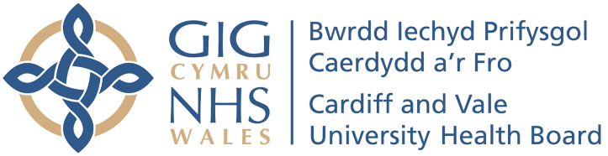






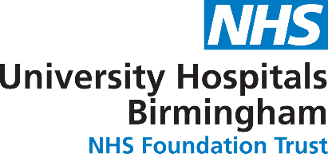

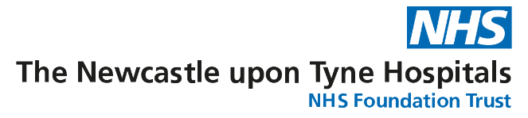

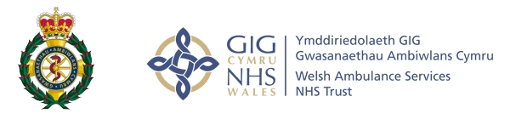


PUBLIC INVOLVEMENT AND ENGAGEMENT
Effective engagement and building partnerships with the public as stakeholders in our research is fundamental to the success of each individual research project. From participating in studies through to sitting on oversight groups, the involvement of patients and public enables our staff to explore new treatments and service models.
An excellent example of research focused on co-production during the past year was that led by Dr Jonathan Howard, Clinical Scientist, within Rehab Engineering, who was awarded a NIHR Innovation Fellowship for his research on scoping the need for personalised assistive devices amongst the public and healthcare professionals.

This work looked to scope out the current need for personalised assistive devices by speaking with members of the public living with long-term health conditions and occupational therapists. To achieve this attendance was arranged at 13 local charitable support groups alongside questionnaires completed by members of the public and occupational therapists. There are a variety of activities of daily living where current assistive equipment is not able to meet people’s needs, with the most common activities relating to feeding, dressing and personal hygiene.
- There are inconsistencies in the care being provided, both due an individual’s health condition and where they live, that would need addressing when considering how individuals may access a service in the future. Members of the public were currently often unsure whom they could contact to make an appropriate referral into a service.
- The individual nature of each person’s needs meant flexibility would be needed both in terms of when and how an individual would access the service and devices.
- The majority of individuals living with long term health conditions wanted to be involved in the design process for making personalised assistive devices.
- Individuals were happy to privately purchase devices, however wanted more information on the types of devices available and how they could access them. However, individuals were also wary not everyone would be able to afford purchasing them privately.

The work also involved a national benchmarking exercise which involved a UK survey of Clinical Engineering departments to understand the un-met clinical needs and recommendations included effective solution sharing between individuals and organisations.

PUBLIC INVOLVEMENT AND ENGAGEMENT

Research & Development Showcase Day
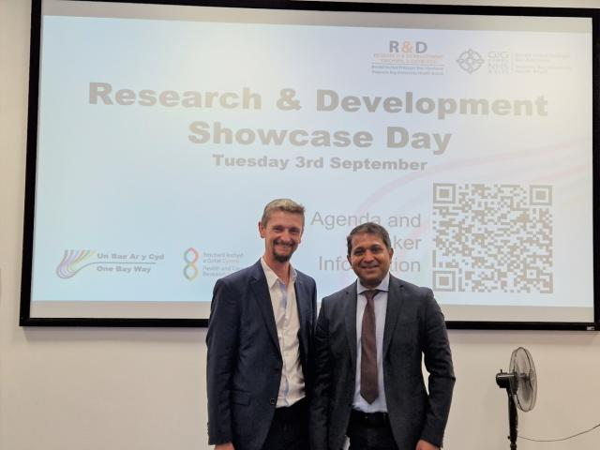
Swansea Bay’s Research and Development (R&D) showcase returned for the first time since before the pandemic.
L-R: Professor Dean Harris and Dr Raj Krishnan
The day-long event, held in Morriston Hospital’s Education Centre in September 2024, saw ten speakers discussing eight different projects, ranging from developing a simple blood test to detect colorectal cancer, to empowering non-clinical staff to become principal investigators (PIs) and leading research.
Deputy Executive Medical Director Raj Krishnan delivered the welcome address and Professor Dean Harris, consultant colorectal surgeon and Deputy Director of Swansea Bay’s Research and Development programme, played host to around 60 guests.
Also present was Dr Nicola Williams, Director of Support and Delivery at Health and Care Research Wales, which supports R&D within Swansea Bay.
(Credit: HCRW News Story)

PUBLIC INVOLVEMENT AND ENGAGEMENT

Supporting Engagement
Alongside internal events, SBU staff were pleased to support national research campaigns and conferences throughout the year, including:
R&D staff attended the UK National NHS R&D Forum
Health and Care Evidence Centre Symposium

Helping promote ‘Red for Research Day’ - a national media campaign highlighting the impact of research.

Health and Care Research Wales Annual conference
Highlighting SBU R&D activity at the Senedd Cross working party event on research

Specialist conferences

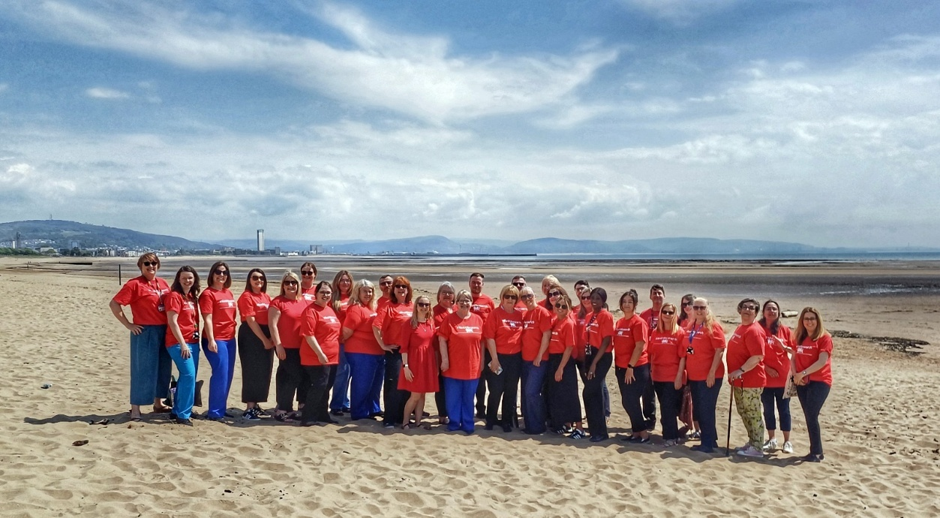
Members of the Research & Development Department celebrating Red for Research Day 2024

OTHER KEY ACHIEVEMENTS






Roll out
of
protected SPA time for Research in Consultant job plans.

NHS Wales Awards 2024 Winners
NHS Wales Learning and Research Award
Swansea Bay University Health Board
On the Ground Clinical Lymphoedema
Education Programme for Community Staff
(OGEP)

Top recruiting sites over the year for studies Steps11, MS, PETNECK2, CLL and ENRICH-AF

Successful launch of medical student placements within SBU R&D JCRF and Cancer delivery teams – in collaboration with Swansea Medical School

MediWales Innovation Awards 2024 Winners
Technology and Digital Impact Award Swansea Bay University Health Board
Orthopaedic
Prehabilitation and
Pre-assessment
Team

Successful collaboration between SBUHB, Velindre NHS Trust and Betsi Cadwaladr UHB with biotechnology company BioNTech to expand access to clinical trials of personalised cancer vaccines across Wales

FINANCIAL SUMMARY

Research Income | Current Year | Previous Year
Research Delivery Funding | £2,329,425 | £2,240,683
Excess Treatment Costs | £136,777.32 | £99,078
VPAG funding | £36,196.20 | £0
Non-commercial grant income – HCRW | £134,424 | £188,974
Commercial research income | £1,700,000 | £1,580,000
TOTAL INCOME | £4,336,823.52 | £4,108,735

Note: Other non-commercial funding received for collaborative grants, including those led by clinicians in their academic capacity, have not been included as those awards are held within the University.

FORWARD LOOK & CONCLUSION
Thank you for taking the time to read our Annual Report 2024-25, we hope it has provided a useful insight into R&D at Swansea Bay UHB.

We are proud to be a research active Health Board where our clinical and non-clinical teams adopt collaborative approaches on research, development and innovation to explore better treatment options to improve health outcomes. This report offers just a glimpse of the type of excellent work being undertaken by SBU staff and shares our ambitions for the future.

The Health Board would like to take the opportunity to thank our research collaborators and partners for their support and most importantly to all the patients who are providing their consent to enable research to make a difference to tomorrows care.
As we reflect on the successes achieved in the domain of RD&I as an individual Health Board, the natural progression is to work regionally with our partners at Hywel Dda University Health Board to unite our ambitions in creating a vibrant regional approach to RD&I, which benefits patients and the wider community. Consequently, plans are underway to develop a regional RD&I Strategy with shared oversight through a Joint Regional R&D Director.

Initial focus is on Oncology clinical trials to enable trials to be opened regionally before assessing further where joint working can be established, drawing on previous examples of collaboration such as the Research Champion roles deployed under the research leadership of Prof Dean Harris which saw non-research clinical staff trained to champion the importance of research and delivered an increase in patient recruitment into trials and the Amgen/JCRF and TriTech cardiovascular collaboration, described above.

The Three Pillar Strategy sets a foundation on which to build with our partners at HDD, with some of these objectives naturally transferring across to a regional Strategy with others retaining a SBU specific focus, such as our relationship with Swansea University in delivering a Joint Clinical Research Facility and Co-sponsorship of certain clinical studies. We want to build a research environment which is collaborative, based on principles of joint working and sharing best practice, with responsiveness and agility in our infrastructure to accommodate the growth of R&D across the region. The diagram below sets out in detail what we are looking to achieve over the next 12 months, with some examples being:

- Securing additional invest via the VPAG scheme, to support a focus on regional Oncology Trial delivery.

FORWARD LOOK & CONCLUSION

- Delivering the 1st Joint SBU/HDD R&D Showcase event as a springboard for future events and collaborative opportunities with partnership working across the region.
- Collaborate with Academic Partners across the region to set up structured forums for Clinical and Academic liaison to support an increase of joint grant applications across specialities.
- Work strategically with Academic Partners and Health and Care Research Wales in growing Clinical Academic roles.
This is an exciting time for us as a health board and a region with opportunities to develop, enhance and increase the clinical research opportunities open to patients, providing hope for their treatments and their futures.

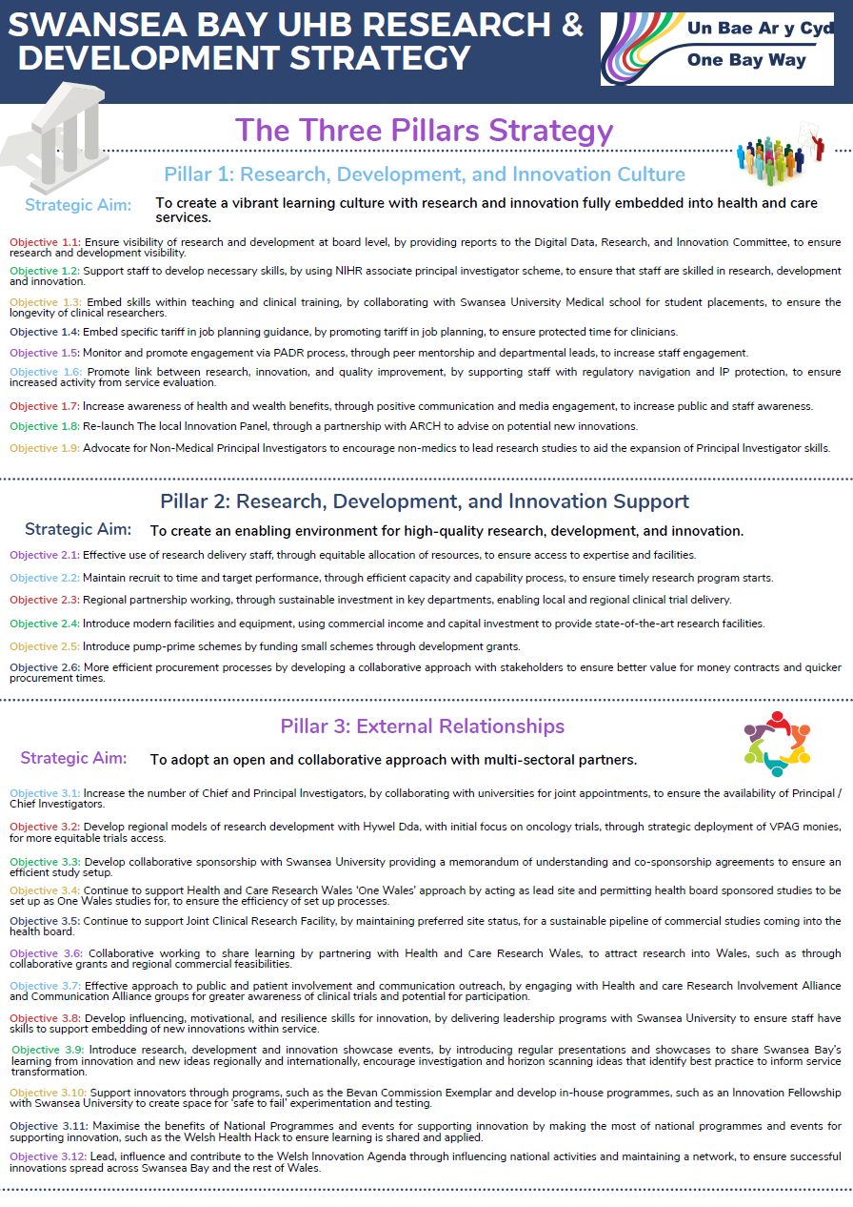
FORWARD LOOK & CONCLUSION

Research & Development Strategy

