Appendix 2. Extended Detail on Digital Developments (Section 3.4)
3.4.1 Following extensive testing, a new SharePoint-based Clinical Audit Application, designed and developed by the Clinical Audit Team, was implemented in February 2026. The application supports audit prioritisation, planning, monitoring, outcome recording, Risk Assurance Matrix scoring and action management.

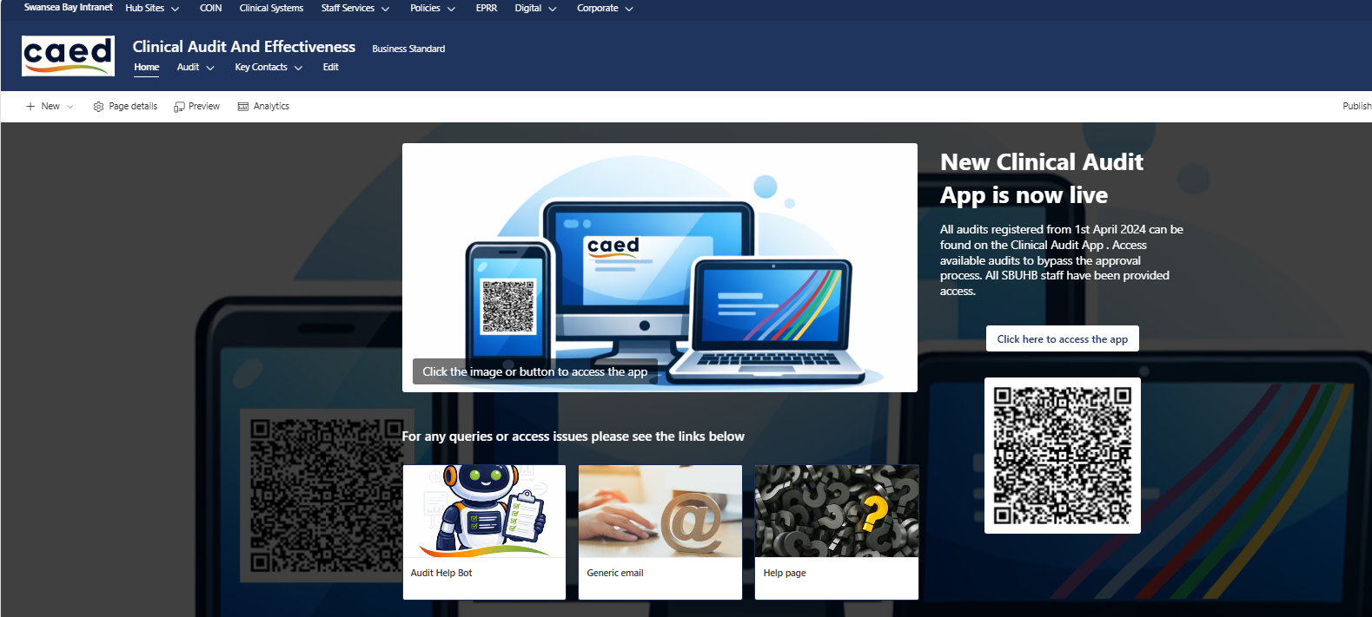

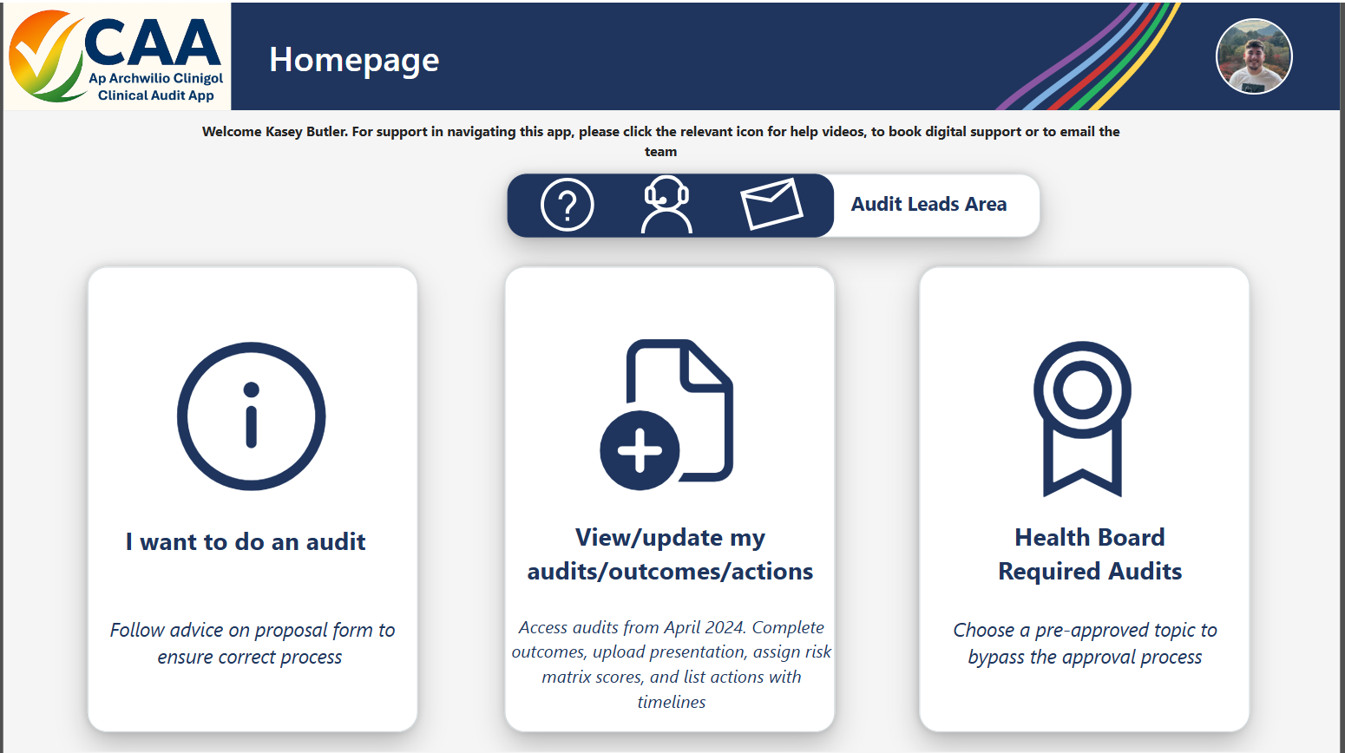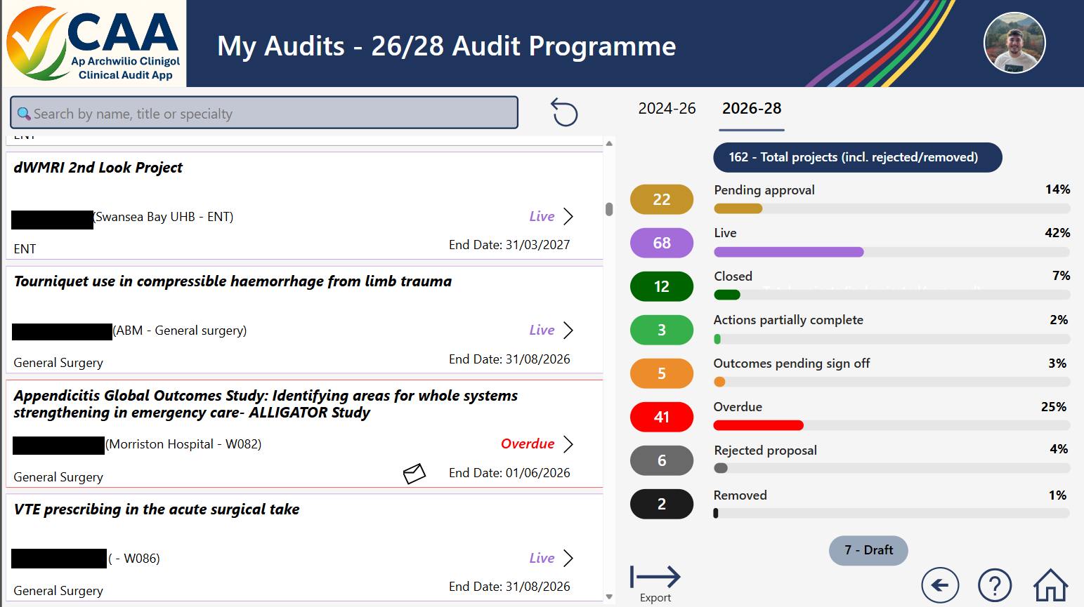

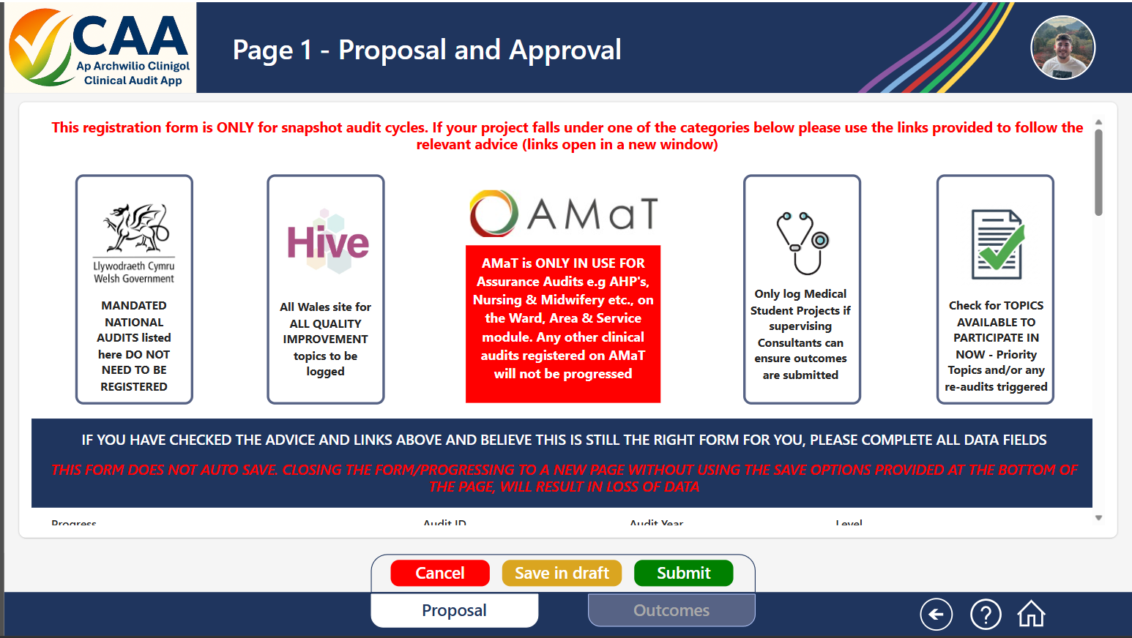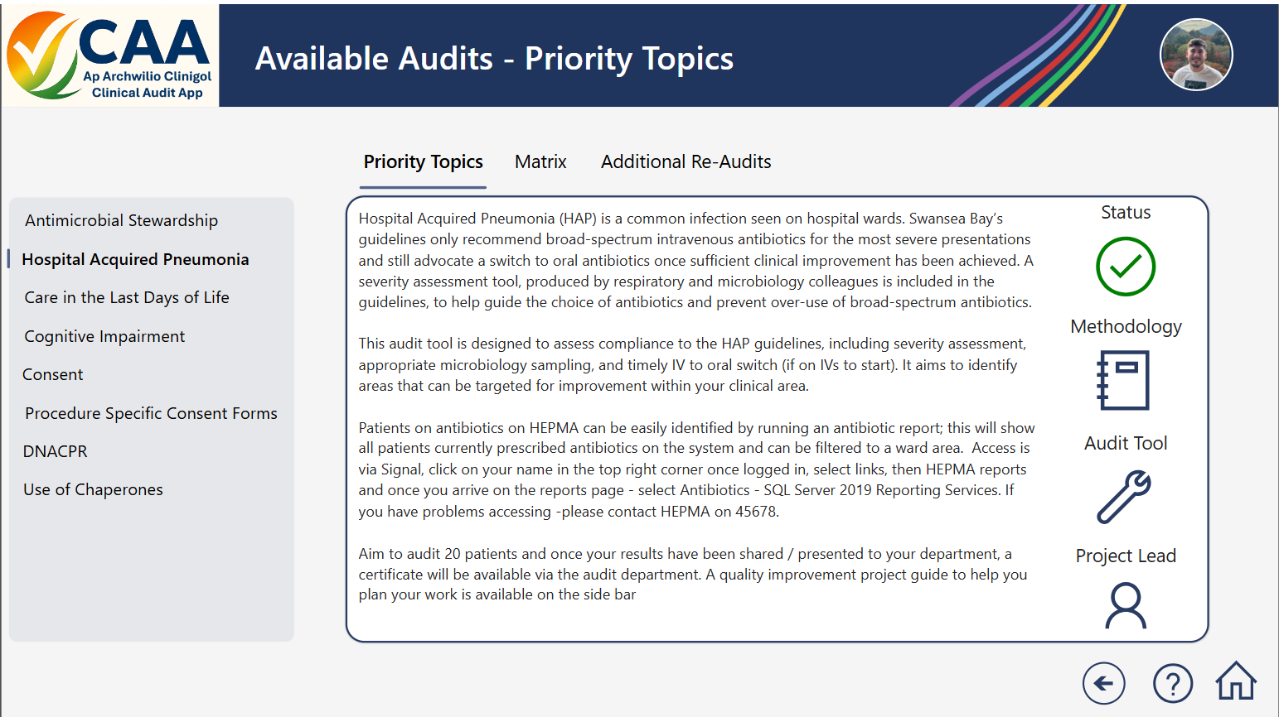
In addition to planned audit activity, the system supports the management of emergent audits, Medical Student projects, and regional or national audit topics not included within the Welsh Government Level 1 programme. A bespoke digital Clinical Audit Companion has also been developed to provide 24/7 access to guidance and frequently asked questions, improving support for users and reducing administrative burden.
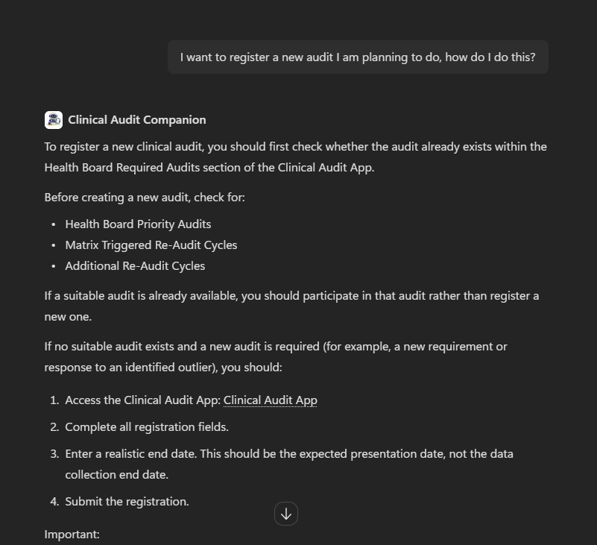
3.4.2 The Clinical Audit Team has further enhanced the COEG Dashboard to provide a clearer and more intuitive overview of clinical audit activity, NICE guidance implementation, Health Technology Wales recommendations and assurance response compliance.
The dashboard now provides a high-level view of performance and compliance trends, supported by detailed drill-down functionality that enables teams to identify areas requiring attention and take timely corrective action.
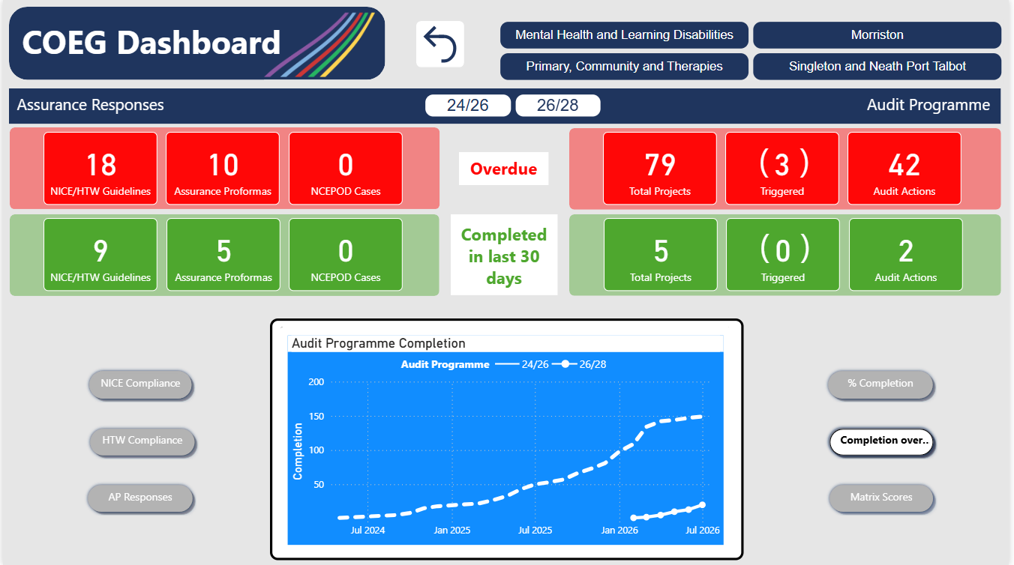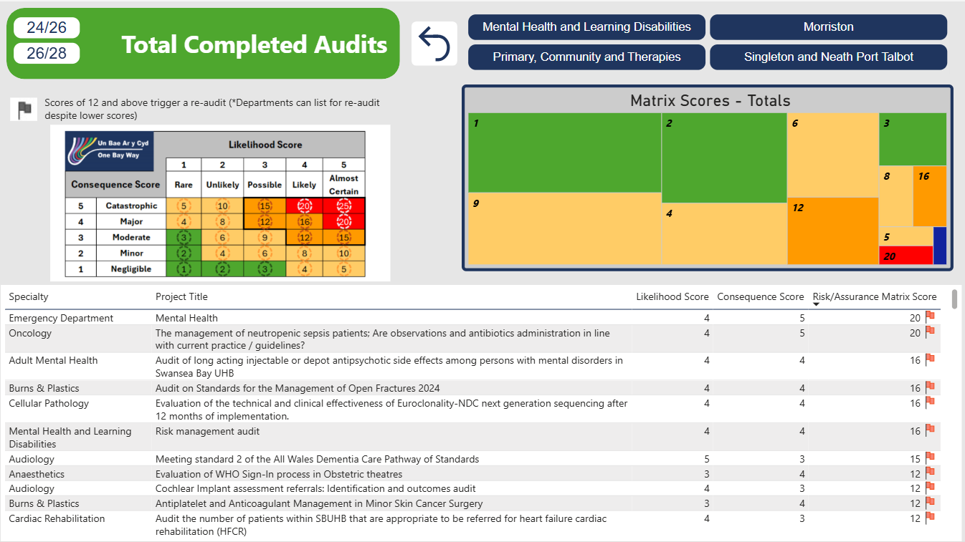
3.4.3 Production of the 2025/26 Clinical Audit Annual Report was supported through a bespoke CoPilot Agent developed by the Clinical Audit Team. The tool was used to summarise outcomes submitted by project contacts and clinical teams, improving consistency of reporting and reducing administrative effort.
3.4.4 Implementation of a new Assurance Responses Application, designed and developed by the Clinical Audit Team, is expected to enhance compliance rates by providing a more accessible and user-friendly platform for response submission.
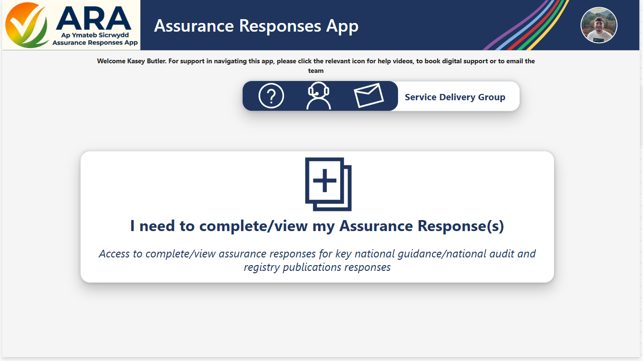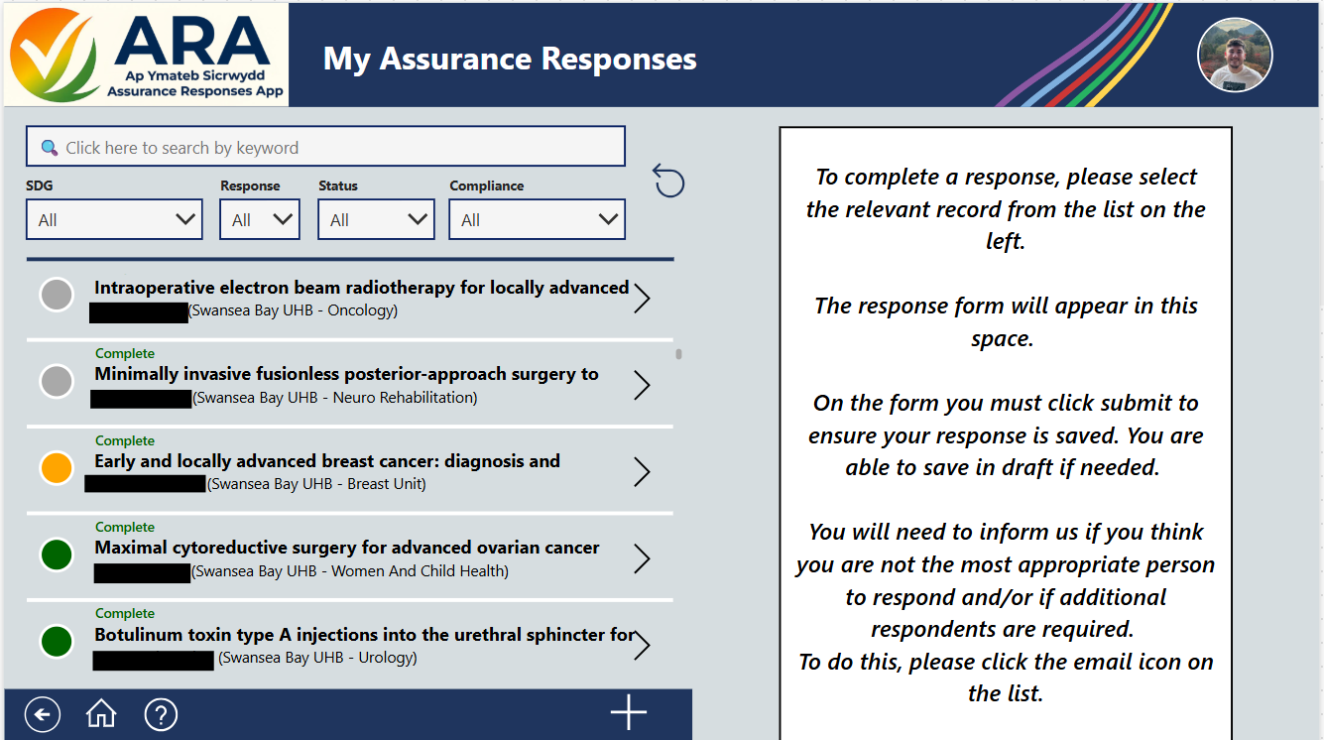
The application includes automated reminders, enhanced functionality and improved visibility of outstanding actions, supporting more timely completion and stronger accountability.
3.4.5 Work remains ongoing with Digital Intelligence colleagues to develop a bespoke mortality dashboard. Once implemented, the dashboard will support identification of trends, outliers and areas of concern, enabling the development and monitoring of targeted improvement plans where required.
3.4.6 Historically, Medical Examiner Referral reports presented to COEG were produced manually. The Clinical Audit Team has now developed an automated reporting solution using SharePoint-derived data to populate an enhanced Excel-based reporting tool with improved analytical capability, graphical presentation and Service Group-level drill-down functionality while significantly reducing report production time and administrative effort.
As part of this work, a bespoke CoPilot Agent was also developed to analyse patient compliments and feedback. The tool generates concise summaries and identifies the most frequently occurring themes, enabling areas of good practice and positive patient experience to be recognised and shared more effectively.
3.4.7 Previously, queries relating to National Major Trauma Registry (NMTR) inclusion criteria were directed to the NMTR Support Manager, whose role spans both Clinical Audit and the South Wales Major Trauma Network. Outside of this support, staff were required to interpret lengthy guidance documentation, leading to inefficiencies and variation in decision making.
To address this, the Clinical Audit Team developed an NMTR Inclusion Bot from national inclusion criteria and guidance.
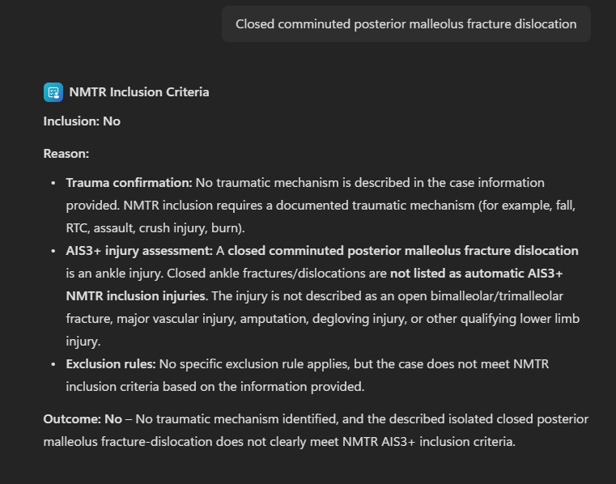
Users across Wales enter key patient and injury information to receive an immediate inclusion decision with supporting rationale. The tool has streamlined decision making, improved consistency and reduced reliance on manual interpretation. The development has been recognised and commended by the South Wales Trauma Network.
To further support performance monitoring, a suite of Power BI dashboards has been developed, providing interactive access to NMTR data. Users can review activity, trends, injury profiles, patient cohorts and performance metrics across selected date ranges, supporting service planning and quality improvement initiatives.
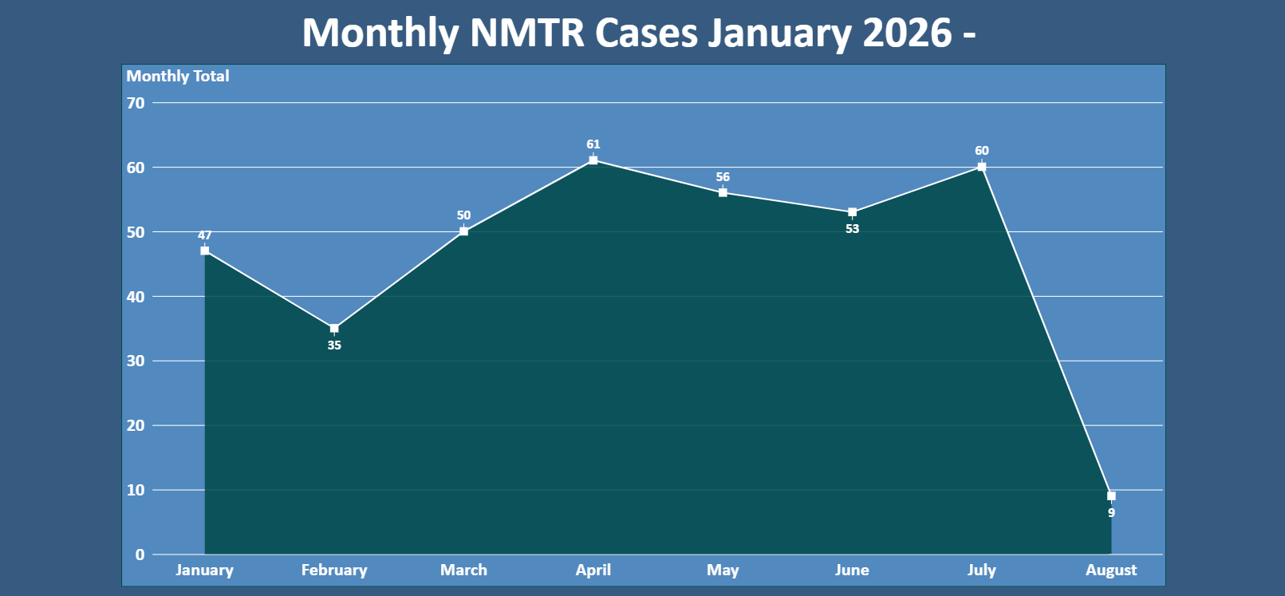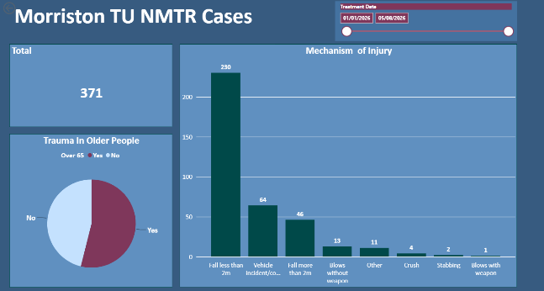
In addition, a dedicated NMTR Performance Tracking Workbook has been developed to support continuous monitoring and improvement. The workbook incorporates RAG ratings, action tracking and trend analysis to assist teams in identifying areas requiring attention and monitoring progress over time.
3.4.8 Determining eligibility for the National Chronic Obstructive Pulmonary Disease (COPD) Secondary Care Audit previously required manual interpretation of detailed inclusion criteria, creating the potential for inconsistency and delays.
To support a standardised approach, the Clinical Audit Team developed a COPD Audit Inclusion Bot. Users enter relevant patient information and receive an immediate eligibility assessment with supporting rationale based on national audit criteria. The tool has improved consistency, reduced reliance on lengthy guidance documentation and streamlined case identification processes.

Appendix 3. Example of a Service Delivery Group Hub Page
