

Clinical Audit & Effectiveness Annual Report 2025/26

Contents

 |  |  | Pages
 | Foreword |  | 2
1. | Report from the Clinical Audit Team |  | 3-4
 | 1.1 Clinical Outcomes & Effectiveness Group (COEG)
 | 1.2 Clinical Audit and Effectiveness Policy, Audit Hierarchy
2. | Activity |  | 4-13
2.1 Digital Systems
2.2 Explaining Figures
 | 2.3 Health Board Overview 2022/23 to 2026
 | 2.4 Governance
 | 2.5 Re-audit
 | 2.6 NICE/Health Technology Guidance Recommendations
 | 2.7 National Audit/Registry Published Reports
 | 2.8 Rejected Proposals 2024-26
 | 2.9 Removed Projects 2024-26
2.10 Deferred Projects 2024-26
2.11 Service Group Breakdown
2.12 Mental Health and Learning Disabilities Summary
2.13 Morriston Summary
2.14 Primary, Community Care and Therapies Summary
2.15 Singleton and Neath Port Talbot Summary
2.16 Summary of Risk Assurance Scoring, by Service Group

3. | Audit Programme 2026/28 |  | 13-14
3.1 Audit Plan
3.2 Additions to the Audit Programme

4. | Mortality |  | 14-17
4.1 Medical Examiners Service and Mortality Reviews
4.2 Deaths and Referrals 2024/25

5. | Useful Links and Contacts |  | 17
6. | Appendices |  | 18-32

Foreword
Clinical outcomes and effectiveness remain a core component of the Health Board’s quality governance arrangements, enabling assurance that services are delivering care in line with agreed standards and identifying opportunities for improvement. During 2025–26, clinical audit activity, mortality reviews, and monitoring of compliance with key national guidance have continued to provide both assurance and learning across acute, specialist, community, and mental health services.

This year’s Annual Report demonstrates a clear strengthening of clinical audit assurance across the organisation. Compared with the previous year, there has been a marked improvement in the completion, visibility, and ownership of audit outcomes, supported by the full implementation of the Clinical Audit App. Risks identified through audit are increasingly associated with demand-pressured pathways rather than failures in governance, with re-audit and Quality Improvement activity appropriately and proportionately triggered where required.

A key development this year has been the increased use of digital approaches to support the delivery and oversight of clinical outcomes and effectiveness work. Enhanced audit submission and reporting tools have enabled more timely capture of outcomes, clearer documentation of actions, and improved visibility of risk and residual assurance at both Service Group and organisational level, strengthening oversight and supporting more consistent monitoring of progress.

The two-year clinical audit programme approach is now established and has enabled more realistic end-to-end completion of audits, from data collection through to action implementation and re-evaluation. In parallel, the continued use of a standardised digital presentation template for Service Group updates to the Clinical Outcomes and Effectiveness Group (COEG) has improved consistency, comparability, and focus across audit plan progress, mortality reviews, and responses to key national guidance.

Together, these approaches have supported clearer articulation of learning, benchmarking, and the impact of change where re-audit or Quality Improvement activity is required.

I would like to extend my thanks to the Clinical Audit Team for their continued focus on developing and embedding digital solutions to support the COEG, clinical teams, and Service Groups. Their work to streamline systems, enhance engagement, and improve compliance with local and national requirements continues to strengthen effective oversight of clinical outcomes and effectiveness across the organisation.

Dr Raj Krishnan
Interim Executive Medical Director

- Report from the Clinical Audit Team
  - Clinical Outcomes and Effectiveness Group (COEG)
Clinical audit plays a critical role in providing assurance, identifying and reducing risk, waste, and inefficiencies, and improving the effectiveness of care pathways, alongside the quality of patient outcomes and experience.
The Clinical Outcomes and Effectiveness Group (COEG) is chaired by members of the Executive Medical Directors Department and acts on behalf of the Health Board to ensure that appropriate and robust systems are in place to support the delivery of effective clinical audit priorities and projects. It provides assurance on the development, delivery and monitoring of the Clinical Audit Programme through regular reporting to relevant governance groups and, where required, escalates risks or issues to the Quality and Safety Committee via the Quality and Safety Group.
In addition, the COEG has oversight of arrangements relating to Mortality Reviews, the review and implementation of NICE guidance applicable to Wales, and consideration of recommendations issued by Health Technology Wales (HTW).
In 2024, COEG supported the extension of the audit cycle to a bi-annual timeframe in recognition of the time required to deliver audit topics and obtain meaningful outcomes. The report provides an update on the position of the 2024–26 Audit Programme and any historic topics that had not previously been formally accounted for. It also outlines the process used for compiling the content of the planned element of the 2026–28 Audit Programme.
1.2 Clinical Audit and Effectiveness Policy & Audit Hierarchy
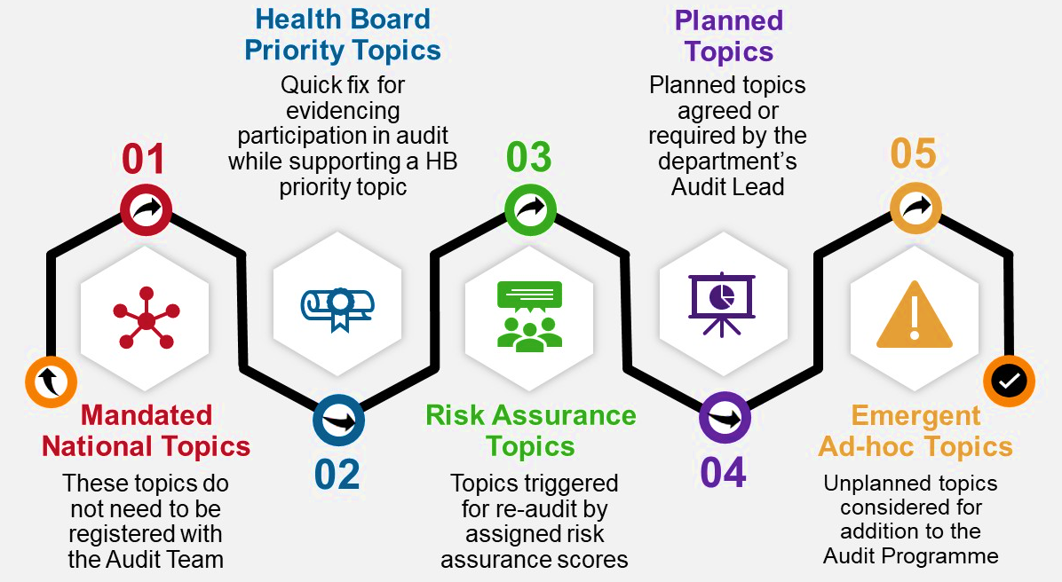
Figure 1. Hierarchy of Audit Priorities
The Clinical Audit and Effectiveness Policy sets out the Executive Medical Director’s vision for a robust framework to prioritise, deliver and monitor clinical audit, in line with best-practice guidance and the requirements of the Health and Care Standards. The Policy describes the governance structures, roles and processes that support the Health Board, Service Groups, doctors in training and other healthcare professionals in navigating the audit hierarchy.
Level 1 requires Welsh Health Boards and Trusts to deliver the Welsh Government-mandated programme of national audits, registries and studies, where relevant to the services provided.
Level 2 comprises a small number of Health Board Priority Audit Topics agreed annually. These are informed by system risks, adverse patient outcomes or patient-safety concerns that impact more than one Service Group.
Levels 3 and 4 At the conclusion of each audit cycle, Project Contacts are required to assign a risk matrix score following presentation and discussion of findings. Scores of 12 or above automatically trigger a re-audit (Level 3). Audit Leads review outcome summaries and risk matrix scores to enable certificate release. Where Audit Leads disagree with the recorded score and/or the requirement to list a re-audit, they are expected to amend the record accordingly. The planning round enables departments to prioritise and list known audit requirements for the given period (Level 4). Topic selection should be informed by areas of concern and redress, findings from national audits and registries, and new or updated NICE and other key guidance. Levels 3 and 4 collectively form the basis of the Audit Plan.
Level 5 recognises that emerging risks or issues may necessitate unplanned audits during the audit period, alongside Medical Student projects and participation in regional or national audits not included at Level 1. These ad-hoc proposals are logged as Level 5 and, if authorised, are incorporated into the wider Audit Programme.
2. Activity
2.1 Digital Systems
At the request of Quality Improvement colleagues, the Clinical Audit and Effectiveness Department (CAED) no longer log Quality Improvement (QI) activities and signpost them to the QI Hive.
Nursing, Midwifery and Allied Health Professionals continue to utilise the Audit Management and Tracking (AMaT) system in support of several continuous or ongoing work-streams.
In response to user feedback, the CAED reverted to using SharePoint for registration and monitoring of audit activities for topics logged from 1st April 2024. In January 2026, the SharePoint site was used as the basis of a new Clinical Audit App. All historic topics unaccounted for on AMaT were migrated across to the new app.
  - Explaining Figures
The figures relate to Levels 3 and 4 of the Audit Hierarchy for 2022/23 and 2023/24. For the 2024/26 completion figures, completed Level 5 ad-hoc topics have also been included.
  - Health Board Overview 2022/23 to 2026
Figure 2 below shows the Health Board’s progress with the individual audit periods at different points in time, supporting the move towards an extended two-year audit programme;
2022/23 |  |  |  |  |  |  |  |  |  |  | .2023/24 |  |  |  |  |  |  |  |  |  |  |  | 2024-26
@ 23/24 |  |  | @ 24/25 |  |  | @ 25/26 |  |  |  | @ 24/25 |  |  |  | @ 25/26 |  |  | @ 26/27 |  |  |  | @ 25/26 |  |  |  |  | @ 26/27
50% |  |  | 81% |  |  | 96% |  |  |  | 39% |  |  |  | 86% |  |  | 86% |  |  |  | 25% |  |  |  |  | 72%

Figure 2. Progress with Audit Plans 2022 to date
As previously reported, the 2022/23 audit period closed with 96% of topics accounted for. Historically, completion rates for plans had peaked at approximately 45–50%, and progress beyond the audit period was not routinely tracked or actively followed up.
Completion rates for the 2024–26 audit period have improved to 72% as at 1st April 2026, despite significant time and resource being diverted to the implementation and population of the new Clinical Audit App.
In 2025, COEG introduced a requirement for Service Groups to present on key agenda items on a rotational basis. This was supported by the development of a new dashboard linking directly to individual audit records, designed to prompt timely action by Audit Leads and Project Contacts where required. This level of visibility and linkage was not achievable using the previous AMaT system.
Sickness absence, staff turnover and increasing, competing priorities within the CAED work programme have impacted the capacity to undertake frequent manual follow-up through emails and meetings with Audit Leads to resolve outstanding actions. The introduction of a summarised overview at monthly COEG meetings, alongside the new app developed for the 2026–28 planning round, will support improved visibility and easier identification of outstanding tasks.
2.4 Governance
Timely registration and reporting of clinical audit activity and outcomes is a Health Board requirement. Historically, some audit topics were not formally registered, limiting organisational learning and assurance.
The introduction of the Clinical Audit App is intended to reduce unregistered audit activity by supporting proposal and approval processes and providing easy access to Health Board Priority Audit topics and required re-audits. In support of the Executive Medical Director’s Audit Hierarchy, retrospective registration of audit activity is not permitted.
The SharePoint-based Clinical Audit App was implemented in February 2026 following extensive testing. It supports audit prioritisation, planning and monitoring, outcome recording, Risk Assurance Matrix scoring, and documentation of resulting actions. Emergent audits, Medical Student projects, and additional regional or national topics not included in the Level 1 Welsh Government programme are recorded using the same process.
For 2026–27, the Planning Round ran from January to mid-March, with plans approved at COEG on 13 March 2026. These included rolled-over incomplete audits, triggered and department-listed re-audits, and known new requirements. Re-audits identified outside the Planning Round are recorded on the wider Audit Programme.

2.5 Re-audit
71 projects on the Audit Programme were identified as re-audits. Of these, 26 were subsequently removed due to alternative improvement approaches (e.g., Quality Improvement work), rejected proposals, or service changes. Of the remaining 45 re-audits, 37 have been completed to date.
2.6 NICE/Health Technology Wales (HTW) Guidance and Recommendations
The Clinical Outcomes and Effectiveness Group (COEG) continues to monitor Health Board compliance with newly published and revised National Institute for Health and Care Excellence (NICE) and Health Technology Wales (HTW) guidance. Senior staff within the Executive Medical Directors Department and Service Groups identify the most appropriate individuals to provide assurance responses on behalf of the organisation.
This process has historically been supported through SharePoint. However, work is underway to upgrade the system using PowerApps. During this transition, and in the context of capacity constraints within the Audit Team, the number of assurance responses issued has been limited and the HTW Adoption Audit responses have been prioritised, affecting 11 guidance documents yet to be issued for review and response.
During 2025/26, 43 guidance responses were issued, 9 of which related to the previous round of the HTW Adoption Audit. 8/9 were completed and submitted. It was not possible to complete the remaining response due to the extended absence of the identified subject matter expert.
14 responses have been requested for the current round of the HTW Adoption Audit, of which 2 have been completed to date. The final submission deadline for this round is 20th June 2026.
Of the remaining 20 guidance responses, 11 have been completed.
At the COEG meeting in April 2026, the Chair agreed that any historic assurance responses should be formally stood down where a more recent update has since been requested, to avoid duplication and ensure focus on current guidance.
It is anticipated that implementation of the new Assurance Responses App will significantly improve completion rates by enabling easier digital submission, enhanced functionality, automated prompts, and a more visually engaging and user-friendly interface, supporting more timely submission.
2.7 National Audit/Registry (Level 1) Published Reports
For the previous report period, 9 assurance proformas issued following publication of national audit/registry reports were outstanding. To date 95% of those publication responses have been completed. Responses to the NCEPOD Study into End-of-Life Care 2024 and the Oesophago-gastric Cancer Report remain incomplete.
For the 2025/26 period currently 30/45 (67%) have been completed to date.
The COEG monitors timeliness of responses, escalating issues to the Quality Safety Group as required for support in attaining the required information. Service Group presentation templates also require updates on compliance. Once implemented, the new Assurance Responses App will further support monitoring, escalation, and improved timeliness through automated tracking and reporting functionality.
2.8 Rejected Projects 2024/26
33/291 topics were not authorised by the Audit Leads who rejected the proposals on submission.
2.9 Removed Projects 2024/26
67/291 topics were removed (of which 26 were re-audits). Topics were removed for a number of reasons, including relevance, need and service changes. No topics triggered by risk scores are removed without valid reason, e.g., improvement work being progressed as part of Quality improvement, changes to pathway etc.
2.10 Deferred Projects 2024/26
33 topics have been deferred to the 2026/28 Audit Plan.
2.11 Service Group Breakdown
Department level information presented is generated from project summaries submitted to date. Outcomes sections include the need for Project Contacts to assign risk/assurance matrix scores. Summaries and scores are subsequently reviewed and signed off by designated Audit Leads prior to release of certificates of completion.
In aligning with the Health Board Risk/Assurance Matrix for the report period, scores of ≥12 automatically trigger the need for a re-audit.
Brief summaries of the outcomes submitted, along with risk/assurance scores, are included as Appendix 1. for information.

2.12 Mental Health & Learning Disabilities (MHLD) Service Group
A total of 13 topics were closed during the 2025-26 period. Audits completed within the MHLD Service Group during 2025–26 demonstrated meaningful impact across medicines optimisation, risk management, pathway effectiveness, and service efficiency. Planned audits provided assurance against national and local standards, particularly in antipsychotic prescribing, physical-health monitoring, dementia care, and perinatal services. Ad-hoc audits and service evaluations were used effectively to respond to emerging risks and service pressures, notably within alcohol detoxification services, forensic practice, and outpatient access.
Strong multidisciplinary engagement was evident, with clear dissemination of findings, implementation of policy refreshes, and measurable improvements in monitoring and documentation in several high-risk areas. However, residual risk remains in relation to consistency of risk assessment practice, governance around high-dose antipsychotic initiation, review and discontinuation of anxiolytics and hypnotics in learning-disability settings, and comprehensive side-effect monitoring for patients with dementia. Documentation gaps and variable use of standardised tools continue to limit full assurance in some pathways.
The above summary and project outlines in Appendix 1 are AI-generated from outcome records submitted between 1st April 2025 and 31 March 2026. They do not represent the full 2024–26 audit programme and may include projects initiated under earlier programmes.
2.12.1 Audit Requirements
As of 1st April 2026, there are a total of 18 topics listed for delivery (Figure 3.), 28% of which originated from the 2024/26 Audit Programme and are now listed as overdue. The remaining 72% are a combination of topics from the 2024/26 programme which were deferred, or newly listed requirements identified during the 2026-28 planning round;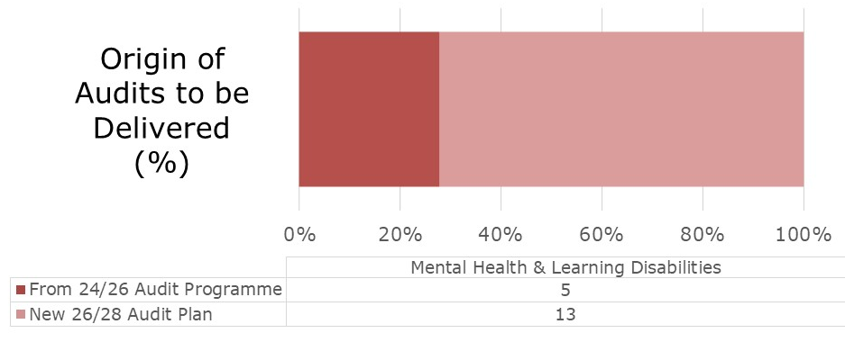
Figure 3. Audit Tasks to be delivered by the Mental Health & Learning Disabilities Service Group

2.13 Morriston Service Group
A total of 36 topics were closed during the 2025-26 period. Audits completed within the Morriston Service Group during 2025–26 provided assurance across a broad range of acute, specialist, and critical care services, including emergency medicine, critical care, renal, surgery, radiology, cardiology, and specialist tertiary pathways. The programme demonstrated meaningful impact in improving documentation standards, adherence to national guidance, pathway efficiency, infection prevention, and patient safety.
Planned audit activity delivered assurance in several higher-risk clinical areas, particularly within intensive care practice, treatment escalation planning, renal services, specialist diagnostics, and surgical pathways. In parallel, ad hoc audits and service evaluations were used effectively to respond to emerging risks and operational pressures, including demand on emergency care pathways, diagnostics, prescribing practice, and resource utilisation.
Strong multidisciplinary engagement was evident across many projects, supported by local guideline development, education, and measurable improvement between audit cycles. However, residual risk remains in relation to consistency of documentation, timeliness of interventions within complex and inter-health board pathways, and variation in compliance with national standards in high-risk emergency and surgical presentations, with several audits appropriately escalated to re-audit or Quality Improvement activity to support sustained improvement.
The above summary and project outlines in Appendix 2 are AI-generated from outcome records submitted between 1st April 2025 and 31 March 2026. They do not represent the full 2024–26 audit programme and may include projects initiated under earlier programmes.
2.13.1 Audit Requirements
As of 1st April 2026, there are a total of 90 topics listed for delivery (Figure 4.), 37% of which originated from the 2024/26 Audit Programme and are now listed as overdue. The remaining 63% are a combination of topics from the 2024/26 programme which were deferred, or newly listed requirements identified during the 2026-28 planning round;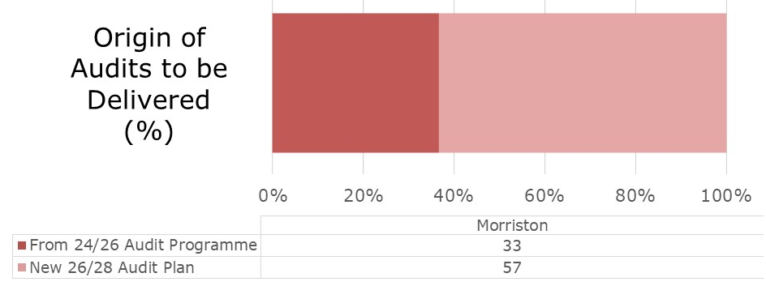
Figure 4. Audit Tasks to be delivered by the Morriston Service Group
2.14 Primary, Community Care and Therapies (PCT)
A total of 10 topics were closed during the 2025-26 period. Audits completed across PCT during 2025–26 provided assurance across a diverse range of community-based, outpatient, and specialist services, including dental services, cardiac rehabilitation, audiology, podiatry, sexual health, therapies, and palliative care. The programme demonstrated effective use of audit to identify pathway bottlenecks, improve access to care, strengthen documentation standards, and support patient safety in lower-volume but high-impact services.
Several audits identified high-value improvement opportunities, particularly where patients were not consistently accessing evidence-based interventions (e.g., cardiac rehabilitation and cochlear implant assessment), or where pathway inefficiencies increased clinical risk. While many projects demonstrated strong compliance with professional standards and measurable improvement following intervention, residual risk remains in relation to service capacity, staff awareness of referral criteria, documentation quality, and sustainability of improvements without further re-audit.
The above summary and project outlines in Appendix 3 are AI-generated from outcome records submitted between 1st April 2025 and 31 March 2026. They do not represent the full 2024–26 audit programme and may include projects initiated under earlier programmes.
2.14.1 Audit Requirements
As of 1st April 2026, there are a total of 14 topics listed for delivery (Figure 5.), 14% of which originated from the 2024/26 Audit Programme and are now listed as overdue. The remaining 86% are a combination of topics from the 2024/26 programme which were deferred, or newly listed requirements identified during the 2026-28 planning round;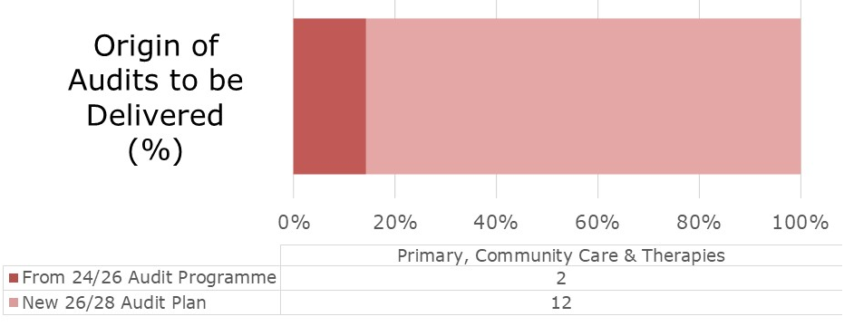
Figure 5. Audit Tasks to be delivered by the Primary, Community Care & Therapies Service Group

2.15 Singleton and Neath Port Talbot
A total of 35 topics were closed during the 2025-26 period. Audits completed across Singleton and Neath Port Talbot services during 2025–26 provided assurance across a wide range of services, including women’s services, oncology, paediatrics, anaesthetics, dermatology, trauma and orthopaedics, haematology, palliative care, and community-based pathways. The programme demonstrated effective multidisciplinary engagement, robust participation in national and local audit activity, and tangible improvements in patient safety, pathway efficiency, documentation standards, clinical outcomes, and medical and surgical training.
Several audits identified high-risk and capacity-driven pressures, particularly within oncology services (including SACT delivery and neutropenic sepsis), maternity fetal monitoring pathways, and neurodevelopmental and paediatric cardiology services, where increasing demand, workforce constraints, reliance on timely documentation, and pathway complexity continue to limit full assurance. While many areas demonstrated good or improving compliance following intervention and re-audit, residual risks remain where practice is inconsistently documented, where services remain demand-pressured, or where system-wide improvement requires sustained monitoring, re-audit, or escalation into formal Quality Improvement activity.
The above summary and project outlines in Appendix 4 are AI-generated from outcome records submitted between 1st April 2025 and 31 March 2026. They do not represent the full 2024–26 audit programme and may include projects initiated under earlier programmes.
2.15.1 Audit Requirements
As of 1st April 2026, there are a total of 41 topics listed for delivery (Figure 6.), 39% of which originated from the 2024/26 Audit Programme and are now listed as overdue. The remaining 61% are a combination of topics from the 2024/26 programme which were deferred, or newly listed requirements identified during the 2026-28 planning round;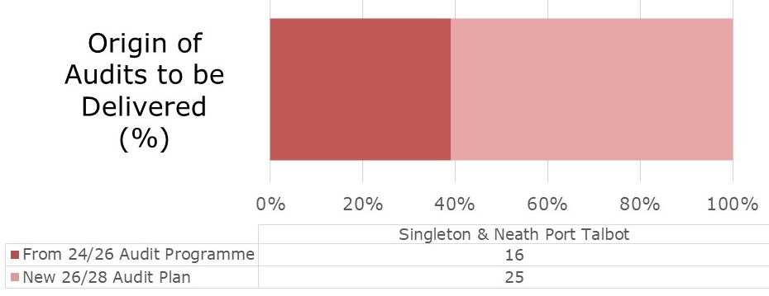
Figure 6. Audit Tasks to be delivered by the Singleton & Neath Port Talbot Service Group
2.16 Summary of Risk Assurance Scoring, by Service Group
Table 1 overleaf summarises the distribution of Risk Assurance Scores across the 94 completed topics. The majority of work sits within the low to moderate risk range, with a smaller number of higher-risk areas appropriately identified.

The highest-risk scores (≥16 and 20) are concentrated within a limited number of services, reflecting demand-pressured and time-critical pathways rather than widespread systemic failure. Despite triggering a re-audit cycle, the Mental Health pathway within the Emergency Department at Morriston Hospital will now be progressed through a quality improvement approach and continue to provide periodic updates to the COEG.

Count of Service Group Combined Consequence x Likelihood (Risk Assurance Scores)
 | 0 | 1 | 2 | 3 | 4 | 5 | 6 | 8 | 9 | 10 | 12 | 15 | 16 | 20 | 25
MH&LD | 1 | 3 | 1 | 0 | 0 | 0 | 4 | 0 | 2 | 0 | 1 | 0 | 1 | 0 | 0
Morriston | 2 | 10 | 3 | 1 | 4 | 0 | 4 | 2 | 7 | 0 | 0 | 0 | 2 | 1 | 0
PCT | 1 | 2 | 2 | 0 | 0 | 0 | 1 | 0 | 1 | 0 | 3 | 0 | 0 | 0 | 0
SNPT | 0 | 6 | 12 | 2 | 5 | 0 | 2 | 0 | 2 | 0 | 4 | 0 | 0 | 2 | 0
Total | 4 | 21 | 18 | 3 | 9 | 0 | 11 | 2 | 12 | 0 | 8 | 0 | 3 | 3 | 0
Table 1. Combined Consequence and Likelihood Scores, by Service Group

3. Audit Programme 2026-28
3.1 Audit Plan 2026-28
Preparatory communications were issued in November and December 2025, with the official planning round opening in January 2026. Audit Leads were supported through written guidance and video demonstrations to help them navigate and utilise the new Clinical Audit App to record known audit requirements for the 2026–2028 period. Where required, members of the Clinical Audit Team met directly with any Audit Leads who preferred an onscreen demonstration, providing additional assistance to resolve outstanding actions and to populate new audit topics.

Deferred 2024-26 projects and risk assurance triggered (Level 3) topics were pre-populated by the Clinical Audit Team, Figure 7.;
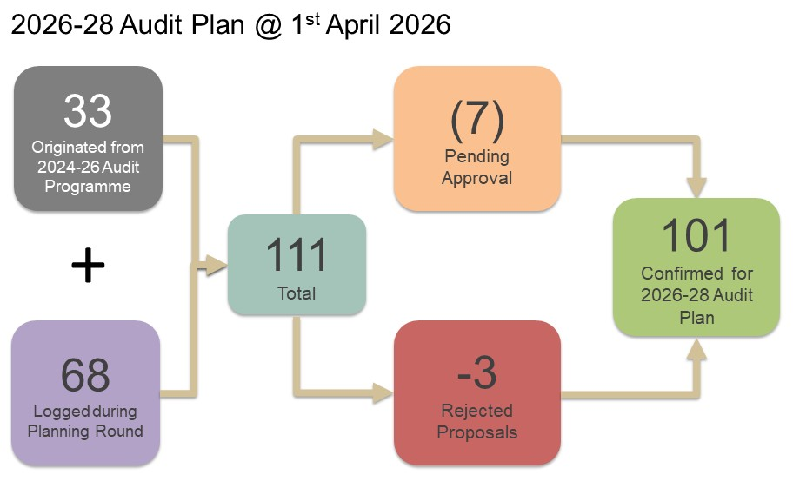
Figure 7. Planned element of the 2026-28 Audit Programme, 1st April 2026
The Audit Plan (Appendix 5) was reviewed and approved at the COEG meeting in March 2026. This followed a two-month period during which specialty Audit Leads were invited to list known requirements. 101 topics were confirmed by 1st April 2026. 7 further topics submitted during the planning round are yet to be reviewed and will be added to the wider Audit Programme, if approved by the designated Audit Leads.
3.2 Additions to the 2026-28 Audit Programme
Risk score triggered re-audit cycles, Audit Lead approved emergent topics and new regional/national projects (not listed on the mandated list at Level 1) meeting Information Governance requirements, will be incorporated into the wider Audit Programme for 2026-28.

4. Mortality

4.1 Medical Examiner Service and Mortality Reviews
The Health Board has adopted the National Learning from Deaths Framework, published by the NHS Delivery Unit and Welsh Government, as the overarching approach for delivering its learning-from-deaths system.
All deaths where the Medical Examiner (ME) Service identifies an issue or query are referred to the Executive Medical Directorate. An initial screening process is undertaken to exclude cases that are already subject to an established redress or investigation process. Cases requiring further scrutiny are escalated to the Swansea Bay University Health Board (SBUHB) Learning from Deaths (LfD) Scrutiny Panel, which was established in May 2021.
The multidisciplinary Panel meets weekly and operates a rota system to allocate cases for review and discussion. The Deputy Executive Medical Director, supported by colleagues from the Learning from Deaths (LfD) Panel, ensures a structured and consistent approach to responding to ME reviews across the Health Board. This includes oversight of formal mortality reviews and ME cases, alongside triangulation with crude mortality data and condition-specific outcomes.
Work is ongoing to complete a bespoke mortality dashboard, being developed by the Business Intelligence team. Once implemented, this dashboard will support the identification of outliers, trends, and areas of concern, enabling the development and monitoring of improvement plans where required.
The LfD Panel have started to identify themes from the ME reviews and improvement work will commence on these once the dashboards are fully developed.

4.1.1 Status of Referrals
There are different levels (1-5) for the ME reviews process. The LfD Panel are supported by members of the Clinical Audit and Effectiveness Department with initial sifting and signposting of referrals received and with facilitation of the Panel meetings where there is multidisciplinary screening and discussion to agree any actions for the clinical teams.
Since January 2023, the Panel have divided the Level 3 Proportionate Investigation section into three subsections as illustrated in Figure 8.;
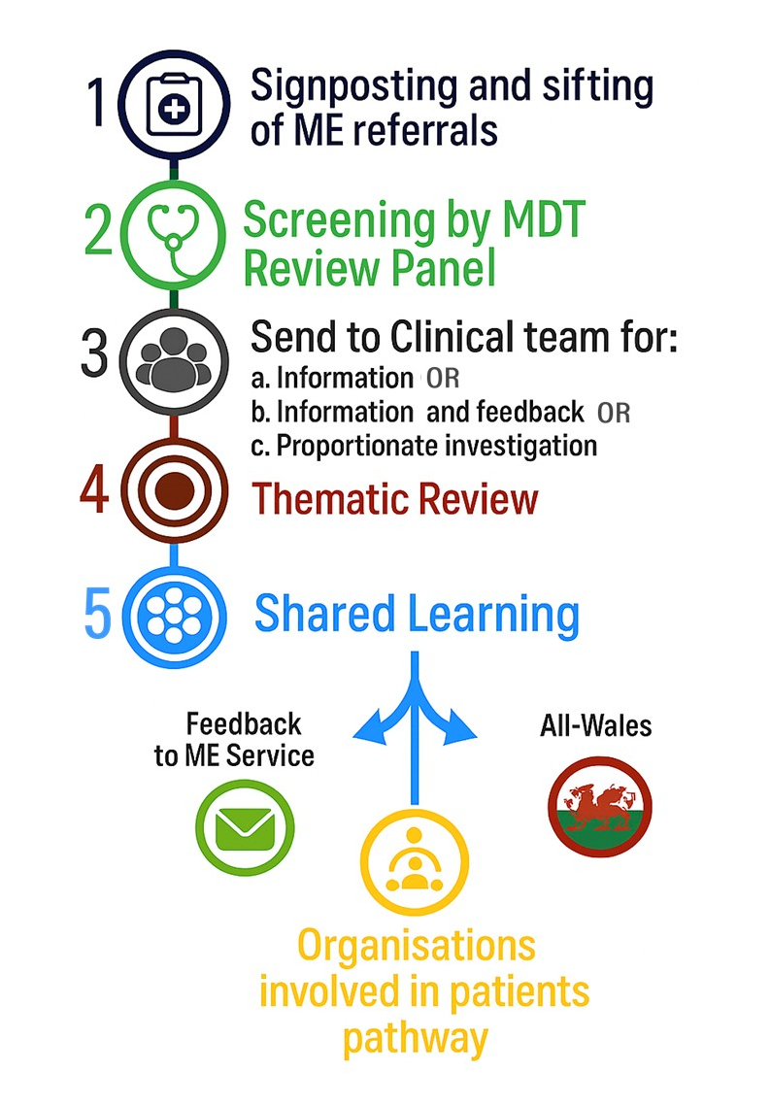
Figure 8. SBUHB Mortality Reviews Process

4.2 Deaths and Medical Examiner Referrals 2025/26
During the report period there were 2,731 deaths across Swansea Bay services, of which 1,046 (38%) were referred to the Medical Examiner service. Figure 9 illustrates the proportion of deaths referred to the Medical Examiner by service. Each row uses a 10-box visual scale (≈10% per box, rounded), with exact referral numbers shown for accuracy.

Morriston |  | |🟦🟦🟦⬜⬜⬜⬜⬜⬜⬜| |  | 596 / 1945
Primary Care  (Community) |  | |🟦🟦🟦🟦🟦🟦⬜⬜⬜⬜| |  | 355 / 569
Singleton/Neath Port Talbot |  | |🟦🟦🟦🟦⬜⬜⬜⬜⬜⬜| |  | 64 / 175
Mental Health |  | |🟦🟦🟦🟦⬜⬜⬜⬜⬜⬜| |  | 4 / 10
Tonna |  | |🟦🟦🟦⬜⬜⬜⬜⬜⬜⬜| |  | 3 / 9
Gorseinon |  | |🟦🟦🟦🟦🟦⬜⬜⬜⬜⬜| |  | 3 / 6
Other Health  Boards* |  | |🟦🟦🟦🟦🟦🟦🟦🟦🟦🟦| |  | 21 / 17*

Figure 9. Proportion of Referrals from Medical Examiner’s Office, by Service Group

Activity is concentrated in acute hospital settings, with Morriston Hospital accounting for the highest absolute numbers of both deaths and referrals. However, the relationship between deaths and referrals varies by care setting. Primary Care (Community) accounts for a smaller share of total deaths but a comparatively higher proportion of Medical Examiner referrals.
*Other Health Boards refers to cases where the Medical Examiner service received referrals for deaths that occurred outside Swansea Bay University Health Board, typically where Swansea Bay clinicians were involved in the individual’s care or where the Medical Examiner function was requested cross-boundary. As a result, the number of referrals recorded in this category can exceed the number of local deaths and should not be interpreted as a referral rate greater than 100% within Swansea Bay services. This category reflects cross-boundary working arrangements rather than local service performance or quality concerns.

It should be noted that the number of referrals received within any given month may not directly correspond to deaths occurring in the same period, as referrals can be subject to delays within the Medical Examiner Service. In addition, referrals may relate to deaths that occurred within other Health Boards where there are queries regarding care provided by Swansea Bay University Health Board (SBUHB).

The Panel review details and themes generated and report them to the monthly COEG meetings through shared membership. Figure 10 overleaf illustrates the top five themes generated from the dashboard for the report period;

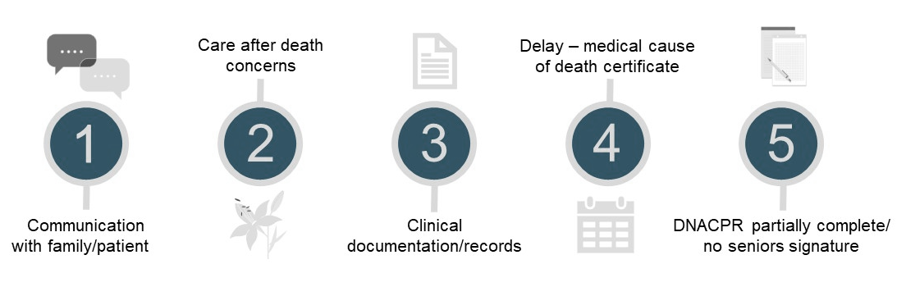

Figure 10. Top Five Themes Generated from Mortality Reviews

- Useful Links and Contacts

Thank you for taking the time to read the Clinical Audit Annual Report. Below are some key links and contacts should you have any specific queries in relation to the Clinical Audit Team’s work programme;

Emails | Links
SBU.ClinicalAuditProposals@wales.nhs.uk | Clinical Audit & Effectiveness - Home  Audit Leads  Audit Process at SBUHB  Audit Dates
SBU.COEG@wales.nhs.uk | Health Board Priority Topics
SBU.MortalityReview@wales.nhs.uk

Appendix 1. Mental Health and Learning Disabilities Service Group Completed Audits
Key;
Impact Level
- Assurance – Confirms practice meets expected standards; no significant concerns identified
- Medium – Issues or variation identified requiring improvement, further review, or strengthening of consistency
- Strong – Significant findings with clear implications for patient safety, system performance, access, or quality
The “So What?”
- Included only where findings clearly support a meaningful conclusion
- Highlights why the audit matters in practice (risk, improvement, system impact, or benefit)

Community Drugs and Alcohol Team (CDAT)

Audit of Assessment and Management of Wernicke’s Encephalopathy. 100% compliance with appropriate assessment and management of Wernicke’s Encephalopathy for patients admitted to Calon Lan, providing strong assurance for this service. Wider organisational work is ongoing, with other areas undertaking parallel audits. (Risk score 1) Impact Level: Assurance

Impact of Duration of Inpatient Alcohol Detoxification on Abstinence Outcomes. Comparable to or better than published evidence, particularly for patients prescribed relapse-prevention medication such as disulfiram. However, shorter admissions were associated with poorer abstinence outcomes, and prescribing practices lacked cohesion. (Risk score 9) Impact Level: Strong
So What: Identifies variation in treatment approach affecting patient outcomes, indicating need for more consistent prescribing and admission practices.

Mental Health & Learning Disabilities (Cross-Service)
Risk Management. Audit Variation in risk-assessment tools, limited understanding of risk formulation and co-production, and continued use of outdated documentation. Findings informed a refresh of the Safety Framework Policy and targeted in reach support to improve the translation of training into practice. (Risk score 16) Impact Level: Strong
So What: Demonstrates systemic weaknesses in risk assessment practice requiring organisational improvement and standardisation.
Older People’s Mental Health Services (OPMHS)
Treatment of Urinary Tract Infection in Older Adult Mental Health Wards. The audit resulted in the removal of urine dipsticks from wards and staff training to align practice with best-practice guidance. However, the absence of a Standard Operating Procedure continues to limit consistent antibiotic prescribing across wards. (Risk score 6) Impact Level: Medium So What: Highlights inconsistency in antibiotic prescribing due to lack of standardisation.
Antipsychotic Monitoring in Patients with Dementia. Good documentation of clinical indication and regular review of antipsychotics, but poor use of monitoring and recommendation forms, limited discontinuation planning, and inconsistent monitoring of key side effects such as parkinsonism and bowel function. (Risk score 9) Impact Level: Medium
So What: Identifies gaps in monitoring that may impact patient safety if not addressed.
Perinatal Mental Health
Physical-Health Monitoring for Patients Prescribed Antipsychotics. Appropriate baseline testing when antipsychotics were initiated, with some evidence of six-monthly and annual follow-up. However, annual monitoring remained inconsistent, and further consideration of guideline applicability to the perinatal period was required. (Risk score 6) Impact Level: Medium
Adherence to College Centre for Quality Improvement (CCQI) Core Standards for Prescribed Medication (Mother and Baby Unit) Therapeutic response was generally well addressed in weekly reviews; however, overall compliance with standards was below expectations, particularly in relation to side-effect documentation. (Risk score 6) Impact Level: Medium
So What: Indicates suboptimal compliance with national standards requiring targeted improvement.
Adult Mental Health
Review of Prescribing of Antipsychotics in Tonna Community Mental Health Team. The audit identified no risks or concerns associated with current prescribing practice, providing full assurance for this service area. (Risk score not provided) Impact Level: Assurance
Adherence to High-Dose Antipsychotic Protocols in Community Mental Health Team. Full compliance with echocardiogram monitoring, blood tests, documentation, interaction checks, and clinical reviews, reflecting strong multidisciplinary team working and improved patient safety. Some gaps remain in formal initiation, capacity assessment, and patient information processes. (Risk score 6) Impact Level: Medium
Psychiatry/Learning Disabilities
Antipsychotic Medication in Neath and Port Talbot Care Homes. The audit demonstrated a reduction in antipsychotic prescribing and improved timeliness of medication reviews, with no risks identified for patients or staff. (Risk score 1) Impact Level: Assurance

Reducing Non-attendance in Learning-Disability Psychiatry Outpatients The project improved clinic attendance, reduced wasted medical time, shortened delays to care, and was strongly preferred by patients and carers, demonstrating both clinical and operational benefit. (Risk score 1) Impact Level: Strong
So What: Demonstrates clear service improvement benefiting both patients and operational efficiency.

Use of Anxiolytics and Hypnotics in Learning-Disability Inpatient Units British National Formulary (BNF) compliant dosing and good documentation of indications; however, reviews were infrequent, long-term prescribing was common, PRN (as needed) guidance for hypnotics was limited, and discontinuation planning was rarely documented. (Risk score 12) Impact Level: Strong
So What: Identifies risks associated with long-term prescribing and inadequate review, requiring improved medication governance.

Forensic Services
Audit of the Use of Urine Drug Screening in a Medium Secure Setting Inconsistent implementation of local testing standards and limited impact of routine urine drug screening on clinical decision-making. The findings suggest risk-based testing would provide greater clinical value and reduce potentially restrictive practices. (Risk score 2) Impact Level: Medium
So What: Suggests current practice offers limited clinical value and could be refined to a more targeted approach.

Appendix 2. Morriston Service Group Completed Audits
Key;
Impact Level
- Assurance – Confirms practice meets expected standards; no significant concerns identified
- Medium – Issues or variation identified requiring improvement, further review, or strengthening of consistency
- Strong – Significant findings with clear implications for patient safety, system performance, access, or quality
The “So What?”
- Included only where findings clearly support a meaningful conclusion
- Highlights why the audit matters in practice (risk, improvement, system impact, or benefit)
Burns and Plastics
Radiation-Induced Angiosarcoma Audit. The audit found no significant difference in disease-specific survival between treatment modalities, providing reassurance on current management strategies. No concerns or risks were identified. (Risk score: 1) Impact Level: Assurance
Merkel Cell Carcinoma National Data Collection. Data submission was successfully completed as part of a national audit. No risks or local concerns were identified. (Risk score: 1) Impact Level: Assurance
Antiplatelet and Anticoagulant Management in Minor Skin Cancer Surgery. The audit identified practice issues as presented in audit findings. Re-audit was scheduled due to incomplete risk scoring and ongoing assurance requirements. (Risk score: 12) Impact Level: Strong
Presentation of Open Lower Limb Fractures by the Ambulatory Service The audit identified reasons for minor delays in meeting standards and informed recommendations to update guidance for ambulatory services. No significant patient safety concerns were identified, and overall risk remained low to moderate. (Risk score: 6) Impact Level: Medium
Audit on Standards for the Management of Open Fractures. The audit identified delays in antibiotic administration, debridement, transfers, and definitive management, particularly in high-energy injuries. These findings represented one of the highest residual risk areas and justified re-audit. (Risk score: 16) Impact Level: Strong
So What: Identifies significant patient safety risks requiring urgent improvement and system-level change.
Cardiology/Cardiothoracic Surgery
Documentation of Driving Advice in Post-Acute Coronary Syndrome Patients. The audit demonstrated improved awareness and documentation of driving advice following targeted education. However, overall compliance remained low, with ongoing undocumented advice representing moderate residual risk. (Risk score: 9) Impact Level: Medium
So What: Highlights ongoing gaps in compliance that may pose safety and medico-legal risk if not addressed.
Medicines and Healthcare Products Regulatory Agency/British Heart Rhythm Society Nationwide Audit on Pacemaker Programming Post-Atrioventricular Node Ablation. Excellent compliance, with <0.1% of patients programmed outside European Society of Cardiology guidelines, aligning with national findings. One year of data provides strong reassurance with no identified concerns and good overall assurance. (Risk score: 8) Impact Level: Assurance
Bioprosthetic Valve Outcomes in Patients Under 60. The audit assessed outcomes of bioprosthetic valve use in younger patients and identified no significant concerns. Residual risk was low. (Risk score: 2) Impact Level: Assurance
Emergency Department
Spontaneous Pneumothorax in Adults. The audit provided assurance that spontaneous pneumothorax cases were managed in line with expected standards in the Emergency Department. No significant risks were identified and re-audit was not required. (Risk score: 9) Impact Level: Assurance
Mental Health (Emergency Department Interface). The audit highlighted significant patient safety concerns relating to identification, assessment delays, and access to psychiatric assessment, particularly overnight. Long waits, transport issues, and absence of an onsite service resulted in a high residual risk despite completion of the project. (Risk score: 20) Impact Level: Strong
So What: Escalates major system risks requiring urgent redesign of services.
Asthma. The audit demonstrated good compliance with oxygen administration but identified gaps in documentation, escalation, and discharge planning. Actions remain partially complete, and assurance is limited due to incomplete data capture. (Risk score not provided) Impact Level: Medium
Cutting Cost, Not Care: Blood Bottle Use in Emergency Department. The audit demonstrated significant financial, environmental, and operational benefit without impacting patient safety. Ongoing adherence was identified as the primary risk to sustainability. (Risk score: 9) Impact Level: Strong
So What: Demonstrates efficiency and sustainability benefits that require continued adherence to maintain impact.
Gastroenterology
Management of Alcohol Withdrawal in Gastroenterology. The audit demonstrated good compliance with Clinical Institute Withdrawal Assessment prescribing and medication initiation. Significant gaps in monitoring, documentation, and appropriate medication use resulted in ongoing risk and the need for re-audit. (Risk score: 6) Impact Level: Medium
So What: Identifies gaps in monitoring and medication use that present ongoing risk.
Comparing Ultrasound (US) Reporting for Hepatocellular Carcinoma to the US Liver Imaging Reporting and Data System (LI-RADS) Algorithm. Good overall compliance with recommended reporting standards (84% compliance), with most reports including key elements and no immediate need for standardised templates identified. Inconsistent reporting of lesion size and non-use of formal LI-RADS outcome categories limited full assurance, though overall residual risk remained low. (Risk score: 2) Impact Level: Assurance
General Medicine
Patients Diagnosed with Community Acquired Pneumonia (CAP) are Booked/Referred for a Repeat Chest X-Ray (CXR) at 6 Weeks. Discrepancies between a clinical diagnosis and radiological confirmation, and successfully benchmarked follow-up CXR compliance against national guidance. Lack of a clear discharge pathway and named consultant responsibility for arranging follow-up imaging limited assurance and represents an ongoing risk. (Risk score: 9, outcomes pending sign-off) Impact Level: Medium
So What: Highlights system gaps in follow-up responsibility that may impact patient outcomes.
General Surgery
Requirement of Pre-operative Blood Typing for Laparoscopic Cholecystectomy. Routine pre-operative blood typing was largely unnecessary, with minimal transfusion requirement identified. Continued over-testing represented low clinical risk but unnecessary resource use, and re-audit was planned. (Risk score: 1) Impact Level: Medium
So What: Identifies avoidable resource use without clinical benefit.
Intensive Care Unit (ICU)
Improving the Use of the Clinical Frailty Scale in ICU. Improvement in documentation of clinical frailty scores in ICU patients. Further re-audits were identified as necessary to sustain and embed improvements over time. (Risk score: 4) Impact Level: Medium
Screening ICU Patients for Delirium Using Confusion Assessment Method. The audit identified that the planned re-audit was not undertaken, limiting ongoing assurance. This resulted in low but unresolved risk due to lack of follow-up evaluation. (Risk score: 1) Impact Level: Medium
Airway Documentation on ICU. The audit successfully completed a national project, demonstrating compliance with airway documentation standards. No risks or concerns were identified. (Risk score: 1) Impact Level: Assurance
Treatment Escalation Plans on ICU Admission. Improved completion of treatment escalation plans on admission to ICU. Full compliance had not yet been achieved, and further promotion was recommended. (Risk score: 6) Impact Level: Medium
Documentation of ICU Patient Heights. The audit demonstrated a marked improvement in height documentation following intervention. Although compliance was not yet 100%, residual risk was low. (Risk score: 4) Impact Level: Medium
Trainee Research Intensive Care-Measuring Antimicrobial (TRIC-MAN) Collaborative Antimicrobial Prescribing Audit. The national audit project was completed successfully. No local risks or concerns were identified. (Risk score: 1) Impact Level: Assurance
Proton Pump Inhibitors Prophylaxis in ICU. The audit identified the need for a departmental guideline, which was subsequently developed and implemented. This resulted in closure of the audit with minimal residual risk. (Risk score: 1) Impact Level: Strong
So What: Demonstrates successful translation of audit findings into practice change.
Critical Care Transfer Documentation. The audit demonstrated very low compliance with transfer checklist use. Incomplete documentation resulted in low to moderate residual risk. (Risk score: 4) Impact Level: Medium
So What: Identifies documentation gaps that may impact patient safety during transfer.
Promoting Sleep Hygiene in ICU. Inconsistent assessment, documentation, and management of sleep hygiene. Although risk was low, further standardisation was recommended. (Risk score: 1) Impact Level: Medium

Neurology
Myelin Oligodendrocyte Glycoprotein Anti-body Disease (MOGAD) Retrospective Review. The audit provided valuable epidemiological insight within a stable population. Limitations in record completeness were acknowledged but did not result in significant clinical risk. (Risk score: 1) Impact Level: Assurance
Radiology
Review of Neuroradiology Neuro-oncology Reporting. High diagnostic accuracy of neuroradiology opinions (92% agreement with pathology), providing strong assurance. Educational value was further supported through shared learning from complex paediatric cases, with moderate residual risk pending formal sign-off. (Risk score: 9, outcomes pending sign-off) Impact Level: Strong
So What: Demonstrates high diagnostic accuracy supporting reliable clinical decision making.

Radiology Computed Tomography Pulmonary Angiogram (CTPA) Audit – Clinical Information Provision and Technical Factors. Generally good technical image quality, with most studies meeting Royal College of Radiologists thresholds, though variation suggests scope for optimisation. Incomplete clinical information on request forms and a low positivity rate highlight concerns around investigation appropriateness and pre-test patient selection. (Risk score: 6, outcomes pending sign-off) Impact Level: Medium
So What: Highlights potential issues in investigation appropriateness and patient selection.

Renal
Peritoneal Dialysis (PD): Peritonitis and Access. The audit demonstrated low infection rates for peritoneal dialysis patients, providing assurance in relation to peritonitis risk. Reduced patency of PD catheters was identified as an ongoing concern, necessitating re-audit. (Risk score: 9) Impact Level: Medium
So What: Identifies device-related issues impacting long-term treatment effectiveness.
Prevention of Bloodstream Infections in Haemodialysis Patients. The audit demonstrated reductions in bacteraemia rates and strengthened governance through implementation of national audit tools. However, delays in vascular access and rates remaining above national standards resulted in high residual risk and re-audit planning. (Risk score: 16) Impact Level: Strong
So What: Indicates ongoing high-risk areas requiring urgent improvement.
InvestigatinG kidNey bIopsy pracTice and outcomEs (IGNITE) National Kidney Biopsy Audit. The audit contributed to identification of national variation in kidney biopsy practice and supported guideline development. Local practice demonstrated compliance, with low residual risk. (Risk score: 2) Impact Level: Assurance
Spinal Surgery
Post-operative Rehabilitation Following Lumbar Decompression. Reasonable compliance with rehabilitation timing recommendations, with the majority of patients accessing physiotherapy within recommended timeframes. Some delays persisted, resulting in low to moderate residual risk. (Risk score: 4) Impact Level: Medium
Surgical Site Infection in Spinal Surgery. The audit demonstrated infection rates aligned with national benchmarks and provided robust baseline data. Limitations in sample size and case mix were identified, but overall risk remained moderate. (Risk score: 9) Impact Level: Medium
Stroke
Do Not Attempt Cardiopulmonary Resuscitation (DNACPR) Audit in Stroke. The audit confirmed improvement in DNACPR documentation in line with national guidance. Some variability in completion and discharge processes remains, but overall risk was low. (Risk score: 1) Impact Level: Medium
Urology
British Association of Urological Surgeons National Nephrostomy Audit. The audit showed good performance for admission-to-diagnosis times compared with national benchmarks. Delays from diagnosis to nephrostomy insertion were identified locally, resulting in moderate residual risk. (Risk score: 8) Impact Level: Medium
So What: Identifies delays impacting timely treatment delivery.
Transurethral Resection of Bladder Tumour Operation Note Documentation. The audit demonstrated low postoperative complication rates. Variability in documentation quality resulted in low to moderate residual risk. (Risk score: 3) Impact Level: Medium

Appendix 3. Primary, Community Care and Therapies Service Group Completed Audits
Key;
Impact Level
- Assurance – Confirms practice meets expected standards; no significant concerns identified
- Medium – Issues or variation identified requiring improvement, further review, or strengthening of consistency
- Strong – Significant findings with clear implications for patient safety, system performance, access, or quality
The “So What?”
- Included only where findings clearly support a meaningful conclusion
- Highlights why the audit matters in practice (risk, improvement, system impact, or benefit)
Audiology
Cochlear Implant Assessment Referrals Audit. The audit identified ongoing failure to consistently recognise or discuss cochlear implant eligibility with suitable patients. This represents a significant access and equity risk, with re-audit required to assess improvement. (Risk score: 12) Impact Level: Strong
So What: Identifies inequity in access to treatment due to inconsistent recognition of eligibility.
Cardiac Rehabilitation
Referral of Patients with Heart Failure to Cardiac Rehabilitation. Many eligible patients with heart failure were not accessing cardiac rehabilitation, resulting in potential adverse patient and organisational outcomes. While awareness of service improved, limited programme capacity resulted in ongoing moderate to high residual risk and the need for re-audit. (Risk score: 12) Impact Level: Strong
So What: Highlights capacity constraints limiting access to beneficial services and impacting patient outcomes.
Community Dental Services
Re-audit of the Use of Flumazenil within Swansea Bay UHB. The re-audit demonstrated appropriate and infrequent use of flumazenil, with administration limited to a single patient on two occasions to support safe recovery. Dosing was appropriate and compliant with guidance, resulting in minimal residual risk. (Risk score: 1) Impact Level: Assurance
National Smoking Cessation Audit (NICE NG209) in the Dental Service. High compliance with oral cancer screening and brief smoking cessation interventions during dental check-ups, with appropriate referral where patients were ready to quit. Inconsistent provision of combined pharmacotherapy and support information, though overall residual risk remained low. (Risk score: 2) Impact Level: Medium
Occupational Therapy
Neurological Upper Limb Splinting Re-audit (Occupational Therapy). The re-audit demonstrated 100% compliance with professional standards for outcome measure use and documentation. Omission of separate monitoring paperwork was deemed appropriate and proportionate, resulting in minimal residual risk. (Risk score: 1) Impact Level: Assurance
Podiatry
Defensive Documentation Re-audit (Podiatry). Good compliance with demographic, medical history, and neurovascular documentation standards. However, gaps in care planning, patient activation documentation, and footwear/offloading plans limited full assurance. (Risk score: 9) Impact Level: Medium
So What: Identifies documentation gaps that may impact effective care planning and patient engagement.
Restorative Dentistry
Dental Oncology Timeline Audit. The audit identified pathway delays that increased the risk of osteoradionecrosis due to bottlenecks and inconsistent processes. Improvements in recall times were achieved following intervention, though ongoing monitoring and re-audit were required to meet national standards. (Risk score: 12) Impact Level: Strong
So What: Identifies pathway delays impacting patient safety and requiring ongoing system improvement.
Improving Staff Access to Medical Emergency Equipment (Restorative Dentistry). The audit demonstrated reduced time to access emergency equipment during simulated scenarios. No risks were identified, providing full assurance for this service area. (Risk score not provided) Impact Level: Assurance
Sexual Health
Compliance with British Association for Sexual Health and Human Immunodeficiency Virus (HIV) Standards for Sexually Transmitted Infections Management. High compliance with result turnaround times, treatment, and referral to health advisors. Minor documentation gaps were identified but overall residual risk was low. (Risk score: 2) Impact Level: Assurance
Specialist Palliative Care
Improving Palliative and End-of-Life Physiotherapy in Bay Cluster. The audit demonstrated that temporary funding supported improved patient outcomes and provided positive proof of concept for enhanced physiotherapy input. Increasing demand without recurrent funding remains a risk to service sustainability. (Risk score: 6) Impact Level: Medium
So What: Highlights sustainability risk where service improvement is dependent on non-recurrent funding.

Appendix 4. Singleton, Neath Port Talbot Service Group Completed Audits
Key;
Impact Level
- Assurance – Confirms practice meets expected standards; no significant concerns identified
- Medium – Issues or variation identified requiring improvement, further review, or strengthening of consistency
- Strong – Significant findings with clear implications for patient safety, system performance, access, or quality
The “So What?”
- Included only where findings clearly support a meaningful conclusion
- Highlights why the audit matters in practice (risk, improvement, system impact, or benefit)
Anaesthetics
Oral Paracetamol Premedication for Elective Paediatric Surgery Patients. The audit demonstrated that 75% of patients received oral paracetamol premedication prior to elective paediatric surgery. No concerns were identified, and overall assurance was good pending formal sign-off. (Risk score: 4) Impact Level: Assurance
Evaluation of World Health Organisation (WHO) Sign-In Process in Obstetric Theatres. Strong compliance with the WHO sign-in process, with timely completion prior to anaesthesia and high engagement from anaesthetic and theatre nursing teams. Limited obstetrician participation and environmental distractions during sign-in represent areas of moderate residual risk requiring improvement. (Risk score: 12) Impact Level: Medium
So What: Identifies areas of inconsistency within an otherwise strong safety process requiring improvement.
Community Paediatrics
Attention Deficit/Hyperactivity Disorder (ADHD) Medicals: Are They Fit for Purpose? Good compliance with assessment standards once children were seen. However, prolonged waits for diagnosis and medication represent a system-level access risk, necessitating re-audit and service review. (Risk score: 1) Impact Level: Strong
So What: Highlights system level delays affecting timely access to diagnosis and treatment.

Dermatology
Enhancing Patient Experience with Procedure Information Leaflets. Patient feedback identified areas for improvement, and revised information leaflets resulted in improved patient understanding and experience. Small sample size and reliance on consistent leaflet use mean further monitoring and re-audit are required. (Risk score: 3) Impact Level: Medium
Paediatric Dupilumab Prescribing and Monitoring. Prescribing practice was compliant with NHS Wales guidance and demonstrated good governance and safety. Documentation gaps relating to severity scoring and counselling limited full assurance. (Risk score: 6) Impact Level: Medium
So What: Identifies documentation gaps limiting full assurance of otherwise compliant practice.
Patch Testing Service Audit 2026 (NPTH). The service was compliant with British Society of Cutaneous Allergy standards, with good documentation and consultant supervision. Capacity constraints and waiting list pressures remain the primary residual risks. (Risk score: 4) Impact Level: Medium
So What: Highlights capacity constraints impacting timely service delivery.
General Paediatrics
Compliance with the Paediatric Sepsis 6 Pathway. High awareness of sepsis recognition and initiation of management among staff. Lower adherence to departmental guidelines indicates the need for further education and re-audit to strengthen consistency. (Risk score: 3) Impact Level: Medium
So What: Identifies inconsistency in guideline adherence requiring further education.
Cardiac Care of Children with Dystrophinopathy and Females Carrying DMD-Gene Variations. Good engagement with cardiology follow-up, with 87% of children under cardiology care and all patients receiving annual echocardiography. Variability in early echocardiography timing, governance arrangements, and initiation of Angiotensin-Converting Enzyme (ACE) inhibitors limited full assurance and represent an ongoing moderate risk. (Risk score: 9, outcomes pending sign-off) Impact Level: Medium
So What: Highlights variability in care delivery that may impact consistency of patient outcomes.
Gynaecology
Readmissions After Urogynaecology Procedures. Readmission rates were within expected standards, with most readmissions reflecting minor complications requiring minimal intervention. Incomplete discharge documentation was identified but overall assurance remains good. (Risk score: 2) Impact Level: Assurance
Haematology
Anticoagulation for Thrombosis Prevention in Multiple Myeloma. Prescribing was fully compliant with national guidance, with no adverse events observed. This audit provides strong assurance while awaiting national benchmarking outcomes. (Risk score: 1) Impact Level: Assurance
Obstetrics
Intelligent Intermittent Auscultation (IIA). Good initial assessment and appropriate use of midwifery-led pathways. Incomplete documentation of ongoing gateway assessments and monitoring represents moderate residual risk, requiring re-audit. (Risk score: 12) Impact Level: Medium
So What: Identifies documentation gaps that may impact ongoing monitoring and care quality.
Antenatal Cardiotocography (CTG) Classification and Escalation. The audit demonstrated good classification and escalation overall. However, low compliance with hourly documentation and Fresh Eyes assessments resulted in moderate residual risk and re-audit requirement. (Risk score: 12) Impact Level: Medium
So What: Highlights gaps in monitoring compliance that may impact patient safety.
Intrapartum Cardiotocography (CTG) Classification and Escalation (“Fresh Eyes”). Good escalation of concerns but poor compliance with hourly CTG documentation and Fresh Eyes principles. These gaps represent a moderate to high risk and warrant continued action and re-audit. (Risk score: 12) Impact Level: Strong
So What: Identifies ongoing monitoring failures representing a significant patient safety risk.
Obstetrics and Gynaecology
Handover on Central Delivery Suite (Obstetrics & Gynaecology). High standards of clinical handover, including successful incorporation of antenatal ward handover. Ongoing focus is required to maintain these standards, though residual risk remains low. (Risk score: 4) Impact Level: Assurance
Oncology
Systematic Anti-Cancer Therapy (SACT) Treatment Metrics. Ongoing audit has supported increased efficiency and secured funding for additional treatment chairs and staffing. Continued growth in activity alongside workforce constraints represents a high residual risk, with actions still in progress. (Risk score: 20) Impact Level: Strong
So What: Highlights capacity and workforce constraints impacting delivery of cancer treatment services.
Audit of Venous Thromboembolism (VTE) Rates in Patients with Pancreatic Cancer Undergoing Systematic Anti-Cancer Therapy (SACT). VTE prophylaxis was consistently considered, with effective communication between pharmacy and clinical teams. Ongoing uncertainty regarding universal prophylaxis benefit limits full assurance, though immediate risk remains moderate. (Risk score: 9) Impact Level: Medium
Rural Access to Neuro-Oncology Services. The audit demonstrated high patient satisfaction with telemedicine and flexible consultation models, supporting equitable access for rural populations. No significant risks were identified, and assurance was high. (Risk score: 1) Impact Level: Assurance
Management of Neutropenic Sepsis. Timely observation recording but variable compliance with antibiotic administration timeframes. Given the high-risk nature of neutropenic sepsis, this represents a significant residual risk despite good recognition. (Risk score: 20) Impact Level: Strong
So What: Identifies delays in time-critical treatment for a high-risk condition.
Palliative Care (Paediatrics)
Agitation Identification, Assessment and Management. Findings disseminated nationally via poster presentation at the Association for Paediatric Palliative Medicine (APPM) conference. Opportunities were identified to strengthen non-pharmacological interventions and improve consistency of care across services, resulting in moderate residual risk. (Risk score: 6, outcomes pending sign-off) Impact Level: Medium
Frequency and Management of Gastrointestinal Dystonia. Good implementation of Association for Paediatric Palliative Medicine (APPM) guidance. Improved multidisciplinary team working, standardised terminology, and closer collaboration with tertiary services were identified to further enhance care consistency and outcomes. (Risk score: 4) Impact Level: Medium
Trauma and Orthopaedics
Adherence to British Orthopaedic Association Standards for Post-operative Weight Bearing Documentation. Good adherence to national standards was demonstrated, with further improvement noted on re-audit. Residual risk was low, with planned future monitoring. (Risk score: 2) Impact Level: Assurance
Compliance with British Orthopaedic Association Standards for Paediatric Forearm Fractures. The audit demonstrated compliance with national guidance in the early management of paediatric forearm fractures. No significant concerns were identified. (Risk score: 2) Impact Level: Assurance
Outcomes Following Knee Ligament Reconstruction/Revision Surgery. The service evaluation demonstrated acceptable clinical outcomes following knee ligament procedures. Residual risk remained low. (Risk score: 2) Impact Level: Assurance
Proximal Metaphyseal Fractures Service Evaluation. The audit demonstrated satisfactory outcomes for proximal metaphyseal fractures. No major concerns were identified, and re-audit was planned. (Risk score: 2) Impact Level: Assurance
Intra-operative Management of Open Lower Limb Fractures. The audit achieved comprehensive data collection. Non-compliance with British Orthopaedic Association documentation standards limited assurance despite likely appropriate practice. (Risk score: 2) Impact Level: Medium
So What: Identifies documentation gaps that limit assurance of clinical practice.
Day-One Post-operative Bloods and Imaging in Arthroplasty. The audit demonstrated improvement in compliance with early post-operative investigations. Planned re-audit was appropriate to ensure sustainability. (Risk score: 2) Impact Level: Medium
Post-operative Complications Following Hemiarthroplasty. The initial audit highlighted the need for improved pre-operative templating and training. Re-audit demonstrated a marked reduction in dislocation rates, providing improved assurance despite isolated complications. (Risk score: 4 → 2) Impact Level: Strong
So What: Demonstrates improvement in clinical outcomes following targeted intervention.
Current Post-operative Complications Following Hemiarthroplasty – Re-audit. Re-audit demonstrated improved pre-operative planning, with a reduction in hip dislocation rates from 3% to <1%, and no dislocations in procedures performed by Registrars. Small number of sciatic nerve palsies identified, but overall residual risk remained low. (Risk score: 2) Impact Level: Strong
So What: Demonstrates sustained improvement in outcomes and strengthened surgical practice.
Documentation of Intra-operative Tourniquet Use (Re-audit). Repeated audit cycles demonstrated sustained improvement in documentation standards. No residual risks identified. (Risk score: 1) Impact Level: Assurance
Impact of Air Exhaust Suits on Periprosthetic Joint Infection. The audit facilitated discussion and review of surgical practice. No risks or concerns were identified. (Risk score: 1) Impact Level: Assurance
Improving Surgical Trauma Training for Orthopaedic Resident Doctors. The audit led to rota redesign and protected theatre time, significantly improving trainee satisfaction. This represented a successful quality improvement initiative with no residual risk. (Risk score: 2) Impact Level: Strong
So What: Demonstrates successful service redesign improving training and operational efficiency.
Open Fractures – Compliance with British Orthopaedic Association Standards. Improved consultant supervision and plastics involvement. Further improvement is required in fracture grading documentation, with re-audit planned. (Risk score: 2) Impact Level: Medium
Outcomes Following Minimally Invasive Plate Osteosynthesis for Tibial Shaft Fractures. The audit demonstrated satisfactory outcomes using minimally invasive techniques. No risks were identified. (Risk score: 1) Impact Level: Assurance
Re-audit of Weight Bearing Status Documentation. Repeated audit cycles demonstrated sustained compliance following system changes. Residual risk remained low. (Risk score: 2) Impact Level: Assurance
Operating for Neck of Femur Fractures. The audit reviewed operative exposure and outcomes for resident doctors. No concerns were identified. (Risk score: 2) Impact Level: Assurance

Appendix 5. Confirmed Audit Plan Topics 2026-28 (Contributing Specialties)
Mental Health and Learning Disabilities
Live |  |  |  | 13
Adult Mental Health |  |  |  | 4
Community Drugs and Alcohol Team |  |  |  | 3
Liaison Psychiatry Team |  |  |  | 1
Mental Health and Learning Disabilities |  |  |  | 2
Perinatal Mental Health |  |  |  | 1
Psychiatry |  |  |  | 2
Morriston
Live | 52
Anaesthetics | 1
Burns & Plastics | 5
Cardiology | 2
Cardiothoracic Surgery | 2
Cellular Pathology | 3
Emergency Department | 2
Ears Nose and Throat | 3
Gastroenterology | 1
General Surgery | 9
Intensive Care Unit | 13
Neurology | 3
Radiology | 1
Renal | 3
Respiratory Medicine | 1
Spinal Surgery | 1
Trauma and Orthopaedics | 1
Vascular Surgery | 1
Outcomes pending sign off | 1
Burns & Plastics | 1
Primary, Community Care and Therapies
Live |  |  | 12
Audiology |  |  | 3
Cardiac Rehabilitation |  |  | 1
Dental Teaching Unit |  |  | 1
Home Enteral Feeding |  |  | 1
Occupational Therapy |  |  | 2
Other |  |  | 2
Speech and Language Therapy |  |  | 2
Singleton Neath Port Talbot
Live |  | 23
Community Paediatrics |  | 2
Dermatology |  | 1
General Paediatrics |  | 3
Gynaecology |  | 2
Major Trauma |  | 1
Microbiology |  | 1
Obstetrics |  | 1
Obstetrics and Gynaecology |  | 2
Oncology |  | 5
Ophthalmology |  | 2
Other |  | 1
Paediatric Palliative Care |  | 1
Trauma and Orthopaedics |  | 1

