

Item 7.1 Appendix –
Briefing Report Agency Suppliers Risk

Author: Michelle Newport-Edwards
Local Counter Fraud Specialist

Date: 19th September 2024

- SITUATION

  - Swansea Bay University Health Board (SBUHB) is exposed to a number of fraud risks related to the use of Agency Staff. These risks arise from vulnerabilities which may be found in the contract management, recruitment, placement and finance processes.

  - To address the potential vulnerabilities a risk assessment was to be undertaken which covers the engagement and management of agency staff and focus on the following key risks in this area
    - Recruitment
    - Impersonation of a Medical Professional
    - Falsified Invoices/Timesheets/Signatures

  - The risk assessment will formalise where SBUHB are in managing the risks exposed by the use of Agency Staff and the controls we currently have in place.

  - The risk assessment also enables SBUHB to log the risk for future review points or intelligence received to ensure we as a Health Board are proactively able to manage these risks effectively

- BACKGROUND

  - SBUHB relies upon agency staff to manage workforce shortages and meet service demands. In the financial year 2023-2024 SBUHB spent over £78m on variable pay largely on Agency Nurses and Locum Doctors but this figure also included bank and overtime.

  - The Counter Fraud Authority (CFA) in England provide a consolidated database of known and emerging fraud risks that are disseminated across England and Wales via Fraud Prevention Notices (FPN). The CFA also provide guidance for counter fraud staff to utilise to enable them to assess their own Health Board’s robustness of processes to minimise the risk potential.

  - In the last 2 years the CFA has confirmed that ‘Agency Fraud’ remains one of the key fraud risks facing the NHS and has published the following documentation to assist in mitigating those risks.
    - Employment Agency Fraud – Guidance on Reducing Risk
    - Impersonating a Medical Professional – Fraud Prevention Notice which detailed an instance where an agency nurse booked on hundreds of shifts but sent multiple unknown persons to the various locations to undertake the work.

  - The Local Counter Fraud Team have been in receipt of referrals relating to instances of fraud involving agency staff. These concerns range from falsified timesheets to impersonation of medical practitioners.

  - The Local Counter Fraud Team undertook a Local Proactive Exercise (LPE) in response to the FPN Impersonating a Medical Professional which highlighted the identification of a significant number of agency shifts paid where there was an overlap of individual staff attending to cover those shifts.

- ANALYSIS

  - To enable the preparation of this risk assessment engagement and support was sought from key stakeholders in both NWSSP and SBUHB to enable us to understand the controls currently in place.

  - The ‘All Wales Contract Specification for the Supply of Registered Agency Nurses, Midwives and Health Visitors, Healthcare Assistants and Operating Department Practitioners to Health Boards and Trusts in Wales’ (All Wales Contract) is the key document which governs the engagement of Agency Staff across Wales.

  - In addition to this SBUHB have implemented their own local controls which compliments and enhances the controls provided by the All Wales Contract.

Recruitment

  - The All Wales Contract requires all Agency Suppliers to undertake all Pre-Employment Checks for agency staff they intend to supply. The Pre-Employment Checks required are aligned to the Pre-Employment checks Health Boards undertake for substantive posts.

  - SBUHB requires Agency Suppliers to provide a completed checklist for each individual they intend to supply. This checklist is audited by the Bank Team at SBUHB to ensure the individual supplied has the required credentials and training. If any issues are identified the Bank Team will seek documentary evidence from the Agency Supplier to validate the information provided.

  - The Bank Team verify all professional registrations via the NMC/HCPC independently of the verification undertaken by the Agency Supplier.

  - If an Agency Supplier is in receipt of a DBS Check which indicates a conviction for an individual they intend to supply this is referred to the Staff Bank Manager to consider whether to accept or reject that individual.

  - Whilst the volume of DBS Checks indicating a conviction for a proposed agency worker requiring review is minimal there is a single point of dependency on the Staff Bank Manager to complete those reviews.

  - The criteria for acceptance or rejection of an individual with a DBS Check indicating a conviction has not been formalised into a written process.

Placement

  - The SBUHB Nursing Midwifery Rostering Policy indicates the order of engagement of additional nursing resources. It details the process for filling empty shifts and specifies where agency workers fit into the cycle of securing additional staff at times when staffing levels are under pressure and the authorisation required to secure that staff.

  - Allocate Software is utilised by SBUHB for the management of booking and payment of agency staff-
    - Health Roster (used for the production of rosters and enables unfilled shifts to be identified for bank / agency fill).
    - Bank Staff (e-system used by the Bank Office Team and approved on-contract agencies to fill shifts).

  - The Allocate Health Roster contains a control which will flag any duplicate or cross over shifts within SBUHB only.

  - The engagement of agency staff will always be susceptible to fraud due to the absence of data sharing or cross matching of data between agencies and other Health Boards.

Identification

  - The All Wales Contract requires agency suppliers to provide all Individuals they supply to the Health Board with an ID Badge which is to be produced on request and worn at all time

  - Ward Staff are required to check the ID badges upon arrival of agency staff and verify the name on the badge to the name shown on Health Roster.

  - Following the outcome of the LPE in response to the FPN Impersonating a Medical Professional SBUHB now require the Agency Supplier to provide a photographic image of all new agency staff they intend to supply for upload to Health Roster. This enables staff on the wards to confirm that the person who turns up on the ward is the person sent by the Agency Supplier.

  - It should be noted that this work is currently ongoing as the Bank Staff Team seek to secure photographic images for historic current agency staff.

Timesheets/Invoices

  - The All Wales Contract requires the Agency Supplier to submit invoices which are accompanied by authorised timesheets.

  - SBUHB require wards to utilise sign in books which staff (substantive, bank and agency) are required to sign in confirming attendance on shift.

  - To secure an authorised timesheet agency staff are required to get their timesheets signed off by the Ward Sister/Nurse in Charge at the end of their shift.

  - Prior to any payments being issued agency shifts have to be finalised on Health Roster. Shifts are finalised utilising the details recorded in the sign in books.

  - SBUHB currently pay all invoices via the Finance Team in accordance with the Nurse Agency Invoice Flow Chart below

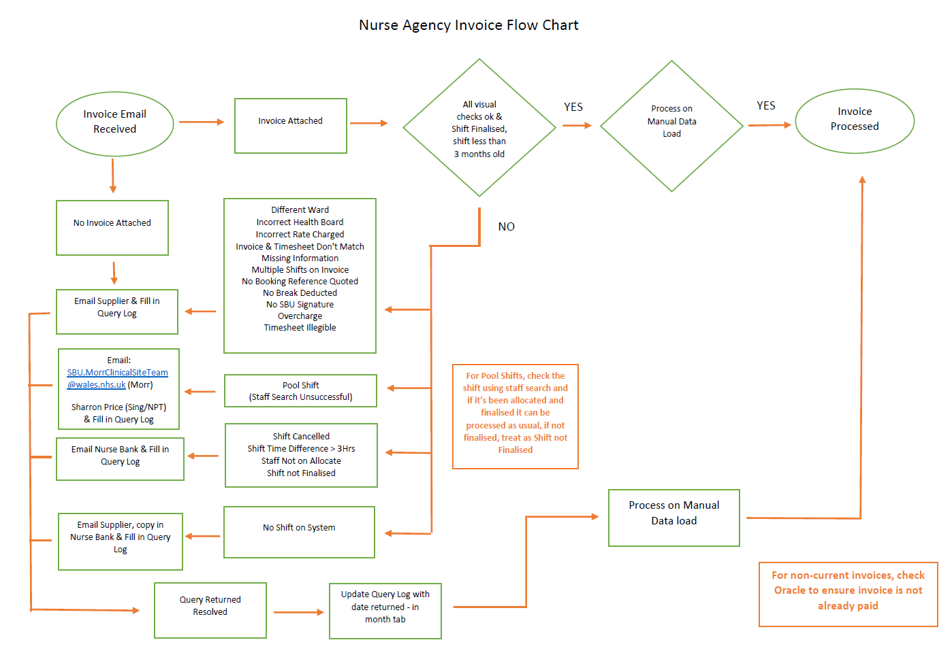

  - It should be noted that the method in which Agency Suppliers are paid will change when the new contract comes into effect in 2025.

Audit

  - The All Wales Contract permits the Health Board to undertake audits to ensure the Agency Suppliers compliance with the contract. The last audit was undertaken by NWSSP in April 2023.

  - Whilst the All Wales Contract provides overarching governance in respect of the engagement of Agency Staff. The primary controls and enhancements are locally led and are centred around the booking and payment systems utilised by the respective Health Boards as well as ward level controls, with ward staff acting as ‘gatekeeper’ to agency staff attending and completing

  - Engagement with the key stakeholders demonstrates that SBUHB have robust controls in place to manage the agency staff risks who are continually seeking to enhance and improve these. There are however some gaps and areas which require enhancement to effectively mitigate some of the identified risks.

- RISK MANAGEMENT ENHANCEMENTS

  - The enhancements highlighted below are being explored both locally in SBU and Nationally with the aim of further mitigating the exposure to these Agency risks
    - Implementation of a control or technological solution which would enable the sharing of an agency workers data, specifically prior to the date of a shift which would prevent booking of overlapping shifts by the same Agency Worker across all Health Boards.
    - Reintroduction of centralised Inductions for Agency Staff which will highlight the Health Boards policies and procedures and the need for compliance
    - Working on a timeframe for the completion of upload of photographic image of historic current agency staff.
    - Seek to formalise the criteria for acceptance/rejection of agency staff with a DBS check indicating a conviction.
    - Finalise the responsibility for who is to complete the Audits under the All Wales Contract whether it be the Health Board or the NWSSP

  - The LCFS will seek to undertake a refresh of this risk assessment following the new contract going live in 2025 which would enable us to identify any new risks of fraud within the process and implement/tighten any current controls

