Meeting Date | 20 November 2025 |  | Agenda Item |  |  | 5.3
Name of Meeting | Audit Committee
Report Title | Recovery and Sustainability Update
Report Author | Deborah Longman, Head of Recovery and Sustainability
Report Sponsor | Darren Griffiths, Executive Director of Finance and Performance
Presented by | Darren Griffiths, Executive Director of Finance and Performance
Freedom of Information | Open
Purpose of the Report | The report updates the committee in respect to the governance processes underpinning the recovery and sustainability program and provides oversight for assurance around the current programme of work.
Key Issues | The Recovery and Sustainability programme and board has clearly established governance structures linking through the organisation.  The current level of identified recurrent savings is insufficient, therefore, the resulting financial pressures require urgent mitigating actions to identify additional recurrent savings and/or reduce the current run rate of the organisation.  The Recovery and Sustainability programme has identified a number of key priority areas; each being led by an executive senior responsible officer to support the delivery of savings across the Health Board.
Specific Action Required  (please choose one only) | Information | Discussion |  | Assurance | Approval
Specific Action Required  (please choose one only) | ☐ | ☒ |  | ☒ | ☐
Recommendations | Members are asked to:  - CONSIDER and comment upon the structure and governance underpinning the R&S Programme.  - TAKE ASSURANCE from the work programme of the support for the executive led savings programmes, noting that the actual budgets are within the service groups.
RECOVERY AND SUSTAINABILITY UPDATE

- INTRODUCTION
The Health Board submitted a 3 Year Financial Plan on 31 March 2025, with an assessed Financial Deficit for Year 1 of £58.7m, predicated on the delivery of £55.4m of savings. At Month 6 the Health Board was off plan by £13.7m, almost exclusively driven by the non-delivery of the savings target.

On 11th September 2025 the Chief Executive Officer, and Executive Director of Finance and Performance met with Welsh Government to present an ambitious savings plan, based around a number of thematic areas. A proportion of these savings could be delivered with confidence, however, some savings were aspirational to meet Welsh Government expectations. These additional savings are not demonstrated within the green and amber pipeline. The scale of this challenge is unprecedented and requires a radical, sustainable and multi-faceted response.

The Health Board has been working with an external support company, initially funded by Welsh Government, to accelerate the delivery of savings. As a result, the Recovery and Sustainability Board which meets twice monthly has changed format, to focus on Thematic programmes in the first meeting, and Service Groups savings in the second meeting.

To support the delivery required, the Health Board has already created a Recovery & Sustainability (R&S) Team, although feedback from the external support has confirmed that this team is likely under-resourced to progress delivery at pace.

- BACKGROUND
The audit committee previously received a report on the governance structures for the R&S in July 2025, those structures remain in place. See diagram one.

Diagram one: Governance Structure
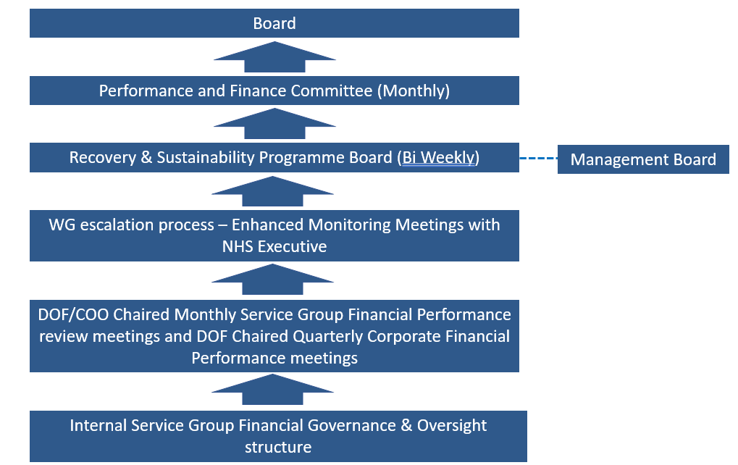

The R&S Board continues to be chaired by the Chief Executive Officer and occurs twice per month. The frequency and pattern of the meetings is now firmly established within the normal pattern of business.

The first meeting of the month focuses on the Thematic Programmes of work which are led by executives. These themes will cut across service groups, with the savings predominantly sitting within Service Group budgets. The thematic programmes have an appointed R&S lead to manage the governance of the programmes. Since a more formal project management approach has been established, these programmes have formal plans on a page which have been submitted and reviewed by Welsh Government. The R&S team also hold the RAID logs (Risks, Actions, Issues and Decisions) to further scrutinise the governance.

The second meeting of the month focuses on the Service Group Savings and provides assurance around the level of confidence on the delivery of the tracker schemes.

These meetings continue to meet face-to-face and are also supported by the external support to provide additional challenge and scrutiny. The membership has continued to be predominantly executives and the service group triumvirate, to ensure that the senior accountable leaders have a detailed understanding of their savings delivery and action plans.

  - R&S Programme Plan
The R&S programme and board have both been designed to support the delivery of the financial plan by building on the devolved accountability process already established within the Service Groups.

The programme facilitates the achievement of savings within the delegated budget holders remit by helping to identify and ‘unlock’ areas of opportunity and progress supportive actions that will result in financial benefit within the Service Groups i.e., the high levels of staffing unavailability within the substantive workforce resulting in high usage of variable pay.

Following support by the external support company, the programme has been amended into eight key themes:

- Workforce – Nursing
- Workforce – Medical
- Workforce – Enabling actions
- Procurement
- Continuing HealthCare (CHC)
- Urgent and Emergency Care (UEC)
- Medicines Management
- Planned Care

Each of the workstreams is led by an executive as the Senior Responsible Officer (SRO). The R&S team will provide programme management and delivery capacity to support these key programmes.

There have been a number of other, lower priority, schemes that R&S have also been supporting, however, these have now been stepped down due to lack of capacity, and have been referred back to the organisational teams to deliver.

  - Progress – top 8 priorities
Workforce (all three schemes) - Tina Ricketts (SRO). Additional controls have been put in place to support the reduction in variable pay. Workforce Boards have been established across all occupational groups to provide additional scrutiny over variable pay usage and vacancy control. The health board is operating a predominantly internal advertising approach only, recognising that the workforce is over established in a number of areas e.g. adult nursing. Additional workstreams around the culture of the workforce have also been established, looking at areas such as sickness, absence and the management of processes.

The variable pay steering group continues to be operational given the urgent need to reduce the variable pay bill based on the health boards current financial run rate.

Procurement– The procurement board continues to meet, chaired by the SRO Darren Griffiths, since its establishment at the start of the year. The procurement team have a clear savings trajectory to achieve this year. Additional scrutiny has been added into the procurement process by lowering approver limits on Oracle, and additional work is underway to add further restrictions on non-pay “discretionary” expenditure. A number of subjective codes are being targeted for enhanced approvals. Discretionary spend remains at around £1m per month, with an aim for a 40% reduction for the remainder of the financial year.

CHC- A CHC board is established and is chaired by SRO Marie Davies. This board has a focus on both performance and financial recovery. The R&S team, external support and the CHC performance team have been working together closely to identify opportunities for savings in year, and potential longer term transformational savings from within the programme. Work is underway looking a right-sizing of packages and repatriation of some Learning Disability (LD) patients.

UEC- A UEC board is established and is chaired by SRO Deb Lewis. This board has a focus on both performance and financial recovery. Significant work has been progressing at pace in this area supporting this area, including a two-week discharge sprint. Investigations are taking place on the possibility to close surge beds in the coming weeks to reduce the need for variable pay expenditure. Additional workstreams are planned to develop this thematic area further.

Medicines management – SRO Dr. Richard Evans, has established a medicines management steering group to maximise the identification of savings. There was initially a focus on the full delivery of the value and sustainability opportunities, identified by the Wales value and sustainability (V&S) group. Further opportunities are now being explored on medicine switches, and a significant amount of savings have now been realised. The Health Board remains focused on identifying further savings, including drugs which have come off patent.

Planned Care – A Planned Care and Cancer board is already established and is chaired by SRO Deb Lewis. As a new addition to the R&S portfolio of programmes, there is not anticipated to be savings in the current financial year. The external support has been working closely with planned care teams to identify opportunities for savings commencing next financial year. Some work in this space has already been identified as part of the procurement workstream, including opportunities for savings within theatre consumables.

  - Service group savings
Via the R&S board, each of the service groups have been tasked with reviewing the red pool and pipeline schemes, with a significant proportion of schemes being translated into green or amber. The potential opportunity if all the remaining red and pipeline schemes could be delivered is c.£19.7 million.

  - R&S Team
The R&S team has evolved over recent months to ensure they offer the correct level of support that facilitates the delivery of the savings. An assigned team member has been aligned to each of the eight workstreams to ensure focus on governance.

Each of the eight identified work streams will be supported with programme documentation that evidences actions, timelines, risk and issues in a standardised manner. The enhanced project governance will enable the earlier identification of any variances from the expected delivery plans.

The R&S team also provides programme support to the Recovery and Sustainability Board, managing the actions occurring from board meetings, and the overall board governance.

  - External Support
Welsh Government provided funding for external support to the Health Board. The provider commenced with the Health Board formally on 14 July 2025.

The external support has been working across the Health Board identifying additional opportunities to close the recurrent savings gap, whilst also considering governance and control arrangements. As a result of the recommendations, the Recovery and Sustainability Board switched to its new focus, with the first meeting focussing on the eight thematic programmes and the second meeting focussing on the service group savings.

- GOVERNANCE AND RISK ISSUES
The established governance processes within the R&S programme and board are clear and robust. The Performance and Finance Committee continues to be supportive and constructive in helping to form the R&S programme whilst maintaining a high degree of oversight and scrutiny.

The current level of identified recurrent savings within the delegated budgets represents a significant risk to the delivery of the financial plan, although the external support are confident that additional identified opportunities could reduce the run rate by the last quarter of the financial year.

- FINANCIAL IMPLICATIONS
The R&S programme is a faciliatory delivery vehicle that supports the financial delivery within the delegated budget holder’s portfolio. There are no direct financial implications of this paper.

- RECOMMENDATIONS
Members are asked to:
- CONSIDER and comment upon the structure and governance underpinning the R&S Programme.
- TAKE ASSURANCE from the work programme of the support for the executive led savings programmes, noting that the actual budgets are within the service groups.

Governance and Assurance

Link to Enabling Objectives  (please choose) | Supporting better health and wellbeing by actively promoting and empowering people to live well in resilient communities
Link to Enabling Objectives  (please choose) | Partnerships for Improving Health and Wellbeing |  | ☐
Link to Enabling Objectives  (please choose) | Co-Production and Health Literacy |  | ☐
Link to Enabling Objectives  (please choose) | Digitally Enabled Health and Wellbeing |  | ☐
Link to Enabling Objectives  (please choose) | Deliver better care through excellent health and care services achieving the outcomes that matter most to people
Link to Enabling Objectives  (please choose) | Best Value Outcomes and High Quality Care |  | ☒
Link to Enabling Objectives  (please choose) | Partnerships for Care |  | ☐
Link to Enabling Objectives  (please choose) | Excellent Staff |  | ☒
Link to Enabling Objectives  (please choose) | Digitally Enabled Care |  | ☐
Link to Enabling Objectives  (please choose) | Outstanding Research, Innovation, Education and Learning |  | ☐
Health and Care Standards
(please choose) | Staying Healthy |  | ☐
(please choose) | Safe Care |  | ☒
(please choose) | Effective Care |  | ☒
(please choose) | Dignified Care |  | ☐
(please choose) | Timely Care |  | ☒
(please choose) | Individual Care |  | ☐
(please choose) | Staff and Resources |  | ☒
Quality, Safety and Patient Experience
Recovery & Sustainability programme, whilst addressing the need for a sustainable financial position, is focused on undertaking through delivery of good quality, safety, and patient experience.

Financial Implications
No direct financial implications
Legal Implications (including equality and diversity assessment)
No implications
Staffing Implications
No direct implications
Long Term Implications (including the impact of the Well-being of Future Generations (Wales) Act 2015)
No implications
Report History |  | n/a
Appendices |  | n/a

