South Wales Spinal Network

End of Year (2023/24) Delivery Assurance Group Report
This end of year report provides a summary of the South Wales Spinal Network since launching in September 2023.

Executive Summary
Several operational and clinical guidelines (Figure 1) have been collaboratively constructed, approved and ratified.
Figure 1:-
- P01 – SWSN Acceptance & Transfer Policy
- P02 – SWSN Automatic Repatriation Policy
- P03 – SWSN Clinical Governance and Quality Improvement Policy
- P04 – SWSN Clinical Guidelines Framework

- CG01- SWSN Cauda Equina Syndrome
- CG02- SWSN Spinal Trauma
- CG03 – SWSN Metastatic Spinal Cord Compression
- CG04 – SWSN Intradural & Complex Neurospinal Surgery

Two metastatic spinal cord compression (MSCC) coordinators have been appointed and they are currently collaboratively developing an MSCC network wide pathway, referral form and audit tool to capture the standards and KPIs in the SWSN MSCC clinical Guideline (CG03).
24/7 emergency MRI provision is available in ABUHB, C&VUHB and SBUHB and there are ongoing progressive discussions with CTMUHB and HDUHB.
12 SID’s were submitted
There is 1 red risk currently on the Risks log, and 3 high priority issues on the Issues log.
The Network Quality Improvement & Research Lead is undertaking an audit of patient’s journey in comparison to the Network published clinical guideline.

Network Structure
The East and West has a variety of Spinal Partners, Non-Spinal Partners feeding into the Spinal Hub, with primary care and CMATS/ MSK interface services feeding into the flows. This then cumulating into the supra regional aspect which encompasses Major Trauma, Paediatric Spinal Surgery and Spinal Cord Injury Rehabilitation, with all organisations feeding into the models that are already established, as displayed in the diagrams below:
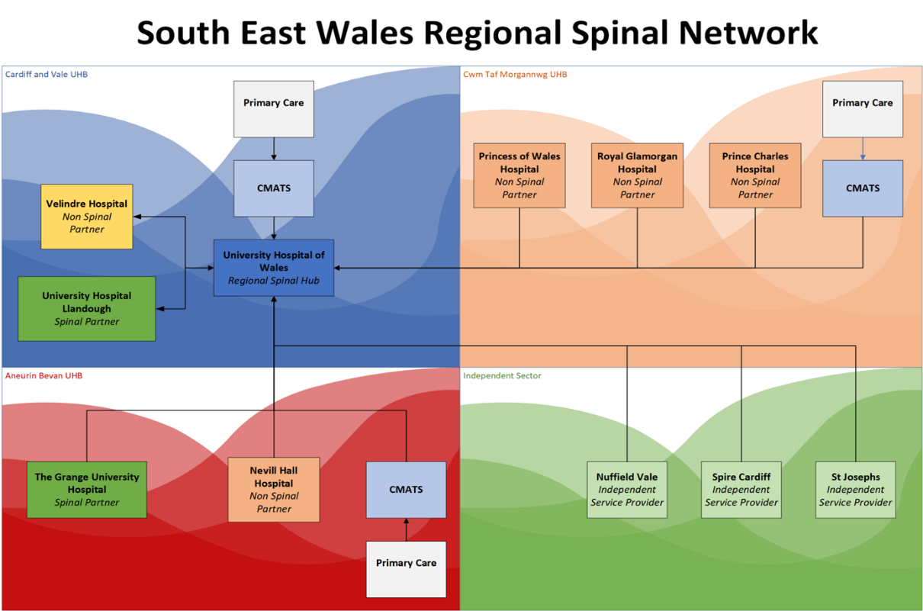

University Hospital Llandough
Non-Spinal Partner

Primary Care

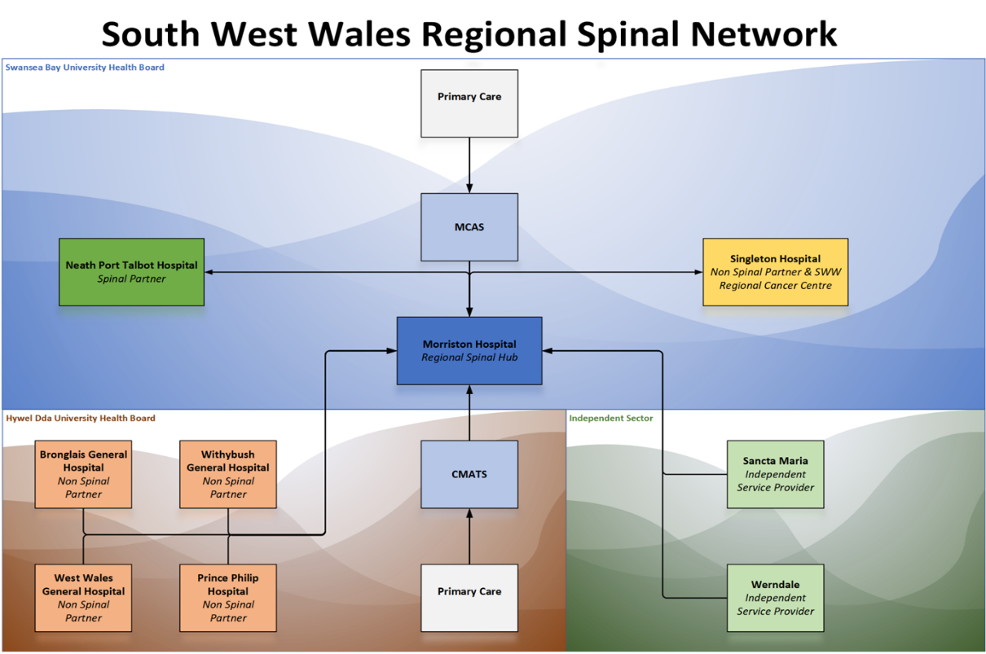

CMATS

CMATS

Staffing
The Operational Delivery Network (ODN) have recently appointed two MSCC coordinators that started in post in April 2024 and appointed the Network Quality Improvement & Research Lead who started in January 2024. The ODN are working with the South Wales Trauma Network (SWTN) to develop clinical leads positions that can transition between consultants, nurses and allied health professionals i.e. Network Training & Education Clinical Lead.

Operational Policies & Clinical Guidelines
Operational policies approved and ratified:
- P01 – SWSN Acceptance & Transfer Policy
This document aims to support member organisations in the SWSN:

- To ensure that patients requiring specialist spinal care are transferred to a spinal hub or partner in a timely manner based on the overall clinical priority of patient need.
- To avoid cancellations of future elective or acute spinal surgery due to the lack of a suitable post-operative bed.
- To improve patient flow between health boards.
- To optimally manage service demand across South Wales.
- To ensure efficient, accurate and appropriate flow of information between clinical teams for safe patient referrals between two senior decision-makers ((Specialist Trainee (ST)3 equivalent or above)).

- P02 – SWSN Automatic Repatriation Policy
This document aims to support member organisations in the SWSN:

- With the process around the repatriation of patients no longer requiring specialist spinal level care back to their partner hospital or closer to home within two calendar days of clinical acceptance.
- To ensure that patients requiring specialist spinal care are transferred to a Spinal Unit in a timely manner based on the overall clinical priority of patient need.
- To avoid cancellations of future elective or acute spinal surgery due to the lack of a suitable post-operative bed.
- To improve patient flow between providers.
- To optimally manage service demand across the region.
- To ensure efficient, accurate and appropriate flow of information between clinical teams for safe patient referrals between two senior decision-makers (ST3 equivalent or above).
- To ensure efficient, accurate and appropriate flow of information between clinical teams for safe patient referrals between two senior decision-makers.

- P03 – SWSN Clinical Governance and Quality Improvement Policy
The SWSN requires a multidisciplinary, multi-professional and inter-organisational approach to clinical governance (CG) and quality improvement (QI). This approach will focus on driving improvements in patient outcomes and experience and providing assurance to commissioning bodies and network host organisation. It aims to be efficient, imposing the minimum additional burden on providers, while ensuring that their internal processes are effective, that lessons are rapidly disseminated and acted upon across the network, and that the network’s governance of its own functions is equally robust.

- P04 – SWSN Clinical Guidelines Framework
This document provides an overview of the structure, content, and example of how all SWSN clinical guidelines should be developed.

Clinical guidelines approved and ratified:-
- CG01- SWSN Cauda Equina Syndrome
This collaborative work stream included stakeholders from all regional organisation involved in the delivery of CES intervention.
The aim of this guideline is to:
- Reduce delays and barriers to diagnosis and surgery for acute cauda equina compression.
- Remove any ambiguity regarding roles and responsibilities of each healthcare provider throughout the pathway.
- Reduce the severity and life-long burden of bladder, bowel and sexual dysfunction in patients who present acutely with symptoms suggestive of cauda equina syndrome by rapid diagnosis with MRI and treatment by decompressive spinal surgery.

- CG02- SWSN Spinal Trauma
The aim of this clinical guidance is to provide clear supportive information on whole pathway management of patients with suspected and confirmed spinal trauma. It must be used in conjunction with the relevant signposted documents and resources. In particular:

- Community Healthpathways for Primary care users.
- SWTN CG14 – for major trauma elements of the pathway.

All 3 resources in conjunction will:

- Describe the management and disposition for suspected stable and unstable spinal trauma presenting to primary care and secondary care.
- Clarify and update the process of communication and routes of disposition for those patients requiring specialist spinal surgical advice and treatment.
- Describe how to access specialist rehabilitation.
- Define the collection of PROMS, PREMS, TARN data and other quality indicators as determined the networks and scrutiny against national standards.

- CG03 – SWSN Metastatic Spinal Cord Compression
This collaborative work stream included stakeholders from all regional organisation involved in the delivery of MSCC intervention.
The aim of this guideline is to:
- Promote early detection, management, and treatment of metastatic spinal cord compression in adult patients (South Wales including South Powys)
- Educate healthcare workers to the network wide and local MSCC pathways.
- Empower patients to seek appropriate medical help.
- Ensure robust communication between primary, secondary and tertiary care to enable points above.
- Ensure timely intervention to Treatment (Radiotherapy or Surgery)
- Ensure appropriate access to imaging (Whole Spine MRI) is available.
- Enable timely access to Allied Health Professionals (AHPs) for specialist rehabilitation and the effective amelioration of symptoms and treatment side effects, including Physiotherapy, Occupational Therapy, Dietitians, Speech and Language Therapists
- Promote a single data collection for South Wales and auditing against national standards.
- Assimilate NICE guidance NG234 to enable adoption at Network level.

- CG04 – SWSN Intradural & Complex Neurospinal Surgery
The aim of this guideline is to outline the pathways / process for patients with intradural pathology. This is exclusively the domain of neurosurgeons, usually with a particular subspecialty interest in either spinal surgery, neuro-oncology, neuro-vascular or paediatric neurosurgery. However, intradural pathology in people younger than 16yrs is managed by paediatric neurosurgeons and is not included in this pathway.

Metastatic Spinal Cord Compression (MSCC) Coordinators
MSCC Co-coordinator will be responsible for operationally coordinating the care pathway for patients with impending MSCC and MSCC across the South Wales Spinal Network (SWSN) in accordance with SWSN MSCC guidelines. They are currently 6 weeks into their appointment and undergoing extensive engagement work to develop necessary cross-provider and partnerships within network acute oncology and emergency care. They will in the future deliver network multi-professional education programmes in collaboration with Acute Oncology teams, spinal teams and Wales Cancer Network.
They are currently collaboratively developing an MSCC network wide pathway, referral form and audit tool to capture the standards and KPIs in the SWSN MSCC clinical Guideline (CG03).

24/7 MRI Provision from Health Boards
All Health Boards have been asked to provide assurance of 24/7 MRI provision to the SWS Network Board. ABUHB, C&VUHB and SBUHB have provided assurance to Network Board. However, there are still ongoing discussions with CTMUHB and HDUHB.
CTMUHB have a Cauda Equina pathway which has been clinically agreed in principle. There is an agreement being drafted with C&VUHB neurosurgery whereby if MRI scanning is required out of hours, there will be a discussion with C&VUHB neurosurgery with regarding to clinical assessment and scans being undertaken within C&VUHB. The Network has expressed concerns that this will not be sustainable without an SLA/formal commissioning and Executive level agreement. CTMUHB are actively seeking a position on an SLA between CTMUHB & C&VUHB for out of hours MRI scanning.

HDUHB are able to provide 24/7 MRI at one of four hospital site (Prince Philip Hospital). This is not the preferred hospital site due to the lack of specialties available in PPH. However, Keith Jones and Owain Ennis will develop a SOP within two weeks to map out how patients with suspected CES presenting to acute site in HDUHB can be transferred as an emergency to PPH for out of hours scanning.

Spinal Incident Database (SID)
Due to the new All Wales Datix system being unable to support the complexities of managing SiDs across multiple organisations, the SWSN has migrated to an internal system on SharePoint, with the support of Delivery Unit, as an interim measure. The system is managed by the ODN team and requests are made to all involved parties for investigation to take place. Outcomes and lessons learnt are shared across the SWSN and form part of the governance programme, lessons learned reports and the network training plan.

September 2023- There was 1 SIDs raised in relation to clinical management.
October 2023- There was 4 SIDs raised in relation to staffing, inappropriate transfer.
November 2023- No SIDs.
December 2023- There was 1 SIDs raised in relation to delayed outpatient follow up.

January 2024- There was 1 SIDs raised in relation to clinical management.
February 2024- There was 2 SIDs raised in relation to clinical handover and delayed repatriation.
March 2024- There was 2 SIDs raised in relation to MRI and delayed radiotherapy.

Concerns: Clinical & Operational

Clinical

Lack of elective spinal surgery capacity across the Network is a major risk of patient with spinal cord compression coming to harm.

In the last audit, 50% of emergency admitted to SBUHB were on an elective pathway. The ODN are in the process of undertaking a snapshot audit with all Health Boards to provide evidence that this is the same circumstance across the Network.

Lack of support from Welsh Government- not supporting CP01 bid which would address the points above.

Operational

Digital

Use of BSR is minimal.

Different referral system for each spinal provider x4

Difficulty with engagement from clinical and managerial leads due to other commitments

Engagement with spinal partners due to lack of substantive SWSN clinical staff- reliant on existing staff.

Risk and Issues log
There is a live risks and issues log that is reviewed by SWSN Governance Group and presented to Network Board. The latest Risk and Issue Registers are attached as appendix 1 & 2 respectively.

There are currently 14 risks identified.
There is one risk that are currently highlighted as a red RAG rating regarding:
- SWSN.004- Limited dedicated support for the management of patients with spinal cord injuries (SCI) on the trauma & orthopedic surgical ward. (The network has requested SBUHB monitor the number of SCI patients and in form the network if the numbers continue to consistently increase.)

There are currently 27 live issues. Three of these issues are high priority:
- SWSN.001- Delayed access to MRI scan has led to delays in diagnosing and treating patients with Cauda Equina Syndrome, which in turn has resulted in suboptimal / poor outcomes for patients. Inadequate provision and convoluted clinical pathways for CES. (The network has requested data from the welsh risk pool to audit any ongoing trends. In addition to The Network Quality Improvement & Research Lead undertaking an audit of the patient’s journey in comparison to the Network published clinical guideline (CG01))
- SWSN.012- The current MTN pathway is that in the presence of trauma and new motor neurology. (SWSN and SWTN spinal trauma clinical guidelines have been aligned but awaiting SWTN final approval and ratification)
- SWSN.018- Inadequate provision and convoluted clinical pathways for CES. (The Network Quality Improvement & Research Lead undertaking an audit of the patient’s journey in comparison to the Network published clinical guideline (CG01))

Service Developments
Governance
The first successful SWSN Governance Group meeting took place on 5th March 2023, the quoracy of the meeting continues to be an issue. There has been an increase in Spinal Incident Database (SID) submissions due to a robust engagement process which has been implemented prior to the launch of the network. The SIDs have enabled us to identify common themes. For example, out of hours MRI scanning is a continuing risk and impacting on the care of patients presenting to Cwm Taf and Hywel Dda health boards. We have identified that patients with conditional devices are at risk when presenting to Cwm Taf with no clear funding in place for these patients to be scanned either in Cardiff or Swansea.

The lack of administrative support to input data into the British Spine Register (BSR) has been highlighted following SID submissions. This prevents the network from capturing meaningful data to improve spinal surgical procedures across the network. BSR is incredibly useful for identifying performance in surgery and outcomes. The use of the digital referral form will improve the collection of information, capture activity and performance to enable the SWSN Governance Group to compare and analyse data across the Network and improve the care of spinal patients.
Quality Improvement & Research
The Network Quality Improvement & Research Lead has been developing education to deliver to A&E/T&O departments across the Network to promote the pathways and responsibilities of both the referring and spinal teams from the Network emergency clinical guidelines:

- CG01 Cauda Equina Syndrome
- CG02 Spinal Trauma
- CG03 Metastatic Spinal Cord Compression

Dates are being finalised to present individually to all acute hospitals across the Network.

Cauda Equina Syndrome Pathway- a survey of service delivery
The Network Quality Improvement & Research Lead is undertaking an audit of patient’s journey in comparison to the Network published clinical guideline. Data collection has started at ABUHB with aim to be rolled out across all acute hospitals in South Wales in coming months. The purpose of the audit is to determine whether and to what extent the patient journey deviates from the prescribed pathway.

Training & Education
The SWSN will be facilitating a Spinal Injuries Association Day in Autumn of 2024. The purpose of the course is to provide an overview of the key issues affecting spinal cord injured people, such as autonomic dysreflexia, bladder and bowel management and care of the skin. It provides an opportunity for organisations working with spinal cord injured people to upskill staff.
Training of MSCC Coordinators- programme to be arranged.

Benefits Realisation Plan
The Network has been developing a benefits realisation plan to ensure that the Network is fulfilling its identified benefits of the service. The document was submitted to Network Board in April 2024 for review and ratification, whereby the document with signed off and is awaiting definitive sign off from the SWSN Delivery Assurance Group (DAG). Appendix 3.

Engagement
The ODN has been actively engaging with organisations across the Network to promote and inform clinicians and operational staff about the South Wales Spinal Network. Appendix 4 highlights the past and upcoming engagement events that are scheduled.

Following quarterly Network Board meetings, the ODN are developing communication briefs for wide circulation across the Network to inform stakeholders of the recent and upcoming developments that the ODN are progressing in line with the programme. Appendix 5 is an example of the communication brief that was circulated in December 2023.

Achievements
Clinical Guidelines
Uniform clinical agreements on emergency pathways and significant reduction in patient harm.
Consensus on spinal neurosurgical pathways finally achieved following neurosurgical centralisation in 2010.

SWSN Disposition
The ODN has collaboratively working with stakeholders to develop a spinal pathology disposition infographic which defines the referral pathways, transfer times and destination for patients with suspected or confirmed spinal pathology. The document was signed off by Network Board in April 2024 and has been rolled out following the approval from Network Board. Appendix 6

SWSN Communication Plan
The ODN has been developing the Network communication plan which was submitted to Network Board in April 2024 and signed off in SWSN DAG scheduled for May 2024. Appendix 7

Appendices
Appendix 1- Network Risk Register

Appendix 2- Network Issue Log

Appendix 3 – Benefits Realisation Plan

Appendix 4- SWSN Engagement Plan
Appendix 5- SWSN Communication Brief- December 2023
Appendix 6- SWSN Disposition
Appendix 7- SWSN Communication Plan

