

Meeting Date | 21 November 2024 |  | Agenda Item |  | 7.1
Report Title | Clinical Governance for the Emergency Medical Retrieval and Transfer Service (EMRTS)
Report Author | Prof David Lockey, National Director, Emergency Medical Retrieval and Transfer Service (EMRTS) Cymru
Report Sponsor | Anjula Mehta, Executive Medical Director
Presented by | Prof David Lockey
Freedom of Information | Open
Purpose of the Report | This report sets out the update to Audit Committee regarding the governance of both the Emergency Medical Retrieval and Transfer Service (EMRTS) and the Adult Critical Care Transfer Service (ACCTS).
Key Issues | - The quality and delivery framework developed with commissioners with quarterly performance and activity (CAREMORE) is attached.  - EMRTS is working with the Wales Air Ambulance Charity (WAAC) and the NHS Wales Joint Commissioning Committee (NWJCC) to reconfigure the future service to deliver an improved and more equitable service to meet the aims of the EMRTS Service Delivery Plan.  - The ACCTS Service is functioning well in North and South Wales and delivering more clinical activity than estimated at Commissioning.
Specific Action Required  (please choose one only) | Information | Discussion | Assurance | Approval
Specific Action Required  (please choose one only) | ☐ | ☐ | ☒ | ☐
Recommendations | Members are asked to note the contents of the report.

INTRODUCTION

EMRTS continues to run a comprehensive governance package, hosted by SBUHB to ensure the quality and safety of the commissioned services. EMRTS works with key partners NWJCC,WAAC and the Welsh Ambulance University NHS Trust (WASUNHST,) to ensure that governance issues affecting more than one service are resolved appropriately. EMRTS Delivery Assurance Group (DAG), chaired by Director of Ambulance/111 – NWJCC with representatives from all Health Boards meet quarterly to review service performance and provide updates against the commissioning intentions.

This report outlines the operational and governance activity in the last complete annual reporting period (2023/24) and highlights the major service developments.

BACKGROUND

  - The service currently delivers one Consultant – Critical Care Practitioner team and one double Critical Care Practitioner team in South Wales and the same configuration in Mid/ North Wales during the 12-hour daytime period. At night a 12-hour Consultant – Critical Care Practitioner operates from Cardiff and provides cover for the whole of Wales. All teams have access to a helicopter and rapid response vehicles.

  - Recruitment into Consultant and CCP posts has been highly competitive in the reporting period.

  - Education & Training

EMRTS continues to provide excellent educational opportunities, we collaborate with other providers including the University of Bangor where we have devised two Master’s in Science degrees (MSc) programmes one in Pre-hospital Emergency Care (PHEM)and a second in relation to Critical Care Transfer and Retrieval.

We also deliver the following programmes:

- IBT PHEM - Pre-Hospital Emergency Medicine Sub Speciality for Doctors.
- Critical Care Practitioner Fellow scheme – 1 year secondment opportunity for paramedics and nurses.
- Clinical Fellow scheme for Health Board trainee doctors in ICM, anaesthetics and Emergency Medicine.
- MOD placement scheme

2.4 CAREMORE Framework

The Quality and Delivery Framework developed by NWJCC and EMRTS is functioning and attached. This includes extensive evidence of governance and performance KPIs. The Care Standards, Activity, Resource Envelope, Model of Care, Operational Arrangements, Review of performance and Evaluation (CAREMORE) report is attached as Appendix 1.

Proposed Service Changes

EMRTS are required to regularly evaluate their performance and consider whether service improvements could be made within current resources. Operational data and external modelling suggested that reconfiguration of working shifts and geographical base location could deliver a more equitable service and more patient attendances. This has resulted in a two-stage public consultation process. The NWJCC approved the relocation of two bases (Welshpool and Caernarfon) into one new location in the centre of North Wales in 2026. EMRTS is working in partnership with WAACT to provide the necessary requirements for this new facility.

- OPERATIONAL ACTIVITY EMRTS & ACCTS

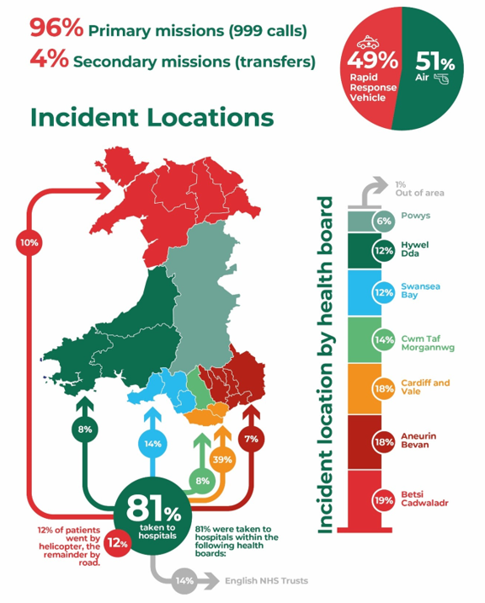

The EMRTS responded to 3934 incidents across Wales and surrounding areas during the last financial year. 51% of cases were responded onboard the Wales Air Ambulance Charitable Trust aircraft, with the remainder via rapid response vehicles. The infographics here outline incident locations, and disposition of the EMRTS provision. In 50% of cases patients received care not available from the ambulance service, including 341 emergency anaesthetics, 130 blood product transfusions and 144 procedural sedations. 27% of call cases are taken through a formal audit pathway as outlined alongside other statistics in the attached CAREMORE reporting template.

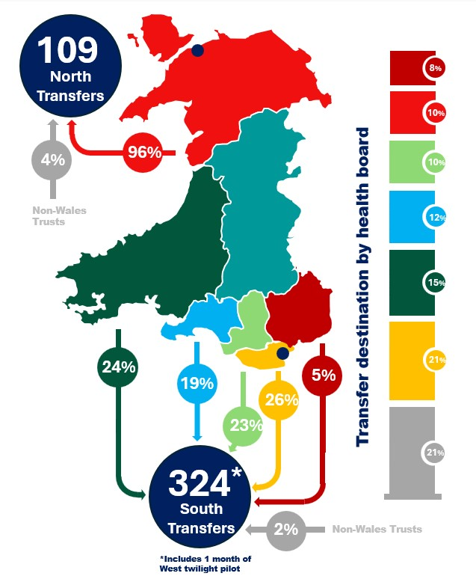
The ACCTS transferred 433 patients, broken down in the second infographic.

More detail including cases studies from both services are included in the annual report attached.

GOVERNANCE AND RISK ISSUES

4.1 There are no high/red risks currently on the EMRTS/ ACCTS risk registers and no high risks on the Health Board Risk Register. The register is attached as Appendix 2.

4.2 Overall governance and audit / service evaluation structure for EMRTS has remained unchanged. The structure and activity per annum (PA) is summarised below:

- Annual Report 2023-24

The annual report is attached as Appendix 3.

FINANCIAL IMPLICATIONS

For the period 2023/24 the services operated within the financial framework and at year end noted that EMRTS incurred a small year-end deficit of £7k after £117k of non-recurrent brokerage from 2022-23 and £180k of non-recurrent funding from the Emergency Ambulance Services Committee (EASC) received in March 2024 was utilised.

RECOMMENDATION

The Audit Committee is asked to note the report for information and assurance.

Governance and Assurance
Link to Enabling | Supporting better health and wellbeing by actively promoting and empowering people to live well in resilient communities
Link to Enabling | Partnerships for Improving Health and Wellbeing |  | ☒
Objectives |  |  | ☒
Objectives | Co-Production and Health Literacy |  | ☐
(please choose) |  |  | ☐
(please choose) | Digitally Enabled Health and Wellbeing |  | ☐
 | Deliver better care through excellent health and care services achieving the
 | outcomes that matter most to people
 | Best Value Outcomes and High Quality Care |  | ☒
 | Partnerships for Care |  | ☒
 | Excellent Staff |  | ☒
 | Digitally Enabled Care |  | ☐
 | Outstanding Research, Innovation, Education and Learning |  | ☐
Health and Care Standards
(please choose) | Staying Healthy |  | ☐
(please choose) | Safe Care |  | ☒
(please choose) | Effective Care |  | ☒
(please choose) | Dignified Care |  | ☐
(please choose) | Timely Care |  | ☒
(please choose) | Individual Care |  | ☒
(please choose) | Staff and Resources |  | ☐
Quality, Safety and Patient Experience
- The CAREMORE matrix reports key quality indicators for the operational and educational activity of the organisation.
- The inter-hospital transfer service delivers benefits to patients and to hospitals with staffing challenges.
Financial Implications
For the year 2023/24 EMRTS incurred a small year-end deficit of £7k (after £117k of non-recurrent brokerage from 2022-23 and £180k of non-recurrent funding from EASC received in March 2024).

Legal Implications (including equality and diversity assessment)
None identified.

Staffing Implications
None identified
Long Term Implications (including the impact of the Well-being of Future Generations (Wales) Act 2015)
Our service development proposal (if implemented) will result in a more equitable night service for Wales and attendance at an increased number of critically unwell patients in the future.
Report History |  | Standing agenda item
Appendices |  | (Available within Resources)  Appendix 1: CAREMORE Annual Report  Appendix 2: Risk Register  Appendix 3: Service Annual Report  Appendix 4: ACCTS Service Evaluation

