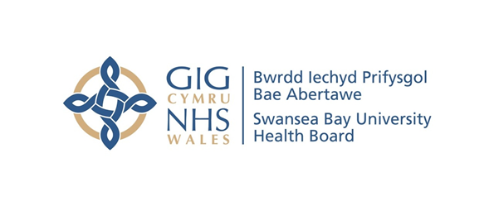
Item 6.1 – Appendix 2
Counter Fraud Benchmark Report
Case Referral Rate | Swansea Bay UHB | All Wales Avg.
2019/20 | 11 | 6.4
2020/21 | 8 | 4.2
2021/22 | 8 | 7.0
2022/23 | 15 | 8.7
2023/24 | 11 | 14.8
2024/25 | 19 | 12.8

Case Closure Rate | Swansea Bay UHB | All Wales Avg.
2019/20 | 1 | 4.8
2020/21 | 16 | 4.9
2021/22 | 8 | 6.6
2022/23 | 20 | 7.6
2023/24 | 10 | 9.7
2024/25 | 14 | 12.5

*5 Investigations Transferred to other NHS body for action
Investigation Progression Rate | Cases Open at Start of FY | Referrals Received | Cases Closed | Total Cases Open End of Period
2019/20 | 43 | 11 | 1 | 53
2020/21 | 50 | 8 | 16 | 42
2021/22 | 33 | 8 | 8 | 33
2022/23 | 24 | 15 | 20 | 19
2023/24 | 20 | 23 | 16 | 22

Sanctions | 2021/22 |  |  | 2022/23 |  |  | 2023/24 |  |  | 2024/25
Sanctions | Criminal | Disp | Civil | Criminal | Disp | Civil | Criminal | Disp | Civil | Criminal | Disp | Civil
Swansea Bay UHB | 1 | 1 | 2 | 2 | 2 | 6 | 2 | 1 | 4 | 2 | 1 | 2
All Wales Avg. | 0.3 | 2.3 | 1.6 | 0.3 | 1.4 | 2.1 | 0.7 | 2.9 | 4.9 | 0.7 | 2.9 | 4.9
All Wales Total | 4 | 30 | 21 | 4 | 18 | 27 | 5 | 13 | 27 | 4 | 24 | 25

Number of Presentations | Swansea Bay UHB | All Wales Avg.
2019/20 | 37 | 15
2020/21 | 4 | 4
2021/22 | 34 | 9
2022/23 | 21 | 8
2023/24 | 20 | 11
2024/25 | 25 | 9

Number of Attendees | Swansea Bay UHB | All Wales Avg.
2019/20 | 1409 | 414
2020/21 | 91 | 72
2021/22 | 593 | 170
2022/23 | 246 | 219
2023/24 | 218 | 243
2024/25 | 479 | 307

Average Attendance of a Presentation | Swansea Bay UHB | All Wales Avg.
2019/20 | 38 | 28
2020/21 | 23 | 18
2021/22 | 17 | 18
2022/23 | 12 | 29
2023/24 | 11 | 22
2024/25 | 19 | 33

Attendance of Presentations as % Staff Headcount | Swansea Bay UHB | All Wales Avg.
2019/20 | 10.5% | 5%
2020/21 | 0.7% | 0.8%
2021/22 | 4.4% | 2.1%
2022/23 | 1.8% | 3%
2023/24 | 1.6% | 3%
2024/25 | 3.6% | 3%

