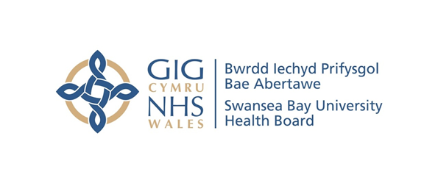
Item 7.1 – Appendix
Counter Fraud Benchmark Report
Case Referral Rate | Swansea Bay UHB | All Wales Avg.
2020/21 | 8 | 2.0
2021/22 | 2 | 2.8
2022/23 | 6 | 3.8
2023/24 | 2 | 6.8
2024/25 | 11 | 7.7
2025/26 | 18 | 6.4
Case Closure Rate | Swansea Bay UHB | All Wales Avg.
2020/21 | 14 | 2.6
2021/22 | 3 | 1.7
2022/23 | 10 | 3.8
2023/24 | 5 | 4.2
2024/25 | 8 | 6.6
2025/26 | 15 | 5.8

Sanctions | 2021/22 |  |  | 2022/23 |  |  | 2023/24 |  |  | 2024/25 |  |  | 2025/26
Sanctions | Criminal | Disp | Civil | Criminal | Disp | Civil | Criminal | Disp | Civil | Criminal | Disp | Civil | Criminal | Disp | Civil
Swansea Bay UHB | 1 | 1 | 2 | 0 | 0 | 4 | 0 | 1 | 1 | 0 | 0 | 2 | 0 | 1 | 0
All Wales Avg. | 0.1 | 0.3 | 0.5 | 0.1 | 0.4 | 1.2 | 0.0 | 0.6 | 0.6 | 0.1 | 1.4 | 1.2 | 0.0 | 0.1 | 0.0
All Wales Total | 1 | 4 | 6 | 1 | 5 | 15 | 0 | 8 | 8 | 1 | 18 | 16 | 0 | 6 | 3

Number of Presentations | Swansea Bay UHB | All Wales Avg.
2020/21 | 0 | 1
2021/22 | 14 | 5
2022/23 | 11 | 3
2023/24 | 13 | 6
2024/25 | 12 | 4
2025/26 | 23 | 6

Number of Attendees | Swansea Bay UHB | All Wales Avg.
2020/21 | 0 | 25
2021/22 | 255 | 97
2022/23 | 184 | 73
2023/24 | 158 | 92
2024/25 | 369 | 114
2025/26 | 464 | 144
Average Attendance of a Presentation | Swansea Bay UHB | All Wales Avg.
2020/21 | 0 | 20
2021/22 | 18 | 21
2022/23 | 17 | 24
2023/24 | 12 | 15
2024/25 | 31 | 28
2025/26 | 20 | 22
Attendance of Presentations as % Staff Headcount | Swansea Bay UHB | All Wales Avg.
2020/21 | 0.0% | 0.3%
2021/22 | 1.9% | 1.2%
2022/23 | 1.4% | 1%
2023/24 | 1.2% | 1%
2024/25 | 2.8% | 1%
2025/26 | 3.1% | 1.6%

