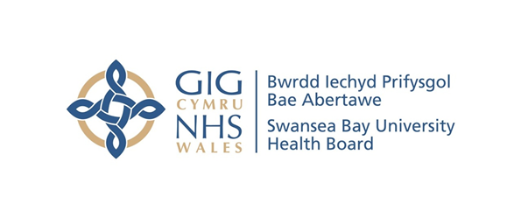
Item 6.1 – Appendix
Counter Fraud Benchmark Report
Case Referral Rate | Swansea Bay UHB | All Wales Avg.
2019/20 | 16 | 9.5
2020/21 | 11 | 6.1
2021/22 | 12 | 11.4
2022/23 | 29 | 12.5
2023/24 | 17 | 20.9
2024/25 | 31 | 18.9

Case Closure Rate | Swansea Bay UHB | All Wales Avg.
2019/20 | 2 | 8.1
2020/21 | 32 | 8.3
2021/22 | 10 | 11.2
2022/23 | 24 | 12.5
2023/24 | 13 | 16.2
2024/25 | 30 | 19.7

Sanctions | 2021/22 |  |  | 2022/23 |  |  | 2023/24 |  |  | 2024/25
Sanctions | Criminal | Disp | Civil | Criminal | Disp | Civil | Criminal | Disp | Civil | Criminal | Disp | Civil
Swansea Bay UHB | 1 | 1 | 3 | 4 | 4 | 9 | 2 | 1 | 5 | 3 | 1 | 2
All Wales Avg. | 0.4 | 3.2 | 2.2 | 0.6 | 2.1 | 2.9 | 0.7 | 2.9 | 4.9 | 0.7 | 2.9 | 4.9
All Wales Total | 5 | 41 | 28 | 8 | 27 | 38 | 6 | 28 | 46 | 5 | 28 | 37

Number of Presentations | Swansea Bay UHB | All Wales Avg.
2019/20 | 63 | 23
2020/21 | 19 | 8
2021/22 | 53 | 14
2022/23 | 37 | 13
2023/24 | 37 | 17
2024/25 | 37 | 15

Number of Attendees | Swansea Bay UHB | All Wales Avg.
2019/20 | 1976 | 627
2020/21 | 359 | 145
2021/22 | 864 | 255
2022/23 | 545 | 363
2023/24 | 430 | 369
2024/25 | 858 | 423

Average Attendance of a Presentation | Swansea Bay UHB | All Wales Avg.
2019/20 | 31 | 27
2020/21 | 19 | 17
2021/22 | 16 | 19
2022/23 | 15 | 28
2023/24 | 12 | 22
2024/25 | 23 | 29

Attendance of Presentations as % Staff Headcount | Swansea Bay UHB | All Wales Avg.
2019/20 | 14.8% | 7%
2020/21 | 2.7% | 1.7%
2021/22 | 6.5% | 3.2%
2022/23 | 4.1% | 5%
2023/24 | 3.2% | 5%
2024/25 | 6.4% | 5%

