Appendix one
Swansea Bay University Heath Board Recovery and Sustainability Board
Variable Pay Steering Group
Draft Terms of Reference
- Context
The health board needs to achieve a minimum of £55.4m in savings in 2025/6 if it is to meet its financial plan. A Recovery and Sustainability Programme Board has been established to achieve the required savings with 12 overarching workstreams as follows:
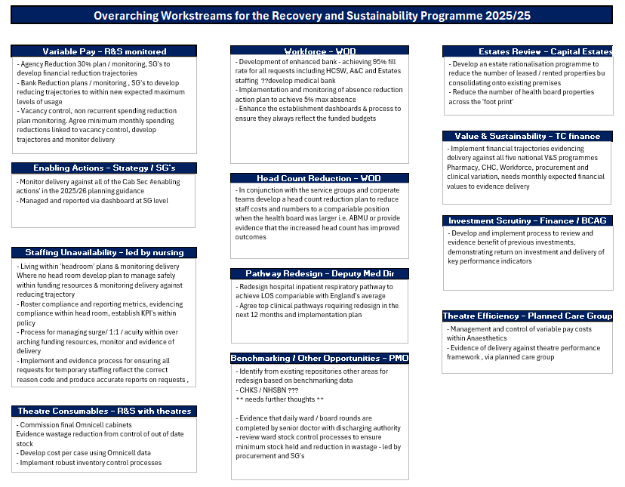
2.0 Scope
It is proposed that a steering group is set up to oversee the delivery of the following workstreams that are linked to variable pay:
- Variable Pay
- Staffing Unavailability
- Workforce
By bringing these workstreams together we will be able to set an overall savings target, avoid a double count and will ensure all interdependencies are managed.
The headcount reduction workstream will be delivered separately through the Organised for Success Programme (see separate terms of reference).
The programmes of work in scope are set out in the following table:

No | Theme | Programme of work | Staff Group | Executive Sponsor | Programme of work Leads
1 | Variable Pay | Agency reduction plan - with a target to reduce our agency usage by 30% from a 2024/5 baseline  Including agreed SOP to ensure correct coding for reason for agency usage | - Medical & Dental  - Nursing & Midwifery  - AHP & Clinical Scientists  - Support Services  - Admin & Clerical | - Medical Director  - Director of Nursing & PE  - Director of AHP & HS  - Director of Finance & Performance  - Director of workforce & OD | tbc
2 | Variable Pay | Bank reduction plan - with a target to reduce our agency usage by a minimum of 15% from a 2024/5 baseline  Including agreed SOP to ensure correct coding for reason for bank usage | - Medical & Dental  - Nursing & Midwifery  - AHP & Clinical Scientists  - Support Services  - Admin & Clerical | - Medical Director  - Director of Nursing & PE  - Director of AHP & HS  - Director of Finance & Performance  - Director of workforce & OD | tbc
3 | Variable Pay | Vacancy control plan - to reset the vacancy factor target based on an updated trajectory | All staff group – through budget review meetings | Director of Finance & Performance | tbc
4 | Staffing Unavailability | Headroom establishment reset – to reset how the 26.08% headroom is apportioned between WTE and £ pay budget | - Nursing & Midwifery  - Healthcare Support Workers | Director of Nursing & PE | tbc
5 | Staffing Unavailability | Roster compliance and reporting – to ensure staff templates are within funded establishment and that annual leave is scheduled appropriately across the year | - Nursing & Midwifery  - Healthcare Support Workers | Director of Nursing & PE | tbc
6 | Staffing Unavailability | Surge/ 1:1 care resource management – to develop and embed an agreed standing operating procedure for the approval and management of additional staffing requested for surge and 1:1 care | - Nursing & Midwifery  - Healthcare Support Workers | Director of Nursing & PE | tbc
No | Theme | Programme of work | Staff Group | Executive Sponsor | Programme of work Leads
7 | Workforce | Temporary Staffing Model – to undertake an options appraisal to ensure current model is fit for purpose for all staff groups | All staff groups | Director of Workforce & OD | Sarah Jenkins
8 | Workforce | Sickness Absence Management – to support each budget holder to meet the sickness absence target of >5.08%. To set improvement trajectories and supporting action plans.  Initial focus on budgets areas with >5% 12 month rolling sickness absence rate. | All service groups through monthly performance review meetings  All corporate directorates through quarterly review meetings | Director of Workforce & OD | Sarah Jenkins
9 | Workforce | Establishment Control - develop policy and SOP to agree how future changes to establishment (recorded on financial ledger) must be agreed and actioned. Agree SOP to align establishment across ledger, ESR and e-rostering | All staff groups | Director of Workforce & OD | Sarah Jenkins
10 | Workforce | Time to hire – to review and streamline time to hire process from resignation to new joiner in post | All staff groups | Director of Workforce & OD | Emma Owen

3.0 Steering Group
Membership
The steering group membership will consist of the executive sponsors:
- Medical Director
- Director of Nursing and Patient Experience
- Director of Allied Health Professional & Healthcare Scientists
- Director of Finance & Performance
- Director of Workforce & OD
Programme of work leads will attend each steering group to provide an update on their programme of work.
Meeting Frequency
The steering group will meet fortnightly initially and will report to the Recovery and Sustainability Board.

