Meeting Date | 17 July 2025 |  | Agenda Item |  |  | 5.3
Name of Meeting | Audit Committee
Report Title | Recovery and Sustainability Update
Report Author | Brian Owens, Director Recovery and Sustainability
Report Sponsor | Darren Griffiths, Executive Director of Finance and Performance
Presented by | Brian Owens, Director Recovery and Sustainability
Freedom of Information | Open
Purpose of the Report | The report updates the committee in respect to the governance processes underpinning the recovery and sustainability program and provides oversight for assurance around the current programme of work.
Key Issues | The Recovery and Sustainability programme and board has clearly established governance structures linking through the organisation.  The current level of identified recurrent savings is insufficient, and the resulting financial pressures therefore require urgent mitigating actions to identify additional recurrent savings and or reduce the reduce the current run rate of the organisation.  The Recovery and Sustainability programme has identified five key priority areas; each being led by an executive senior responsible officer to support the delivery of savings across the Health Board.
Specific Action Required  (please choose one only) | Information | Discussion |  | Assurance | Approval
Specific Action Required  (please choose one only) | ☐ | ☒ |  | ☒ | ☐
Recommendations | Members are asked to:  - CONSIDER and comment upon the structure and governance underpinning the R&S Programme.  - TAKE ASSURANCE from the work programme of the support for the executive led savings programmes, noting that the actual budgets are within the service groups.

RECOVERY AND SUSTAINABILITY UPDATE

- INTRODUCTION
The Health Board submitted a 3 Year Financial Plan on 31 March 2025, with an assessed Financial Deficit for Year 1 of £58.7m, predicated on the delivery of £55.4m of savings. At Month 2 the Health Board was off plan by £7.3m, almost exclusively driven by the non-delivery of the savings target.

On 6 June 2025 Welsh Government wrote to confirm the expectation for 2025/26, which as a minimum must equal the outturn from 2024/25 (£42.5m deficit). This requires an additional £16.2m of savings to be delivered, taking the total savings requirement for 2025/26 to £71.6m. At the time of writing this report £18.8m of savings have been identified on the trackers, with 68% of these still categorised as red or pipeline. The scale of this challenge is unprecedented and requires a radical, sustainable and multi-faceted response.

The Health Board must now, with pace, identify and deliver a significant level of cash releasing savings or run rate reductions to achieve the £42.5m deficit.

To support the delivery required, the Health Board has already created a Recovery & Sustainability (R&S) Team, established the Executive Led programmes of work and commenced the procurement of external support with a view to the support starting within the first two weeks of July 2025.

- BACKGROUND
The audit committee previously received a report on the governance structures for the Recovery and Sustainability programme (R&S) in January 2025, those structures remain in place. See diagram one.

Diagram one: Governance Structure
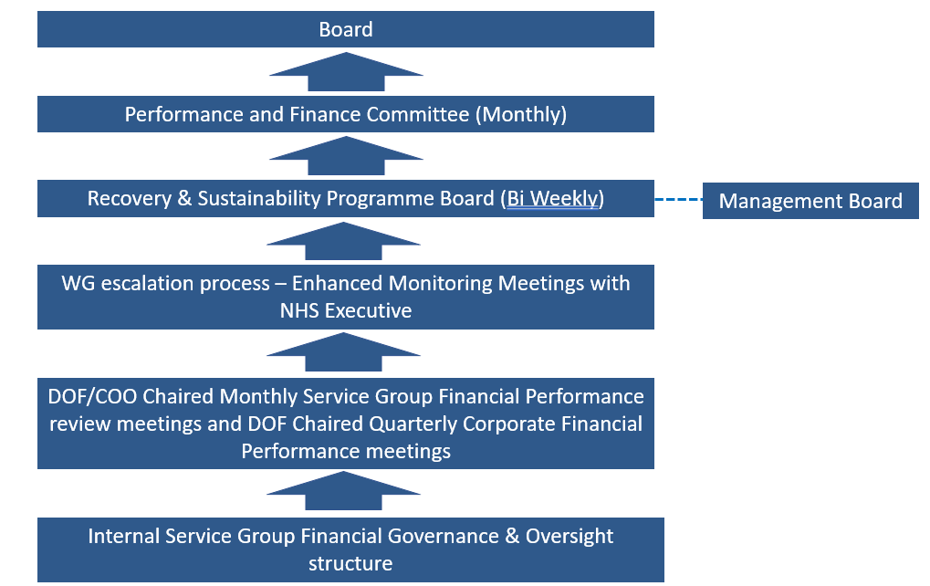

The R&S Board continues to be chaired by the Chief Executive Officer and occurs twice per month. The frequency and pattern of the meetings is now firmly established within the normal pattern of business.

The terms of reference where previously shared with the committee, these will be reviewed shortly to reflect that on 11th June the meeting changed from being facilitated on Microsoft Teams to a face-to-face meeting. The purpose of the change was to reflect the increasing need for urgent actions to be delivered within the service groups. The non-core membership had also increased, reflecting the importance and engagement of the R&S programme however, this is now under review. Since 11th June meeting the membership has been reduced to predominantly executives and the service group triumvirate, to ensure that the senior accountable leaders have a detailed understanding of their savings delivery and action plans.

  - R&S Programme Plan
The R&S programme and board have both been designed to support the delivery of the financial plan by building on the devolved accountability process already established within the Service Groups.

The programme facilitates the achievement of savings within the delegated budget holders remit by helping to identify and ‘unlock’ areas of opportunity and progress supportive actions that will result in financial benefit within the Service Groups i.e. the high levels of staffing unavailability within the substantive workforce resulting in high usage of variable pay.

At the start of the current financial year, 2025/26, the R&S Board approved a workplan for the R&S programme. See diagram two.
Diagram two: 2025/26 work programme

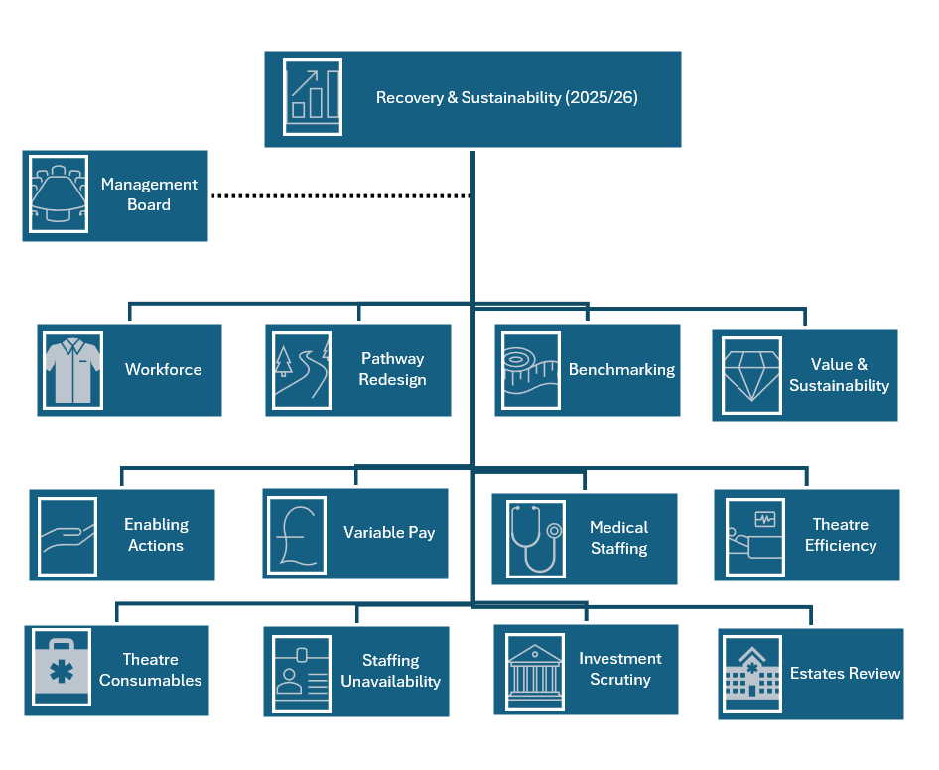
During June, following the regular update to the Performance and Finance Committee, the membership advised the programme to focus on five primary overarching objectives. The priority areas identified are those that our being led by executives across the health board as these were
considered to have the greatest potential to deliver recurrent savings within the service groups.

The five primary work streams for the R&S programme to support during 2025/26 are the following, not in priority order:

- Variable Pay and Head Count Reduction
- Procurement
- CHC
- Urgent and Emergency Care (UEC)
- Medicines Management

Each of the workstreams is led by an executive as the senior responsible officer, SRO. The R&S team will provide programme management and delivery capacity to support these key programmes. There are other lower priority schemes that R&S have also been supporting however, these are now a second order priority in respect to the deployment of capacity.

  - Progress – top 5 priorities
Variable Pay - SRO Tina Ricketts. Several work elements have already been established over recent months that support the reduction in variable pay. These include a range of areas, that are designed to decrease the requirement for temporary workforce by maximising the staff currently employed, change the culture around staffing establishment, enhanced executive level control and ensuring that recruitment process is timely and addressing longer term vacancies. The variable pay work stream has brought together all the various strands of work across all professional groups that utilise variable pay to support the achievement of the delivery of the recently agreed pay cap, maximum £1.8 million per month. If achieved this will produce a savings of c. £32.3 million, albeit potentially non recurrently, subject to further discussion.

Appendix one, provides the draft terms of reference for the overarching group and details the key objectives to be delivered to support the service group to achieve the variable pay cap. The terms of reference are draft at the time of writing the report however, the inaugural overarching meeting is scheduled for 2nd July where they are expected to be ratified.

Given the urgent need to reduce the variable pay bill based on the health boards current financial run rate this area has been the primary focus of the R&S team since the decision was made to establish the overarching executive led workstream.

Procurement– a procurement board has been established by the SRO Darren Griffiths, since the start of the year. The procurement team have a clear savings trajectory to achieve this year. Reviews are currently underway to assess further opportunities, and the programme is being support by the R&S team.

The CHC, SRO Marie Davies and UEC, SRO Deb Lewis, programmes already have existing boards and currently the executive leads have indicated they have appropriate support to deliver their programmes. Further work is required to understand the savings delivery trajectories of both work streams. This is work in progress and needs clarifying as they remain within the top five priorities, identified by the Performance and Finance Committee.

Medicines management – SRO Richard Evans, has established the medicine management programme. Initially focusing on ensuring the full delivery of the value and sustainability opportunities, identified by the Wales value and sustainability (V&S) group. The Health Board has already made good progress in most of the areas, 8 out of 10 with the savings being reported as part of the Neath, Singleton service group achievements. Moving forwards the R&S team will support the work stream to agree a savings trajectory related to the remaining V&S opportunities.

  - Other Areas of Progress
Via the R&S board, each of the service groups have been tasked with reviewing the red pool schemes, high risk areas, that were not delivered from the previous financial year. The potential opportunity if all the schemes could be delivered is c.£27 million.

An initial review was completed and fed back into the R&S board on 25th June however, further scrutiny and assessment is required from all service groups given the scale of the unidentified savings in their plans at that time.

As mentioned, the R&S team are supporting a range of other priority two areas as capacity allows to work with the service groups to explore additional opportunities. The following provides a brief overview of those areas; it is intended only as an indicative summary:

- Implementation of the Omnicell stock control cabinets in theatres for the Neath, Singleton service group
- Review of sexual health service for the primary care service group
- Redesign of the respiratory pathway in conjunction with Morriston service group
- Development of multiple suites of project documentation to support the local delivery of the mental health and learning disability service group (MH/LD) savings programme
- Financial assessment of the opportunities associated with reducing printing and postage costs by moving to more digital solutions across the health board
- Ongoing assessment of space utilisation with HQ using monitoring equipment provided free of charge by shared services to establish options around space consolidation and rationalisation of estate
- Provision of weekly variable pay expenditure report analysis

At the time of writing the team has also been approached to consider support for the mental health older persons redesign programme. This is currently being assessed to ensure that there is adequate capacity to support whilst continuing to focus on the primary priorities as agreed with the Performance and Finance Committee.

  - R&S Team
The R&S team has evolved offer recent months to ensure they offer the correct level of support that facilitates the delivery of the savings from within the delegated budget holders in the service groups.

The team has enhanced its internal governance processes this year, 2025/26 and has adopted a more formal project management approach. Each of the significant work streams will be supported with programme documentation that evidences actions, timelines, risk and issues in a standardised manner. The enhanced project governance will enable the earlier identification of any variances from the expected delivery plans.

The Head of Recovery and Sustainability commenced in post at the start of June. The individual is an experienced project manager. The appointed individual was already a substantive employee of the health board who had recently completed an external secondment. Additionally, within the finance team an Organisational Change Process (OCP) has been successfully completed that has transferred the former programme management office (PMO) into the R&S programme. The transfer enables a different approach to be adopted that builds on the programme governance and project approach.

Additionally, the R&S team has successfully recruited into three vacant posts that were originally with the former PMO team. These individuals commence in post during July and August. Therefore, the team will be at full compliment for the first time since the introduction of the R&S programme.

  - External Support
Welsh Government has provided funding for external support to the Health Board. The preferred provider has been appointed and will commence with the Health Board formally on 14 July 2025. Initial document review and meeting with the Health Board SRO, Director of Finance and Performance, has already taken place in week commencing 7 July 2025.

The external support will work across the Health Board identifying additional opportunities to close the recurrent savings gap, whilst also considering governance and control arrangements.

- GOVERNANCE AND RISK ISSUES
The established governance processes within the R&S programme and board are clear and robust. The Performance and Finance Committee continues to be supportive and constructive in helping to form the R&S programme whilst maintaining a high degree of oversight and scrutiny.

The current low level of identified recurrent savings within the delegated budgets represents a significant risk to the delivery of the financial plan, although the external support was confident that they could mitigate the gaps by identifying additional opportunities.

- FINANCIAL IMPLICATIONS
The R&S programme is a faciliatory delivery vehicle that supports the financial delivery within the delegated budget holder’s portfolio. There are no direct financial implications of this paper.

- RECOMMENDATIONS
Members are asked to:
- CONSIDER and comment upon the structure and governance underpinning the R&S Programme.
- TAKE ASSURANCE from the work programme of the support for the executive led savings programmes, noting that the actual budgets are within the service groups.

Governance and Assurance

Link to Enabling Objectives  (please choose) | Supporting better health and wellbeing by actively promoting and empowering people to live well in resilient communities
Link to Enabling Objectives  (please choose) | Partnerships for Improving Health and Wellbeing |  | ☐
Link to Enabling Objectives  (please choose) | Co-Production and Health Literacy |  | ☐
Link to Enabling Objectives  (please choose) | Digitally Enabled Health and Wellbeing |  | ☐
Link to Enabling Objectives  (please choose) | Deliver better care through excellent health and care services achieving the outcomes that matter most to people
Link to Enabling Objectives  (please choose) | Best Value Outcomes and High Quality Care |  | ☒
Link to Enabling Objectives  (please choose) | Partnerships for Care |  | ☐
Link to Enabling Objectives  (please choose) | Excellent Staff |  | ☒
Link to Enabling Objectives  (please choose) | Digitally Enabled Care |  | ☐
Link to Enabling Objectives  (please choose) | Outstanding Research, Innovation, Education and Learning |  | ☐
Health and Care Standards
(please choose) | Staying Healthy |  | ☐
(please choose) | Safe Care |  | ☒
(please choose) | Effective Care |  | ☒
(please choose) | Dignified Care |  | ☐
(please choose) | Timely Care |  | ☒
(please choose) | Individual Care |  | ☐
(please choose) | Staff and Resources |  | ☒
Quality, Safety and Patient Experience
Recovery & Sustainability programme, whilst addressing the need for a sustainable financial position, is focused on undertaking through delivery of good quality, safety, and patient experience.

Financial Implications
No direct financial implications
Legal Implications (including equality and diversity assessment)
No implications
Staffing Implications
No direct implications
Long Term Implications (including the impact of the Well-being of Future Generations (Wales) Act 2015)
No implications
Report History |  | n/a
Appendices |  | Appendix one – terms of reference

