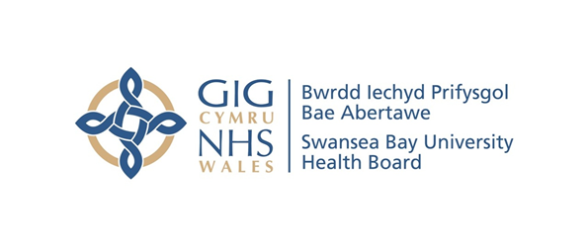
Item 7.1 – Appendix 1
Counter Fraud Benchmark Report
Case Referral Rate | SBUHB | All Wales Avg.
2019/20 | 25 | 12.6
2020/21 | 19 | 8.8
2021/22 | 23 | 14.5
2022/23 | 39 | 18.4
2023/24 | 23 | 32.4

Case Closure Rate | SBUHB | All Wales Avg.
2019/20 | 18 | 11.7
2020/21 | 36 | 12.4
2021/22 | 32 | 16.2
2022/23 | 43 | 18.6
2023/24 | 16 | 26.8

Investigation Progression Rate | Cases Open at Start of FY | Referrals Received | Cases Closed | Total Cases Open End of Period
2019/20 | 43 | 25 | 18 | 50
2020/21 | 50 | 19 | 36 | 33
2021/22 | 33 | 23 | 32 | 24
2022/23 | 24 | 39 | 43 | 20
2023/24 | 20 | 23 | 16 | 22*
*5 Investigations Transferred to other NHS body for action

Sanctions | 2020/21 |  |  | 2021/22 |  |  | 2022/23 |  |  | 2023/24
Sanctions | Criminal | Disp | Civil | Criminal | Disp | Civil | Criminal | Disp | Civil | Criminal | Disp | Civil
SBUHB | 4 | 7 | 3 | 1 | 8 | 5 | 4 | 5 | 13 | 2 | 1 | 6
All Wales Avg. | 0.8 | 1.8 | 1.6 | 0.4 | 4.0 | 3.0 | 0.7 | 2.8 | 4.6 | 0.7 | 2.9 | 4.9
All Wales Total | 9 | 21 | 19 | 5 | 52 | 39 | 9 | 37 | 60 | 8 | 35 | 59

Number of Presentations | SBUHB | All Wales Avg.
2019/20 | 71 | 36
2020/21 | 30 | 12
2021/22 | 65 | 17
2022/23 | 51 | 20
2023/24 | 47 | 15

Number of Attendees | SBUHB | All Wales Avg.
2019/20 | 2264 | 952
2020/21 | 541 | 221
2021/22 | 1004 | 311
2022/23 | 591 | 479
2023/24 | 527 | 518
Average Attendance of a Presentation | SBUHB | All Wales Avg.
2019/20 | 32 | 27
2020/21 | 18 | 19
2021/22 | 15 | 19
2022/23 | 12 | 24
2023/24 | 11 | 22

Attendance of Presentations as % Staff Headcount | SBUHB | All Wales Avg.
2019/20 | 16.9% | 11%
2020/21 | 4.0% | 2.6%
2021/22 | 7.5% | 3.9%
2022/23 | 4.4% | 6%
2023/24 | 4.0% | 6%

