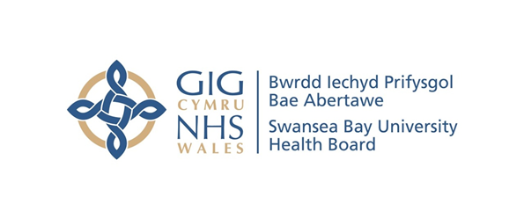
Item 7.1 Appendix 1 -
Counter Fraud Benchmark Report
Case Referral Rate | Swansea Bay UHB | All Wales Avg.
2019/20 | 25 | 12.6
2020/21 | 19 | 8.8
2021/22 | 23 | 14.5
2022/23 | 39 | 18.4

Case Closure Rate | Swansea Bay UHB | All Wales Avg.
2019/20 | 18 | 11.7
2020/21 | 36 | 12.4
2021/22 | 32 | 16.2
2022/23 | 43 | 18.6

Investigation Progression Rate | Cases Open at Start of FY | Referrals Received | Cases Closed | Total Cases Open End of Period
2019/20 | 43 | 25 | 18 | 50
2020/21 | 50 | 19 | 36 | 33
2021/22 | 33 | 23 | 32 | 24
2022/23 | 24 | 39 | 43 | 20

Sanctions | 2019/20 |  |  | 2020/21 |  |  | 2021/22 |  |  | 2022/23
Sanctions | Criminal | Disp | Civil | Criminal | Disp | Civil | Criminal | Disp | Civil | Criminal | Disp | Civil
Swansea Bay UHB | 4 | 5 | 10 | 4 | 7 | 3 | 1 | 8 | 5 | 4 | 5 | 9
All Wales Avg. | 1.2 | 2.3 | 3.3 | 0.8 | 1.8 | 1.6 | 0.4 | 4.0 | 3.0 | 0.7 | 2.8 | 4.4
All Wales Total | 14 | 27 | 39 | 9 | 21 | 19 | 5 | 52 | 39 | 9 | 37 | 57

Number of Presentations | Swansea Bay UHB | All Wales Avg.
2019/20 | 71 | 36
2020/21 | 30 | 12
2021/22 | 65 | 17
2022/23 | 51 | 20

Number of Attendees | Swansea Bay UHB | All Wales Avg.
2019/20 | 2264 | 952
2020/21 | 541 | 221
2021/22 | 1004 | 311
2022/23 | 591 | 479
Average Attendance of a Presentation | Swansea Bay UHB | All Wales Avg.
2019/20 | 32 | 27
2020/21 | 18 | 19
2021/22 | 15 | 19
2022/23 | 12 | 24

Attendance of Presentations as % Staff Headcount | Swansea Bay UHB | All Wales Avg.
2019/20 | 16.9% | 11%
2020/21 | 4.0% | 2.6%
2021/22 | 7.5% | 3.9%
2022/23 | 4.4% | 6%

