


Meeting Date | 27 June 2023 |  | Agenda Item |  |  | 6.2
Report Title | Audit Wales Report; Tackling the Waiting List Backlog A comparative picture for Swansea Bay University Health Board
Report Author | Brett Denning, Associate Service Director, Specialist Surgical Services
Report Sponsor | Deb Lewis, Chief Operating Officer
Presented by | Brett Denning Associate Service Director
Freedom of Information | Open
Purpose of the Report | To share the Audit Wales report into Orthopaedic waiting times in Swansea bay UHB
Key Issues | - The Wales Audit report provides analysis of the orthopaedic waiting list position at Swansea Bay University Health Board (the Health Board).  - At the time of the report (November 2022) SBUHB reported high number of patients waiting for orthopaedic services compared to other health board in Wales
Specific Action Required  (please choose one only) | Information | Discussion |  | Assurance | Approval
Specific Action Required  (please choose one only) | ☐ | ☐ |  | ☒ | ☐
Recommendations | Members are asked to  - Approve the organisational response to the Wales Audit Report (appendix 1 & 2)  - Note the progress in implementing the recommendations of the GIRFT report

Audit Wales Report; Tackling The Waiting List Backlog A Comparative Picture For Swansea Bay University Health Board

- INTRODUCTION

The Audit Wales Report (appendix 1) provides an analysis of the orthopaedic waiting list position at Swansea Bay University Health Board. The report presents a range of data to inform discussion and oversight of the current challenges associated with the recovery of orthopaedic waiting times.

- BACKGROUND

The report notes a number of areas where waiting times for patients in Swansea Bay are longer than those experienced in other health boards as illustrated by the two charts below:
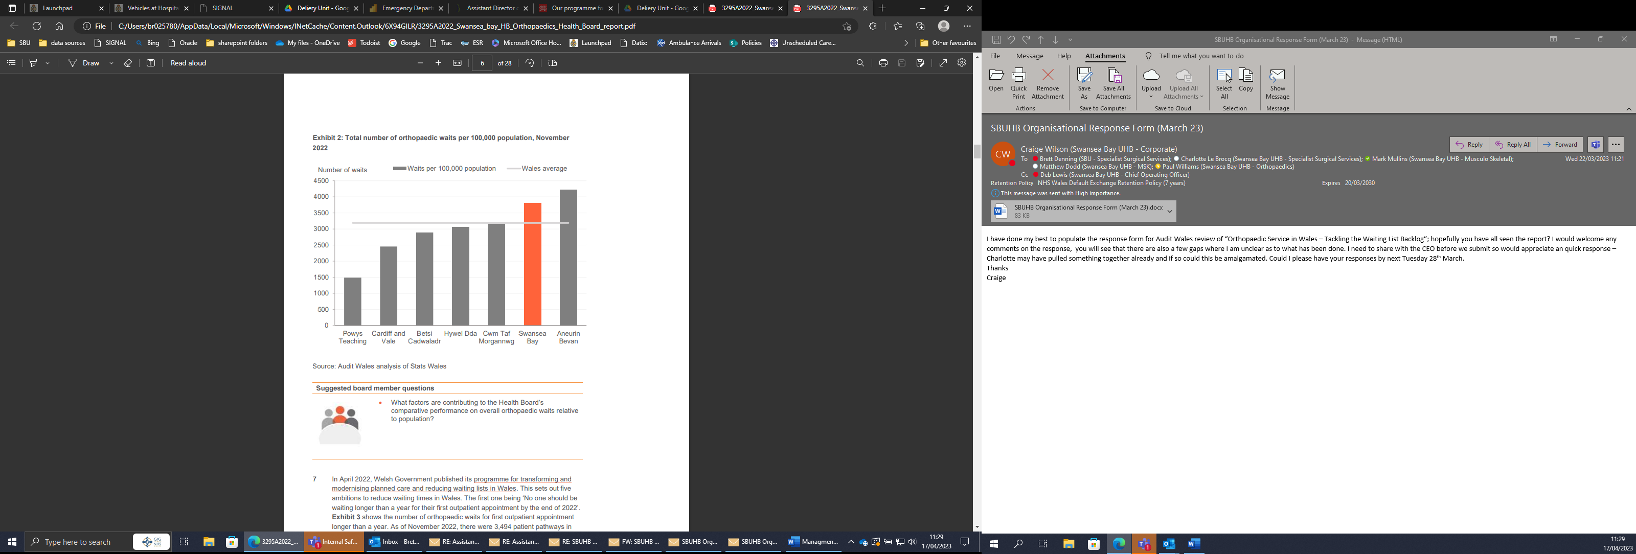
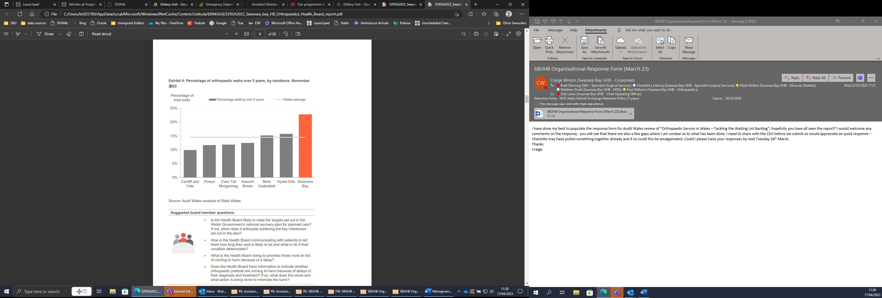
The report also provides a range of comparative analysis of resources allocated to orthopaedic services together with several scenarios for future waiting times improvement.
The report makes several references to the GIRFT report from 2022 which has also been included (appendix 3) with the latest version of the GIRFT action plan (Appendix 4).
The organisational response to the report is attached (Appendix 2) addressing each of the recommendations and questions set out by Audit Wales.
It acknowledges that the Health Board had long waiting times for orthopaedic surgery pre Covid due to reduced access to the orthopaedic ward in Morriston and a demand that outstripped the capacity available. The situation was compounded during the pandemic due to a loss of outpatient and capacity and a focus trauma surgery. Consequently, the Health Board has some of the longest waiting times in Wales. The Inability to ring fence beds for the more complex patients due to the demand for medical patients, unscheduled care, trauma, and cancer surgery on the acute site has been a major issue.
In the response the health board highlights our strategy for Orthopaedics which is consistent with the GIRFT recommendations. A demarcation has been established between trauma and elective surgery with all inpatient trauma being undertaken at Morriston Hospital and ambulatory trauma where possible being performed in Neath Port Talbot and Singleton Day Surgery Units. There is still currently a need to maintain an elective ward in Morriston to accommodate the Low Volume High Complexity (LVHC) patients, whilst Neath Port Talbot Hospital (NPTH) is being developed as a High Volume Low Complexity (HVLC) centre to serve both Swansea Bay and neighbouring health boards. An additional three laminar air flow theatres opened in NPTH in June 2023 and will see increasing numbers of orthopaedic patients over the coming months as new theatre and anaesthetic staff join the health board. The NPTH service includes the development of the high care facility to ensure the maximum number of patients, including revision and spinal surgery will be accommodated.
The ambition is that the elective orthopaedic centre in NPTH becomes an accredited GIRFT facility; there are currently eight centres in England with this status.

- GOVERNANCE AND RISK ISSUES

The long waiting times for orthopaedic surgery results in risks to both patient experience and outcomes and the reputation of the Health Board.

During 2023/24 the significant investments that have been made in orthopaedic services will address the excessive waiting times.

- FINANCIAL IMPLICATIONS
The required resources to increase orthopaedic surgery both in Morrison and NPTH is already accounted for and available in the 2023/24 financial plan.

- RECOMMENDATION

- Approve the organisational response to the Wales Audit Report (appendix 1 & 2)
- Note the progress in implementing the recommendations of the GIRFT report

Governance and Assurance

Link to Enabling Objectives  (please choose) | Supporting better health and wellbeing by actively promoting and empowering people to live well in resilient communities
Link to Enabling Objectives  (please choose) | Partnerships for Improving Health and Wellbeing |  | ☐
Link to Enabling Objectives  (please choose) | Co-Production and Health Literacy |  | ☐
Link to Enabling Objectives  (please choose) | Digitally Enabled Health and Wellbeing |  | ☐
Link to Enabling Objectives  (please choose) | Deliver better care through excellent health and care services achieving the outcomes that matter most to people
Link to Enabling Objectives  (please choose) | Best Value Outcomes and High Quality Care |  | ☒
Link to Enabling Objectives  (please choose) | Partnerships for Care |  | ☐
Link to Enabling Objectives  (please choose) | Excellent Staff |  | ☐
Link to Enabling Objectives  (please choose) | Digitally Enabled Care |  | ☐
Link to Enabling Objectives  (please choose) | Outstanding Research, Innovation, Education and Learning |  | ☐
Health and Care Standards
(please choose) | Staying Healthy |  | ☐
(please choose) | Safe Care |  | ☒
(please choose) | Effective Care |  | ☒
(please choose) | Dignified Care |  | ☐
(please choose) | Timely Care |  | ☒
(please choose) | Individual Care |  | ☐
(please choose) | Staff and Resources |  | ☐
Quality, Safety and Patient Experience
The ongoing work to address excessive waits for orthopaedic surgery in SBUHB will have a positive impact on patient experience

Financial Implications
The expansion of orthopaedic inpatient services at NPTH has been included in the financial plan

Legal Implications (including equality and diversity assessment)
N/A.

Staffing Implications
The expansion of staffing to deliver orthopaedics has been taken forward under the NPT Orthopaedic Project board.

Long Term Implications (including the impact of the Well-being of Future Generations (Wales) Act 2015)
Report History
Appendices |  | Appendix 1: Audit Wales Report  Appendix 2: Organisational Response  Appendix 3: GIRFT report  Appendix 4: GIRFT action plan

