Meeting Date | 23 July 2024 |  | Agenda Item |  |  | 4.2
Report Title | Suicide and Self Harm Prevention
Report Author | Nerys Edmonds, Public Health Specialist Lead  Michelle Davies, Head of Strategic Planning & Partnerships
Report Sponsor | Nerissa Vaughan, Interim Director of Strategy  Jennifer Davies, Interim Director of Public Health
Presented by | Karen Stapleton, Deputy Director of Strategy
Freedom of Information | Open
Purpose of the Report | - To provide an update on work undertaken to progress the suicide and self-harm prevention agenda  - To highlight the recent Welsh Government consultation in relation to suicide and self-harm and the Swansea Bay University Health Board (SBUHB) response  - To set-out next steps for SBUHB, and specifically further engagement with partners on suicide and self-harm prevention
Key Issues | - There is an absence of strategic leadership for suicide and self -harm as an issue for our region. ​  - A multi-agency approach is critical if we are committed to preventing suicide and self-harm,  - SBUHB and the region now have the opportunity to create the conditions for successful implementation of the new Welsh Government Strategy when it is launched later this year
Specific Action Required  (please choose one only) | Information | Discussion |  | Assurance | Approval
Specific Action Required  (please choose one only) | ☒ | ☒ |  | ☐ | ☐
Recommendations | Members are asked to:  - Receive an update on the work undertaken to progress the suicide and self-harm prevention agenda  - Note the response to the Welsh Government Consultation Document;  - Note the conclusions and next steps for SBUHB and specifically the further engagement with partners

Suicide and Self Harm Prevention

- INTRODUCTION

Suicide is usually in response to a series of complex reasons that are contextual to the individual. However, if risk factors at the individual, community and population level are effectively addressed suicide is largely preventable. To tackle these complex social issues, partnership working, close co-ordination and commitment across all agencies in Swansea Bay is required.

In a paper shared with Members of the Quality & Safety Committee in December 2023 a comprehensive update was provided in relation to the SBUHB position and that paper is attached as appendix 1. At the time of the previous paper the existing Talk 2 Me 2 national suicide prevention strategy was in place. From January to March 2024 Welsh Government conducted consultations on new ten-year strategies on Mental Health and Wellbeing and Suicide and Self-Harm Prevention (SSHP). This paper provides an update to the Committee on actions taken since the last report and proposes next steps.

- BACKGROUND

SBUHB Management Board have confirmed their commitment to progress with a strategic approach to suicide and self-harm prevention and the Public Health Team have worked with the Corporate Strategy Team to initiate a work programme to ensure readiness to implement the new Welsh Government SSHP Strategy.

2.1 SBUHB Population Health Data

The annual England and Wales average rate of suicide in 2022 was 10.7 deaths per 100,000 people (Office for National Statistics, 2023). Wales had the second highest suicide rate with 12.5 deaths per 100,000 people and the North East of England had the highest rate at 12.8.

The three-year rolling suicide rates for SBUHB have remained relatively stable over time and the latest data indicates that whilst our rates are higher than the Wales average they are not statistically significantly so. (See Figure 1).

Figure 1: Rate of suicide per 100,000 persons. Three year rolling average.
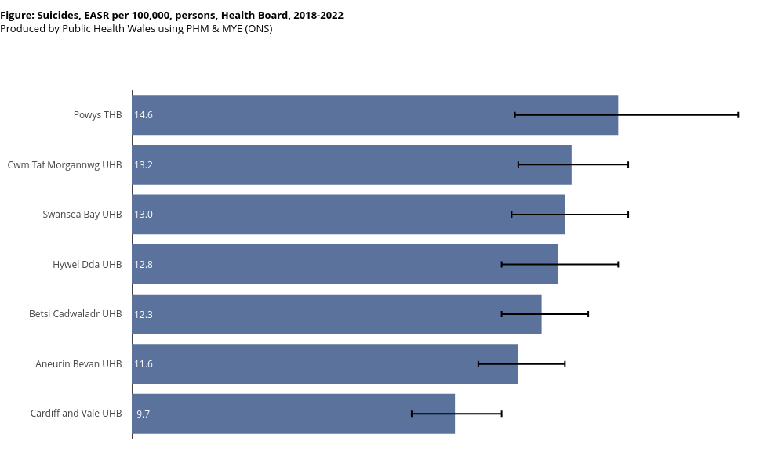

Self-harm results in 5,500 medical admissions per year in Wales across all ages and is one of the top five causes of admissions - much of this is unscheduled. Whilst there has been a decline in the overall number of hospital admissions for self-harm, there has been a gradual increase in self-harm admission rates amongst young people in Wales, particularly girls aged 10-14. Prevalence of self-harm amongst children and young people is consistently highest in the most deprived 40 per cent of areas in Wales, although over the past decade there have been increasing incidences of self-harm in more affluent areas (Welsh Government, 2024).

2.2 Policy Context and Strategic Drivers

The Welsh Government launched a consultation on a Strategy document for Suicide & Self-Harm in January 2024, and this will replace the previous strategy Talk to me 2: the suicide and self-harm prevention strategy for 2015-2022. The Health Board conducted a comprehensive response to the consultation document and further details in relation to the Consultation are included in Section 3.1 of this report.

The Swansea Bay Population Health strategy looks at how as a Health Board we work with partners to influence the social determinants of health, including key risk factors for suicide and self-harm, such as unemployment and homelessness. The Four Pillars outlined within the Population Health Strategy set out the Health Board’s role as a Health provider, Employer, Productive Partner and as an Anchor institution. We need to fulfil those roles to benefit the population and how we work productively with partner agencies.

The Welsh Government have also consulted on a Mental Health and Wellbeing Strategy for Wales 2024-34 and Vision Statement 2 as follows has good alignment with the SBUHB Population Health Strategy and the Suicide and Self-Harm agenda:

Vision statement 2 is that there is cross government action to protect good mental health and wellbeing.

A Ministerial summit on inpatient mental health care was held in November 2023. This highlighted suicide prevention in mental health services as a priority and further work is to be undertaken by Welsh Government and the NHS Executive on the assessment of suicide risk, environmental safety, ligature audits and staff training.

South Wales Police are currently implementing a new approach to their threshold for responding to vulnerable people with general health and mental health needs called Right Care Right Person. This has a number of implications for the effectiveness and safety of multi-agency responses to people in mental health crisis. The Health Board has established a Task and Finish group to assess the impact and plan how Health Board policies and practices will need to change in response.

2.3 SBUHB Progress to Date

The Health Board has acknowledged the need for action to reduce suicide rates and in 2021 Suicide Prevention became one of the 5 quality priorities. This has led to a programme of work that specifically focuses on staff mental wellbeing. Given that healthcare staff and female nurses in particular, are one of the higher occupational risk groups, this has been an important development. Please note that the delivery of the quality priority to date has focussed on the following key areas:
- Reduction of the risk of staff suicide through promoting help-seeking behaviours. ​
- Increased awareness of the risk of suicide through delivery of training programme for health board staff. ​
- Contribution to the multi-agency working
- This has been led through a health board wide steering group, co-ordinated by the Suicide Prevention Quality Improvement Lead.
In addition to the work set out in the quality priority there are a number of initiatives being implemented across SBUHB and partners that are important contributions to suicide and self-harm prevention including;

- Improved response to children, young people and adults in mental health crisis: Call 111 press 2 service and the development of sanctuary services​
- Rapid response service for people bereaved by suicide, with significant attempts response also active.​
- SBU Bereavement service​: people who have been bereaved by suicide have an increased risk of suicide. We have been the first Health Board in Wales to have a bereavement service. Whilst this is not solely focused on bereavement through suicide, it has been an important contributor to the support offered to those who have been bereaved by suicide that are in contact with the Health Board
- Western Bay Drugs Commission: people who misuse drugs and alcohol are a high-risk group for suicide.​The Drugs Commission was initiated following concern on rates of drug related deaths in the region. Therefore, this commission and its recommendations are relevant to suicide prevention in our population.
- Primary care: the City Cluster has funded a nurse led pilot intervention for patients in primary care who have self-harmed or had suicidal thoughts.

2.4 Governance - Overview of current position

- A Mid and West Wales Regional Suicide and Self-Harm Prevention Forum is an established element of the overall delivery and governance structure for the previous and forthcoming Welsh Government SSHP strategies. This covers a footprint across Hywel Dda, Powys and Swansea Bay UHB areas. This is supported by a Chair representing Digital Health & Care Wales and a regional co-ordinator to support strategy implementation across the three Health Board areas. There is common agreement that whilst the forum is very useful for practice and information sharing, it cannot adequately provide the governance, oversight and accountability required for partner delivery of actions at the Health Board or local authority level.
- There is currently no regional forum /governance structure which takes responsibility for coordination, delivery and evaluation of whole system actions aimed at reducing the risk of suicide or self-harm for Swansea Bay. ​
- There is no ‘collective’ identity or presence for this work which limits joint work such as how we engage those with lived experience.
- There is limited capacity & capability to undertake intelligence analysis which impacts on our ability to adopt an intelligence led approach across Swansea Bay – enabling us to go beyond high-level themes / risk factor analysis or evaluate the impact of investments, identify the gaps or improvements in delivery.

2.5 Update on Actions since the last meeting

2.5.1 Swansea Bay UHB Response to the Welsh Government Consultation - Suicide & Self-Harm Strategy 2024-34
The Welsh Government launched a consultation on the above document in January 2024, and the closing date for responses was the 11th June 2024. The Strategy is an ‘all age’ strategy and will replace the previous strategy Talk to me 2: the suicide and self-harm prevention strategy for 2015-2022.

The implementation of the Strategy is reliant on multi-sectoral collaboration and ownership across Government, making sure that strengthened governance frameworks are in place to drive action and monitor effectiveness. Everyone has a role to play in preventing suicide and self-harm, which have a disproportionate impact on the most vulnerable people in our society.

The following principles run through the strategy:

  - Leadership, ownership and accountability
  - Suicide and self-harm are everybody’s business
  - Focus on inequalities and at risk groups
  - Multi-sectoral collaboration
  - Person-centred with the involvement of those with lived/living experience
  - Evidenced-based and intelligence led

There are six high-level objectives included in the document with an explanation of what the objective means and sub objectives. The high-level objectives are as follows:

- High-level Objective 1: Establish a robust evidence base for suicide and self-harm in Wales, drawing on a range of data, research and information; and develop robust infrastructure to facilitate the analysis and sharing of information to focus resources, shape policy and drive action
- High-Level Objective 2: Co-ordinate cross-Government and cross-sectoral action which collectively tackles the drivers of suicide and reduces access to means to suicide.
- High-level Objective 3: Deliver rapid and impactful prevention, intervention, and support to those groups in society who are the most vulnerable to suicide and self-harm through the settings with which they are most engaged
- High-level Objective 4: Increase skills, awareness, knowledge and understanding of suicide and self-harm amongst the public, professionals and agencies who may come into contact with people at risk of suicide and self-harm
- High-level Objective 5: Ensure an appropriate, compassionate and person-centred response is offered to all those who self-harm, have suicidal thoughts, or who have been affected or bereaved by suicide, promoting effective recovery and reduced stigma including implementation of NICE guidelines on Self-harm
- High-level Objective 6: Responsible communication, media reporting, and social media use regarding self-harm, suicide and suicidal behaviour.

The Strategy and Public Health teams brought together colleagues from across the Health Board to attend a workshop in May to get their views on the proposed Strategy. These views contributed to an overarching Health Board comprehensive response, which is attached as appendix 2.

2.5.2 Reviewing governance structures across Wales

The Public Health Team have undertaken a rapid review of the governance across Wales to understand how other health board areas are approaching the governance of this work. A summary is attached as appendix 3. The review identified that the Swansea Bay region was the only region in Wales that does not have a multi-agency plan for suicide and self-harm prevention. Most regions have a close alignment with the mental health governance structure and the Regional Partnership Boards (RPB) in both Gwent and the Cardiff & Vale provide multi-agency leadership.

A number of areas are currently reviewing their governance arrangements and the mapping also highlighted some shared governance challenges:
- Ensuring governance structure enables the full spectrum of Suicide and Self-Harm Prevention data, policy and action by partners from prevention to postvention to be visible, represented and accountable
- Ensuring links and engagement to wider regional prevention and population health work e.g. PSB agenda
- Getting senior level engagement to ensure ownership and accountability for plans
- Overcoming silo working
- Ensuring that data and health intelligence is informing action
- Monitoring and evaluation of local actions/interventions
Going forward, consideration is needed as to how any governance for SSHP aligns and links to implementation structures for the new Welsh Government Mental Health and Wellbeing Strategy.

SBUHB Management Board have previously confirmed their commitment to progress with a strategic approach to suicide and self-harm prevention and gave approval for discussions with partners on a way forward.

To date, this matter has been raised at both Swansea and NPT informal PSB meetings, and both indicated that they do not see the PSB as the appropriate governance structure for this work, given the work programmes are already committed and there is no dedicated resource associated with PSB delivery.

2.6 Conclusion and Next Steps

2.6.1 Summary

    - Suicide and self-harm prevention are important priorities for improving population health in Swansea Bay. There are opportunities to enhance our approach to prevention.
    - A new Welsh Government Suicide & Self Harm Prevention Strategy provides the opportunity for the Health Board to engage with multisector partners to create to conditions for effective implementation of the strategy and move forward. There is now a period of time before the launch of the final version of the strategy to review what assets, data, interventions and networks are in place already in the region; the principles, evidence and outcomes that underpin current activities and services, and identify opportunities for enhancing a preventative approach. This may require additional/new governance arrangements to be put in place.

2.6.2 Next Steps:

- Conduct further stakeholder engagement to map current delivery, data, outcomes and constraints in relation to the objectives of the new Welsh Government SSHP Strategy.
- Coordinate dedicated resource between Directorates to produce a detailed briefing on the National /local context, current position in the region, and issues/opportunities to inform stakeholder engagement
- Engaging with the Regional Partnership Board via Directors of Social Services in the first instance to inform the approach and agree next steps.

- GOVERNANCE AND RISK ISSUES

The need to improve governance for suicide and self-harm as outlined in section 2.4 of this report.

- FINANCIAL IMPLICATIONS

There are no financial implications for the Committee to consider.

- RECOMMENDATION

Members are asked to:
  - Receive an update on the work undertaken to progress the suicide and self-harm prevention agenda
  - Note the response to the Welsh Government Consultation Document;
  - Note the conclusions and next steps for SBUHB and specifically the further engagement with partners

Governance and Assurance

Link to Enabling Objectives  (please choose) | Supporting better health and wellbeing by actively promoting and empowering people to live well in resilient communities
Link to Enabling Objectives  (please choose) | Partnerships for Improving Health and Wellbeing |  | ☒
Link to Enabling Objectives  (please choose) | Co-Production and Health Literacy |  | ☐
Link to Enabling Objectives  (please choose) | Digitally Enabled Health and Wellbeing |  | ☐
Link to Enabling Objectives  (please choose) | Deliver better care through excellent health and care services achieving the outcomes that matter most to people
Link to Enabling Objectives  (please choose) | Best Value Outcomes and High Quality Care |  | ☐
Link to Enabling Objectives  (please choose) | Partnerships for Care |  | ☒
Link to Enabling Objectives  (please choose) | Excellent Staff |  | ☐
Link to Enabling Objectives  (please choose) | Digitally Enabled Care |  | ☐
Link to Enabling Objectives  (please choose) | Outstanding Research, Innovation, Education and Learning |  | ☐
Health and Care Standards
(please choose) | Staying Healthy |  | ☐
(please choose) | Safe Care |  | ☒
(please choose) | Effective Care |  | ☒
(please choose) | Dignified Care |  | ☐
(please choose) | Timely Care |  | ☐
(please choose) | Individual Care |  | ☐
(please choose) | Staff and Resources |  | ☐
Quality, Safety and Patient Experience
There are no immediate implications for quality, safety and patient experience, however there is a need to take a preventative approach if the Swansea Bay region is to achieve an improvement in suicide deaths and self-harm.

Financial Implications
There are no direct financial implications covered off in this report for members to consider.

Legal Implications (including equality and diversity assessment)
There are no direct legal implications covered off in this report for members to consider.

Staffing Implications
There are no direct staffing implications covered off in this report for members to consider.

Long Term Implications (including the impact of the Well-being of Future Generations (Wales) Act 2015)
The recommendations and conclusions contained within this report are closely aligned to the five ways of working. There is a need to work collaboratively with partners to ensure that we improve outcomes in the long term.
Report History |  | The Committee received a report in December 2023, which is included below as appendix 1.
Appendices |  | Appendix 1 – Q&S Paper, December 2023  Appendix 2 – SBUHB response to Welsh Government Consultation  Appendix 3 – Governance Mapping

