Meeting Date | 23rd July 2024 |  | Agenda Item |  |  | 4.1
Report Title | Deep Dive Review of Quality Priority Nutrition & Hydration
Report Author | Jayne Whitney, Clinical Quality Improvement Lead
Report Sponsor | Sarah Collier – Head of Psychology SRO for QP Nutrition & Hydration  Hazel Powell - Acting Director of Nursing & Patient Experience
Presented by | Jayne Whitney, Clinical Quality Improvement Lead
Freedom of Information | Open
Purpose of the Report | This report provides an update on progress against the Nutrition & Hydration quality priority to date for assurance
Key Issues | - Confirmed April 2024 to be Sarah Collier – Head of Psychology  - Weight data from WNCR system resolved in terms of access and requesting data.  - Progress on dashboard that will allow more visibility and easier to pull data.  - Singleton & NPT service group forum commenced on 4th December 2023.  - Steering group to agree action plan and GMOs for the template. This deep dive reflects developments since October 2023.  - Governance and reporting being finalised.  - Issues regarding outstanding bed contracts and outcomes of scoping exercise on equipment.  - A QP Nutrition & Hydration web page has been set up.  - Baseline data is still required from catering such as complaints and questionnaires.
Specific Action Required  (Please choose one only) | Information | Discussion |  | Assurance | Approval
Specific Action Required  (Please choose one only) | ☒ | ☐ |  | ☒ | ☐
Recommendations | - To commence with a QP N & H Steering group – chaired by SRO – Sarah Collier.  - To note specialised equipment deficit within highly complex areas of patient need (weights).  - To note the outline of report as assurance in the progress of the QP priority.

Quality Priority – Nutrition and Hydration

- INTRODUCTION

Nutrition and Hydration was made a quality priority for Swansea Bay University Health Board in October 2023. This report outlines progress against the initial GMOs, achievements to date with focus on the first phase of the QI projects agreed within the Nutrition & Hydration Steering Group.

- BACKGROUND

Delivery of Quality Priority

Nutrition and hydration play a crucial part in any patient’s recovery. Malnourished patients have a 30% increased length of stay. One in three patients are considered malnourished or at risk of it, and early identification and treatment is key. Nutritional status not only affects the length of hospital stay, but also rehabilitation outcomes, hospital admissions, re-admissions and clinical outcomes. The average cost associated with a malnourished patient is more than double to that of a non-malnourished patient. Malnutrition in acute hospitals is often unrecognised and unmanaged in 70% of cases. This leads to an increase of clinical complications, increased length of hospital stay and mortality.
The quality priority work will also focus on hydration, ensuring patients are taking in adequate levels of fluids is key to preventing dehydration. Dehydration can be the underlying cause of many common conditions that can complicate a hospital stay, including constipation, falls, infections and pressure ulcers, as well as conditions, such as acute kidney injury, cardiac disease and venous thromboembolism.
Taking an accurate patient weight is essential for safe and effective care. It helps us assess and monitor a patient’s nutritional status and is also important for accurate medication prescribing and fluid balance. Despite its importance national evidence suggests only 13.5-55% of patients are weighed throughout an inpatient stay.
Project Team: Project Team:
Senior Responsible Owner – Sarah Collier, Project Manager – Jayne Whitney, QI data lead – Samantha Scott, Project support – Paul Evans.

QI areas
1. Meet minimum standards all Wales catering standards
2. Nutritional screening & processes
3. Compliance with taking weights
4. Safe artificial nutrition non oral
5. Hydration - jugs
6. Nil by mouth days
7. MH & LD, re-visit SLT & RD provision OPMH
First QI project agreed as Weight Monitoring (WM) pilot area Morriston site. Data requested from WMCR system on estimated weights within in patient care at Morriston Hospital. 1st phase of QI work to be focussed on above WM, Snack provision & Hydration. Standards of catering and patient feedback would develop within the work already being undertaken.
Site visits being undertaken to engage with teams and explore equipment standards, best practice, challenges and opportunities.
Table 1: GMOs set 2024
A summary of progress against the individual actions to achieve the goals, methods and outcomes of the priority follows:

Goals | Methods | Outcomes | Progress
Compliance with taking weights. Moving away from inputting estimated weights to accurate weights on the WNCR system. | Morriston pilot area for scoping.  Scoping exercise will look at equipment available, speak to staff to understand challenges.  WNCR system to be viewed to gain greater awareness of weights section. Spot check on patients admitted to determine how weights are being recorded.  Link in with other health boards and research standards of best practice. | Report complete and features as appendix 1.  Equipment required to safely take weights in complex areas.  Comparison data from Hywel Dda Health Board shows every critical care bed is a weighing bed. Explored up to date information regarding possibility of SBUHB bed management contract. No plans to date to provide weighing beds. | - On Track completed
Meet minimum standards all Wales catering standards | Visits to all main site catering departments. Morriston, singleton, Neath Port Talbot | SBAR with recommendations.  Appendix 2 | - On Track complete
Hydration | To source a monitoring Hydration system. | Ward W piloting a coloured lid jug system. NPT Hospital are using a red jug system for those on fluid charts | - Ward W to meet and discuss learning and wrap around QI  - Engagement has started with NPT regarding Red lid system
Comms & Education | To engage with Comms and commence educational campaigns | Agreed a phased approach to comms and education.  Articles feature within main body of report | - Nutrition and Hydration article covering Neath Port Talbot Hospital featured on Internal and external comms as well as Bay News (March, April/May).  - Why keeping patients nourished and hydrated article by QP lead published in Bay News (April/May Addition)  - Screen Saver to run via internal IT system on QP at end of April for 3 months approx.  - Campaign regarding “Don’t Wait to Weigh”
Learning Symposium June 2024 | To organise a learning symposium of education and include exemplars of good practice throughout the service groups | To cascade learning across the health board and capture QI and good practice. | - In the process of being arranged.

Weight Monitoring – PILOT study Morriston site (Scoping within hot spot areas)
Morriston site visit completed week commencing 30/10/2023 –areas visited D, E, F, A, B, W & Critical Care area. Scoping report Appendix 1.
Risks identified
It is evident within the scoping exercise that hot spot areas have a deficit in the appropriate weighing equipment, which is a barrier to accurate weights. Critical care is an area where there is a barrier to weighing due to the nature of the complexity of patient need. A comparison study against another health board showed that all critical care beds are weighing beds. This would easily solve the situation. The TBM contract will be awarded by end of 2024, however the tender will only include Surgical Beds, Low Beds, Foam Mattresses and Dynamic Mattresses, no speciality beds for example Bariatric or beds with weighing scales have been included. Exemption discussions will be picked up with bed contractors to explore options.
Main Themes & Challenges – captured in Fishbone Diagram,
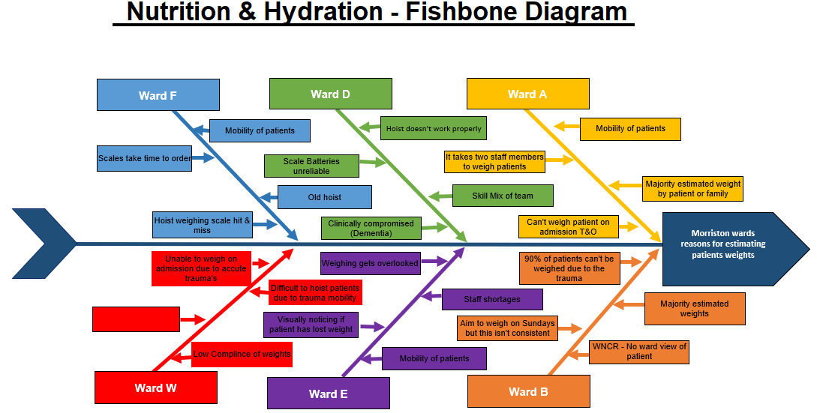

To define within the fishbone “No ward view of patient” when you go into WNCR you have to go into each patient record, you cannot get a ward view of all weights unless you request this from WNCR – you cannot automatically get this information for all patients at the same time – you have to go into each record to check records. The introduction of a dashboard to display this information will increase the ability to view data more easily and visually.
Best Practice Observed & Solution Focussed
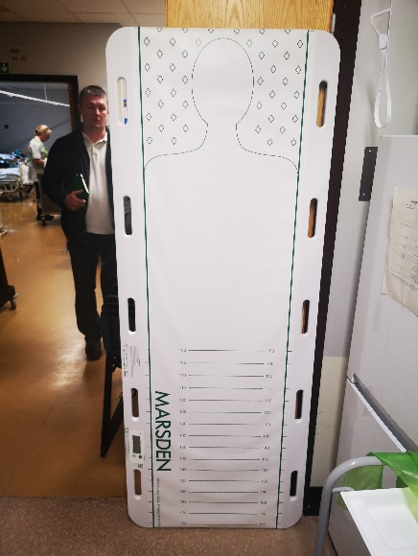

Ward W – Due to low compliance of weights, challenges of patient group and clinically compromised patients. A weighted pat slide recently purchased is a solution to the barriers. Weighing days have been staggered to each bay rather than 1 day allocated a week.

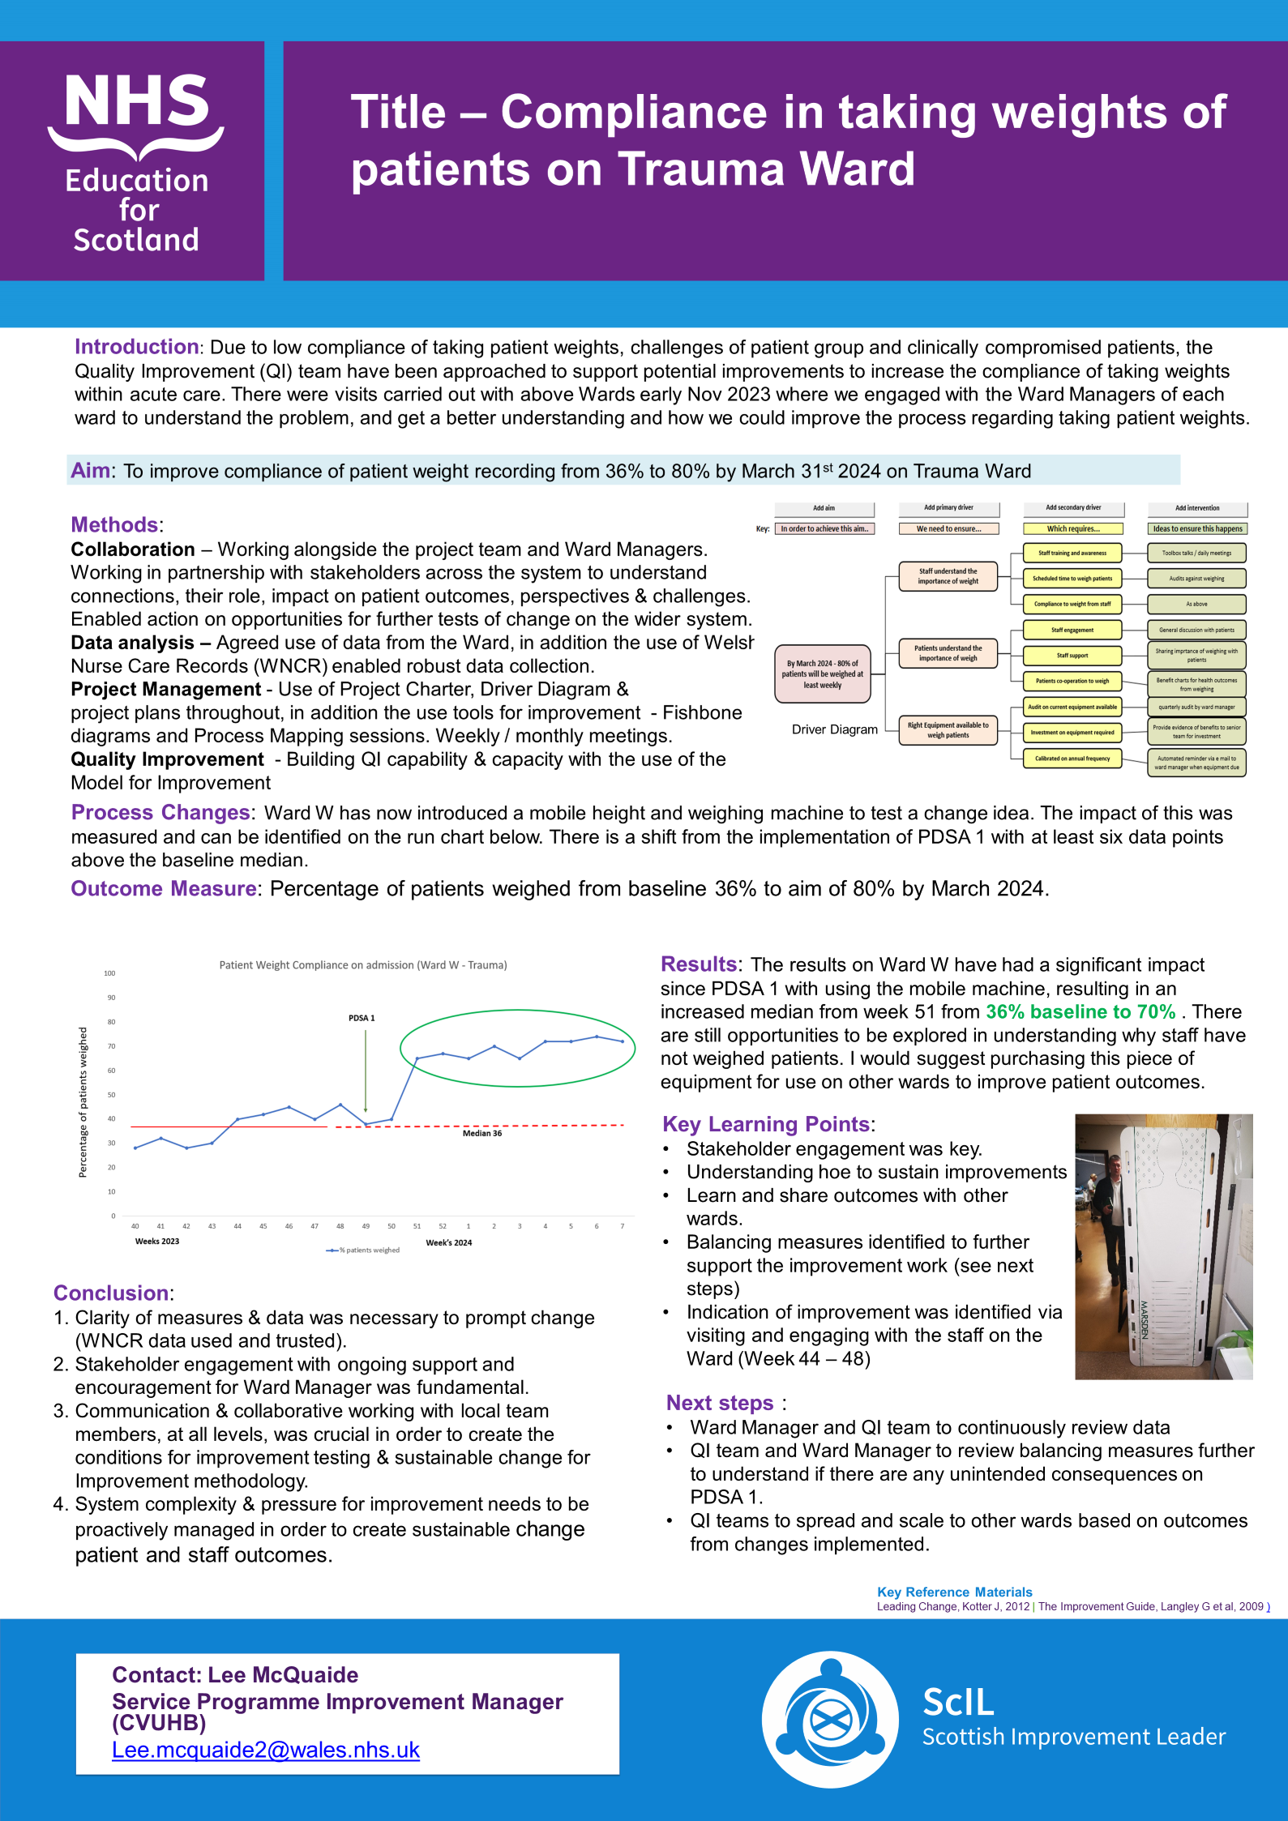
More detail on Driver Diagrams & project can be found in Appendix 2

Best Practice Observed on other areas of Nutrition & Hydration
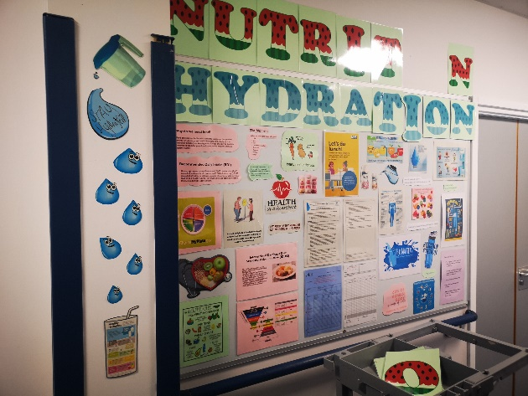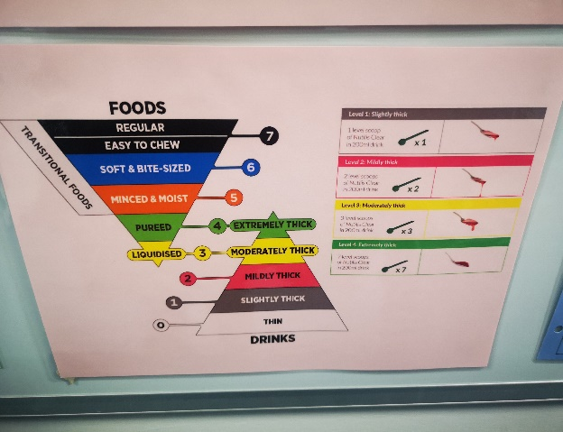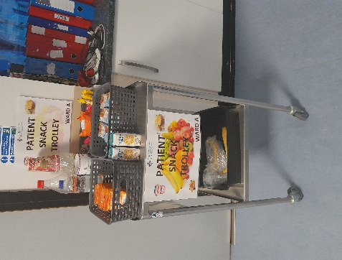
Information board visibly displayed between Wards A & B and snack trolley on Ward A
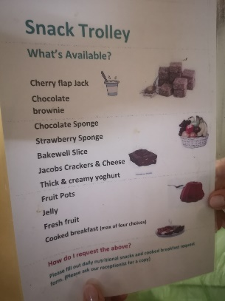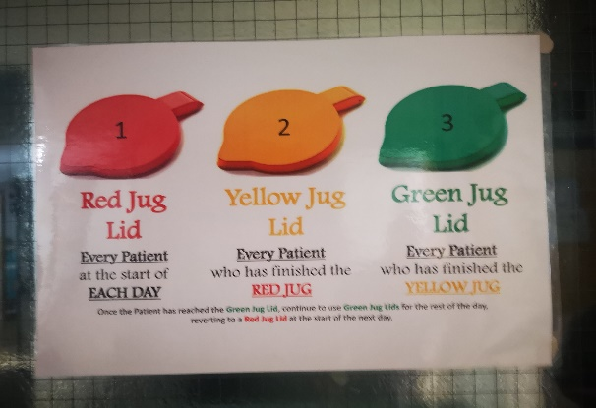
Ward W visible list of snacks and snack trolley in situ. A pilot study underway under the guidance of Beverley Williams – Clinical Educator for Trauma and orthopaedics for hydration jugs.
Expectation that N & H boards will be visible within in patient areas – this is work in progress. This information on best practice and visual aids above has been cascaded to the steering group (all stakeholders) as exemplars of best practice.

Promotional Campaigns & Comms
- March 2024 comms will run an article on the catering department. Comms will visit NPT hospital and the feature will include a day in the life of and how the catering department functions, including narratives from staff and visuals.

- An article will be written by Jayne Whitney for Bay news outlining the launch of the policy.

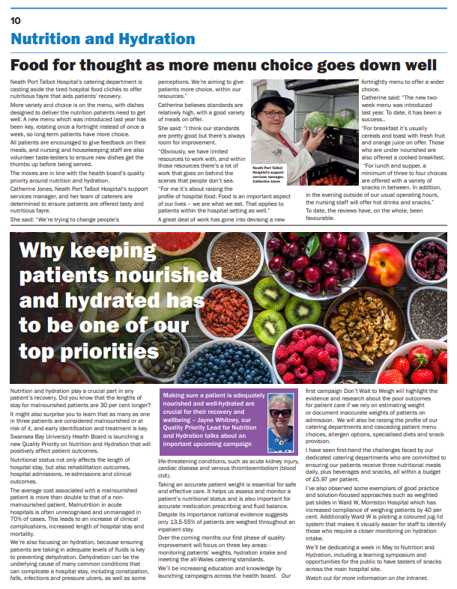

1st campaign will be launched “Don’t wait to Weigh” which will cover why it’s important to weigh patients on admission, continued monitoring and risk assessments for nutritional compromised patients

A phased approach to comms in situ and a longer article planned on the QP in June with the planning of a learning symposium where key stakeholders will be invited to present, so far

A promotional event in May - where we will promote snacks, menus and samplers for the public across the three main sites.

Wards across the health board will have an H & N QP board highlighting best practice, education and information for patients and will be IPC compliant.

Screen Saver to run from April – June 2024 on N & H Priority – Appendix 3

Catering Departments – Standards
Following site visits 13 recommendations made and discussed in the catering strategy group

Promoting finger foods more widely especially within Paediatrics.
Progress the idea of an admission booklet with QR codes that would navigate the patient to menu choices, snacks, specialised menus with QR feedback form.
Opportunity for team based QI training offered.
Invite to Llais to attend taster session of patient food at Tonna Hospital.

Full SBAR report Appendix 4

- GOVERNANCE AND RISK ISSUES

There are no specific governance risks noted at present. Risks to embedding & improvements noted within the report.

- FINANCIAL IMPLICATIONS

Equipment required in complex patient care for weighing beds

- RECOMMENDATION

- To commence with a QP N & H Steering group – chaired by newly appointed SRO for QP – Sarah Collier
- To note specialised equipment deficit within highly complex areas of patient need (weights)
- To note the outline of report as assurance in the progress of the QP priority

Governance and Assurance

Link to Enabling Objectives  (Please choose) | Supporting better health and wellbeing by actively promoting and empowering people to live well in resilient communities
Link to Enabling Objectives  (Please choose) | Partnerships for Improving Health and Wellbeing |  | ☒
Link to Enabling Objectives  (Please choose) | Co-Production and Health Literacy |  | ☒
Link to Enabling Objectives  (Please choose) | Digitally Enabled Health and Wellbeing |  | ☒
Link to Enabling Objectives  (Please choose) | Deliver better care through excellent health and care services achieving the outcomes that matter most to people
Link to Enabling Objectives  (Please choose) | Best Value Outcomes and High-Quality Care |  | ☒
Link to Enabling Objectives  (Please choose) | Partnerships for Care |  | ☒
Link to Enabling Objectives  (Please choose) | Excellent Staff |  | ☒
Link to Enabling Objectives  (Please choose) | Digitally Enabled Care |  | ☒
Link to Enabling Objectives  (Please choose) | Outstanding Research, Innovation, Education and Learning |  | ☒
Health and Care Standards
(Please choose) | Staying Healthy |  | ☒
(Please choose) | Safe Care |  | ☒
(Please choose) | Effective Care |  | ☒
(Please choose) | Dignified Care |  | ☒
(Please choose) | Timely Care |  | ☒
(Please choose) | Individual Care |  | ☒
(Please choose) | Staff and Resources |  | ☒
Quality, Safety and Patient Experience
Nutritional status is closely linked to length of hospital stay (30% longer for patients who are malnourished), rehabilitation outcomes, hospital admissions, re-admissions and clinical outcomes. Around 1 in 3 patients admitted to acute care are malnourished or at risk of being malnourished and early identification and treatment is key. The average cost associated with a malnourished patient is more than double a non-malnourished patient and malnutrition in acute hospital goes unrecognised and unmanaged in 70% of cases leading.
Hydration is key to preventing dehydration which can be the underlying cause of many common conditions which can complicate a hospital stay, including constipation, falls, infections and pressure ulcers, as well as some life-threatening conditions, such as acute kidney injury, cardiac disease and venous thromboembolism.

Financial Implications
As noted above
Legal Implications (including equality and diversity assessment)
None identified.
Staffing Implications
Staffing implications on ability to weigh patients has been identified within the scoping report and fishbone diagram
Long Term Implications (including the impact of the Well-being of Future Generations (Wales) Act 2015)
To continue to educate stakeholders on Hydration & Nutrition Priority.

Report History |  | First report
Appendices |  | (Available within Resources on Admin Control)  Appendix 1 - Full Scoping report on weights within Morriston Hospital hotspot areas.  Appendix 2 – Driver Diagram and further information on QI project Ward W – weighted pat slide  Appendix 3 – QP screen saver to run from late April for 3 months.  Appendix 4 – SBAR on Catering Departments

