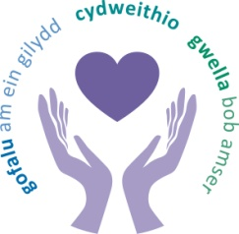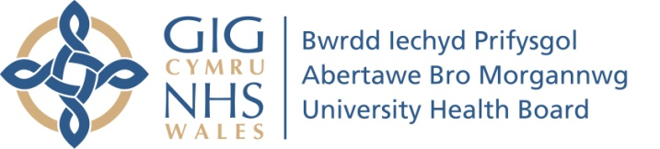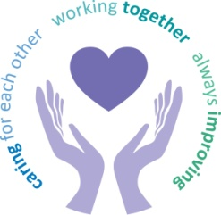
 |  | Agenda Item | 5.1 (v)
Freedom of Information Status |  | Open
Reporting Committee | Charitable Funds Committee
Author | Claire Mulcahy, Committee Services Officer
Chaired by | Martyn Waygood, Independent Member
Lead Executive Director (s) | Lynne Hamilton, Director of Finance
Date of last meeting | 25 March 2019
Summary of key matters considered by the committee and any related decisions made.
- Changes to the Health Board’s charitable objects and subsidiary charities as a result of the Bridgend Boundary Change - The Charity Commission had confirmed the process for changing the name and the information required to amend the charitable objects and transfer the Maesteg Hospital Charity to Cwm Taf Health Board. The committee approved the transfer of Maesteg Hospital Charity to Cwm Taf Board Charity with effect from 1st April 2019. They also approved the removal of the Hill House Charity and Fairwood Hospital Charity from the list of subsidiary charities.

- Small Grants Scheme – The committee heard how the funds allocated to the scheme for 2018/19 had been utilised and the big impact the funds had made to small organisations and service users. Nevertheless, the committee felt that more information was required in the form of a business plan for the Small Grants Scheme to enable them to agree an allocation for 2019/20. They also felt they needed sight of the Annual Report in order to get a full insight and requested this be provided at the next committee meeting.

- IRIS (Identification and Referral to Improve Safety) Domestic Violence Programme – The committee received a bid for funding for the rollout of the IRIS domestic violence programme across the health board. The committee were not content to approve the application for funding on the basis that training and education should be core business.

Key risks and issues/matters of concern of which the board needs to be made aware:
- Princess of Wales Maternity Fund – Members were asked to agree the reimbursement of incorrectly utilised funds from the Princess of Wales Maternity Fund. The funds were used for the purchase of 23 cots for the Morriston paediatric unit. The committee heard that an independent review of the facts had taken place and they could be assured that this was unintentional. The committee agreed the reimbursement of £30,622.37 to the POW maternity fund from the charitable funds committee fund.

Delegated action by the committee:
None
Main sources of information received:
- Total income received for the period amounted to £1,442,578 with expenditure of £1,611,411;
- Income was received into 50% of the delegated funds during the period with expenditure being incurred from 66%;
- The portfolio was performing well with £300k of unrealised gains which was ahead of the benchmark;
- The balance on the Charitable Funds Committee fund was £317,682 with commitments against the fund for 2018/19 currently totalling £257,447;
- An update on the work to reduce dormant funds and future legacies;
- The Investment Manager’s report;
- Compliance of Investments with Well-being of Future Generations Act;
- Details of funds closed since the previous meeting;
- Information on future legacies;
- The committee’s work plan for 2019/20 and terms of reference;
- A report on the actions taken to follow up on the charitable funds internal audit report.

Highlights from sub-groups reporting into this committee:
A report was received from the bids panel providing an update on recent bids received and the corresponding decisions.
Matters referred to other committees
None identified.
Date of next meeting | 24 June 2019

