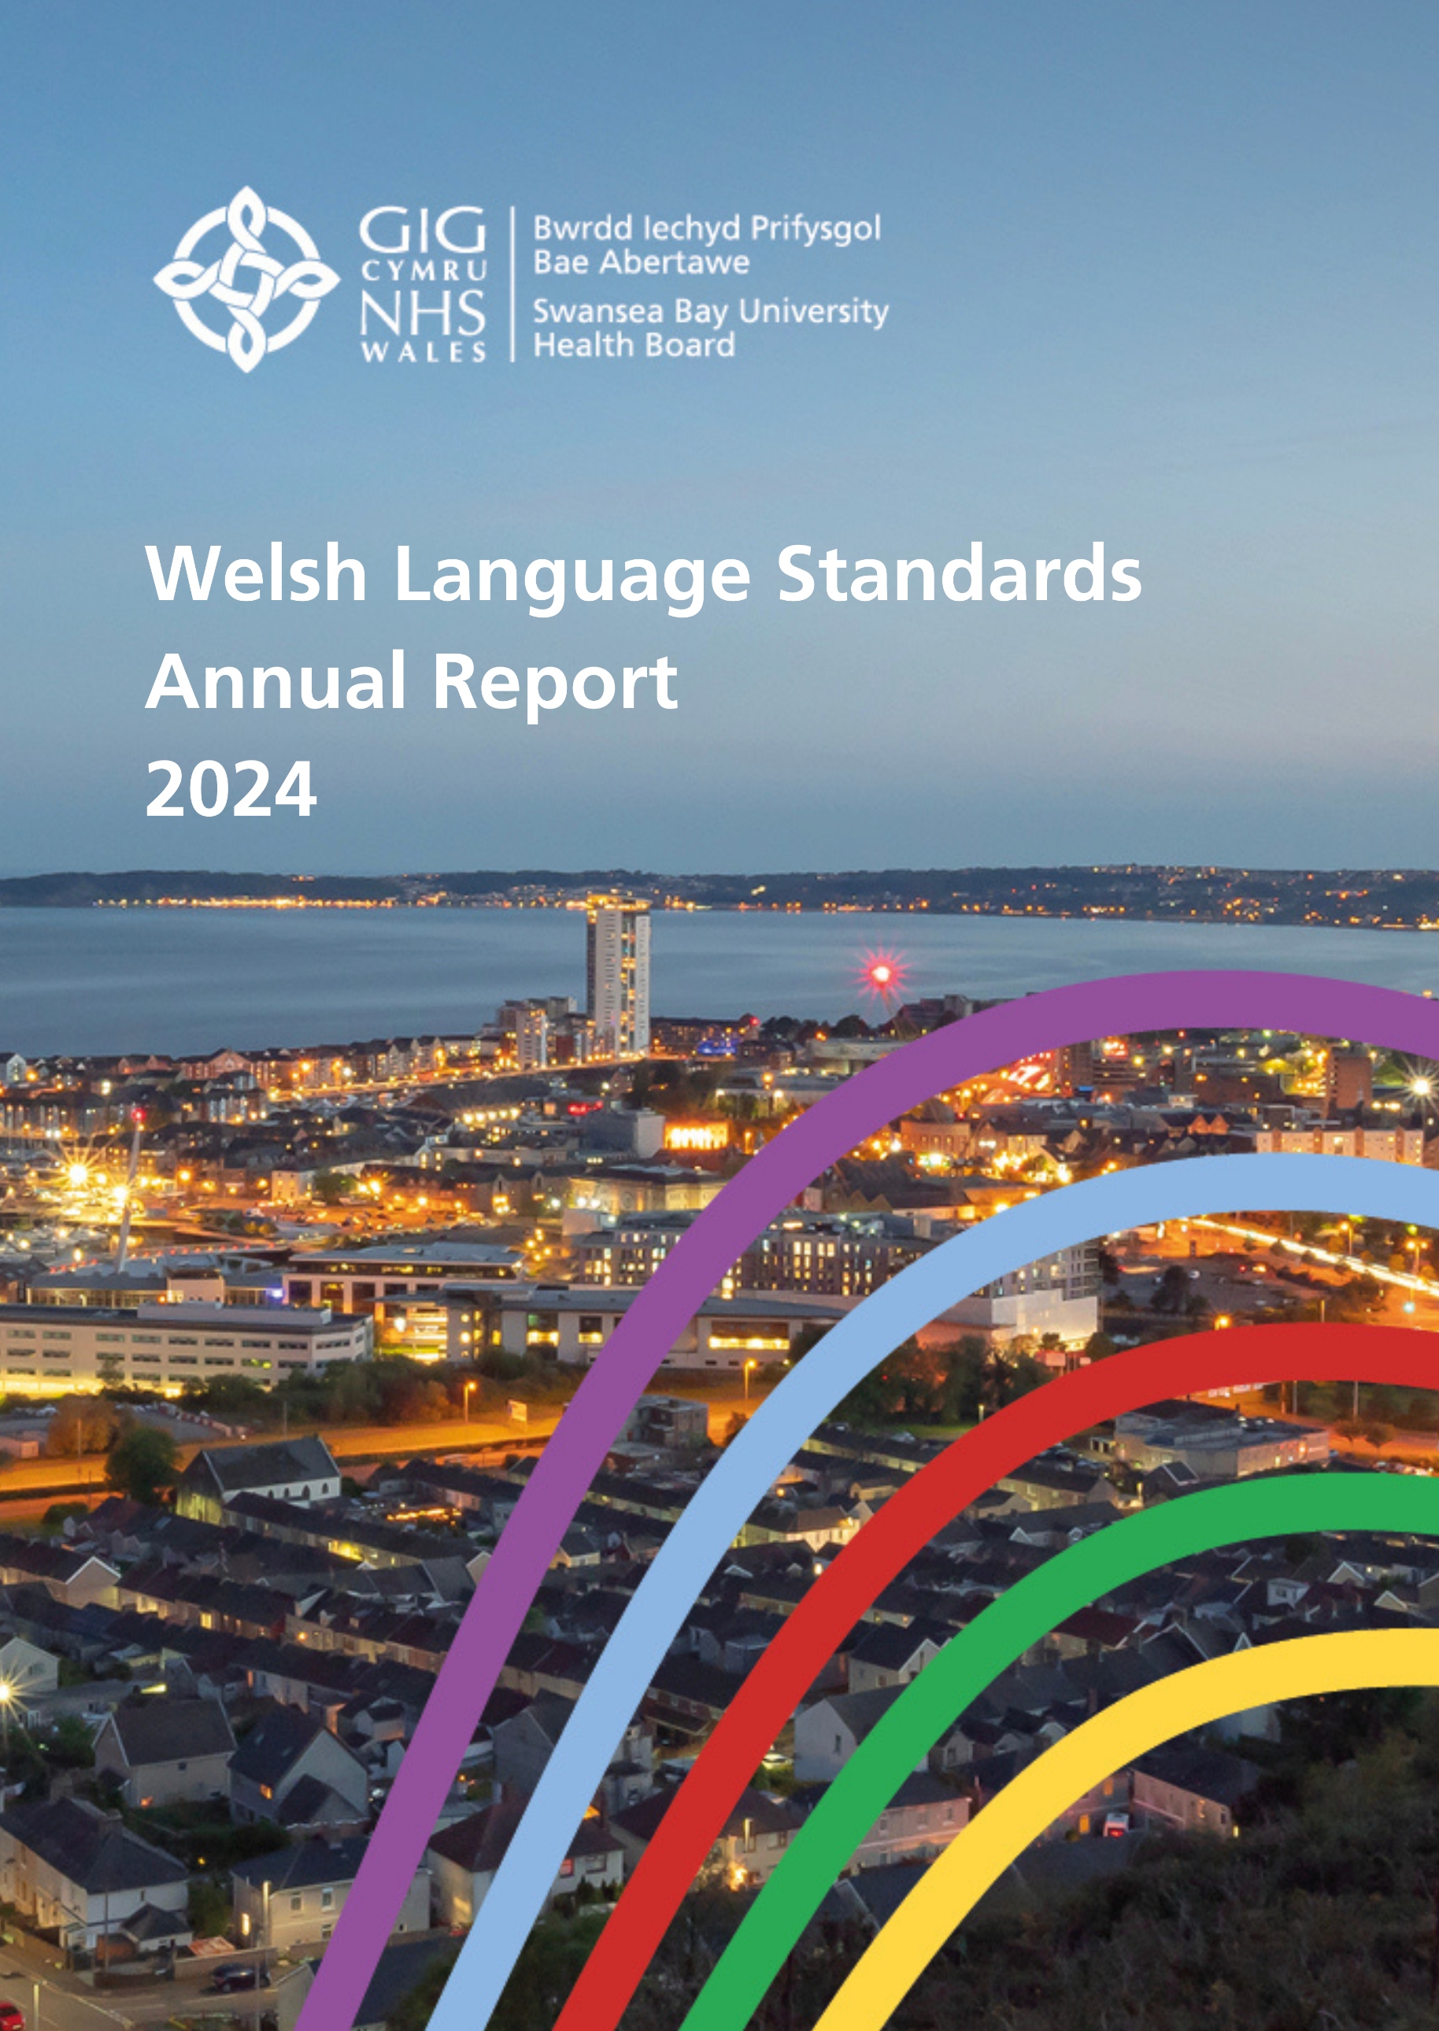

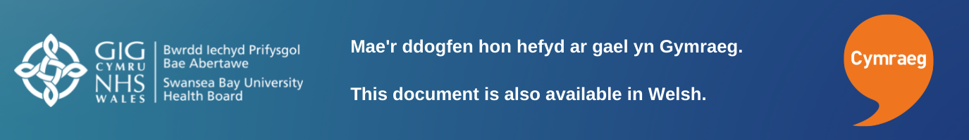

Contents

3 Introduction
4 Accountability
5 Service Delivery
9 Policy
10 Operational Standards
14 Partnerships
15 Conclusion

18 Record Keeping and Appendices

Introduction
Swansea Bay University Health Board has a statutory duty under the Welsh Language (Wales) Measure 2011 to produce and publish an annual report on its compliance with standards set by the Welsh Language Commissioner.

This report will illustrate how this Health Board has performed in relation to our compliance notice for the reporting period; 1st April 2023 – 31st March 2024.

We recognise and understand that being able to offer and deliver services in Welsh is vital to many of our service users. We are committed to increasing our ability to operate bilingually whilst maintaining the high-quality care our patients expect.
Our dedicated staff are showing enthusiasm and commitment to delivering Welsh language services to patients, despite the significant pressures placed on all our services. For this, we must offer them our thanks and admiration.

Our Welsh Language Services Team are working proactively across the organisation to raise awareness of the Welsh language measure and the standards imposed on the Health Board. As a result of this work, throughout this year we have seen continued growth in demand for services offered by our Welsh Language Services team, namely translation and additional training opportunities.

Accountability
Producing an annual report is a public display of accountability. At Swansea Bay University Health Board, the content of our annual Welsh Language Standards report is scrutinised by members of the Welsh Language Delivery Group. It is then escalated for further scrutiny by the Workforce and Digital Committee and finally the Health Board before being made public.
The Director of Corporate Governance is the responsible officer for the Health Board under the Welsh Language Act, ensuring compliance with its requirements, advising on specific cases as necessary, and promoting Health Board-wide awareness of the legislation.
The Head of Compliance is responsible for leading on compliance with the Welsh Language Standards for the Health Board.
The Welsh Language Officer is responsible for providing specialist advice and direction to all departments across the Health Board in order to strengthen the provision of bilingual services, thus assisting the Health Board in delivering its statutory legal requirements in order to comply with the Welsh Language Standards (No.7) 2018 under the Welsh Language Measure (Wales) 2011.
The strategic guidance that this team offers to managers and staff across our organisation ensures that, as a body, we are interpreting and implementing the standards appropriately.
Our Welsh Language Standards Delivery Group exists to provide assurance to the Board that systems and processes are in place to enable the organisation to meet its responsibilities under the Welsh Language Measure. This group is chaired by an Independent Member of the Board, and reports through him to the Workforce and Digital Committee, which in turn reports to the Health Board.
This report has been compiled in line with guidance set out by the office of the Welsh Language Commissioner.

Service Delivery
Correspondence
We communicate with our patients and service users in many different ways. Whilst more of our services are now able to use electronic means to communicate, we still over the course of a year, send thousands of letters.
Our ability to correspond in Welsh has been very good for an extended period of time. Our primary administration systems are able to publish system letters bilingually, and over the course of this reporting period, we have managed to ensure that all letters issued by systems used in our Primary, Community and Therapies departments have been brought into full compliance with the requirements of the standards.
As with all systems and processes, there is a constant need to monitor and review to ensure accuracy. We regularly undertake assurance tests to guarantee that bilingual communications are available to all our service users. We have identified some isolated instances of non-compliance during the reporting period, and system developments and staff training have resolved these issues meaning that we are confident in our abilities in this area.

To further enhance the experience for those who wish to correspond with us in Welsh, this year, we have commenced an incremental adoption process for Welsh language email addresses. Whilst this Health Board has no control over the domain name used by the NHS in Wales, it is within our gift to use the Welsh language for the portion of the email address which appears before the ‘@’ symbol.
In the short period since we have introduced them, we are now able to offer 125 Welsh email addresses. Our most frequently used accounts have been our primary focus, and we are continuing to establish Welsh addresses when new accounts are created, and existing accounts are identified.

Telephony
Over the course of the year, we have delivered training to all our switchboard staff so that we can offer the best experience to callers who wish to speak with us in Welsh. Our operators have a thorough understanding of the need to offer a Welsh language service and have positively engaged with the training and support offered to them to help us achieve this.
6 of our switchboard team have a solid understanding of the Welsh language, we recognise that there are differing levels of confidence with using the language and are adopting a whole team approach to increasing confidence, so that even those who have limited Welsh feel empowered to use it.
We continue to face challenges in recruiting staff into roles within our switchboard who have both the right skills and language abilities. Despite attempting numerous times to appoint suitable candidates, we have not been successful. We will continue to work to attract more Welsh speakers into these roles and keep the Welsh Language Commissioner updated on our progress in this area.
We are also working to improve the experience for all our callers by introducing an automated front-end menu to our main numbers which will be fully bilingual. This will be our priority for the next reporting period, and we look forward to sharing further information on the roll out in our next annual report.

Meetings
A wide range of internal and external meetings are held across our departments and services daily. These include public meetings of the Health Board and interagency meetings through to case conferences and internal operational meetings.
Staff who are regularly arranging meetings open to the public and external partners have access to guidance to support them in ensuring the meetings are offered bilingually and are accessible to all.
Guidance and support to assist managers and staff members to use Welsh during internal meetings are available through both our intranet pages and from our Welsh language officer. We have also recently promoted an opportunity for staff to attend an external training opportunity on chairing bilingual meetings in Welsh. Wherever a staff member expresses an interest in using more Welsh internally, the Welsh Language Officer will support them in achieving this.

Publicity and display materials, documents and forms
Our Welsh language policy requires that all signage and posters produced or commissioned by us are bilingual, and that documents and forms for use by the public are available bilingually at the point of publication.
There are robust procedures in place to ensure that all new permanent signage installed across our estate complies fully with guidance produced by the Welsh language commissioner. Extant signs installed prior to 2019 have been assessed for compliance and will be replaced with compliant versions when they reach the end of their useful life. Guidance has been produced to support staff in identifying such signage.
Temporary signage and posters continue to present a challenge to us; however, it is a challenge that we are rising to. Unannounced audit and compliance work carried out over the reporting period has shown that we have succeeded in drastically reducing the number of non-compliant examples at both Singleton and Neath Port Talbot Hospitals. We continue to work with teams at all locations to raise awareness and quickly remedy instances of non-compliance. We will work to improve this further over the next year.
Overall, there is a good level of understanding amongst staff for items which fall under this category to be bilingual, and we will continue to work with managers and teams to ensure our own internal standards are adhered to over the coming period.

Website and social media
Our organisation has a fully bilingual web presence. Updates to our English Website are automatically translated by machine to produce our Welsh website www.bipba.gig.cymru. The automated translations are proofread for quality by a member of our communications team before being made live at the same time as the equivalent page on our English site.
Our English site carries a statement on each page advising visitors that the content is available in Welsh. This statement also acknowledges that we welcome telephone calls in Welsh.
Our website and social media presence are periodically audited by the Welsh Language Services team for compliance with the Welsh language standards.

Statistics relevant to social media accounts

Our organisation has a corporate presence on the following social media platforms, where we administer separate Welsh and English accounts for each platform.

The Health Board has accounts on a variety of social media platforms. It is organisational policy to maintain separate accounts for English and Welsh language communications. The content posted to these accounts is released simultaneously and equivalent in nature.
- On Facebook, our Welsh language account has 188 subscribers. (+17)
- On Twitter, our Welsh language account has 371 followers. (+32)
- On Instagram, our Welsh language account has 88 followers. (+9)
- On LinkedIn, our Welsh language account has 11 subscribers. (+3)

Reception services
As do all NHS Health Boards in Wales, we rely heavily on volunteers to staff our main reception areas. They offer a warm welcome to all patients, visitors and staff who cross our threshold. These volunteers’ direct enquiries and signpost visitors to satellite reception desks across our sites where they are then greeted by employed members of staff. The linguistic make up of staff that man those satellite receptions desks is as follows:

- Morriston Hospital
16 members of staff cover the reception desk within the Emergency Department (ED). Of these, 1 (6.25%) are Welsh speakers.
10 directly employed staff provide main Outpatients Department reception services, 2 of whom (20%) are Welsh speaking.
- Singleton Hospital
17 part-time staff provide reception services for our Outpatients department at this hospital. None of these staff speak Welsh.
- Neath Port Talbot Hospital
11 staff provide reception services on a rota at our Minor Injuries Unit. 1 of them is a Welsh speaker. (9%)
20 staff welcome patients to our main Outpatients department at this hospital. 1 (5%) of them is a Welsh speaker.

Awarding of contracts
Our process for awarding of contracts is managed centrally by our partners at NHS Wales Shared Services Partnership. The process complies fully with the requirements of the Welsh language standards.

Primary Care
We support our colleagues in primary care to carry out the six duties imposed on them by the Welsh Language Commissioner. We regularly circulate information to the sector to raise awareness of the obligations placed on them and we continue to offer support in promoting any services that can be offered by a primary care contractor in Welsh.

We offer a limited translation service to the sector to ensure that signage and notices displayed by them at their premises are bilingual. This service is offered without charge.

We have seen increased engagement from this sector over this reporting period. We have supported many practices with translation requests and by providing materials to them to raise awareness of staff within their practices who are Welsh speakers.

Policy Making Standards
The requirement to consider the effects on the Welsh language of any changes we make to our services or organisational structure are key to our vision for Person Centred Care. Following a recent seminar held by the Commissioner’s office, we now have a better understanding of the expectations on us and the need for a conscientious effort to have been made when considering the effects on the Welsh Language that decisions we take could have. We acknowledge that we must do better in this area and will work over the next reporting period to develop more robust processes.

We are now in the second year of our five-year Quality Strategy. This strategy acknowledges the importance of the Welsh language in providing high quality care to our patients and communities and gives a commitment to supporting the organisation in meeting our responsibilities under the Welsh Language Standards.

Our 2023-2024 annual quality report includes examples of progress against the More Than Just Words framework and we aim to develop this reporting route in future years. We envisage that into the future we will see a greater appreciation across not just our organisation, but across the wider Healthcare sector of the importance of language as a fundamental component of delivering safe, high-quality care.

Key Health Board policies are subject to scrutiny by the Stakeholder Reference Group. The terms of reference of this group require at least one member be appointed as champion of the Welsh language and for them to address any issues that become apparent as part of the review process.

When undertaking consultation with the public, we have ensured that all documentation has been made available in Welsh and distributed along with English versions. This has meant that those documents have been readily available to Welsh speaking members of our community without them having to make a request.

We recognise that the availability of Welsh versions of documents is only part of the way that we need to engage with Welsh speakers in our communities. Our Department for Insight, Communication and Engagement is considering how else we can meaningfully engage with Welsh speaking patients.

Our commitment to improving the experiences of Welsh speaking service users as well as our process for considering the impact decisions taken could have on the language is always outlined in our consultation documents. Whilst we provide these documents in text format, we are also prepared to provide them in braille and audio formats in Welsh if required.

Operational Standards
Internal use of Welsh language
Our policy on the Welsh language establishes organisational responsibilities with regard use of the language throughout our internal operations. This policy aids staff in remaining compliant with the Welsh Language Standards and helps in promoting and facilitating the use of Welsh across our organisation.

Along with pages on our staff intranet site, this policy offers practical advice and guidance to all staff to be able to use more Welsh at work.

Software packages

We offer all our staff the option of installing software on their computer systems which will aid them in using their Welsh language skills in their work. The software packages approved for use on our networks are:

Cysgliad – This suite of programmes offers a Welsh to English and English to Welsh dictionary, as well as a spelling and grammar check function.

To Bach – This programme, once installed, allows the user to access special characters used frequently in Welsh by means of a simple shortcut key stroke.

Microsoft 365 Interface - Microsoft have launched a Welsh language interface for their 365 suite of programmes. Staff can access and apply this interface through their personal user settings.

Additionally, our in-house translation team have been using translation memory software since January 2022 and we are seeing a slow but steady growth in the size of key terms and phrases stored in our local memory. We must extend our thanks to our friends at Cwm Taf Morgannwg UHB who supported us with some training and by sharing their translation memory data with us. This is the kind of supportive, collaborative working we need to see more of in the NHS Wales in order to improve and enhance the pace at which Welsh language care can become more widely available. Here at Swansea Bay, we will always do our best to support our sister Health Boards, where that support will ultimately benefit patients.

We regularly monitor the market for new applications or websites which could support our staff in using their Welsh language skills in the workplace.

Intranet
Around two years ago, this Health Board established a new intranet based on a sharepoint platform. This has enabled us to be more creative in how we use this as a tool to support staff with all things related to the Welsh language. The homepage of our Welsh Language Services Team acts as a hub site for staff to navigate to different pages where support can be found.
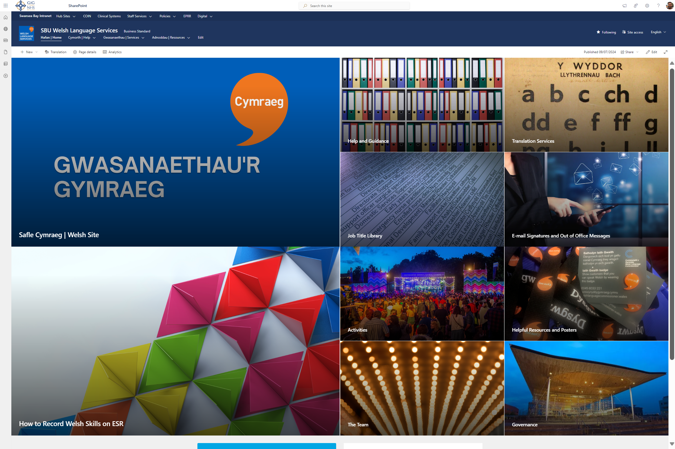

Under the help and guidance section, staff can access information relating to how we maintain compliance with the Welsh language standards with detailed information on processes ranging from ‘Responding to Correspondence’ and ‘Using Social Media’, through to ‘Conducting Meetings’ and ‘Workforce Planning’. The content on these pages is kept under constant review to ensure that the advice being provided to staff is making Cymraeg as accessible as possible.
Through other pages linked from this homepage, staff can:
- access resources such as bilingual posters encouraging patients and visitors to use Welsh with us,
- order Iaith Gwaith badges and Lanyards.
- access frequently translated job titles, departments and addresses as well as a directory of email addresses and their Welsh equivalent aliases.
The content available to staff through this site is constantly growing, so that staff can access the information they need, when they need it.

Documents and procedures relating to employment
Swansea Bay University Health Board automatically issue all its contracts of employment to staff bilingually.

We use the national ESR system to process annual leave and absence reporting. Due to linguistic limitations of the platform, it is not possible for us to implement these processes in Welsh at present. This is an issue that is not unique to us here at Swansea Bay and our partners at DHCW and NWSSP continue to push for improvements to the system at a UK level. A replacement for ESR is currently in the very early stages of development and representations are being made to ensure that the replacement platform will perform as required.

We manage the process of recording and supporting staff through sickness absence at a local level. All paperwork associated with this procedure is available to staff in both English and Welsh.

During this reporting year we have increased the number of organisational policies relating to the terms and conditions of employment which are available in Welsh and continue to keep which policies require translation under review.

As an employer we are fully committed to ensuring that our staff can engage with us in the language that they are most comfortable using. This includes throughout our recruitment processes, where staff can apply for jobs with us in Welsh and request that interviews are conducted in Welsh.

Linguistic profile of our Workforce
This Health Board is required to capture information around the ability of our workforce to communicate in Welsh. The requirement on our staff to provide this information is, however, voluntary.
At the end of March 2024, 51.84% of our workforce had self-assessed their Welsh language skill levels and recorded that information on the Electronic Staff Record (ESR). This is an increase of over 20% since March of 2023.
Our efforts to encourage staff to record this information continues, and we hope that this figure will continue to improve year on year.

Opportunities to learn Welsh
More members of our workforce than ever before are learning Welsh.
During 2022-23 we proudly reported that we had established two Entry level 1 classes for staff at our headquarters. It is a pleasure to be able to report that many of those Entry level 1 learners have now progressed to level 2 and are continuing on their language journey.
Additionally, during this reporting period, and thanks to funding from Welsh Government via the National Centre for Learning Welsh, we have been able to offer Entry level 1 courses to 130 members of staff. 2 classes have been offered at each of our 3 main hospital sites. The interest in them was phenomenal with over 350 staff members expressing an interest. Unfortunately, we weren’t able to offer the opportunity to all, but will continue to work with our external partners to ensure that these learning opportunities are sustainable long term and offer our colleagues the best possible chance of becoming daily Welsh language users.
Many of our staff have also taken advantage of fully funded courses offered by Nant Gwrtheyrn to improve and boost confidence in their Welsh language abilities. Feedback from staff has shown that these opportunities are invaluable. Helping to give advanced learners the reassurance that their Welsh is good enough to be used and boosting the confidence of lapsed Welsh speakers to blow off the cobwebs and be proud that they can offer a bilingual service to our patients and visitors.
All our staff have access to online self-study to develop their Welsh language skills. Staff are able to access this learning through our internal intranet pages.
‘Dysgu Cymraeg’ is a key component of the work we are doing to increase the visibility of Welsh across our organisation. Along with recruiting more Welsh speaking staff into roles, upskilling staff is a key component of our Bilingual Skills Strategy. It is therefore vital that Welsh Government continue to invest in opportunities for our workforce to learn Welsh, whilst at the same time ensuring that candidates for our future workforce have appropriate Welsh language skills on leaving education.

Public address and recorded announcements
Public address systems are not used at our sites. Our use of recorded announcements is limited. We use them at some main entrances to our hospitals to remind patients and visitors that smoking or vaping is not permitted on our grounds. We also use them on some of the public use elevators across our estate. The majority of these announce bilingually, and those that are not currently compliant will be brought into compliance as the maintenance contracts for them allow.

Building Partnerships

This year has been a good one for developing relationships and building partnerships with other organisations. Our Welsh language officer continues to sit on and contribute to the All-Wales strategic group for the Welsh language which meets quarterly. This group is made up of Welsh language managers from all Healthcare organisations in Wales. Collaborative working and sharing best practice were the aims of this group at its inception, but as it has developed, it has been able to make formal all-Wales representations to Welsh Government and the Welsh Language Commissioner on matters concerning the Welsh language.
Our Welsh Language Officer also regularly meets with Welsh Government to report and receive feedback on progress with ‘More Than Just Words’ and other matters affecting the Welsh language agenda.

In March 2024 in partnership with Swansea University we hosted a virtual congress for staff and students. At ‘Gofalu yn Gymraeg‘ we enjoyed contributions from leaders in their field with highlights including a presentation for Dr Aitor Lasarte from the Basque country who shared detail with us of implementing compulsory bilingual services to their population and a panel discussion involving the Welsh Language Commissioner which considered how we make the ‘Active Offer’ practicable given the pressures on the NHS. Participation in this event was initially for Swansea Bay Health Board staff and staff and students at Swansea University. Such was the interest in the event, we saw delegates join us from Universities and Health Boards across Wales, as well as representatives from the Welsh Language Commissioner’s Office and Welsh Government. The event was a great success, and we look forward to working with interested parties to develop this into a regular event.

This year, we started engaging with schools across the region in order to attract more young people into the variety of roles we offer across the NHS. From a Welsh language perspective, this work is in its infancy here at Swasnsea Bay, but is an area of work we are keen to grow when sufficient resource is available. To make progress here, we have built links with Careers Wales, and will approach Coleg Cymraeg Cenedlaethol over the coming reporting period.

We’re thankful for the positive engagement we have had with the ‘Learn Welsh’ Centres, both local and nationally. Their enthusiasm for giving the Welsh language to more of our workforce matches ours, and we look forward to growing this partnership further.

Conclusion and priorities
for the year ahead

Clinical Consultations
We are proud of our achievements in developing 5-year action plans within the More Than Just Words key priority areas; in order to increase our ability to offer to carry out clinical consultations in Welsh. Senior leaders in these areas positively engaged with us to identify steps that could be taken into the future to ensure that patients who need to access their care in Welsh can do so. The action plans are currently going through internal scrutiny, and we look forward to further developing them over the coming months ready for publication in December. These plans will set solid milestones for our services, with success being measured not just in terms of availability, but also sustainability. We are committed to this piece of work delivering meaningful progress, and as such, monitoring and reporting will be embedded into existing departmental scrutiny processes.

Staff Skills
We’ve continued to make progress in collecting data on staff Welsh language ability over the past year. Whilst there is still a way to go until we reach a point where we could consider ourselves able to offer a high level of assurance in this area, we have been able to increase the number of records we hold by about 20% this year. This equates to around 1630 additional members of staff telling us about their abilities over this reporting period. We will continue this work over the next year.

Dysgu Cymraeg
As you will have already read, we have taken great steps forward in offering opportunities for our workforce to learn Welsh. After asking for expressions of interest from staff at our three main hospital sites, hundreds got in touch. Thanks to support from the National Centre for Learning Welsh through their Cymraeg Gwaith scheme, we had already been able to offer opportunities for 40 staff at our headquarters to start their learning. Thanks to funding from Welsh Government, the centre was further able to support our ambitions and enable us to offer classes for 120 of those staff members who expressed an interest. We believe that, at this time, this is the largest cohort of NHS staff embarking on their Welsh journey anywhere in Wales.
What became very apparent to us whilst establishing these classes, was that there was a need for a tailored learning or coaching opportunity for members of our workforce who have a good understanding of Welsh, but for whatever reason, lack the confidence to use it. Thankfully, this has also been identified at a national level. We are in advanced talks with providers to deliver an ongoing project which will empower those who find themselves in that position, to use the skills they have with pride. We are excited to continue working with both the National Centre and the local Swansea Centre for learning Welsh, for the benefit of our staff and patients.

Recruitment Administration
During this reporting period, we have developed an action plan to improve how we advertise and recruit to vacant posts. The Welsh language standards require us to publish adverts, job descriptions and all other related documents in Welsh as well as English. This is no mean feat. This Health board recruits to around 2,500 roles per year and could see our in-house translation team needing to translate an additional ten million words per year on average. We are currently working on procuring external translation services to support our in-house team, as well as developing our use of translation memory software to avoid duplication of work. Senior staff working in recruitment have engaged positively with the action plan. They are currently developing a marketing strategy to raise awareness amongst recruiting managers across the organisation, so that we are in a good position by the end of the year.
It is important to us that any changes we make to our administrative processes and procedures are meaningful. We feel that with the support of the Welsh Language Commissioner’s office we have been able to produce a robust action plan which will bring us much closer to full compliance with a clear progression pathway ahead of us.

Patient Satisfaction
You will see in the appendices of this report statistics relating to patient satisfaction whilst attempting to access our services in Welsh. These statistics paint a positive picture generally, but concern has been expressed within some departments that we are not capturing sufficient feedback from patients on Welsh language provision in order to enact meaningful change. This is an area which we will explore further over the coming months. Internally, we will look at who we approach for feedback, why they are selected, and establish what obstacles there are to asking all participants in feedback gathering about their experiences in accessing Welsh language services. We will also work positively with external partners such as ‘Llais’ to ensure that our patients’ voices are heard.
Only by improving the data we gather from patients’; can we identify where the need is greatest and then work to improve our ability to meet that need. Only by capturing high quality data will we be able to develop and deliver high quality Welsh language care.

Nurturing a bilingual community
Our Occupational Health, Speech and Language, and Mental Health teams are leading the work of creating teams of Welsh language champions to promote and encourage the use of Welsh at a micro level across the organisation. We’ve hesitated in starting this work and for good reason. It is important to us that every member of our workforce feels that they can be a part of, and even take ownership of the Welsh language. We wanted to get the right balance of people doing this role. Variety in seniority, but also in language ability. We did not want this piece of work to feel exclusive. We didn’t want non-Welsh speakers to see it as an elitist group, “Us and them”.
To this aim, we won’t be using the title ‘champion’ internally. This immediately puts somebody on a podium, and what we are promoting and encouraging here is that everybody can use some Welsh. A ‘bore da’ from reception staff can have equal or greater impact as an executive presenting in Welsh. All use of the language is important to us.

The message is clear. We all have a voice, but we can all have a Welsh voice. Our ‘encouragers’ within the teams mentioned above will share best practice across the key priority areas identified in the More Than Just Words framework. We aim to have the ‘Encourager’ role established in all these areas by our next report.

The year ahead promises to be one full of opportunities for us to build on the positive work that has been happening across our organisation. Our teams are enthused to build on the good work. In 2025, the Urdd’s National Eisteddfod visits our region, and our teams have already started thinking of ways to engage with visitors to this event to promote not only the services we offer, but opportunities for young people to develop careers with us too.
We will continue to work collaboratively with our colleagues in other health boards and health bodies. We share a common goal, and it is wise for us to bring our work ever closer if this will enable us to reach our destination quicker. We’ve talked about some of the new links we’ve created with bodies beyond the healthcare sector in this report. We will maintain our contact there also, supporting each other to enhance a Welsh offering wherever possible.

Record Keeping

Appendix 1
Record of New and Vacant Posts

Appendix 2
Welsh Language Staff Competency

Appendix 3
Complaints

Appendix 4
The Welsh language in Swansea and Neath Port Talbot


Appendix 5
Patient Experience – Survey Feedback

Appendix 1
Record of New and Vacant Posts
Recruitment
Statistics relating to the Welsh language status/requirements for jobs advertised by the Health Board during 2023/24 are set out below. For the second year, we have seen a significant decrease in the number of posts advertised as ‘Welsh Not Required’.
We continue to keep our bilingual skills strategy under review, emphasising the need to ensure that the Welsh language requirements of all vacancies are robustly assessed prior to any advertisements being placed. This will help to ensure the development of a workforce with the capacity to deliver care and services in the recipient’s preferred language.

Posts advertised by us between 01 April 2023 and 31 March 2024.

During this period, 2,445 posts were advertised by our Health Board. The Welsh language skills requirements of those posts were assessed as follows:

- Welsh language skills are Essential – 4 Posts advertised.
- Welsh language skills are Desirable – 2,387 posts advertised.
- Welsh language must be learnt on appointment – No posts advertised in this category.
- Welsh language skills are not required – 54 posts advertised.

We are fortunate to have the use of the TRAC website and also NHS Jobs which enables us to promote and administer posts through the medium of Welsh. Both gateways enable applicants to submit applications in Welsh, and all communication with the applicant is bilingual. Applications submitted to us in Welsh are given priority by our translation team, so that managers can score the application within a specified timeframe. The electronic application form asks the applicant if they wish any interview to be conducted in Welsh, and we have a process in place to enable this to happen.

Appendix 2
Staff Welsh Language Competency
As one of the region’s largest employers, we employ 16,039 members of staff. On the last day of March 2024, 8,284 (51.65%) of those staff members had recorded at least one language competency through the National ESR system. On the same day, 6,039 members of staff had not yet recorded their language competencies.

Breakdown of Welsh language skills of our workforce
The following percentages are based on the staff members who have recorded their language skills with us.
Speaking
430 Members of staff have told us that they have speaking and listening skills at Level 5 (5.19%), whilst 386 members of staff felt that their skills were at a level 4 (4.65%).
Fewer staff recorded their skill levels at level 3. 324 Recorded their skill at this level (3.91%). 385 noted their skill at level 2 (4.64%).
The numbers increase significantly when looking at levels 1 and 0. 1,520 recorded their skill at level 1 (18.34%) and 5,237 recorded level 0 (63.21%).
Reading
Of those who have responded, 435 recorded their reading skill level at level 5 (5.31%), and 375 recorded their reading skill at level 4 (4.58%).
The figure reduces when we look at level 3, with 242 (2.95%) recording this level. 401 staff members recorded their skill at level 2 (4.89%).
Again, the numbers increase significantly when looking at levels 1 and 0, with 1,331 members of staff recording reading skills at level 1 (16.25%), and 5,343 recording a reading skill level at level 0 (65.26%).
Writing
370 members of staff told us they could write in Welsh to Level 5 (4.56%). This figure reduces to 284 when we look at the responses to level 4 (3.5%).
264 members of staff have recorded their writing skill at level 3 (3.25%) and 434 noted skills at level 2 (5.34%).
The pattern of the numbers increasing significantly continues when we look at reading skills at levels 1 and 0. 1,157 members of staff told us their writing skills in Welsh are at level 1 (14.26%) and 5,545 recorded their skills at level 0 (68.34%).
Summary of Welsh language competency at levels 4 and/or 5
Number of staff who have told us that they have Welsh language skills at levels 4 or 5:
- Speaking and listening, 816 members of staff. This is an increase of 59% on last year’s number.
- Reading, 810 members of staff. This is an increase of 58% on last year’s figure.
- Writing, 654 members of staff. Again, this is an increase of 58% on the number reported last year.

Appendix 3
Complaints
Details of the Health Board’s complaint procedure, including complaints relating to our compliance with the Welsh Language Standards, are published on our website in line with the requirements of our compliance notice.
During this reporting period, our complaints team have not received any complaints relating to a possible breach of the Welsh Language Standards.

Appendix 4

Cymraeg in the Community
The number of people who can speak, read and write in Welsh is captured as part of the national census. The results of the 2021 census were released last year and data for the communities we serve is shown here.

City and County of Swansea
11.20% of Swansea’s population over the age of 3 can speak Welsh. 8.60% of residents over the age of 3 can speak, read, and write in Welsh.

Neath Port Talbot County Borough
13.50% of residents in Neath Port Talbot over the age of 3 can speak Welsh. 10.20% of residents over the age of 3 can speak, read and write in Welsh.

Swansea Bay Region
The Health Board’s area incorporates both counties mentioned above.
12.06% of the residents of our region over the age of 3 can speak Welsh.
9.20% of the residents of this region over the age of 3 can speak, read and write in Welsh.

Office of National Statistics (ONS) data
We use ONS data to guide our ambitions in developing a bilingual workforce. We are aiming to demonstrate a greater correlation between the two data sources as we develop the skills of our current workforce and recruit more Welsh speakers into key ‘More than just words’ roles.

Appendix 5

Patient/Service User Experience
Survey Feedback

During the reporting year, we asked the following question to 15, 118 respondents:

Were you able to speak with staff in Welsh if you needed to?

The question was not applicable to 12,434 (82.24%) of the respondents. The following data is based on the responses of the 2,684 (17.75%) respondents to whom the question was applicable.

64.19% of respondents answered that they were able to speak in Welsh with a staff member “Every time”.
11.95% of respondents answered that they were able to speak in Welsh with a staff member “Usually”.
7.48% of respondents answered that they were able to speak in Welsh with a staff member “Sometimes”.
16.35% of respondents answered that they were “Never” able to speak in Welsh with a staff member.

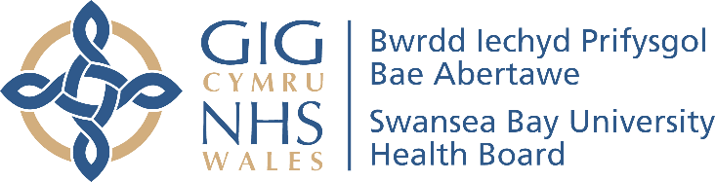

Report Author: Jordan Morgan-Hughes
Date of Publication: xx September 2024

You can direct questions relating to this report to:
Welsh Language Services Department
Swansea Bay University Health Board
Headquarters
1 Talbot Gateway
Baglan
SA12 7BR

SBU.Cymraeg@wales.nhs.uk

