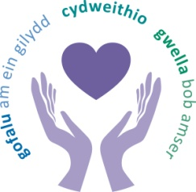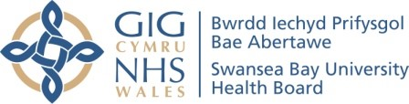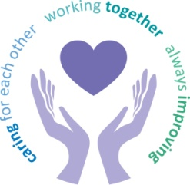
 |  | Agenda Item | 6.2
Freedom of Information Status |  | Open
Reporting Committee | Charitable Funds Committee
Author | Liz Stauber, Head of Corporate Governance
Chaired by | Nuria Zolle, Independent Member
Lead Executive Director (s) | Darren Griffiths, Director of Finance and Performance
Date of last meeting | 18 July 2023
Matters to Draw to the Attention of the Board (particularly areas relating to risk or quality)
- Fundraising Update
The charity team’s strategy was agreed by the trustees in March 2023 and aimed for a more proactive, larger foundation and substantive fundraising. A business case is being developed. Work has been undertaken to minimize running costs for the charity and some things have been put in place for better and more efficient ways of working. Recruitment would start for head of charity after the summer and the job description was in development. A rebrand for the Health Charity is being planned alongside the rebranding work for the Health Board so that is consistent
- Helping Hands Update
Currently the bids panel is not scheduled to meet as there is insufficient funding available to allocate given that the current fund has £46,000 ring-fenced out of the £53,000 balance to support the small grants scheme in 2023-24. There is no significant income coming into the fund and any requests for funding have been referred back to the general funds for the relevant service areas. Due to lack of funds and shortfall of income there is unlikely to be a meeting for the remainder of this financial year. A meeting was to be arranged to discuss a broader strategy moving forward looking at the investment fund and the current position with regard to benchmarking and short and long term strategy.
Other Areas of Discussion
- Teenage Cancer Outreach Clinical Nurse Specialist
A teenage and young adult outreach clinical nurse specialist post is funded by Cardiff and Vale University Health Board and Swansea Bay patients have to travel to Cardiff for this service. Cardiff and Vale University Health Board have received a finance agreement to appoint a teenager and young adult clinical nurse specialist that will have honorary contracts with Swansea Bay and Hywel Dda university health boards to act as a link for patients so their treatment pathway is more streamlined. Costs of £5,550 would be split between the two health boards. Members agreed it was a scheme with merit but sought more information to determine if this was a core service which should be financed by revenue as opposed to charitable funds.
- Finance Update
A new look finance update was presented and feedback from members was as to the information they would like to see and the frequency. In terms of the update, it was noted that Income was higher this year than last year and expenditure was lower, however there have been some realised losses on sales of investments. The fund balance has reduced by £27,000 with investments down by £63,000. Since the last CFC meeting £85,000 has been received from a cancer charity for an ultrasound scanner. The locally held cash balance at the end of May 2023 was £0.367m. This has deceased from the normal level of cash held in previous months.
- Investment Manager Update
A payment of £55,000 per quarter to achieve a total annual payment of £220,000 has been set. Currently the portfolio generates £140000 from income and the rest is paid out of capital.
- Staff Employed from Charitable Funds
The majority of permanent posts relate to fundraising or administration and three fixed-term posts relating to the arts on prescription post, the music in health facilitator post and a research fellow post. In addition to this there is also a temporary consultancy support cost for replacing the head of charity. The actual cost for the posts funded from charitable funds in 2022-23 was £341,706. The estimated cost for these posts in 2023-24 is £270,719. The head of charity post is not included in the forecast so if that post goes ahead those costs will have to be added in as well
Decisions Made
Members agreed:
- The opening of a new fund for the 25th anniversary of the cancer centre;
- The funding for the small grants scheme for 2023-24;
- Closure of a restricted fund of just over £4,000 to support patients and staff through Covid 19 and its aftermath – this money would be transferred to the Helping Hands Fund.
Updates Received from Sub-Groups
There were no updates received from sub-groups.
Matters Referred to Other Committees
No matters were referred to other committees.
Date of next meeting | 12 October 2023

