


Meeting Date | 28 September 2023 |  | Agenda Item |  |  | 1.9
Report Title | Chief Executive’s Report
Report Author | Joanne Abbott-Davies, Assistant Director of Insight, Engagement and Fundraising
Report Sponsor | Richard Evans, Interim Chief Executive
Presented by | Richard Evans, Interim Chief Executive
Freedom of Information | Open
Purpose of the Report | To update the Board on current key issues and interactions since the last full Board meeting.
Key Issues | This report includes updates on:  - Delivery of Recovery & Sustainability Plan 2023-24  - Taking Changing for the Future Forward  - Quality  - Our People  - Finances  - Our Charity
Specific Action Required  (please choose one only) | Information | Discussion |  | Assurance | Approval
Specific Action Required  (please choose one only) | ☒ | ☐ |  | ☐ | ☐
Recommendations | Members are asked to:  - Note the report

CHIEF EXECUTIVE’S REPORT

- INTRODUCTION
This is my first report to the Board in my new role as Interim Chief Executive, which I took up on 1st September following the retirement of Mark Hackett. I will use this report to update the Board on current key issues and interactions since the last full Board meeting in July 2023. I, along with my Executive Director colleagues, am looking forward to leading the organisation and working with Independent Members to continue to make a reality the direction of travel carved out so clearly by Mark. I am committed to ensuring a smooth transition and providing continuity as we make further improvements to our services at pace, in line with our Clinical Services Plan Changing for the Future.

- OVERVIEW
Overall the health and social care system in Swansea Bay remains under pressure, making the organisation’s continued efforts to deliver Changing for the Future even more important. In the space of two years we have completed the redesign of our front door for surgery and medicine. Without these changes it is clear we would be in a much worse position in dealing with these pressures. Continuing to operate services as we have done over many years does not serve our staff or patients well.

Based on the feedback from our staff and stakeholders as part of Our Big Conversation we have developed a 10 year vision for our Health Board. This vision is that we become a High Quality Organisation and we have developed the “One Bay Way”, which shows how we will achieve this through:.

- Living our values and behaviours
- Being clinically led
- Empowering staff
- Recognising that with responsibility comes accountability
- Being patient centred, adopting a joined-up approach
- Delivering efficiently through quality
- Adopting a population health focus – a preventative agenda

We will continue to work collaboratively with our staff and unions to ensure staff feedback, alongside that of our patients, our citizens and stakeholders continue to shape our services and organisation now and in the future. We want to encourage services and all of our teams to do the right things for our patients, taking more ownership to change and improve services, knowing that they will be supported to do so and not face criticism or sanctions. We are challenging everyone across our organisation to take responsibility for identifying changes which need to be made and then to get on and make these happen.

We need to flatten our structures and reduce bureaucracy so we have launched a Voluntary Early Release Scheme which allows staff not providing direct patient-facing services to leave the Health Board with a lump sum payment. This is our collective challenge and we need to act differently so that everyone can contribute to making our Health Board a better place to work and where we can be proud of all the services we provide to all our patients and their families.

Access to services – whether to unscheduled or planned care - is a key quality issue and delays result in patient harm. These are system-wide issues which cannot be resolved by an individual service or Delivery Group, but rather need the collective action of all of us and every part of our Health Board to be achieved.

Increasingly, as we move to integrated services in line with A Healthier Wales and the recently published Welsh Government State of Intent Building Capacity through Community Care – Further Faster this collective action will need to encompass social care, our partners in the third sector, as well as service users, carers and citizens and the work being taken forward by the West Glamorgan Regional Partnership.

We know that the risk in some of our services is high with staff not being able to deliver the quality of care they want to, particularly in relation to discharging medically fit patients, which needs a multiagency response, so that we can provide timely care for acutely ill patients presenting at our hospitals. Taking forward at pace the transformation of our urgent and emergency surgical services, expanding planned care capacity and developing our main hospital sites into Centres of Excellence continues to be our main focus. We need to recognise that doing nothing is the path of greatest risk.

These priorities are included in our Plan for 2023-24 and we all need to continue to be energetic and determined to achieve these, in order to improve and not just maintain services for our patients.

We have overspent in the first four months of 2023-24 and we need to recover this position and make significant recurrent savings in order to deliver the quality improvements we all want to make. Getting things right first time is key to providing high quality services, but also saves money and time so we need to focus on delivering on this in all that we do. If we can concentrate on using our core services to address access issues, and so improve quality, we will also be able to invest in services within the Health Board and the local area, rather than using external, premium cost providers, so improving the quality of services provided and reducing costs.

- TAKING CHANGING FOR THE FUTURE FORWARD

  - Unscheduled Care
The past six months have seen a fundamental transformation of our Urgent and Emergency Care services, with the centralisation of admissions to Morriston Hospital to help address long-term pressures in the system. These services remain under pressure despite these changes. The number of medical admissions are no higher than in 2019-20, although indications are that patient acuity has risen. We recognise that pressures on staff and impacts on patient care are not acceptable, and work continues to support staff and improve patient experience. This is not a Morriston Hospital, Emergency Department or Unscheduled Care problem, it is a health system problem, and as such needs action from every single one of us and our services to contribute to improving care and support for our patients and staff – be it clinical or non-clinical support services, primary and community services or our other hospitals.

The next phase of our transformation of urgent and emergency care services at Morriston Hospital is the acute surgical reconfiguration programme. Progress since the last Board meeting is outlined below:
- The new Surgical Assessment Unit has been constructed in the void space above the Acute Medical Unit at Morriston, with £1.5m revenue and £1.5m capital investment and is now operational with 8 trollies and 6 ambulatory chairs.
- The reconfiguration of downstream wards within the existing surgical bed footprint is underway, to reinstate dedicated specialty wards and to create a short stay ward to support patient flow.

These are all part of our continued efforts to transform Unscheduled and Urgent Care services, but everyone’s dedicated efforts, across all partners, sectors and services are needed to achieve the improvements we need to make for our patients.

The Acute Medical Unit at Morriston continues to support a large number of medical patients, with 6,146 admissions to the unit between 5th December 2022 and 5th September 2023, with 54.8% of patients discharged directly from AMU and 2,879 patients transferred to downstream wards. This balance of discharges vs admissions has been consistent over the past 6 months, indicating a stabilisation in these services. However, the success of all these changes requires system wide effort and focus and is dependent on ensuring only appropriate admissions are made to hospital and rapid discharge supports the discharge of patients at the earliest opportunity.

The response of our staff to these fundamental changes in our health system has been incredible, we thank them and owe them a sincere debt of gratitude.

  - Planned Care
The new theatre complex at Neath Port Talbot Hospital is now operational, with activity being phased-in as funding and staffing allow. In the meantime, activity is also being insourced to make the most of the facility while substantive recruitment takes place. The maximum additional capacity of the facilities is for an additional 3,000 operations a year. £21m has been invested in creating 3 new theatres, 5 pre-assessment rooms and staff accommodation.
A robotic business case for Morriston Hospital is under consideration which will be used for a range of specialties, including Urology. Further business cases for additional theatre activity at Singleton and Neath Port Talbot Hospitals are in preparation.
Welsh Government has outlined its expectations in relation to planned care trajectories, and discussions will be held internally regarding these. Further work is underway with Cwm Taf Morgannwg UHB to disaggregate other residual services from Bridgend Boundary Change. Discussions are underway with Llais to identify any public engagement requirements arising from these.
Across all specialities the number of patients waiting at the end of August 2023 compared to the previous five months was:
Number of patients | March 2023 | April 2023 | May 2023 | June 2023 | July  2023 | August  2023 | In-month Change
>26 weeks for a new appointment | 15,381 | 15,184 | 14,734 | 13,427 | 12,933 | 13,122 | +189
>36 weeks at all stages | 29,303 | 28,087 | 26,362 | 26,459 | 25,841 | 25,994 | +153
>52 weeks at all stages | 18,178 | 17,823 | 16,975 | 15,446 | 15,116 | 14,877 | -239
>104 weeks | 6,012 | 5,952 | 5,791 | 5,474 | 5,299 | 4996 | -303

By the end of July 2023 we eradicated waits of more than 52 weeks for outpatient appointments in all areas except orthopaedics and this improvement has been sustained during August. This is a massive achievement and one we need to build on further to reduce the times our patients have to wait to be seen and to have their operations. For Orthopaedics we will clear over 52-week waiters by the end of October 2023. Sustainable reductions in waiting lists will need to see a combination of transformative approaches to service redesign and better productivity of services, and in line with our One Bay Way approach, this is being taken forward on a system wide approach, involving all our staff, services and partners.

  - Cancer
Providing timely treatment for cancer patients is a key focus for the Health Board. We have not been doing as well as we would like, far from it. There was a slight improvement in performance up to and including April 2023 as illustrated below but this fell away in May and June 2023 although there was an improvement in July 2023.

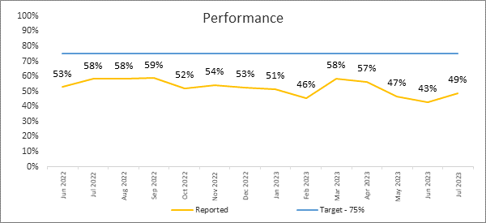

The main concern remains Gynaecological cancer with only 17% of patients treated within target and the highest volume of patients in backlog. Performance has ranged between 44% and 59% over the past year, and there is a need for all specialties to move more rapidly towards the 75% national target. Therefore, there will be a continued focus on improvements with the teams on all of the cancer sites. These need to be clinically owned and led, as many of the improvements are simple and effective working practice changes.

The National Cancer Recovery and Improvement Taskforce has been established to work with health boards to look at the current constraints to deliver and identify means of improving. As a result workshops for gynaecology, urology and Upper GI cancer sites have been held. So far these have identified common themes around demand management and inconsistency of approaches. Trackers and Multidisciplinary Team Coordinators are being centralised within the Health Board from October to help ensure consistency of approach across all specialties.

3.3.1 Diagnostics
Delivery of diagnostics for cancer patients has been broadly maintained. The table below outlines the delivery of radiology investigations in May and June. Demand has continued to increase in May and June, with the percentage of reported scans within 7 days decreasing from 71% to 68% as a result.

June | Within 14 days | Within 7 days | July | Within 14 days | Within 7 days
1565 examinations | 92% | 68% | 1680 examinations | 96% | 81%

3.3.2 Endoscopy
An agreement to increase additional core capacity for cancer has been reached, and work is underway to establish this in practice. Additional capacity currently continues with ID Medical which is improving waiting times for patients. More patients have been able to have their procedure within 14 days, increasing from 31% in May 2023 to 43% in June 2023 to 55% in July

  - Covid-19 and Flu
There has been an increase in the number of Covid cases and new variants of the virus emerging. It is possible that by the start to middle of October 2023 that there will be a new Covid wave. We are therefore encouraging all our staff to have both the flu and Covid booster vaccination during September to safeguard their health and wellbeing and, in turn, the health of the patients that we serve as well as helping to support the resilience of the NHS and care system at a time of increasing pressure. It is clear that without a successful vaccination programme the risk of our services being overwhelmed would be significantly increased so this vaccination programme remains of critical importance.

  - Annual Plan 2023-24 / Integrated Medium Term Plan (IMTP) development
Quarter 1 delivery against milestones is largely on track with mitigating actions in place and revised delivery timescales for those off target. To support this a revised reporting structure and process had been introduced in Quarter 1, reviewing quarterly updates against the Plan, discussing interdependencies and highlighting issues and risk before submitting to the Board. Planned care trajectories and milestones are now being developed in light of the additional funding agreed with Welsh Government. Minimum Data Set forms part of the formal submission to Welsh Government and provides a triangulation between workforce, planned service activity and finance. We have collated these and identified any gaps in information which we are now working with leads to resolve.

  - Annual Plan 2024-25 development
Work has commenced on developing the Annual Plan for 2024-25, which will incorporate elements of our vision and our “One Bay Way”. The plan will build on the 2023-24 Annual Plan, with the following assumptions:
- We will not be in a position to develop an approvable Integrated Medium Term Plan due to the challenging financial position which means the plan is unlikely to be financially balanced. Therefore, approach is to develop an Annual Plan set in a three-year context
- We will work to the formal submission deadline (to Welsh Government) of 31st January 2024, based on the expectation that National Planning Guidance will be published in the Autumn and Financial Allocations will be received in mid-December
- Development of the plan requires a continued whole-system focus, with clear accountability and ownership through the Executive Team and Health Board Senior Leaders

Prioritisation and realism will be important in developing the plan and ensuring the right balance between challenging objectives and the ability to realise the changes needed within the resources available. An Annual Plan Development Workshop was held on 14th September to shape the strategic objectives and system visions for next year, including embedding system and pathway work as well as the Population Health Strategy.

- QUALITY
As reflected above, work continues on our vision for becoming a High Quality Organisation. Our ambition is to become a leading UK health system that delivers national and international clinical and academic achievement, where staff work together in great teams to ensure patients and carers receive the highest standards of care and where the best people want to come to learn, work and research. All in order to deliver the maximum contribution to health and wellbeing. Quality therefore continues to be a key focus for us and highlighted below are some of the work underway to contribute to this vision:
Following the tragedies that occurred within the Countess of Chester Hospital, it is important to take stock within NHS Wales that mechanisms to support quality and safety are robust and well implemented across organisations. A Framework for Speaking up Safely in NHS Wales has been issued to all health boards on the 25th August 2023 and the Board considered the safety systems and systems to support speak up in place as part of a Board development meeting earlier in September.

;
A self-assessment is being undertaken against the framework and a response will be submitted, and a plan to address any areas of development as required, to Welsh Government by the 30th October 2023;

  - Maternity Services
We have been working hard to develop proposals to revise our midwifery staffing model so that the Birthing Centre at Neath Port Talbot Hospital and the Home Birth Service can be reopened. These services were temporarily closed in July 2021 due to the lack of midwifery staff to run all of our services and the need to ensure safe services at Singleton Hospital. These plans have been finalised to ensure safe services linked to changes to the service model, workforce modernisation and expansion of community midwifery birthing numbers. These will ensure effective, safe midwifery services and we will be investing £750,000 in these services over two years to secure this, which will increase community services, meet Birthrate Plus standards and improve the number of mother’s birthing at Neath Port Talbot Hospital.

An organisational change process has been undertaken for midwives providing care at Singleton Hospital. We have also recruited new Maternity Care Assistants who will support midwives and allow them to spend more time doing what only they can do. The first cohort of 14 Maternity Care Assistants includes eight existing Swansea Bay staff from across the health Board, as well as new recruits. They will spend one day a week on the Certificate of Maternity Care programme in Swansea University and the rest of the time working with midwives and maternity staff to develop skills and achieve competencies. We are fortunate to have obtained the services of transformation midwife Dr Sarah Norris, who created the bespoke training programme. A further organisational change process has also now been completed to reconfigure community midwifery services. Based on the outcomes of these, there will be a process of retraining and upskilling staff so that the Neath Port Talbot Birthing Centre can be reopened and the Home Birthing service restarted. This will start in October 2023 with all services fully reopened by early 2024. Further discussions have been held regarding reconfiguring the delivery of community midwifery services in partnerships with our Primary Care Clusters, with any changes being developed early in 2024, for public engagement later next year.

  - Cwmavon / Cwmmer GP Practice
Following concerns raised about the experiences of patients of Cwmavon / Cwmmer GP Practice, David Rees and Jeremy Miles arranged public meetings to allow the Health Board to listen to these issues. Several hundred people attended and kindly gave their time to help us understand their concerns. An action plan has been developed to address the issues with this GP Practice which is currently being directly managed by the Health Board. Staffing at the practice remains fragile but recruitment is continuing at pace and efforts are continuing to improve patient care. A further round of public meetings are being arranged for October and the Health Board is actively pursuing options to return the Practice to independent contractor status.

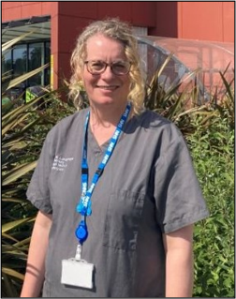
  - New Trans and Gender Diverse Service
Swansea Bay is the first Health Board in Wales to introduce a specialist service to support transgender people to align their voices with their true selves. A dedicated speech and language therapist, Rebekah Gabbitas, teaches them about voice care and explores different aspects of communication associated with gender. The service aims to support and guide transgender and gender diverse people towards their gender identity.

  - Nursing and Midwifery Academy Opens
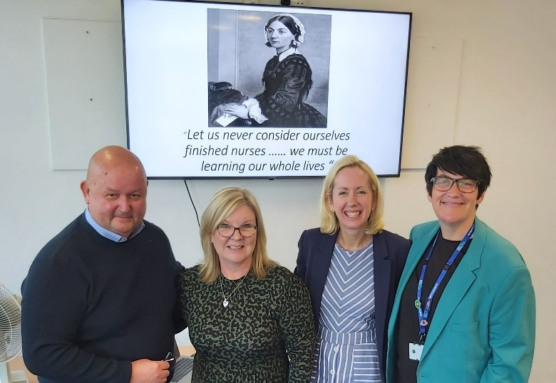
Swansea Bay has recently launched its new Nursing and Midwifery Academy. Linked closely to the Florence Nightingale Foundation, the aim of the new academy is to promote quality and excellence by supporting nurses at all stages of their career to learn, grow and develop with our Health Board. Key to the academy’s success will be easy access to free online training, making it much simpler for busy staff to fit continual professional development into their timetables. It will also support preceptorship and revalidation processes. The new academy follows the launch of the purpose-built Nurse Education Training Suite at Baglan HQ and is another tangible show of the Health Board’s commitment to nursing. Our nursing staff are our lifeblood and this is an important step forward in improving training and career progression, which in turn will hopefully lead to us retaining more of our highly valued nursing staff.

  - Hand Hygiene
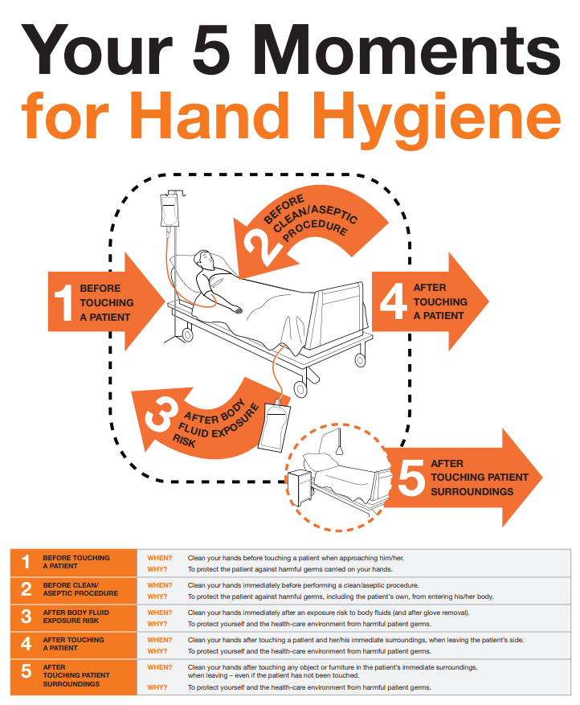
Antibiotic resistant bacteria are on the rise globally and we are seeing this in Swansea Bay. These bacteria can cause infections which are very difficult to treat; some are developing resistance to the most potent antibiotics, raising fears that these may become untreatable in the near future. It is crucial that we do everything possible to stop the spread of antibiotic resistant bacteria and, indeed, infections of any kind. We must protect our patients and staff. Hand hygiene performed at the right time and with the right technique is key. IT is simply the single most effective way to prevent infection spreading.

Disappointingly a recent spot audit revealed almost half of staff observed, from all clinical groups, missed crucial hand hygiene steps. The Five Moments of Hand Hygiene are clearly outlined by the WHO.

Observing hand hygiene standards is not new and is routinely observed in healthcare institutions across the words, we are no different in Swansea Bay and we expect all staff to adhere to these standards, without exception.

  - Speak Up Month
In October Swansea Bay is launching a campaign that supports NHS colleagues to speak up about concerns and issues, no matter how big or small. This campaign aligns with our ‘One Bay Way’ and our on-going work to create an open, and transparent culture where staff are engaged with and listened to. This leads to the protection of patient safety, providing the high quality of care that our patients deserve, and improving the experience for everyone.

For Swansea Bay, Speak Up month allows us to build on the work of previous local campaigns, most recently ‘Our Big Conversation’ Staff Engagement Programme. This enabled the voices of almost 1,300 staff, students and volunteers to be listened to, which has informed the priorities for our organisation. Being able to speak up safely is integral our values and why we offer a comprehensive range of ways for staff can raise concerns and access support. This includes our trade Unions; occupational health and staff wellbeing; our staff networks Calon and BAME, the chaplaincy service and the Guardian Service. It is also important because in April 2023, The NHS Duty of Candour came into place. It requires NHS organisations and their staff to be open and honest with patients and services users when things go wrong.

The Call to Action for Speak Up Month this year is ‘Breaking Barriers’, aiming to remove the obstacles which people feel stop them from speaking up. Only by understanding and raising awareness of what these barriers are, can we then start to address them. The campaign is a month-long event with themed weeks and an opportunity for a ‘wear green day’ to show your support locally.

  - Child & Adolescent Mental Health Services School In-Reach Expansion
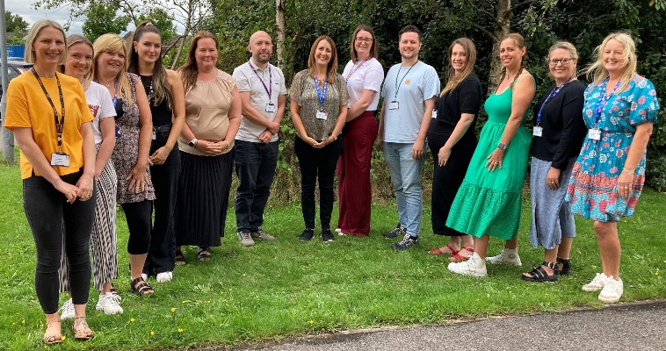
Our Swansea Bay Child & Adolescent Mental Health Service is expanding its School In-Reach Team. The service, which focuses on early intervention rather than waiting for problems to escalate, has already prevented hundreds of schoolchildren needing referrals into mental health services. The service works with around 275 primary and secondary schools in Swansea Bay, having started as a pilot in one school just 5 years ago. It helps pupils up to 6th form level, while it also supports parents of children who are home-schooled.

- OUR PEOPLE

  - Celebrating and Recognising Our Staff – Living Our Values Awards 2023

126 staff or teams were nominated for awards from across the Health Board in 15 categories. Over 8,500 votes were cast, resulting in 44 shortlisted candidates. The Living Our Values Awards 2023 were held in the Swansea Arena to celebrate all these achievements as well as sharing learning, best practice and innovation.

  - Pathology Staff & National Poet of Wales
Swansea Bay pathology staff were invited to the Senedd recently to hear the first reading of a poem by Hanan Issa, the National Poet of Wales “The Unsung”, who was inspired by their work following a visit to our labs in Morriston Hospital which opened her eyes to the role played by pathologist in diagnosis and treatment, as part of the NHS 75th birthday celebrations.

  - Congratulations to:
- Richard Thomas, Director of Insight, Communications & Engagement, who was picked to play touch rugby for Wales and competed internationally
- Sarah Mitchell, paediatric physiotherapy technical instructor who has been named the Chartered Society of Physiotherapy Health & Safety Rep of the Year
- Omobola Akinad, practice development nurse has been nominated in the Compassionate & Inclusive Leader category of the National BAME Health & Care Awards
- Rachel Jones, lead nurse practitioner for acute oncology, who has become 1 of the first 2 nurses to be selected for a Welsh Clinical Leadership Training Fellowship with Health Education & Improvement Wales

- Swansea Bay Health Charity
Swansea Bay Health Charity is the Health Board’s official charity. Money raised is used for equipment, staff training, research and special projects for the benefit of our patients and staff, above and beyond what the NHS can provide. The Charity’s Trustees recently agreed a new Strategy for our Charity, marking a move to larger scale fundraising with less focus on small events and more on the contribution it can make to help the Health Board achieve our key priorities. This Strategy marks a step change in our fundraising efforts with Charity Hubs planned for each of our main sites to raise visibility with our staff, patients and the public.

6.1 Third Jiffy’s Cancer 50 Challenge
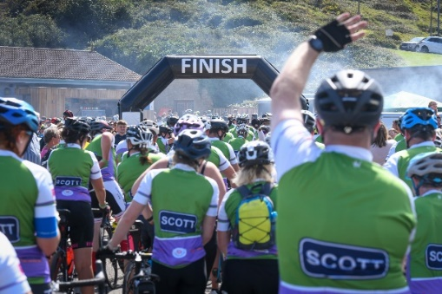
The charity cycle ride organised by former rugby union and league star Jonathan Davies – known as Jiffy - has raised significant funds for the two Cancer Centres serving South Wales (at Velindre and Singleton hospitals). The 2023 event was held on Sunday, August 20 with over 600 riders, starting at Cardiff City Stadium and finishing in a spectacular finish at The Lighthouse in Bracelet Bay. For the first time, three distances were available in order to cater for cyclists of all ages and abilities. Funds will once again be split between the Velindre Cancer Centre and South West Wales Cancer Centre, based in Singleton Hospital, Swansea, which is the second largest non-surgical Cancer Centre in Wales. Over £50,000 has been raised to date and work has already started on planning the event for 2024.

6.2 Covid Memorials
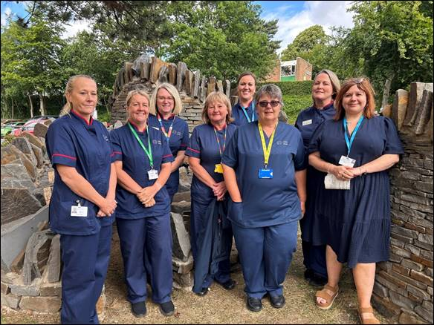
The latest of a series of outdoor tributes to the impact of the Covid-19 pandemic on Swansea Bay has been unveiled at Singleton Hospital. The memorial is made up of curved stone seating pods, with timber benches for staff, patients and public to sit and relax. Its dry-stone walls feature personalised clay tiles, hand-made by our staff, Parkland Primary School pupils and members of the public. Similar tributes have already been launched at Morriston and Neath Port Talbot Hospitals and a fourth at Cefn Coed Hospital will be unveiled in a few weeks. Funding was made available from a grant provided by NHS Charities Together, obtained by our Swansea Bay Health Charity for the benefit of our patients and staff.

