Meeting Date | 29th November 2024 |  | Agenda Item |  |  | 5.6
Report Title | Overview Mental Health Services within Swansea Bay
Report Author | Dermot Nolan, Joint Service Group Director, Mental Health and Learning Disabilities  Anjula Mehta, Deputy Medical Director  Darren Griffiths, Director of Finance  Hazel Powell, Acting Director of Nursing  Richard Evans, Executive Medical Director  Matt John, Director of Digital
Report Sponsor | Hazel Powell, Acting Director of Nursing  Richard Evans, Executive Medical Director
Presented by | Hazel Powell, Acting Director of Nursing
Freedom of Information | Open
Purpose of the Report | The purpose of the paper is to provide the Board with an overview of the current Mental Health Services, including pressures on services, the outcomes from internal and external reviews of the service, and ongoing plans for the modernisation and transformation of the service.
Key Issues | - Mental health and substance use disorders are one of the leading causes of poor health in Wales  - The number of people aged over 16 in Wales reporting a mental disorder has increased from 9% in 2019 to 12% in 2023;  - In 2018-19, rates of reporting mental disorder were over twice as high at 13% in areas of highest deprivation in Wales compared to the least deprived at 6%;  - Over 1.85 million people were in contact with mental health, learning disability and autism services at the end of November 2023, up from 1.36 million at the end of November 2019 in England  - Efforts will need to be focussed on prevention and to improve the conditions of everyday life, beginning before birth and progressing into early childhood, older childhood and adolescence, during family building and working ages, and through to older age.  - Action throughout these life stages would provide opportunities for both improving population mental health, and for reducing risk of those mental disorders that are associated with social inequalities.  - The health board’s mental health services cover a breadth of areas and are delivered through inpatient and community services;  - A significant amount of work is being undertaken by the service group to develop its governance and leadership arrangements to better experience and quality of care;  - Performance measured through key performance indicators which show there is room for improvement; and concerns highlighted by Prevention of Future Deaths reports.  - Additional challenges are presented by workforce constraints, and the provision of care in estate in need of significant modernisation;  - Focus is being given to modernisation and transformation to create robust and sustainable services for the future.  - Further work is required to identify specific areas for action, to consider priorities, and to describe these in detail through the IMTP process.
Specific Action Required  (please choose one only) | Information | Discussion |  | Assurance | Approval
Specific Action Required  (please choose one only) | ☐ | ☐ |  | ☒ | ☐
Recommendations | Members are asked to:  - ACKNOWLEDGE the progress made in mental health services;  - ACKNOWLEDGE the ongoing challenges for which action is being identified;  - ENDORSE the intention to transform and modernise services to meet the needs of the population.

- INTRODUCTION
The purpose of the paper is to provide the Board with an overview of the current Mental Health Services, ongoing pressures on services, outcomes from internal and external reviews of the service and areas of existing and planned modernisation and transformation for parts of the service.

- BACKGROUND
The Mental Health and Learning Disability Service Group within the Health Board comprises of three Divisions, Mental Health Division, Secure Services & Recovery Division and Learning Disabilities Division. For the purpose of this board paper Learning Disability Services have not been included.

The following are the Mental Health services provided across the Swansea Bay University Health Board areas for its population, some of which are via Joint Commissioning Committee arrangements:

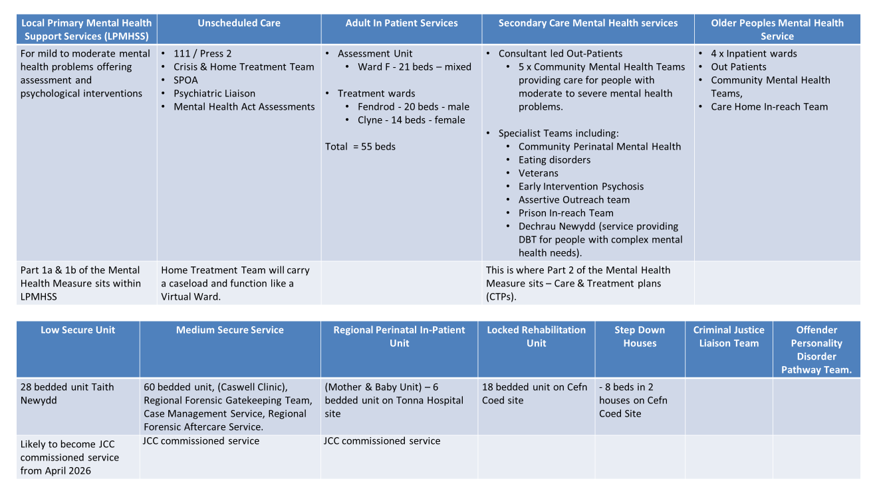

Inpatient facilities and a breakdown of services provided include:

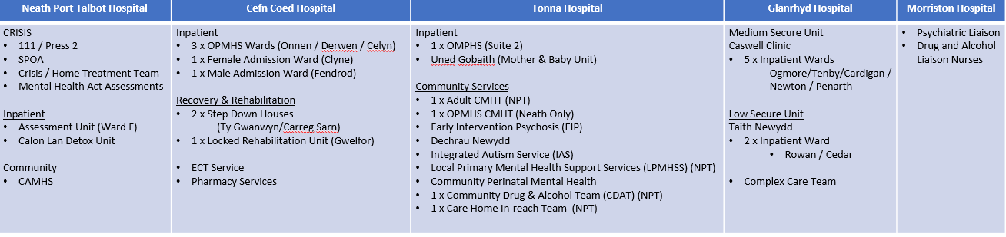

The majority of the overall Service Group’s provision is within the community services with a much smaller element within inpatient services, which is for the most complex presentation and complex needs that cannot be provided for within the community setting or with the enhanced home treatment services. Services include:

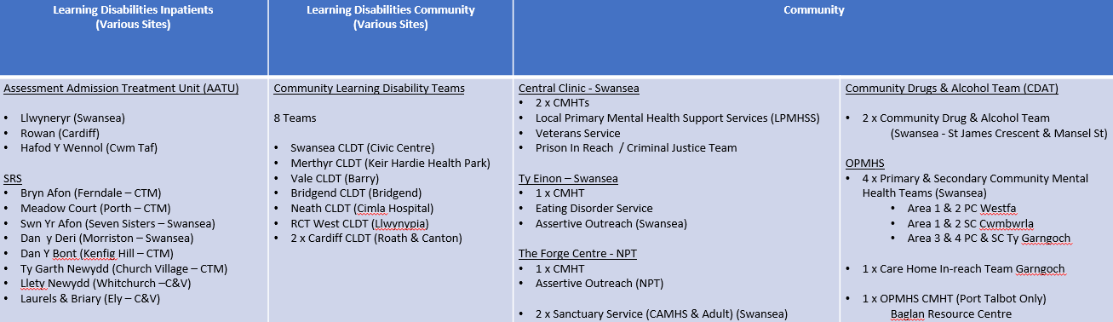

- GOVERNANCE AND RISK ISSUES

- Prevalence, Policy and Legislation

- Prevalence
Mental health and substance use disorders are one of the leading causes of poor health in Wales: being the second largest cause of Years Lived with Disability (YLD), and fourth largest contributor to Disability Adjusted Life Years (DALYs) (PHW, 2018).
The COVID-19 pandemic and cost of living crisis have had an impact on levels of mental health and ill-health in Wales which are evidenced in significant increase in demand on mental health services across Wales.

The number of people aged over 16 in Wales reporting a mental disorder has increased from 9% in 2019 to 12% in 2023. (National Survey for Wales, 2022-2023).
In 2018-19, rates of reporting mental disorder were over twice as high at 13% in areas of highest deprivation in Wales compared to the least deprived at 6% (National Survey for Wales, 2018/19).

There was an observed rise in prevalence in young people between 2017 and 2020. Rates of probable mental disorder in children and young people have remained stable in all age groups between 2022 and 2023 (NHS Digital, England 2023):

In 2023, about 1 in 5 children and young people aged 8 to 25 years had a probable mental disorder. Rates of probable mental disorder for 8 to 16 year olds were similar for boys and girls, while for 17 to 25 year olds, rates were twice as high for young women than young men

Research from Royal College of Psychiatrists (RCPsych) suggests an increase rise in mental health problems and along with this a rise in demand for services. Over 1.85 million people were in contact with mental health, learning disability and autism services at the end of November 2023, up from 1.36 million at the end of November 2019 in England.

The Service Group have continued to invest into the community-based services in line with the recommendations from the external reviewed completed by Niche in 2019 in preparation for the consultation on our Adult Mental Health Inpatient Reprovision.

Over the past four years the service has implemented investment into the various mental health community services in line with the guidance around the use of the Welsh Government Mental Health Service Improvement Funding. This has allowed the service to try and maintain growth in capacity in some areas in line with the ongoing demand during and post COVID.

In relation to the Adult Inpatient services the Health Board developed the Strategic Outline Case for the Reprovision Adult Inpatient Services. Part of the SOC was the public and service user participation in identifying the location of the future build and model of service. Extensive work was carried out and lead by the Health Board Planning and Strategy department in relation to this aspect. This level of engagement with all partners and interested agencies when the Health Board gets to the next stage in development the Outline Business Case for the development.
This development has been included on the Health Boards Capital prioritisation submission to WG and we are awaiting the outcome of the WG decision regarding capital allocation.

This development is a major priority for the MH and LD Service Group as SBUHB are the only Health Board in Wales to still be providing their adult mental health inpatient services from outdated Victorian buildings that are not fit for purpose and do not allow the service group to provide the mental health services they would want to achieve for the Swansea Bay population.

Currently our adult mental health assessment wards have an average occupancy rate at 108%, with RCPsych best practice standards suggesting this should be 85%.

Recent work led by the NHS Executive as part of the All-Wales Strategic Programme for Mental Health has recognised that our mental health services in Wales are fragile. Across Wales the most fragile mental health services are Adult In-Patient services, and Adult Community teams followed by Children and Young Persons Community and In-Patient Services.

Both the Health Board and the MH and LD Services continue to engage with this National Program and also engaging with the final consultation and the development of the implantation plan for the new Mental Health Strategy for Wales.

- Suicide and self harm
Whilst suicidal thoughts and self-harm are not mental health diagnoses, they are closely related to mental health. Current data suggests that over the course of someone’s lifetime:
- 1 in 5 people have suicidal thoughts
- 1 in 14 people self – harm
- 1 in 15 people attempt suicide

Women are more likely to have suicidal thoughts and make suicide attempts than men but men are 3 times more likely to take their own life than women.
Health and social care staff are one of the groups of higher risk of suicide.

Real time surveillance system data is now available in Wales. This surveillance system has been set up to overcome the delays in reporting of suicide rates in the ONS official statistics and to enable preventative interventions to be informed by more up to date data.

These data are based primarily from Police-based data capture methods, and therefore these incidents have not necessarily been confirmed as a suicide by the coroner, and are therefore termed “suspected suicides”.

Current report for 2022-23 indicates that the rates of suspected suicides in residents of Powys Teaching Health Board and Swansea Bay University Health Board were statistically significantly higher than the rates in residents of Betsi Cadwaladr University Health Board, Cardiff & Vale University Health Board and Cwm Taf Morgannwg University Health Boards.

Of the 356 people who died by suspected suicide in Wales, 96 (27%) were known to mental health services, 152 (43%) were not known to mental health services, and for 108 (30%), it was unknown whether they were known to mental health services or not therefore it is possible that this figure is underestimated. Further work is being done for the next report to ensure improved accuracy by better data entry whether people were in touch or not with mental health services.

Data from the Surveillance system currently shows that the most common associated factor for suicide was mental illness, which was reported in 47% people. Alcohol and substance misuse was reported in 22% and a domestic abuse perpetrator history was reported in 19% of people.

- Determinants of Health
Mental health is multifaceted with a number of biological, psychological and social factors affecting mental wellbeing.

Wider determinants of health are a range of personal, social, economic and environmental factors that influence the health status of individuals or populations.
There are strong links between the wider determinants of health and the mental wellbeing/health agenda. We know about the impact deprivation can have on mental health such as debt/money worries, unemployment and poor housing and education. Those who have a mental health illness are much more likely to be out of work, have money worries and live in poverty.

Efforts will need to be focussed on prevention and to improve the conditions of everyday life, beginning before birth and progressing into early childhood, older childhood and adolescence, during family building and working ages, and through to older age. Action throughout these life stages would provide opportunities for both improving population mental health, and for reducing risk of those mental disorders that are associated with social inequalities.

These important links are well described and progressed within the SBUHB Population Health Strategy and the People’s Strategy.

- Policy context
Wales has a breadth of MH legislation and policy across mental health services with a reviewed mental health strategy expected soon.
- Together for Mental Health – A Mental Health and Wellbeing Strategy for Wales (reviewed and consultation closed in July 2024 for 2nd 10 year strategy)
- Talk to Me 2 - Suicide and self harm prevention strategy
- NEST Framework
- Connecting the dots: tackling mental health inequalities
- Strategic programme for mental health
- Mental Health Act 1983
- Mental Capacity Act 2005
- Mental Health Measures 2010

Key themes and principals of these these are:
- Human rights based
- Least restrictive practice
- Person centred and family centred care
- Community based
- Reducing inequalities
- Early intervention

National performance and quality of care indicators have been developed considering all relevant policies and legislation. Of particular importance are the Mental Health Measure. The Mental Health (Wales) Measure is a law introduced by the National Assembly for Wales in 2010 which will help people with mental health problems in four different ways. The Measure aims to ensure that appropriate care is in place across Wales, which focuses on people’s individual mental health needs. It places responsibilities on Health Boards and Local Authorities in Wales, and collects data to monitor and evaluate how well each area is doing

- Part 1: Local Primary Mental Health Support Services
This Measure will:

Ensure more services are available for GPs to refer service users to if they present with mental health problems (including anxiety and depression)

- Part Two: Care Coordination and Care and Treatment Planning
This Measure will:

Ensure that if a person requires more specialised care and support for their mental health condition, their care and treatment is overseen by a professional such as a psychiatrist, psychologist, nurse or social worker (called Care Coordinators)
A care treatment plan sets out the goals a person is working towards and the services that will be provided to help them reach their goals

- Part Three: Assessment of people who have used specialist mental health services before
If a person has received specialised treatment in the past, the Measure will:

Enable a person to go back to the mental health service that was previously looking after them, to advice whether they need any further help or treatment. There is no need to go to a GP first, unless they want to talk this through.

- Part Four: Independent Mental Health Advocacy
If a person is in hospital and they have mental health problems, the Measure will:

Enable them to ask for help from an Independent Mental Health Advocate (IMAH). An IMAH is an expert in mental health who will make a service users’ views known

The health board has a Mental Health Legislation Committee in place which has oversight of the application of the legislation

Recent work led by the strategic programme for mental health has recognised that our mental health services in Wales are fragile and across Wales the most fragile mental health services are Neurodevelopmental, Adult In-Patient services, and Adult Community teams followed by CYP Community and In-Patient Services.

- SBUHB Mental Health Services

Our Mental health and Learning Disability Service Group covers a significant breadth of services delivered on hospital sites, in the community and in the patient’s home across the SBUHB and South Wales footprint.

At the very front of the pathway community based Local Primary Mental Health Support Services LPMHSS cover part 1a and 1b of the mental health measure and provide assessment and brief interventions for referrals from primary care in line with the 28 days target under the measure.

In addition SBUHB has recruited qualified Band 6 mental health nurse link workers who are allocated to each cluster to assess and signpost patients into respective community services. They also act as a liaison with any secondary mental health services when required to assist with referrals. Recently there has also been an investment into psychology professionals working within cluster populations to assess and scope the need for early interventions.

Urgent and emergency access is delivered via the 111 Option 2 or Single Point of Access Service with escalation to crisis or home treatment teams, psychiatric liaison or Mental Health Assessment if needed.

We offer 55 beds for assessment and treatment of acute mental health presentations. These are located at NPTH and Cefn Coed.

In regards to ongoing care provision SBUHB is divided into 5 areas with 5 Community Health Teams led by a consultant providing care for patients with moderate to severe mental health conditions. The CMHTs can draw in input from specialist services if needed such as the community perinatal mental health, veterans MH or assertive outreach teams. This service model fulfils the second part of the Mental Health Measures to provide Care and treatment plans.

For older people’s mental health we have 4 IP wards at Cefn Coed, OP clinic such as memory clinics, CMHT and a care home in-reach team.

In addition there are a number of other Mental Health services, 2 of which cover an All Wales footprint and are JCC commissioned: the medium secure unit and the Mother baby unit in Tonna.

Currently our adult mental health assessment wards have an average occupancy rate at 108%, with RCPsych best practice standards suggesting this should be 85% which aligns with the All Wales picture of increasing demand for mental health support within our populations.

With a SG providing such diverse and breadth of services a robust governance structure is require to ensure high quality service delivery. MH&LD have continuously worked to refine and adapt existing structures to be responsive to what is it needed.
Unique for MH&LD is the Research, Development, Innovation, Improvement, Audit and Learning Hub which this is the learning arm of the Quality & Safety Governance Structures. It is chaired by Prof Jason Davies and reports into the SG’s Quality & Safety Committee. Respective subgroup report into RDIIAL.
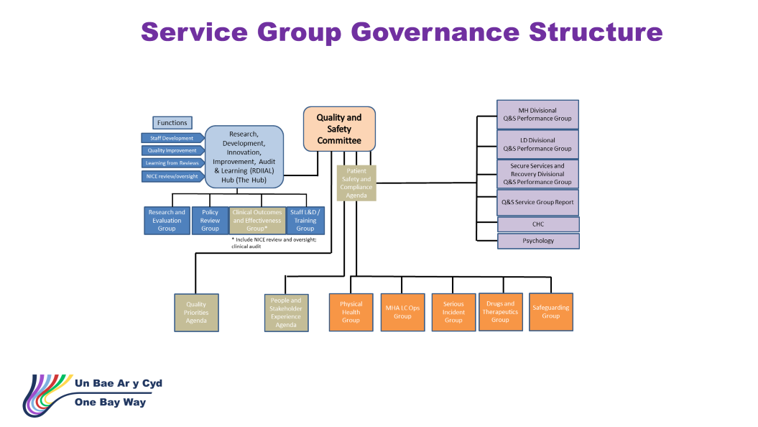

In addition a new Mental Health Quality Assurance, Performance and Improvement Group has been established to further support progress in all four areas of a Quality Management System – Quality Planning, Control, Assurance and Improvement. The Group is chaired by the Executive Director for Nursing with wider Executive Director, Independent Board, Service Group and NHS Exec representation. Key focus within this group will be:
- Progress against external and internal assurance reports or improvement reviews/notices and action plans, e.g. Healthcare Inspectorate Wales (HIW), coroner’s inquests.
- Identify areas for improvement in respect of incident themes and complaint themes and confirm the actions in response to adverse trends where appropriate;
- Identify areas for improvement in respect of staff feedback/ incident themes
- Review the key mental health performance indicators ensuring required standards are achieved and that there is appropriate action being taken where concerns about clinical quality are identified
- Identify examples of good practice and improvement initiatives.

- Performance
There are a number of national performance and quality indicators which are reported and reviewed on a regular basis. In addition local performance indicators have been agreed to allow targeted and informed service reviews and improvement.

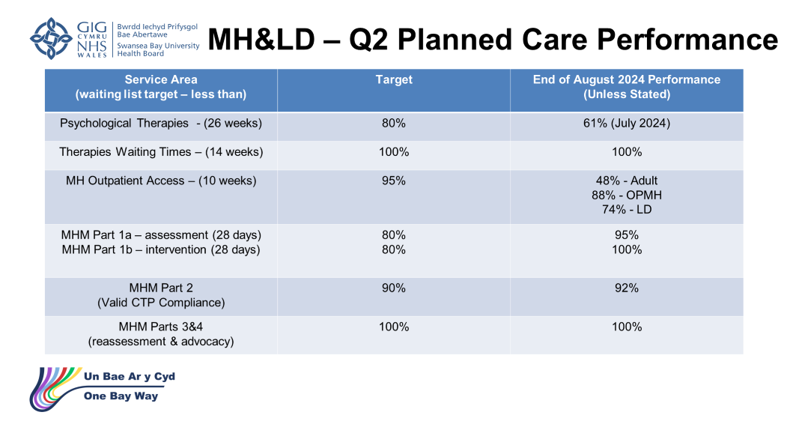
There has been continuous improvement demonstrated with our planned care performance exceeding the targets for all Mental Health measures.
However further improvement is needed to achieve the OP waiting times targets for psychological therapies of 26 weeks and for Outpatient MH patients of 10 week. In particular, our performance against the 10 weeks target for new adult MH is low at only 43%.

It is fair to say that all Health Boards are struggling to meet the waiting list target for psychological therapies, but SBUHB’s performance at 60.8 is slightly below the all Wales average of 61%. Our position has further declined over the last 2 months and an increase of referrals has been noted over that period increasing existing backlog even further. Mitigations are in place with allocating additional clinician hours and recruitment.
There are a number of wider actions planned to address current Outpatient waiting time performance, including implementation of a Service Group Outpatient modernisation group, validation of waiting lists, centralisation of Outpatient services and optimisation of current processes to avoid any delays.

- Challenges
There are a number of challenges for the service to manage with the following being the highest priorities:

- HIW Reports
Over the course of the last two years there have been a number of announced and unannounced HIW visits to multiple sites and services within the Mental Health & Learning Disability Service Group. Each of the external reviews has generated action plans which are monitored and progressed within the Service Group’s governance structure and assurance is provided via the Quality & Safety committee to board level.

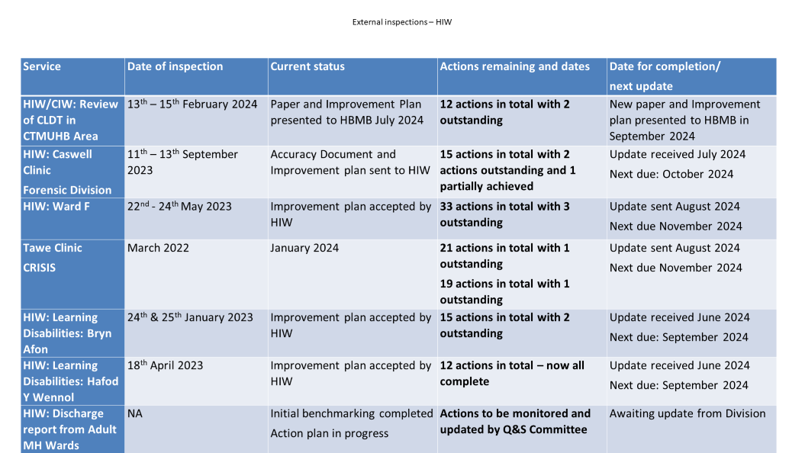

A HIW visit to Ward F at Neath Port Talbot Hospital (Adult assessment ward) was conducted in May 2023 which identified several areas of improvement and the need for targeted actions. Whilst the majority of the actions have been addressed, the following are still outstanding and work is ongoing to complete these:

- The health board must ensure that patients adhere to the Welsh Government smoking legislation on hospital grounds
- The health board must review the location of the nurse call alarms in the refurbished patient bedrooms
- The health board must ensure PBS (positive behaviours support) plans are developed with patients that contain proactive and reactive strategies to understand what things are important to patients and help staff identify when they may need to intervene to de-escalate challenging behaviour

The Service Group also participates in external review processes as part of their Royal College of Psychiatry accreditation, as well as participation in UK benchmarking specifically for Mental Health, Learning Disabilities and CAMHs provision.

- Prevention of Future Deaths Reports

Over the last 18 months the Health Board received four Prevention of Future Deaths / Regulation 28 notifications. One was issued to another Health Board which the Service Groups provided prison In-reach services for that Health Board.

Three of the four have been closed awaiting coroner’s feedback.

A detailed response to the Prevention of Future Deaths report issued in April this year after Dr Kim Harrison’s inquest has been submitted to the coroner’s office.
The key finding from the coroner’s inquest for this case related to required improvements in gathering collateral information as part of Mental Health Act assessment process, lack of timely access to all relevant information for clinicians completing Mental Health Act assessment and the need to improve risk assessments for patients, these are being addressed as part of the detailed action plan submitted to the coroner’s office.

It is essential that the care provided is patient-centred and that families are listened to as part the assessment and treatment process, and that this is culturally embedded in routine clinical practice.

- Workforce
There are recruitment challenges across MH services (and across Wales and UK). HEIW has launched a strategic Mental Health Workforce Plan for Health & Social Care with a timeline of implementation from 2023-2025 to address current and future workforce shortages within Mental Health Services in Wales.

In SBUHB Mental Health And Learning Disabilities Services a current overall vacancies factor of staffing of 6.54% is being reported. The main pressure although reduced, continues to be centred on Medical staff with 19.88 WTE/21.19% (whole time equivalent) vacancies and Registered Nursing at 65.8 WTE/6.35% vacancies. Recruitment and retention challenges are resulting in a high reliance on bank and agency staff. A reduction in turnover of staff has been noted over the last quarter with the main reason for staff leaving the service remaining age retirement.

Positive progress has been made in regards to medical and nursing recruitment utilising UK Nurse recruitment schemes and recruitment for nursing posts by the central resourcing team. Furthermore the recruitment of Internationally Educated Nurses from September last year, which is a unique approach for Wales and the wider UK has added 59 appointments and an additional 22 Student Nurse streamlining posts have been uploaded to the system for March 2024 intake.
Equally Specialist Doctor medical appointments have been successfully completed utilising the Shared Services Overseas recruitment initiative.

Work is ongoing in regards to developing a future workforce plan which will include skills mix review and considering alternative roles and upskilling existing staff to cover gaps safely.

- Estates
The health board provides mental health services in a range of facilities across the geographical areas, as highlighted above, with some inpatient services remaining in older buildings which are no longer fit for purpose. Previous developments at the Cefn Coed hospital have seen modern, fit for purpose, accommodation provided for older people (see bullets below) but the two wards for adult care at Cefn Coed Hospital must be re-provided.

The most recent purpose built mental health facilities are at Cefn Coed Hospital and were built more than 10 years ago, comprising:

- 18-bed Adult Recovery beds & two 4-bed Adult Rehabilitation Step-Down houses; and​
- Older Persons’ 60-bed Intermediate Care Bed facility – in addition to four separate parcels of land disposals

Proposals are in the final stages for a new acute adult inpatient facility on the Cefn Coed site following board approval to acquire land owned by the Welsh Ambulance Service NHS Trust. This will require demolition of some of the existing older buildings to redevelop the site, but the remaining land could potentially be sold to create income to address some of the backlog maintenance work required across the rest of the site, which is around £3.1m. An OBC (outline business case) has been submitted to Welsh Government with next steps subject to the outcome of All-Wales capital prioritisation process.

The other main site for inpatient mental health services is Tonna Hospital, which houses services for older person’s mental health services and the mother and baby unit which has a backlog maintenance cost of just under £5m. The mother and baby unit is a recent addition and is fairly good condition, but was designed to fit within existing building fabric and is therefore not bespoke designed to fully meet the needs. However, its location is temporary as it was established during the pandemic to give women services in Wales to access. The Joint Commissioning Committee will consider the longer-term strategy for the service as part its five-year plan, but there is potential to include it in the plans for the adult acute unit at Cefn Coed Hospital, albeit as a separate entrance.

A prioritised plan is in place to address the backlog maintenance issues and updates are provided to the board on a regular basis.

Ward F, the adult acute ward, is currently based at Neath Port Talbot Hospital and maintenance for this is covered under the private finance initiative which covers the full hospital.

There are inpatient medium secure and low secure mental health services based at the Glanrhyd Hospital site. These services are provided on a commissioned basis for south-Wales by Swansea Bay but the buildings are managed by Cwm Taf Morgannwg University Health Board as they are based on a site within its region.

In terms of the facilities used by the community mental health teams, discussions have commenced on the requirements for modernised estate for Swansea City Centre. Further work will be required to assess the priorities for the current estates and how future developments can link into the proposed Swansea Wellness Centre as well as other developments being undertaken by the local authority. This will need to be based on the mental health service model to shape the buildings in this area.

- Digital and Data
The majority of the mental health service still relies on paper in the recording clinical documentation. The Welsh Clinical Communication Information System (WCCIS), procured by Welsh Government (WG) in 2017, was intended to provide a digital information sharing solution across mental health, community and social services. Swansea Local Authority (LA) implemented the WCCIS across social services and 300+ of our mental health staff, who work in integrated teams with Swansea LA colleagues, also use the system. However, for many reasons, including delays in the availability of health functionality, the Health Board never established a contract for the system and the rest of the mental health service do not use it.

Over the last 18 months, a number digital solutions have been implemented across the mental health inpatient areas including: electronic prescribing and medicines administration (EPMA); the Signal inpatient management system; and the Welsh Clinical Portal (WCP). The use of these systems has had a positive impact on quality, safety and efficiency in ward areas.

- Actions Taken:
The health board has an ambition to undertake transformation through a four-year strategic plan aligned with best practice, but this will require the right resources and infrastructure. There are further significant changes and modernisation required across Mental Health and Learning Disability to further build on developments that have already taken place. Further work is required to identify specific areas for action, to consider priorities, and to describe these in detail through the IMTP process.

- Learning
Ongoing work to address all identified actions and learning from HIW reports, Prevention of Future Deaths reports, patient complaints and incidents via existing governance structures.

- WG Support
SBUHB has requested support from WG to implement service redesign and transformation and to ensure alignment with best practice service models. To facilitate this SBUHB has been escalated as level 2 intervention under the escalation procedure (‘Area of Concern’) for adult inpatient services. Terms of reference for provide assurance as part of this escalation but also to receive support for developing evidence based improvement and transformation plans have been agreed between WG and SBUHB.

- External expertise
The CEO and Executive Medical Director have been exploring potential opportunities to bring in external expertise to advise on Mental Health services in SBUHB, not only in the current provision, but to advise on how these can be strengthened to ensure that they are modern and sustainable.

- Estates
Consideration is being given to the prioritisation of capital works needed, particularly on the Cefn Coed site. In addition, the external expertise that it being sought will also provide an opportunity to review more broadly in terms of the benefits of co-location of physical and mental health.

- Digital and Data
The WCCIS system is end of life in January 2026. The National Connecting Care Programme has been established to deliver new solutions for health and social care, including mental health services. SBUHB leads are working closely with the national programme and local authority colleagues to ensure that the right solutions are procured and implemented before WCCIS becomes unavailable. From a health board perspective, the initial priority is to provide continuity for the existing mental health WCCIS users who work in integrated teams with Swansea LA colleagues. The aim is to achieve this by January 2026. Once this has been completed, the health board plans to provide the preferred solution across the rest of the mental health services and secure the ability to share all appropriate information with both Swansea and NPT LAs.

There are further significant changes and modernisation required across Mental Health and Learning Disability to further build on developments that have already taken place.

The ongoing increasing demand for mental health services across Wales presents further challenges and risks for the Health Board.

- FINANCIAL IMPLICATIONS
Mental Health have various funding streams for various parts of the services, which range from the WG Mental Health Ring Fenced allocation, JCC funding for regional services and Substance Use Ring Fenced allocation to Health Board and Area Planning Board.

In the last three years there was additional Welsh Government Funding for Mental Health Service Improvement Fund which was targeted at specific parts of the services, which allowed SBUHB to develop its MH 111 press 2 service, Community Perinatal Mental Health Services, expanding the psychological therapy provision amongst other developments. This additional funding ceased in 2024 so the future modernisation of services will have to be completed from existing allocation.

There is a significant need for substantial capital funding for both Mental Health services to get both the inpatient and community models of services fit for purpose.

Mental Health are having to compete for limited Capital allocation not just with other Mental Health Services but wider health services which are usually higher profile that Mental Health services.

- RECOMMENDATION
Members are asked to:
- ACKNOWLEDGE the progress made in mental health services;
- ACKNOWLEDGE the ongoing challenges for which action is being identified;
- ENDORSE the intention to transform and modernise services to meet the needs of the population.

Governance and Assurance

Link to Enabling Objectives  (please choose) | Supporting better health and wellbeing by actively promoting and empowering people to live well in resilient communities
Link to Enabling Objectives  (please choose) | Partnerships for Improving Health and Wellbeing |  | ☐
Link to Enabling Objectives  (please choose) | Co-Production and Health Literacy |  | ☐
Link to Enabling Objectives  (please choose) | Digitally Enabled Health and Wellbeing |  | ☐
Link to Enabling Objectives  (please choose) | Deliver better care through excellent health and care services achieving the outcomes that matter most to people
Link to Enabling Objectives  (please choose) | Best Value Outcomes and High Quality Care |  | ☐
Link to Enabling Objectives  (please choose) | Partnerships for Care |  | ☐
Link to Enabling Objectives  (please choose) | Excellent Staff |  | ☐
Link to Enabling Objectives  (please choose) | Digitally Enabled Care |  | ☐
Link to Enabling Objectives  (please choose) | Outstanding Research, Innovation, Education and Learning |  | ☐
Health and Care Standards
(please choose) | Staying Healthy |  | ☐
(please choose) | Safe Care |  | ☐
(please choose) | Effective Care |  | ☐
(please choose) | Dignified Care |  | ☐
(please choose) | Timely Care |  | ☐
(please choose) | Individual Care |  | ☐
(please choose) | Staff and Resources |  | ☐
Quality, Safety and Patient Experience
The modernisation of mental health services will enhance the quality, safety and patient experience as well better meet the needs for the population.

Financial Implications
Financial implications are set out in the report.

Legal Implications (including equality and diversity assessment)
There are no legal implications.

Staffing Implications
Staffing implications are set out in the report.

Long Term Implications (including the impact of the Well-being of Future Generations (Wales) Act 2015)
The development of mental health services will enhance the services provided for the longer-term, making them more robust, sustainable and fit for purpose. This aligns with the health board’s vision to be a high quality organisation.

Report History |  | First report
Appendices |  | No appendices

