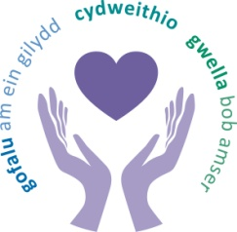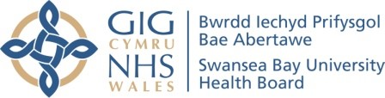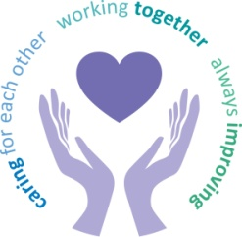
 |  | Agenda Item | 5.1
Freedom of Information Status |  | Open
Reporting Committee | Audit Committee
Author | Georgia Pennells, Corporate Governance Officer
Chaired by | Nuria Zolle, Independent Member
Lead Executive Director (s) | Hazel Lloyd, Director of Corporate Governance
Date of last meeting | 14 September 2023
Matters to Draw to the Attention of the Board (particularly areas relating to risk or quality)
- Quality and Safety Systems
A report setting out the progress to develop a quality management framework was received. Members gave thanks for all the good work undertaken to date. Members noted it was important to keep an eye on the outcomes in terms of the culture, the embedding of processes between board to floor and requested a reflective report be brought to a future committee.
- Covid-19 Inquiry – Digital Issues
The briefing paper highlighted an NHS Wales wide Microsoft Office 365 configuration error which has resulted in mailboxes being deleted for staff who have left the organisation. The paper also provided assurance on the actions that have been carried out to resolve the issue and mitigate against further risk. Committee members were content with the level of assurance in the report and that the internal governance systems in place for SBUHB were operating effectively should the incident happened again however, recongised it was complex and relied on an All Wales system approach.
Other Areas of Discussion
- Internal Audit Progress Reports
The following internal Audit reports were received:
- Continuing Healthcare; Limited Assurance – to be referred to Performance and Finance.
- Estates; Limited Assurance.
- Capital; Substantial Assurance.
- Commissioning LTA Contracts; Reasonable Assurance.
- Audit Wales Performance and Progress Report and Work Programme
The Audit Wales performance progress report was received. Members were made aware that Audit Wales were planning to carry out a deep dive into digital services’ as part of the structured assessment work, however due to the current pressures on health boards in relation to the financial position this was now the area of focus. The scope of work would be shared with health boards shortly.
- Declaration of Interest, Gifts and Hospitality Registers
The mid-year declaration of interest, gifts and hospitality registers were received and noted.
- Post Payment Verification (PPV) Report
Committee members were advised in the past year 2022/2023, PPV have faced challenges associated with the ability to perform ‘Business as Usual’ due to different factors. Members were assured that there were clear and valid reasons behind the low numbers.
- Month 5 – Financial Positon
The Director of Finance and Performance provided a verbal update on the month 5 financial position. It was agreed committee members would be kept fully appraised with updates and actions, following discussions at the September Performance and Finance Committee with Morriston service group.
- NWSSP Single Tender and Quotations
During the period 23/06/23 to the 25/08/23, there were 3 Single Quotation Actions (SQAs) approved, with a total value of £50,030 (inc. VAT) and 6 Single Tender Actions (STAs), with a total value of £733,206.24 (inc. VAT). 5 Retrospective action file notes were sent to the Head of Procurement for approval, with a total value of £795,590.80. In comparison with the last reporting period, the volumes were lower for SQAs and STAs which was a result of applying the All Wales exemptions list.
- Losses and Special Payments
The losses and special payments report covering the period between 1st April 2023 – 31st July 2023 was received and noted. Committee members asked for executive colleagues to explore the complaint handling and learning from settled cases, to which it was agreed to include the detail in the report to November 2023 Quality and Safety Committee.
- Counter Fraud
Members were informed that the Counter Fraud Team had launched a new blog style publication, ‘Fraud Focus’, available to staff via the Health Board’s intranet. The blog aimed to deliver fraud awareness to staff with plans to present this in the format of myth debunking, a Counter Fraud Specialist’s dear diary, counter fraud agony aunt, and an interview with special guests. Members highlighted the case referral rates, it was recognised there was an upward trend in the All Wales average however there wasn’t any specific trends, and SBUHBs position was being monitored closely.
- Counter Fraud Risk Management
A process has been implemented within the Counter Fraud Team to align completion of fraud risk assessment with existing risk management processes. Policy changes had been recommended to embed fraud risk within the Health Board’s risk governance framework. Overall, the work would increase accountability for fraud across the Health Board and also ensure a more efficient, focused and dedicated approach to fraud prevention. Members were content with how the report outlined the processes, but it was to monitor to ensure the processes worked in practice.
- Lymphoedema Wales Clinical Network Annual Report
The report confirmed that Lymphoedema Wales Clinical Network were complying with the governance obligations to SBUHB as the hosts of the service. Executive colleagues commended the service and no concerns were raised.
Decisions Made for Approval by the Board
Members recommended the following for board approval:
- Standing Orders.
Updates Received from Sub-Groups
There were no updates received from Sub-Groups.
Matters Referred to Other Committees
The following were referred to other committees:
- Continuing Healthcare; Limited Assurance – Performance and Finance Committee.
- Complaint Handling; November 2023 reporting to Quality and Safety Committee.
Date of next meeting | 09 November 2023

