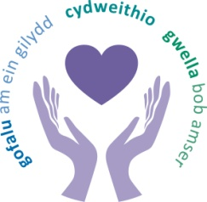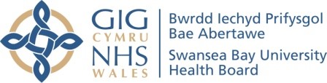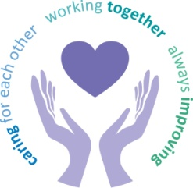
 |  | Agenda Item | 6.1
Freedom of Information Status |  | Open
Reporting Committee | Mental Health Legislation Committee
Author | Liz Stauber, Head of Corporate Governance
Chaired by | Steve Spill, Vice Chair
Lead Executive Director (s) | Gareth Howells, Executive Director of Nursing and Patient Experience
Date of last meeting | 02 November 2023
Matters to Draw to the Attention of the Board (particularly areas relating to risk or quality)
- Mental Health (Wales) Measure 2010 Monitoring Report
Part 1 80% of assessment by the Local Primary Mental Health (LPMHSS) undertaken within 28 days of referrals. Performance for Child and Adolescent Mental Health Services (CAMHS) stood at 33% in August and a concern raised in meetings with regards to performance since taken over the service in April 2023. There was a significant uplift in September to 56%. 80% of interventions (either on an individual or group basis) started within 28 days followed by an assessment by LPMHSS. Adults 100% in August and 97% in September. CAMHS hit target of 91% in August and 95% September. Part 3 Mental Health Measure (self-referrals and timely assessments) is no longer published by Welsh Government but would continue to monitor. Part 4 Mental Health Measure (Advocacy) SBUHB met the target for the 1st quarter of 2023/2024.

Other Areas of Discussion
- Mental Capacity Act 2005 Monitoring Report
Mental Capacity Act (MCA) reporting/compliance had been fragmented with many teams monitoring compliance and work will now begin to transfer the elements into the newly formed MCA DoLS team in accordance with organisational change requirements. Training would require a robust training model which easily accessible and meets the needs of the staff Benchmarking had been held across Wales to establish how other areas complete their training within Health Boards, groups. Two Best Interest Assessors are in place and it had been recognised that there was decline in the number of breaches. Concerns were highlighted regarding consistency of the Court of Protection process and there is a need to review and implement an updated robust monitoring process across the whole Health Board.

- Mental Health Act 1983 Monitoring Report
Section 5(2) Doctors Holding Power (up to 72 hours) was used on 29 occasions Section 2 Admission for Assessment (up to 28 days) was used on 65 occasions during the reporting period primarily on Ward F. Section 4 Emergency Admission for Assessment (up to 72 hours) was used on two occasions in the community with patients who came into Ward F. There were no CAMHS admissions into Ward F and did allow one enquiry to activate a bed, but fortunately an alternative treatment pathway was identified for the patient and remained a sustained period. There were 12 new Community Treatment Orders (CTO). Health Inspectorate Wales have undertaken an unannounced visit to Caswell Clinic. No issues of immediate assurance were identified. There were 29 rectifiable errors during this reporting period, 12 made by social services staff and 18 made by Health Board staff which were mainly due to errors on MHA paperwork. 6 non-rectifiable errors during this reporting period resulted in six unlawful detentions and lapsed detention periods by social services staff or health board staff.
- Transition from Child and Adolescent Mental Health Service
There are two areas on the action plan that remain incomplete. The first action related to the health board transition policy and the Second action was the DBS checks for Ward F staff.

Decisions Made
The committee work programme was approved.
Updates Received from Sub-Groups
No updates received from sub-groups.
Matters Referred to Other Committees
No referrals to other committees.
Date of next meeting | 01 February 2024

