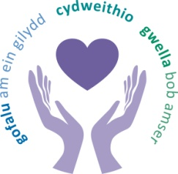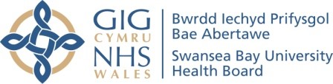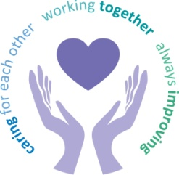
 |  | Agenda Item | 5.1
Freedom of Information Status |  | Open
Reporting Committee | Population Health and Partnership Committee
Author | Claire Mulcahy, Corporate Governance Manager
Chaired by | Emma Woollett, Chair
Lead Executive Director (s) | Keith Reid, Director of Public Health and Nerissa Vaughan, Interim Director of Strategy
Date of last meeting | 12 October 2023
Matters to Draw to the Attention of the Board (particularly areas relating to risk or quality)
No matters to draw to the attention of the Board.
Other Areas of Discussion
- West Glamorgan Regional Partnership Board (RPB)
The report provided a strategic overview of the Health and Social care Regional Integration Fund (RIF) and described how the partnership funding is allocated. Key features of the fund include a strong focus on prevention and early intervention, embedding national models of care and creating long term pooled fund arrangements and to ensure there is investment and embedding of the six priority national models of care. The RIF is a revenue fund and the regional allocations is circa £18m and supports the delivery of the priority areas. The Capital element of the RIF is £7.7m each year for the first two years and there was a bidding process in place. There is also a regional allocation of the £60m Integration and Rebalancing Care Fund (IRCF). Evaluations of the 49 funded schemes were due to take place and this will determine whether schemes move into the embedding stage or are stopped for funding to be re-allocated.

- Public Service Board (PSB)
The report provided detail on the statutory requirements for partnership working, the governance and health board representation on the PSB and the inter-relationships between partnership priorities. The guidance is underpinned by the seven Wellbeing Goals and the Five Ways of Working; Both the Swansea and Neath Port Talbot PSB’s have developed separate wellbeing plans which set out local objectives and proposals. The health board understands the challenges surrounding partnership working and the need to improve the internal approach to this through engagement. The health board play a key role in delivering Early Years services and in collaboration with other partner agencies. The inter-relationships between the PSB and RBP are very different. Although there is some alignment, they are focussed on different needs within the community, with the RPB focusing on key services for specific vulnerable populations and the PSB more on universal approaches to wellbeing. The health board’s duty as an anchor institution was discussed and it was agreed that committee would look further into how the board moves from a passive to active anchor organisation.
- Role of Public Service Board in Population Health Gain
The report highlighted that within the public sector the ‘how’ to deliver on a population health strategy is missing and the skills and capabilities required are identified as a gap for the health board. Productive partnerships are vital in achieving population health gain. There are important and significant differences and relationships between the PSBs and what role the health board plays in these partnerships. The South West Wales Corporate Joint Committee (CJC) was established in June 2022 and has links and a role to play in the delivery of actions outlined within the Population Health Strategy.
- Internal Capability and Capacity to progress Population Health Aspirations and Priorities
A system wide approach to population health is essential and there are areas already in development of this such as cross cutting business cases, ensuring population health implication and impact are considered as part of the business case approval and scrutiny process. Ensuring the distribution of resources in both revenue and capital to focus on maximising the potential population health gain. Understanding how to link in with the development of the Recovery and Sustainability Plan and also contributing to the development of the capability to deliver the One Bay Way and the development of skills and capability of existing staff. A framework had been developed which focuses on three key elements. Development programmes have been suggested to focus on strengthening the strategic narrative and leadership capability, strengthening the ability and capability to provide appropriate tactical response and a also supporting the capability at an operational level. Embedding a population health mind-set required cultural development and needed to be owned by every member of the health board. There were varying degrees of engagement at service group level and this needed to be addressed.

Decisions Made for Approval by the Board
The committee’s terms of reference were agreed for approval by the Board.
Updates Received from Sub-Groups
There were no updates received from Sub-Groups.
Matters Referred to Other Committees
There were no matters referred to Other Committees.
Date of next meeting | 07 December 2023

