

Meeting Date | 30th November 2023 |  | Agenda Item |  |  | 3.3
Report Title | Update on Annual Plan 24/25 Development and Approval of Health Board Strategic Objectives
Report Author | Ruth Tovey, Head of Strategic Planning  Ffion Ansari, Head of IMTP Development
Report Sponsor | Nerissa Vaughan, Interim Director of Strategy
Presented by | Nerissa Vaughan, Interim Director of Strategy
Freedom of Information | Open
Purpose of the Report | To set out progress made in developing the Health Board’s Annual Plan for the period 2024/25, approve the revised Strategic Objective and next steps
Key Issues | - Management Board received and discussed the update on the development of the Annual Plan 2024/25 in October 2023 and again in November 2023. This paper sets out: -  - The revised Strategic Objectives further refined since the October Management Board for approval.  - The proposed work to develop Strategic Indicators  - An overview of the anticipated national priorities and requirements for the Annual Plan 2023/24  - An overview of the progress to date in developing the Annual plan 2024/25  - The next steps in Annual Plan development for endorsement.
Specific Action Required | Information | Discussion |  | Assurance | Approval
Specific Action Required | ☐ | ☐ |  | ☐ | ☒
Recommendations | The Board is asked to:  - APPROVE the Strategic Objectives  - NOTE progress to date  - ENDORSE the next steps
UPDATE ON ANNUAL PLAN 24/25 DEVELOPMENT AND APPROVAL OF HEALTH BOARD STRATEGIC OBJECTIVES
- INTRODUCTION
The Health Board has a statutory duty to submit a financially balanced Integrated Medium Term Plan (IMTP) annually. In consideration of the national financial context, the Health Board is progressing with the development of an Annual Plan for 2024/25.
In order to maintain momentum on our planning process, the October Management Board received an update on the progress made in developing the Annual Plan 2024/25. Work has continued to progress and this paper sets out the key progress and issues for consideration and endorsement by the Board.

2. PROGRESS WITH DEVELOPING THE ANNUAL PLAN 24/25

2.1 Progress Since October Update
Work continues to progress to develop the Annual Plan for 2024/25, which will incorporate elements of our vision and our “One Bay Way”.
- Following further engagement since the 18th October 2023 Management Board, the revised Strategic Objectives were discussed at the Board Development session in October 2023 and are presented here for endorsement prior to submission to Board in November 2023 for approval.
- In support of the development of Strategic Objectives, Board level discussions have also taken place in relation to a proposed approach for taking forward Strategic level Indicators for the organisation with an update on this discussion to be received at Board Development in February 2024.
- The process for identifying emerging priorities through analysis of the current issues and challenges and the evidence base for possible solutions has commenced. These emerging priorities have been tested with the Integrated Planning Group to identify cross system opportunities and risks.
- These emerging priorities are now being further developed to establish the implications and outcomes in readiness for initial review by the Executive Team in early December 2023.

  - Strategic Objectives and Indicators
Our Strategic Objectives seek to articulate the future state of Swansea Bay University Health Board (SBUHB) as a high quality organisation, describing what this looks like and how we measure success. These Strategic Objectives also bring together the key strategies and policies in one place tying together in a single framework our Strategic Objectives, Wellbeing Objectives, Population Health Strategy and Quality Strategy.

The Strategic Objectives presented here for endorsement have been developed and tested through engagement at the Annual Plan workshop, Integrated planning Group, Management Board, Executive Steering Group, Health Partnerships Forum and Board Development where it was agreed to delegate additional amendments to the Executive Team.

The Proposed Strategic Objectives are:

- People of Swansea Bay live healthier, equitable and more equal and prosperous lives
- Care is high quality, safe, efficient and delivers the best possible outcomes for people
- Care is delivered in safe and appropriate settings supported by innovative digital solutions
- The Health Board is a great place to work where staff feel valued and work together towards a common goal
- The Health Board is a resilient, financially sustainable and responsible organisation

The statements to describe what High Quality looks like for each strategic objective are included in Appendix 1 for information. Board is also asked to approve the High Quality Statement s for Objectives 1 as the Organisations Wellbeing Objectives.

These are:
- Every child has the best start in life
- All children, young people and adults are enabled to maximise their capabilities and have control over their lives
- Good work and fair employment is created for all
- A healthy standard of living is ensured for all
- Healthy and sustainable places are created through placemaking
- The role and impact of ill-health prevention is strengthened

An organisation wide developmental approach to developing indicators at strategic & tactical levels has been discussed at Board Development and will be taken forward in coming months to ensure the health board is provided with a longer term view of change at population level and assurance of delivery of the Strategic Objectives
2.3 Assumed National Priorities and Requirements
Welsh Government have yet to issue the Formal National Planning Guidance or any accompanying templates. Through Directors and Assistant Directors of Planning networks informal indications of what these might include have been sought and are presented below for information. In developing the Annual plan 2024/25 the below will be used as a checklist to ensure the Health Board is meeting all national expectations and requirements. This will be updated to reflect and further formal or informal guidance received from Welsh Government.

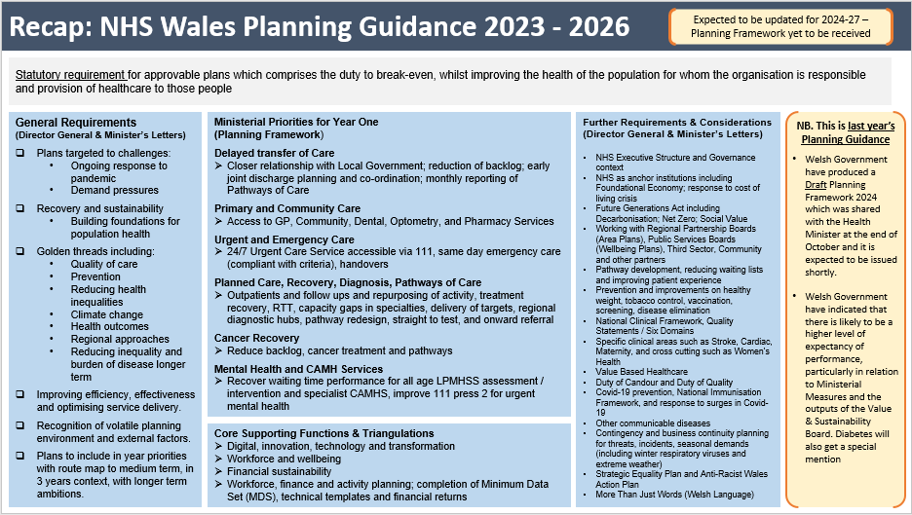
  - Workforce Considerations.
As we know our people will be central to the delivery of the annual plan. Time was spent in the workshop referenced in this paper on exploring and unpacking the strategic objective, Excellent People which was amended in draft to The Health Board is a great place to work where staff feel valued and work towards a common goal.
Board should note that the Workforce and Organisational Development (WOD) Directorate has developed a People Strategy in draft. This has been coproduced with all the staff in the WOD Directorate and is aligned to key national documents such as the National Implementation Plan. It supports the Health Board’s Vision document; One Bay Way and it is linked to the People Promise which unifies both documents.
The Strategy was out for engagement with all staff during October 2023, having already spoken with the Partnership Forum and LNC. The Strategy is due to be submitted to Board in November 2023 and finally launched in December 2023.
This will be an important document for the Health Board and will support and underpin all future Service Group and Health Board plans given the importance of the workforce in those programmes of work. .
2.5 Next Steps
The emerging priorities are now being further developed into to establish the implications and outcomes in readiness for initial review by the Exec Team in early December 2023.
- Further engagement to take place with Service Group Directors to ensure all priorities areas have been covered off;
- Finalise and issue the Impact and Delivery template to Systems for complete by the end of November 2023, to capture focused detail required for Executive decisions on final Health Board Priorities.
- Confirm prioritisation approach for Executive validation on the most critical and feasible priorities for delivery in 2024/25, to take place in December 2023.
The key dates and next steps are as below:
By end Nov | FINANCE Review cost pressures/ in year funding requirements – includes GMOs to be fully costed
By end Nov | Complete System GMO template for return to Strategy
W/C 4th Dec | Exec Prioritisation Session of GMOs Propose to use ESG 7th Dec to do this
8th Dec | FINANCE Complete Full Long List Financial Demands against £3.5m
15th Dec | FINANCE Confirm Total potential additional expenditure 2024/25 (taking into account national demands, e.g inflation, growth NICE, energy, Business Cases (RISP/LINC), NWSSP (WRP, ESR), CHC, LTA
20th Dec | Management Board receive indicative Year 1 list of GMOs (subject to final finance allocation received)
21st Dec – mid Jan | Finance and Workforce final review/ prioritisation of Year 1 GMOs
5th Jan | Assessment of the 2024/25 Allocation Letter (key issues WG uplift and management of pay award 24/25)
Mid Jan | FDU/ WG review of draft Financial Plan 24/25
25th Jan | Health Board approval of Annual Plan 24/25
31st Jan | Submit approved Annual Plan 24/25 to WG tbc awaiting expectations from WG

3. FINANCIAL IMPLICATIONS
There are no direct financial implications associated with this paper.
.
4. The Board is asked to:
- APPROVE the Strategic Objectives
- NOTE progress to date
- ENDORSE the next steps

Governance and Assurance
Link to Enabling Objectives  (please choose) | Supporting better health and wellbeing by actively promoting and empowering people to live well in resilient communities
Link to Enabling Objectives  (please choose) | Partnerships for Improving Health and Wellbeing |  | ☒
Link to Enabling Objectives  (please choose) | Co-Production and Health Literacy |  | ☒
Link to Enabling Objectives  (please choose) | Digitally Enabled Health and Wellbeing |  | ☒
Link to Enabling Objectives  (please choose) | Deliver better care through excellent health and care services achieving the outcomes that matter most to people
Link to Enabling Objectives  (please choose) | Best Value Outcomes and High Quality Care |  | ☒
Link to Enabling Objectives  (please choose) | Partnerships for Care |  | ☒
Link to Enabling Objectives  (please choose) | Excellent Staff |  | ☒
Link to Enabling Objectives  (please choose) | Digitally Enabled Care |  | ☒
Link to Enabling Objectives  (please choose) | Outstanding Research, Innovation, Education and Learning |  | ☒
Health and Care Standards
(please choose) | Staying Healthy |  | ☒
(please choose) | Safe Care |  | ☐
(please choose) | Effective Care |  | ☒
(please choose) | Dignified Care |  | ☒
(please choose) | Timely Care |  | ☒
(please choose) | Individual Care |  | ☒
(please choose) | Staff and Resources |  | ☒
Quality, Safety and Patient Experience
No direct implications of this report, however the Plan is predicated on improving quality, safety and patient experience.
Financial Implications
No direct financial implications of this report.
Legal Implications (including equality and diversity assessment)
A Quality Impact Assessment and Equality Impact Assessment process will be part of the broader planning arrangements to ensure that service models detailed in the Plan are quality and equality/ diversity impact assessed.
Staffing Implications
No direct impact outlined in this report however there will be significant staffing implications as a result of new service models outlined in the Plan – risks and implications to workforce form an integral part to planning arrangements.
Long Term Implications (including the impact of the Well-being of Future Generations (Wales) Act 2015)
Development of the Plan involved a review of our Strategic Objectives, aligned to the WBFGA and five ways of working.
Report History |  | Follow up to Management Board report on 18 October 2023, version of this was presented to Management Board on 15th November 2023
Appendices |  | Appendix 1: Strategic Objectives: What High Quality Looks Like

