Meeting Date | 27 March 2025 |  | Agenda Item |  |  | 4.5
Meeting Title | Health Board
Report Title | Cancer Performance Deep Dive
Report Author | Dr Raj Krishnan, Deputy Medical Director  Craige Wilson, Deputy Chief Operating Officer
Report Sponsor | Dr Richard Evans, Executive Medical Director  Deb Lewis, Chief Operating Officer
Presented by | Craige Wilson, Deputy Chief Operating Officer
Freedom of Information | Open
Purpose of the Report | The purpose of the report is to set out a deep dive into cancer performance, including an update on the action plan arising from the publication of Audit Wales report on Cancer Services in Wales (14 January 2025 - the Audit Wales (AW) Report)
Key Issues | - Whilst the AW Report recommendations are at a national level for Welsh Government (WG) to take forward, it highlights the fact that Swansea Bay University Health Board (SBUHB) cancer performance is not where it needs to be.  - This is not new information, as WG has already placed SBUHB in’ Targeted Intervention’ (TI), under its Escalation Policy.  - Actions have been underway during the last year to improve the position, including service developments;  - There are still a number of areas that required improvement, and risks to mitigate; some traction is, however, evident.
Specific Action Required  (please choose one only) | Information | Discussion |  | Assurance | Approval
Specific Action Required  (please choose one only) | ☐ | ☐ |  | ☒ | ☐
Recommendations | Members are asked to:  - RECEIVE the AW Report; this sets out strategic recommendations for WG, whilst also having implications for cancer service provision at local and regional levels.  - ACKNOWLEDGE the need for improvements to cancer performance to ensure that patients receive a diagnosis and start treatment within 62-days;  - TAKE ASSURANCE FROM improvement plans in place and the actions at a tumour site level, not just at service level, to address specific concerns;  - TAKE ASSURANCE from service changes designed to provide better diagnoses and treatment  - ACKNOWLEDGE the financial status of the elements of the plan highlighted.

- INTRODUCTION
The purpose of the report is to set out a deep dive into cancer performance, including an update on the action plan arising from the publication of Audit Wales Report on Cancer Services in Wales (14 January 2025 - the AW Report).

As part of the overall conclusions, the AW Report found “despite increased investment, there is a continuing failure to meet the national performance targets for cancer with a minority of patients facing unacceptably long waits for diagnosis and/or treatment. Cancer outcomes in Wales have improved over recent years but are still poor compared to other countries.”

While the recommendations were targeted at Welsh Government to take forward on a nation level, it nevertheless demonstrated the need for improvement within SBUHB . This is not new information and work has been underway for some time to improve access to cancer treatments.

- BACKGROUND
SBUHB is dedicated to providing comprehensive cancer care to its local population and to the wider population of South-West Wales, including patients from Hywel Dda University Health Board, Cwm Taf Morgannwg University Health Board and Powys Teaching Health Board. Furthermore, SBUHB provides specialist surgical services for pancreatic cancer and soft tissue sarcoma. Cancer care is delivered across a range of services, diagnostic and therapeutic. SBUHB also provides regional care via the South-West Wales Cancer Centre, located at Singleton Hospital and is the main regional referral centre providing radiotherapy, chemotherapy, immunotherapy and supportive care.

Over the last two decades, diagnosis of cancer has increased by 25% and there has been a significant change in the treatment regimens with more adjuvant therapies available.

SBUHB monitors patients’ access to cancer treatment via the 62-day Suspected Cancer Pathway (SCP). This was introduced by WG in 2019 (in shadow form) to set the target of 62 days for cancer diagnosis and the start of treatment, on a total pathway basis. This differs from the previous Urgent Suspected Cancer pathway, because of the removal of any time adjustments to pathways for clinical or non-clinical reasons. The aim of this change was to better reflect the wait patients experience for cancer diagnosis and treatment.

The all-Wales performance since the introduction of the SCP has been inconsistent and this is mirrored within SBUHB on a month by month and tumour site basis. There are some areas in which performance is better, while there are others, such as upper/lower gastrointestinal and urology, which continue to be areas of challenge.

Due to SBUHB performance levels, WG placed cancer care under Targeted Intervention (TI) in February 2024, with a target of achieving 60% compliance for a period of 6 months and delivering 70% compliance by the end of March 2025. The current national target for meeting the SCP is 75% (no health board is achieving this target) but this has been revised to 80% by March 2026.

- GOVERNANCE AND RISK ISSUES

- Cancer Improvement Plan
The Audit Wales Report published in 2024 recommended that health board’s should be delivering on the Cancer Improvement Plan (CIP) and performance monitoring data for the following should be available to the public:

- The number of people currently waiting for cancer diagnosis or treatment (open pathway data);
- Performance against the 62-day target Single Cancer Pathway (SCP).
- Performance across the patient pathways including timeliness of diagnostic reporting across different tumour sites;
- Timeliness of diagnosis and treatment for patients referred from the screening programmes, and
- Accurate information on equity of access, including ethnicity of cancer patients as well as the experiences of different patient groups including children and young people.

The attached (appendix 1) demonstrates the progress that SBUHB is making against the actions set out in the CIP for Wales. The appendix maps out the outstanding actions illustrates where SBUHB is addressing them in the Annual Plan for 2025/26.

- Performance Oversight
Cancer care covers 13 different tumour sites, within which there are a variety of diagnostic and treatment procedures. Performance against the 62-day performance is monitored on a tumour site basis, as well as overall for cancer services, through the following mechanisms:

- Fortnightly TI meetings, led by the Chief Operating Officer;
- Weekly tumour site meetings led by the Deputy Chief Operating Officer supported by the Cancer Performance and Information Manager;
- Monthly Cancer Performance and Improvement Group (CPIG) meetings, led by the Deputy Medical Director.

In addition, regular TI progress reports are provided to Health Board and Performance and Finance Committee, with a quarterly cancer deep dive also provided to the latter.

The fortnightly TI and weekly tumour site meetings focus solely on the performance targets and the actions being taken to improve delivery. In addition, the CPIG also exercises strategic oversight of the longer-term improvement and sustainability of cancer services.

The CPIG is integral to SBUHB efforts to enhance cancer care services. The group is attended by senior leaders from across the organisation, including representatives from all the Service Groups and Public Health and its primary objectives include performance monitoring, strategic planning and ensuring engagement with all the relevant stakeholders.

- Performance Targets
Performance against the SCP is regularly monitored and reported by the Chief Operating Officer to the Performance and Finance Committee, Management Board and Health Board and is a standing agenda item for the CPIG meeting.

Over the few last months, there has been steady improvements against the SCP target as demonstrated below and with retrospective reporting (when outstanding pathology results are available) 60% compliance achieved since March 2024.

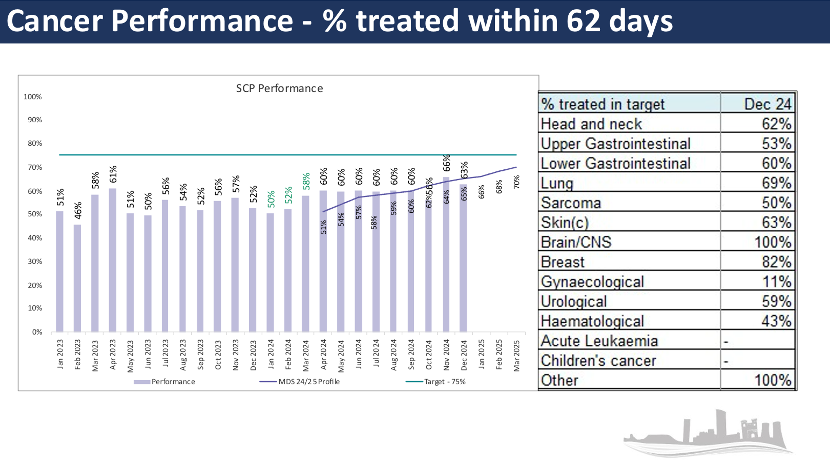
In addition to the SCP target, SBUHB also monitors the number of patients who are currently in the backlog i.e., waiting in excess of 62 days.
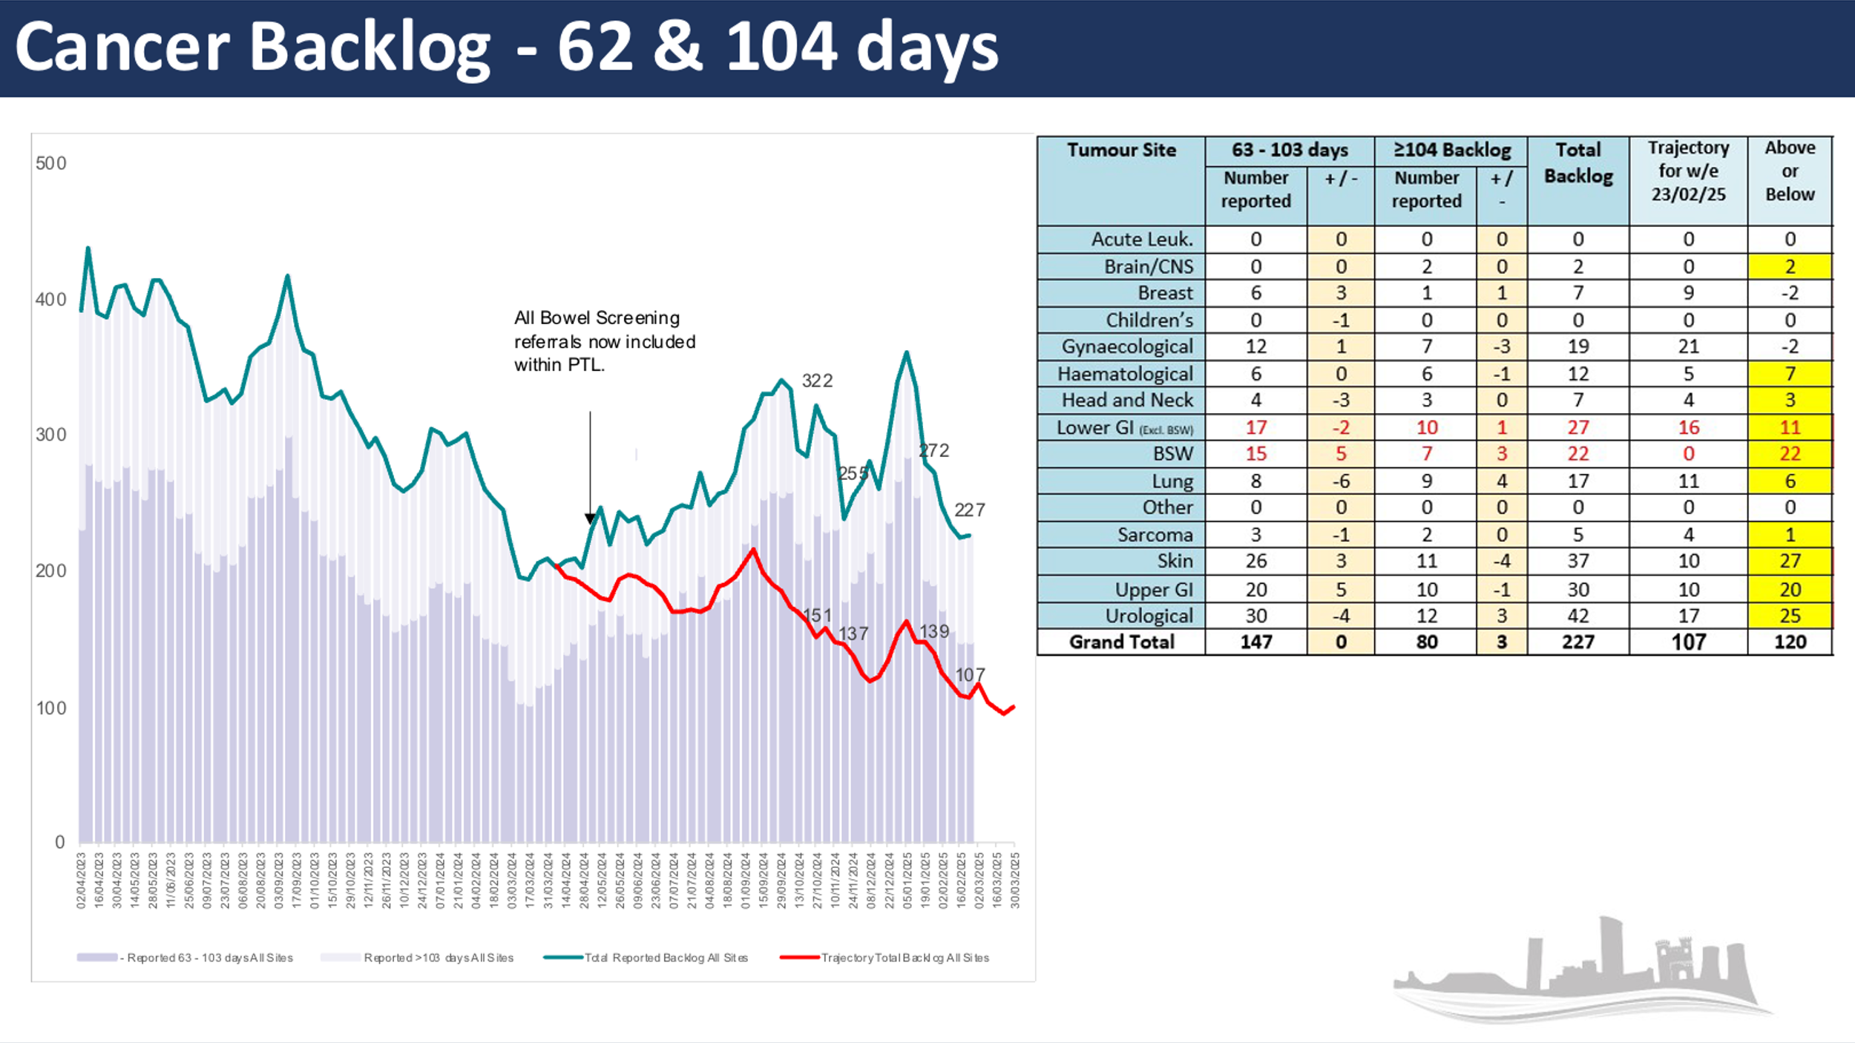
The backlog trajectory was steadily reducing until April 2024. This increase coincided with the inclusion of Bowel Screening Wales data in suspected pathways (previously only included following a positive diagnosis) and also in the change to the screening age, which has seen a subsequent increase in demand. This increase in demand is currently being addressed with additional lists within Endoscopy services.

Diagnostic reporting for Cellular Pathology is as follows:

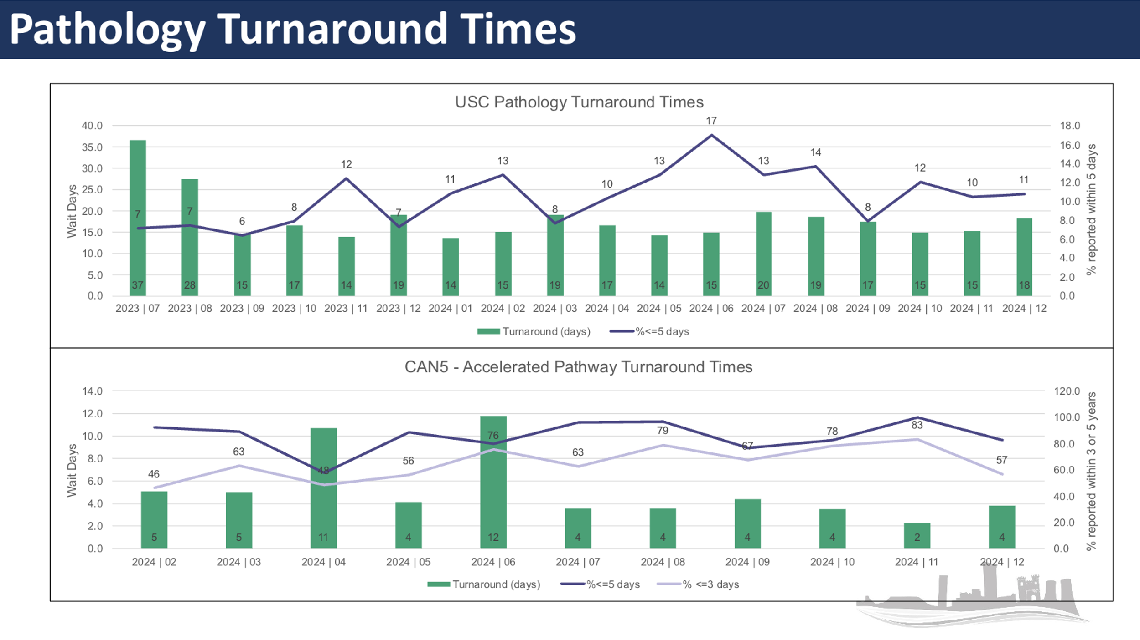
- Tumour Site Improvement Plans
Whilst some tumour sites are performing better than others, improvement is needed in all, and individual tumour site improvement plans are in place, monitored through weekly tumour sites meetings. Some of the key points include:

- Monitoring outpatient waiting times within services with the aim of offering all patient an appointment within 10 working days. Skin performance is directly linked to first appointment waits. Between August and December 2024, the median wait to a dermatology appointment was longer than the whole 62-day pathway. Sickness was a key reason for the decline; however it is also recognised that SBUHB has fewer consultants serving the population than any other HB in Wales. The service has been heavily reliant on waiting list initiatives (WLIs) for recovery and a locum consultant post has been approved pending a wider workforce review. Waits have improved, and are continuing to improve, which in turn will improve performance.
- Pre-operative assessment delays for cancer patients, including anaesthetic assessment. Task and Finish groups have been established as part of the theatre governance structure.
- To reduce Bowel Screening Wales (BSW) waits to index colonoscopy. Further discussion is required with Public Health Wales (PHW). There are currently only 3 accredited BSW Consultants in SBUHB carrying out weekly lists and we are dependent on a BSW list provided in Hywel Dda for SBUHB patients. Optimally seven weekly lists are required. Insourcing weekend work being utilised for the shortfall. One clinician is currently participating in the accreditation process and is due for assessment April 2025.

- Pressure Points and Areas of Risk and Challenge

Whilst positive progress has been made in reducing the time patients wait for their initial outpatient appointment, and progress has also been made in meeting the target of achieving a decision to treat within 31 days, there remain some pressure points which hamper the delivery of the 62-day target.

As shown above, Cellular Pathology is an area of significant challenge, particularly from a consultant workforce perspective with vacancies, retirements and an already acknowledged capacity gap. The service is reliant on what has become routine outsourcing and non-recurrent funding. Further mitigating actions include WLIs and a recently retired consultant providing sessions via bank; the Healthcare Systems Engineering Team is also working with the service to maximise pathway efficiency opportunities. An advert aimed at recruiting to a vacant consultant post is imminent, and a further post is going through the vacancy control process, whilst also seeking locum cover.

Surgical capacity is also a key factor for a number of specialties;
- Colorectal cancer – due to insufficient theatre sessions to meet increasing demand; exploring rebalancing with other cancer specialties and routine capacity and opportunities for regional working with Hywel Dda UHB;
- Gynae-Oncology – significant consultant workforce challenges; working with colleagues in Cardiff and Vale University Health Board and Hywel Dda University Health Board to look at opportunities to address these challenges;
- Urology – the addition of the new robot at Morriston Hospital has provided valuable additional capacity for prostatectomy surgery; in addition, however, approval for the OR1 business case is required to provide capacity for other Urology surgical treatments.

Another of the main pressure points for cancer services is the delivery of System Anti-Cancer Treatment (SACT) which includes chemotherapy, hormone therapy, immunotherapy and targeted therapies. A business case is currently in development for the provision of additional chairs and relevant support services to improve the provision.

- Sustainability and Service Developments

Skin
The significant increase in dermatology referrals from the middle of 2024 had a significant impact on skin cancer performance and the service is still trying to get on top of the backlog. Whilst there has been agreement to take on an additional locum consultant, there have also been initiatives to reduce demand on secondary care services. In primary care there are a number of practices who manage patients with Basal Cell Carcinomas (BCC) and other skin lesion and work is ongoing to ensure that referrals for suspected skin cancer are directed to the correct service using Health Pathways; plastic surgery, ENT, ophthalmology and Oral Maxillofacial Surgery (OMFS) all accept referrals for suspected skin cancer.

In addition, between January and December 2024, 21.6% of dermatology referrals received in SBUHB were triaged to teledermatology. Further consultant sessions are required to increase capacity within teledermatology which the service is reviewing. In addition, the Cancer Network/ NHS Executive has allocated £25K to SBUHB for the purchase of new and additional camera equipment for primary care.

Breast
SBUHB has committed a significant amount of investment (circa £400k) to support the breast cancer services during 2024/25. This investment and changes to prioritisation and management of breast cancer services has resulted in a significant improvement in SCP performance during the year.

Urology
The development of robotic surgery at Morriston Hospital for some urological cancers had seen a significant reduction in the backlog of patients awaiting this surgery during 2024/25; previously undertaken in the University Hospital for Wales. However, as cited above, additional sessions are required to further reduce the backlog and provide sustainable capacity.
Due to the nature of the prostate cancer pathway and need for long term follow up of large volumes of patients, a business case is being developed in support of a Band 4 support worker whose role will support the Urology Clinical Nurse Specialists in the implementation of risk stratified follow up.

Accelerated Diagnostic Pathway
An accelerated diagnostic pathway for endoscopy, pathology and radiological investigations has been introduced for colorectal pathway. This has had significant impact in ensuring a Decision to Treat (DTT) is achieved within the 31-day target. However, as already noted, this has now highlighted that additional surgical/theatre capacity is required to bring about an improvement in SCP performance.

Research
As part of ensuring service sustainability and service developments, research and development are vital, and SBUHB is one of the more active research organisations across NHS Wales. Cancer trials are an area which is currently challenged, due in part of the capacity of pharmacy support. As such, a bid has been submitted to the Voluntary Scheme for Branded Medicines, Pricing, Access and Growth (VPAG), a scheme which is investing £300m to increase commercial trial activity in Wales, £22m of which is for Wales, for pharmacy support, medical leadership for the oncology team and a liaison nurse based in the chemotherapy day unit to support the delivery of trials within. A second bid was submitted jointly with Hywel Dda University Health Board around oncology resources. This aligns with recent discussions as part of the Joint Committee between the two health boards as part of a commitment to more regional work.

- Digital

Work continues within Digital Heath Care Wales (DHCW) to replace the previous outdated cancer information system (Canisc). Progress has been very slow, and services continue to rely on fragmented digital systems. Health Boards were asked to implement the new cancer informatics solution by end of March 2025, a deadline which was extended 18-24 months from its original target. At this time, DHCW is not able to deliver the full product by the March 2025 deadline. SBUHB has been fully engaged throughout and has implemented the Cancer Information System (CIS) within the Multi-Disciplinary Team (MDT) workstream and Palliative Care workstream is ongoing. It remains difficult to predict full implementation as the product remains in various stages of development at DHCW.

The scope of the CIS work did not include improved tracking systems. SBUHB uses the Welsh Patient Administration System (WPAS) Cancer Tracker module. It is increasingly apparent that the module is now outdated, too heavily reliant on manual data entry of information that already exists elsewhere, and requires investment for improvement. TheRE is strong support amongst the Cancer Operational Managers Group (COMG), a group chaired and facilitated by the NHS Executive, for a review and assessment of requirements to be undertaken, especially as all Health Boards using WPAS are, or will be, capturing data within the module.

There are a number of tools, locally and nationally to support tracking and analysis of trends, but as this data is primarily sourced from the WPAS Cancer Tracker Module, it has limitations.

- FINANCIAL IMPLICATIONS

The financial implications are summarised in the table below:

Area | Detail | Summarised Financial Assessment
SACT | Additional Chairs to support SACT | 2025/26 Financial Plan contains £0.4m to support 2 additional chairs  Additional chairs above the two funded within the plan will require transfer of existing resources from within the health board.
Urology / NHS Wales Joint Commissioning Committee | Expanding the capacity above the current funded Theatre Robotic capacity | SBUHB budgetary position of the includes current level of provision. To expand this level of capacity will require additional funding via the commissioning bodies of NHS Joint Commissioning Committee, Hywel Dda and Cwm Taf Morgannwg Health Boards. No additional funding to support the expansion is assumed within the Financial Plan.
Cellular Pathology | Substantive appointments (to existing vacancies) and further service transformation are required to provide a sustainable solution to the current capacity deficit | 2025/26 Financial Plan funding to support sustainable service will need to be sourced and agreed from the Planned Care Recovery funding stream.
Gynaecology Oncology | SBUHB is seeking additional locum support, with a plan to insource additional routine capacity in the first quarter of 2025/26 to support the service. | Whilst SBUHB has committed funding within 2024/25, the costs are not incorporated within the underlying deficit position of Neath Port Talbot Singleton Service Group and therefore any expenditure to support this will need to be transferred from other areas of the 2025/26 plan.

- RECOMMENDATION
Members are asked to:

- RECEIVE the Audit Wales Report; this sets out strategic recommendations for Welsh Government whilst also having implications for cancer services delivery at local and regional level;
- ACKNOWLEDGE that improvements are required to cancer performance to ensure patients receive a diagnosis and start treatment within 62-days;
- TAKE ASSURANCE from improvement plans that are in place and that action is being taken on a tumour site level not just at service level to address specific concerns;
- TAKE ASSURANCE from service changes designed to provide better diagnoses and treatment;
- ACKNOWLEDGE the financial status of the elements of the plan highlighted.

Governance and Assurance

Link to Enabling Objectives  (please choose) | Supporting better health and wellbeing by actively promoting and empowering people to live well in resilient communities
Link to Enabling Objectives  (please choose) | Partnerships for Improving Health and Wellbeing |  | ☒
Link to Enabling Objectives  (please choose) | Co-Production and Health Literacy |  | ☐
Link to Enabling Objectives  (please choose) | Digitally Enabled Health and Wellbeing |  | ☐
Link to Enabling Objectives  (please choose) | Deliver better care through excellent health and care services achieving the outcomes that matter most to people
Link to Enabling Objectives  (please choose) | Best Value Outcomes and High Quality Care |  | ☒
Link to Enabling Objectives  (please choose) | Partnerships for Care |  | ☐
Link to Enabling Objectives  (please choose) | Excellent Staff |  | ☐
Link to Enabling Objectives  (please choose) | Digitally Enabled Care |  | ☐
Link to Enabling Objectives  (please choose) | Outstanding Research, Innovation, Education and Learning |  | ☐
Health and Care Standards
(please choose) | Staying Healthy |  | ☐
(please choose) | Safe Care |  | ☒
(please choose) | Effective Care |  | ☒
(please choose) | Dignified Care |  | ☒
(please choose) | Timely Care |  | ☒
(please choose) | Individual Care |  | ☒
(please choose) | Staff and Resources |  | ☐
Quality, Safety and Patient Experience
Timely diagnosis and start of treatment can positively affect a patient’s outcome. It can also put the minds of those who do not have cancer at rest as waiting for a diagnosis is an anxious time.
Financial Implications
There are no financial implications to this report.
Legal Implications (including equality and diversity assessment)
There are no legal implications to this report.
Staffing Implications
There are no staffing implications to this report.
Long Term Implications (including the impact of the Well-being of Future Generations (Wales) Act 2015)
It is important that improvements and service developments are made to the way in which cancer services are provided in order to have robust and sustainable services for the future.
Report History |  | First report to the board
Appendices |  | Appendix one – Cancer Improvement Plan

