
Meeting Date | 28th March 2024 |  | Agenda Item | 2.7
Report Title | Quarter 3 Ministerial Priorities Update Report
Report Author | Charlotte Angell, Health Board Performance Support Officer  Samantha Moss, Deputy Director of Finance  Ruth Tovey, Head of Strategic Planning
Report Sponsor | Darren Griffiths, Executive Director of Finance and Performance, Acting Deputy CEO  Nerissa Vaughan, Interim Director of Strategy
Presented by | Darren Griffiths, Executive Director of Finance and Performance, Acting Deputy CEO
Freedom of Information | Open
Purpose of the Report | The purpose of this report is to provide the Board with a quarter 3 update in a series of routine quarterly reports which updates the Board on performance delivery against key Ministerial Priorities as selected by the Board.
Key Issues | Ministerial Priorities are reported routinely to the Board via the Integrated Performance report but are contained within a range of other measures. This separate priorities focussed report provides the Board with a single assessment of these priorities.  Performance delivery against the Ministerial Priorities is also reflected alongside financial performance and the report draws out the status of the directed investment plans to support the delivery of the priorities.  The key priority areas are: -  - Unscheduled Care – access times  - Unscheduled Care – ambulance handover performance  - Single Cancer Pathway – access times  - Planned Care – access times  - Child and Adolescent Mental Health Services (CAMHS) and Neuro Development Disorders (NDD) – access times  - Finance  In each of the sections of the report a confidence of delivery assessment is made and where an area is off target the required corrective actions are set out.  Appendix 1 to this report is the full Integrated Performance Report as reported to Performance and Finance Committee.  Through the Health Board’s ongoing discussions with Welsh Government and the NHS Executive clarity is being sought as to the key metrics to be monitored as part of the Targeted Intervention and Enhanced Monitoring processes and where improvement is required to de-escalate such areas.  Once these are agreed this report will be updated to include these, along with 2024/25 Ministerial priorities to provide clarity to the Board on progress and status of actions.  Appendix 2 provides further information on the detailed elements of the plan that link to the performance delivery.
Specific Action Required | Information | Discussion | Assurance | Approval
Recommendations | The Board is asked to:  - NOTE: The Health Board performance against the Ministerial priorities  - NOTE: The actions planned for areas which are outside of planned trajectory  - NOTE: The work planned to incorporate performance escalation metrics once agreed with Welsh Government and the NHS Executive.

QUARTER 2 KEY PRIORITIES UPDATE REPORT

- INTRODUCTION
This report updates the Health Board on the performance of key ministerial priority measures in Quarter 3 (2023-24). This report is not an exhaustive assessment of all performance areas, but a highlight report on the selected ministerial priority performance areas of unscheduled care, cancer services, planned care, CAMHS, NDD and Finance. The metrics reported are as follows: -

Unscheduled Care – access times
- 4 hour waits (%) in the Emergency Department (ED)
- 12 hour waits (#) in the ED
Unscheduled Care – ambulance performance
- Ambulance handovers – lost hours (#)
Single Cancer Pathway – access times
- 62 day access time delivery (%)
- Patients waiting over 63 days (#)
Planned Care – access times
- 104 week waits (#) all patients
- 52 week waits (#) outpatients only
- Endoscopy 8 week waits (#)
Child and Adolescent Mental Health Services (CAMHS) and Neuro Development Disorders (NDD) – access times
- CAMHS Part 1a – assessments undertaken within 28 days (%)
- CAMHS Part 1b – interventions undertaken within 28 days (%)
- CAMHS Part 2 – patients in receipt of secondary mental health Care and Treatment Plan (%)
- NDD – patients waiting for an ADHD or ASD assessment within 26 weeks (%)
Finance
- Spend against plan areas
- Overall delivery against plan

The routine Health Board Integrated Performance Report is attached as Appendix 1 for the Board’s information.

Each of the areas has been assessed against delivery using a simple RAG rating. Where areas are off plan further actions for quarter 4 are described in the paper. Detailed actions by quarter are provided in Appendix 2 to this report.

- PERFORMANCE MEASURES

Unscheduled Care

4 hour Emergency Department (ED) access
Unscheduled care performance has seen an improvement throughout Quarter 3 as a result of developing and implementing a new on-boarding/escalation operational policy to support more timely ambulance handovers. The improvement actions outlined as part of the newly implemented Continuous flow model and Six Goals programme are supporting unscheduled care performance benefits. Updated 2023/24 performance trajectories can be seen below.

Performance against the 4-hour access target was on track in October 2023 and was 74.7% at the end of Decebmer 2023.

Status - AMBER

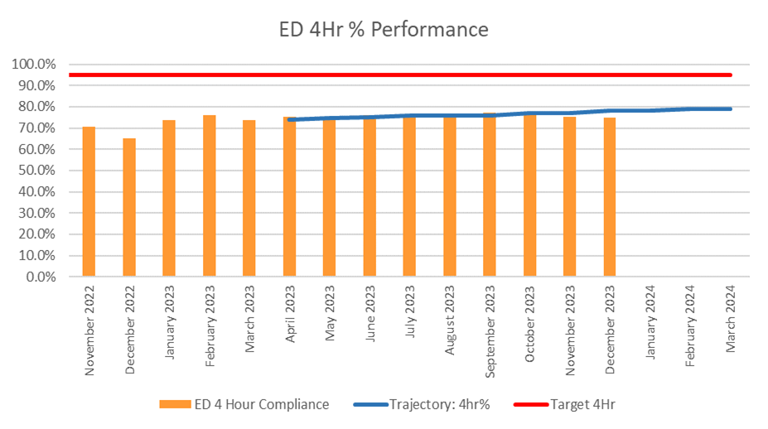

Patients waiting over 12 hours in ED
Performance against the 12-hour wait improved during the last two months of quarter 3, but remains outside of the agreed reduction profile. The number of patients waiting over 12-hours in the Emergency Department was 994 in December 2023.

Status - RED
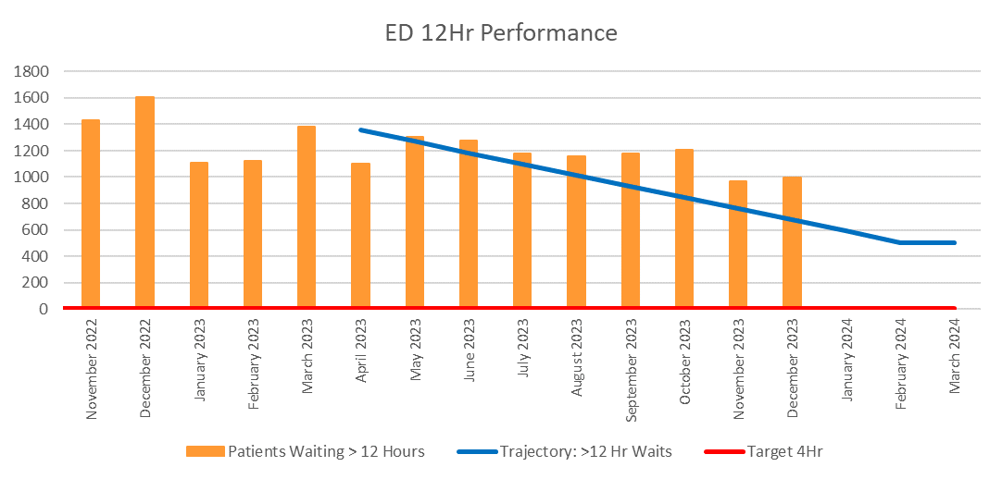

Number of hours lost to handover delays > 15 minutes
The ambulance handover lost hours rate has remained broadly flat through Quarter 3. In December 2023 3,787 hours were lost to handover delays which is significantly above trajectory. This is a key area of concern relating to Targeted Intervention and the Health Board has plans to implement pathway changes and a frailty model to begin to address the system wide pressures which are leading to these delays.

Status - RED

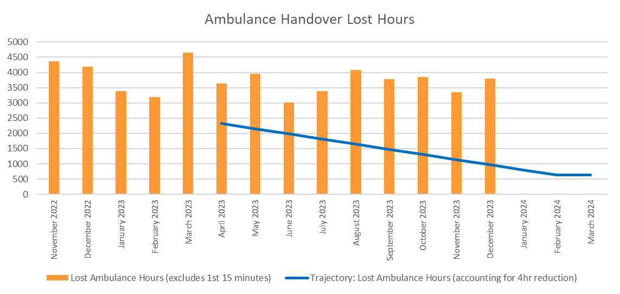

Cancer

Access to cancer treatment within 62 days
The final SCP performance for December 2023 was 51%, which is a minor deterioration on the previous month from 53%. As with unscheduled care, cancer performance has been escalated internally to increased monitoring and a detailed recovery plan is currently in place. The management of cancer performance is now being led by the COO and the Interim Medical Director. The 2023/24 Single Cancer Pathway trajectory can be found below.

Status: RED
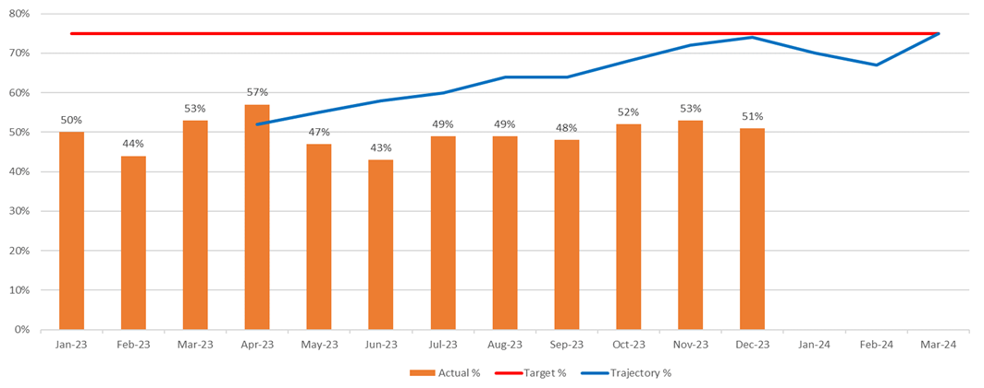

Single cancer pathway backlog volume – 63 days and over
Single Cancer Pathway (SCP) Backlog figures had seen an improvement across quarter 3 but saw rise in the last few weeks of December 2023. The total backlog at 07/01/24 was 302 against a trajectory of 272. The main tumour sites that make up the backlog are as follows: -

- Gynaecology – 60
- Urological – 56
- Lower GI – 52
- Upper GI - 37

Status – AMBER
SCP Backlog waiting over 63 days

The actions required to recover the SCP percentage target to trajectory as planned for Quarter 4 are: -

Actions:
- Maintain a focus on reducing backlog volumes aligned to the trajectory
- Weekly tumour site review meetings are underway to ensure focus on key issues
- Over-arching weekly focussed cancer improvement meetings have been established by the Interim Medical Director
- Focus on 1st outpatient appointment within 10 days and Decision To Treat achieved within 31days

Planned Care

Patients waiting over 104 weeks (All Pathways)
The number of patients waiting over 104 weeks on all stages of their RTT pathway saw a further reduction in December 2023 to 2,969 and has improved consistently across Quarter 3.

A substantial amount of resource is contained within the overall financial plan (£22.9m) to support the delivery of the planned care target. The plan for this area is currently under review to align the planned resource to optimise the target delivery. The target is that 1% or fewer of patients should be waiting under 104 weeks by March 2024.

The Board will be aware that the Health Board has also been allocated £15.5m (£14m for orthopaedics and £1.5m for endoscopy) from the Welsh Government regional allocation funding which was top sliced this year.

Status - AMBER
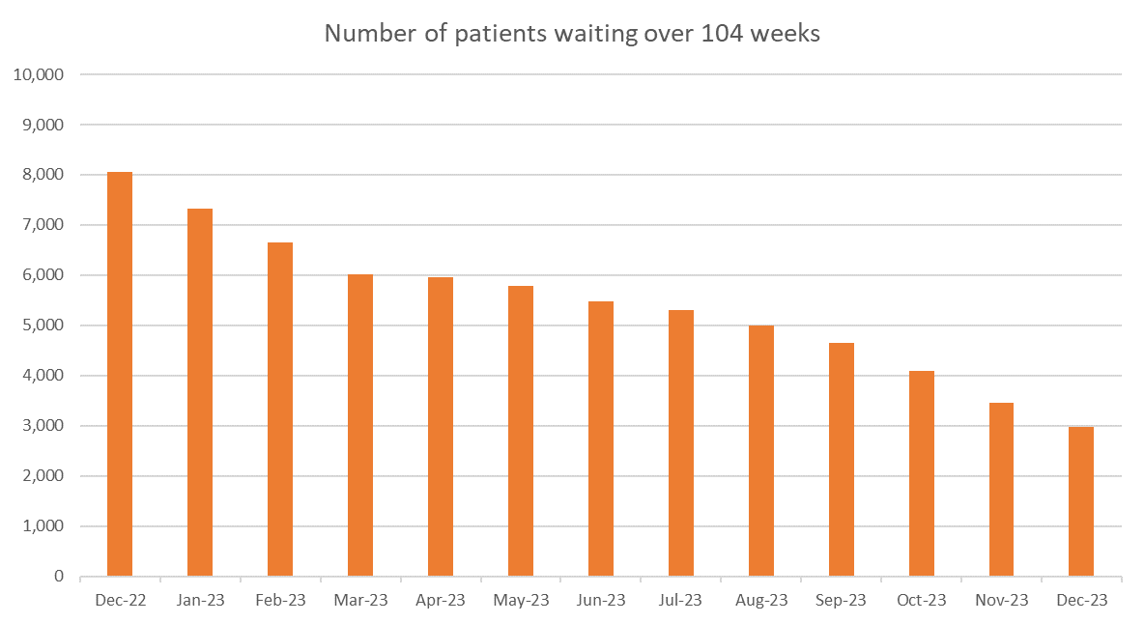

ACTION: Implement planned care efficiency measures which include; over-booking clinics, improving treat in turn rates, increasing capacity, validation of pathways and internal administrative and clinical validation.

Patient waiting over 52 weeks for a first outpatient appointment
The number of patients waiting over 52 weeks at Stage 1 (new outpatient) fell below 52 weeks in October 2023 in line with plan. This has remained the case through the quarter and is therefore meeting the national target.

Status - GREEN
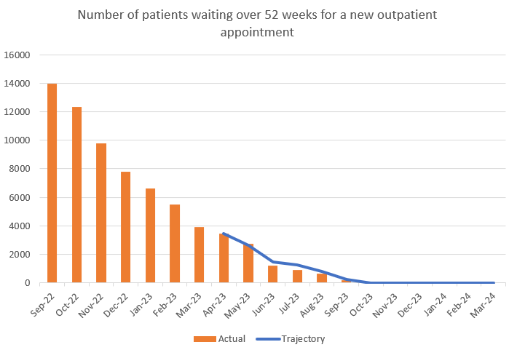

Patients waiting over 8 weeks for diagnostic endoscopy
The number of patients waiting over 8 weeks for a diagnostic endoscopy has decreased across Quarter 3 but saw a small increase in December 2023. At the end of September 2023 there were 4,148 patients waiting over 8 weeks and at the end of December 2023 this had improved to 3,553. It is anticipated that performance will improve after the Christmas break and across Quarter 4. The figures are currently slightly outperforming the submitted trajectory and the Endoscopy team continue to implement several actions to support future improvement and continue to maintain their two-week cancer waits. A detail demand and capacity exercise is also underway and will report in Quarter 1 of 2024/25.

Status - AMBER
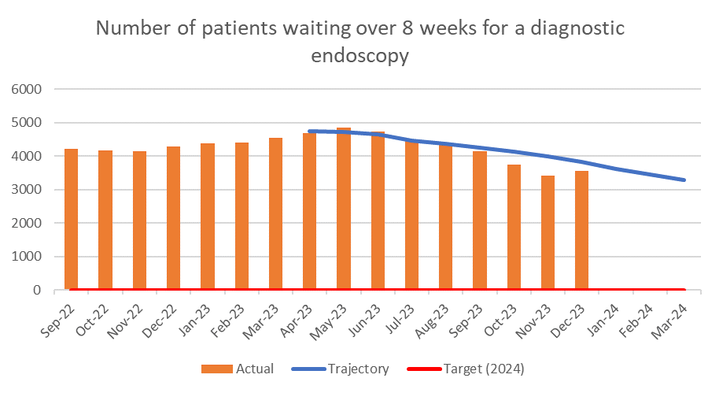
ACTION: Undertake Endoscopy waiting list validation exercise to ensure the position is an accurate reflection of the position- November 2023

CAMHS

CAMHS access for assessment and intervention access times
Performance against the CAMHS performance targets can be seen in the graphs below. As a Health Board, we are outperforming the submitted Welsh Government Trajectories and are now providing far greater access to assessments and interventions for both part 1A and part 1B measures.

Status: GREEN

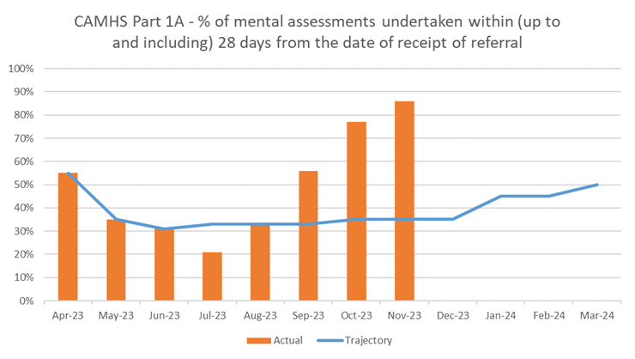

Status - GREEN
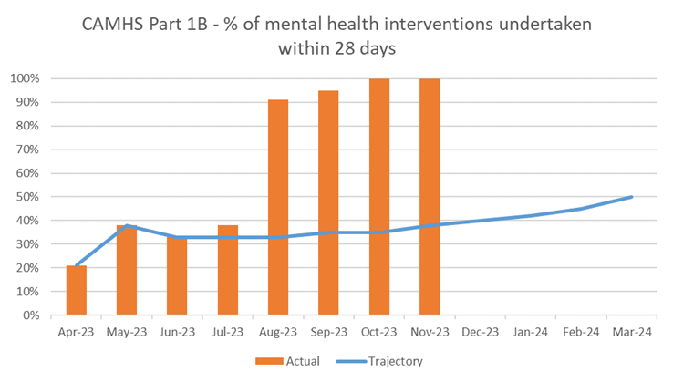

Status: GREEN
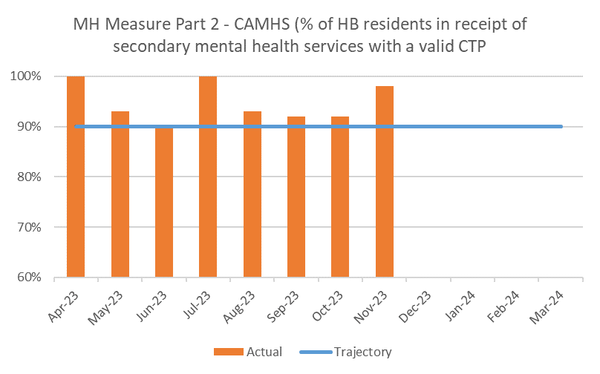

NDD

Patients waiting for a Neurodevelopmental Assessment within 26 weeks
There are currently 1,080 patients waiting for ADHD/ASD diagnostic assessments as at 31/12/23. Of the 1,080, 787 are waiting over 26 weeks, with 28% of patients waiting less than 26 weeks at the end of December 2023.

The service continues to see vacancies within the team impacting on capacity and many recent attempts to recruit have not been successful. A further round of recruitment is underway now and an additional Advancer practitioner post has been secured to support diagnostic assessments.

A significant amount of modernisation work is underway within the team utilising electronic referrals, pathway redesign, awareness sessions and equipment upgrading.

Status - RED

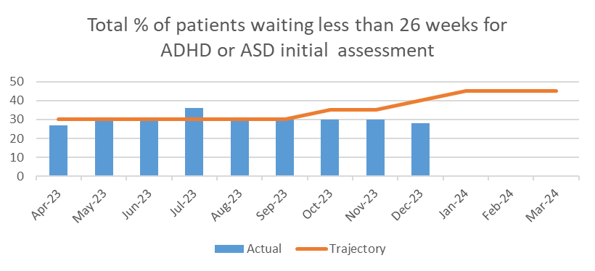

- GOVERNANCE ISSUES AND RISKS
There are a number of risks reported on the health board risk register and the key risks are highlighted in the table below for reference. These risks are reported within the Health Board Risk Register report to the Board today. The risks are under routine assessment by the Executive Leads and are subject to discussions at the relevant Committees.

Risk Ref | Risk & Mitigating Actions | Current  Risk Score
1 | Access to Unscheduled Care | 25
50 | Access to Cancer Services | 25
16 | Access to Planned Care | 20
69 | Safeguarding: Adolescents on Adult Mental Health Wards (this is being reviewed in light of CAHMS transfer) | 20
92 | Finance – Forecast Deficit | 20

- FINANCIAL IMPLICATIONS
The Health Board (HB) submitted a revised plan at 31st May 2023 which reported a deficit of £86.6m. As noted in the Q2 report as a result of the hard work undertaken by Welsh Government colleagues, the HB has received significant additional funding of £60.8m for 2023/24, of which £43.3m is recurrent. For 2023/24 there is then a requirement for the HB to deliver a further 10% reduction in expenditure to achieve a control total of £17m.

Within the Financial Plan the Health Board provided additional support for service pressures and investments in many areas, including the Ministerial Priorities. A summary of the investments made by area is provided below:

Area | 23/24 Funding  £M | Utilisation of Funding
Cancer | 1.00 | £3m has been provided over the last 3 financial years and has been committed in full. In 2023/24 the funding was transferred in full to NPTS to ensure the Cancer Board had direct access to utilise the resources available.
UEC | 5.43 | WG has provided the Health Board with £2.960m until 2025/26 to support 6 Goals/UEC. The Health Board investment has invested £2.47m above the £2.960m within the 23/24 to support UEC’s combined investment of £5.43m
Planned Care | 22.90 | £15.2m was provided by WG with the Health Board investing a further £7.7m to support delivery of planned care targets. At the end of quarter 1 the Health Board had already spent £5.2m.
Planned Care (Regional) | 15.50 | £15.50m has been made available to support Orthopaedic Theatre development in the NPT hospital along with additional diagnostics.
CAMHs | 2.69 | Whilst this is not additional funding the £2.69m is the value previously provided to CTM to support CAMHS which has now been transferred in full from the Commissioning Budget to the MH/LD Service Group in Swansea Bay to provide the services for its population. There will be further investment provided in 23/24 for CAMHS In Reach support to Schools direct from WG.

As noted in the Financial Performance paper the original plan was set on a tapered profile reflecting the expectation that some of the run rate work would take two quarters to fully embed and deliver. The additional funding of £60.8m has been profiled on a straight line basis, consistent with the approach adopted by other HB’s. During Q3 the HB has been focusing on the establishment of its ‘Landing Plan to achieve its control total and the action required. At the end of Q3 the HB remained overspent by £41.5m, but is on target to deliver the actions within the Landing Plan, although recognising significant work was required during Q4 to achieve the target.

A full update of the Financial Position is provided to the Board within the Financial Performance paper.

- Recommendations
The Board is asked to:
  - NOTE: The Health Board performance against the Ministerial priorities
  - NOTE: The actions planned for areas which are outside of planned trajectory
  - NOTE: The work planned to incorporate performance escalation metrics once agreed with Welsh Government and the NHS Executive.
Governance and Assurance
Link to Enabling Objectives  (please choose) | Supporting better health and wellbeing by actively promoting and empowering people to live well in resilient communities
Link to Enabling Objectives  (please choose) | Partnerships for Improving Health and Wellbeing |  | ☒
Link to Enabling Objectives  (please choose) | Co-Production and Health Literacy |  | ☒
Link to Enabling Objectives  (please choose) | Digitally Enabled Health and Wellbeing |  | ☒
Link to Enabling Objectives  (please choose) | Deliver better care through excellent health and care services achieving the outcomes that matter most to people
Link to Enabling Objectives  (please choose) | Best Value Outcomes and High Quality Care |  | ☒
Link to Enabling Objectives  (please choose) | Partnerships for Care |  | ☒
Link to Enabling Objectives  (please choose) | Excellent Staff |  | ☒
Link to Enabling Objectives  (please choose) | Digitally Enabled Care |  | ☒
Link to Enabling Objectives  (please choose) | Outstanding Research, Innovation, Education and Learning |  | ☒
Health and Care Standards
(please choose) | Staying Healthy |  | ☒
(please choose) | Safe Care |  | ☒
(please choose) | Effective Care |  | ☒
(please choose) | Dignified Care |  | ☒
(please choose) | Timely Care |  | ☒
(please choose) | Individual Care |  | ☒
(please choose) | Staff and Resources |  | ☒
Quality, Safety and Patient Experience
The performance report sets out a series of illustrations across unscheduled, planned and cancer care to inform the Management Board of the current position.

The selected performance metrics provide a context to understand the quality, safety and patient experience of patients in these systems of care.

There are no directly related Equality and Diversity implications as a result of this report.

Financial Implications
These are set out above

Legal Implications (including equality and diversity assessment)
n/a

Staffing Implications
n/a

Long Term Implications (including the impact of the Well-being of Future Generations (Wales) Act 2015)
The ‘5 Ways of Working’ are demonstrated in the report as follows:
- Long term – Actions within this report are both long and short term in order to balance the immediate service issues with long term objectives. In addition, profiles have been included for the Targeted Intervention Priorities for 2019/20 which provides focus on the expected delivery for every month as well as the year end position in March 2020.
- Prevention – the NHS Wales Delivery framework provides a measureable mechanism to evidence how the NHS is positively influencing the health and well-being of the citizens of Wales with a particular focus upon maximising people’s physical and mental well-being.
- Integration – this selected performance report brings together key performance measures across a number of care systems.
- Collaboration – in order to manage performance, the Corporate Functions within the Health Board liaise with leads from the Service Groups as well as key individuals from partner organisations including the Local Authorities, Welsh Ambulance Services Trust, Public Health Wales and external Health Boards.
- Involvement – Corporate and Service Group leads are key in identifying performance issues and identifying actions to take forward.
Report History |  | This report is a routine quarterly Ministerial priority summary overview of performance presented to the Board
Appendices |  | Appendix 1: Health Board Integrated Performance Report  Appendix 2: High Level Plan Overview – Q3

APPENDIX 2
SBUHB ANNUAL PLAN 23/24
HIGH LEVEL PLAN OVERVIEW: Q3 REPORTING

Purpose: To provide an update on delivery of the key priorities in the SBUHB Annual Plan 23/24 which align to the Ministerial Priorities for delivery in 23/24. The agreed delivery actions (methods, underpinned by quarterly milestones) and intended performance impact (Year 1 outcome, underpinned by monthly/ quarterly trajectories) have been assessed by SROs using the following definitions:

METHODS RAG STATUS: | Definitions
Green | ON TRACK - Action progressing as planned and to agreed timelines
Amber | OFF TRACK - action not progressing as planned/ to original timelines, however this is manageable and mitigating actions are in place
Red | OFF TRACK - action not progressing as planned/ to original timelines, there are significant issues which require escalating

Q3 Reporting of all Year 1 GMOs as stated in the Annual Plan 23/24 was provided to Management Board on 21st February 2024, Performance & Finance Committee on 27th February 2024 and Board on 28th March 2024 for assurance on overall delivery of the plan.

PRIORITY 1: UEC - AMBULANCE HANDOVERS AND ED PERFORMANCE
Ministerial Priorities: | Implementation of a 24/7 urgent care service, accessible via NHS 111 Wales to support improved access and GMS sustainability
Ministerial Priorities: | Implementation of Same Day Emergency Care services
Ministerial Priorities: | Health boards must honour commitments that have been made to reduce handover waits
Goals and Vision | Reduce ambulance waits and improve 4/12 hr performance in ED.  This is aligned to the national Six Goals of Urgent and Emergency Care [UEC] in which the overall vision is to create ‘one urgent and emergency care system’ which clearly supports patients and communities in knowing where and when they can get the care they need in an emergency. This will be achieved through consistent and integrated delivery of the Six Goals to help achieve the best possible clinical outcomes, value and experience for patients and staff involved in the delivery of care.  The Goals focus on:  - Co-ordinated planning and support for populations at greater risk of needing UEC;  - Signposting people with UEC needs to the right place, first time;  - Clinically safe alternatives to hospital; Rapid response in a physical or mental health crisis;  - Optimal hospital care and discharge practice from the point of admission;  - Home first approach and reduce the risk of re-admission.  Goals have been mapped to x4 programmes established to deliver the overall UEC 6 Goals vision for SBUHB.
GMO ref: | Methods/ Actions to deliver Ministerial Priorities
UEC_008 | Further develop SDEC model (inclusive of OPAS and merging of UPCC/ AEC/ AGPU) so as to reduce presentations and admissions at ED.[Part of UEC 6 Goals – Programme 2 Integrated Front Door]
UEC_018 | Improve and expand surgery services (e.g. Acute Surgical Unit) so as improve the assessment and treatment of surgical patients in a timely manner to meet demand and waiting list targets. [Part of UEC 6 Goals - Programme 3: Acute Hospital flow and discharge}
UEC_023 | Embed centralised acute admissions model at Morriston[Part of UEC 6 Goals - Programme 3: Acute Hospital flow and discharge}
ED operational level actions - Links to UEC 6 Goals Programme GMOs | Increase the footfall/ patients treated in an ambulatory way via SDEC – aims to decongest Acute Medical Unit (AMU - short stay unit), which in turn frees up ED capacity.
 | Initiate zero tolerance on 4hr ambulance waits policy and develop offloading/ on-boarding policy regarding compliance with zero tolerance on 4hr waits at times when hospitals are under greatest pressure.
 | Learning from elsewhere, e.g. explore work implemented and outcomes delivered by Cardiff and Vale UHB to improve their 4 and 12 hour compliance by focussing on handover specific actions
 | Increase workforce capacity and sustainability
 | Review the potential for Rapid Assessment and Treatment model (RAT) at ED front door (subject to funding available)
It is recognised that improvements to ED waiting times is multi-faceted, therefore there are key links to other UEC GMOs, including admission avoidance, flow activities to support reduced occupancy and improve flow, and additional capacity schemes:
UEC_001 | Focussed management of at risk UEC patients, to avoid admission to acute settings: Expand the Virtual Ward model, implement phase 4 (FDS expansion) and 5 (Inreach and 7/7 service) [Part of UEC 6 Goals Programme 1 – Coordination, signposting and alternatives to admission]
UEC_012 | Implementation and embedding of SAFER, Red2Green, D2RA across all sites [Part of UEC 6 Goals - Programme 3: Acute Hospital flow and discharge]
UEC_024 | Implementation of Single Point of Access/Integrated Discharge Hub for all community services Part of UEC 6 Goals - Programme 4 – Integrated Discharge]
UEC_016 | In conjunction with the RPB provide additional EMI placements to provide discharge to assess services [Part of UEC 6 Goals Programme 4 – Integrated Discharge]
GMO ref: | Milestones 23/24:
GMO ref: | Quarter 1  (See METHODS status definitions above) | Quarter 2  (See METHODS status definitions above) | Quarter 3 | Quarter 4
UEC_008 | Project group formed - work underway in relation to merging services that form part of SDEC | - Review learning from medical SDEC improvement event  - Begin improvement changes  - Progress with SDMU capital improvements/ model review | New model rolled out following sharing of learning from rapid improvement event  GMO is Amber (due to challenging position re; bedding overnight) | Test and further embedding of improved SDEC model  Anticipated that further work will take place re; SDEC with 24/ 25 as part of improvements to ED/ AMU/ SDEC/ MIU pathways - SEE AMSR 2 GMO WITHIN SERVICE GROUP 24/ 25 plan (planned cross-reporting with work led within MGH Service Group)
UEC_008 | Q1 Update SDEC:  - Medical SDEC learning/ improvement event phase 1 (review/ discover period) completed – currently reviewing learning from event and looking at what improvements can take place. Aim for this period was to pull 10 additional patients per day and look at joint working opportunities  - SDMU capital improvements and review of model underway – target completion date of capital improvements is July 23 | Q2 Update SDEC:  - 10 additional patients through SDEC per day  - Triage for AMU and SDEC within SDEC and all-walks in’s now coming through SDEC  - Perfect fortnight completed – successfully decompressed yellow zone (and fit to sit area altered to trollies) - anecdotal improvements in flow from ED  - Challenge that SDEC now regularly utilised as surge area (bedded overnight)  - SAU planning/ pre-reconfiguration works underway | Q3 Priorities:  - Confirm way forward re; model (staffing/ rotas etc.) to ensure levels of work can continue in SDEC/ AMU as per the ‘perfect fortnight’ (and continue decompressing ED)  - Address challenge re; bedding in SDEC area/ utilised as surge (impacting on SDEC service to deliver the following day)  - Progress with SDMU (SAU) model change – planned reconfiguration of new model in early November. | Q4 Priorities:  - Continue work to further integrate AMU and SDEC into an acute hub  - Address challenge re; bedding in SDEC area/ utilised as surge (impacting on SDEC service to deliver the following day)  - Embed SDMU (SAU) model change –reconfiguration of new model took place in early November
UEC_018 | Project group formed - work underway in relation to new model; Capital improvements underway; Business Case for Acute Surgical Unit (ASU) operating model to be developed | - Capital build works timetabled to be completed in July 23  - Business case to be taken to management board  - Pathways and workforce model confirmed | Embed new model (subject to approved business case) | Make new model BAU (subject to approved business case)
UEC_018 | Q1 Update/ mitigations ASU:  - Capital build/ improvements underway (minor delays to completion expected).  - Work underway to confirm whether model will be in place by time capital build completed.  - Lead for mitigating actions is SGH Service Group Director. | Q2 Update ASU:  - Capital build (SAU) completed.  - Acute Surgical Reconfiguration business case approved and reconfiguration to commence start of November | Q3 Priorities ASU:  Reconfiguration underway | Q4 Priorities:  - Put in place plans to mitigate medical outliers  - Monitoring of benefits realisation performance
UEC_023 | Reviewing acute hub model with rapid testing in SDEC | SDEC rapid learning event completed - shared across acute hub footprint | Broader acute hub/ AMU model amended in line with changes to SDEC | Continue works – focus to be ambulatory first modal and work to decongest ED and AMU
UEC_023 | Q1 Update Embed centralised acute admissions  - Circa 10 additional patients seen in SDEC being pulled from ED and AMU Yellow Bay  - Staffing vacancies being worked on  - Reduction in average bed occupancy, medical outliers and COPs seen since opening AMU | Q2 Update Embed centralised acute admissions:  Work ongoing to embed all acute admissions at MGH, including:  - 2 Acute Care Physician posts being progressed  - Future staffing model including expanded Advanced Clinical Practitioners to be reviewed- awaiting workforce input  - AMU escalation criteria to be agreed and implemented  - SDEC admission criteria for out of hours’ usage agreed on.  - Review of SDEC corridor usage to ensure all relevant alternatives to admission are explored | Q3 Priorities Embed centralised acute admissions:  Continue works – focus to be ambulatory first model and work to decongest ED and AMU | Q4 Priorities:  - Continue works as Business as Usual – monitoring of AMU to take place through Morriston Management Group structures
UEC_001 | Refocussing of workforce requirements and scoping of rotational roles required for delivery. Commenced Business Case development | Business Case approval/ commence recruitment | Continue to look for in-reach and expansion opportunities. Further develop/ grow VW model (funding yet to be sourced). Fracture Discharge Service to continue operating/ developing as appropriate | Milestones TBC  Original Q4 Milestone: Phased delivery of bed savings
UEC_001 | Q1 Update Virtual wards:  - Virtual wards in all clusters and performance over target. | Q2 Update VW expansion phase 4/5:  - Virtual wards require funding to expand to 7/7 and in reach model. Business case developed however cannot be progressed as requires identification of savings to fund the proposed model.  - However funded VW model (phase 1 and 2) remains in place in all clusters and are performing above set targets; Phase 1 Bed days saved (Sept 23) = 1210, compared to target of 667; Phase 2 Bed days saved (Sept 23) = 1068, compared to target of 667  - Work underway re; fracture discharge service (FDS) in place and operating. | Q3 Priorities:  As above | Q4 Priorities:  - Continue to look for in-reach and expansion opportunities (finance). Further develop/ grow VW model (funding yet to be sourced). FDS to continue operating/ developing as appropriate
UEC_012 | Roll-out of SAFER & D2RA across all sites underway | Roll-out of SAFER & D2RA completed | Test and embedding of cultural change/ new ways of working | Further test and embedding of cultural change/ new ways of working
UEC_012 | Q1 Update SAFER/ Red2Green/ D2RA:  - Rollout underway across MGH, SGH & NPT  - 23 wards rolled out to at MGH | Q2 Update SAFER/ Red2Green/ D2RA:  - Criteria Led Discharge underway  - 6 ward/areas have had sign off in relation to their competency framework. This will allow the ward managers to sign off the rest of their substantive staff by 17th November 23. The remaining 6 medical wards will be signed off by the end of this week and will be given one month to complete sign off for all their substantive staff.  - Failed CLD’S will be reviewed each Tuesday to see why they didn’t happen and matrons to attend the weekend D/C meeting to discuss failed D/C’s from their own wards.  - OT/PT’s have been brought on board and their clinical lead is reviewing whether therapists could be also be signed off on the competency framework to allow for a greater number of staff to supporting/enabling CLD.  - Signal system changes underway so as to carry out reporting of all discharges (all discharges forming part of D2RA framework) | Q3 Priorities SAFER/ Red2Green/ D2RA:  - Continue roll-out of D2RA, preventing deconditioning and criteria led discharge across sites  - Undertake activity to record D2RA measures on Signal | Q4 Priorities:  - Continue roll-out of D2RA, preventing deconditioning and criteria led discharge across sites  - Undertake activity to record D2RA measures on Signal  Anticipated that further work will take place re; SAFER, Red2Green, D2RA as part of 'Productive ward(s) to reduce length of stay' 24/ 25 UEC GMO
UEC_024 | Scoping of current service | Complete workforce mapping and confirm next steps re; implementation plan | Secure agreement on way forward regarding PAT in winter and longer term agreement re; wider IDH development | TBC
UEC_024 | Q1 Update: Implementation of Single Point of Access/ Integrated Discharge Hub  - Leads in place – workforce mapping underway | Q2 Update Implementation of Single Point of Access/ Integrated Discharge Hub:  - Improvement project started on 4th Sept and with roll-out of Patient Assignment Team (PAT) within AMU. PAT improvement project operated for 4 weeks - proposal developed for continuing PAT throughout winter period | Q3 priorities as above | Q4 Priorities:  - Roll-out PAT for Winter period - secure agreement on way forward in the longer term re; wider IDH development  Anticipated that further work will take place re; IDH - project/ GMO related to implementing full model (1. Patient Assignment Team; 2. Discharge facilitation team; 3. Complex discharge team) in 24/ 25 - full team roll-out subject to funding and/ or re-allocation of resource
UEC_016 | Planning - scoping of current service | Roll-out and implementation of pilot (ongoing review and investigate exit strategy/ ongoing funding) | Roll-out and implementation of pilot (ongoing review and investigate exit strategy/ ongoing funding
UEC_016 | Q1 Update: Provide additional EMI beds  - Pilot approved subject to ongoing review – pilot to begin June 23 until March 24 | Q2 Priorities EMI Beds:  - Pilot approved subject to ongoing review – pilot to begin June 23 until March 24 | Q3 Priorities as above | Q4 Priorities:  - Roll-out and implementation of pilot (ongoing review and investigate exit strategy/ ongoing funding)  Current funding to cease in March 24 (financial year 23/ 24) - GMO listed in 24/ 25 to source additional funding re; EMI bed opportunities
Current Governance arrangements | Overall reporting to UEC 6 Goals Board, SRO: Deb Lewis  Project Director: Richard Lee, Programme Manager: Lee Elwell  Programme Leads:  Programme 1: Co-ordination, signposting & alternatives to admission – Emily Warren  Programme 2: Integrated Front Door – Fiona Hughes  Programme 3: Acute Hospital flow and discharge – Sue Moore  Programme 4: Integrated Discharge – Brian Owens

PRIORITY 2: PLANNED CARE- RTT 104 WEEK WAITS
Ministerial Priorities: | Eliminate 3 year (156 week) RTT pathways by end of Q2 (end Sept 23)
Ministerial Priorities: | Eliminate 2 year (104 week) RTT pathways by end of Q3 (end Dec 23)
Vision/ Goals | Clear RTT 156 week waits by the end of Sept and 104 wks by end of December (i.e. 0 patients waiting >156weeks/ 104weeks), except in Orthopaedics, Spines, DIEPs (Breast).  Aligned to Planned Care Goals set out in Annual Plan 23/24:  - Deliver out-patient waits >52 weeks (with the exception of orthopaedics) by June 2023 and 36 week wait by March 24  - Create greater capacity at Singleton to eradicate >24 waits in all specialties by June 2024  - Deliver orthopaedic strategy to eradicate the >24 month /Stage 5 waits by March '24.
GMO ref: | Methods/ Actions to deliver Ministerial Priorities
PC_009 | Continue current improvement trajectory for outpatients utilising additional capacity where necessary and through efficiency gains. Develop further initiatives in primary care to reduce demand including the introduction of at least 50 Health Pathways.
PC_005 | Finalise business case and secure finalise support to develop a 3 theatre module in Singleton
PC_006 | Expand colorectal / general surgery sessions by 15 including increasing consultant numbers by 2 WTE for benign surgery
PC_007 | Deliver gynaecology ambulatory care facility at Singleton to increase capacity for hysteroscopies and additional theatre sessions.
PC_008 | Create 5 ENT sessions at Singleton
PC_001 | Provide protected elective capacity on Clydach Ward in Morriston for those patients with the highest acuity.
PC_002 | Work with colleagues in Hywel Dda to explore the possibility of utilising orthopaedic capacity in Prince Phillip Hospital to accommodate high acuity patient as part of a regional approach.
PC_003 | Utilise the high care facility in Neath Port Talbot Hospital to accommodate suitable LVHC patients with suitable transfer arrangement to mitigate any risks.
PC_004 | Utilise the new orthopaedic theatres in NPTH for HVLC patients.
GMO ref: | Milestones 23/24:
GMO ref: | Quarter 1 | Quarter 2 | Quarter 3 |  | Quarter 4
PC_009 |  | Deliver 52-week outpatient targets for orthodontics (July) and orthopaedics (September) and maintain target in all other specialties. |  |  | Q4 Priorities:  Transformation, HCSE and Digital to hold individual feedback sessions with each stakeholder group.  The outcomes of these discussions will form the basis of Sprint 2 and feed in to:  - Digital Outpatient Transformation  - HealthPathways  - Consultant Connect  - Maintain zero breach at 52 weeks position for Outpatient waits
PC_009 | Q1 Update Outpatients:  - Health Board’s position improved with good steady progress against the 52-week and 104-week targets. The 52-week outpatient target set for the end of June achieved in all specialties with the exception of orthopaedics and orthodontics; a target of September has been set for orthopaedics and July for orthodontics.  - Revised trajectories for clearing 99% of 104 weeks (all stages) by the end of March 2024 are currently under developed but are still dependent on securing the necessary funding from WG.  - Executive Board approved the centralisation of the Outpatients Service to be managed within the Singleton/Neath Port Talbot Service Group. | Q2 Update Outpatients:  - The Health Board’s position has improved with good steady progress against the 52-week and 104-week targets. The 52-week outpatient target set for the end of October is on track to be achieved. | HB have achieved 52 weeks for first Outpatient wait since October 2023 and no risks identified to continue achieving this target at Month End. Demand and Capacity work ongoing with Service Managers to achieve the 36 week target.  HealthPathways on track to go live on 28th February
PC_005 - 008 |  | Submit business case for Singleton theatre development to WG. | Submit business case for Singleton theatre development to WG. |  | Q4 Priorities:  - Awaiting feedback from WG  - No milestones agreed
PC_005 - 008 | Q1 Update Singleton Theatres:  Draft business case developed, CEO has reviewed and finance detail requires amending. | Q2 Update Singleton Theatres:  Business case submitted and agreed by BCAG to progress to HB/ WG by end Nov
PC_001
PC_001 | Q1 Update:  Protected elective ortho capacity for higher acuity patients in place in Clydach ward, Morriston | Q2 Update: COMPLETED | Clydach Ward maintained ringfencing over Christmas and New Year period |  | Q4 Priorities:  - Capacity in place – maintain for remainder of 23/24
PC_002
PC_002 | Q1 Update Regional Orthopaedics:  Awaiting the outcome of proposal submitted to WG for additional funding to commission activity at PPH. | Q2 Update Regional Orthopaedics:  Ongoing conversations with HDd, programme in development via ARCh | Ongoing conversations with H.Dda  Update for Q3 First list with PPH on 27th Nov |  | Q4 Priorities:  - Programme Manager recruitment completed  - Initiate development of Regional Orthopaedics Programme  - Maintain PPH list to increase capacity
PC_003-004 |  | Open additional theatre capacity in NPTH in August 2023 | PC_003 | PC_004
PC_003-004 | Q1 Update NPT Theatres:  - New surgical hub opened on the 5th June with the first patients on the 12th June. Due to difficulties recruiting anaesthetics staff and the training requirements of theatre staff, additional capacity is not available until 28th Aug 2023 at present but insourcing option are being explored to ensure that theatres are operational as soon as possible.  - Progress made on the increasing acuity of patients via implementation of a fully operational HLCU by the end of August, and an agreement of the criteria for patients attending and a transfer SOP.  - HSDU capacity impacting on current theatre activity and is limiting factor for increasing capacity. External options and greater of single use items are being explored. | Q2 Update NPT Theatres  - Some delays due to staffing arrangements and limited by HSDU capacity however all theatres to be fully operational by Feb 24. | Clinical oversight group established for NPTH Surgical Hub in order to bottom out the clinical model - linked to ongoing development of the HLCU | Insourcing conversations underway but ongoing issues with one theatre and interdependency with HSDU. Staffing issues not fully resolved | Q4 Priorities:  - COO to COO discussions have taken place on strengthening ACCTS transfer arrangements - to begin in Quarter 4.
Current Governance arrangements | Overall reporting to Planned Care Board  SRO: Deb Lewis  - Outpatients Transformation Group – SRO, Ceri Gimblett  - Surgery and Theatres Group – SRO, Ceri Gimblett

PRIORITY 3: CANCER RECOVERY
Ministerial Priorities: | Reduction in backlog of patients waiting over 62 days to enable delivery of 75% of patients starting their first definitive cancer treatment 62 days from point of suspicion
Vision/ Goals | Reduce cancer backlog (patients waiting >62 days for first definitive cancer tx from point of suspicion) and improve performance against Single Cancer Pathway (%patients starting first definitive cancer treatment 62 days from point of suspicion).  The impact of specific actions as set out in Cancer Recovery Plans for tumour sites are focused on addressing demand and capacity issues in pathways.
GMO ref: | Methods/ Actions to deliver Ministerial Priorities
Cancer Recovery Plans 23/24 | Deliver recovery plans that are in place for highest volume/ most problematics tumour sites and areas where pathways are under review, namely:  - Lower GI  - Breast  - Gynae  - Urology  - Lung  - Endoscopy
GMO ref: | Milestones 23/24:
GMO ref: | Quarter 1 | Quarter 2 | Quarter 3 | Quarter 4
Cancer Recovery Plans 23/24:  Lower GI | Expand Rapid Diagnostic Clinic (RDC) to include patients referred as SCP. | Working with University colleagues to capture the data from the ongoing 2 year Moondance project to support the expansion of the RDC ethos and capacity across the Health Board. | Submit business case to HB for agreement on sustainable funding for expanded RDC (from 24/25)  BC for BCAG approval 30th Jan (delayed from Dec due to quoracy) | Q4 Priorities:  - Secure funding for sustainable services in line with Annual Plan 24/25 process
Cancer Recovery Plans 23/24:  Lower GI | Increased operating capacity at both Morriston and Singleton | Established task and finish group to advance progress with the  accelerated diagnostics project/pilot - includes pathology  services in scope, in order to align both imaging and biopsy results, ensuring  prompt discussion at MDT, streamlining the diagnostic phase. | Conclude initial work on LGI Pathway mapping exercise by Amgen at end of Oct. Arrange workshop to discuss findings; consider and  prioritise actions for improvement.  - Commence accelerated diagnostic pathway – initial success has been shown | Q4 Priorities:  - Finalise action plan for improvement.  - Accelerated Diagnostic Pathway Audit to be completed
Cancer Recovery Plans 23/24:  Lower GI | Increased bed capacity for surgical patients at Morriston | Appointed additional clinical nurse specialist (CNS) within General Surgery and commenced in post; to act as gate keeper for patients progressing through the MDM (multi-disciplinary  meeting) process/
Cancer Recovery Plans 23/24:  Gynae | Introduce outpatient assessment / contact | Continued additional sessions for the post-menopausal bleeding service | Reinstate PMB service meetings from October 2023, membership  extended to CTM. | Delayed into 24/25  Q4 Priorities:  - The locum Gynae-oncologist is leaving at the end of February 2024, the team are actively seeking a replacement, however no suitable candidate has been identified to date.  - Appointment of a Senior Clinical Fellow; started in post at the beginning of February 2024.
Cancer Recovery Plans 23/24:  Gynae | Increase the existing 5 hysteroscopy clinics per week with an additional patient per list | Utilise (PMB)/endometrial pathway WLI (waiting list initiatives) and insourcing | Appointment of additional Senior Clinical Fellow. | Linked to PMB Transfer – delayed to 24/25  Q4 Priorities:  - Additional lists for the PMB/endometrial pathway utilising WLI and insourcing activities are planned through to the end of the financial year, although this will continue beyond March until sustainable solutions are worked through  - A PMB dashboard is being validated for use by the service to better monitor waiting times and analyse capacity and demand.
Cancer Recovery Plans 23/24:  Gynae | Transfer of non-USC hysteroscopy capacity | Increase number of patients booked to scheduled PMB and hysteroscopy | Implemented local booking of PMB clinics in NPTH (moved from CTM)  The benefits of which  means there will be control over the process and the ability to book and fill slots at  short notice. Also enable the service to contact patients prior to clinic to  ensure their attendance, improving DNA (did not attend) rates and slot utilisation. | Linked to PMB Transfer – delayed to 24/25.  Q4 Priorities:  - See above
Cancer Recovery Plans 23/24:  Gynae | Develop business case for a dedicated hysteroscopy suite at Singleton Hospital. Included in Singleton Additional Theatres B/C | Continued additional theatre capacity on Saturdays
Cancer Recovery Plans 23/24:  Breast | Commission enhanced recovery unit at Singleton | Identified two additional theatre sessions per week | Secure four additional theatre sessions from October, with a view to operate on 5 patients | Disaggregation of the SLA (service level agreement) with Cwm Taf Morgannwg  (CTM) from January 2024, with the caveat that they will continue to support until end of March 2024.  Now likely to take place on 31st March 2024
Cancer Recovery Plans 23/24:  Breast |  | Following the resignation and departure of the lead consultant surgeon in  September 2023, a new lead appointed and a locum breast surgeon  began in post in September 2023
Cancer Recovery Plans 23/24:  Urology  (3 pathways each with own capacity issues – Bladder, Prostate, Renal | Prostate: Deliver additional investments into the service for that will expand reporting capacity (longer term). In the interim, outsource biopsies for non-cancer work. | Urology MDT (multi-disciplinary team) and wider support services working  with Improvement Cymru to identify constraints and pathway improvements in  relation to the diagnostic phase of pathway for Bladder and Prostate. | Undertake Toyota Production System Training during September  and October to support identifying constraints and pathway improvements | Q4 Priorities:  - New MDT Lead Clinician commences Feb 2024 – review MDM and data collection
 | Bladder: Commence Improvements to Ward A to deliver high care services (two beds) | Approve Robotics case at BCAG/ MB – implement initially in urology from Q1 24/25 | - Notice served to CAVUHB for Robot for Urology | Q4 Priorities:  - The urology MDT and wider support services are working with Improvement Cymru to identify constraints and pathway improvements in relation to the diagnostic phase of pathway for Bladder and Prostate.
 | Develop business case This would provide cross cover of theatre lists, release of consultant time and facilitate additional operating lists in Neath |  | - Notice served to CAVUHB for Robot for Urology
 | Work with Hywel Dda to review current delays in the pathway and establish solutions that would increase prompt early referral to the tertiary service in SBUHB |  | - Notice served to CAVUHB for Robot for Urology
Cancer Recovery Plans 23/24: Lung | Reinstate walk-in” service for chest x-rays for patients referred by the GP | Progressed developments for dedicated radiology rooms to accommodate  patients requiring CT guided biopsy currently requiring admission to hospital for post  procedure monitoring | Work to address a number of key delays in the pathway for lung cancer patients’ in particular diagnostic delays around access to CT biopsy and complex immunohistochemistry and molecular analysis of pathology specimens. Diagnostic difficulty has contributed to the breach position, where repeat biopsies have been required to establish a confirmatory diagnosis as well as synchronous presentation of multiple separate primary tumours | Q4 Priorities:  - Lung MDT Lead and management team are reviewing an improvement plan to be presented to the Lung Scrutiny Meeting Feb 2024  - Radiology progressing developments for dedicated radiology space to accommodate patients requiring CT guided biopsy currently requiring admission to hospital for post procedure monitoring.  - Locum Thoracic Surgeon to be in place by Feb/Mar 2024
Cancer Recovery Plans 23/24: Lung | Undertake pathway reviews
Cancer Recovery Plans 23/24: Lung | Develop business case for a Radiology Treatment Room (2 trolleys) that will provide capacity for CT Biopsy service at Morriston
Endoscopy  PC_011 | Deliver regional plan for South West Wales, as submitted to WG - proposed the recruitment of additional medical and non-medical endoscopists with the associated supporting staff.  In the interim, insourcing/outsourcing solutions will provide the capacity to reduce waiting times within the 8-week waiting time target by the end of March 2024 | Appointed 2 new Gastroenterology Consultant posts - 0.8wte commenced in September. Recruited additional Endoscopy Nursing Team.  Regional Diagnostics Programme agreed with ARCH | Regional Activity  - Continue working on expansion of Regional solutions  Local Activity  - Improved Endoscopy waiting times across all modalities although patient deferments to continue to impact our longest waiting cohorts | Endoscopy will achieve the revised target with Welsh Government:  3466 patients waiting > 8 weeks by end of March 2024.
Current Governance arrangements | Cancer Performance SRO: Deb Lewis/ Craige Wilson  Currently weekly meetings with tumour site respective Directorate Managers to review performance and progress against plans.  Overall:  With the exception of Skin, Brain/CNS and Children’s, the required time to treatment timescales were not met. There number reported to breach in December was unchanged from November 2023, and whilst the total volume treated remained high, the volume was slightly lower, resulting in the drop in performance.  Whilst there has been a reduction in the overall numbers of patients waiting over 62 days, this has not been reflected in an improvement in performance against the SCP target. This is due to the backlog number consisting of patients with a cancer diagnosis and those who do not yet have a clear diagnosis; only confirmed new diagnoses of cancer contribute to the overall SCP target.  An Internal Audit review of the SCP waiting list management is being undertaken to establish whether all patients on the waiting list have been assessed and assigned an appropriate priority rating in line with appropriate guidance.

PRIORITY 4: CAMHS
Ministerial Priorities: | Recover waiting time performance to performance framework standards for Specialist CAMHS
Vision/ Goals | Disaggregate and transfer CAMHS to Swansea Bay. Consolidate team and services and review impact of transfer, ensuring service is provided in line with agreed national standards.
GMO ref: | Methods/ Actions to deliver Ministerial Priorities
MHLD_004 | Establish service and embed into MH & LD Service Group. Identifying risks and baseline for performance monitoring. Agree actions to address performance issues and achieve national targets/ improvement trajectories.
GMO ref: | Milestones 23/24:
GMO ref: | Quarter 1 | Quarter 2 | Quarter 3 | Quarter 4
MHLD_004 | Undertake full demand and capacity analysis (by the end of May) and develop revised trajectories for submission in June 23 | Achieve a fully functioning IT / digital infrastructure to support the delivery of CAMHS services, and to have started the skills action plan to upskill the workforce | To have a fully skilled workforce in IT/ digital services used in CAMHS and to further develop the use of the SBUHB IT infrastructure to include use of digital dictation systems.  CAMHS has been successfully transferred. CAMHS continue to work through issues as they arise and staff are receiving appropriate training to utilise relevant systems. | Robust reporting arrangements in place to monitor performance.  Q4 Priorities:  - Recruitment of 2 additional experts by Experience in Learning Disabilities.  - All CAMHS staff embedded into service and full training received on digital systems.  - All staff recruited to for CAMHS psychological therapies service and action plan approved for implementation.
Current Governance arrangements | MHLD Service Group, SRO – Janet Williams

