


Meeting Date | 28 March 2024 |  | Agenda Item |  | 1.9
Report Title | Chief Executive’s Report
Report Author | Joanne Abbott-Davies, Assistant Director of Insight, Engagement and Fundraising
Report Sponsor | Richard Evans, Interim Chief Executive
Presented by | Richard Evans, Interim Chief Executive
Freedom of Information | Open
Purpose of the Report | To update the Board on current key issues and interactions since the last full Board meeting.
Key Issues | This report includes updates on:  - Revised escalation status  - Industrial action  - Unscheduled and emergency care pressures  - Planned care  - Cancer  - Quality  - Finances  - Our Charity
Specific Action Required  (please choose one only) | Information | Discussion | Assurance | Approval
Specific Action Required  (please choose one only) | ☒ | ☐ | ☐ | ☐
Recommendations | Members are asked to:  - Note the report

CHIEF EXECUTIVE’S REPORT

- OVERVIEW
The first quarter of 2024 has presented the Health Board with a number of challenges for the Health Board alongside operational pressures which have been particularly acute over recent weeks.
In spite of these pressures, the Health Board remains focused on delivering our 10-year Vision of improving our services for the people we serve, putting patients at the centre of all we do, and driving up quality and efficiency throughout our organisation. In the coming months we will continue to focus on a One Bay Way approach that will help us on our journey to becoming a high quality organisation. And that’s important, because we want to deliver the best possible healthcare for our patients whilst at the same time providing our staff with an experience that makes people proud to work for Swansea Bay University Health Board, and we believe that this is the only way that we will address the root causes of some of the pressures we are facing today.
In fact, some of the very pressures we have faced over recent weeks have confirmed our collective ability as an organisation to be resilient and cope with challenges, and to do so in line with our One Bay Way. We saw a business continuity incident in our urgent and emergency care services (6th- 8th March 2024) as a result of sustained pressures faced at Morriston. We declared this to unlock additional ways of dealing with the pressures, to help us de-escalate in an orderly fashion and then get back onto an even keel. Through immense efforts collectively across all our teams, including staff from our primary care teams and those on our other hospital sites, this is exactly what we managed to do. While the following weekend was still very busy, there’s no doubt that our period in Business Continuity enabled us to get a grip on things and stop any further deterioration in our position with the impacts this has on our population.
Alongside these extreme pressures in acute and emergency services we have had to accelerate progress to do everything we can to meet our planned care targets and the challenges of the junior doctor’s industrial action. Our staff throughout the Health Board have gone over and above to help us cope with these demands alongside other pressures, and I’d like to say a particular thank you to all our support departments, who have had significant additional pressure placed on them, which has allowed our clinical teams to operate as efficiently as possible in the circumstances.
There are some changes to our Executive Team to update on:
Following the departure of Debbie Eyitayo, Director of Workforce & OD, I’m delighted to say that Sarah Jenkins one of our Assistant Directors, has been appointed to the role on an interim basis for the next 6-9 months while we go out to substantive recruitment.
Gareth Howells, Executive Director of Nursing, is on a secondment to the Health Board which ends in September. In anticipation of this, Gareth will be working 2 days a week between April and September while remaining Executive Director of Nursing and having the Board responsibility. Hazel Powell, our current Deputy Director of Nursing, has been appointed as Acting Director of Nursing to work alongside Gareth. Our intention will be to start the recruitment for a new substantive Executive Director of Nursing to coincide with Gareth’s departure in the autumn.
Dr Keith Reid, Director of Public Health, has been successful in securing a secondment to Welsh Government as Deputy Chief Medical Officer for Public Health. This is Keith’s last Board meeting and I would like to pay tribute to his professionalism and dedication whilst also acknowledging the fact that he has done some brilliant work in developing Swansea Bay’s Population Health Strategy and making sure that it is becoming embedded across the organisation. Keith will be replaced on an interim basis by Jennifer Davies, currently Deputy Director of Public Health.
Our top priorities for 2024 reflect the need to make improvements in the areas of greatest challenge, but these are also the areas of greatest opportunity, since resolving these issues will improve the quality and effectiveness of care we provide, and will result in better outcomes for patients:
Reduce the length of stay of patients in our hospitals so that we can improve patient flow and relieve the pressure on our urgent and emergency care services. Better integrating the way primary and secondary care works, making the One Bay Way a reality, will help us here. There needs to be a seamless interaction between the two and if we can deliver that, it will have a major and positive impact on lengths of stay but it will also mean that more patients spend more time closer to home.
Continue to improve our delivery of outpatient services. We’ve reduced 52 week waits in this area to zero and we must keep it there, but we also need to reduce long waits for procedures and treatments – far too many patients currently wait over 104 weeks.
Improve our performance when it comes to cancer. Our performance in this area continues to lag behind where we want to be and we have to change that this year.
Adopt a quality focused approach - for the benefit of our patients, our staff and to help us live within our financial means, given the challenging financial situation NHS Wales finds itself in. Getting things right first time, reducing infections and preventing rather than curing will help us deliver improved patient outcomes in a more timely way. That, in turn, will enable us to make the best possible use of every £1 we spend.
There are some positives to celebrate:
We have eradicated waits of over 52 weeks for outpatient appointments and sustained this for 4 months, so we’re seeing our patients more quickly, leading to earlier diagnoses and a better idea of how to prioritise treatment for those who need it and peace of mind for those who don’t.
We’re also making big inroads into our 104 week waits for treatment achieving 96.6% against the Ministerial target of 97% at the end of December.
The provisional position for 104 weeks at the end of February is 2204, which is ahead of the trajectory submitted to Welsh Government.
  - Revised Escalation Status
All Health Boards were informed by Welsh Government in January of their revised escalation status.
This decision is informed by a bi-annual tripartite meeting between Welsh Government, Audit Wales and Healthcare Inspectorate Wales (HIW).
Swansea Bay UHB had previously been in Enhanced Monitoring for planned care, cancer, finance, planning, and maternity and neonatal services. As a result of the latest tripartite meeting, the escalation status of SBUHB has been increased to Targeted Intervention (TI) for performance and outcomes (planned care, urgent care and cancer); while planning, finance and maternity and neonatal services remain in Enhanced Monitoring. Meetings have now been held with Welsh Government in relation to these various areas to agree the type and frequency of reporting required. While there are some areas in which we are doing well and have made great strides in improving timeliness of treatment, we recognise the need to redouble our efforts and find sustainable solutions to these areas of greatest concern.

1.2 Industrial Action
The industrial action in January and February impacted on both planned operations and outpatient capacity, which may impact our ability to sustain performance going forward. A lot of planning and preparations were carried out ahead of the strikes to ensure patient safety was not compromised, particularly around unscheduled and urgent care, but it was the commitment and flexibility of staff which was key to this being delivered. Most of our planned care over these dates had to be cancelled and we are now rescheduling these appointments and will give patients new dates as soon as possible.

Additional dates for further industrial action have now been confirmed, with junior doctors striking from 25th – 29th March 2024 and consultants and specialist doctors striking from 16th – 18th April 2024. We are planning our approach to these strikes, learning from our experience in January and February, but this further industrial action will undoubtedly put more pressure on our staff and services and impact our patients, as well as affecting our ability to achieve planned care targets.

- UNSCHEDULED CARE
Pressures across Swansea Bay and Wales continue and have been particularly acute over recent weeks. This is a key priority for us all and which will require action & effort across the whole Health Board and more broadly with Local Authority services
We know pressures on staff and impacts on patient care are not acceptable, and we’re working to support staff & improve patient experience.
In Swansea Bay we stated that our focus in 2023-24 would be working towards creating capacity at our front door, improving ambulance handover times at our hospitals and work to simplify our discharge process. Our focus is on:
  - Same Day Emergency Care
  - Frailty services
  - Integrated front door
  - Improved hospital flow and discharge
Detailed below are tables showing our performance on key unscheduled care targets:
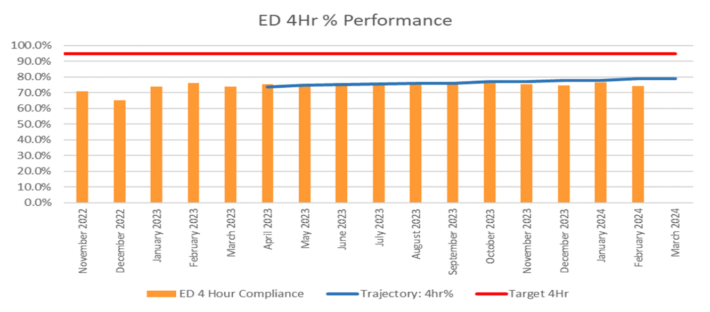
This shows our performance against the 4hour Emergency Department target. As can be seen there is consistent performance over the past year, and, whilst not achieving the national target, the Morriston Emergency Department is one of the best performing ED’s on this measure. February figure is undergoing final validation.
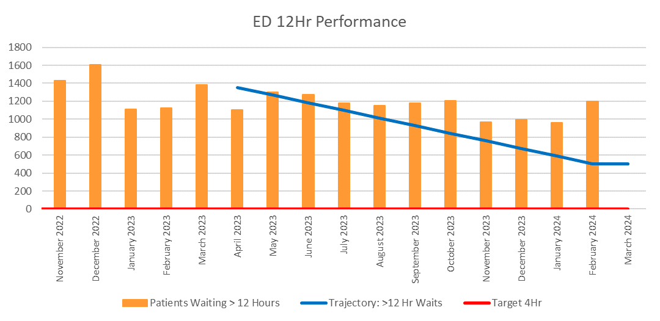
The table above shows that our performance against 12 hour targets is not improving in line with our planned trajectory and indicates that where a patient needs admitting then our waiting times are longer than many other hospitals in Wales.
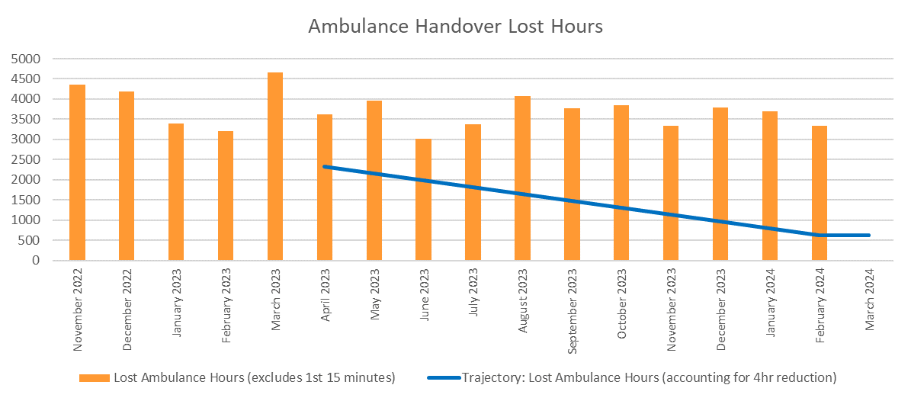
The graph shows that ambulance handovers are still a significant problem. We recognise this and are working to improve. Recently Executives from Swansea Bay visited Cardiff and Vale UHB to understand their approach as their performance is significantly better so that learning can be applied within Swansea Bay.
We know that the risks in our services are high with staff not being able to deliver the quality of care they want to, particularly in relation to discharging medically fit patients, which needs a multiagency response, so that we can provide timely care for acutely ill patients presenting at our hospitals. We are making sure that everyone across the Health Board thinks about what we can do to facilitate discharge from hospital and we are working with partners to explore what else they can do to unlock this problem with us. Many of our patients are elderly and frail with multiple medical conditions. The aim of a hospital stay is to address the emergency issue, not other issues which patients may have managed effectively in the community. Its important people get back out into their communities as quickly as possible, not only because we know the risks of deconditioning, but also because people recover better in their own environments.

Everyone’s dedicated efforts, across all partners, sectors and services are needed to achieve the improvements we need to make for our patients, and success is dependent on ensuring only appropriate admissions are made to hospital and rapid discharge supports the discharge of patients at the earliest opportunity. The response of staff across the system to these fundamental changes in our health system has been incredible, we thank them and owe a massive debt of gratitude to them.

- PLANNED CARE
We achieved the Ministerial target of no 52-week outpatient breaches at the end of October 2023 and have continued to maintain that position for the past 5 months.
The Ministerial target for the end of December was 97% of all patients should not be waiting longer than 104 weeks for treatment and we achieved 96.6%. The target for the end of March 2024 is 99% but also that all of the longest waiting patients (i.e. waiting over 4 and 5 years) are cleared. The number of patients waiting over 104 weeks has continued to reduce, by a further 391 in February 2024. Across all specialities the number of patients waiting at the end of February 2024 compared to the previous five months was:
Number of patients | September 2023 | October 2023 | November 2023 | December 2023 | January 2024 | February 2024 | In-month Improvement
>26 weeks for a new appointment | 12,786 | 11,169 | 10,425 | 10,889 | 10,772 | 10,941 | +169
>36 weeks at all stages | 25,515 | 23,997 | 23,432 | 24,059 | 24,006 | 24,006 | -
>52 weeks for a new appointment | 180 | 0 | 0 | 0 | 0 | 0 | -
>52 weeks at all stages | 14,417 | 13,945 | 13,453 | 13,386 | 13,318 | 13,214 | 104
>104 weeks | 4,645 | 4,097 | 3,460 | 2,969 | 2,566 | 2,175 | 391

The table below shows the position with patients waiting over 104 weeks: these have been updated to reflect the impacts of industrial action and return of patients from outsourced providers as part of our financial plan:

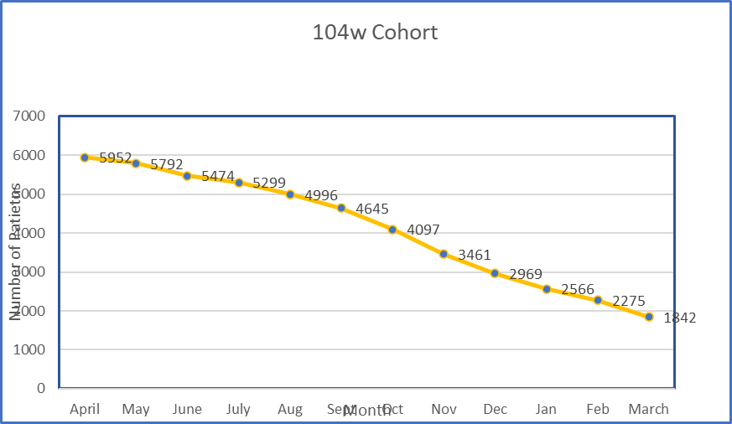

- CANCER
Providing timely treatment for cancer patients is a key focus for the Health Board. Performance has ranged between 46% and 61% over the past 12 months. We clearly have significant work to do to progress towards the national target of 75%. Performance in January fell to 48%. The volume of patients treated remained high, 3% higher than the 13 month average, but the number of patients reported to breach target was also high (equal to January 2023).

There is a continued focus on pathway improvements with the teams in all of the cancer sites to ensure first outpatient waits are no longer than 2 weeks and that decision to treat has been made by day 31, so making achievement of the 62-day target for treatment starting more realistic.

As can be seen below, for January 2024, with the exception of Skin, Brain/CNS, Acute Leukaemia and Other, the required time to treatment timescales were not met. The gynaecological tumour site remains a significant concern for us, being the lowest performing site, and there is intensive work underway with the team to address the performance issues. Breast, Urological and Lower Gastrointestinal are tumour groups the Health Board are targeting specifically for improvement. This is because they are the sites with highest volumes for both total treated and breached and so will have the greatest impacts on improving services for patients. Skin is another tumour site with high volumes, however generally this tumour group performs well.
January 2024 position / tumour site:
Tumour Site | Total No. of patients treated | No. of patients treated within target | % | Tumour Site | Total No. of patients treated | No. of patients treated within target | %
Head and neck | 13 | 8 | 62% | Breast | 26 | 7 | 27%
Upper GI | 18 | 10 | 56% | Gynaecological | 13 | 2 | 15%
Lower GI | 20 | 1 | 5% | Urological | 48 | 17 | 35%
Lung | 30 | 14 | 47% | Haematological | 14 | 1 | 7%
Sarcoma | 3 | 1 | 33% | Acute Leuk. | 1 | 1 | 100%
Skin(c) | 73 | 59 | 81% | Children's | 0 | 0 | N/A
Brain/CNS | 1 | 1 | 100% | Other | 3 | 3 | 100%

4.1 Diagnostics
As demonstrated below the volume of USC scans performed has remained consistently high, although in keeping with SCP demand and other activities, the number of requests fell in December 2023.
The percentage of scans performed in 7 days improved from 69% in December to 71% in January, but with the increased demand overall, the scans performed within 14 days fell to 91%, a decrease of 4%. 47% of scans were reported within 1 day of the investigation being performed: 95% within 7 days, the latter an improvement of 4%.
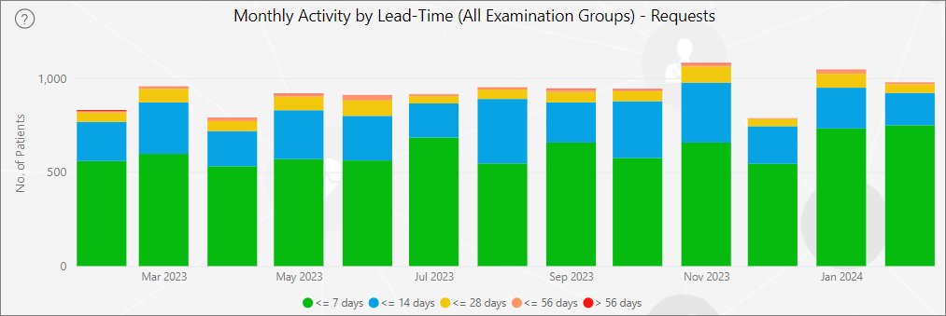

4.2 Endoscopy
Across the USC / USC STT endoscopic procedures for upper and lower GI, the median wait was 15 days in January. This was an improvement of 5 days from December 2023, resulting in an increased percentage of patients scoped within two weeks.

December | Within 14 days | Median Days | January | Within 14 days | Median Days
442 | 25% | 20 | 470 | 47% | 15

- COVID, FLU AND MEASLES
We have recently seen a slight but appreciable rise in COVID-19 infection and admission rates in Swansea Bay. This pattern is variable across Wales but is associated with increased rates in the over 80s and in children. Despite this rise rates remain at a historical low level and are still half those observed in December. The dominant variant in Wales is now the Omicron JN.1 variant which has emerged since mid-November.
The rate of Respiratory Syncytial Virus (RSV) cases in young children has now returned to background levels, in line with the usual seasonal trends. It also appears that influenza infections this winter have been at a very low level overall and are now at background levels.
Preparation is underway for the Spring COVID booster campaign that will start after Easter. Priority groups are care home residents, those over 75 and anyone who is immunosuppressed.
Despite concern over ongoing measles outbreaks and clusters in England, there have been no further cases in Wales beyond the cluster in Cardiff. Work to address immunisation uptake in school-age children and in health and social care workers is underway. This is based on identifying those at risk and offering targeted catch-up in schools and through occupational health as well as signposting to general practice. Work is underway reviewing our regional approach to responding to individual measles cases.

- TATA STEEL
In addition to consideration of the loss of the 1,929 jobs over a period of an assumed 4-9 months, additionally consideration must be given to:
- The work involved in demolition and remediation associated with the removal of the blast furnaces and associated infrastructure (‘heavy end plant’) on the site
- The work involved in preparing for and undertaking the construction of the new Electric Arc Furnaces
- The impact of many thousands of contractors engaged in these operations and associated vehicle and plant movements in terms of physical and environmental and social disruption
- The wider impact on the community of the intangibles of the change – increased uncertainty, wider economic impact of changes in commercial and retail spending, and environmental and social disruption.

In response, UK Government jointly with TSUK and the Welsh Government has established a Transition Board to manage some of the wider implications of this change. This Board will have access to £100M of funding to invest in skills and regeneration programmes for the local area once the outcome of the formal consultation is known.

A People, Skills and Business Transition Sub-Group has been established, with Health Board representation. It’s Terms of Reference state:
The sub-groups will be responsible for mobilising local partners and gathering information on a range of support programmes, recommending courses of actions or interventions to the Transition Board.

The Health Board contribution to the response fall into these broad areas:
- Jointly with partners to provide strategic co-ordination aimed at addressing the wider impacts of TSUK proposals on our local communities’ health and wellbeing
- A need to establish appropriate internal machinery to identify needs and plan and co-ordinate responses across the entire health sector. This will require investment in individuals with appropriate skills and seniority to command authority in external forums at a strategic level. It will also require appropriate support from business functions.
- A need to establish machinery to support and enable community-led responses aimed at supporting health and wellbeing.
- A need to establish a mechanism for monitoring the effectiveness of the response and the changing health status of the population.

We are aware that these changes will impact not only our population but our staff who ae affected by them. We are encouraging staff to support each other through this difficult time and to direct staff where appropriate to our wellbeing services.

- TAKING CHANGING FOR THE FUTURE FORWARD
7.1 Integrated Medium Term Plan / Annual Plan 2023-24
The Quarter 3 review of delivery against our Annual Plan is being reviewed by the Health Board. The report shows that the majority of actions are on track (67%), with a further 20% expected to be back on track in Quarter 4.

7.2 Integrated Medium Term Plan / Annual Plan 2024-25 development
The Executive Team has reviewed and prioritised the actions in the form of Goals, Methods and Outcomes (GMOs) for the Health Board’s Integrated Medium Term Plan / Annual Plan for 2024-25. The GMOs were prioritised based on criticality and feasibility.

Criticality was reviewed against the impact on quality as set out in the Health Board’s Quality Strategy:
- Alignment with Ministerial Priorities
- Contribution to delivering the Population Health Strategy
- Alignment with the Health Board’s highest risks (>20)
- Expected impact in terms of benefits

Feasibility was assessed in terms of:
- Financial impact
- Workforce deliverability
- Delivery infrastructure required
- Delivery timescales
These priorities have undergone further test and challenge and financial assessment. Robust and transparent prioritisation has been vital, particularly to support difficult decisions in the current challenging financial climate. These scored and ranked GMOs which have been prioritised by the Executive Team will be incorporated into our Integrated Medium Term Plan / Annual Plan which will be submitted to Welsh Government on 28th March 2024, following Health Board approval.

- QUALITY
As reflected above, work continues on our vision for becoming a High Quality Organisation. Our ambition is to become a leading UK health system that delivers national and international clinical and academic achievement, where staff work together in great teams to ensure patients and carers receive the highest standards of care and where the best people want to come to learn, work and research. All in order to deliver the maximum contribution to health and wellbeing.
Quality therefore continues to be a key focus for us and highlighted below is some of the work underway to contribute to this vision:

8.1 Maternity and Neonatal Services
The last few months have been difficult for our Maternity and Neonatal staff, with significant media, social media and Welsh Government interest having a negative impact on morale.

Since the last briefing we can report the following progress:
- Work continues to complete the actions highlighted by Health Inspectorate Wales’s review of Maternity Services – most are now complete and we are awaiting HIW’s response.
- Neonatal staffing is being reviewed against the British Association of Perinatal Medicine standards and actions will be agreed to address any shortfalls
- Recruitment of additional neonatal nurses is currently underway
- Clinical Director of Midwifery / Deputy to Group Nurse Director recruitment underway
- Work continues to enable the reopening of the Neath Port Talbot Hospital Birthing Centre and the home delivery service. The outcome of the gateway review will be reported to Management Board in April 2024 when a decision will be made over the date of reintroduction of services taking into account any additional actions required to ensure safe services can be sustained across Singleton and Neath Port Talbot Hospitals and in community midwifery services
- A single database of all feedback on Maternity and Neonatal services has been established across the Health Board to collate social media, complaints, emails etc that have been received so that these can be passed onto the engagement lead for the external review.

External Review
- The external review commissioned by the Health Board is progressing with the essential building blocks being put in place
- Margaret Bowron KC issued the following update on Tuesday 19 March 2024:

Swansea Bay Independent Maternity and Neonatal Review- An update from Chair of the Oversight Panel, Margaret Bowron KC

It has been a number of weeks since my appointment as Chair of the Oversight Panel was announced and I would therefore like to provide an update on the progress that has been made in that time and next steps. Whilst I am fully committed to ensuring the Review commences as soon as possible, there are a number of key steps that need to be taken in advance of this to ensure the Review can proceed in such a way that it is meaningful to families and addresses the concerns that they have raised.

In terms of progress, the process of appointing the remaining members of the Oversight Panel is almost complete and I expect to be in a position to announce the names of those I have appointed shortly. I have conducted a robust interview process with individuals who are recognised as experts in their fields. I can confirm that the candidates were selected by me and have all confirmed that they have no previous affiliation with the Health Board.

The scope is a core component of the Review and it is paramount we get this right. I have reflected both on the views that have expressed to me by experts in the maternity and neonatal areas as part of the Oversight Panel appointment process and those families who have written to me and can confirm that I fully recognise that the scope of the clinical review of cases needs to be widened.

I am committed to ensuring that all voices are heard when it comes to the process of finalising the scope and the Terms of Reference. I therefore will be seeking views on the further draft of the Terms of Reference from patients and staff and those views will be fully considered by the Oversight Panel before the Terms of Reference are finalised. I also want to make clear that the scope of the Review and the Terms of Reference are entirely the responsibility of the Oversight Panel to determine (having taken account of expert, patient and staff views). My next update will be after the Easter holidays.

  - Wales Fertility Institute
The Wales Fertility Institute provides services across South Wales. There have been detailed discussions between Swansea Bay as the provider of these services, WHSSC as the commissioner and the Human Fertilisation and Embryology Authority (HFEA), as the regulator. HFEA raised concerns at a visit to the Neath Port Talbot site last year and carried out a visit to the Cardiff site in February. Whilst there were some findings identified, for which we have submitted an action plan for improvement, the HFEA inspector did not identify findings that impact on our licence and they were not related to issues found in previous inspections. There is an HFEA audit scheduled for the Neath Port Talbot site in March 2024.

WHSSC and the Health Board are committed to putting the service on a sustainable footing. The Person Responsible issues raised at the last visit by HFEA have highlighted that there a number of sustainability issues that need further review by SBUHB including:
- Fragility across workforce groups
- Ability to meet contracted (WHSSC and direct) activity.
- Financial review
- Review of business case which had been developed to grow the service which may improve sustainability
- Review of outcomes
- Maintenance of regulatory requirements and Development of the Quality Management System
- Review of culture, leadership and team dynamics

We have been able to identify five individuals who are going to sit the exam to become a qualified Person Responsible – HFEA have reviewed them and all are considered potentially suitable. We are progressing this urgently with the aim of appointing two Persons Responsible. We have also appointed an experienced manager for the service.

A deep dive, service review has been carried out to better understand the service constraints and risks. This means we will have a baseline assessment which can form the basis for developing options and recommendations to put the service on a more sustainable footing or highlight where there are continuing risks. Some options may require public engagement and Llais are being kept up to date on these issues.
  - IPC
Infection-related risks and challenges have increased over Quarter 3. A hospital-wide outbreak of C. difficile had been identified in Morriston Hospital, with fourteen gnomically linked cases, which is being tightly managed by a Gold outbreak control group. This is the first genomically confirmed hospital-wide outbreak of C. difficile that has occurred in Swansea Bay. A round table event has been held with the Healthcare Associated Infection, Antimicrobial Resistance & Prescribing Programme (HARP), and specialists from the UK Anaerobic Reference Unit to support and share learning. Decant and cleaning plans are being implemented and further work is underway to review bed management and movement of patients.

  - Cwmavon / Cymmer GP Practice
Following concerns raised about the experiences of patients of Cwmavon / Cymmer GP Practice, David Rees and Jeremy Miles arranged public meetings to allow the Health Board to listen to these issues. Several hundred people attended and kindly gave their time to help us understand their concerns. An action plan has been developed to address the issues with this GP Practice which is currently being directly managed by the Health Board. Further rounds of public meetings (quarterly) have now been held which identified that issues still exist but these had reduced in number and complaints from patients at the practice have reduced. Work continues to address outstanding issues but although the clinical staffing at the practice has returned to planned staffing levels, there is still a significant deficit in administrative staff, exacerbated by a number of people taking up posts but then deciding to leave. The agreed reduction in opening hours at Cymmer Practice two afternoons a week was implemented on a temporary basis from Monday 4th December.

Further public meetings have now been held in January / February in Cymmer, Cwmavon and Tonmawr. The main concerns continue to be around access to prescriptions, which is now due to administrative staff shortages delaying processing of them rather than clinical staff delays in signing them. Particular concerns were raised over medicines being dispensed which haven’t been requested and not receiving those requested and the waste involved as a result.

  - Singleton Facelift
Singleton has a fresh look after undergoing a 3-year, £13m facelift, including the installation of new cladding and windows. The renovation, fully funded by Welsh Government, started in March 2021. Everyone worked tirelessly in the design and phasing to minimise the impact on operational services throughout the project, but our thanks go to our patients and staff for their patience while these works were completed. We are proud to say that the success of the project has led to a report being delivered to Welsh Government to share with other Health Boards undertaking similar projects.

- DIGITAL TRANSFORMATION
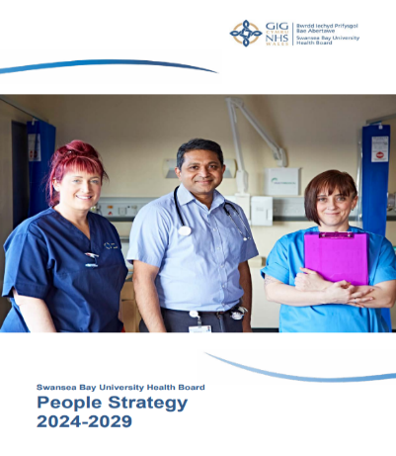
Work has been underway to develop a Digital Strategy for the Health Board. Attached are slides showing the key elements of work involved.

- PEOPLE

10.1 People Strategy 2024-29
Our new People Strategy for 2024-29 has now been launched, with a full version and one page summary available. The full version is included as an appendix to this report:
- The content is aligned to national workforce strategies, Our 10-Year Vision, and responds to Our Big Conversation feedback
- Includes 7 strategic people aims / goals, each outlining methods of delivery and success measures.
- It will be reviewed and updated annually.

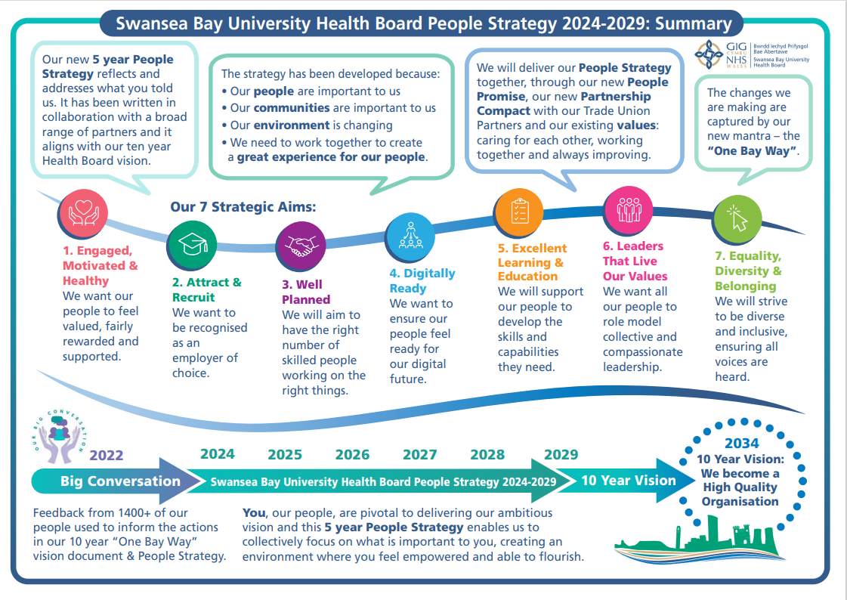
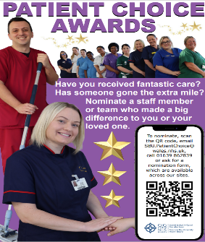
10.2 Relaunch of our Patient Choice Awards
Our Patient Choice Awards which were suspended from the start of the pandemic have now been relaunched. This is a wonderful opportunity for our patients and their families to say a huge thank to individual staff and teams who they feel have gone above and beyond to deliver superb care and support. The awards were launched in 2015 at the suggestion of the Health Board’s Disability Reference Group who felt that it was made clear how to complain but not to recognise Health Board staff who really made a difference.

Nominations are now open. A copy of the nomination form in English and Welsh are attached.

- FINANCES
The Board committed to doing whatever it could to deliver the Control Total at its meeting on the 30th November 2023 when it scrutinised the opportunities and actions needed to deliver the achieve the £17.1m deficit target set by WG. This is now summarised within one core document called the Health Board ‘Landing Plan’ overseen by the Performance & Finance Committee, which details each action required to ensure the control total is achieved.
As previously advised, the more difficult areas to achieve are not profiled to deliver until Month 11 and Month 12 and therefore work will continue to ensure all actions within the plan are addressed.
In month 11 our financial position remained largely unchanged but as we move towards the year end a number of the key components of the plan are becoming more certain and we have high confidence of delivering the control total set.
The final components of the plan will be transacted in the month 12 position with a number of these being accountancy gains rather than real cost reductions in service.
Work is nearly complete on the assessment of the 2024-25 plan and we recognise the significant resource made available to the NHS and are working hard to understand the options and choices we have to move towards financial sustainability. However, we will be taking a deficit of £55m into next year due to not achieving recurrent savings and operational pressures spend above funded levels, particularly in urgent and unscheduled care, prescribing and continuing healthcare. This is likely to involve some challenging decisions around the services we provide and we will need to ensure strong controls are in place alongside ensuring the additional funding is used to deliver sustainable services so that we remain within the funding allocated.

We are now working through in detail the Financial Plan and governance processes for submission to Welsh Government at the end of March with Board members receiving a further update on the financial plan on 13th March 2024 prior to consideration at Performance and Finance Committee and the Board at the end of the month.

- Emergency Medical Retrieval and Transfer Service Update

The Emergency Ambulance Services Committee (the Joint Committee) met on 19th March 2024. At this meeting an update was received on the conclusion and the recommended option for the Emergency Medical Retrieval and Transfer Service (EMRTS) Service Review, the relevant papers from this meeting are available at March 2024 - Emergency Ambulance Services Committee (nhs.wales) (item 2.4).

An update on the engagement process undertaken was provided, with phase 3 engagement concluding on 29 February 2024 where 568 questionnaire responses were received. The detail papers and the engagement feedback can be accessed within the link provided above.

The Joint Committee was presented with the following recommendations:

- Recommendation 1 ñ The Committee approves the consolidation of the
- Emergency Medical Retrieval and Transfer Services currently operating at
- Welshpool and Caernarfon bases into a single site in North Wales.
- Recommendation 2 - The Committee requests that the Charity secures an
- appropriately located operational base in line with the findings of the EMRTS
- Service Review Report.
- Recommendation 3 - The Committee requires that a joint plan is developed by EMRTS and the Charity, that maintains service provision across Wales during the transition to a new base and that this plan is included within the Committee’s commissioning arrangements.
- Recommendation 4 - The Committee approves the development of a commissioning proposal for bespoke road-based enhanced and/or critical care services in rural and remote areas.

The Joint Committee discussed in detail the ongoing public and political concerns which remain around the proposed changes to the operation of the EMRTS and the Wales Air Ambulance Charity (WAAC), particularly in relation to the potential closure of local bases and a perceived local loss of service, as per the initial Service Development Proposal. Representations from Llais were also considered. Attached as Appendix 2 to my report is the correspondence from the Regional Director at Llais outlining their comments in relation to the review.

The Joint Committee also discussed the risks identified through engagement in respect of the potential risk of decreased donations to the Wales Air Ambulance charity and impacts on its income, potentially threatening its sustainability. Delays in decision making regarding the Service Review had been raised by the charity and the Joint Committee acknowledged the requirement for a decision on the Service Review to be taken at the earliest opportunity.

Upon conclusion of discussion, the Joint Committee agreed that further work is required in relation to:
• Responding to the issues and representations raised during the engagement period and;
• That further development of recommendation was needed.

The outcome of this work will be presented to the Health Board for decision at a special public Board meeting to be held on 10th April, based upon a final recommendation from the Joint Committee.

- SWANSEA BAY HEALTH CHARITY

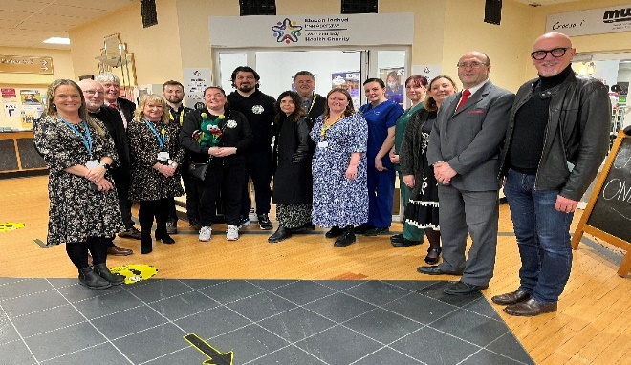
Swansea Bay Health Charity is the Health Board’s official charity. Money raised is used for equipment, staff training, research and special projects for the benefit of our patients and staff, above and beyond what the NHS can provide.

Last week the Charity opened a new hub at Singleton Hospital and also used the opportunity to unveil its new identity.


The Swansea Bay Health Charity identity has been given a positive, fun and engaging refresh to mark a new era.
The star is a symbol of hope but is also a nod to a starfish, to represent the beautiful Swansea Bay coastline.
The colours surrounding the star represent the diverse community coming together to support and contribute to the funds and projects that enhance patient and staff wellbeing.
The logo positions the charity as a separate entity but the colours, which match the One Bay Way colour palette, signify the inherent link to the health board.
The new Charity Hub at Singleton Hospital will be a visible presence for the Charity team who will regularly work from the Hub and hold meetings there.

It will also be a venue for events and fundraising activity which was exactly what happened last Friday when the Charity hosted a coffee morning and cake sale there.

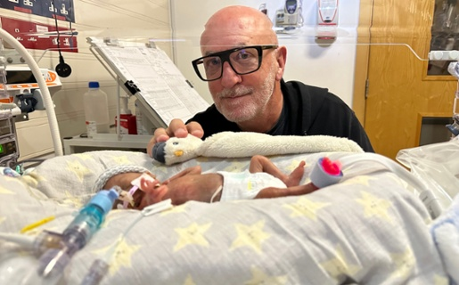
On Valentine’s Day we launched our Cwtsh Clos campaign, which aims to raise £160,000 for an upgrade of the accommodation we offer to families who need to stay close to their babies at Singleton.

Our thanks to Mal Pope for lending his support to the campaign and sharing his own, very personal experience of our Neonatal Intensive Care Unit. Cwtsh Clos is a terrace of 5 houses on the Singleton Hospital site and offers parents a free and welcoming home-from-home so they can be close to their babies at all times. However, the well-used properties are now in need of a facelift. This service covers the whole of South West Wales, so we are looking at how to develop partnerships across the whole Region rather than just in Swansea Bay.

We’ve had lots of positive feedback and are delighted that we have already raised £32,500 so far. If you or anyone you know would like to support this important appeal, please contact us on swanseabay.healthcharity@wales.nhs.uk or ring us on 01639 683 684.

