
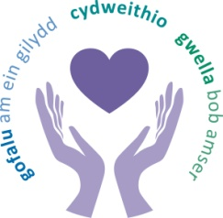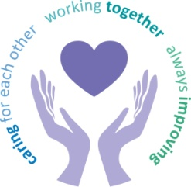
 |  | Agenda Item
Health Board July 2024
Freedom of Information Status |  | Open
Reporting Committee | Health Board Partnership Forum
Author | Kim Clee -Workforce Manager
Lead Executive Director (s) | Sarah Jenkins- Interim Director of Workforce and OD
Date of meeting | 16th May 2024
Summary of matters considered by the Health Board Partnership Forum at its meeting on 16th May 2024.
MATERNITY AND NEONATES
An update was received on Maternity and Neonates. It was confirmed that the service remained in enhanced monitoring, but recent meetings with Welsh Government and an inspection by HIW had been positive.

FRAILITY STRATEGY
A presentation on the Frailty Strategy was received which sets out the Health Board’s commitment to provide focused transformation and improvement to ensure dedicated patient centered care and to ensure high quality patient pathways, consistent with best practice. This Frailty Strategy is intrinsic to the success of the Continuous Flow model. It was confirmed that the Frailty Unit opens in September 2024.

NURSING UPDATE
A Nursing update was received on the following key relevant nursing matters as follows:
- Work to review the Rostering Policy
- Progress against the HIW nurse retention plan
- Update on professional issues
- Reduction in Nurse agency spend
- Digital strategy
- Self-referral option for neurodiverse students to ensure appropriate support is made available
- Pilot on Flexible Visiting
HEALTH PASSPORT /PROJECT WINGMAN

The Staff Health Passport was shared. This document allows staff to set out information about their health condition or disability, along with anything they felt would help them in the work environment. This could be shared with their managers, as they moved around the organisation, or if their manager changed, so that they could be properly supported.

It was reported that Project Wingman had now ended. It was felt to be a successful initiative and some user statistics were shared.

WORKFORCE METRICS

A Workforce Metrics report was shared for information.

Key risks and issues/matters of concern of which the board needs to be made aware:
None
Delegated action by the committee:
None
Main sources of information received:
Oral Updates were received from:
Sharron Price-Group Nurse Director, Singleton/NPT Service Group.

Presentations/ papers were received from:
Anjula Mehta- Acting Executive Medical Director
Helen Griffiths-Corporate Head of Nursing
Paul Dunning Professional Head of Staff Health and wellbeing
Emma Owen- Acting Assistant Director of Workforce

Highlights from sub-groups reporting into this committee:
None received
Matters referred to other committees
None identified
Date of next meeting | 11 July 2024

