Meeting Date | 25th July 2024 |  | Agenda Item |  | 3.5
Report Title | Financial Report – Month 03 2023/24
Report Author | Samantha Moss, Deputy Director of Finance  Rebecca Hayes, Assistant Director of Finance  Gemma Pearson, Finance Business Partner
Report Sponsor | Darren Griffiths, Executive Director of Finance and Performance, Acting Deputy Chief Executive
Presented by | Darren Griffiths, Executive Director of Finance and Performance, Acting Deputy Chief Executive
Freedom of Information | Open
Purpose of the Report | The report advises the Board of the Health Board’s financial position for Month 03 (June 2024) and sets out the actions being undertaken to improve forecast financial performance.
Key Issues | The report invites the Board to note the detailed analysis of the financial position for Month 03 (June 2024).  The report includes details on the revenue position both in month and Year To Date and the forecast year-end revenue position based on current planning assumptions.  The report describes the actions being undertaken to de-risk the financial forecast and improve the outturn position in year, alongside setting out actions for recovery and sustainability of financial performance.  The report asks the Board to support the development of new plan for the remainder of 2024/25 on the basis that the current plan cannot be supported or accepted.  The report invites the Board to note the Cash position, key Balance Sheet movements and the Capital position.
Specific Action Required  (please choose one only) | Information | Discussion | Assurance | Approval
Specific Action Required  (please choose one only) | ☒ | ☐ | ☒ | ☐
Recommendations | Members are asked to: -  - CONSIDER and comment upon the Board’s financial performance for Month 03 2024/25 (Revenue and Capital)  - TAKE ASSURANCE on the actions being undertaken or identify any further actions required  - SUPPORT the development of a revised plan for 2024/25 for consideration and approval at a future Board meeting in September 2024  - CONSIDER the current risks associated to financial performance

FINANCIAL REPORT – MONTH 3

- INTRODUCTION
The report invites the Board to note the detailed analysis of the Month 3 (June 2024) revenue financial position, along with Cash and Capital.

The report describes the actions being undertaken to de-risk the financial forecast and improve the outturn position in year, alongside setting out actions for recovery and sustainability of financial performance.

- BACKGROUND
  - The Health Board has two key statutory duties to achieve:

- To submit an Integrated Medium Term Plan (IMTP) to secure compliance with breakeven over 3 years.

2022/23 3-year plan approved
2023/24 3-year plan submitted
2024/25 3-year plan submitted

The Health Board will fail to meet this in 2024/25 as its plan will not breakeven over 3 years.

- To achieve financial breakeven over a rolling three-year period, which commenced on 1st April 2020 and will end on 31st March 2023.

2022/23 Breakeven position achieved
2023/24 Deficit Control Total £17.1m achieved
2024/25 Deficit Plan £50.1m

The Health Board will fail to achieve this Statutory Duty.

  - Summary of Performance against Key Financial Targets

Financial KPIs : To ensure that net operating costs do not exceed the revenue resource limit set by Welsh Government | Value  £’000
Reported in-month financial position – deficit/(surplus) | 7.483
Reported cumulative financial position – deficit/(surplus) | 25.824
Capital KPIs: To ensure that costs do not exceed the capital resource limit set by Welsh Government | Value  £’000
Reported year to date financial position – deficit/(surplus) | (1.911)
Forecast outturn financial position – deficit/(surplus) (prior to additional allocations) | 0
PSPP Target : To pay a minimum of 95% of all non NHS creditors within 30 days of receipt of goods or a valid invoice | Value  %
Cumulative year to date % of invoices paid within 30 days (by number) | 95.4

- FINANCIAL PLAN 2024/25
The Health Board submitted an Annual Plan on 28th March 2024 which reported a deficit of £50.1m. This has not been approved by Welsh Government (WG) with the request that as a minimum the Health Board reduces its deficit to £17.1m or better; work and discussions are ongoing. In order to meet the £50.1m deficit plan operational savings totalling £26.1m are required and all service areas are required to breakeven to their delegated budgets. This will require the need for a significant reduction to the Health Board’s run rate of expenditure.

A further review of the deficit in light of the Month 1 position was undertaken to be considered alongside the thematic work programme to reduce the deficit. The Board was advised in May 2024 that whilst the thematic review work had identified some technical changes that could be made and some variable benefits which could be realised, in light of the emerging Month 1 position there were not sufficient granular plans to reduce the forecast deficit as actions would first be required to de-risk the run rate. Therefore the plan remains at a £50.1m deficit.

Section 5 of this report describes in more detail the work underway and planned to improve the financial position.

- FINANCIAL PERFORMANCE – MONTH 3
The key metrics linked to the revenue position are provided in the information below. Further details on the key drivers to this are provided in Table 3 below, in section 5.1 and in appendix 1 of this report.

Summary Revenue Performance

Graph 1 & 2 Summary Revenue & Savings

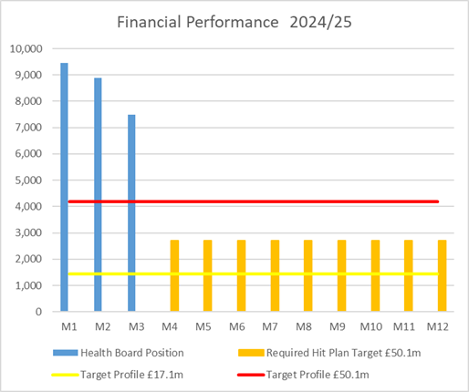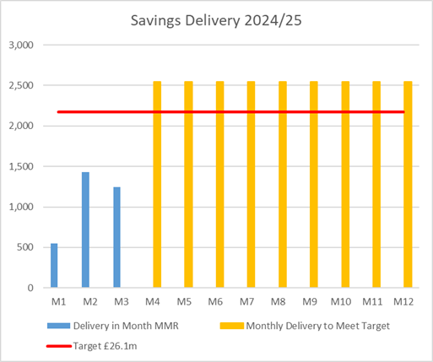

Table 1: Key Revenue Metrics
Target | In Month  £’m | Year To Date (YTD)  £’m
Delivery Against Revenue Resource Limit (RRL) DEFICIT / (SURPLUS) | 7.483 | 25.824
Delivery Against Total Run Rate/Savings Target In Ledger DEFICIT / (SURPLUS) | 1.242 | 3.220

In summary, the Month 3 financial position was £7.5m overspent, this was £3.3m higher than the forecast deficit for the month.

The Annual Plan submitted on 28th March 2024 reported a deficit of £50.1m after the delivery of £26.1m of savings. The expectation was that the in-month position would reflect one 12th of the £50.1m deficit. For Month 3 the Health Board (HB) has reported a deficit of £7.5m against a 12th of the deficit plan of £4.2m and is £25.8m overspent against cumulative deficit plan of £12.5m. Clearly this position is unacceptable and immediate actions are being taken. The three component and the respective impact on the £7.5m are visualised in the chart below:

Table 2: Breakdown Deficit In Month
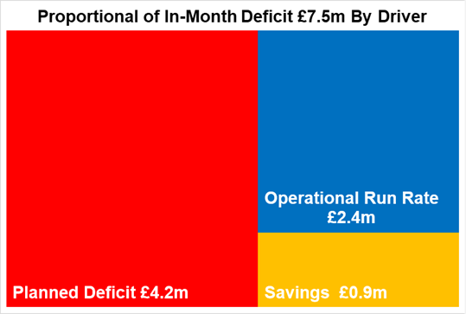

At the end of Month 3 the cumulative £25.8m overspent is broken down by Service Group and Corporate Directorate as per the Table 3 below:

Table 3: Key Drivers by Service Area Year to Date (YTD) @ End Month 3

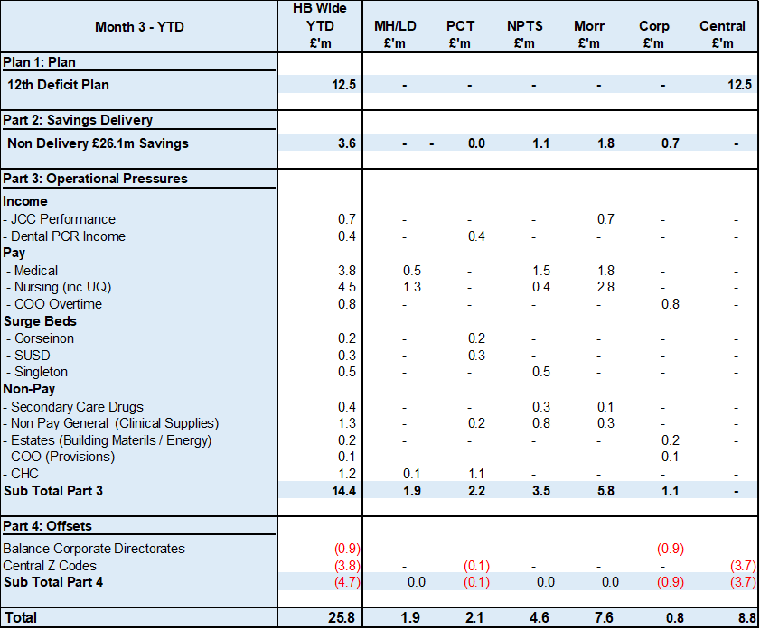

Key points of notes by type spent:

- Income
The Joint Commissioning Committee (JCC) Income as a provider deteriorated in-month, with an in-month underachievement of £0.5m, largely due to activity levels in Burns & Plastics, Bariatric and TAVI/Cardiology procedures. The YTD underachievement is £0.8m. Dental Contract Income continued to underachieve by £0.1m in-month, with an YTD underachievement of £0.4m.

- Pay
The Month 3 pay overspend was £2.8m (Month 2, £2.3m), largely driven by Medical & Dental and Nursing across the acute sites and MH&LD in addition to Hotel Services within COO. The pay pressures are driven by a number of factors including the continuation of staffing surge bed capacity, pressures on services across the organisation and high levels acuity, coupled with high levels of sickness.

- Prescribing
At Month 3 the YTD position reflected in the ledger on Prescribing is an underspend of £0.2m following the issuing of both growth and price inflationary investments within the Annual Plan, and in-month delivery of savings. However at this point in the year the Health Board has only received one month’s data for 2024/25.

- Non Delivery Savings
The Health Board has set a 2.5% savings target for 2024/25 which has been issued to Service Areas. There is currently a gap in the identification, and therefore delivery, of savings to meet the target set which has resulted in a £0.9m (Month 2, £0.7m) variance in Month 3.

Action being Taken to Mitigate Position
The Chief Executive Officer (CEO) set out a number of actions to address the run rate pressures and during May 2024 the CEO also established clear actions for each Executive Team member, which are in addition to the Thematic Programmes.

The additional actions above the Thematic Programmes, and associated Lead Executive, focus on:
- Medical Staffing Variable Pay – Acting Medical Director
- Nursing (Registered and Unregisters) Variable Pay – Director of Nursing
- Review Bank – Acting Director of Workforce
- Review Non Pay Outsourcing – COO
- Maximising Value & Sustainability opportunities – Director of Finance & Performance

As part of an Independent Members’ Financial Briefing post the Month 2 position, held on 11th June 2024, a series of further and immediate next steps were discussed and with actions underway. The full specific updates on the actions are noted below:

- Deliver activity needed to meet Joint Commissioning Committee (JCC) contact levels to achieve income targets.
- Compliance review on variable pay commitment following CEO instructions – UPDATE @ Month 3 Further clarity provided by CEO in Management Board on 19th June
- Corporate positions to not commit further spend beyond Business As Usual (BAU) – UPDATE @ Month 3 All Corporate Directorates continue to maintain underspending positions to support operational pressures in the Service Groups .
- Urgent review of all cost pressures and inflation assumptions funded in this year’s plan in addition to ‘choices’ part of the Recovery & Sustainability Portfolio – UPDATE @ Month 3 this review will be completed as part of the Recovery & Sustainability Portfolio.
- Assess and then roll out options to engage and support budget holders - UPDATE @ Month 3 New training video commenced.
- Establishment of the internal run rate reduction team – UPDATE @ Month 3 Director of Recovery & Sustainability appointed and in post on 8th July. Further work underway on the External Advisor support and the establishment of a wider Support Team for next 24 months.
- Review of individual Service Area financial strategies and identification of options for the Board to consider. UPDATE @ Month 3 detailed in paragraph below.
- Implementation of weekly reporting to monitor drivers of financial expenditure during the month and taking corrective action earlier in the month. UPDATE @ Month 3 is that the data (with one exception) is now provided on regular basis and the resources to produce the report identified, with go live proposed for end July.
- Briefing Independent Members (IM) – to ensure all members are briefed as early as possible the DOF will attend the next available weekly IM briefing post Day 5 close on a monthly basis.

With regards to the Financial Strategies, the ongoing work linked to the requirements of the Accountability Letters required the four service areas to provide the Health Board with options to support the reduction of the run rate and the delivery of the financial plan. Submissions were received on 28th June 2024. The initial assessment of all options, regardless of risk on deliverability or service impact, totalled £55m. The next step in the process is for each of the Service Groups to attend a ‘Star Chamber’ event chaired by the CEO to identify those options that can be actioned without the need for Board approval. These meetings commenced on 11th July 2024. Following these meetings a summary of the position will be presented for discussion with Independent Members.

As of 8th July 2024 a Director of Recovery and Sustainability has been put in to place. This is a result of internal reconfiguration of roles. The Director will work directly to the Director of Finance and Performance and SRO. A three programme approach has been adopted and a team is being formed to support the delivery of this programme.

- ACTIONS FOR FINANCIAL IMPROVEMENT
This section of the report updates on the actions in place and planned to reduce the risk in the current financial plan and to identify opportunities for further financial improvement both in year and in future years.

As set out above the Health Board is currently £25.8m overspent after 3 months. The rate of improvement in the financial position from month 1 to month 3 is not sufficient to achieve the forecast deficit of £50.1m and the current pipeline of options and choices does not move the Health Board closer to the 2023/24 target control total of a £17.1m deficit or better.

Formal feedback from Welsh Government on the current forecast is that this is unsupportable and unacceptable and the Health Board fully acknowledges this. The Health Board also acknowledges that the level of risk within the overall plan needs to be further reduced with additional options and choices required for further financial improvement.

Budget holders were required to submit their plans to achieve balance against their delegated positions at the end of May 2024 and following scrutiny, updates to these plans were required by the end of June 2024 to provide clarity on the granularity of the plans and the range of options and choices driving the current forecasts.

The illustration below shows the outcome of this exercise (the illustration taken directly from a pack prepared for discussion with Welsh Government at the plan scrutiny meeting held on 3rd July 2024). Formal feedback on the plan has not yet been received and it is anticipated that the Health Board will receive a written position from Welsh Government shortly. It is clear that the current range of plans and options identified do not meet either Welsh Government or Health Board requirements.

Effectively the review identified £55.2m worth of actions to reduce run rate and deliver savings which would move the Health Board to an estimated deficit of £65m (£15m short of the current unacceptable forecast and £48m short of the £17.1m target control total).

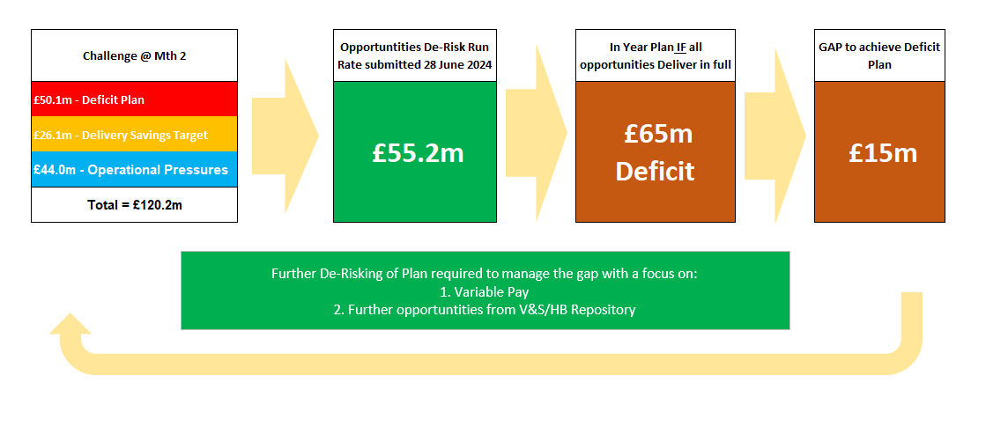

The actions within the £55.2m were RAG rated based on deliverability at the time of writing. The distribution was as follows: -

- Green £9.7m
- Amber £16.8m
- Red £28.7m

In order to test the deliverability of these actions a series of Star Chamber meetings (formal review of plans by Chief executive Officer) have been undertaken in July within the final review scheduled for 24th July 2024. It has become clear from these review discussions that some of the actions marked as “Red” would be challenging to deliver and would have impacts on service delivery which are currently beyond the Health Board’s acceptability levels. This position is currently subject to review given the scale of the financial challenge that needs to be addressed.

Prior to the outcome of month 3 reporting it was already clear that the scale and pace of current plans would not improve the financial position to a point that both the Board and Welsh Government could accept. Continuation of the business processes adopted in previous years will produce similar outcomes to previous years and hence a new approach is required.

The Health Board has therefore established a Recovery and Sustainability Programme which has three main work streams: -

- Immediate expenditure control and reduction
- Short term service change to identify new options for expenditure reduction and savings delivery over and above existing plans
- Medium term financial recovery plan to set out the route to balance for the Health Board

Individuals within the Recovery and Sustainability Programme are existing Health Board employees and do not represent and additional overhead or cost burden for the organisation.

Immediate focus of the Programme is on the first 2 work streams and actions have already been put in to place above those previously identified to manage spend reduction. These include: -

- an immediate pause on administrative and clerical, bank, agency and overtime usage
- pause administrative and clerical recruitment for a period of three months to enable a review of the current process and to facilitate a health board wide single process to be developed
- commence review of all business cases supported over the last three years to test for benefits realisation

The impacts of the new system of control being introduced by the Recovery and Sustainability Team, the business case review and the LTA revision have been introduced after the 3rd July 2024 exercise and the Performance and Finance Committee scheduled for 23rd July 2024 will receive an update on the current position.

It is clear that reducing the risk in the current financial plan and making sustainable financial improvements will require incredibly challenging decisions for the Health Board. Some of the actions within the current “Red” assessment above have service impacts such as bed number reduction (across all sites), reduced access to some community services and reduced staffing levels in clinical areas. Decisions on these have NOT been made yet as further consideration is underway of the possibility of reducing the rate of planned care recovery, more direct variable pay controls in clinical areas, revised prescribing practice and accelerated change in CHC processes. The Board would not, in any event, be prepared to make these decisions, but given the scale of the financial challenge and the need to move further and faster towards a more acceptable financial position, these will be reconsidered against clear criteria to assess impact; these are currently being developed and worked through in a prioritised manner with budget holders. Schemes will be reviewed and a series of options and choices developed to provide a clear assessment of financial resource release and the related service impact. All costs associated with avoidable harm and variation are direct opportunities for linked quality and financial improvement.

The Board will continue to be updated on progress on this work with the Performance and Finance Committee providing detailed oversight of the position.

Welsh Government has made it clear that it will not approve the existing plan. The Board will need to develop a revised plan for the remainder of 2024/25. It is proposed that this revised plan be brought to a formal special Board meeting in early September 2024 for approval (precise date to be determined). The options and choices to develop this revised plan will be worked up immediately (work is already underway) and refined following receipt of written Welsh Government feedback on the original plan which is expected shortly.

Given the scale of the financial challenge the Health Board is facing, clear criteria looking at impacts on quality, safety, access, workforce, partnerships and finance are being developed to aid decision making. The emphasis will need to be on sustainable recurrent change to provide a platform for further financial improvement towards balance in future years.

- KEY AREAS OF NOTE
Further details on specific issues impacting the revenue position are provided in Appendix 1 of this report.

The section below provides highlights other issues influencing the delivery of the wider financial position, including Balance Sheet.

  - Savings
Based on the run rate reduction/savings position reported by the Savings Project Management Office (PMO) at Reporting Day 5, the schemes identified for delivery in 2024/25 by service areas are summarised below. For clarity the first call on savings will be to address the £26.1m target by area, any opportunities above this will be allocated to management of Run Rates.

Table 4: All Savings

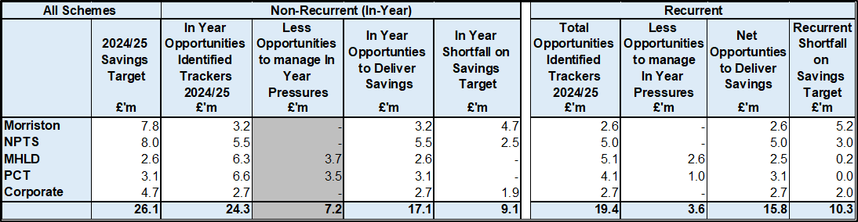

Table 4 – reflects all opportunities including those identified as red along with pipeline ideas, which total £24.3m. Of this total £7.2m will mitigate run rate pressures outside of the £26.1m target set in the plan, which leaves £17.1m to meet £26.1m 24/25 target. Overall this leaves a gap of £9.1m. Recurrently, £19.4m of opportunities have been identified, with £3.6m to mitigate run rate pressures, leaving £15.8m of schemes identified recurrently, and a recurrent shortfall of £10.3m.

Table 5: Green & Amber Savings

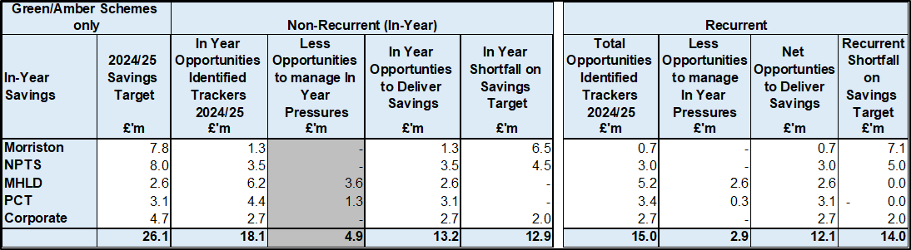

Table 5 – reflects only those opportunities which are deemed Green and Amber schemes. As a result, the overall total reduces to £18.1m at end of June. £4.9m of this is a reduction to run rate pressures outside of the £26.1m target set in the plan, which leaves £13.2m to meet the £26.1m 2024/25 target. Overall, this leaves a gap of £12.9m. Recurrently, £15.0m of opportunities have been identified, with £2.9m to mitigate run rate pressures, leaving £12.1m of schemes identified recurrently, and a recurrent shortfall of £14.0m.

Overall there is a material shortfall in the identification of opportunities to address the £26.1m target set in the 2024/25 Financial Plan, and this will form part of the focus of the monthly Financial Performance meetings.

  - Capital
The approved Capital Resource Limit (CRL) value issued on 9th July is £37.285m. The approved CRL value includes Discretionary Capital, schemes under the All-Wales Capital Programme and new/renewal IFRS 16 Leases.

Outturn Performance
The forecast outturn shows a balanced position. The balanced position mitigates any non-receipt of the £1.228m business case fees shown as anticipated allocations below.

Scheme | £m | Narrative
Business Case Fees - Modular Theatres, Singleton | 0.477 | Business case fees incurred for schemes included in the Health Board 10 year capital programme/national prioritisation.
Business Case Fees - Adult Acute Mental Health | 0.172 | Business case fees incurred for schemes included in the Health Board 10 year capital programme/national prioritisation.
Business Case Fees - Tonna Older Adults Mental Health | 0.043 | Business case fees incurred for schemes included in the Health Board 10 year capital programme/national prioritisation.
Business Case Fees – Thoracic, Morriston | 0.069 | Business case fees incurred for schemes included in the Health Board 10 year capital programme/national prioritisation.
Business Case Fees - Urology Morriston to NPT | 0.276 | Business case fees incurred for schemes included in the Health Board 10 year capital programme/national prioritisation.
Business Case Fees - PET CT, Singleton | 0.117 | Business case fees incurred for schemes included in the Health Board 10 year capital programme/national prioritisation.
Business Case Fees - 2nd CT Sim, Singleton | 0.074 | Business case fees incurred for schemes included in the Health Board 10 year capital programme/national prioritisation.

The following allocations are classed as risks.

Scheme | £m / Risk Level | Narrative
Singleton Cladding - Main works and Patient Waiting Area, Morriston Hospital | 0.205 / High | A CRL transfer from Singleton Cladding - Main Works to Patient Waiting Area, Morriston Hospital of £0.205m is required as agreed with Ian Gunney.

All other schemes are low risk and any variances are linked to planned contributions from discretionary and in some instances payback of prior year fees.

Capital Disposals
Cymmer Health Centre was disposed earlier this year with sale proceeds of £0.175m. There are three other planned property disposals of Garngoch, Phillips Parade and Morriston land with combined expected sale proceeds of £0.850m.

  - Balance Sheet
The key issues in respect of the statement of financial position movements are as follows:

The inventory value has decreased from £12.264m at the end of March 2024 to £11.378m at the end of June 2024, a decrease of £0.886m. This mainly relates to drugs stocks across all hospital sites.

There has been a decrease in trade receivables from £242.977m at the end of March 2024 to £218.628m at the end of June 2024, a decrease of £24.349m. The reduction relates to WRP (Welsh Risk Pool) debtors of £16.28m, with the majority of the other movements relating to a reduction in NHS Debtors.

The closing June 2024 cash balance of £16.733m is well above the Health Board target of a cash balance of £1-£1.5m at month end and the best practice cash target for the Health Board of £6m. As outlined in section 11, the high cash balance is due to:
- An internal oversight in the timing of an expected Pharmacy payment (£8m);
- An unforeseen reduction in Revenue payment runs of £5m due to staffing issues.

The trade and other payables figure saw a reduction from £279.628m at the end of March 2024 to £233.2646m at the end of June 2024, a reduction of £46.364m. This comprised a reduction in capital and revenue payables. The reduction in revenue payables mainly relates to reductions in goods received not invoiced, accruals, NHS and WGA (Whole Government Account), and other creditors.

Provisions decreased by £3.039m from £200.389m at the end of March 2024 to £197.350m at the end of June 2024. The quantum received are now being reflected in the financial ledger on a monthly basis, rather than quarterly. This will create a more regular movement for both the Trade Receivables (WRP Debtors) and the Provision figures.

  - Cash
As at the end of June 2024, the Health Board had a cash balance of £16.733m, which is significantly higher than the best practice cash target for the Health Board of £6m.

The high cash balance is due to:
- An internal oversight in the timing of an expected Pharmacy payment (£8m);
- An unforeseen reduction in Revenue payment runs of £5m due to staffing issues.
The cash deficit position of £103.455m is detailed in the table below:

The difference between the £103.455m forecast cash deficit and the Forecast I&E deficit Cash figure, reflects the £9.307m of capital cash to reimburse revenue CRL, and the movement in the working capital balances.

The cash flow is updated daily and a full review of the cash forecast is currently being undertaken several times a week, to ensure that any changes to our cash requirements, can be communicated in a timely manner to WG.

  - Public Sector Payment Policy (PSPP)
The Health Board achieved the 95% PSPP target; the % of Non NHS Invoices Paid within 30 in Quarter 1 achieved compliance at 95.4% for the quarter.

NHS payment compliance for invoices paid within 30 days was, however, below 95% with the quarterly performance being 83.2%. The Health Board remains focussed on improving PSPP compliance for NHS invoices and ensuring that performance remains above 95% for Non NHS invoices.

Further updates will be reported at the end of Quarter 2.

- RISKS (Revenue Income & Expenditure)

- Achieving financial plan (HBR92) with the key elements as follows: -

  - Risk of delivery of savings quantum
  - Risk of operational overspend being in excess of funding available agreed via the Financial Plan
  - Risk of commitment of reserves (e.g. NICE) being above reserves available.
  - Risk of achieving the actions outlined in the 2024/25 Landing Plan.

Based on the financial performance at Month 3, it is proposed that the Health Board Corporate Risk Register retain the existing risk score to 25 given the unacceptability of the current financial plan and the variance from plan in quarter 1.

- Availability of capital (HBR93). This risk was re-opened in 2022/23 given the reduction in discretionary capital allocation. Whilst work is underway to manage schemes to reduce commitments in 2024/25 and to produce a balanced plan, the risk varies during the year as more details on schemes emerge and potential slippage funding is made available by Welsh Government.

A score of 20 is suggested at this stage as whilst the plan is now balanced, a number of schemes are on hold and the flexibility within the plan is extremely limited given the reduction in the allocation.

- RECOMMENDATIONS
Members are asked to: -
- CONSIDER and comment upon the Board’s financial performance for Month 03 2024/25 (Revenue and Capital)
- TAKE ASSURANCE on the actions being undertaken or identify any further actions required
- SUPPORT the development of a revised plan for 2024/25 for consideration and approval at a future Board meeting in September 2024
- CONSIDER the current risks associated to financial performance

Governance and Assurance

Link to Enabling Objectives  (please choose) | Supporting better health and wellbeing by actively promoting and empowering people to live well in resilient communities
Link to Enabling Objectives  (please choose) | Partnerships for Improving Health and Wellbeing |  | ☐
Link to Enabling Objectives  (please choose) | Co-Production and Health Literacy |  | ☐
Link to Enabling Objectives  (please choose) | Digitally Enabled Health and Wellbeing |  | ☐
Link to Enabling Objectives  (please choose) | Deliver better care through excellent health and care services achieving the outcomes that matter most to people
Link to Enabling Objectives  (please choose) | Best Value Outcomes and High Quality Care |  | ☐
Link to Enabling Objectives  (please choose) | Partnerships for Care |  | ☐
Link to Enabling Objectives  (please choose) | Excellent Staff |  | ☐
Link to Enabling Objectives  (please choose) | Digitally Enabled Care |  | ☐
Link to Enabling Objectives  (please choose) | Outstanding Research, Innovation, Education and Learning |  | ☐
Health and Care Standards
(please choose) | Staying Healthy |  | ☐
(please choose) | Safe Care |  | ☐
(please choose) | Effective Care |  | ☐
(please choose) | Dignified Care |  | ☐
(please choose) | Timely Care |  | ☐
(please choose) | Individual Care |  | ☐
(please choose) | Staff and Resources |  | ☐
Quality, Safety and Patient Experience
Financial Governance supports quality, safety and patient experience.

Financial Implications
The Board is reporting a breakeven financial outturn.

Legal Implications (including equality and diversity assessment)
No implications for the Board to be aware of.

Staffing Implications
No implications for the Board to be aware of.

Long Term Implications (including the impact of the Well-being of Future Generations (Wales) Act 2015)
No implications for the Board to be aware of.

Report History |  | Board receives an update on the financial position at every meeting
Appendices |  | Appendix 1 – supplementary information

APPENDIX 1 – FURTHER DETAIL ON VARIANCES BY TYPE OF SPEND

- Overview Financial Position

- Overview of Income
A correction was made in Month 2 to reflect the subjective being used in R&D between Income & Non Pay totalling £3.9m

- Overview of Pay Variances

Overall Variance by month

Actual Variable Pay by month and type

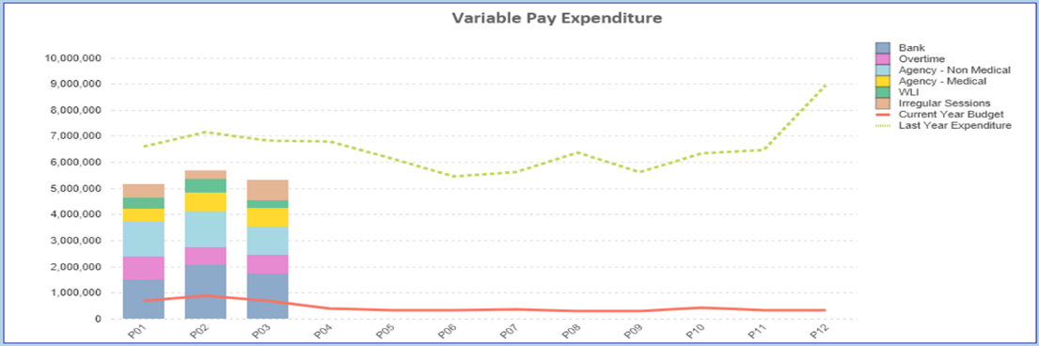

- Overview Non-Pay

A correction was made in Month 2 to reflect the subjective being used in R&D between Income & Non Pay totalling £3.9m

Below are further details on the key areas of Non-Pay (excluding savings that is addressed in main body):

  - Clinical Consumables
This area continues to be a significant pressure with an in-month position of £1.2m (Month 2, £1.4m). There are 80+ subjective lines within this category including secondary care drugs but areas seeing most pressures YTD continue to be general consumables (M&SE), laboratory products and implants (which in part will be driven by activity).

  - Energy
An update was received on 10th June 2024 from NWSSP regarding the forecast which has been validated and included in Month 3 reported position.

  - CHC
The variance against budget for CHC is £0.6m overspent in-month. An analysis of actual expenditure and patient numbers for 2024/25, along with the average values from 2024/25 is provided in table below.

CHC Analysis by Month

Please note:
- The above numbers include Domiciliary care cases.
- PCT Group does not include the Singleton/NPT element. The NPTS element which covers Children and Young People CHC patients is provided internally by the Health Board and as such is part of the wider NPTS position and is not recorded in the ledger as PCT/MH/LD CHC is recorded.

  - Prescribing
See commentary in section 4 in the main body of the report.

  - LTA Performance
For noting LTA contracts were finalised and approved at the end of June but the initial assessment of performance against these contracts will not be known for a number of months. Therefore updates on LTA performance will be provided once data in available during Q2.

