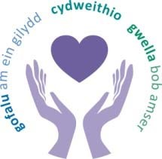
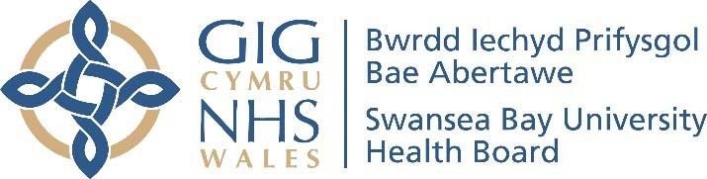
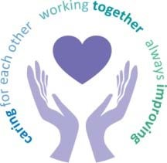

Meeting Date | 31st January 2024 |  | Agenda Item |  | 5.3
Report Title | Update On Key External Partnerships
Report Author | Michelle Davies, Head of Strategic Partnerships Heledd Bingham, Senior Strategic Planning Manager
Report Sponsor | Nerissa Vaughan, Interim Director of Strategy
Presented by | Nerissa Vaughan, Interim Director of Strategy
Freedom of Information | Open
Purpose of the Report | The purpose of this report is to provide an overview of the recent key external partnerships of which the Health Board is a statutory member.
Key Issues | The following report sets out some of the key issues discussed at recent key external partnerships meetings and in particular, those relevant for the Health Board. Minutes of the meetings are not included with the report and may not be available at this time due to timings of meetings, but a summary of the key issues from the Health Board’s point of view are included so that the Board is aware of these in a more timely manner.
Specific Action Required  (please choose one only) | Information | Discussion | Assurance | Approval
Specific Action Required  (please choose one only) | ☒ | ☐ | ☐ | ☐
Recommendations | Members are asked to:  - NOTE the key external partnerships which  Swansea Bay UHB works as a part of;  - NOTE the issues discussed in these external partnerships.

UPDATE ON KEY EXTERNAL PARTNERSHIPS

1. INTRODUCTION

Swansea Bay UHB is a statutory partner in a range of external partnerships, including those listed below:

- West Glamorgan Regional Partnership Board & its supporting governance structure
- Swansea Public Services Board
- Neath Port Talbot Public Services Board
- West Glamorgan Substance Misuse Area Planning Board
- Neath Port Talbot Youth Justice and Early Intervention Services Management Board
- Swansea Youth Justice Management Board
- Neath Port Talbot Community Safety Partnership
- Swansea Community Safety Partnership

This report provides an overview of the key discussions of these external partnerships from the Health Board’s point of view and any key areas of work being undertaken as a result. The report includes a summary from the most recent partnership meetings held in Quarter 3 2023/ 24.

2. BACKGROUND

The following section sets out the key issues discussed at the external partnership groups from a Health Board point of view and any areas of work being undertaken as a result.

West Glamorgan Regional Partnership Board (RPB) – Updated Governance

Following approval of a new five-year Area Plan on the 25th January 2023, revised and strengthened Governance arrangements have since been in place to support delivery of the plan. These reflect the updated priorities and aim to rationalise/reduce meetings.
The updated governance structure below was signed off by all West Glamorgan RPB Statutory partners on the 20th June 2023.

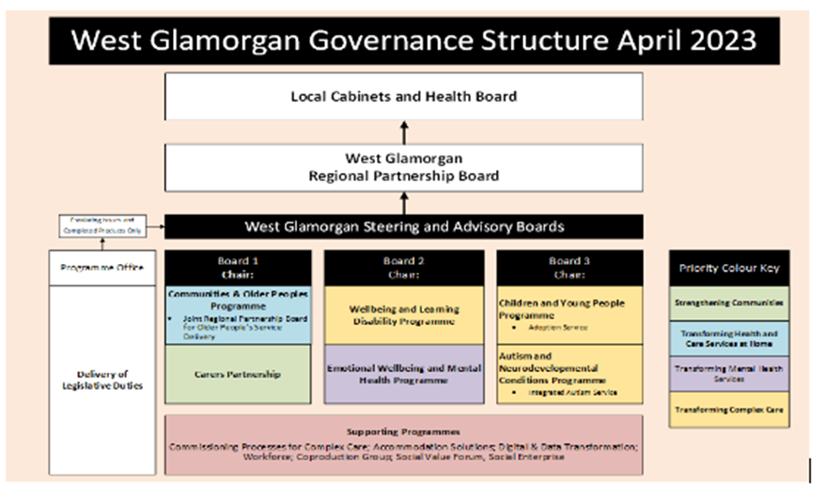

The structure above includes three Steering Advisory Boards (SABs) aligned to the priority areas and the Boards are chaired by the Directors of the three key agencies – Swansea Council, Neath Port Talbot Council and Swansea Bay University Health Board. Six Population Programmes have been set-up that report directly to the SABs –and Health Board membership has been revised to ensure strong leadership and representation.

2.1.1 West Glamorgan Regional Partnership Board (RPB)
Since the previous update, the RPB has met on the 8th August, 17th October and 12th December 2023. On the agenda the following reports/ presentations were provided for information/ endorsement.

Integrated Winter Plan 2023/24
The Regional Integrated Winter Plan was presented to the RPB for endorsement on the 12th December 2023. The Plan covered regional Integrated Planning, Winter Resilience and Emergency Planning. It was confirmed that there were no additional funds from Welsh Government for the delivery of the plan for this year. Partners felt that the risks section required strengthening to reflect discussion on the financial constraints within partner organisations and challenges over winter. The RPB endorsed the Winter Plan.

RPB Welsh Government Self-Assessment Process
- An update was presented to the Board on the 12th December 2023. Oxford Brooks University, on behalf of Welsh Government, had been appointed as independent facilitators for the self-assessment process. Following the completion of a survey by all RPB members, responses will be presented back to the RPB Board in February 2024. An action plan for the region will be developed following workshop discussion.

Regional Integration Fund (RIF) Q2 Performance Returns
- The Q2 RIF performance returns were presented for endorsement on the 12th December 2023, prior to submission to Welsh Government. Regional and national work was underway to strengthen the reporting arrangements and ensure a consistent approach across Wales, especially in relation to measuring outcomes and cost avoidance. The RPB endorsed the Q2 performance reports.

Regional Strategic Capital Plan
- The Regional Strategic Capital Plan was approved for submission to Welsh Government on the 8th August 2023. The plan supports the delivery of the Area plan and outlines the regional capital investment requirements for the delivery of Health and Social care models over the next 10 years.

Emotional and Mental Wellbeing Strategy
- A presentation was shared with the RPB Board on the 8th August 20203 of the detailed work undertaken to date on the strategy. Members were assured that an implementation plan was in development and regular updates would be provided at future RPB meeting.

2.1.2 Steering Advisory Board 1 (SAB 1) Communities and Older People.
The first meeting of the newly established programme took place on the 14th of November 2023.
Communities and Older People
- A presentation was given on the aims and vision of the programme.
- Workshops would be taking place over the coming months to drive forward the work and to produce a detailed action plan. A communication/ engagement plan would be developed as part of this work.

Carers’ Partnership
- A presentation was given on the carers’ partnership and priorities over the next 3-5 years.
- Four key focus areas were outlined as Respite and short breaks, direct payments, carers’ needs assessment and Information, advice, assistance and support.
- Action plans for each priority area were being developed

2.1.3 Steering Advisory Board 2. Wellbeing and Learning Disability Programme
The first meeting of the newly established programme took place on the 10th October 2023.
Learning Disabilities Strategy Update:
- An engagement exercise had taken place and further work was planned to strengthen the voices of Children and Young People throughout the strategy.
- The updated strategy would be discussed further at a future Board meeting.

EWB&MH Programme Update
- The Emotional and Mental Wellbeing Strategy was approved by all partners in August 2023, and members of the Board received an update on next steps. Workshops had been arranged to initiate the development of the Strategy Implementation Plan to take place during December with the aim to ‘Turn Vision into Action’.

2.1.4 Steering Advisory Board 3: Children and Young People & Neuro-divergence
The first meeting of the newly established programme took place on the 24th October 2023.
Children and Young People (CYP)
- The structure of the Children and Young People’s Programme had been confirmed. 4 work streams had been established: Safe Accommodation, Participation and Engagement, Emotional Health and Wellbeing, Multi Agency and Therapeutic Support Services.
- A discussion on moving to a joint commissioning model between SBUHB and the Local Authorities of CYP with complex needs took place. This would bring the region in line with other regions. E.g. Gwent and North Wales. It was agreed that further detail would be required, especially by the health board, to understand implications and requirements of such a model.

Neuro-divergence Programme
- Newly formed group (previously the Regional Strategic Autism Group)
- Further workshops were planned to enable better understanding of the key issues, map out system / services and what the future vision and steps required to deliver the vision including use of grant and core funding.

2.2 Public Service Boards (PSB)

In 2023, Well-being Plans for Swansea and Neath Port Talbot were published, and as a statutory partner of the PSB the Health Board will play a key role in the implementation of the Plans and the Well-being objectives agreed. Progress has been made to ensure that the governance supporting the PSBs is effective and allows all partners to participate in discussions. Informal Public Service Board (PSB) Steering Boards have been set-up to oversee the development and delivery of the PSB Wellbeing Plans with a series of work streams established including stronger communities and early year’s integration. The Health Board received a paper on the PSB Wellbeing Plans in March and is attached as appendix 2.

2.2.1 Swansea Public Services Board

The Swansea PSB Joint Committee met twice – July and October, the following were the key discussions:
- Election of Chair for the Municipal Year 2023-2024 – agreed at the meeting that Councillor Andrea Lewis, Swansea Council be elected as Chair, and that Roger Thomas, Mid & West Wales Fire & Rescue Service be elected as Vice Chair.
- Work had been progressed with PSB partners to agree a PSB action plan for 23/24, and members agreed that an update should be provided at each PSB meeting. All partners had been assigned to lead on the agreed steps within the Wellbeing Plan. The Health Board will lead the work programme to support the transformation of early year’s services. The Health Board have enhanced existing regional governance with a focus on developing a strategic approach to integration.
- Walking in Our Shoes Event held on 17th October 2023 hosted by Mid and West Wales Fire Authority (MWWFA) had been an opportunity for partners to learn more about the Authority operates, and an update was provided to members. Representatives from the Health Board were in attendance at the event. All PSB partners will be required to hold a Walking in Our Shoes Event.

2.2.2 Neath Port Talbot Public Services Board

The Neath Port Talbot PSB met twice – in June and September, the following were the key discussions:
- The focus of the discussion in June was to agree the approach to delivering the Wellbeing Plan for NPT including the governance structure that supports implementation. A number of existing work steams would be used to take forward the Plan, and the partners would be asked to ensure that they have representation on those work streams. The approach agreed in Neath Port Talbot on publication of the Plan was to develop Outcome Delivery Plans using a Theory of Change methodology. These Plans will also be referred to as Logic Models and will give us the opportunity to clearly consider the complexities of the issues we are facing, ensuring that all our stakeholders will be involved in the process of identifying existing evidence, assumptions, and associated risks.
- In September, there was a round table event to discuss the work programme of the Local Economic Partnerships. Notes have not been made available for this event as yet, however there were presentations from National Resource Wales and the Global Centre of Rail Excellence.

2.3 West Bay Substance Misuse Area Planning Board

The West Bay Substance Misuse APB met four times since the last report in June, July, September and November. Please note the following:

- Area Planning Board (APB) Structure – A review of the APB structure was initiated in June, with the main aim to re-affirm the Board’s role as the strategic board for substance misuse. Members endorsed a number of changes to the structure at the September meeting including the reinstatement of the Clinical Governance Group, and the creation of an early intervention, prevention and children and young people’s sub group.
- Western Bay Drugs Commission – since its establishment in December 22 a number of public facing meetings have been held, where evidence has been gathered, identifying the top issues/ themes people are concerned about locally that need further review - themes include housing, mental wellbeing and prescribing. The commission visited services in October and a public session to hear from people with lived experiences and family members was held on the 6th December. A final public session is scheduled for the 10th January, with a focus on cultural and governance issues.
- Intensive Multi-Agency Panel (IMAP) – A progress update was provided to members at the July meeting on the development of IMAP. The aims of IMAP include the development of operational responses to address the volume of Drug Related Deaths (DRDs) and inter-agency working to problem solve and increase support around the person. The first meeting of IMAP was held on the 28th September ‘23 with subsequent monthly meetings arranged.
- Independent Review Panel (IRP) – The IRP has been working for over a year reviewing suspected/confirmed DRD’s across the region. They have reviewed many cases, identified themes/recommendations/lessons learnt and given feedback to service providers. Themes identified include the need to improve partnerships working and the need for public health messaging to target those not engaged with services. The IRP presented the end of year report to the Board in July including the limitations to the data and information sharing and details on toxicology and inquest results were shared with members. The September update highlighted that a learning from practice process had been developed to audit current cases and that the results would be presented back to the APB. At the November meeting the IRP highlighted that a reduction had been seen from 37 to 27 Drug Related Deaths, however they are still averaging 3.85 deaths a month.
- Alliance Approach - The Alliance Approach is an Integrated Public Health Model for Substance Misuse. At the September meeting a business case was endorsed by members to take forward the Alliance Programme, with some of the key themes identified as demand & capacity issues, quality of care and integration. Whilst the business case was endorsed it was highlighted that further engagement and co-production was required with a robust commissioning strategy.
- Co-occurring Strategy & Framework – work to develop a Co-occurring Strategy & Framework has been led by the Health Board and the Strategy has now been agreed. The Health Board is leading the development of an implementation plan with a focus on two areas specifically, 1) development of an overarching regional service model and 2) workforce development and training requirements to enable the implementation of the strategy.

Youth Justice Service, Management Board

A Senior Representative of the Health Board is invited to attend the Management Boards in Swansea and Neath Port Talbot – that role currently sits within the Strategy directorate. The role of the management board is to work collaboratively to improve access to services. The Health Board provides the following services:
- Mental Health – a designated band 7 CAMHS Nurse, supports both Swansea and Neath Port Talbot, employed by Swansea Bay UHB. The recruitment & retention of this post has been an ongoing issue, however a nurse is now in post.
- Speech & Language Therapy – an SLA exists between the local authorities and the Health Board to provide specialist SALT to the young people who access the youth justice service
- Sexual Health – designated clinics are provided for the Youth Justice Service as part of core service.
The National Youth Justice Board launched a new oversight framework in April 2023, and presentations were received by individual Boards. The framework will 1) increase understanding of performance across the system and 2) assure value for money from the Youth Justice Core Grant.

Neath Port Talbot Youth Justice and Early Intervention Services Management Board

The Management Board met in September 2023. Please note the following in relation to the performance report:
- A performance report was not available at the Board meeting in September, however a recent report of the Out Of Court Scrutiny Panel was shared, and highlighted that 8 young people had been referred to the Bureau section of the service with a total of 11 offences, with the largest category of offences being violence against the person. Further analysis was undertaken with detailed case studies to enable partner agencies to identify trends to support future solutions.
- Safeguarding is a regular item on the agenda for the Board and whilst the service is confident that their safeguarding processes are robust, a number of priority areas have been agreed including, ensuring that the emotional health and well-being needs of our young people are met with a clear consideration of safeguarding within those needs and linking in regularly with the safeguarding leads of the local authority and our partner agencies to ensure we are looking at all the safeguarding needs of our young people.

Swansea Youth Justice Service Management Board

Performance reports are shared with all partners during each Board, when trends are reviewed collaboratively. The Management Board met in May, September and December 2023. Please note the following in relation to the performance report:
- The Prevention service is where Health Board Services will refer into, including CAMHS. Three referrals were made by Health for a Prevention Intervention during Q2 out of 23 referrals. The main areas of concern are anti-social behaviour with 10 referrals and domestic abuse with 5 referrals.
- Prevention (including Bail Support/Vol Support/Turn) referrals remain fairly consistent with previous quarters. Standard prevention referrals received between Jul – Sept has decreased slightly from 61 to 53, and the remaining numbers have been identified as referrals for the Turnaround project, and bail/ voluntary support interventions (which are also included in the prevention cohort). We continue to see increasing numbers bail/voluntary support being offered/accepted.

Neath Port Talbot Community Safety Partnership (CSP) Board

The Partnership met in June and September 2023. Please note the following:
- The performance report provided by South Wales Police (April to June), highlighted a reduction in criminal offences relating to violence against women and girls (46% reduction), and hate crime (20% reduction) compared to the previous quarter. However, an increase has been seen in drug related offences specifically county lines (17, compared to 9 in the last quarter), and vehicle crime (121, compared to 62 in the last quarter).
- The Healthy Relationships Strategy is a joint 3-year Strategy between NPT Council and Swansea Bay University Health Board. The Strategy has recently been updated and signed off by both agencies, following a public consultation.
- As part of crime prevention the Partnership hosted 2 events, 1) A Safer Sandfields and 2) A Safer Ystalyfera. These events have been prioritised in these areas due to specific concerns on criminal activity.

Safer Swansea Partnership Meeting

The Partnership met in September 2023. Please note the following:
- Members received an update on Anti-Social Behaviour (ASB) within Swansea and that increases are being seen nationally, and specifically in pockets of Swansea. It was highlighted that there is a lot of under reporting and so difficult to understand the scale of the challenge. The ASB Scrutiny review report is pending and this will contain recommendations for partners to consider.
- Work ongoing to increase work in relation to Safe Streets with a focus on substance misuse, street lighting and CCTV Units. The initiatives currently being considered is expected to have a positive impact on ASB.

3. RECOMMENDATIONS

Members of the Board are recommended to:
- NOTE the key external partnerships which Swansea Bay UHB works as a part of;
- NOTE the issues discussed in these external partnerships.
Governance and Assurance

Link to  Enabling Objectives  (please choose) | Supporting better health and wellbeing by actively promoting and empowering people to live well in resilient communities
Link to  Enabling Objectives  (please choose) | Partnerships for Improving Health and Wellbeing |  | ☒
Link to  Enabling Objectives  (please choose) | Co-Production and Health Literacy |  | ☒
Link to  Enabling Objectives  (please choose) | Digitally Enabled Health and Wellbeing |  | ☒
Link to  Enabling Objectives  (please choose) | Deliver better care through excellent health and care services achieving the outcomes that matter most to people
Link to  Enabling Objectives  (please choose) | Best Value Outcomes and High Quality Care |  | ☒
Link to  Enabling Objectives  (please choose) | Partnerships for Care |  | ☒
Link to  Enabling Objectives  (please choose) | Excellent Staff |  | ☐
Link to  Enabling Objectives  (please choose) | Digitally Enabled Care |  | ☒
Link to  Enabling Objectives  (please choose) | Outstanding Research, Innovation, Education and Learning |  | ☐
Health and Care Standards
(please choose) | Staying Healthy |  | ☒
(please choose) | Safe Care |  | ☒
(please choose) | Effective Care |  | ☒
(please choose) | Dignified Care |  | ☒
(please choose) | Timely Care |  | ☒
(please choose) | Individual Care |  | ☒
(please choose) | Staff and Resources |  | ☐
Quality, Safety and Patient Experience
The report highlights the current partnership arrangements with Local Authorities and other partners. These arrangements have been developed to improve outcomes for patients and mitigate any quality and safety risks.
Financial Implications
The recommendations made are not associated with any financial implications. Members of the Committee are not being asked to consider or approve any financial assumptions.
Legal Implications (including equality and diversity assessment)
There are no legal implications associated with this report or the plans outlined within it. The Health Board is fulfilling the statutory requirements placed on it to participate in the partnerships outlined in this paper.
Staffing Implications
There are no staffing implications associated with this report or the plans outlined within it.
Long Term Implications (including the impact of the Well-being of Future Generations (Wales) Act 2015)
The actions outlined in the report support the five ways of working outlined in the Act. Swansea Bay UHB is working collaboratively with partner organisations to identify improved ways of working to support the longer-term strategic vision of the organisations involved.
Report History |  | This Board considered a previous Partnership Report Update in June 2023.
Appendices |  | (Included within Resources in Admin Control)  Appendix 1 - West Glamorgan Area Plan  Appendix 2 - PSB Wellbeing Plans

